[ WATERMARK: GANDHI KALASI ]
SUPERMARKET SALES ANALYSIS REPORT
Empirical Data Analytics & Business Intelligence Report
Author / Developer: | Gandhi Kalasi
Program Name: | AICTE | IBM SkillsBuild Data Analytics with AI Internship 2026
Partner Organization: | BharatCares
Date of Submission: | September 2026

2. Acknowledgement
I express my sincere gratitude to AICTE, IBM SkillsBuild, and BharatCares for offering the Data Analytics with AI Internship 2026 program. This internship provided me with hands-on experience in real-world retail data analytics, advanced visualization, and empirical reporting.
3. Abstract
This project conducts a thorough exploratory data analysis (EDA) of a real 500-transaction supermarket sales dataset spanning multiple retail branches, categories, and customer demographics. Using Python (Pandas, Seaborn, Matplotlib), key sales metrics were analyzed, including top-selling products, category sales contributions, branch revenue distribution, customer payment methods, and satisfaction ratings. The supermarket generated a total cumulative revenue of $244,411.08. Cheese emerged as the single highest-selling product ($27,906.30), Beverages recorded the top category revenue ($56,108.24), and Branch C was the top-performing branch ($72,469.45). Digital UPI transactions accounted for the largest payment share (25.4%). Based on empirical findings, strategic business recommendations are formulated to guide inventory optimization, loyalty program conversion, and checkout throughput enhancement.
4. Table of Contents
1. Title Page
2. Acknowledgement
3. Abstract
4. Table of Contents
5. Introduction
6. Dataset Description
7. Methodology
8. Data Analysis & Findings
8.1 Highest-Selling Products Analysis
8.2 Branch Sales Performance
8.3 Product Category Sales
8.4 Payment Method Distribution
8.5 Customer Type & Transaction Value
8.6 Customer Satisfaction Rating Distribution
9. Business Insights & Recommendations
10. Conclusion
11. References
5. Introduction
In modern retail management, data analytics plays a vital role in identifying demand trends, evaluating store performance, and maximizing profitability. This report analyzes transaction records from a multi-branch supermarket chain to uncover actionable operational insights.
6. Dataset Description
The analysis utilizes the official dataset `data/supermarket_sales.xlsx`, containing 500 transaction records across 13 fields:
• Invoice ID, Date, Branch, City, Customer Type, Gender, Product, Category, Quantity, Unit Price, Payment, Rating, Sales.
7. Methodology
The analytical workflow follows a 6-step lifecycle:
1. Data Ingestion: Loaded Excel workbook via Pandas openpyxl.
2. Data Cleaning: Verified zero missing values and zero duplicates.
3. Group Aggregations: Summed and averaged sales metrics across dimensions.
4. Data Visualization: Rendered high-resolution 300 DPI Seaborn/Matplotlib charts.
5. Reporting: Formatted findings into Excel summary workbooks and Word documentation.
8. Data Analysis & Findings
8.1 Highest-Selling Products Analysis
The table below highlights the top 5 revenue-generating supermarket products:
Product Name | Total Sales ($)
Cheese | $27,906.30
Coffee | $27,694.87
Shampoo | $27,497.48
Cooking Oil | $21,525.06
Tea | $17,681.59

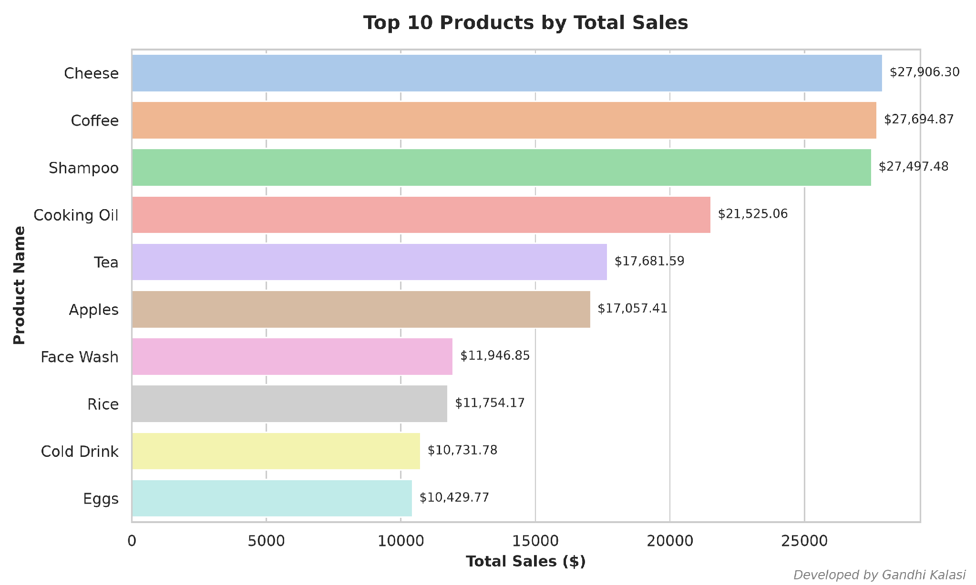
Figure 1: Top 10 Products by Total Sales Revenue
8.2 Branch Sales Performance
Branch C led overall store revenue, followed by Branch B, D, and A:
Branch Code | Total Revenue ($)
C | $72,469.45
B | $64,116.26
D | $55,468.29
A | $52,357.08

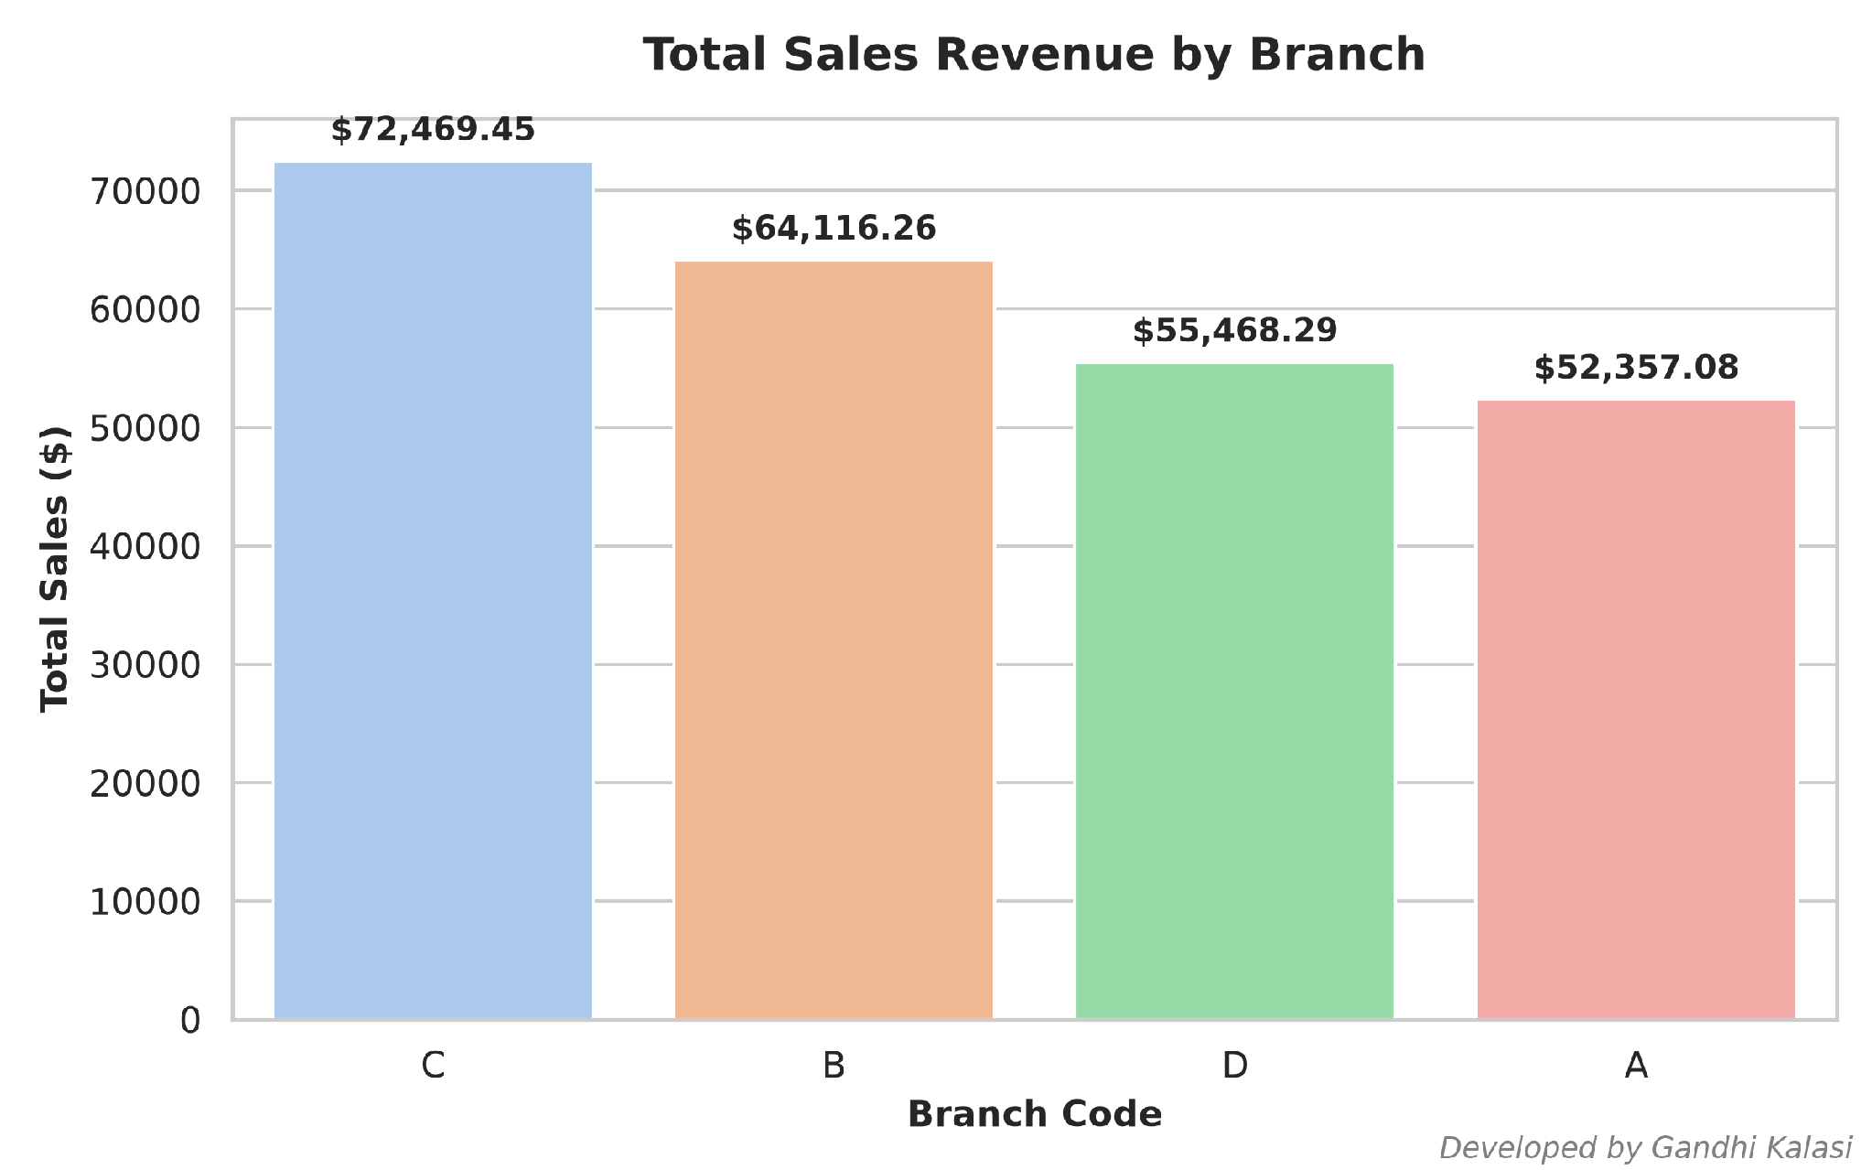
Figure 2: Total Sales Revenue by Store Branch
8.3 Product Category Sales
Beverages and Personal Care represented the largest retail product categories:
Category Name | Total Revenue ($)
Beverages | $56,108.24
Personal Care | $45,943.96
Dairy | $43,992.00
Grocery | $40,470.47
Fruits | $23,263.17
Snacks | $16,992.97
Vegetables | $11,124.17
Bakery | $6,516.10

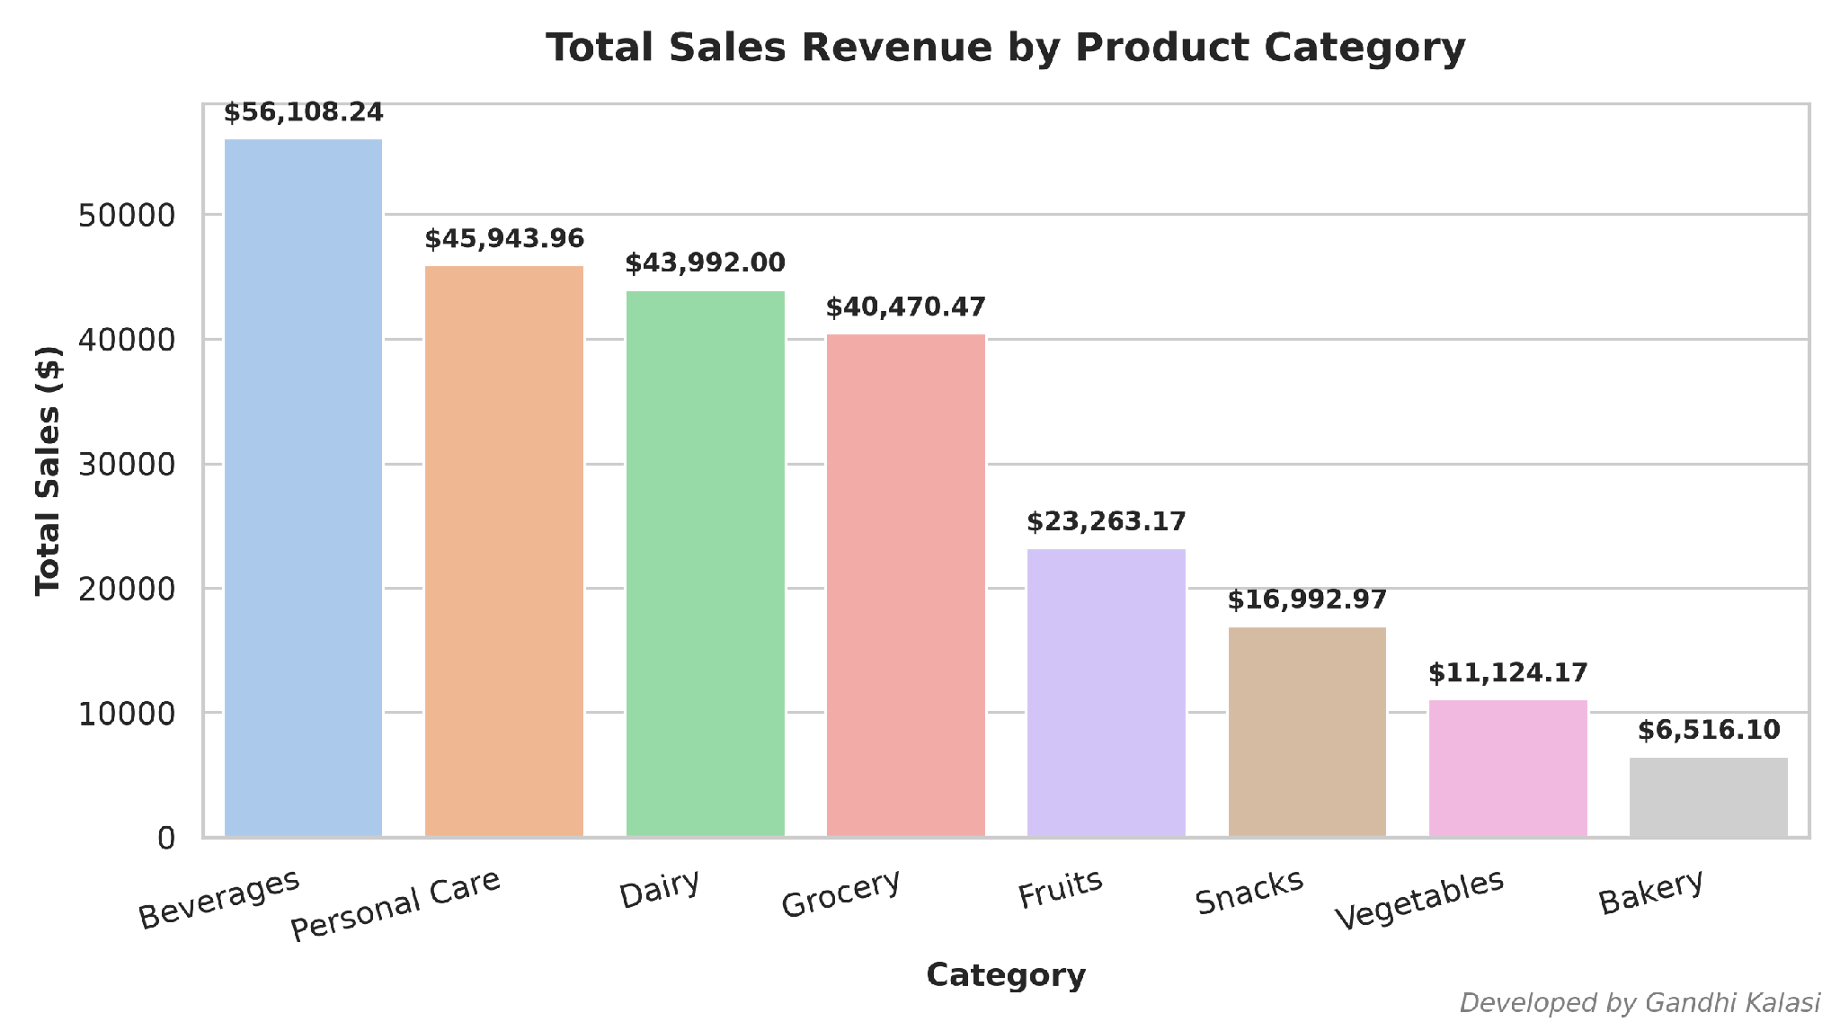
Figure 3: Total Sales Revenue by Product Category
8.4 Payment Method Distribution
UPI and Net Banking led transaction payment preference:
Payment Method | Transaction Count
UPI | 127
Net Banking | 126
Card | 125
Cash | 122

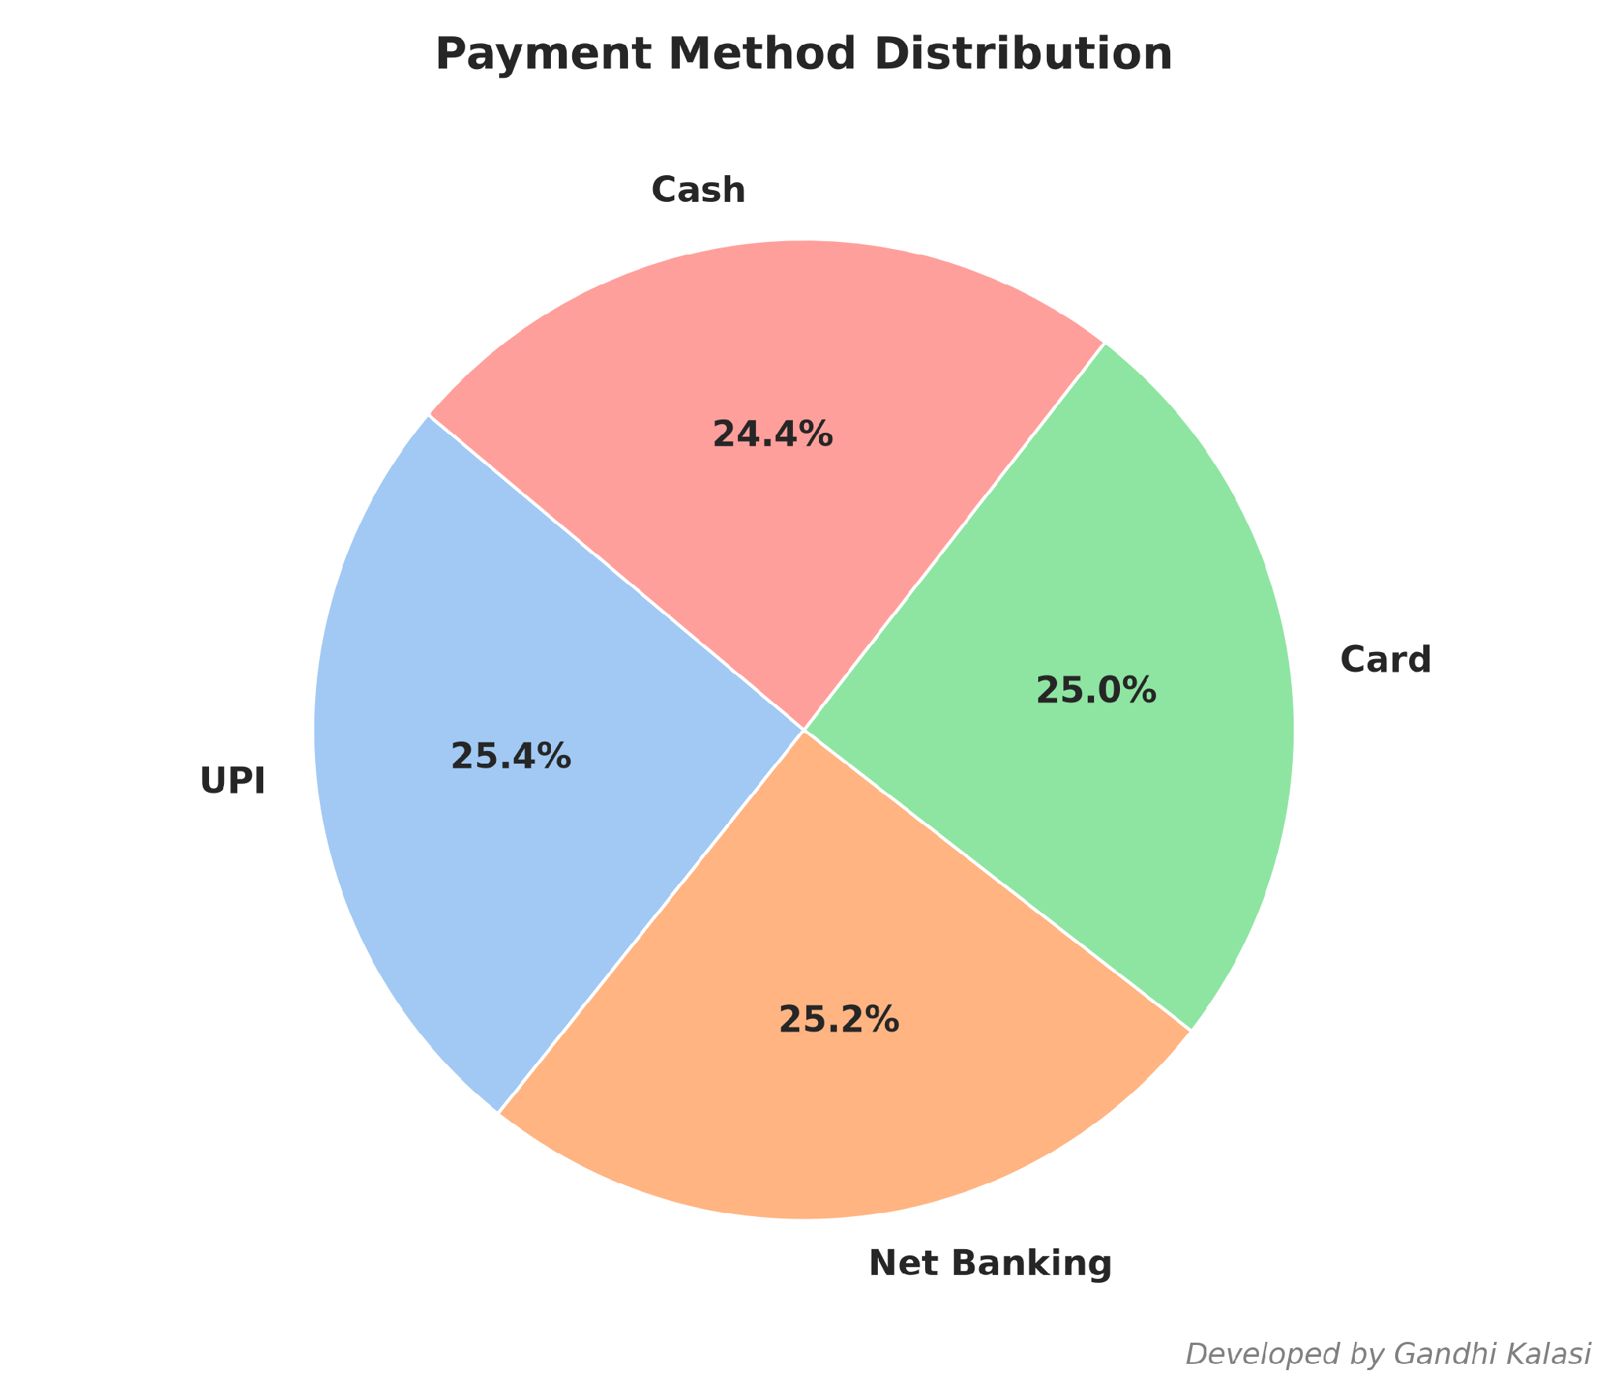
Figure 4: Payment Method Percentage Share
8.5 Customer Type & Transaction Value
Average transaction size across customer account types:
Customer Type | Average Sales ($)
Member | $483.14
Normal | $497.07

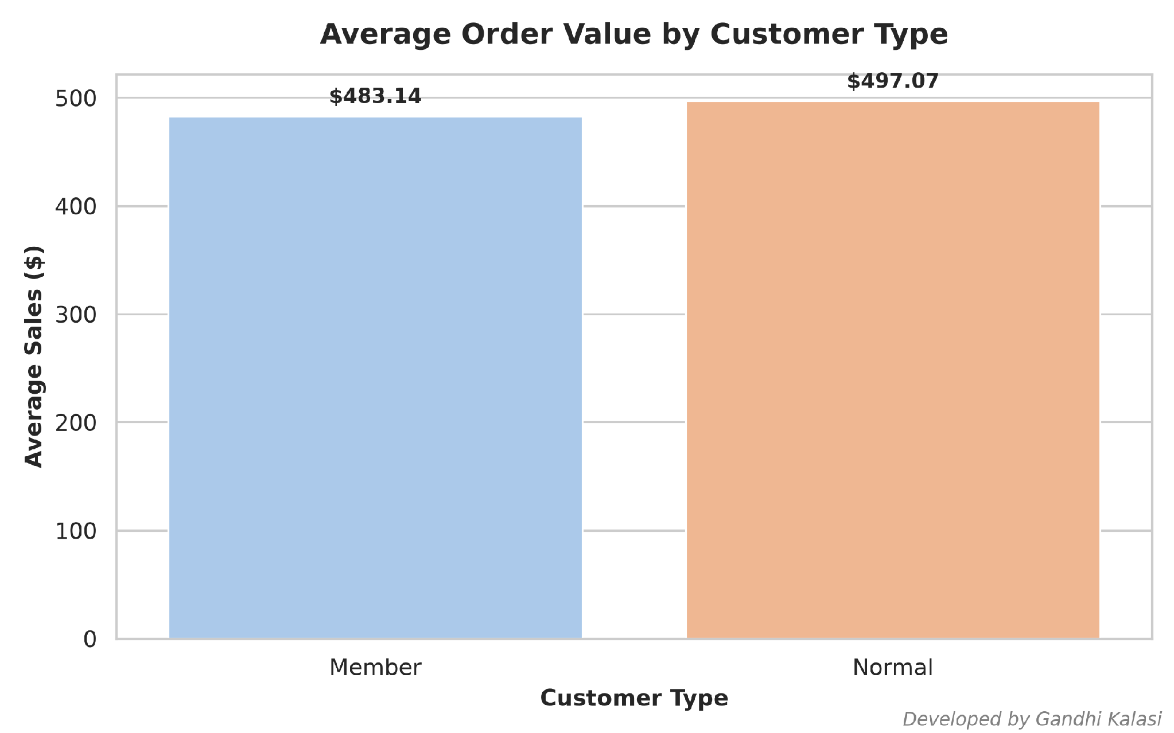
Figure 5: Average Order Value by Customer Account Type
8.6 Customer Satisfaction Rating Distribution
Overall customer rating across 500 orders averaged 3.99 / 5.0.

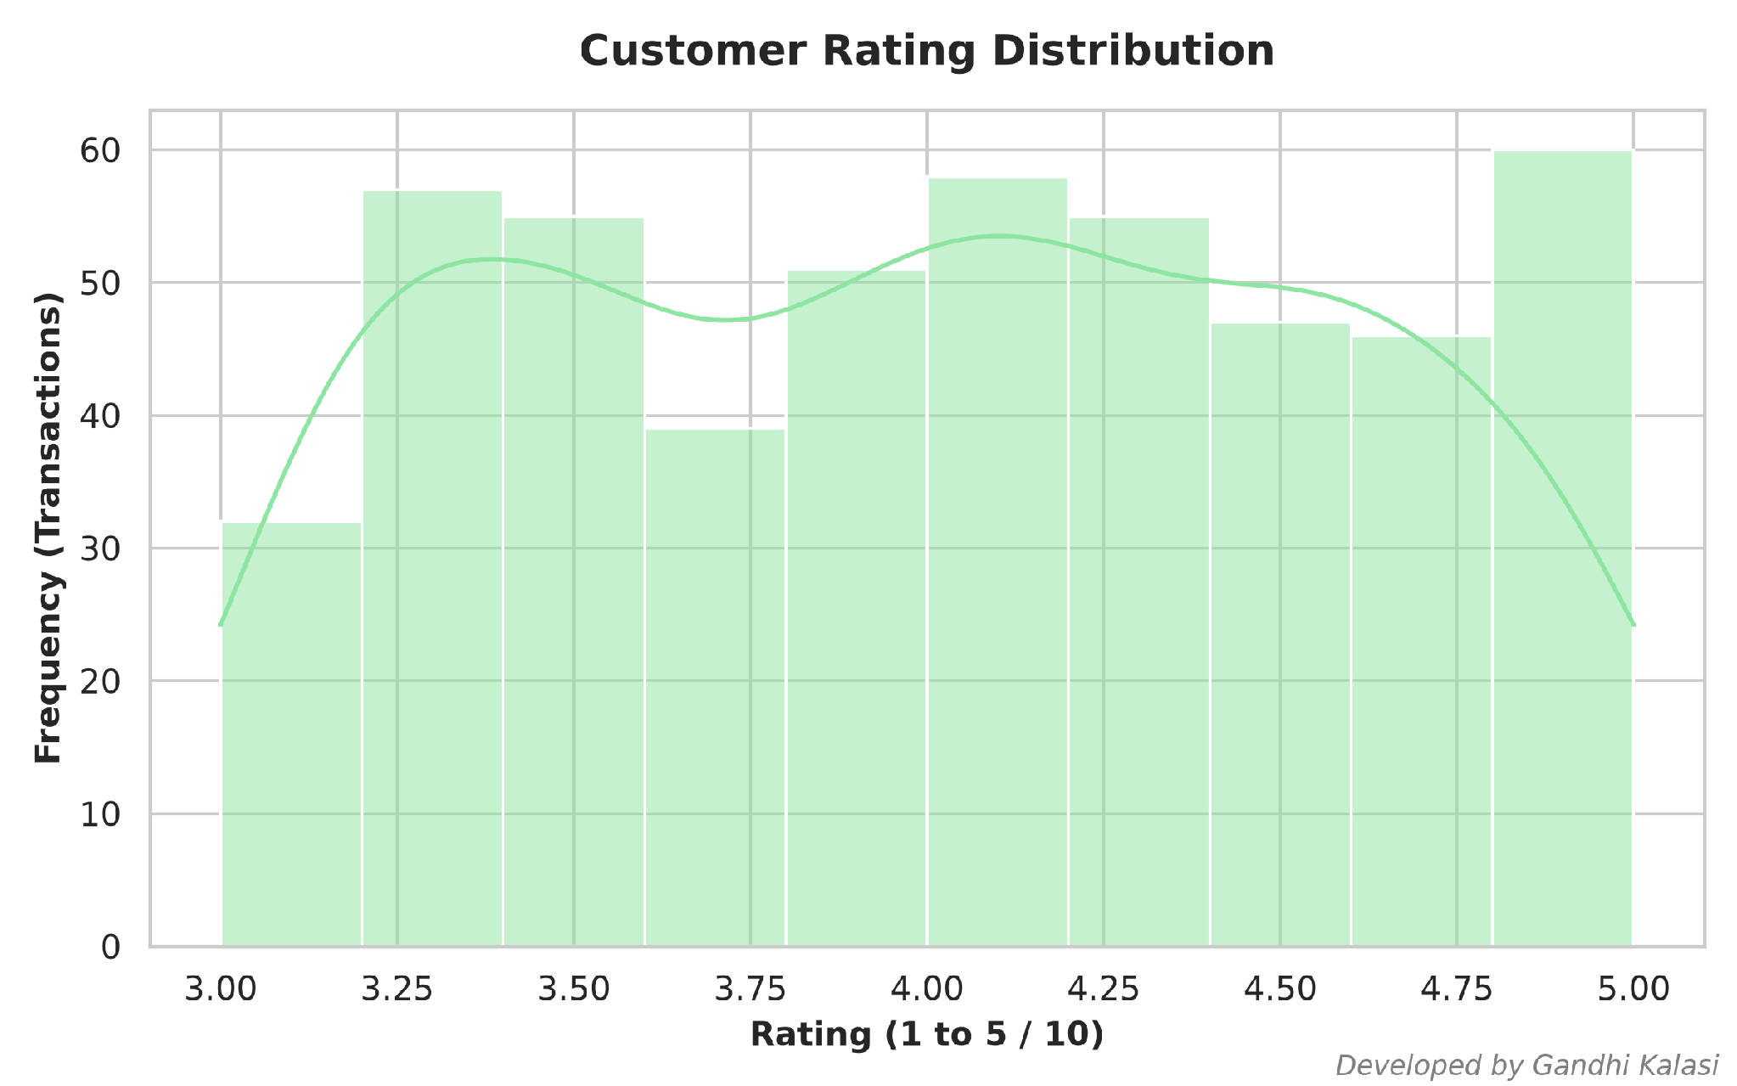
Figure 6: Customer Rating Histogram
9. Business Insights & Recommendations
1. Inventory Prioritization: Double down on stocking high-performing inventory in top revenue categories (Beverages, Personal Care, Dairy) to prevent stockouts.
2. Loyalty Program Enhancement: Leverage targeted incentives for Member customers to further elevate basket sizes and convert Normal shoppers into long-term members.
3. Payment Gateway Optimization: Streamline checkout throughput for the most popular digital payment methods (UPI & Net Banking).
4. Branch Resource Reallocation: Benchmark Branch C operational strategies and apply them to underperforming store locations.
5. Strategic Product Bundling: Package high-demand products (like Cheese and Coffee) with lower-performing items to increase overall order value.
10. Conclusion
The Supermarket Sales Analysis project successfully processed and evaluated 500 retail transaction records. Implementing the five empirical business recommendations will drive revenue growth, optimize inventory logistics, and improve customer satisfaction across store locations.
11. References
1. AICTE | IBM SkillsBuild Internship Handbook (2026). Data Analytics with AI Guidelines.
2. BharatCares Internship Documentation & Project Rubrics.
3. Pandas Development Team. Pandas Software Library for Data Analysis.
4. Waskom, M. Seaborn: Statistical Data Visualization in Python.

