WorkFlow Document

1. Preparation Phase
Tools: Google Docs, Draw.io

2. Create the Incident Response Template (SANS Format)

Create a New Doc
Title: "Phishing Incident – Response"

Executive Summary
  - Provide a brief overview of the phishing incident, affected users, and high-level actions taken.

Timeline

Impact Analysis
  - Number of users affected
  - Systems compromised
  - Data access attempted/exfiltrated
  - Business impact

Remediation Steps
  - Actions performed to contain the incident
  - Recovery measures
  - Verification steps

Lessons Learned
  - Gaps identified
  - Process improvements
  - Recommendations

3. Document Investigation Steps

Add the Log Table
Workflow Steps:
- Record every action as soon as it happens.
- Maintain exact timestamps.
- Add evidence links (screenshots, logs, header files).
- Review and finalize after the incident is resolved.

4. Create a Phishing Response Checklist

Checklist Template:
- Confirm email headers
- Check link reputation in VirusTotal
- Identify affected users
- Validate login patterns for affected accounts
- Block sender/domain/IP at mail gateway
- Reset credentials and enforce MFA if necessary
- Document Indicators of Compromise (IOCs)
- Produce final IR report

5. Draw.io Diagram Creation

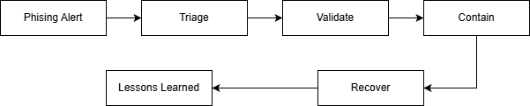

Image 1: Workflow Diagram

