**INTRODUCTION**

What Is Java?

|  |
| --- |
| Java is a general-purpose Object-Oriented Programming Language. |

What is a language?

|  |
| --- |
| A language is a medium which is used to interact with others |

What is a programming language?

|  |
| --- |
| It is also a medium which is used to interact with a computer. |

Why we learn a programming language?

|  |
| --- |
| To develop a software or applications. |

What are the similarities we can found between a language and a programming language?

|  |  |
| --- | --- |
| English | C or C++ or Java |
| In English we are having 26 characters | 1. In C or C++ we have 256 characters 2. In Java we have 65534 only |
| We can form words by using alphabets(characters)  Ex: going, cricket, watch, play, to, am, we, I, movie. | We can form words(tokens) in programming language.  Ex: int, char, double, if, = , +, 100,10.50,’A’,”madhu”,a,b,c,eno,sal,ename etc..  **Types of tokens**   1. Keywords 2. Identifier 3. Operators 4. Literals or constants or values 5. Separators 6. Special symbols 7. Comments |
| We can form sentences by using words  Ex: I am going to play cricket  Ex: I am going to watch movie | We can form statements by using tokens  Ex: int a=100; //variable declaration  Ex: double sal=200000.00; |
| We can write a paragraph by using sentences | We can write a program by using statements. |
| We can write essays, articles, stories, lesions etc.. by u sing paragraphs. | We can develop software by using programs |

In C or C++ what a character set is called as?

|  |
| --- |
| ASCII character set which In range of 0 to 255  Every character is assigned with a number, that number is called as ASCII value  Ex: a -> 97  Ex: A -> 65  Ex: 0 -> 48 |

In Java what a character set is called as?

|  |
| --- |
| In java it is called as UNICODE character set in a range 0 to 65533  A -> 65  a -> 97  అ -> 3077  अ -> 2309  Etc.. |

What is a statement?

|  |
| --- |
| 1. A statement is an instruction or command given to a computer. 2. We can for a statement by using tokens.   Int a=100; //it is a variable declaration cum initialization statement  Int 🡪 keyword  a 🡪 identifier  = 🡪 operator  100 🡪 literal  ; 🡪 separator (special symbol)  // 🡪 comments |

What is a special symbol?

|  |
| --- |
| Other than alphabets and digits are called as special symbols |

What is a program?

|  |
| --- |
| Set of statements |

What is a software?

|  |
| --- |
| Collection of programs. |

What is a general-purpose programming language?

|  |
| --- |
| Java is called as general-purpose programming language because, by using Java we can develop different types of applications like   1. Standalone applications 2. Websites or Web Applications 3. Mobile applications 4. We can develop software for home appliances 5. We can use java to develop data analytics applications etc. |

What is a stand-alone application?

|  |
| --- |
| It is an application which runs in device where it was installed. |

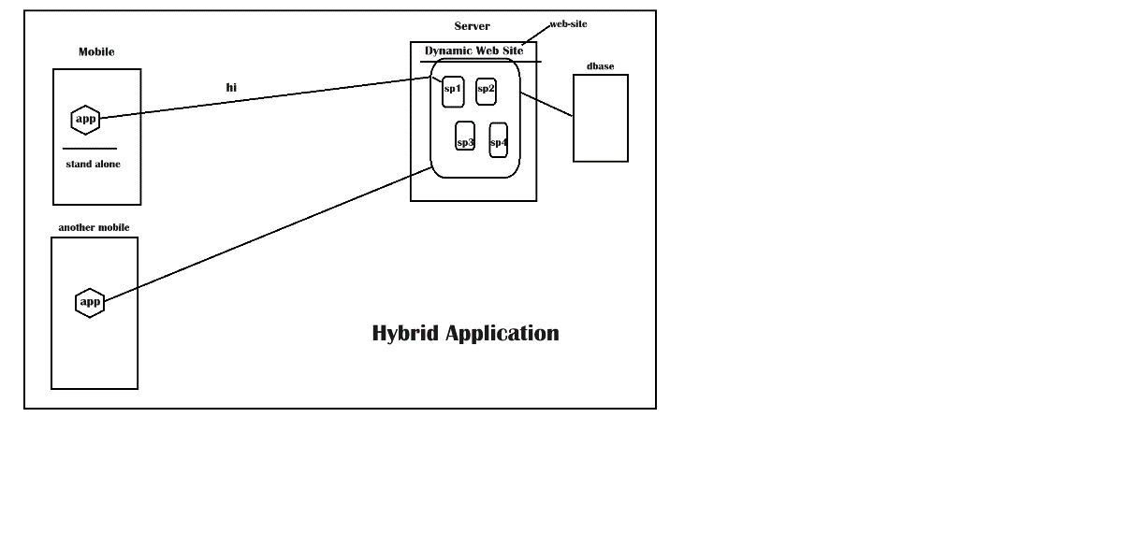

What is an object-oriented programming language?

|  |
| --- |
| It is a language which supports OOP’S concepts   1. **Data abstraction & Encapsulation** 2. **Polymorphism** 3. **Inheritance**   Ex: C++, Java, Python, C#.net, Small Talk etc.. |