AI-Assisted Threat Detection Dashboard
Using Google Cloud Platform (GCP)

ARCHITECTURE AND WORKFLOW REPORT

Project Domain
Artificial Intelligence | Machine Learning | Cybersecurity | Data Analytics

Submitted By
Name: Ganta Cheradeep
Team: B
College: Anil Neerukonda Institute Of Technology and Sciences

SYSTEM ARCHITECTURE
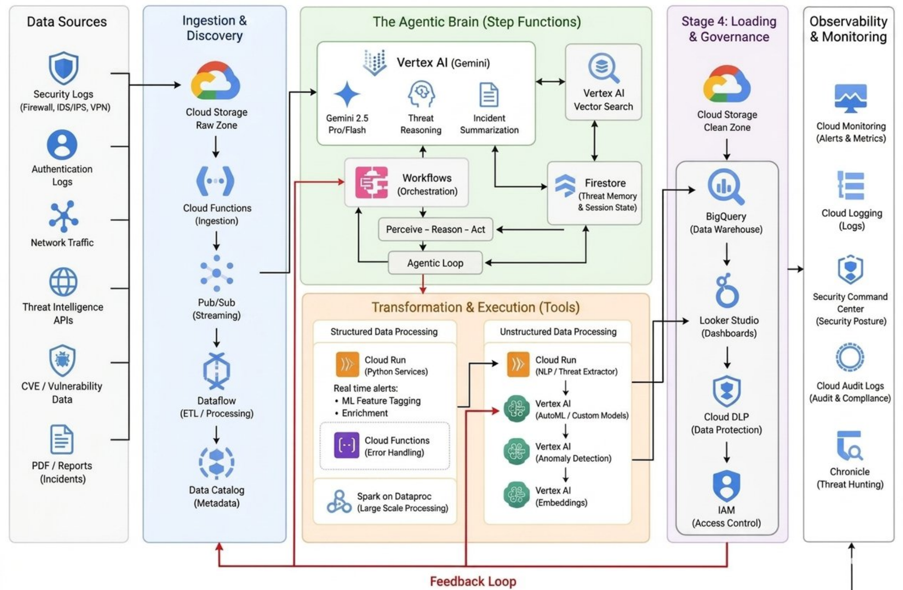
Explanation:
This system follows a fully cloud-native architecture, built end-to-end on Google Cloud Platform, that ingests, cleans, analyzes, and visualizes enterprise security logs as they arrive. Rather than treating the pipeline as a single monolithic process, the design breaks the workflow into clearly separated processing stages, each handling a distinct responsibility.
Traditional rule-based security monitoring is replaced here with a combination of automated machine learning and an Agentic AI layer capable of independent reasoning. Incoming network and authentication traffic is absorbed by high-throughput streaming components so that no data is lost or delayed, even under heavy load.
Once the data has been prepared, custom-trained models hosted on Vertex AI examine it for statistical irregularities and behavioral outliers. Whenever a suspicious pattern is detected, the system hands it off to an autonomous reasoning agent, built on Google Gemini together with Vector Search, that investigates the surrounding context of the potential threat.
Before any information reaches the final monitoring interface, a governance layer scrubs and secures the data, striking a balance between delivering actionable threat intelligence and upholding strict privacy and compliance standards.

WORKFLOW:
START
│
Real-Time Security Logs Stream In
│
Cloud Storage (Raw Storage Zone)
│
Cloud Functions Triggered Automatically
│
Pub/Sub Streaming Queue
│
Cloud Dataflow (Data Preprocessing)
│
Cloud Run (Feature Tagging & Enrichment)
│
Vertex AI Anomaly Detection (ML Prediction)
│
Vertex AI Gemini & Vector Search (AI Detective Reasoning)
│
Cloud Firestore (Store Threat Memory)
│
Google BigQuery Warehouse
│
Cloud DLP (Data Privacy Masking)
│
Looker Studio Dashboard Visualization
│
Generate Executive Reports
│
END

STEP-BY-STEP WORKFLOW EXPLANATION

Step 1: Real-Time Stream Ingestion and Landing
The workflow starts by continuously capturing high-volume security logs generated across the organization's infrastructure. Each raw payload is temporarily held in a dedicated Cloud Storage Raw Storage Zone before further processing. By decoupling ingestion from analysis in this way, the architecture prevents sudden spikes in log volume from creating bottlenecks further down the pipeline.

Step 2: Automated Orchestration and Message Queuing
As soon as a raw log file lands in storage, an event-driven Cloud Function fires automatically. It picks up the incoming data packets and forwards them into a Google Cloud Pub/Sub queue. Acting as a high-speed buffer, Pub/Sub absorbs sudden bursts of network activity, keeping packet loss at zero even while an attack is actively unfolding.

Step 3: Distributed Stream Preprocessing (ETL)
Google Cloud Dataflow then consumes this stream directly from Pub/Sub in real time. It performs on-the-fly cleansing of the raw, unstructured logs, stripping out noisy fields, filling in missing values, parsing timestamp formats, and reshaping varied input sources into a single, consistent schema ready for analysis.

Step 4: Containerized Feature Tagging and Enrichment
Once standardized, the logs are passed to serverless microservices running on Cloud Run. These services quickly tag each payload with relevant features, attaching live system metadata and security telemetry markers. The result is a set of enriched data vectors ready to be fed into the machine learning stage.

Step 5: Machine Learning Inference and Anomaly Prediction
The enriched payloads are then routed into Vertex AI's anomaly detection models. Rather than depending on brittle, hand-written rules, this layer relies on statistical classification algorithms to identify structural irregularities and flag behaviour that departs from established system baselines.

Step 6: Agentic RAG Reasoning and State Tracking
Whenever an anomaly is flagged, an autonomous Gemini-based agent takes over. Using a Retrieval-Augmented Generation (RAG) approach, it searches a vectorized index maintained in Vertex AI Vector Search, matching the log's attributes against known MITRE ATT&CK techniques and current CVE records. The agent's reasoning trail and session state are stored securely in Cloud Firestore so that context is retained across the investigation.

Step 7: Centralized Warehousing and Security Governance
Finalized threat records are then loaded into the organization's data warehouse in Google BigQuery. Before this information is archived or made visible to end users, Cloud DLP automatically inspects each payload, detecting and masking any personally identifiable information to keep the pipeline aligned with global data-protection regulations.

Step 8: Dynamic BI Visualization and Executive Reporting
In the final stage, Looker Studio runs low-latency, live queries straight against BigQuery. Its dashboard refreshes continuously with up-to-date risk scores, asset-level threat breakdowns, and attack timelines. This gives security operations teams the real-time visibility they need to activate response playbooks and produce compliance reports, completing the workflow.

