Since we use reflectance (i.e., the ratio of radiance to solar irradiance) in the retrievals, the quality of solar irradiance is equally important to that of radiance. To enhance the signal-to-noise ratio (SNR), we adopt the leading principle component or average of a series of OMI irradiance measurements (with Sun-Earth distance properly considered), which essentially removed the contribution of irradiance noise on retrievals. This method performed well for our OMI glyoxal and water vapor retrievals [*Chan Miller et al.*, 2014; *Wang et al.*, 2014], as the OMI irradiance measurements have been very stable with only slow degradation. Our H2CO retrieval used the mean radiance references from remote tropical Pacific areas instead of the solar irradiance spectrum to avoid cross-track stripes [*González Abad et al.*, 2015, 2016]. However, the solar measurements from other satellite sensors are less stable and require a consistent framework to quantify their changes. Using a multi-year average solar reference may introduce time-dependent systematic offsets if the degradation is not properly accounted for. The GOME solar diffuser plate, used to attenuate solar radiation and enable the same detector to view both the Sun and the Earth, introduces small, temporally varying spectral features into the solar spectra [*Richter and Wagner*, 2001], which in turn causes temporally varying offset in trace gas retrievals. We have developed methods to correct for this varying offset by fitting individual solar irradiances to those from the beginning [*Martin et al.*, 2002]. Such spectral artifacts also occur for SCIAMACHY and GOME-2, but are significantly reduced.

We have developed a stand-alone software package to monitor the performance on-orbit solar irradiance slit function width, wavelength shift, and degradation, as shown in Fig. XXX. It has been successfully applied to OCO-2 [*Sun et al.*, 2017a] and OMI [*Sun et al.*, 2017b] and can be readily modified for GOME, SCIAMACHY, and GOME-2. The relative degradation of individual daily solar irradiance can be corrected. Running average of those corrected solar irradiances within a certain time period (e.g., a month) can be used in retrievals to reduce the noise and mitigate the impact of solar cycles. We propose to apply this approach, which is led by K. Sun, consistently to individual daily solar irradiances in the UV and VIS channels of all instruments and then derive noise-reduced and calibrated solar references.

The slit functions are another vital component for retrieval. Although the OMI slit functions are found to be stable over the mission, the on-orbit slit functions in the UV bands show U-shaped cross-track dependences that cannot be fully represented by the preflight ones [*Sun et al.*, 2017b]. In contrast, the slit functions of GOME-2 have changed significantly over time [*Munro et al.*, 2016]. Substantial improvement of H2CO retrieval has been reported after fitting the slit functions based on daily irradiance measurements rather than taking the preflight slit functions [*De Smedt et al.*, 2012]. In addition to the daily slit function variations derived from solar spectra, we propose to account for the intra-orbit slit function changes due to changes in instrument temperature [*Beirle et al.*, 2017] and scene heterogeneity [*Noël et al.*, 2012] by incorporating linearized “pseudo-absorbers” in the retrievals. This method has been implemented in the SAO OMI water vapor retrieval.

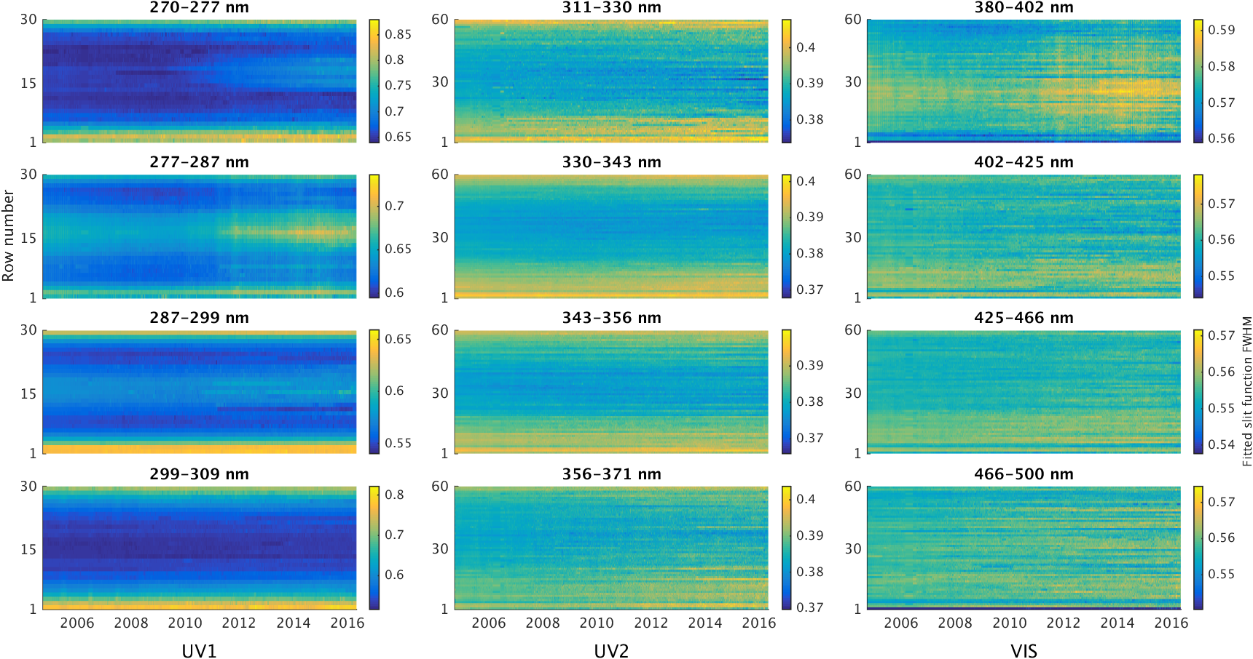

Fig. XXX. Temporal variations of derived OMI slit functions width from solar irradiance for all cross-track positions (1-60) from September 2004 to May 2016. Three OMI bands (columns of the plot) are each divided into four spectral windows (rows of the plot). The wavelength shift and degradation are derived simultaneously.

References

Beirle, S., J. Lampel, C. Lerot, H. Sihler, and T. Wagner (2017), Parameterizing the instrumental spectral response function and its changes by a super-Gaussian and its derivatives, *Atmos. Meas. Tech.*, *10*(2), 581–598, doi:10.5194/amt-10-581-2017.

Chan Miller, C., G. Gonzalez Abad, H. Wang, X. Liu, T. Kurosu, D. J. Jacob, and K. Chance (2014), Glyoxal retrieval from the Ozone Monitoring Instrument, *Atmos. Meas. Tech.*, *7*(11), 3891–3907, doi:10.5194/amt-7-3891-2014.

González Abad, G., X. Liu, K. Chance, H. Wang, T. P. Kurosu, and R. Suleiman (2015), Updated Smithsonian Astrophysical Observatory Ozone Monitoring Instrument (SAO OMI) formaldehyde retrieval, *Atmos. Meas. Tech.*, *8*(1), 19–32, doi:10.5194/amt-8-19-2015.

González Abad, G., A. Vasilkov, C. Seftor, X. Liu, and K. Chance (2016), Smithsonian Astrophysical Observatory Ozone Mapping and Profiler Suite (SAO OMPS) formaldehyde retrieval, *Atmos. Meas. Tech.*, *9*(7), 2797–2812, doi:10.5194/amt-9-2797-2016.

Martin, R. V. et al. (2002), An improved retrieval of tropospheric nitrogen dioxide from GOME, *J. Geophys. Res.*, *107*(D20), 4437, doi:10.1029/2001JD001027.

Munro, R. et al. (2016), The GOME-2 instrument on the Metop series of satellites: instrument design, calibration, and level 1 data processing – an overview, *Atmos. Meas. Tech.*, *9*(3), 1279–1301, doi:10.5194/amt-9-1279-2016.

Noël, S., K. Bramstedt, H. Bovensmann, K. Gerilowski, J. P. Burrows, C. Standfuss, E. Dufour, and B. Veihelmann (2012), Quantification and mitigation of the impact of scene inhomogeneity on Sentinel-4 UVN UV-VIS retrievals, *Atmos. Meas. Tech.*, *5*(6), 1319–1331, doi:10.5194/amt-5-1319-2012.

Richter, A., and T. Wagner (2001), Diffuser plate spectral structures and their influence on GOME slant columns, *Tech. note*, 4.

De Smedt, I., M. Van Roozendael, T. Stavrakou, J.-F. Müller, C. Lerot, N. Theys, P. Valks, N. Hao, and R. van der A (2012), Improved retrieval of global tropospheric formaldehyde columns from GOME-2/MetOp-A addressing noise reduction and instrumental degradation issues, *Atmos. Meas. Tech.*, *5*(11), 2933–2949, doi:10.5194/amt-5-2933-2012.

Sun, K., X. Liu, C. R. Nowlan, Z. Cai, K. Chance, C. Frankenberg, R. A. M. Lee, R. Pollock, R. Rosenberg, and D. Crisp (2017a), Characterization of the OCO-2 instrument line shape functions using on-orbit solar measurements, *Atmos. Meas. Tech*, *10*, 939–953, doi:10.5194/amt-10-939-2017.

Sun, K., X. Liu, G. Huang, G. González Abad, Z. Cai, K. Chance, and K. Yang (2017b), Deriving the slit functions from OMI solar observations and its implications for ozone-profile retrieval, *submitted to Atmos. Meas. Tech. Discuss.*

Wang, H., X. Liu, K. Chance, G. González Abad, and C. Chan Miller (2014), Water vapor retrieval from OMI visible spectra, *Atmos. Meas. Tech.*, *7*(6), 1901–1913, doi:10.5194/amt-7-1901-2014.