**IAS Seminar Feedback Survey as of March 21, 10:11 PM**

**Total Responses:**

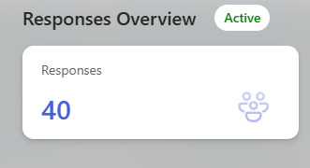

**Year Level & Course:**

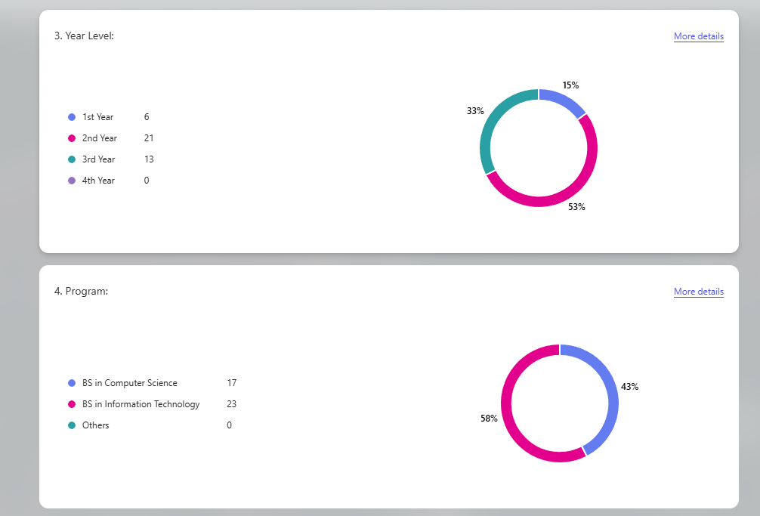

**Ratings:**

