**Pre-Registration Results As of March 19, 2025 02:55 PM:**

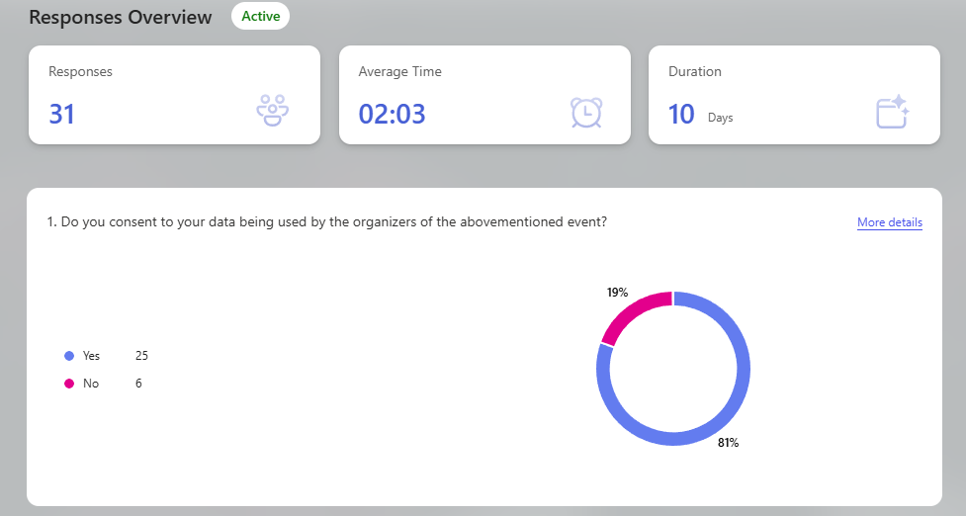

Email and Student Number of Students that answered:

|  |  |  |
| --- | --- | --- |
| **Student Number** | **Email** | **Course & Year** |
| 2023-10489 | christianvalalzate@lpulaguna.edu.ph | BSIT 2-1 |
| 2022-20011 | yvesisiahribao@lpulaguna.edu.ph | BSIT 3-1 |
| 2022-10002 | maxinebenitez@lpulaguna.edu.ph | BSCS 3-1 |
| 2023-10421 | mariabreaestrella@lpulaguna.edu.ph | BSCS 2-1 |
| 2022-10845 | sophiashinbendicion@lpulaguna.edu.ph | BSCS 3-1 |
| 2022-10401 | raymondangelobendal@lpulaguna.edu.ph | BSCS 3-1 |
| 2021-10502 | kylechristiannovillos@lpulaguna.edu.ph | BSCS 4-1 |
| 2021-10700 | patrickjamestrambulo@lpulaguna.com | BSIT 3-1 |
| 2022-10840 | ronaldbaldo@lpulaguna.edu.ph | BSIT 2-1 |
| 2024-10628 | erronashleymonteverde@lpulaguna.edu.ph | BSIT 1-1 |
| 2020-10230 | rpabsalon@lpulaguna.edu.ph | BSCS 2-1 |
| 2023-20037 | joloegenemacaraan@lpulaguna.edu.ph | BSCS 2-1 |
| 2022-30028 | johnrovicrodrigez@lpulaguna.edu.ph | BSCS 3-1 |
| 2020-10798 | jmontevirgen@lpulaguna.edu.ph | BSCS 3-1 |
| 2019-10997 | gabrielluigyerestain@lpulaguna.edu.ph | BSCS 2-1 |
| 2024-10905 | richkitsonbelen@Lpulaguna.edu.ph | BSIT 1-1 |
| 2024-10970 | mhyrashlyabetria@lpulaguna.edu.ph | BSIT 1-1 |
| 2024-11033 | francheskanataliamanuel@lpulaguna.edu.ph | BSIT 1-1 |
| 2024-11026 | johnclydebacsa@lpulaguna.edu.ph | BSIT 1-1 |
| 2024-10555 | angellovelyncarpio@lpulaguna.edu.ph | BSIT 1-1 |
| 2023-11114 | joanacalibo@lpulaguna.edu.ph | BSIT 2-1 |
| 2023-10408 | denicebethanyescanlar@lpulaguna.edu.ph | BSIT 1-1 |
| 2024-10731 | alliahmayantonio@lpulaguna.edu.ph | BSIT 1-1 |
| 2023-10992 | almamaymonterozo@lpulaguna.edu.ph | BSIT 2-1 |
| 2024-10929 | jericryankaw@lpulaguna.edu.ph | BSIT 1-1 |