電通二乙微處理器實驗 實驗結報

實驗名稱 | BLINK
組別 | 34 | 組員 | 林暐傑 莊珦鋐

- 實驗目的
使用 circuits.io 模擬 Arduino UNO 電路及程式
繪製電路圖
觀察 Arduino UNO 之輸出
學習將程式碼及實驗報告上傳至 Github

- 實驗步驟
填寫分組表單
啓動 Arduino IDE, 載入 Blink 程式碼
至 circuits.io 註冊帳號，啟動 Arduino 模擬器
接上 LED 電路
修改程式，將 LED 輸出改為 Pin 9
觀察 LED 之閃爍間隔
修改程式, 使 LED 閃爍間隔分別增加為 2 倍及 ½ 倍, 重新量測並截圖
畫出電路圖

- 程式碼
// _ ___ _______ ___ ___ ___ ___ _ _ ___ _____ ___
// / |_ )__ / \ / __|_ _| _ \/ __| | | |_ _|_ _/ __|
// | |/ / |_ \ |) | | (__ | || / (__| |_| || | | | \__ \
// |_/___|___/___/ \___|___|_|_\\___|\___/|___| |_| |___/
//
// The Unnamed Circuit
//
// Made by a99182003 a99182003
// License: CC-BY-SA 3.0
// Downloaded from: https://circuits.io/circuits/4059802-the-unnamed-circuit

// Pin 13 has an LED connected on most Arduino boards.
// give it a name:
int led = 13;

// the setup routine runs once when you press reset:
void setup() {
// initialize the digital pin as an output.
pinMode(led, OUTPUT);
}

// the loop routine runs over and over again forever:
void loop() {
digitalWrite(led, HIGH); // turn the LED on (HIGH is the voltage level)
delay(1000); // wait for a second
digitalWrite(led, LOW); // turn the LED off by making the voltage LOW
delay(1000); // wait for a second
}
- 實驗結果及分析
2000閃爍的間隔最長，500最短。
- 心得討論
這次實驗讓我們對Arduino以及Github有初步的認識。
- 修正電路圖
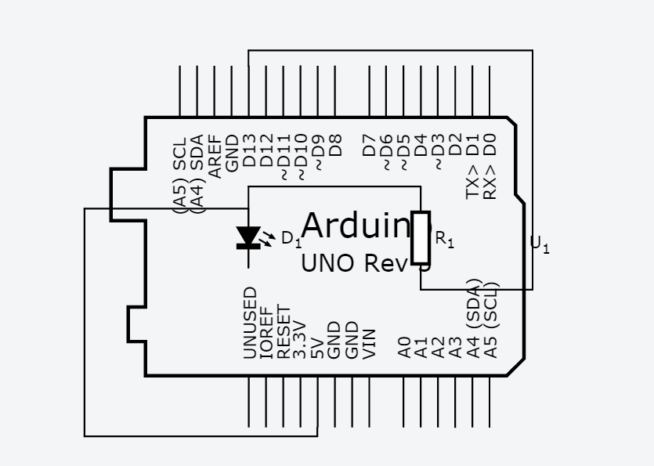
- 修正程式碼

// _ ___ _______ ___ ___ ___ ___ _ _ ___ _____ ___
// / |_ )__ / \ / __|_ _| _ \/ __| | | |_ _|_ _/ __|
// | |/ / |_ \ |) | | (__ | || / (__| |_| || | | | \__ \
// |_/___|___/___/ \___|___|_|_\\___|\___/|___| |_| |___/
//
// The Unnamed Circuit
//
// Made by a99182003 a99182003
// License: CC-BY-SA 3.0
// Downloaded from: https://circuits.io/circuits/4059802-the-unnamed-circuit

// Pin 13 has an LED connected on most Arduino boards.
// give it a name:
int led = 13;

// the setup routine runs once when you press reset:
void setup() {
// initialize the digital pin as an output.
pinMode(led, OUTPUT);
}

// the loop routine runs over and over again forever:
void loop() {
digitalWrite(led, HIGH); // turn the LED on (HIGH is the voltage level)
delay(500); // wait for a second
digitalWrite(led, LOW); // turn the LED off by making the voltage LOW
delay(500); // wait for a second
}

// _ ___ _______ ___ ___ ___ ___ _ _ ___ _____ ___
// / |_ )__ / \ / __|_ _| _ \/ __| | | |_ _|_ _/ __|
// | |/ / |_ \ |) | | (__ | || / (__| |_| || | | | \__ \
// |_/___|___/___/ \___|___|_|_\\___|\___/|___| |_| |___/
//
// The Unnamed Circuit
//
// Made by a99182003 a99182003
// License: CC-BY-SA 3.0
// Downloaded from: https://circuits.io/circuits/4059802-the-unnamed-circuit

// Pin 13 has an LED connected on most Arduino boards.
// give it a name:
int led = 13;

// the setup routine runs once when you press reset:
void setup() {
// initialize the digital pin as an output.
pinMode(led, OUTPUT);
}

// the loop routine runs over and over again forever:
void loop() {
digitalWrite(led, HIGH); // turn the LED on (HIGH is the voltage level)
delay(2000); // wait for a second
digitalWrite(led, LOW); // turn the LED off by making the voltage LOW
delay(2000); // wait for a second
}

