VISVESVARAYA TECHNOLOGICAL UNIVERSITY

“JnanaSangama”, Belgaum -590014, Karnataka.
LAB REPORT
On

DATA STRUCTURES (23CS3PCDST)

Submitted by
Garvit Mundra (1WN24CS102)

in partial fulfillment for the award of the degree of BACHELOR OF ENGINEERING
in
COMPUTER SCIENCE AND ENGINEERING


B.M.S. COLLEGE OF ENGINEERING
(Autonomous Institution under VTU) BENGALURU-560019 August-
December 2025
B. M. S. College of Engineering, Bull Temple Road, Bangalore 560019

(Affiliated To Visvesvaraya Technological University, Belgaum) Department of Computer Science and Engineering


This is to certify that the Lab work entitled “DATA STRUCTURES” carried out by GARVIT MUNDRA(1WN24CS102), who is bonafide student of B. M. S. College of Engineering. It is in partial fulfillment for the award of Bachelor of Engineering in Computer Science and Engineering of the Visvesvaraya Technological University, Belgaum during the year 20252026. The Lab report has been approved as it satisfies the academic requirements in respect of Data structures Lab - (23CS3PCDST) work prescribed for the said degree.

Mrs. Manjula S | Dr. Kavitha Sooda
Assistant Professor | Professor and Head
Department of CSE | Department of CSE
BMSCE, Bengaluru | BMSCE, Bengaluru

Index
Sl.  No. | Experiment Title | Page No.
1 | Push, Pop, Display using Stack | 4
2 | Infix to postfix Conversion | 7
3 | Queues | 9
4 | Insertion in Singly Linked List | 11
5 | Deletion in Singly Liked List | 14
6 | Sort, Reverse And Concatenate | 19
7 | Doubly Linked List | 22
8 | Binary Search Tree | 26
9 | Traverse a Graph Using BFS method | 29
10 | Linear Probing Hash Table Implementation | 32
11 | Leetcode Problem 1 | 35
12 | Leetcode Problem 2 | 36
13 | Leetcode Problem 3 | 39
14 | Leetcode Problem 4 | 41
15 | Leetcode Problem 5 | 43
16 | Leetcode Problem 6 | 45
17 | Leetcode Problem 7 | 48
Course outcomes:

CO1 | Apply the concept of linear and nonlinear data structures.
CO2 | Analyze data structure operations for a given problem
CO3 | Design and develop solutions using the operations of linear and nonlinear data structure for a given specification.
CO4 | Conduct practical experiments for demonstrating the operations of different data structures.

Lab program 1:
Write a program to simulate the working of stack using an array with the following:
- Push
- Pop
- Display
The program should print appropriate messages for stack overflow, stack underflow.
#include <stdio.h> #include<stdlib.h> #define STACK_SIZE 5 void push(int st[],int *top)
{
int item; if(*top==STACK_SIZE-1)
printf("Stack overflow\n");

else
{

}
}

printf("\nEnter an item :"); scanf("%d",&item); (*top)+
+;
st[*top]=item;

void pop(int st[],int *top)
{ if(*top==-1) printf("Stack underflow\n"); else
{
printf("\n%d item was deleted",st[(*top)--]); }
}
void display(int st[],int *top)
{

} void main()
{
int i;
if(*top==-1) printf("Stack is empty\n");
for(i=0;i<=*top;i++)
printf("%d\t",st[i]);

int st[10],top=-1, c,val_del; while(1)
{ printf("\n1. Push\n2. Pop\n3. Display\n"); printf("\nEnter your choice :"); scanf("%d",&c);

switch(c)
{ case 1: push(st,&top);
break;
case 2: pop(st,&top); break;
case 3: display(st,&top);
break;
default: printf("\nInvalid choice!!!"); exit(0);
}
}
}
Output:

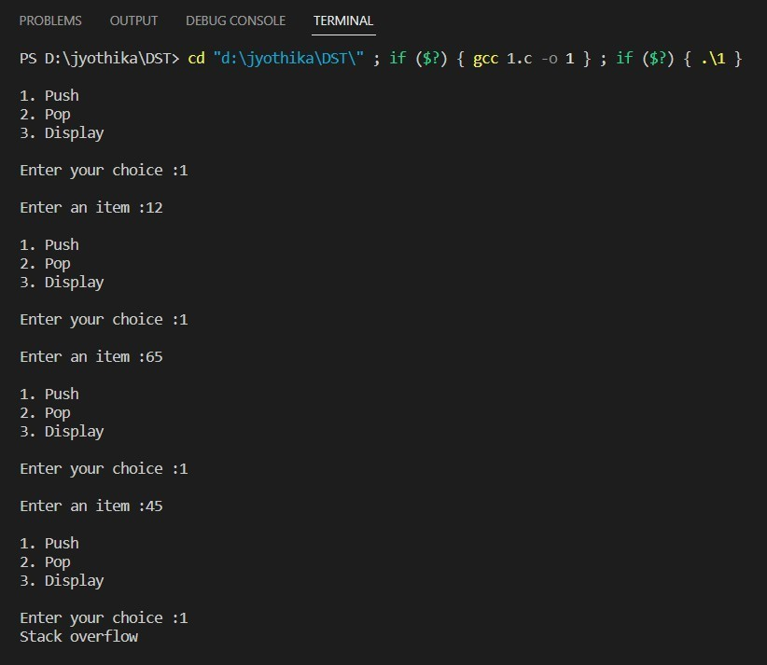

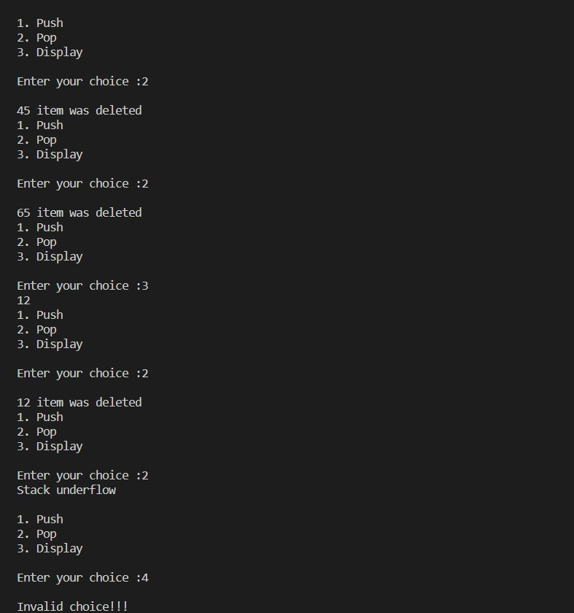

Lab Program 2

WAP to convert a given valid parenthesized infix arithmetic expression to postfix expression. The expression consists of single character operands and the binary operators + (plus), - (minus), * (multiply) and / (divide).

#include <stdio.h> #include <ctype.h> #define MAX 100 char stack[MAX]; int top = -1;

void push(char x) { stack[++top] = x;
}

char pop() {
if (top == -1) return -1;
else
return stack[top--];
}

int priority(char x) {
if (x == '+' || x == '-') return 1;
if (x == '*' || x == '/') return 2;
return 0;
}

int main() {
char infix[MAX], postfix[MAX]; int i = 0, k = 0;
char ch;

printf("Enter a valid parenthesized infix expression: "); scanf("%s", infix);

while ((ch = infix[i++]) != '\0') {

if (isalnum(ch)) { postfix[k++] = ch;
}

else if (ch == '(') { push(ch);
}

else if (ch == ')') { while (stack[top] != '(') {
postfix[k++] = pop();
}
pop();
}

else {
while (top != -1 && priority(stack[top]) >= priority(ch)) { postfix[k++] = pop();
}
push(ch);
}
}

while (top != -1) { postfix[k++] = pop();
}

postfix[k] = '\0';

printf("Postfix expression: %s\n", postfix);

return 0;
}

Output:
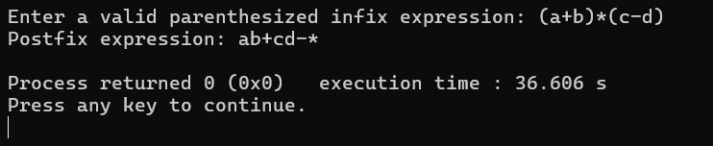

Lab Program 2

- WAP to simulate the working of a queue of integers using an array. Provide the following operations: Insert, Delete, Display The programshould print appropriate messagesfor queue empty and queue overflow conditions

#include <stdio.h> #define MAX 5 int queue[MAX];
int front = -1, rear = -1;

void insert() { int x;
if (rear == MAX - 1) { printf("Queue Overflow\n"); return;
}
if (front == -1) front = 0;
printf("Enter element: "); scanf("%d", &x); queue[++rear] = x;
}

void delete() {
if (front == -1 || front > rear) { printf("Queue Empty\n"); return;
}
printf("Deleted element: %d\n", queue[front++]);
}

void display() { int i;
if (front == -1 || front > rear) { printf("Queue Empty\n"); return;

}
for (i = front; i <= rear; i++) printf("%d ", queue[i]);
printf("\n");
}

int main() { int choice; while (1) {
printf("1.Insert 2.Delete 3.Display 4.Exit\n"); scanf("%d", &choice);
switch (choice) {
case 1: insert(); break; case 2: delete(); break; case 3: display(); break; case 4: return 0;
default: printf("Invalid choice\n");
}
}
}
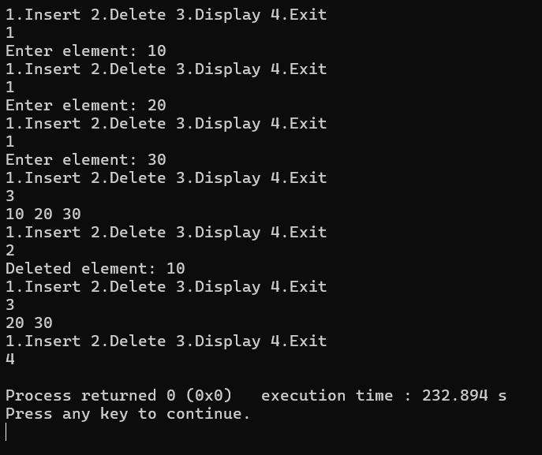

Lab Program 3

- WAP to simulate the working of a circular queue of integers using an array. Provide the following operations: Insert, Delete & Display The programshould print appropriate messagesfor queue empty and queue overflow conditions
#include <stdio.h> #define MAX 5 int queue[MAX];
int front = -1, rear = -1;

void insert() { int x;
if ((front == 0 && rear == MAX - 1) || (front == rear + 1)) { printf("Queue Overflow\n");
return;
}
printf("Enter element: "); scanf("%d", &x);
if (front == -1) { front = 0;
rear = 0;
} else if (rear == MAX - 1) { rear = 0;
} else {
rear++;
}
queue[rear] = x;
}

void delete() {
if (front == -1) { printf("Queue Empty\n"); return;
}
printf("Deleted element: %d\n", queue[front]); if (front == rear) {
front = -1;
rear = -1;
} else if (front == MAX - 1) {

front = 0;
} else {
front++;
}
}

void display() { int i;
if (front == -1) { printf("Queue Empty\n"); return;
}
i = front; while (1) {
printf("%d ", queue[i]); if (i == rear)
break;
i = (i + 1) % MAX;
}
printf("\n");
}

int main() { int choice; while (1) {
printf("1.Insert 2.Delete 3.Display 4.Exit\n"); scanf("%d", &choice);
switch (choice) {
case 1: insert(); break; case 2: delete(); break; case 3: display(); break; case 4: return 0;
default: printf("Invalid choice\n");
}
}
}

Output

Lab Program 4 and 5

WAP to Implement Singly Linked List with following operations
- Createalinkedlist.
- Insertion of a node at first position, at any position and at end of list.
Display the contents of the linked list.

WAP to Implement Singly Linked List with following operations
- Create a linked list.
- Deletion of first element, specified element and last element in the list.
- Display the contents of the linked list.

#include <stdio.h> #include <stdlib.h>

struct node { int data;
struct node *next;
};
struct node *head = NULL; void create() {
int n, x;
struct node *temp, *newnode; scanf("%d", &n);
while (n--) {
newnode = malloc(sizeof(struct node)); scanf("%d", &x);
newnode->data = x; newnode->next = NULL; if (head == NULL) {
head = newnode;
} else {
temp = head;
while (temp->next != NULL) temp = temp->next;
temp->next = newnode;
}

}
}

void insert_first() { int x;
struct node *newnode = malloc(sizeof(struct node)); scanf("%d", &x);
newnode->data = x; newnode->next = head; head = newnode;
}

void insert_end() { int x;
struct node *newnode = malloc(sizeof(struct node)); struct node *temp;
scanf("%d", &x); newnode->data = x; newnode->next = NULL; if (head == NULL) {
head = newnode; return;
}
temp = head;
while (temp->next != NULL) temp = temp->next;
temp->next = newnode;
}

void insert_pos() { int x, pos, i;
struct node *newnode, *temp; scanf("%d", &pos);
if (pos == 1) { insert_first(); return;
}
newnode = malloc(sizeof(struct node)); scanf("%d", &x);
newnode->data = x; temp = head;
for (i = 1; i < pos - 1 && temp != NULL; i++) temp = temp->next;

if (temp == NULL) { printf("Invalid position\n"); free(newnode);
return;
}
newnode->next = temp->next; temp->next = newnode;
}

void delete_first() { struct node *temp;
if (head == NULL) { printf("List is empty\n"); return;
}
temp = head;
head = head->next; free(temp);
}

void delete_end() {
struct node *temp, *prev; if (head == NULL) {
printf("List is empty\n"); return;
}
if (head->next == NULL) { free(head);
head = NULL; return;
}
temp = head;
while (temp->next != NULL) { prev = temp;
temp = temp->next;
}
prev->next = NULL; free(temp);
}

void delete_element() { int x;
struct node *temp, *prev;

if (head == NULL) { printf("List is empty\n"); return;
}
scanf("%d", &x);
if (head->data == x) { delete_first(); return;
}
temp = head;
while (temp != NULL && temp->data != x) { prev = temp;
temp = temp->next;
}
if (temp == NULL) { printf("Element not found\n"); return;
}
prev->next = temp->next; free(temp);
}

void display() {
struct node *temp = head; if (temp == NULL) {
printf("List is empty\n"); return;
}
while (temp != NULL) { printf("%d ", temp->data); temp = temp->next;
}
printf("\n");
}

int main() { int choice; while (1) {
printf("1.Create 2.InsertFirst 3.InsertPosition 4.InsertEnd 5.DeleteFirst 6.DeleteElement 7.DeleteEnd 8.Display 9.Exit\n");
scanf("%d", &choice); switch (choice) {
case 1: create(); break;

case 2: insert_first(); break; case 3: insert_pos(); break; case 4: insert_end(); break; case 5: delete_first(); break; case 6: delete_element(); break; case 7: delete_end(); break; case 8: display(); break;
case 9: return 0;
default: printf("Invalid choice\n");
}
}
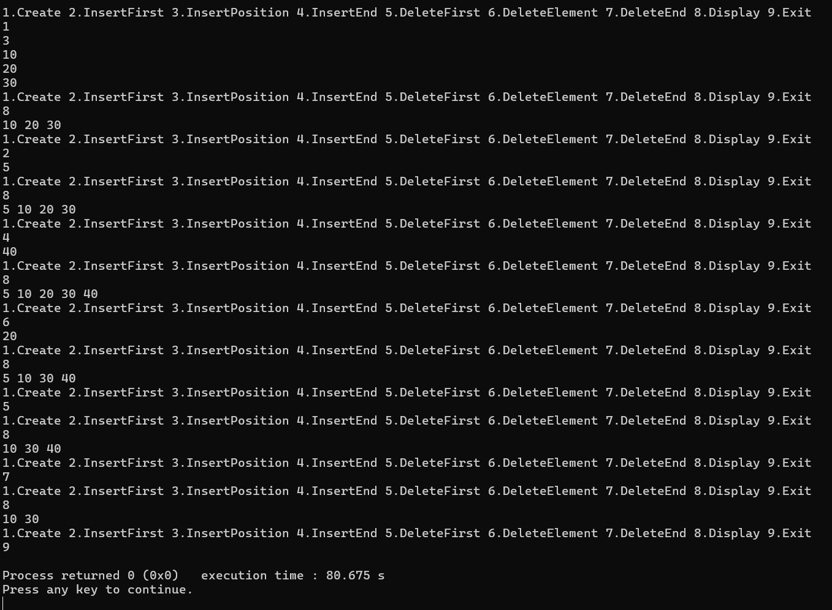
}

Lab Program 6

- WAP to Implement Single Link List with following operations: Sort the linked list, Reverse the linked list, Concatenation of two linked lists.

#include <stdio.h> #include <stdlib.h>

struct node { int data;
struct node *next;
};

struct node *head1 = NULL; struct node *head2 = NULL;

void create(struct node **head) { int n, x;
struct node *temp, *newnode; scanf("%d", &n);
while (n--) {
newnode = malloc(sizeof(struct node)); scanf("%d", &x);
newnode->data = x; newnode->next = NULL; if (*head == NULL) {
*head = newnode;
} else {
temp = *head;
while (temp->next != NULL) temp = temp->next;
temp->next = newnode;
}
}
}

void display(struct node *head) { struct node *temp = head;
if (temp == NULL) { printf("List is empty\n"); return;
}

while (temp != NULL) { printf("%d ", temp->data); temp = temp->next;
}
printf("\n");
}

void sort(struct node *head) { struct node *i, *j;
int temp;
for (i = head; i != NULL; i = i->next) {
for (j = i->next; j != NULL; j = j->next) { if (i->data > j->data) {
temp = i->data;
i->data = j->data;
j->data = temp;
}
}
}
}

void reverse(struct node **head) {
struct node *prev = NULL, *curr = *head, *next; while (curr != NULL) {
next = curr->next; curr->next = prev; prev = curr;
curr = next;
}
*head = prev;
}

void concatenate() { struct node *temp;
if (head1 == NULL) { head1 = head2; return;
}
temp = head1;
while (temp->next != NULL) temp = temp->next;
temp->next = head2;
}

int main() { int choice; while (1) {
printf("1.CreateList1 2.CreateList2 3.DisplayList1 4.SortList1 5.ReverseList1 6.Concatenate 7.Exit\n");
scanf("%d", &choice); switch (choice) {
case 1: create(&head1); break; case 2: create(&head2); break; case 3: display(head1); break; case 4: sort(head1); break;
case 5: reverse(&head1); break; case 6: concatenate(); break; case 7: return 0;
default: printf("Invalid choice\n");
}
}
}
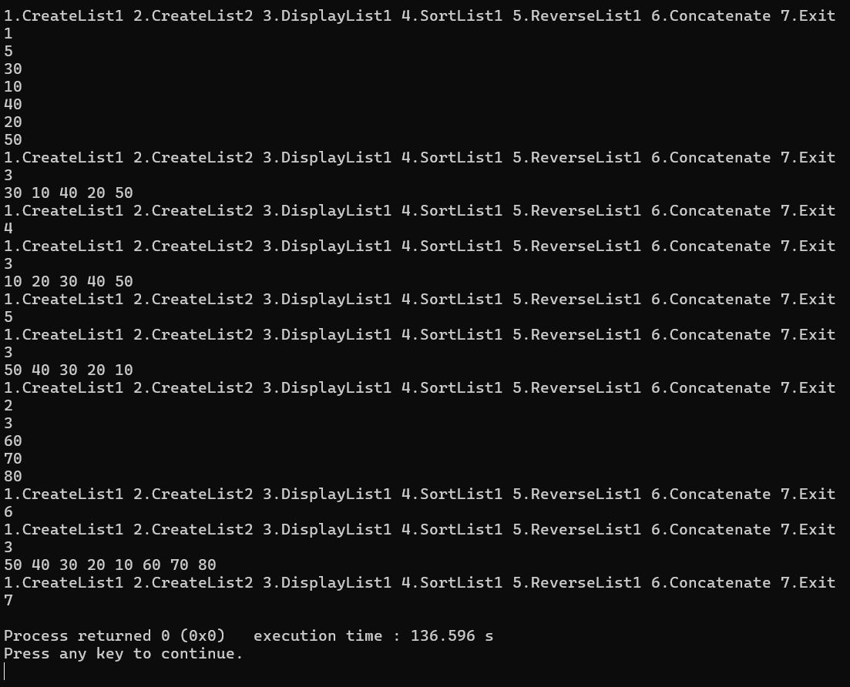

Lab Program 7

WAP to Implement doubly link list with primitive operations
- Create a doubly linked list.
- Insert a new node to the left of the node.
- Delete the node based on a specific value
- Display the contents of the list

#include <stdio.h> #include <stdlib.h>

struct node { int data;
struct node *prev; struct node *next;
};
struct node *head = NULL; void create() {
int n, x;
struct node *temp, *newnode; scanf("%d", &n);
while (n--) {
newnode = malloc(sizeof(struct node)); scanf("%d", &x);
newnode->data = x;
newnode->prev = newnode->next = NULL; if (head == NULL) {
head = newnode;
} else {
temp = head;
while (temp->next != NULL) temp = temp->next;
temp->next = newnode; newnode->prev = temp;
}
}
}

void insert_left() { int key, x;

struct node *temp, *newnode; scanf("%d", &key);
scanf("%d", &x); temp = head;
while (temp != NULL && temp->data != key) temp = temp->next;
if (temp == NULL) { printf("Element not found\n"); return;
}
newnode = malloc(sizeof(struct node)); newnode->data = x;
newnode->prev = temp->prev; newnode->next = temp;
if (temp->prev != NULL)
temp->prev->next = newnode; else
head = newnode; temp->prev = newnode;
}

void delete_value() { int x;
struct node *temp; scanf("%d", &x); temp = head;
while (temp != NULL && temp->data != x) temp = temp->next;
if (temp == NULL) { printf("Element not found\n"); return;
}
if (temp->prev != NULL)
temp->prev->next = temp->next; else
head = temp->next;
if (temp->next != NULL)
temp->next->prev = temp->prev; free(temp);
}

void display() {
struct node *temp = head;

if (temp == NULL) { printf("List is empty\n"); return;
}
while (temp != NULL) { printf("%d ", temp->data); temp = temp->next;
}
printf("\n");
}

int main() { int choice; while (1) {
printf("1.Create 2.InsertLeft 3.DeleteValue 4.Display 5.Exit\n"); scanf("%d", &choice);
switch (choice) {
case 1: create(); break; case 2: insert_left(); break;
case 3: delete_value(); break; case 4: display(); break;
case 5: return 0;
default: printf("Invalid choice\n");
}
}
}

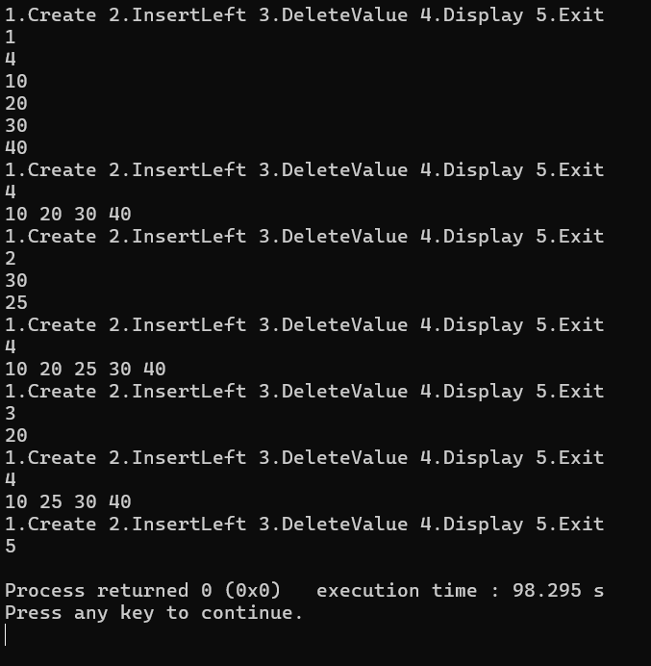

Lab Program 8

Write a program
- ToconstructabinarySearchtree.
- To traverse the tree using all the methods i.e., in-order, preorder and post order
- To display the elements in the tree.

#include <stdio.h> #include <stdlib.h>

struct node { int data;
struct node *left; struct node *right;
};

struct node *root = NULL;

struct node* insert(struct node *root, int x) { if (root == NULL) {
root = malloc(sizeof(struct node)); root->data = x;
root->left = root->right = NULL; return root;
}
if (x < root->data)
root->left = insert(root->left, x); else if (x > root->data)
root->right = insert(root->right, x); return root;
}

void inorder(struct node *root) { if (root != NULL) {
inorder(root->left); printf("%d ", root->data); inorder(root->right);
}
}

void preorder(struct node *root) {

if (root != NULL) { printf("%d ", root->data); preorder(root->left); preorder(root->right);
}
}

void postorder(struct node *root) { if (root != NULL) {
postorder(root->left); postorder(root->right); printf("%d ", root->data);
}
}

int main() {
int n, x, i, choice; while (1) {
printf("1.Insert 2.Inorder 3.Preorder 4.Postorder 5.Exit\n"); scanf("%d", &choice);
switch (choice) { case 1:
scanf("%d", &n);
for (i = 0; i < n; i++) { scanf("%d", &x); root = insert(root, x);
}
break; case 2:
inorder(root); printf("\n"); break;
case 3:
preorder(root); printf("\n"); break;
case 4:
postorder(root); printf("\n"); break;
case 5:
return 0;
}

}
}
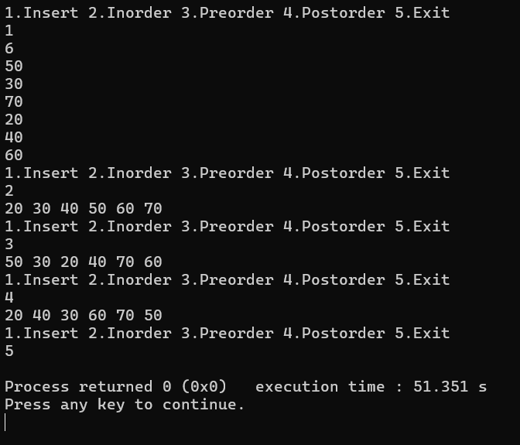

Lab Program 9

- Write a program to traverse a graph using BFS method.

- Write a program to check whether given graph is connected or not using DFS method.

#include <stdio.h> #include <stdlib.h>

#define MAX 20
int queue[MAX], front = -1, rear = -1; void enqueue(int x) {
if (rear == MAX - 1) return; if (front == -1) front = 0; queue[++rear] = x;
}

int dequeue() {
if (front == -1) return -1; int x = queue[front];
if (front == rear) front = rear = -1; else front++;
return x;
}

void bfs(int n, int adj[n][n], int start) { int visited[n];
for (int i = 0; i < n; i++) visited[i] = 0; enqueue(start);
visited[start] = 1; printf("BFS: "); while (front != -1) {
int u = dequeue(); printf("%d ", u);
for (int v = 0; v < n; v++) {
if (adj[u][v] && !visited[v]) { enqueue(v);
visited[v] = 1;
}

}
}
printf("\n");
}

void dfs_util(int n, int adj[n][n], int visited[n], int u) { visited[u] = 1;
for (int v = 0; v < n; v++) {
if (adj[u][v] && !visited[v]) dfs_util(n, adj, visited, v);
}
}

int is_connected(int n, int adj[n][n]) { int visited[n];
for (int i = 0; i < n; i++) visited[i] = 0; dfs_util(n, adj, visited, 0);
for (int i = 0; i < n; i++) if (!visited[i]) return 0;
return 1;
}

int main() { int n, i, j;
printf("Enter number of vertices: "); scanf("%d", &n);
int adj[n][n];
printf("Enter adjacency matrix:\n"); for (i = 0; i < n; i++)
for (j = 0; j < n; j++) scanf("%d", &adj[i][j]);
bfs(n, adj, 0);
if (is_connected(n, adj)) printf("Graph is connected\n");
else
printf("Graph is not connected\n"); return 0;
}

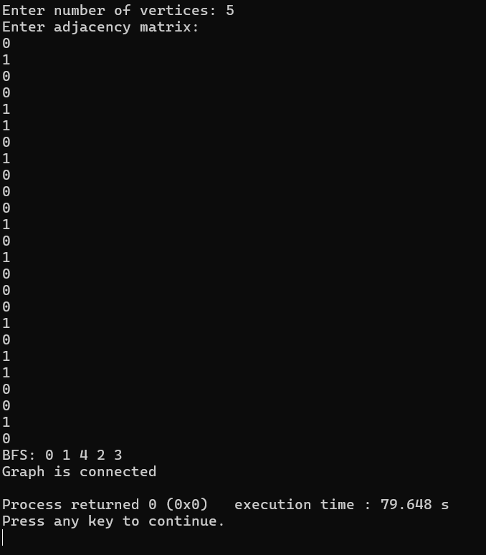

Lab Program 10

Given a File of N employee records with a set K of Keys(4-digit) which uniquely determine the records in file F. Assume that file F is maintained in memory by a Hash Table (HT) of m memory locations with L as the set of memory addresses (2- digit) of locations in HT. Let the keys in K and addresses in L are integers.
Design and develop a Program in C that uses Hash function H: K -> L as H(K)=K mod m (remainder method), and implement hashing technique to map a given key K to the address space L. Resolve the collision (if any) using linear probing.

#include &lt;stdio.h&gt; #define M 100
typedef struct { int key;
int used;
} Record;
int hash(int k) { return k % M;
}
void insert(Record ht[], int k) { int i = hash(k);
int start = i;
while (ht[i].used) { i = (i + 1) % M;
if (i == start) return;
}
ht[i].key = k;
ht[i].used = 1;
}
int search(Record ht[], int k) { int i = hash(k);
int start = i;
while (ht[i].used) {
if (ht[i].key == k) return i;
i = (i + 1) % M;
if (i == start) break;
}
return -1;

}
int main() { Record ht[M];

int n, k, i, pos, choice; for (i = 0; i &lt; M; i++) ht[i].used = 0;
printf(&quot;Enter number of employee records: &quot;); scanf(&quot;%d&quot;, &amp;n);
for (i = 0; i &lt; n; i++) { printf(&quot;Enter 4-digit key: &quot;); scanf(&quot;%d&quot;, &amp;k); insert(ht, k);
}
do {
printf(&quot;Enter key to search: &quot;); scanf(&quot;%d&quot;, &amp;k);
pos = search(ht, k); if (pos == -1)
printf(&quot;Key not found\n&quot;); else
printf(&quot;Key found at address %02d\n&quot;, pos); printf(&quot;Search another key? (1-Yes / 0-No): &quot;); scanf(&quot;%d&quot;, &amp;choice);
} while (choice == 1); return 0;
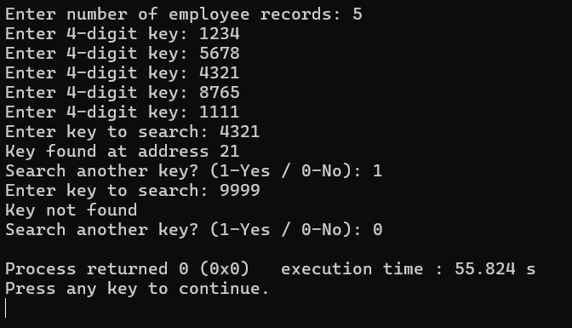
}

Leetcode Problem 1

Remove Linked List Elements

Given the of a linked list and an integer val , remove all the nodes of the
head
linked list that has Node.val == val , and return the new head.

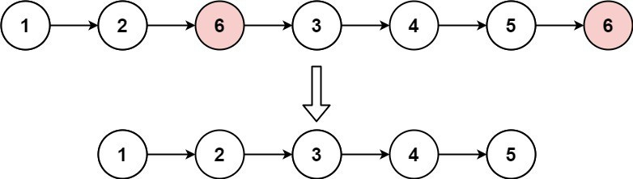
Example 1:

Input: head = [1,2,6,3,4,5,6], val = 6
Output: [1,2,3,4,5]

Example 2:
Input: head = [], val = 1

Output: []
Example 3:
Input: head = [7,7,7,7], val = 7

Output: []

Constraints:
- The number of nodes in the list is in the range [0, 10 4 ] .
1 <= Node.val <= 50
0 <= val <= 50

struct ListNode* removeElements(struct ListNode* head, int val) { struct ListNode dummy;
dummy.next = head;
struct ListNode* current = &dummy; while (current->next != NULL) {

if (current->next->val == val) {
struct ListNode* temp = current->next; current->next = current->next->next; free(temp);
} else {
current = current->next;
}
}

return dummy.next;
}



Leetcode Problem 2

Sort List

Given the of a linked list, return the list after sorting it in ascending order .
head

Example 1:

Input: head = [4,2,1,3]
Output: [1,2,3,4]

Example 2:

Input: head = [-1,5,3,4,0]
Output: [-1,0,3,4,5]

Example 3:
Input: head = []

Output: []

Constraints:
- The number of nodes in the list is in the range [0, 5 * 10 4 ].
- -10 5 <= Node.val <= 10 5
struct ListNode* merge(struct ListNode* l1, struct ListNode* l2) { struct ListNode dummy;
struct ListNode* tail = &dummy; dummy.next = NULL;

while (l1 && l2) {
if (l1->val < l2->val) { tail->next = l1;
l1 = l1->next;
} else {
tail->next = l2; l2 = l2->next;
}
tail = tail->next;
}

tail->next = l1 ? l1 : l2;

return dummy.next;
}

struct ListNode* getMid(struct ListNode* head) { struct ListNode* slow = head;
struct ListNode* fast = head->next;

while (fast && fast->next) { slow = slow->next;
fast = fast->next->next;
}

return slow;
}

struct ListNode* sortList(struct ListNode* head) { if (!head || !head->next)
return head;

struct ListNode* mid = getMid(head); struct ListNode* right = mid->next; mid->next = NULL;

struct ListNode* leftSorted = sortList(head); struct ListNode* rightSorted = sortList(right);

return merge(leftSorted, rightSorted);
}



Leetcode Problem 3

Given the of a singly linked list, reverse the list, and return the reversed list .
head

Example 1:
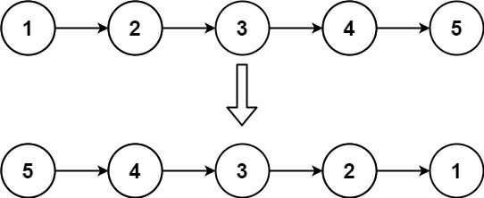
Input: head = [1,2,3,4,5]
Output: [5,4,3,2,1]

Example 2:
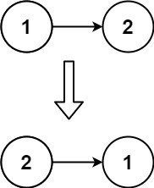

Input: head = [1,2]
Output: [2,1]

Example 3:
Input: head = []

Output: []

Constraints:
- The number of nodes in the list is the range [0, 5000] .
-5000 <= Node.val <= 5000

struct ListNode* reverseList(struct ListNode* head) { struct ListNode* prev = NULL;
struct ListNode* curr = head; struct ListNode* next = NULL;

while (curr != NULL) { next = curr->next; curr->next = prev; prev = curr;
curr = next;
}

return prev;
}



Leetcode Program 4

You are given the heads of two sorted linked lists and list2 .
list1
Merge the two lists into one sorted list. The list should be made by splicing together the nodes of the first two lists.
Return the head of the merged linked list .

Example 1:
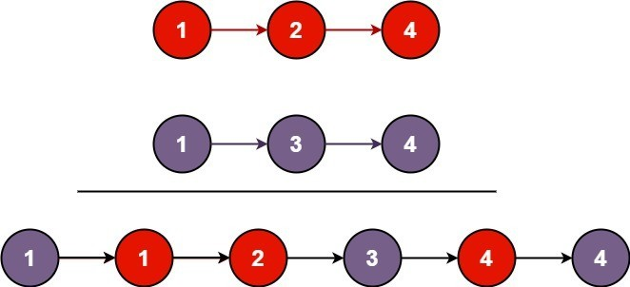
Input: list1 = [1,2,4], list2 = [1,3,4]
Output: [1,1,2,3,4,4]

Example 2:
Input: list1 = [], list2 = []

Output: []
Example 3:
Input: list1 = [], list2 = [0]
Output: [0]

Constraints:
- The number of nodes in both lists is in the range [0, 50] .
-100 <= Node.val <= 100
Both | list1 | and | list2

- are sorted in non-decreasing order.

struct ListNode* mergeTwoLists(struct ListNode* list1, struct ListNode* list2) { struct ListNode dummy;

struct ListNode* tail = &dummy; dummy.next = NULL;

while (list1 && list2) {
if (list1->val <= list2->val) { tail->next = list1;
list1 = list1->next;
} else {
tail->next = list2; list2 = list2->next;
}
tail = tail->next;
}

tail->next = list1 ? list1 : list2; return dummy.next;
}

Leetcode Program 5

Given head , the head of a linked list, determine if the linked list has a cycle in it. There is a cycle in a linked list if there is some node in the list that can be reached
next
next
pos

again by continuously following the
pos
pointer. Internally,
is used to denote

the index of the node that tail's

passed as a parameter .
pointer is connected to. Note that

is not

Return if there is a cycle in the linked list . Otherwise, return false .
true

Example 1:
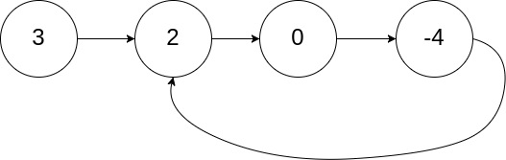

Input: head = [3,2,0,-4], pos = 1
Output: true
Explanation: There is a cycle in the linked list, where the tail connects to the 1st node (0-indexed).

Example 2:
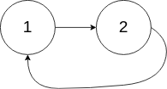
Input: head = [1,2], pos = 0
Output: true
Explanation: There is a cycle in the linked list, where the tail connects to the 0th node.

Example 3:

Input: head = [1], pos = -1
Output: false
Explanation: There is no cycle in the linked list.

Constraints:
- The number of the nodes in the list is in the range [0, 10 4 ].
- -10 5 <= Node.val <= 10 5
- pos is -1 or a valid index in the linked-list.

Follow up: Can you solve it using (i.e. constant) memory?
O(1)

bool hasCycle(struct ListNode *head) { struct ListNode* slow = head;
struct ListNode* fast = head;

while (fast && fast->next) { slow = slow->next;
fast = fast->next->next; if (slow == fast)
return true;
}

return false;
}



Leetcode Problem 6

Given the of a linked list, return the node where the cycle begins. If there is no
head
cycle, return null .
There is a cycle in a linked list if there is some node in the list that can be reached
next
pos

again by continuously following the
pointer. Internally,
is used to denote

the index of the node that tail's next pointer is connected to ( 0-indexed ). It is if there is no cycle. Note that pos is not passed as a parameter .
-1
Do not modify the linked list.

Example 1:

Input: head = [3,2,0,-4], pos = 1
Output: tail connects to node index 1
Explanation: There is a cycle in the linked list, where tail connects to the second node.

Example 2:

Input: head = [1,2], pos = 0
Output: tail connects to node index 0
Explanation: There is a cycle in the linked list, where tail connects to the first node.

Example 3:
Input: head = [1], pos = -1
Output: no cycle

Explanation: There is no cycle in the linked list.

Constraints:
- The number of the nodes in the list is in the range [0, 10 4 ].
- -10 5 <= Node.val <= 10 5
- pos is -1 or a valid index in the linked-list.

struct ListNode *detectCycle(struct ListNode *head) { struct ListNode* slow = head;
struct ListNode* fast = head;

while (fast && fast->next) { slow = slow->next;
fast = fast->next->next; if (slow == fast)
break;
}

if (!fast || !fast->next) return NULL;

slow = head;
while (slow != fast) { slow = slow->next; fast = fast->next;
}

return slow;
}



Leetcode Problem 7

There is a bi-directional graph with vertices, where each vertex is labeled
n
from ( inclusive ). The edges in the graph are represented as a 2D integer
v
edges[i] = [u
0 | to | n - 1
edges

array
, where each
i , v i ] denotes a bi-directional

edge between vertex u i and vertex i. Every vertex pair is connected by at most
one edge, and no vertex has an edge to itself.
You want to determine if there is a valid path that exists from vertex to
source

vertex Given
.
and the integers ,
edges
destination
n

, and
source

, return if
destination
true

there is a valid path from source to destination , or false otherwise.

Example 1:
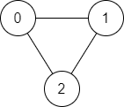

Input: n = 3, edges = [[0,1],[1,2],[2,0]], source = 0, destination = 2
Output: true
Explanation: There are two paths from vertex 0 to vertex 2:
- 0 → 1 → 2
- 0 → 2

Example 2:
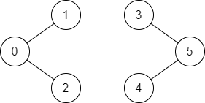

Input: n = 6, edges = [[0,1],[0,2],[3,5],[5,4],[4,3]], source = 0, destination = 5
Output: false
Explanation: There is no path from vertex 0 to vertex 5.

Constraints:

•
1 <= n <= 2 * 10 5
0 <= edges.length <= 2 * 10 5
edges[i].length == 2
0 <= u i <= n - 1 u != v i
0 <= source, destination <= n - 1
i
, v
i
•
•
•
•
•
  - There are no duplicate edges.
  - There are no self edges.


