**Customers on Telco**

**CIND-820**

Name: Jiahui Peng

Supervisor:

Date of submission: 2022-09-26

With the advancement of the technology, internet is becoming widespread. People is used to using internet in their daily life. Internet is not only used for checking the text information the website, but also internet can be used for calling, streaming and e-gaming. Specially during COVID-19, outdoor activities reducing, the demand of internet is keeping growing up. And now, people could not leave without internet. In such this high demand market, there are a huge business attracting people join in it. However, more and more telecom companies are found, the competitions are getting intense. We can try to using a simple dataset to understand the telecom companies developing direction.

Dataset using: Telco customer churn dataset from Kaggle.com, search from google database

Total 7043 records, 21 attributes.

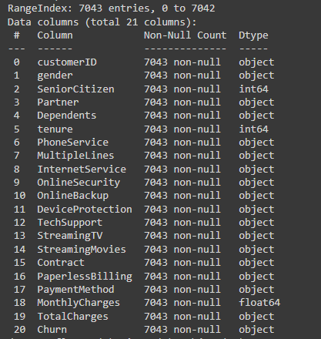

Here are the first 10 records of the dataset.

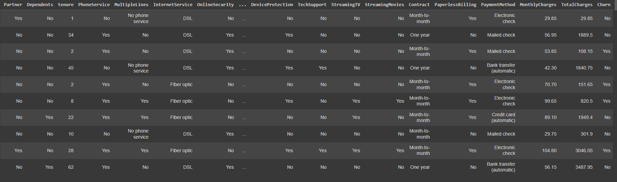

1. What is the main age area of customers? Are they the families’ users or single users?

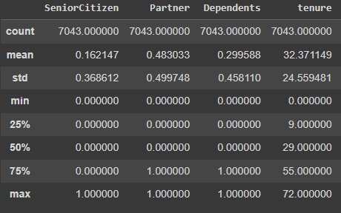

(Senior Citizen:0=No, 1=Yes; Partner:0=No, 1=Yes; Dependents: 0=No, 1=Yes)

As we could see in the table, Senior customers were 16% of total customers, younger or mid-age customers were the main users, 84%. And 48% of them are the family’s users and 29% of customers had dependents.

1. Which attributes seem to be correlated? Which attributes seem to be most linked to the Churn attribute?

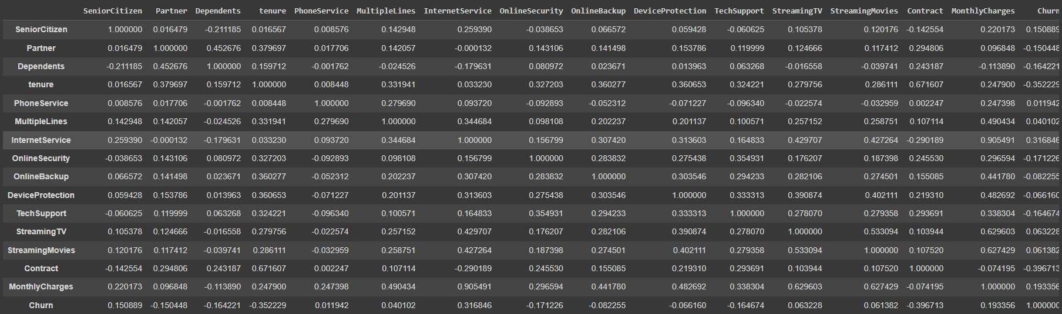

According to the table, monthly charges and Internet service would be the most correlated. Tenure and Contract seems to be the most linked to the Churn attribute.

1. Graph the frequency distribution of all attributes. (No=0, Yes=1)

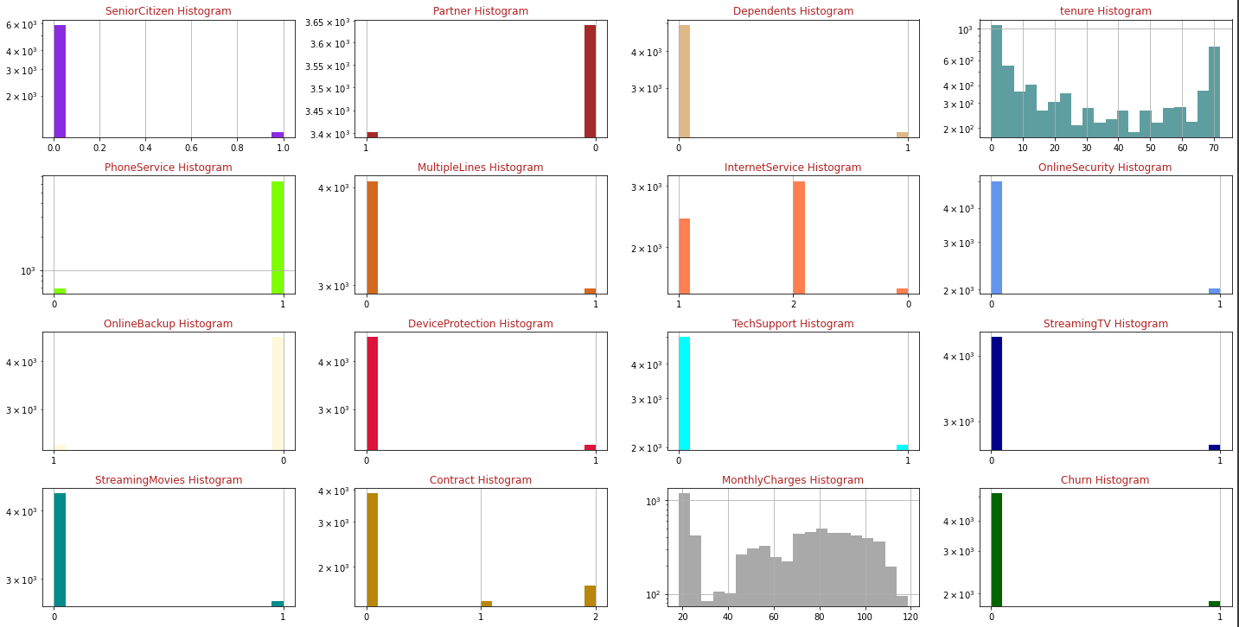

In the frequency distribution of all attributes, we could know 90% customers had the phone services. Most of customers had the internet service, and more than half of them would like to have high-speed internet (fiber optic). Around 38% of customers had internet service and streaming TV, and 38% of customers had internet service and streaming Movies service. Most of customers would like to pay month to month, less customers were willing to accept one year’s or two years’ contracts. At last, there was 26.5% customers churn rate.

1. Use the Logistic Regression algorithm to predict the churn of customer using its attributes; evaluate the model performance by computing Accuracy, Sensitivity, and Specificity. (70% of records as training data, 30% as testing data).

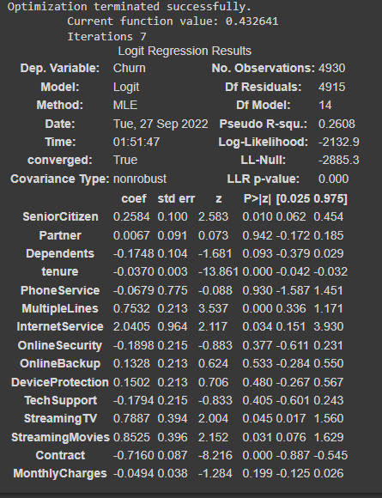

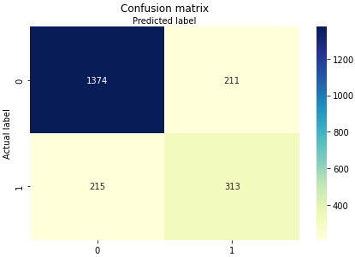

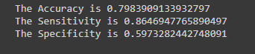

1. Use the KNN algorithm to predict the churn of customer using its attributes; evaluate the model performance by computing Accuracy, Sensitivity, and Specificity.

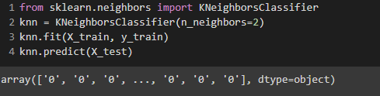

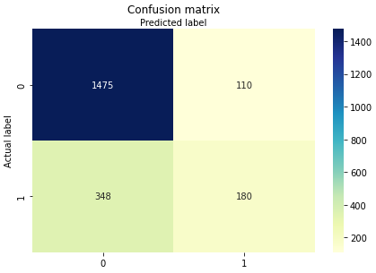

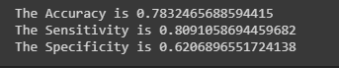

1. Conclusion and Recommendations

In conclusion, we could know about younger or mid-age customers were the main group users, half of them were not a single. We could assume around 4 devices connected to internet in the same time by each customer. Therefore, half of their internet service would more than 4 devices in the same time, and also they would use internet for streaming TV or movies. It means they highly required the stable and high-speed internet. Mean while we know Internet service would be the most correlated with monthly charges. And the customers churn was correlated with contract. In order to reducing the customers churn rate, company should attract more customers who paid month to month into contract customers.

Therefore, the telco company could provide a promotion as a new faster high-speed internet package with the 1 year’s or 2 years’ contract, and the price would be higher than the current package. Also, the company could provide the same current speed internet service with the 1 year’s or 2 years’ contract as a lower price.

Dataset from:

https://www.kaggle.com/datasets/blastchar/telco-customer-churn?select=WA_Fn-UseC_-Telco-Customer-Churn.csv

Base information from: <https://community.ibm.com/community/user/businessanalytics/blogs/steven-macko/2019/07/11/telco-customer-churn-1113>