Open Source Development Lab

Memory Game in Python
By – 14bce022, 14bce030

Abstract-
This is a small game developed in python. Here user is given just 5 seconds to remember the tiles with images on it. After 5 seconds all the tiles are covered with same image, and user has to pair up tiles with same images.
This application has only one level and provides the user with flexibility of loading some previous game and saving game for future use.
Matching and Memory games have the following advantages -

- improve concentration
- train visual memory
- increase short term memory
- increase attention to detail
- improve the ability to find similarities and differences in objects
- help to classify objects that are grouped by similar traits

Flow Diagram -
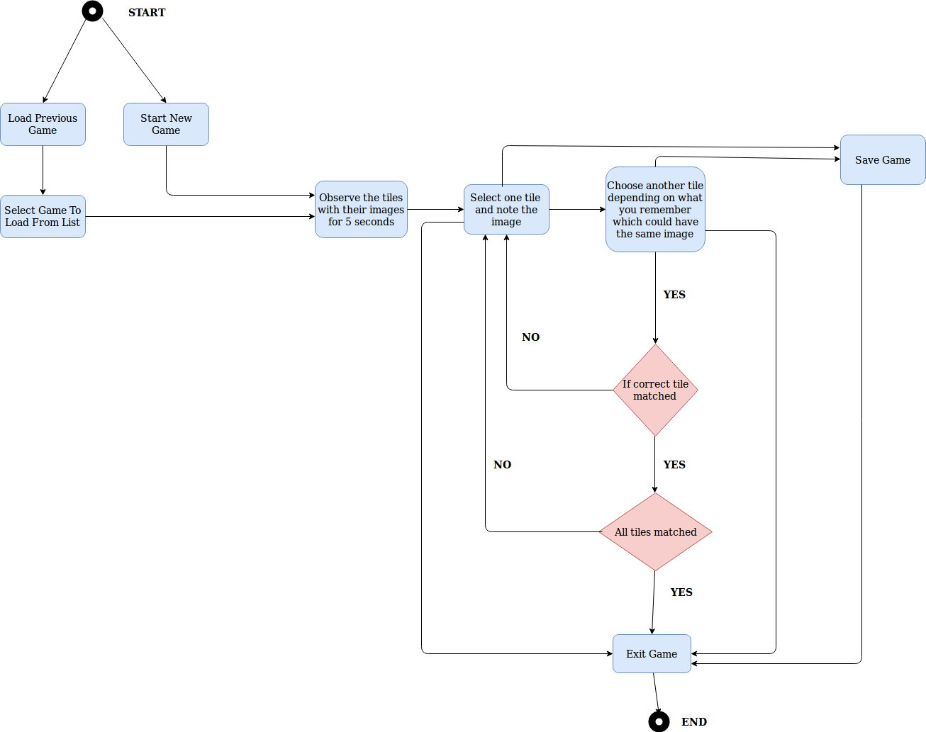

Features of Python Used -
Tkinter – It is the standard GUI library for Python. Python when combined with Tkinter provides a fast and easy way to create GUI applications. Tkinter provides a powerful object-oriented interface to the Tk GUI toolkit.
Creating a GUI application using Tkinter is an easy task. All you need to do is perform the following steps −
- Import the Tkinter module.
- Create the GUI application main window.
- Add one or more of the above-mentioned widgets to the GUI application.
- Enter the main event loop to take action against each event triggered by the user.

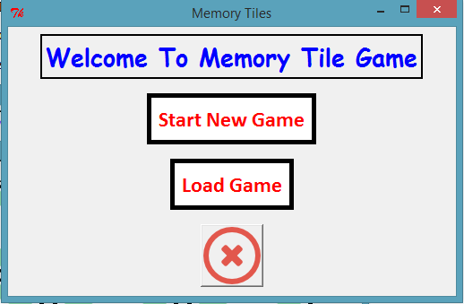

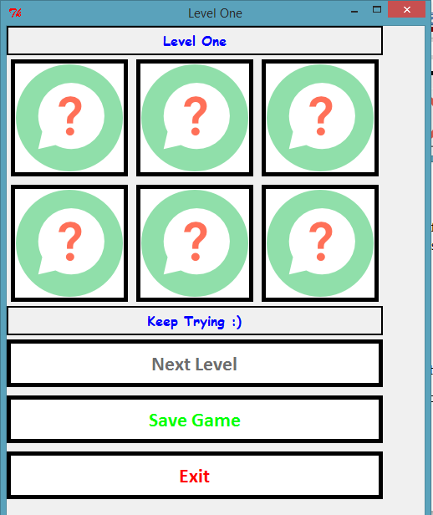

Python MySQLdb Interface - MySQLdb is an interface for connecting to a MySQL database server from Python. It implements the Python Database API v2.0 and is built on top of the MySQL C API.

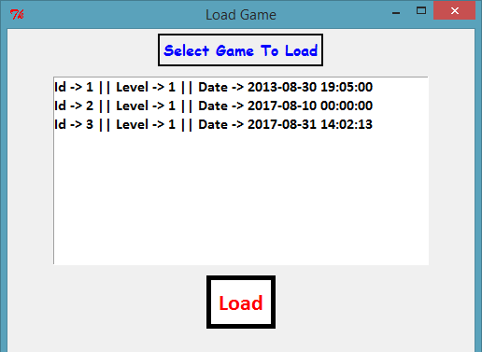

Limitations -
- The application has only one level of game which might make if redundant after some use.
- Same three images are used again and again for different games which might make the game easy for some users.
- The application does not keep track of time taken by the user to pair all tiles.
- The application does not not keep track of the number of moves taken by the user which many cases can give a good idea of how the user’s memory is.

Conclusion -
The application is developed to get introduction to python GUI programming. The application developed is limited in many ways but at the same time can be used by a wide variety of users for fun. The application can be enhanced by adding more levels and implementing machine learning to decide the level of the game on the basis of how a particular user plays the game.

