Software Engineering Team Project

Milestone 3

Milestone 3 - API Sprint 1 Consolidated Report
Project: Community Services Platform
System: Library Management System for Study Libraries
Product: Smart Library App
Team: MAY2026-Team-021
Submission date: 2 August 2026
Team Members
- Shubham Nagar (21f3000093)
- Gaurav Ramesh Ghodge (22f2000467)
- Piyush Jha (21f1002373)
- Mandeep (23f2001951)
- Hitarth Mehta (23f1001948)

1. Sprint Summary
Milestone 3 API Sprint 1 (Project Sprint 7) replaced the frontend-only mock foundation with working FastAPI, SQLAlchemy, JWT, tenant isolation, and PostgreSQL-compatible domain APIs. The result is an integrated owner workflow for registering a library, managing students and physical resources, allocating seats, recording fees, publishing announcements, and viewing operational reports.
74documented API operations
133 passedbackend pytest cases in the final run
87backend application Python files
26backend test modules

Continuity from Milestones 1 and 2
Milestone 1 identified Library Owners/Managers as primary users and documented their need for secure access, digital student records, shift-aware seats, conflict-free allocations, fees, receipts, reminders, and reports. Milestone 2 translated those needs into Vue, Pinia, service, FastAPI, repository, and database components. This sprint implemented and tested the backend contracts behind that design.
Milestone 1 need | Milestone 2 design | Milestone 3 evidence
Library registration and secure login | Authentication and library-registration components | 13 authentication operations, JWT session tests, and library bootstrap test
Students, shifts, seat visibility, and conflict prevention | Core library, seat availability, and allocation components | 32 student/floor/seat/shift/allocation operations with overlap and tenant tests
Monthly fees, receipts, reminders, and pending dues | Fee record, transaction, receipt, and reminder components | 9 payment/receipt operations with partial-payment and balance tests
Announcements and seat-change requests | Owner lifecycle and student self-service components | 13 announcement/request operations with role and lifecycle tests
Dashboard and operational reports | Dashboard, reports, and analytics components | Database-backed report and dashboard APIs with reconciliation tests

Sprint goals
- Establish a secure authentication, role, tenant, error, and API-contract foundation.
- Implement owner-facing core library, seat-allocation, payment, and announcement workflows.
- Integrate completed frontend services with real APIs without changing the page/store/service architecture.
- Protect historical records, prevent cross-library access, and test positive and negative paths.
- Generate a Swagger-compatible YAML contract with operation descriptions, errors, and user-story mapping.

Final technical baseline
- FastAPI routes use Pydantic schemas, service rules, tenant-scoped repositories, and SQLAlchemy models.
- Passwords use salted scrypt hashes. Access tokens are JWTs and refresh sessions rotate and are revocable.
- Every expected API error uses a structured code/message/details envelope and includes an X-Request-ID.
- Browser authentication uses an HttpOnly refresh cookie; API clients may use explicit refresh tokens.
- Frontend integrations retain the Vue page to Pinia store to Axios service flow.

2. Architecture and Functional Delivery
Vue page/component
-> Pinia store
-> Axios service
-> FastAPI route + authentication/tenant dependency
-> Pydantic request/response schema
-> application service + transaction boundary
-> tenant-scoped SQLAlchemy repository
-> database models
Functional area | Delivered behavior
Authentication | Library registration, login, access/refresh tokens, refresh rotation, browser sessions, logout, current user, profile, password change, and invitation activation.
Core library data | Student CRUD/status/invitations, floor CRUD, physical seat CRUD and bulk status, shift CRUD and overlap validation, and library settings.
Seat allocation | Date- and shift-aware availability, overnight overlap detection, atomic multi-shift creation, conflict prevention, lifecycle closure, snapshots, and history.
Fees and payments | Idempotent monthly generation, full/partial transactions, calculated balances, receipts, downloads, and persisted reminder-link generation.
Announcements | Owner list/create/update/publish/archive/delete lifecycle and student feed/read state.
Seat requests | Student submit/cancel workflow and tenant-scoped owner review.
Dashboard and reports | Database-backed student, seat, occupancy, revenue, pending-fee, ageing, activity, and attention metrics.
Student self-service | Own profile, seat/allocation history, fee summary, receipts, announcements, and seat-change requests.

Important business rules implemented
- The active membership determines libraryId; tenant-owned APIs never trust a client-supplied library identifier.
- Maintenance, blocked, inactive, or deleted seats and inactive/deleted shifts cannot receive new allocations.
- Allocation date ranges are inclusive; consecutive booking starts on the day after the earlier allocation ends.
- Shift comparison handles midnight crossings such as 22:00-02:00 versus 01:00-06:00.
- Monthly fee records are idempotent and payment balances are calculated from completed append-only transactions.
- Soft deletion and lifecycle statuses retain student, seat, shift, allocation, payment, receipt, and audit history.

3. API Inventory and Swagger Evidence
The submitted openapi.yaml is generated from FastAPI and validated against OpenAPI 3.1. It contains stable operation IDs, descriptions, request/response schemas, authentication requirements, structured error responses, request-ID headers, examples, and x-user-stories mappings.
Route group | Operations | Representative user stories
Authentication | 13 | Register library, login, rotate session, logout, profile, password, student activation
Students | 9 | Owner CRUD and invitation; student profile view/update
Floors and seats | 12 | Physical layout CRUD, status and bulk actions
Shifts | 6 | Shift administration and overlapping-selection validation
Seat allocations | 5 | Availability, create, list/history, close, student seat view
Seat requests | 5 | Student submit/cancel; owner list/review
Payments and receipts | 9 | Monthly generation, transactions, receipts, reminder links, student fee view
Announcements | 8 | Owner lifecycle; student audience feed and read state
Reports | 3 | Filter options, owner reports, operational dashboard
Settings and system | 4 | Library settings, API discovery, health
Total | 74 | All operations mapped in the YAML
Final contract audit: 74 operations; 0 missing descriptions; 0 missing user-story mappings; 0 missing documented 4xx/5xx responses. The semantic drift test passed against the checked-in YAML.

Shared error contract
{
"error": {
"code": "SEAT_ALLOCATION_CONFLICT",
"message": "Seat A-01 is occupied during the requested period.",
"details": {}
},
"requestId": "frontend-request-123"
}

4. API Test Cases - Part A
Environment: Python 3.12, FastAPI in-process ASGI client, and an isolated test database.

API-001 - Register library with initial physical resources
API
POST /api/v1/auth/register-library
Input
Valid library/owner details with seatCount: 25.
Expected
201; admin user, library ID, access/refresh tokens; one settings row, Floor 1, three default shifts, and 25 seats.
Actual
201; all response fields and database bootstrap counts matched.
Result
SUCCESS
Pytest
test_registration_bootstraps_library_and_me
Snapshot of pytest function - backend/tests/test_auth_api.py 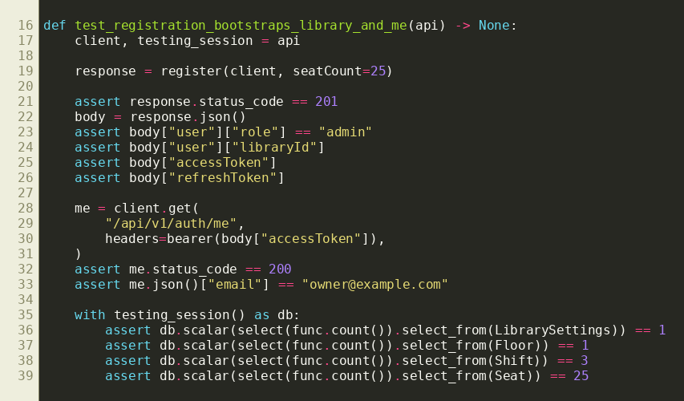

API-002 - Reject invalid registration seat count
API
POST /api/v1/auth/register-library
Input
Valid registration fields with seatCount: 0.
Expected
422 with error code VALIDATION_ERROR, field details, and matching request ID.
Actual
422; message was “The request contains invalid data.” and request ID matched the response header.
Result
SUCCESS
Pytest
test_validation_errors_use_the_shared_error_contract
Snapshot of pytest function - backend/tests/test_api_foundation.py 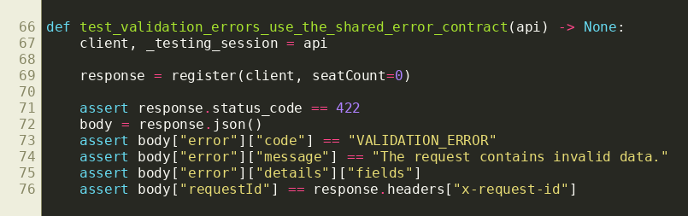

API-003 - Refresh-token rotation and reuse prevention
API
POST /api/v1/auth/refresh
Input
Use a valid refresh token, then submit the original token again after rotation.
Expected
First request 200 with new tokens; reused old refresh token 401; old access session revoked.
Actual
200 for rotation; 401 for token reuse and old access-token use.
Result
SUCCESS
Pytest
test_refresh_rotation_revokes_old_session_and_logout_revokes_new_one
Snapshot of pytest function - backend/tests/test_auth_api.py 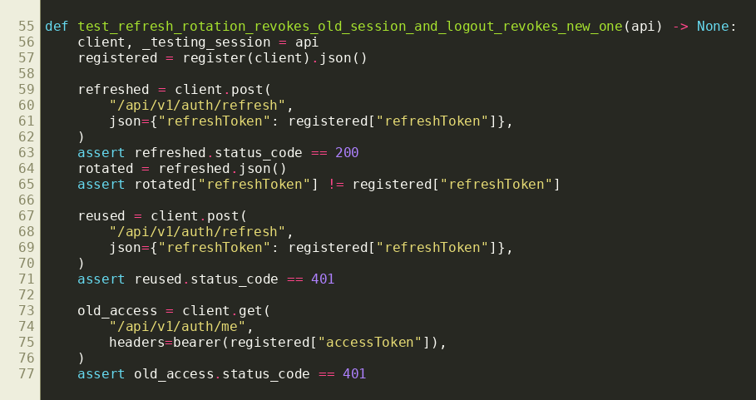

API-004 - Student invitation activation and one-time use
APIs
POST /students, GET /auth/invitations/validate, POST /auth/invitations/accept
Input
Create student with invitation, validate token, set password, then reuse the same token.
Expected
Student 201; validation 200; activation 200; repeated activation rejected with 422.
Actual
All statuses matched; activated credentials logged in as the Student role.
Result
SUCCESS
Pytest
test_student_crud_invitation_and_password_setup
Snapshot of pytest function - backend/tests/test_core_library_api.py 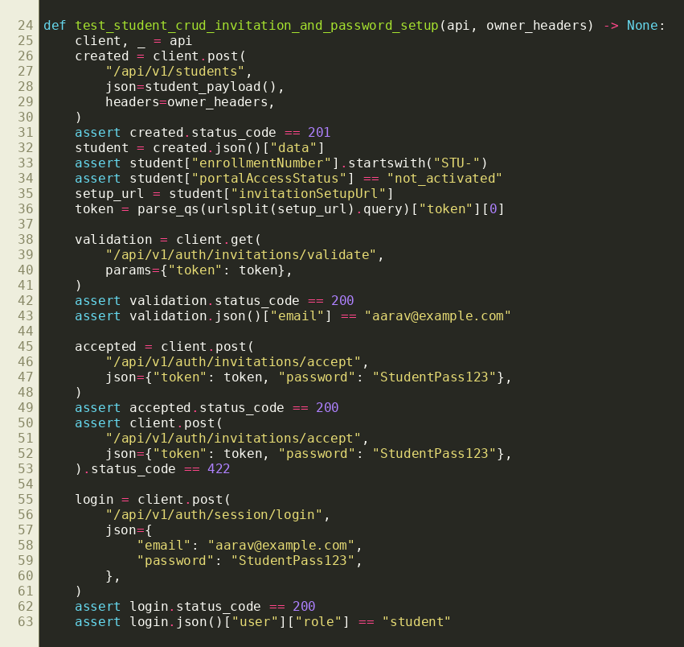

5. API Test Cases - Part B

API-005 - Detect overlapping overnight shifts
API
POST /api/v1/shifts/validate-selection
Input
Overnight 22:00-02:00 and Early 01:00-06:00 shift IDs.
Expected
200 response with data.valid: false because the shifts overlap from 01:00 to 02:00.
Actual
200 with invalid selection and overlap conflict details.
Result
SUCCESS
Pytest
test_floor_seat_shift_and_settings_workflows
Snapshot of relevant pytest function lines - backend/tests/test_core_library_api.py 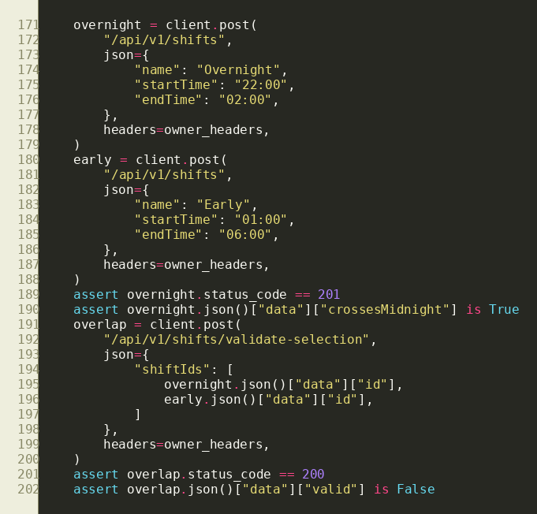

API-006 - Reject overlapping seat allocation
API
POST /api/v1/seat-allocations
Input
A second student requests the same seat and Morning shift during an overlapping date range.
Expected
409 with SEAT_ALLOCATION_CONFLICT; no partial allocation or success audit record.
Actual
409 with the expected code; database and audit counts remained unchanged.
Result
SUCCESS
Pytest
test_conflicts_atomicity_status_precedence_and_consecutive_dates
Snapshot of relevant pytest function lines - backend/tests/test_seat_allocation_api.py 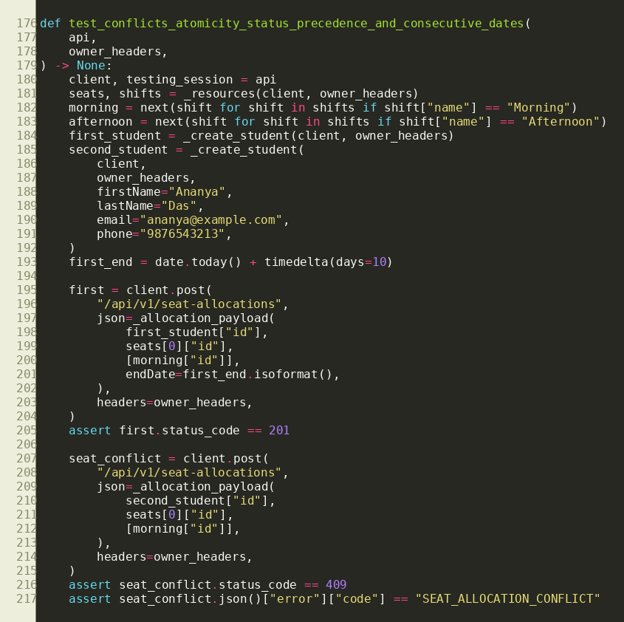

API-007 - Record partial and final payment
API
POST /api/v1/payments/{feeRecordId}/transactions
Input
Fee total 1200.00; transactions of 400.25 and 799.75.
Expected
First response partially paid with 799.75 balance; final response paid with 0.00 balance and two completed transactions.
Actual
Calculated totals, lifecycle status, transaction count, receipt count, and audit count matched.
Result
SUCCESS
Pytest
test_partial_and_full_payments_recalculate_server_totals
Snapshot of pytest function - partial payment assertions 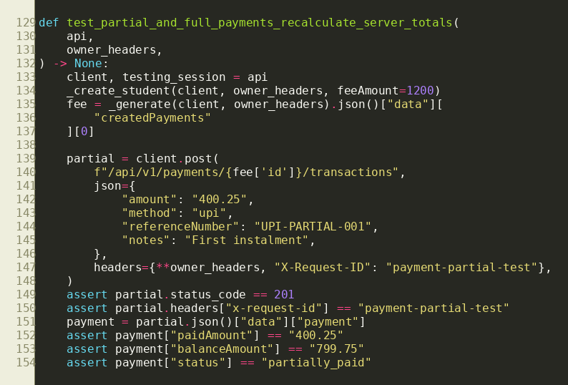 Snapshot of pytest function - final payment assertions 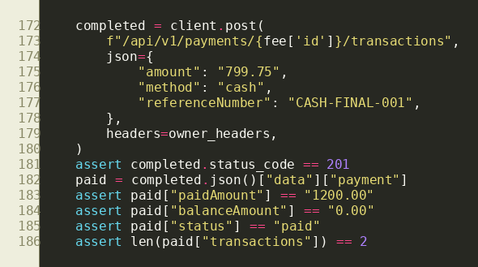

API-008 - Hide another library's student
API
GET /api/v1/students/{studentId}
Input
Owner B requests a Student ID belonging to Library A.
Expected
404, without exposing the student name or Library A.
Actual
404; cross-library student record was hidden.
Result
SUCCESS
Pytest
test_student_records_are_isolated_by_library
Snapshot of pytest function - backend/tests/test_core_library_api.py 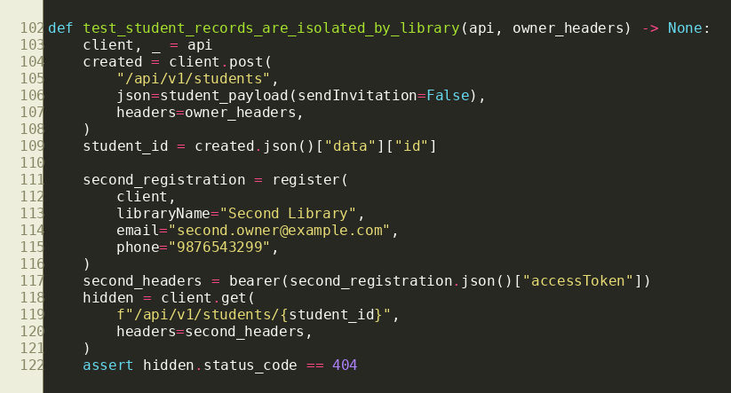

6. Required Expected-vs-Actual Mismatch

API-009 - Expired database session initially accepted an access JWT
API
GET /api/v1/auth/me
Input
A cryptographically valid, unexpired access JWT whose backing user_sessions.expires_at value was changed to a past time.
Expected
401 Unauthorized because the server-side session is expired.
Initial actual
200 OK. The signed JWT was accepted even though its backing database session had expired.
Initial result
FAIL
Root cause
The authentication dependency validated JWT claims but did not enforce the backing session's expiry/revocation state for every protected request.
Fix
Added active-session validation to protected requests and strengthened refresh/logout revocation. Implemented in commit 3dd6ad9.
Retest actual
401 Unauthorized.
Retest result
SUCCESS
Pytest
test_expired_backing_session_is_rejected
Snapshot of the regression test that initially failed and now passes - backend/tests/test_auth_api.py 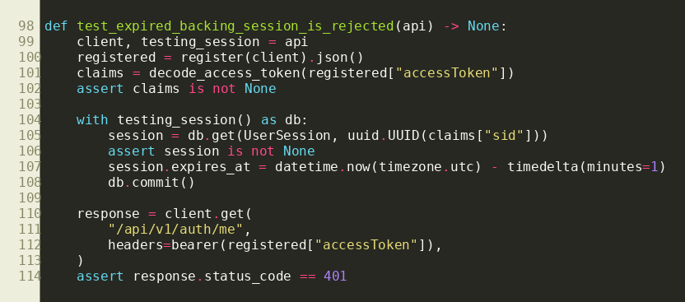
This mismatch demonstrates the value of API testing: signature validation alone looked correct during normal login testing, but a server-side session expiry scenario revealed that revoked or expired sessions could remain usable. The regression test now prevents recurrence.

Other defects found and resolved during Milestone 3 API Sprint 1
Defect | Resolution | Evidence
Concurrent refresh or payment/allocation requests could race. | Added deterministic row locking, atomic transactions, conflict handling, and rollback tests. | Concurrency-focused API tests and service-level transaction tests.
Registration did not initially bootstrap all requested library resources. | Registration now creates settings, Floor 1, default shifts, requested seats, membership, owner, and session atomically. | test_registration_bootstraps_library_and_me
Payment list parameters temporarily drifted from the frontend/API contract. | Restored the complete parameter set and regenerated the checked-in OpenAPI file. | Commit 838a0af and semantic drift test.
Overnight shifts could be mishandled by simple linear time comparison. | Split crossing-midnight intervals and reused one authoritative overlap algorithm in validation and allocation checks. | Overnight unit and API tests.

7. Test Execution and Quality Evidence
Command/check | Final result
backend/venv/bin/pytest -q | 133 backend tests passed
python backend/scripts/export_openapi.py --check | OpenAPI contract valid and current
pytest backend/tests/test_openapi_contract.py | 3 passed, including all-operation documentation audit
OpenAPI completeness scan | 74 operations; no missing descriptions, stories, or error responses
Frontend service/component tests | Passed during integrated module validation
Frontend lint and production build | Passed during integrated module validation

Test categories represented
- Successful creation, retrieval, update, status, lifecycle, and deletion paths.
- Required-field and business-rule validation.
- Unauthenticated, malformed-token, wrong-role, inactive membership, and suspended-library access.
- Cross-tenant resource hiding and not-found behavior.
- Duplicate records, payment overrun, seat/student conflicts, and transaction rollback.
- Search, filters, pagination, sorting, date overlap, overnight overlap, ageing boundaries, and report reconciliation.
- OpenAPI validity and semantic drift between FastAPI and the submitted YAML.

8. User Feedback and Actions
The integrated owner workflows were demonstrated and reviewed by team members acting in the Library Owner role. Feedback was captured during the Seat Management and Payment Management walkthroughs and then converted into fixes or backend acceptance tests.
Feedback received | Decision | Action taken
An overnight shift (22:00-02:00) and early shift (01:00-06:00) must be shown as overlapping. | Fix immediately | Implemented midnight-aware overlap logic and added frontend and backend regression tests.
Seat availability should be calculated for the selected shift instead of showing every shift inside every seat card. | Accepted | Created a shift-first seat map and one authoritative availability API with blocker details.
Student registration/edit should allow multiple non-overlapping shifts and only show seats available for those shifts. | Accepted | Added multi-shift validation, real availability lookup, and atomic student/allocation changes with rollback.
Action menus should close after an action, outside click, or Escape, and clickable controls should show a pointer cursor. | Fix immediately | Added a reusable dismissible-menu pattern and consistent trigger behavior.
Monthly payments should open on the current month, allow other months, and give owners access to receipts. | Accepted | Connected month-filtered fee APIs, receipt list/detail/download, and payment history.
API failures should explain conflicts clearly instead of exposing database errors. | Accepted | Introduced typed business errors, stable codes, safe messages, field details, and request correlation IDs.

What users considered successful
- Shift-aware seat status made the same physical seat understandable across Morning, Afternoon, Evening, and custom shifts.
- Student registration, seat assignment, and payment workflows remained usable on mobile layouts.
- Clear conflict messages and retained allocation/payment history improved administrative confidence.

9. Plan for Milestone 3 API Sprint 2 (Project Sprint 8)
Several Milestone 4 vertical slices were completed early, including student self-service, seat-request review, receipts/reminders, and owner reports. The next API sprint will focus on the remaining platform scope and release hardening while continuing the project schedule documented in Milestone 2.
Priority | Planned work | Exit evidence
1 | Implement Super Admin library, owner, platform analytics, and platform-settings APIs and replace remaining production mocks. | OpenAPI routes, role/tenant tests, frontend integration, reviewed PR.
2 | Run concurrency and report-performance suites against a disposable test database. | Passing tests, query plans, timings, and evidence-backed index decision.
3 | Expand audit coverage for student, floor, shift, and settings mutations and add an authorized audit-history view if time permits. | Audit assertions and tenant/role tests.
4 | Complete scheduled/background behavior for fee generation, reminders, and announcement lifecycle where required by final scope. | Idempotency tests and documented task execution.
5 | Conduct end-to-end owner and student UAT, browser/accessibility regression, security configuration review, and deployment rehearsal. | Feedback log, resolved issues, screenshots, test report, deployment checklist.
6 | Prepare Milestone 4 submission and final demonstration. | Updated PDF, Swagger YAML, executable code ZIP, test evidence, tagged release.

Known next-sprint risks
- A dedicated disposable test database is required for destructive locking and performance evidence.
- Super Admin frontend currently has mock-backed areas and must not silently fall back after API integration.
- Final deployment secrets, secure cookies, CORS origins, and database migrations require environment-specific verification.

10. Submission Contents and Reproduction

A. Milestone 3 PDF Report
This document contains sprint delivery, API test cases, the required failed test, user feedback, fixes, and the next-sprint plan.

B. Swagger YAML
openapi.yaml documents all 74 current operations with schemas, descriptions, user stories, errors, security requirements, and request-ID headers.

C. Backend ZIP
The ZIP contains backend application code, migrations, tests, scripts, dependency manifest, example environment, documentation, CI workflow, and a copy of the API contract. It intentionally excludes the local .env, virtual environment, caches, bytecode, databases, and secrets.

Local execution
cd backend
python -m venv venv
source venv/bin/activate
pip install -r requirements.txt
cp .env.example .env
alembic upgrade head
pytest
uvicorn app.main:app --reload

Swagger verification
python scripts/export_openapi.py --check
pytest tests/test_openapi_contract.py
# Swagger UI: http://127.0.0.1:8000/docs
Final status: report prepared from repository evidence; Swagger contract current; backend standard test suite passing; executable submission package assembled without secrets.
Evidence references: commits 3dd6ad9, ecc3fdb, ac4ea6f, 5202f0d, 0cec5ba, 885ceb7, 4471fbd, 802c0d6, f39a1bb, c22a17f, and 838a0af.

