**INFORMATICS**

**PRACTICES**

PROJECT FILE



Teachers Name : Ms. Reeba Mariam Ninan

Students Name : Gaurav Rayat

Class : XII-SCIENCE

Project Name : The Analyser

TOPIC :- Analysis of crimes in India

CERTIFICATE

This is to certify that **Gaurav Rayat** of class **XII - Science** has successfully completed the project on **Crime and Murders** in India under the guidance of **Ms. Reeba Mariam Ninan** for the session 2021-2022.

**Ms. Reeba Mariam Ninan**

**(PGT)**

ACKNOWLEDGEMENT

It gives me immense pleasure in expressing a deep sense of gratitude to our helpful and respected teacher

**Ms. Reeba Mariam Ninan,**

for her guidance throughout the preparation of the project.

We are also thankful to all our teachers who helped us with their valuable suggestions.

***Gaurav Rayat***

**XII - Science**

PROJECT - SYNOPSIS

**TITLE :- *The Analyser***

By,

Gaurav Rayat(Student),

Deepalaya school,

Kalkaji Extn,

New Delhi - 110019

# **Problem Definition:**

Today we are continuously hearing about growth in Crime rates and the number of murders executed day by day.It is very unfortunate that we are living in the country known as the hub of criminals. About 3.5 lakhs crimes have been committed in just 12 years from 2001 to 2012. This is the most in any country ever recorded. So in order to decrease this awful rate of crime we need to analyse it from the core and this project "The Analyser '' helps us to do that.

# **Features :**

1. Analyse different Criminal activities done in different States in particular Year.
2. Analyse murders done in various states in different Years.
3. Visualisation of criminal activities.
4. Visualisation of Murders in India.  
     
   **Objective :**

This software project is developed to review the number of **Crimes and Murders** that have been done from 2001 - 2012 in **India**.

The purpose of the project is to develop a program which provides a Command Line Friendly Interface for the user to review the number of **Crimes** in **India**.

The user can not make changes to the program since it is released under **GNU GPL License**.

## Hardware Requirements :

A Computer or Laptop with

* **Windows 7 or Above / Linux / Mac**
* **CPU : Intel Celeron N3060 or Above**
* **RAM : 4 GB**
* **ROM : Minimum 10 GB**

## Software Requirements :

* **Python 3.8.x or higher version**
* **Spreadsheets or Excel Installed.**
* **Matplotlib should be installed.**
* **Pandas should be installed.**
* **Rich should be installed.**

## Limitations :

* It is not a web based project.
* More functionality can be added as per requirement.
* No provision to print hard copies.
* It does not visually interact with users as GUI.

## References :

* kaggle.com.
* Python Documentation.
* Rich Documentation.
* Google.com
* NCERT textbooks

**THEORETICAL BACKGROUND**

* **PYTHON - Language Used  
  Python** is an interpreted, high-level and general-purpose programming language. Python's design philosophy emphasizes code readability with its notable use of significant whitespace. Its language constructs and Object-Oriented approach aim to help programmers write clear and logical code for small and large-scale projects.   
  Python is dynamically typed and garbage-collected. It supports multiple programming paradigms, including structured, object-oriented, and functional programming.   
  Python is often described as a "batteries included" language due to its comprehensive standard library. Python was created in the late **1980s**, and first released in **1991**, by **Guido Van Rossum** as a successor to the ABC programming language.
* **PANDAS**In computer programming, **pandas** is a software library written for the Python programming language for data manipulation and analysis.  
  In particular, it offers data structures and operations for manipulating numerical tables and time series. It is free software released under the three-clause BSD license.
* **MATPLOTLIB  
  Matplotlib** is a plotting library for the Python programming language and its numerical mathematics extension **NumPy**. It provides an object-oriented API for embedding plots into applications using general-purpose GUI toolkits.  
  Matplotlib was originally written by John D. Hunter.
* **PYPLOT(matplotlib.pyplot)  
  Matplotlib.pyplot** is a collection of functions that make matplotlib work like MATLAB. Each pyplot function makes some change to a figure : e.g., creates a figure, creates a plotting area in a figure, plots some lines in a plotting area, decorates the plot with labels, etc.In matplotlib.pyplot various states are preserved across function calls, so that it keeps track of things like the current figure and plotting area, and the plotting functions are directed to the current axes.
* **CSV FILES**The csv module gives the Python programmer the ability to parse CSV (Comma Separated Values) files. A CSV file is a human readable text file where each line has a number of fields, separated by commas or some other delimiter. The csv module will be able to read the vast majority of CSV.

**TOOLS USED**

* **Linux Ubuntu LTS 20.04 as the operating system.**
* **Python 3.8.10**
* **Pandas 1.2.3**
* **Matplotlib 3.4.1**
* **Rich (Console Designer)**
* **VS Code for coding**
* **WPS Spreadsheets**

**Project Links**

* <https://github.com/GAURAV-ROBUST/IP_Project_2022>
* <https://bit.ly/3FB48z2>

**Modules used**

1. os
2. sys
3. time
4. datetime
5. pandas (EXTERNAL)
6. matplotlib (EXTERNAL)
7. rich (EXTERNAL)

**CODE :**

**Importing desired Modules :**

# Import commands

import os # Built - IN Modules

import sys # Built - IN Modules

import time # Built - IN Modules

from datetime import datetime # Built - IN Modules

try:

from pandas import *

except:

print("Installing Pandas....")

os.system("pip3 install pandas")

from pandas import *

try:

from matplotlib import pyplot as plt

except:

print("Installing Matplotlib....")

os.system("pip3 install matplotlib")

from matplotlib import pyplot as plt

try:

from rich.console import Console

from rich.markdown import Markdown

except:

print("Installing Rich module....")

os.system("pip3 install rich")

try:

from rich.console import Console

from rich.markdown import Markdown

except:

print("Rich Can't be installed for some reason...")

pass

**Creating Class and hence functions to be used in following program :**

class main():

# FUNCTIONS

def printer(): # Main Printer(Initial)

console.print(Markdown("# The Analyser "))

console.print("1. Analyse Different Crimes in India.\n2. Analyse Murders.",style="cyan")

console.print("3. Visualise Crimes\n4. Visualise Murders\n5. Exit\n",style="cyan")

def printer_8_9(): #crime printer of option 8 and 9

console.print("1. Total number of crimes in particular age group.",style=style)

console.print("2. Total number of crimes in particular age group in a given state.",style=style)

console.print("3. Total number of crimes in particular age group in a given state in a given year.",style=style)

def crime_printer(): # Main Crime printer(All options)

console.print("What do you want to do with data?",style=style)

console.print("1. Total Number of crimes in India from 2001 to 2012.",style=style)

console.print("2. Total Number of crimes in particular State.",style=style)

console.print("3. Total Number of crimes in particular year.",style=style)

console.print("4. Total Number of crimes in a state in particular year.",style=style)

console.print("5. Particular Crime in the given year.",style=style)

console.print("6. Particular Crime in the given State.",style=style)

console.print("7. Particular Crime in the given State in given Year.",style=style)

console.print("8. Analyse Crimes on Male(with Age group).",style=style)

console.print("9. Analyse Crimes on Female(with age group)",style=style)

console.print("10. Exit",style=style)

def murder_printer(): #Murder printer Main (All options)

console.print("What do you want to do with data?\n",style=style)

console.print("1. Total Number of Murders in India from 2013",style=style)

console.print("2. Total Number of Murders in particular State.",style=style)

console.print("3. Murder of a Female(with Age group).",style=style)

console.print("4. Murder of a Male(with age group)",style=style)

console.print("5. Murder of a Female(with Age group) in specific state.",style=style)

console.print("6. Murder of a male(with Age group) in specific state.",style=style)

console.print("7. Exit")

def murder_m_f(gen):

if gen == "female":

#Murder of female in a state with specific age group also.

df = murder.loc[1:len(murder.index)+1:3,['STATE/UT','Upto 10 years','10-15 years','15-18 years','18-30 years','30-50 years','Above 50 years']]

elif gen == "male":

#Murder of male in a state with specific age group also.

df = murder.loc[0:len(murder.index)+1:3,['STATE/UT','Upto 10 years','10-15 years','15-18 years','18-30 years','30-50 years','Above 50 years']]

list1 = []

list_states = []

dict1 ={}

dict2 = {}

sum = 0

for index,cols in df.iteritems():

if index == 'STATE/UT':

for i in cols:

list_states.append(i)

list1.append(index)

list1.remove('STATE/UT')

for index,value in enumerate(list1):

console.print(f"{index+1}. {value}",style=style1)

dict1[index+1] = value

inp3 = int(input("Enter Your Choice :"))

for index,value in enumerate(list_states):

console.print(f"{index+1}. {value}",style=style1)

dict2[index+1] = value

inp4 = int(input("Enter Your Choice :"))

df1 = df.loc[:,['STATE/UT',dict1[inp3]]]

for index,row in df1.iterrows():

if row[0] == dict2[inp4]:

sum = row[1]

print()

console.print(f"Your Result :",sum,style=style2)

print()

def m_f1(gen): #Male female choice 1

df = crimes.loc[13:len(crimes.index)+1:14,[f'{gen} upto 10 years',f'{gen} 10-15 years',f'{gen} 15-18 years',f'{gen} 18-30 years',f'{gen} 30-50 years',f'{gen} above 50 years']]

list1 = []

dict1 = {}

sum = 0

for index,cols in df.iteritems():

list1.append(index)

for index,values in enumerate(list1):

console.print(f"{index+1}. {values}",style=style1)

dict1[index+1] = values

inp4 = int(input("Enter Your Choice :"))

for index,cols in df.iteritems():

if index == dict1[inp4]:

cols.index = range(len(df.index))

for i in range(len(df.index)):

sum+=cols[i]

console.print(f"Total Number of crimes in {dict1[inp4]} =",sum,style=style2)

def m_f2(gen): #Male female choice 2

df = crimes.loc[13:len(crimes.index)+1:14,['STATE/UT',f'{gen} upto 10 years',f'{gen} 10-15 years',f'{gen} 15-18 years',f'{gen} 18-30 years',f'{gen} 30-50 years',f'{gen} above 50 years']]

list1 = []

dict1 = {}

list2 = []

dict_states = {}

sum = 0

for index,cols in df.iteritems():

list1.append(index)

list1.remove('STATE/UT')

for index,values in enumerate(list1):

console.print(f"{index+1}. {values}",style=style1)

dict1[index+1] = values

inp4 = int(input("Enter Your Choice :"))

for index,row in df.iterrows():

if row[0] in list2:

pass

else:

list2.append(row[0])

for index,values in enumerate(list2):

console.print(f"{index+1}. {values}",style=style1)

dict_states[index+1] = values

inp5 = int(input("Enter The State :"))

df1 = df.loc[:,['STATE/UT',dict1[inp4]]]

for index,row in df1.iterrows():

if row[0] == dict_states[inp5]:

sum += row[1]

console.print("Your Result :",sum,style=style2)

def m_f3(gen): #Male female choice 3

df = crimes.loc[13:len(crimes.index)+1:14,['STATE/UT','YEAR',f'{gen} upto 10 years',f'{gen} 10-15 years',f'{gen} 15-18 years',f'{gen} 18-30 years',f'{gen} 30-50 years',f'{gen} above 50 years']]

list1 = []

dict1 = {}

list2 = []

dict_states = {}

sum = 0

for index,cols in df.iteritems():

list1.append(index)

list1.remove('STATE/UT')

list1.remove('YEAR')

for index,values in enumerate(list1):

console.print(f"{index+1}. {values}",style=style1)

dict1[index+1] = values

inp4 = int(input("Enter Your Choice :"))

for index,row in df.iterrows():

if row[0] in list2:

pass

else:

list2.append(row[0])

for index,values in enumerate(list2):

console.print(f"{index+1}. {values}",style=style1)

dict_states[index+1] = values

inp5 = int(input("Enter The State :"))

inp6 = int(input("Enter The Year [2001 - 2012] :"))

df1 = df.loc[:,['STATE/UT','YEAR',dict1[inp4]]]

for index,row in df1.iterrows():

if row[0] == dict_states[inp5] and row[1] == inp6:

sum += row[2]

print()

console.print("Your Result :",sum,style=style2)

print()

def murder_finder_age_group(start,gender):

murder_sample = read_csv("murder.csv",usecols=['Upto 10 years','10-15 years','15-18 years','18-30 years','30-50 years','Above 50 years'])

murder_sample = murder_sample.loc[start:len(murder_sample.index)+1:3]

list1 = murder_sample.T.index

dict1 ={}

sum = 0

for index,values in enumerate(list1):

console.print(f"{index+1}. {values}",style=style1)

dict1[index+1] = values

inp3 = int(input("Enter Your Choice :"))

murder_sample.index = range(0,len(murder_sample.index))

for i in range(0,len(murder_sample.index)):

sum += murder_sample[dict1[inp3]][i]

console.print()

console.print(f"Total Number of {gender} murders in 2013 =",sum,style=style2)

console.print()

def crime_1():

df = crimes.loc[13:len(crimes.index)+1:14,['Grand Total']]

df.index = range(1,len(df.index)+1)

total = 0

for i in range(len(df.index)):

total += df['Grand Total'][i+1]

console.print()

console.print("Total number of Crimes in India =",total,style=style2)

console.print()

def crime_2():

df = crimes.loc[13:len(crimes.index)+1:14,['STATE/UT','YEAR','Grand Total']]

df.index = range(1,len(df.index)+1)

df_states = crimes.loc[13:len(crimes.index)+1:167,['STATE/UT']]

df_states.index = range(1,len(df_states.index)+1)

state_names = []

dict1 ={}

for i in range(len(df_states.index)):

state_names.append(df_states['STATE/UT'][i+1])

for index,value in enumerate(state_names):

console.print(f"{index+1}. {value}",style=style1)

dict1[index+1] = value

inp3 = int(input("Enter Your Choice :"))

sum = 0

for index,row in df.iterrows():

if row[0] == dict1[inp3]:

sum += row[2]

console.print()

console.print(f"Total number of crimes in {dict1[inp3]} = {sum}.",style=style2)

console.print()

def crime_3():

try:

inp3 = int(input("Enter The Year (2001 to 2012):"))

except:

console.print("Enter The Valid Year")

inp3 = int(input("Enter The Year (2001 to 2012):"))

sum = 0

for index,row in crimes.iterrows():

if row[1] == inp3:

sum += row[18]

console.print()

console.print(f"Total Number of Crimes in {inp3} = {sum}",style=style2)

console.print()

def crime_4():

try:

inp3 = int(input("Enter The Year (2001 to 2012):"))

except:

console.print("Enter The Valid Year")

inp3 = int(input("Enter The Year (2001 to 2012):"))

df_states = crimes.loc[13:len(crimes.index)+1:167,['STATE/UT']]

df_states.index = range(1,len(df_states.index)+1)

state_names = []

dict1 ={}

for i in range(len(df_states.index)):

state_names.append(df_states['STATE/UT'][i+1])

for index,value in enumerate(state_names):

console.print(f"{index+1}. {value}",style=style1)

dict1[index+1] = value

inp4 = int(input("Enter Your Choice :"))

df = crimes.loc[13:len(crimes.index)+1:14,['STATE/UT','YEAR','Grand Total']]

for index,row in df.iterrows():

if row[0] == dict1[inp4] and row[1] == inp3:

crime_number = row[2]

console.print()

console.print(f"Number of Crime cases in {dict1[inp4]} in {inp3} = {crime_number}",style=style2)

console.print()

def crime_5():

list1 = []

dict1 = {}

sum = 0

for index,row in crimes.iterrows():

if row[2] in list1:

pass

else:

if row[2] == "Total" or row[2] == "For unlawful activity":

pass

else:

list1.append(row[2])

for index,value in enumerate(list1):

console.print(f"{index+1}. {value}",style=style1)

dict1[index+1] = value

try:

inp3 = int(input("Enter Your Choice :"))

except:

console.print("Your Choice should be in Integer!!")

inp3 = int(input("Enter Your Choice :"))

for index,row in crimes.iterrows():

if row[2] == dict1[inp3]:

sum += row[18]

console.print(f"Total Number of Crimes = ",sum,style=style2)

def crime_6():

#Printing States

df_states = crimes.loc[13:len(crimes.index)+1:167,['STATE/UT']]

df_states.index = range(1,len(df_states.index)+1)

state_names = []

dict1 ={}

for i in range(len(df_states.index)):

state_names.append(df_states['STATE/UT'][i+1])

for index,value in enumerate(state_names):

console.print(f"{index+1}. {value}",style=style1)

dict1[index+1] = value

inp3 = int(input("Enter The place :"))

#Printing Crimes

list1 = []

dict2 = {}

sum = 0

for index,row in crimes.iterrows():

if row[2] in list1:

pass

else:

if row[2] == "Total" or row[2] == "For unlawful activity":

pass

else:

list1.append(row[2])

for index,value in enumerate(list1):

console.print(f"{index+1}. {value}",style=style1)

dict2[index+1] = value

inp4 = int(input("Enter The Kind :"))

for index,row in crimes.iterrows():

if row[0] == dict1[inp3] and row[2] == dict2[inp4]:

sum += row[18]

console.print()

console.print(f"Total Number of Crime {dict2[inp4]} in {dict1[inp3]} =",sum,style=style2)

console.print()

def crime_7():

try:

inp3 = int(input("Enter The Year (2001 to 2012):"))

except:

console.print("Enter The Valid Year")

inp3 = int(input("Enter The Year (2001 to 2012):"))

#Printing States

df_states = crimes.loc[13:len(crimes.index)+1:167,['STATE/UT']]

df_states.index = range(1,len(df_states.index)+1)

state_names = []

dict1 ={}

for i in range(len(df_states.index)):

state_names.append(df_states['STATE/UT'][i+1])

for index,value in enumerate(state_names):

console.print(f"{index+1}. {value}",style=style1)

dict1[index+1] = value

inp4 = int(input("Enter The place :"))

#Printing Crimes

list1 = []

dict2 = {}

sum = 0

for index,row in crimes.iterrows():

if row[2] in list1:

pass

else:

if row[2] == "Total" or row[2] == "For unlawful activity":

pass

else:

list1.append(row[2])

for index,value in enumerate(list1):

console.print(f"{index+1}. {value}",style=style1)

dict2[index+1] = value

inp5 = int(input("Enter The Kind :"))

for index,row in crimes.iterrows():

if row[0] == dict1[inp4] and row[2] == dict2[inp5] and row[1] == inp3:

sum += row[18]

console.print()

console.print(f"Total Number of Crime {dict2[inp5]} at {dict1[inp4]} in {inp3} =",sum,style=style2)

console.print()

# Loader

def spinning_cursor():

while True:

for cursor in '|/-\\':

yield cursor

# Loading Printer

def load(x):

spinner = spinning_cursor()

for _ in range(x):

sys.stdout.write(next(spinner))

sys.stdout.flush()

time.sleep(0.1)

sys.stdout.write('\b')

**Printing initial choice and taking user input :**

if __name__ == "__main__":

#Printing Date

console.print("Date -",datetime.date(datetime.now()),style=style2)

console.print("Time -",datetime.time(datetime.now()),style=style2)

console.print()

#Printing Choice

main.printer()

try:

inp1 = int(input("Enter Your Choice :"))

except:

console.print("You need to enter your choice in Integer form.")

inp1 = int(input("Enter Your Choice :"))

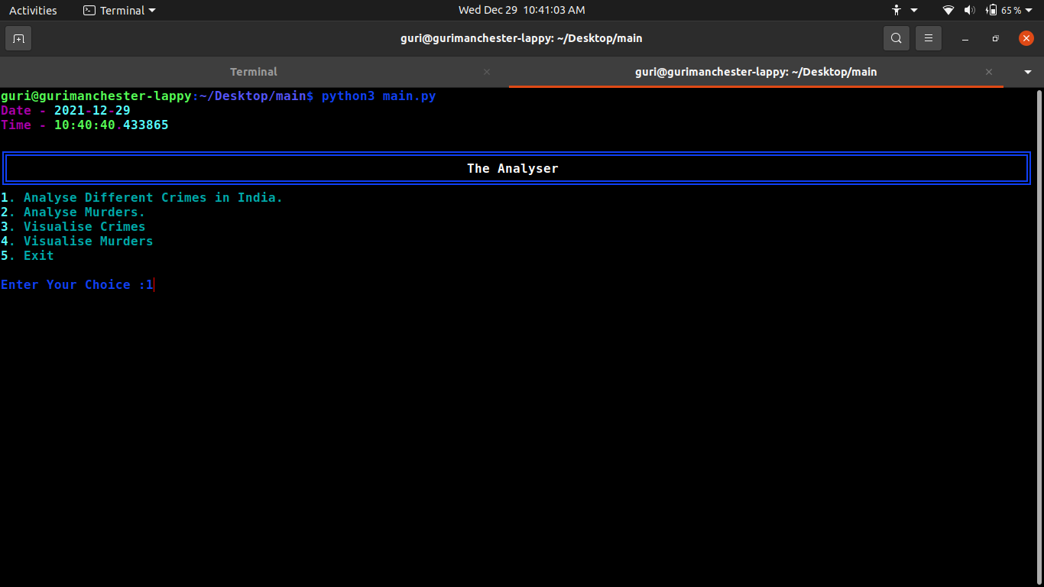

**If User’s Choose 1 to analyse crimes in India :**

if inp1 == 1:

while True:

crimes = read_csv("crimes.csv")

main.crime_printer() # Crime analyser choice printer

try:

inp2 = int(input("Enter Your Choice :"))

except:

console.print("You need to enter your choice in Integer form.")

inp2 = int(input("Enter Your Choice :"))

# Analysis Starts Here

if inp2 == 1:

main.crime_1()

elif inp2 == 2:

main.crime_2()

elif inp2 == 3:

main.crime_3()

elif inp2 == 4:

main.crime_4()

elif inp2 == 5:

main.crime_5()

elif inp2 == 6:

main.crime_6()

elif inp2 == 7:

main.crime_7()

elif inp2 == 8:

main.printer_8_9()

inp3 = int(input("Enter Your choice :"))

if inp3 == 1:

main.m_f1("Male")

elif inp3 == 2:

main.m_f2("Male")

elif inp3 == 3:

main.m_f3("Male")

else:

console.print("wrong choice!!")

elif inp2 == 9:

main.printer_8_9()

inp3 = int(input("Enter Your Choice :"))

if inp3 == 1:

main.m_f1("Female")

elif inp3 == 2:

main.m_f2("Female")

elif inp3 == 3:

main.m_f3("Female")

else:

console.print("Terminating!!")

load(25)

exit()

elif inp2 == 10:

console.print("Please Wait\nTerminating")

load(25)

exit()

else:

console.print("Wrong Choice!!")

break

console.print("Do you want to continue? [y or n]")

inp5 = input("Enter Your Choice :")

if inp5 == ("y" or "Y"):

continue

else:

console.print("Terminating!!")

load(25)

Break

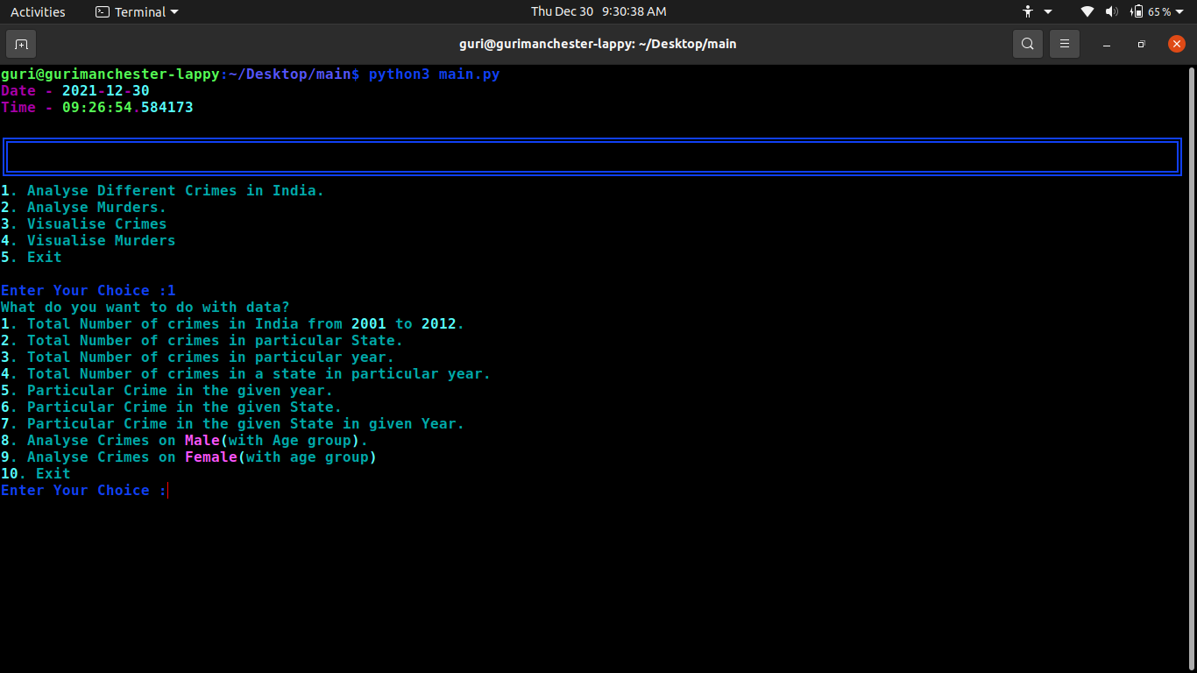

**User Choice is 1 in crime analyser :**

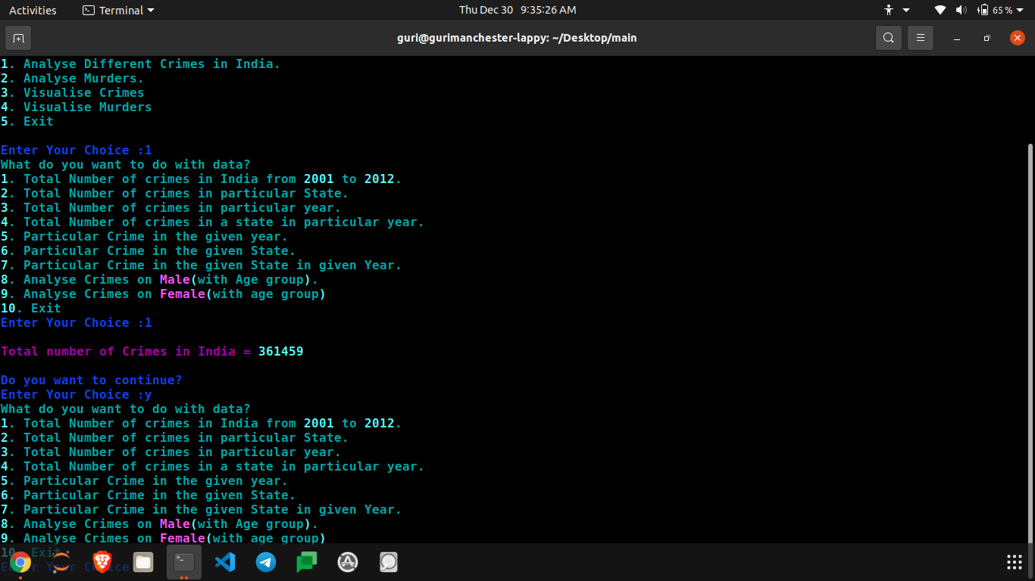

**User Choice is 2 in Crime Analyser :**

***When a user wants to analyse crime - The crime analyser has 9 different options to analyse crimes in India, all in different manners.***

* ***Users can see total number of crimes in india from 2001 to 2012.***
* ***He/She can see the total number of crimes in a particular state.***
* ***He/She can see the total numbers of crimes in a given Year.***
* ***He/She can see the total number of crimes in a particular state in the given year.***
* ***AND MANY MORE*  :)**

**IN THIS GIVEN DOCUMENTATION, THERE ARE ONLY 2 OPTIONS SHOWN.**

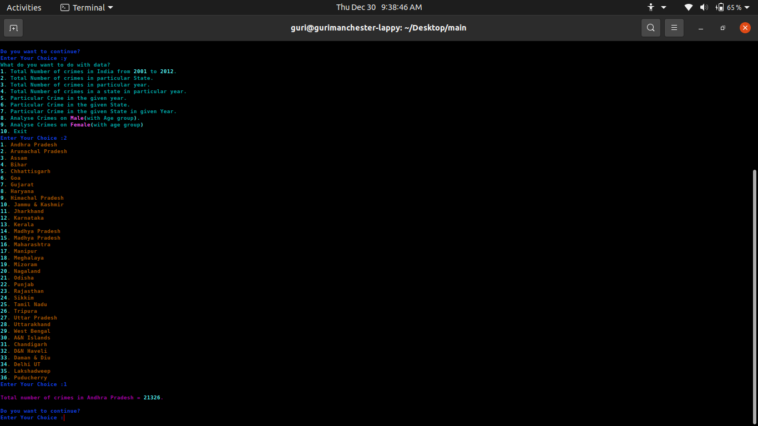

**If User Choose 2 to Analyse Murders in india :**

elif inp1 == 2:

murder = read_csv("murder.csv")

while True:

main.murder_printer()  **# Murder Analyser Choice Printer**

try:

inp2 = int(input("Enter Your Choice :"))

except:

console.print("You need to enter your choice in Integer form.")

inp2 = int(input("Enter Your Choice :"))

if inp2 == 1:

df = murder.loc[2:len(murder.index)+1:3,["Total"]]

df.index = range(1,len(df.index)+1,1)

sum = 0

for index,row in df.iterrows():

sum += row[0]

console.print("Total Number of Murders in 2013 =",sum)

elif inp2 == 2:

list1 = []

dict1 = {}

sum = 0

for index,row in murder.iterrows():

if row[0] in list1:

pass

else:

list1.append(row[0])

for index,value in enumerate(list1):

console.print(f"{index + 1}. {value}")

dict1[index+1] = value

inp3 = int(input("Enter You Choice :"))

for index,row in murder.iterrows():

if row[0] == dict1[inp3] and index in range(2,len(murder.index)+1,3):

sum += row[9]

console.print(f"Total Number of Murders in {dict1[inp3]} =",sum)

elif inp2 == 3:

main.murder_finder_age_group(1,"Female")

elif inp2 == 4:

main.murder_finder_age_group(2,"Male")

elif inp2 == 5:

main.murder_m_f("female")

elif inp2 == 6:

main.murder_m_f("male")

elif inp2 == 7:

console.print("Please Wait while Terminating")

load(25)

exit()

else:

console.print("Wrong Choice \nTry Again")

continue

console.print("Do You want to continue? [y or n] :")

inp3 = input("Enter :")

if inp3 == ("y" or "Y"):

continue

else:

console.print("Exiting The Analyser!!")

load(30)

break

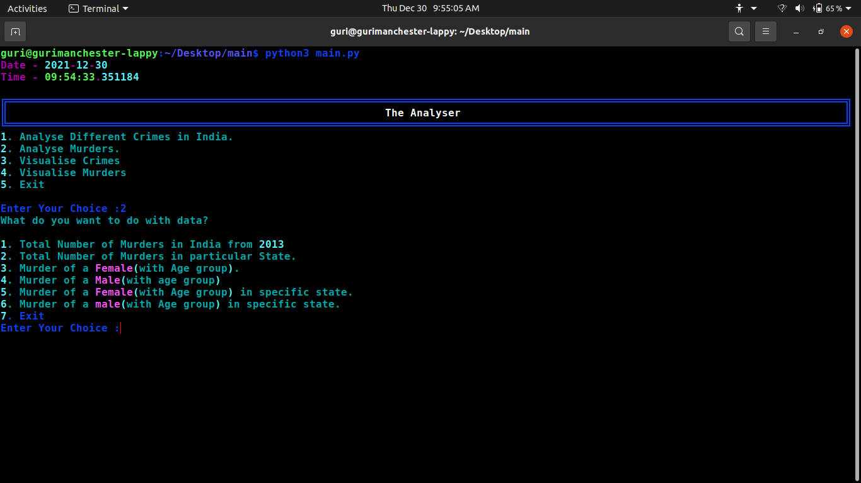

**If User choose 1 in Murder Analyser :**

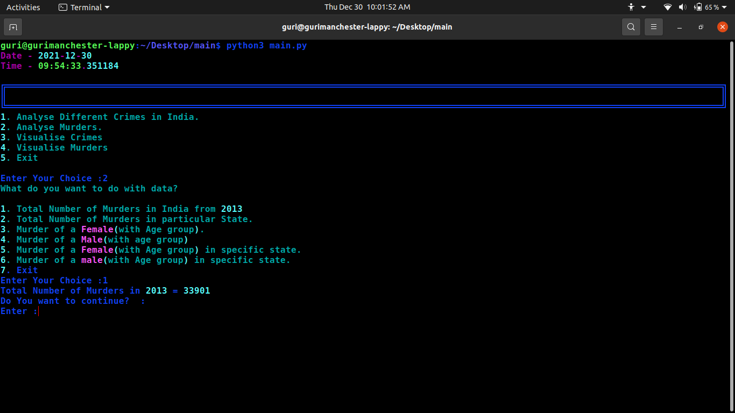

**If User choose 2 in Murder Analyser :**

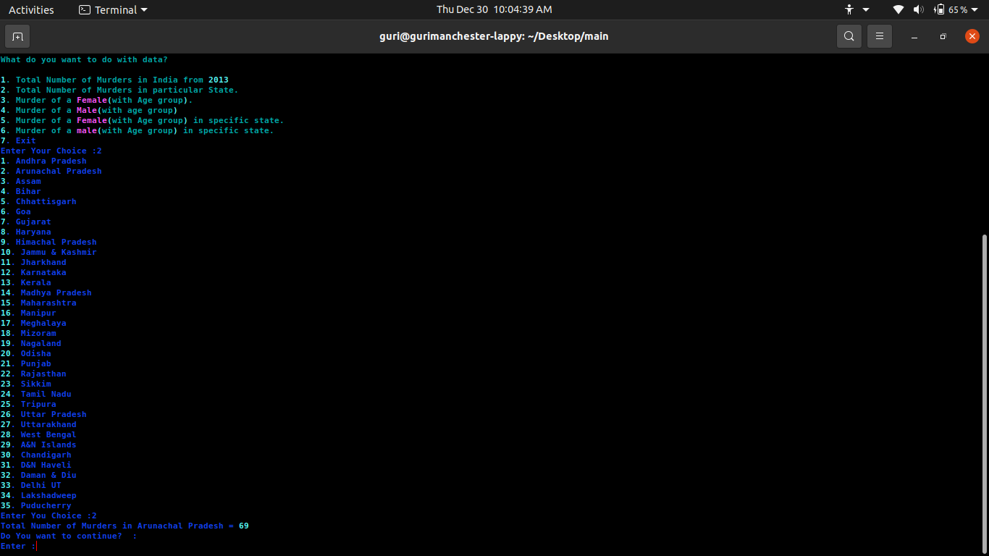

**If User Choose 3 to Visualise Crimes in india :**

elif inp1 == 3:

crimes = read_csv("crimes.csv")

# plt.style.use('dark_background')

crimes.plot(kind="line",ls=':',lw=0.5)

plt.show()

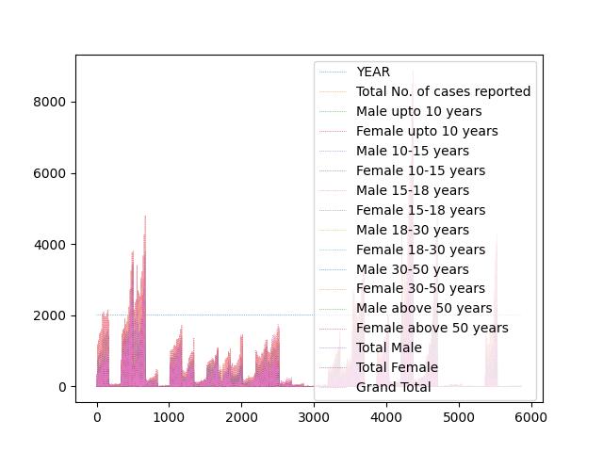

**If User Choose 4 to Visualise Murders in india :**

elif inp1 == 4:

murder = read_csv("murder.csv")

plt.style.use('dark_background')

murder.plot(kind="line",ls=':',lw=0.5)

plt.show()

