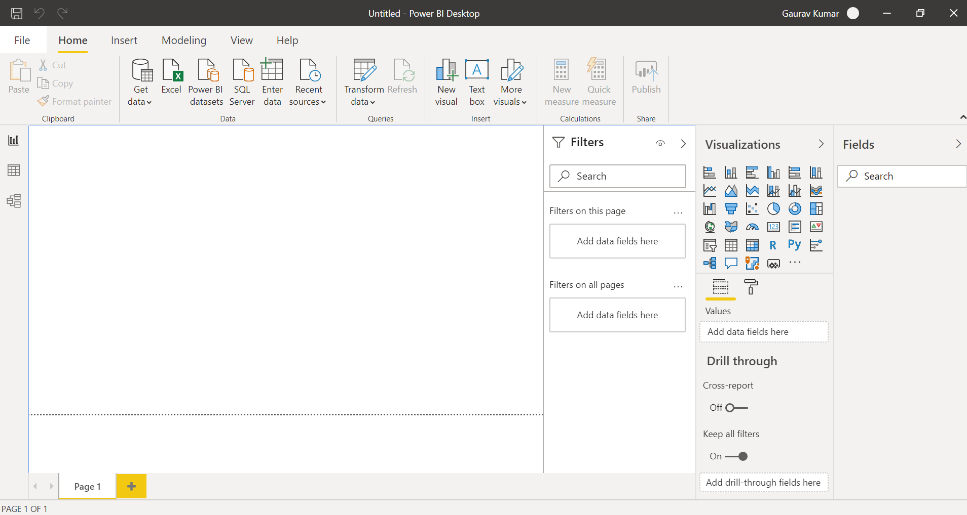

Report View:-

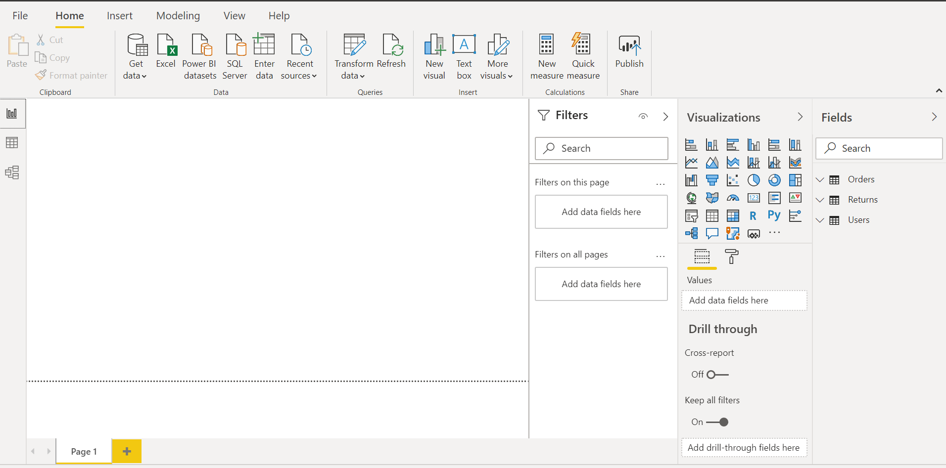

Data View:-

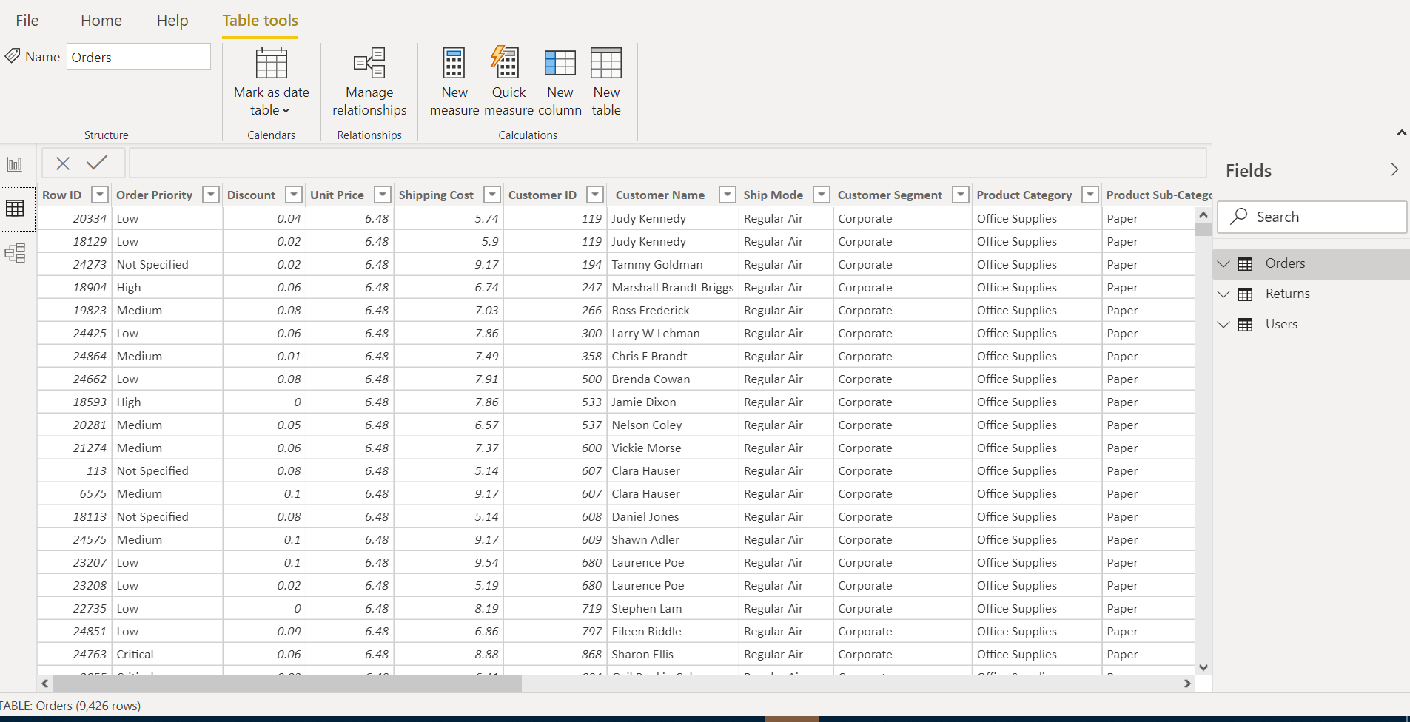

Model View:-

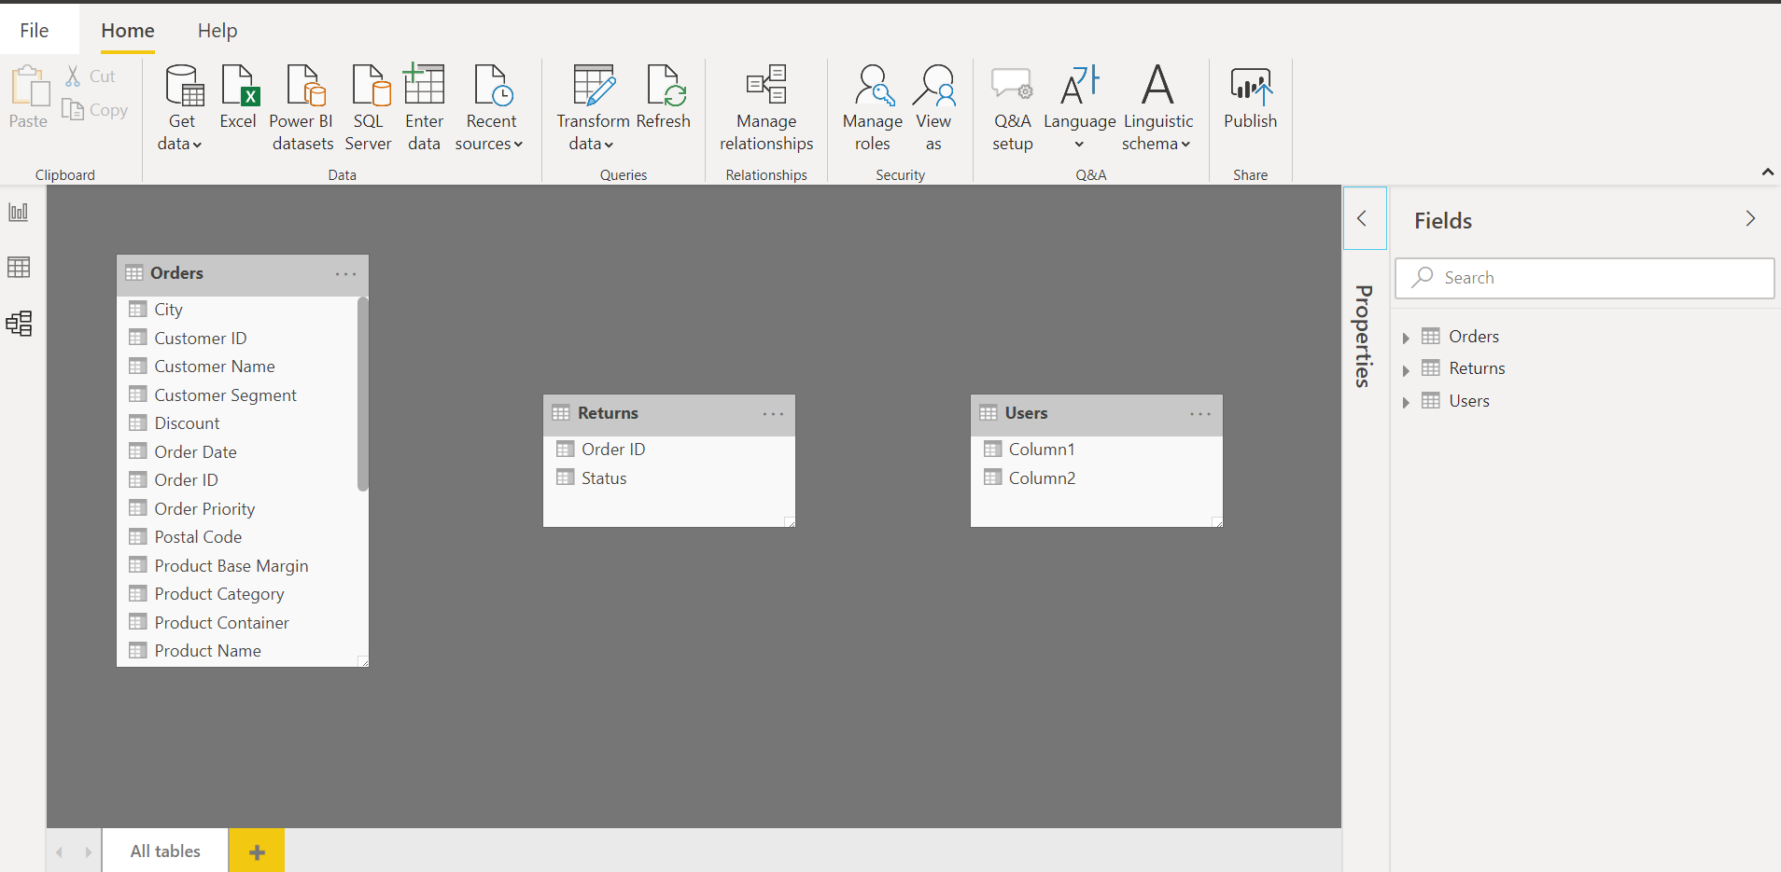

Power Query Editor:-

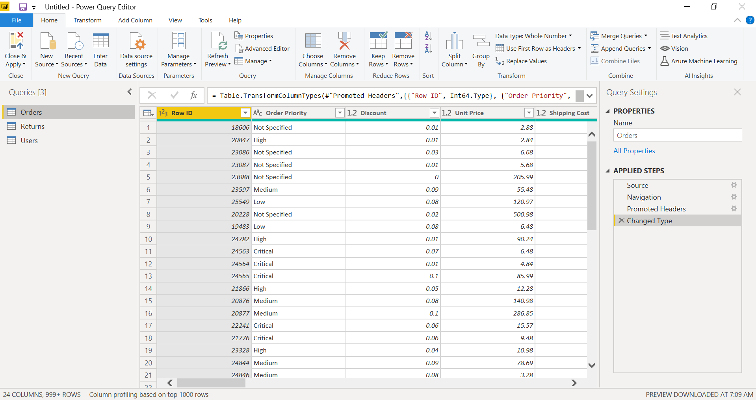

Advance Editor:-

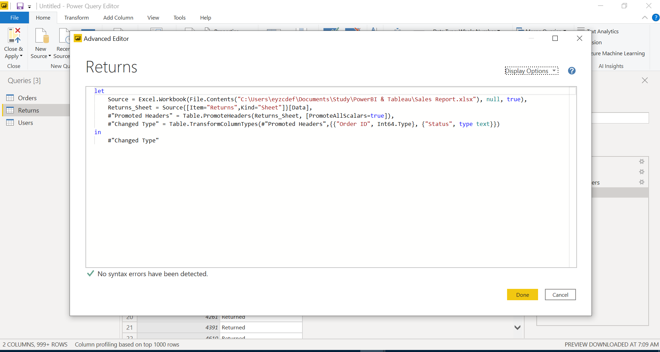

What is Power BI Desktop?

Power BI Desktop is the free version of Power BI that you can install on your local computer as a program, and acts as a companion desktop application to the full version of Power BI. If you need to consolidate your data sources, create your own reports and conduct your own analysis or test it’s capabilities, it’s the perfect version to start with for all skill levels - whether you’re non-IT and want to make your reports more interactive, or analysts seeking richer detail, it's one of the best business analytics tools to use.

Price:- Free

What is Power BI Pro?

Power BI Pro is the full version of Power BI, complete with the ability to use Power BI for both building dashboards and reports and unlimited viewing, sharing and consumption of your created reports (and reports shared by others)

Price:- $9.99/user/month

What is Power BI Premium?

Power BI Premium is the most expensive tier of Power BI currently available and very distinct from the other two versions available on the market.

Price:- $4,995 a month per dedicated cloud compute and storage resource.