Assignment-1

Task 1:

1. Install Jupyter notebook and run the first program and share the screenshot of the output.

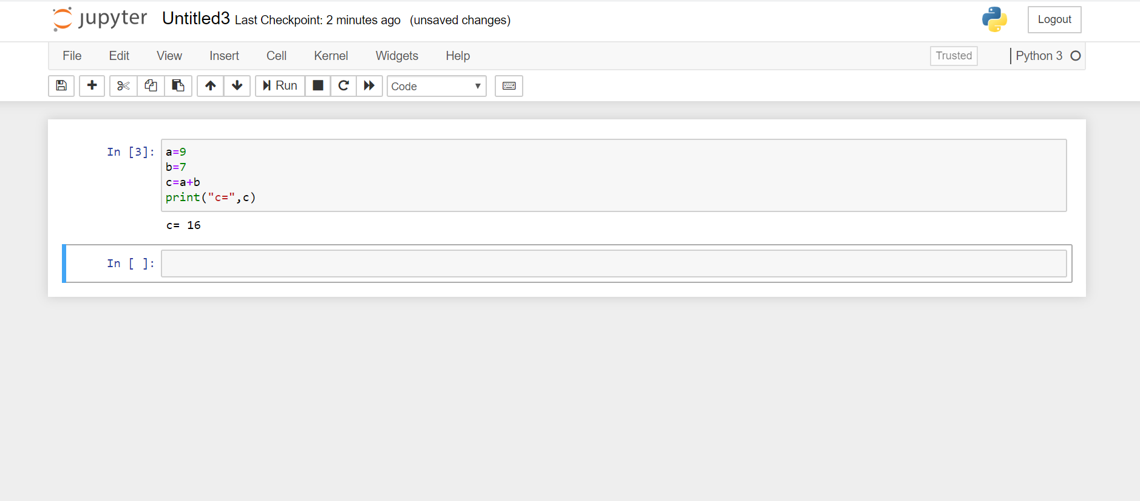

1. Write a program which will find all such numbers which are divisible by 7 but are not a multiple of 5, between 2000 and 3200 (both included). The numbers obtained should be printed in a comma-separated sequence on a single line

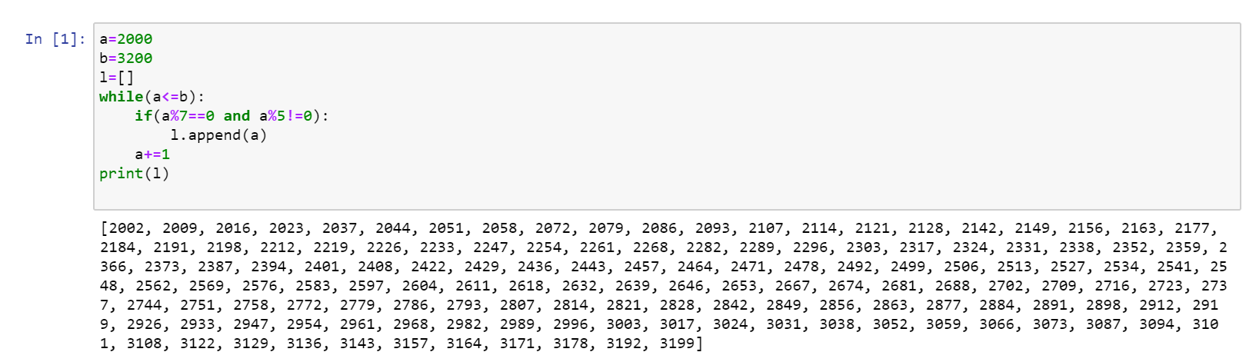

1. Write a Python program to accept the user's first and last name and then getting them printed in the the reverse order with a space between first name and last name.

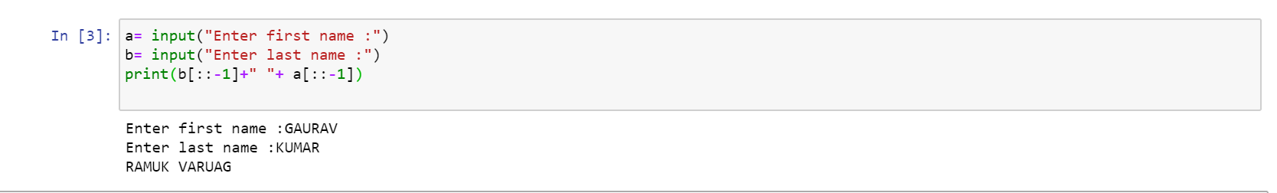

1. Write a Python program to find the volume of a sphere with diameter 12 cm

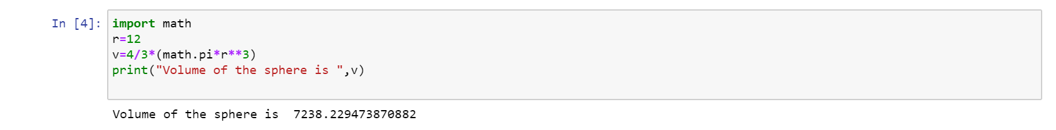

Task 2:

1. Write a program which accepts a sequence of comma-separated numbers from console and generate a list.

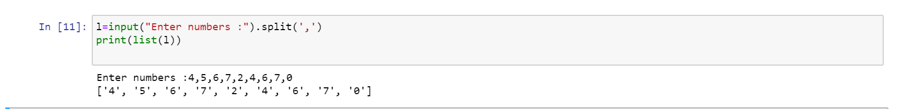

1. Create the below pattern using nested for loop in Python.

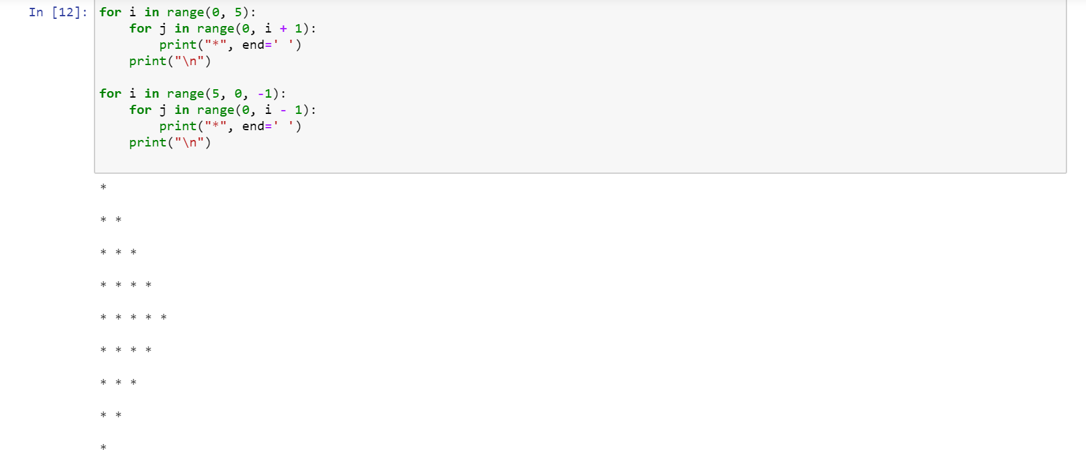

1. Write a Python program to reverse a word after accepting the input from the user

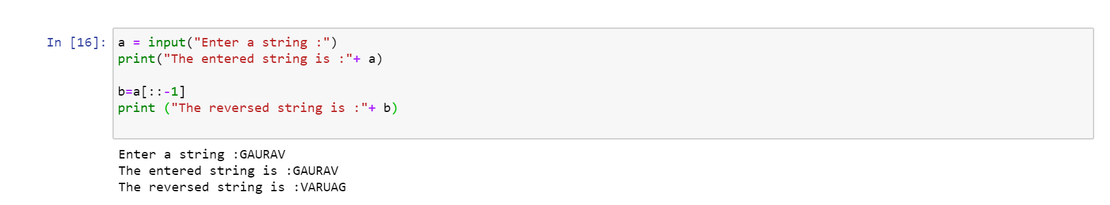

1. Write a Python Program to print the given string in the format specified in the sample output. WE, THE PEOPLE OF INDIA, having solemnly resolved to constitute India into a SOVEREIGN, SOCIALIST, SECULAR, DEMOCRATIC REPUBLIC and to secure to all its citizens

