1.)

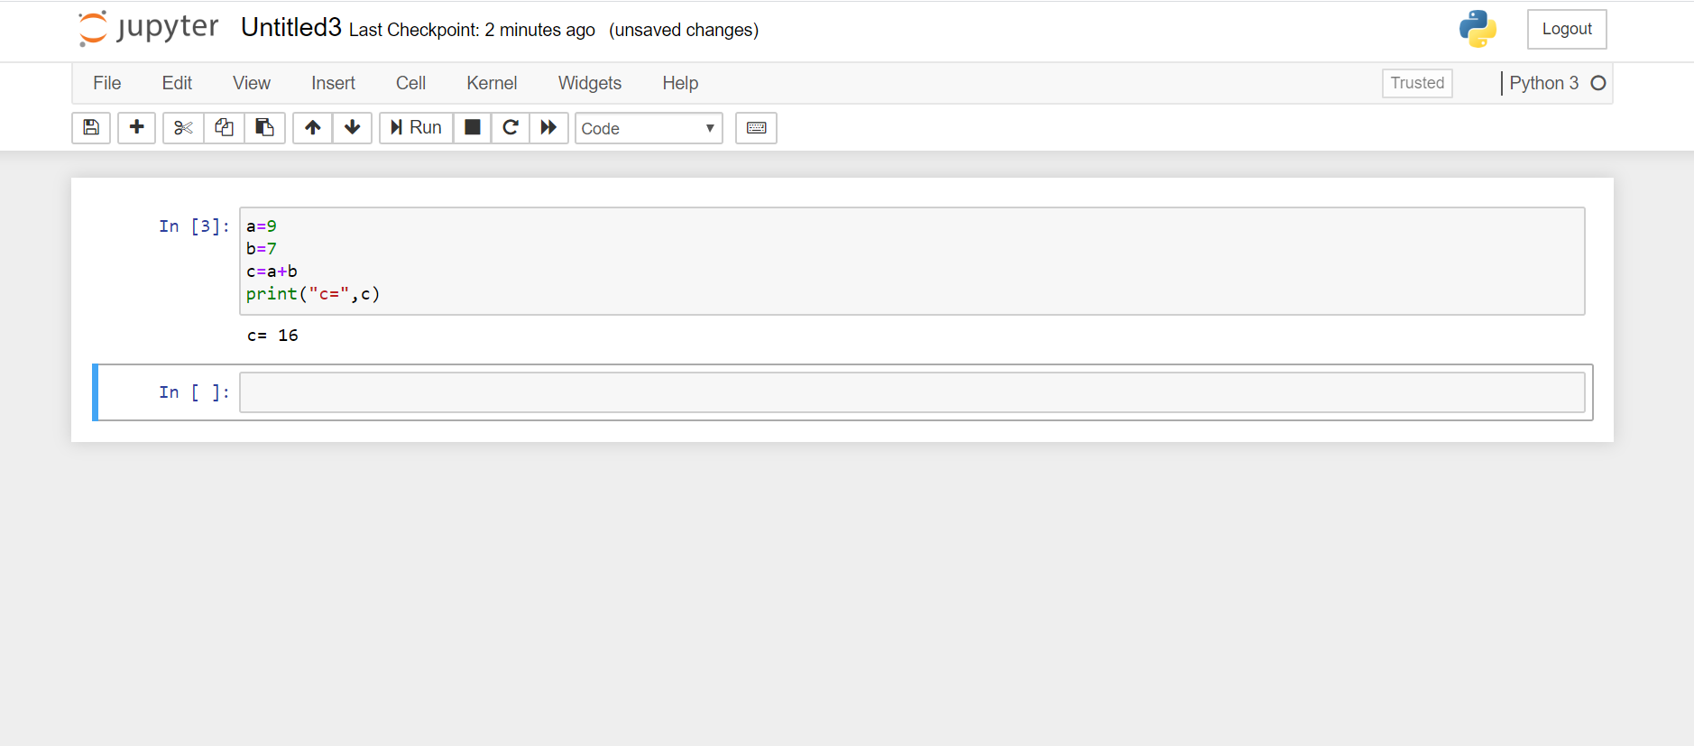

2.)

a=2000

b=3200

l=[]

while(a<=b):

if(a%7==0 and a%5!=0):

l.append(a)

a+=1

print(l)

3.)

a= input("Enter first name")

b= input("Enter last name")

print(b[::-1]+" "+ a[::-1])