DATABASE MANAGEMENT SYSTEM

CAPSTONE PROJECT

Gaurav Upadhyay
2401010009
B.Tech CSE — Semester IV
🏥 Hospital Management System

🏥 Project Description — Hospital Management System

This project focuses on designing and implementing a relational database system for a Hospital Management System using MySQL. The system models core entities involved in hospital operations, including departments, doctors, patients, rooms, admissions, appointments, surgeries, billing, medicines, prescriptions, and patient transfers. Each table is designed with appropriate primary keys, foreign keys, and constraints to maintain data integrity and establish clear relationships between the components of the system.

SQL queries are implemented to handle essential operations such as tracking patient admissions, discharges, and transfers between departments, scheduling surgeries, managing hospital resources, handling billing and outstanding payments, managing medicine inventory, and generating comprehensive patient reports. These queries help automate hospital workflows, ensure patient safety, and support clinical decision-making.

The project demonstrates how a well-structured relational database can power a production-grade hospital management platform — enabling real-time patient tracking, surgical scheduling, resource allocation, and seamless billing from admission to discharge.

🏥 Key Objectives

- Design a schema to manage patient records including medical history, appointments, and treatments
- Implement queries to track patient admissions, discharges, and transfers between departments
- Handle complex queries for scheduling surgeries, managing hospital resources, and ensuring patient safety
- Track billing records, payment statuses, and generate financial summaries per admission
- Manage medicine inventory, prescriptions, and alert for low-stock or expiring medicines
- Support multi-department transfers with complete audit trail for patient movement

🏥 Project Information

Project Title | Hospital Management System
Technology | MySQL (Relational Database)
Domain | Healthcare / Hospital Operations
Key Entities | Departments, Doctors, Patients, Rooms, Admissions, Appointments, Surgeries, Billing, Medicines, Prescriptions, Transfers
Core Features | Patient admission/discharge, Surgery scheduling, Billing management, Medicine inventory, Department transfers, Medical history tracking
Subject Code | ENCS254 — Database Management System
Faculty | Dr. Swati Gupta

🏥 Database Schema Overview

Table | Key Columns
Department | dept_id (PK), dept_name, location, head_of_dept, contact_no
Doctor | doctor_id (PK), first_name, last_name, specialization, dept_id (FK), phone, email, joining_date
Patient | patient_id (PK), first_name, last_name, dob, gender, blood_group, phone, address, emergency_contact, registration_date
Medical_History | history_id (PK), patient_id (FK), condition_name, diagnosed_date, treatment, notes
Room | room_id (PK), room_number, room_type (General/Private/ICU/Emergency/OT), capacity, available, charges_per_day
Admission | admission_id (PK), patient_id (FK), doctor_id (FK), room_id (FK), admission_date, discharge_date, reason, status
Appointment | appointment_id (PK), patient_id (FK), doctor_id (FK), appt_date, appt_time, status (Scheduled/Completed/Cancelled), notes
Nurse | nurse_id (PK), first_name, last_name, dept_id (FK), phone, shift (Morning/Evening/Night)
Surgery | surgery_id (PK), patient_id (FK), doctor_id (FK), surgery_name, surgery_date, duration_min, outcome, notes
Billing | bill_id (PK), patient_id (FK), admission_id (FK), bill_date, total_amount, paid_amount, payment_status, payment_mode
Medicine | medicine_id (PK), name, category, stock_qty, unit_price, expiry_date
Prescription | prescription_id (PK), patient_id (FK), doctor_id (FK), medicine_id (FK), prescribed_date, dosage, duration_days
Transfer | transfer_id (PK), patient_id (FK), from_dept_id (FK), to_dept_id (FK), transfer_date, reason

🏥 CODE

🏥 CREATE DATABASE

DROP DATABASE IF EXISTS HospitalDB;
CREATE DATABASE HospitalDB;
USE HospitalDB;

🏥 CREATE TABLE

🏥 Department Table
CREATE TABLE Department (
dept_id INT AUTO_INCREMENT PRIMARY KEY,
dept_name VARCHAR(100) NOT NULL UNIQUE,
location VARCHAR(100),
head_of_dept VARCHAR(100),
contact_no VARCHAR(15)
);

🏥 Doctor Table
CREATE TABLE Doctor (
doctor_id INT AUTO_INCREMENT PRIMARY KEY,
first_name VARCHAR(50) NOT NULL,
last_name VARCHAR(50) NOT NULL,
specialization VARCHAR(100) NOT NULL,
dept_id INT,
phone VARCHAR(15),
email VARCHAR(100) UNIQUE,
joining_date DATE,
CONSTRAINT fk_doctor_dept FOREIGN KEY (dept_id)
REFERENCES Department(dept_id) ON DELETE SET NULL
);

🏥 Patient Table
CREATE TABLE Patient (
patient_id INT AUTO_INCREMENT PRIMARY KEY,
first_name VARCHAR(50) NOT NULL,
last_name VARCHAR(50) NOT NULL,
dob DATE,
gender ENUM('Male','Female','Other') NOT NULL,
blood_group VARCHAR(5),
phone VARCHAR(15),
email VARCHAR(100),
address TEXT,
emergency_contact VARCHAR(15),
registration_date DATE DEFAULT (CURRENT_DATE)
);

🏥 Medical_History Table (Weak Entity)
CREATE TABLE Medical_History (
history_id INT AUTO_INCREMENT PRIMARY KEY,
patient_id INT NOT NULL,
condition_name VARCHAR(150),
diagnosed_date DATE,
treatment TEXT,
notes TEXT,
CONSTRAINT fk_mh_patient FOREIGN KEY (patient_id)
REFERENCES Patient(patient_id) ON DELETE CASCADE
);

🏥 Room Table
CREATE TABLE Room (
room_id INT AUTO_INCREMENT PRIMARY KEY,
room_number VARCHAR(10) NOT NULL UNIQUE,
room_type ENUM('General','Private','ICU','Emergency','OT') NOT NULL,
capacity INT DEFAULT 1,
available BOOLEAN DEFAULT TRUE,
charges_per_day DECIMAL(10,2)
);

🏥 Admission Table
CREATE TABLE Admission (
admission_id INT AUTO_INCREMENT PRIMARY KEY,
patient_id INT NOT NULL,
doctor_id INT,
room_id INT,
admission_date DATETIME DEFAULT CURRENT_TIMESTAMP,
discharge_date DATETIME,
reason TEXT,
status ENUM('Admitted','Discharged','Transferred') DEFAULT 'Admitted',
CONSTRAINT fk_adm_patient FOREIGN KEY (patient_id)
REFERENCES Patient(patient_id) ON DELETE CASCADE,
CONSTRAINT fk_adm_doctor FOREIGN KEY (doctor_id)
REFERENCES Doctor(doctor_id) ON DELETE SET NULL,
CONSTRAINT fk_adm_room FOREIGN KEY (room_id)
REFERENCES Room(room_id) ON DELETE SET NULL
);

🏥 Appointment Table
CREATE TABLE Appointment (
appointment_id INT AUTO_INCREMENT PRIMARY KEY,
patient_id INT NOT NULL,
doctor_id INT NOT NULL,
appt_date DATE NOT NULL,
appt_time TIME NOT NULL,
status ENUM('Scheduled','Completed','Cancelled') DEFAULT 'Scheduled',
notes TEXT,
CONSTRAINT fk_appt_patient FOREIGN KEY (patient_id)
REFERENCES Patient(patient_id) ON DELETE CASCADE,
CONSTRAINT fk_appt_doctor FOREIGN KEY (doctor_id)
REFERENCES Doctor(doctor_id) ON DELETE CASCADE
);

🏥 Nurse Table
CREATE TABLE Nurse (
nurse_id INT AUTO_INCREMENT PRIMARY KEY,
first_name VARCHAR(50) NOT NULL,
last_name VARCHAR(50) NOT NULL,
dept_id INT,
phone VARCHAR(15),
shift ENUM('Morning','Evening','Night'),
CONSTRAINT fk_nurse_dept FOREIGN KEY (dept_id)
REFERENCES Department(dept_id) ON DELETE SET NULL
);

🏥 Surgery Table
CREATE TABLE Surgery (
surgery_id INT AUTO_INCREMENT PRIMARY KEY,
patient_id INT NOT NULL,
doctor_id INT NOT NULL,
surgery_name VARCHAR(150) NOT NULL,
surgery_date DATETIME,
duration_min INT,
outcome ENUM('Successful','Unsuccessful','Ongoing') DEFAULT 'Ongoing',
notes TEXT,
CONSTRAINT fk_surg_patient FOREIGN KEY (patient_id)
REFERENCES Patient(patient_id) ON DELETE CASCADE,
CONSTRAINT fk_surg_doctor FOREIGN KEY (doctor_id)
REFERENCES Doctor(doctor_id) ON DELETE CASCADE
);

🏥 Billing Table
CREATE TABLE Billing (
bill_id INT AUTO_INCREMENT PRIMARY KEY,
patient_id INT NOT NULL,
admission_id INT,
bill_date DATE DEFAULT (CURRENT_DATE),
total_amount DECIMAL(12,2),
paid_amount DECIMAL(12,2) DEFAULT 0,
payment_status ENUM('Paid','Pending','Partial') DEFAULT 'Pending',
payment_mode ENUM('Cash','Card','Insurance','Online'),
CONSTRAINT fk_bill_patient FOREIGN KEY (patient_id)
REFERENCES Patient(patient_id) ON DELETE CASCADE,
CONSTRAINT fk_bill_admission FOREIGN KEY (admission_id)
REFERENCES Admission(admission_id) ON DELETE SET NULL
);

🏥 Medicine Table
CREATE TABLE Medicine (
medicine_id INT AUTO_INCREMENT PRIMARY KEY,
name VARCHAR(100) NOT NULL,
category VARCHAR(50),
stock_qty INT DEFAULT 0,
unit_price DECIMAL(8,2),
expiry_date DATE
);

🏥 Prescription Table
CREATE TABLE Prescription (
prescription_id INT AUTO_INCREMENT PRIMARY KEY,
patient_id INT NOT NULL,
doctor_id INT NOT NULL,
medicine_id INT NOT NULL,
prescribed_date DATE DEFAULT (CURRENT_DATE),
dosage VARCHAR(100),
duration_days INT,
CONSTRAINT fk_pres_patient FOREIGN KEY (patient_id)
REFERENCES Patient(patient_id) ON DELETE CASCADE,
CONSTRAINT fk_pres_doctor FOREIGN KEY (doctor_id)
REFERENCES Doctor(doctor_id) ON DELETE CASCADE,
CONSTRAINT fk_pres_medicine FOREIGN KEY (medicine_id)
REFERENCES Medicine(medicine_id) ON DELETE CASCADE
);

🏥 Transfer Table
CREATE TABLE Transfer (
transfer_id INT AUTO_INCREMENT PRIMARY KEY,
patient_id INT NOT NULL,
from_dept_id INT,
to_dept_id INT,
transfer_date DATETIME DEFAULT CURRENT_TIMESTAMP,
reason TEXT,
CONSTRAINT fk_tr_patient FOREIGN KEY (patient_id)
REFERENCES Patient(patient_id) ON DELETE CASCADE,
CONSTRAINT fk_tr_from_dept FOREIGN KEY (from_dept_id)
REFERENCES Department(dept_id) ON DELETE SET NULL,
CONSTRAINT fk_tr_to_dept FOREIGN KEY (to_dept_id)
REFERENCES Department(dept_id) ON DELETE SET NULL
);

🏥 INSERTION OF SAMPLE DATA

🏥 Insert Departments
INSERT INTO Department (dept_name, location, head_of_dept, contact_no) VALUES
('Cardiology', 'Block A, Floor 2', 'Dr. Ramesh Sharma', '9811001100'),
('Neurology', 'Block B, Floor 3', 'Dr. Priya Verma', '9811002200'),
('Orthopedics', 'Block A, Floor 1', 'Dr. Suresh Mehta', '9811003300'),
('Oncology', 'Block C, Floor 4', 'Dr. Neha Singh', '9811004400'),
('Emergency', 'Block D, Floor 0', 'Dr. Vikram Rao', '9811005500'),
('General Surgery', 'Block B, Floor 1', 'Dr. Anita Kapoor', '9811006600'),
('Pediatrics', 'Block E, Floor 2', 'Dr. Deepak Gupta', '9811007700'),
('Radiology', 'Block A, Floor 0', 'Dr. Sunita Joshi', '9811008800');

🏥 Insert Doctors
INSERT INTO Doctor (first_name, last_name, specialization, dept_id, phone, email, joining_date) VALUES
('Ramesh','Sharma','Cardiologist', 1,'9900110011','ramesh.sharma@hospital.com','2018-06-01'),
('Priya', 'Verma', 'Neurologist', 2,'9900220022','priya.verma@hospital.com', '2019-03-15'),
('Suresh','Mehta', 'Orthopedic Surgeon', 3,'9900330033','suresh.mehta@hospital.com', '2017-09-10'),
('Neha', 'Singh', 'Oncologist', 4,'9900440044','neha.singh@hospital.com', '2020-01-20'),
('Vikram','Rao', 'Emergency Specialist',5,'9900550055','vikram.rao@hospital.com', '2016-11-05'),
('Anita', 'Kapoor','General Surgeon', 6,'9900660066','anita.kapoor@hospital.com', '2021-07-25'),
('Deepak','Gupta', 'Pediatrician', 7,'9900770077','deepak.gupta@hospital.com', '2015-04-18'),
('Sunita','Joshi', 'Radiologist', 8,'9900880088','sunita.joshi@hospital.com', '2022-02-14');

🏥 Insert Patients
INSERT INTO Patient (first_name, last_name, dob, gender, blood_group, phone, address, emergency_contact, registration_date) VALUES
('Amit', 'Kumar', '1985-03-12','Male', 'O+', '9812340001','Delhi', '9812340010','2024-01-05'),
('Sunita', 'Patel', '1990-07-22','Female','A+', '9812340002','Mumbai', '9812340020','2024-01-10'),
('Rajesh', 'Singh', '1978-11-30','Male', 'B+', '9812340003','Kolkata', '9812340030','2024-02-01'),
('Pooja', 'Sharma', '2000-05-14','Female','AB+','9812340004','Bengaluru','9812340040','2024-02-15'),
('Vivek', 'Gupta', '1995-09-08','Male', 'O-', '9812340005','Hyderabad','9812340050','2024-03-01'),
('Kavya', 'Reddy', '1988-12-25','Female','B-', '9812340006','Chennai', '9812340060','2024-03-10'),
('Nikhil', 'Joshi', '2010-04-18','Male', 'A-', '9812340007','Pune', '9812340070','2024-04-01'),
('Ananya', 'Mishra', '1970-06-30','Female','AB-','9812340008','Jaipur', '9812340080','2024-04-15'),
('Rohit', 'Yadav', '1993-01-17','Male', 'O+', '9812340009','Ahmedabad','9812340090','2024-05-01'),
('Sanjay', 'Tiwari', '1982-02-28','Male', 'B+', '9812340012','Lucknow', '9812340120','2024-06-01');

🏥 Insert Rooms
INSERT INTO Room (room_number, room_type, capacity, available, charges_per_day) VALUES
('G101','General', 4, TRUE, 500.00),
('G102','General', 4, TRUE, 500.00),
('P201','Private', 1, TRUE, 2000.00),
('P202','Private', 1, FALSE, 2000.00),
('I301','ICU', 1, FALSE, 8000.00),
('I302','ICU', 1, TRUE, 8000.00),
('E401','Emergency',2, FALSE, 3000.00),
('E402','Emergency',2, TRUE, 3000.00),
('OT01','OT', 1, TRUE, 15000.00);

🏥 Insert Admissions
INSERT INTO Admission (patient_id, doctor_id, room_id, admission_date, discharge_date, reason, status) VALUES
(1, 1, 3, '2024-06-01 09:00:00', '2024-06-07 11:00:00', 'Chest pain evaluation', 'Discharged'),
(3, 3, 1, '2024-06-05 10:30:00', '2024-06-12 09:00:00', 'Knee replacement surgery', 'Discharged'),
(5, 5, 7, '2024-06-15 02:00:00', NULL, 'Acute abdominal pain', 'Admitted'),
(8, 4, 5, '2024-06-20 08:00:00', NULL, 'Chemotherapy cycle', 'Admitted'),
(2, 2, 6, '2024-07-01 09:00:00', NULL, 'Severe migraine with vomiting', 'Admitted');

🏥 Insert Appointments
INSERT INTO Appointment (patient_id, doctor_id, appt_date, appt_time, status, notes) VALUES
(1, 1, '2024-08-01', '10:00:00', 'Scheduled', 'Follow-up for BP check'),
(2, 2, '2024-08-02', '11:30:00', 'Scheduled', 'Neurology consult'),
(3, 3, '2024-07-25', '09:00:00', 'Completed', 'Post-surgery follow-up'),
(4, 2, '2024-07-30', '14:00:00', 'Completed', 'Migraine management'),
(5, 6, '2024-08-05', '16:00:00', 'Scheduled', 'Surgery consultation'),
(8, 4, '2024-08-10', '09:30:00', 'Scheduled', 'Oncology review');

🏥 Insert Surgeries
INSERT INTO Surgery (patient_id, doctor_id, surgery_name, surgery_date, duration_min, outcome) VALUES
(3, 3, 'Right Knee Replacement', '2024-06-06 08:00:00', 180, 'Successful'),
(9, 6, 'Appendectomy', '2024-05-02 10:00:00', 60, 'Successful'),
(8, 4, 'Tumor Removal — Breast', '2021-11-15 09:00:00', 240, 'Successful'),
(1, 1, 'Coronary Angioplasty', '2023-09-10 08:30:00', 90, 'Successful'),
(10,1, 'Bypass Graft Surgery', '2024-07-07 07:00:00', 300, 'Ongoing');

🏥 Insert Medicines & Prescriptions
INSERT INTO Medicine (name, category, stock_qty, unit_price, expiry_date) VALUES
('Amlodipine 5mg', 'Antihypertensive', 500, 2.50, '2026-12-31'),
('Metformin 500mg', 'Antidiabetic', 800, 1.80, '2026-06-30'),
('Sumatriptan 50mg', 'Antimigraine', 200, 45.00, '2026-03-31'),
('Cefazolin 1g IV', 'Antibiotic', 300, 75.00, '2025-06-30'),
('Morphine 10mg', 'Analgesic', 50, 200.00, '2025-03-31'),
('Paracetamol 500mg', 'Analgesic', 1000, 1.50, '2027-01-31');

INSERT INTO Prescription (patient_id, doctor_id, medicine_id, prescribed_date, dosage, duration_days) VALUES
(1, 1, 1, '2024-06-07', '5mg once daily in morning', 90),
(1, 1, 2, '2024-06-07', '500mg twice daily after meals', 90),
(2, 2, 3, '2024-07-02', '50mg at onset of migraine', 30),
(8, 4, 5, '2024-06-20', '10mg IV every 4 hours PRN', 14);

🏥 Insert Billing & Transfers
INSERT INTO Billing (patient_id, admission_id, bill_date, total_amount, paid_amount, payment_status, payment_mode) VALUES
(1, 1, '2024-06-07', 26000.00, 26000.00, 'Paid', 'Insurance'),
(3, 2, '2024-06-12', 18500.00, 18500.00, 'Paid', 'Card'),
(8, 4, '2024-07-15', 92000.00, 50000.00, 'Partial', 'Insurance'),
(2, 5, '2024-07-10', 45000.00, 0.00, 'Pending', NULL);

INSERT INTO Transfer (patient_id, from_dept_id, to_dept_id, transfer_date, reason) VALUES
(5, 5, 6, '2024-06-15 08:00:00', 'Requires surgical intervention'),
(8, 4, 5, '2024-06-20 14:00:00', 'Critical condition post-chemo');

🏥 QUERIES

🏥 View All Doctors with Department

SELECT d.doctor_id, CONCAT(d.first_name,' ',d.last_name) AS Doctor_Name,
d.specialization, dep.dept_name, d.phone
FROM Doctor d
JOIN Department dep ON d.dept_id = dep.dept_id
ORDER BY dep.dept_name;

OUTPUT:

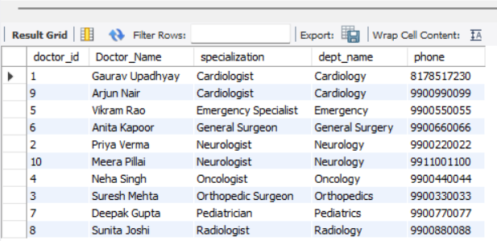

🏥 Check Currently Admitted Patients

SELECT a.admission_id,
CONCAT(p.first_name,' ',p.last_name) AS Patient_Name,
r.room_number, r.room_type,
a.admission_date, a.reason,
CONCAT(doc.first_name,' ',doc.last_name) AS Attending_Doctor
FROM Admission a
JOIN Patient p ON a.patient_id = p.patient_id
JOIN Room r ON a.room_id = r.room_id
JOIN Doctor doc ON a.doctor_id = doc.doctor_id
WHERE a.status = 'Admitted';

OUTPUT:
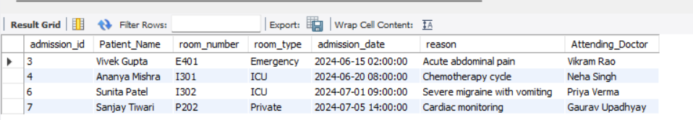

🏥 Discharge Summary — June 2024

SELECT a.admission_id,
CONCAT(p.first_name,' ',p.last_name) AS Patient_Name,
a.admission_date, a.discharge_date,
DATEDIFF(a.discharge_date, a.admission_date) AS Days_Stayed,
a.reason
FROM Admission a
JOIN Patient p ON a.patient_id = p.patient_id
WHERE a.status = 'Discharged'
AND MONTH(a.discharge_date) = 6
AND YEAR(a.discharge_date) = 2024;

OUTPUT:

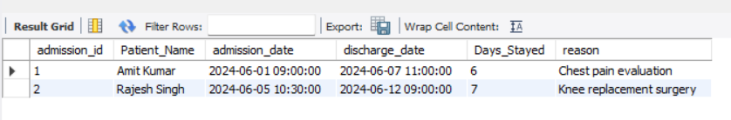

🏥 Patient Transfer History

SELECT t.transfer_id,
CONCAT(p.first_name,' ',p.last_name) AS Patient_Name,
fd.dept_name AS From_Department,
td.dept_name AS To_Department,
t.transfer_date, t.reason
FROM Transfer t
JOIN Patient p ON t.patient_id = p.patient_id
JOIN Department fd ON t.from_dept_id = fd.dept_id
JOIN Department td ON t.to_dept_id = td.dept_id
ORDER BY t.transfer_date;

OUTPUT:

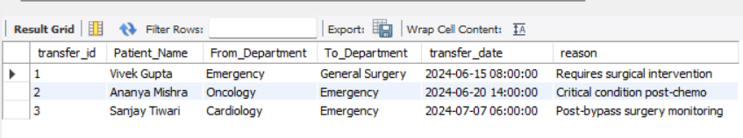

🏥 Surgery Schedule with Surgeon Details

SELECT s.surgery_id,
CONCAT(p.first_name,' ',p.last_name) AS Patient_Name,
CONCAT(d.first_name,' ',d.last_name) AS Surgeon,
s.surgery_name, s.surgery_date,
s.duration_min, s.outcome
FROM Surgery s
JOIN Patient p ON s.patient_id = p.patient_id
JOIN Doctor d ON s.doctor_id = d.doctor_id
ORDER BY s.surgery_date DESC;

OUTPUT:

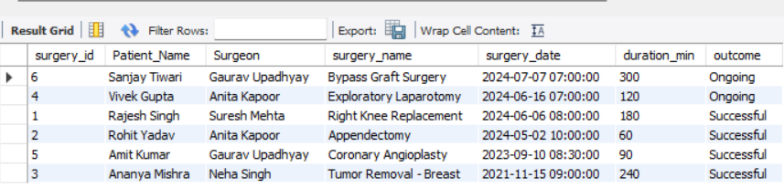

🏥 Room Utilization — Available vs Occupied

SELECT room_type,
COUNT(*) AS Total_Rooms,
SUM(CASE WHEN available = TRUE THEN 1 ELSE 0 END) AS Available,
SUM(CASE WHEN available = FALSE THEN 1 ELSE 0 END) AS Occupied
FROM Room
GROUP BY room_type;

OUTPUT:
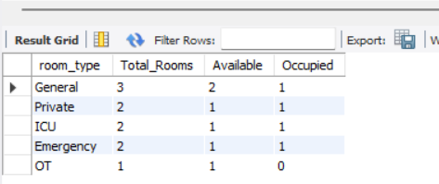

🏥 Outstanding Bills (Pending / Partial)

SELECT b.bill_id,
CONCAT(p.first_name,' ',p.last_name) AS Patient_Name,
b.bill_date, b.total_amount, b.paid_amount,
(b.total_amount - b.paid_amount) AS Balance_Due,
b.payment_status
FROM Billing b
JOIN Patient p ON b.patient_id = p.patient_id
WHERE b.payment_status IN ('Pending','Partial')
ORDER BY Balance_Due DESC;

OUTPUT:
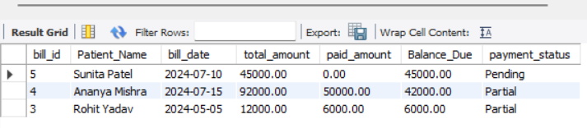

🏥 Total Revenue Collected
SELECT
SUM(paid_amount) AS Total_Revenue_Collected,
SUM(total_amount) AS Total_Billed,
SUM(total_amount - paid_amount) AS Total_Outstanding
FROM Billing
WHERE YEAR(bill_date) = 2024;

OUTPUT:
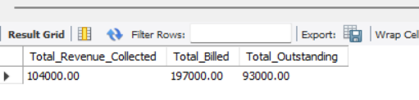

🏥 Medicines with Low Stock (< 100 units)
SELECT medicine_id, name, category,
stock_qty, unit_price, expiry_date
FROM Medicine
WHERE stock_qty < 100
ORDER BY stock_qty ASC;

OUTPUT:
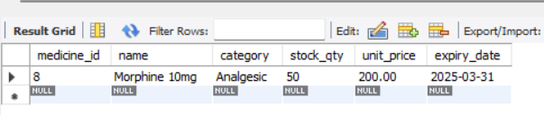

🏥 Full Patient Report — Admission to Billing
SELECT CONCAT(p.first_name,' ',p.last_name) AS Patient_Name,
p.blood_group,
CONCAT(doc.first_name,' ',doc.last_name) AS Doctor,
dep.dept_name, r.room_number, r.room_type,
a.admission_date, a.discharge_date,
a.status AS Admission_Status,
b.total_amount, b.paid_amount, b.payment_status
FROM Admission a
JOIN Patient p ON a.patient_id = p.patient_id
JOIN Doctor doc ON a.doctor_id = doc.doctor_id
JOIN Department dep ON doc.dept_id = dep.dept_id
JOIN Room r ON a.room_id = r.room_id
LEFT JOIN Billing b ON b.admission_id = a.admission_id
ORDER BY a.admission_date DESC;

OUTPUT:
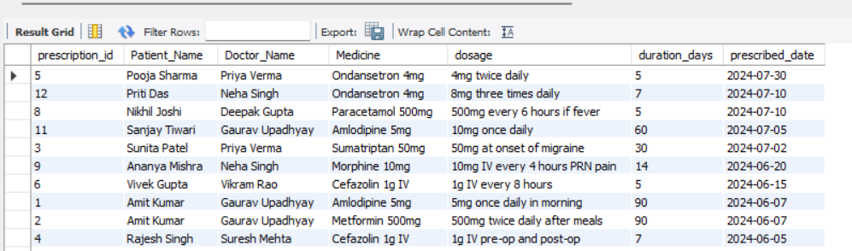

— End of Hospital Management System Capstone Project

