Project Report
On
LingoQuest

Submitted by:
Pranjal Dutta (2401010051)
Gaurav (2401010009)
Priyanshu (2401010174)

Department of
Computer Science and Engineering

School of Engineering and Technology
K. R. Mangalam University, Gurugram- 122003

Index
Topic | Page Number
Abstract | i
1. Introduction | 1
1.1 Background | 1
1.2 Project Objectives | 2
1.3 Scope | 2
2. Technology Overview | 3
2.1 HTML5 & CSS3 | 3
2.2 NODE.JS | 4
2.3 SQL | 5
3. Project Implementation | 10
4. Key Features Developed | 13
5. Screenshots | 14
6. Conclusion and Future Work | 18
7. References | 20

Abstract

LingoQuest is an innovative web-based platform developed with the main objective of transforming language learning into a more engaging and personalized process for users of all backgrounds. Utilizing robust MERN stack technologies—MongoDB, Express.js, React, and Node.js—the application offers a dynamic environment where learners can select their preferred language, access a wide range of interactive lessons, and track their progress over time. Features such as gamification, animated user interfaces, leaderboards, and daily streak rewards motivate learners to continue practicing daily. This system not only encourages individual achievement, but also cultivates a sense of community and healthy competition through social features. LingoQuest aims to bridge the gap between traditional, rigid language learning methods and the modern, flexible needs of today’s digital learners……

Submitted To :-
Dr.Aarti

Introduction

The demand for effective language learning platforms has grown dramatically in recent years, driven by globalization and the rise of remote communication. Traditional approaches—such as classroom instruction and language textbooks—often lack the interactivity and instant feedback that digital platforms provide. LingoQuest is designed to address these shortcomings by harnessing the power of full-stack web development and educational psychology, creating a solution that is not only accessible from anywhere but also personalized according to individual strengths and weaknesses. The project’s focus on modular lesson design, immediate feedback, and adaptive content makes it exceptionally suited for both independent learners and formal education settings. By integrating real-time progress tracking and community-driven features, LingoQuest fosters a motivating learning environment that promotes mastery and confidence in speaking new languages.

1.1 Background

Language acquisition is universally recognized as a vital skill in the modern world, opening doors for career development, travel, and cross-cultural understanding. However, learning a new language can be intimidating, especially for beginners who lack the resources or support systems available in traditional classrooms. Recent advances in technology have demonstrated that online platforms can offer a wide array of teaching methodologies, from spaced repetition and contextual exercises to gamification and social engagement. LingoQuest builds upon these best practices, using technology to deliver accessible, effective, and enjoyable language learning experiences.

1.2 Project Objectives
The primary objectives of LingoQuest are to:
- Provide learners with a flexible platform to select and pursue a language of their choice.
- Offer curated lesson plans that follow recognized language acquisition strategies, including vocabulary building, grammar exercises, conversation simulations, and cultural immersion.
- Motivate users through gamified elements such as XP points, streaks, and competitive leaderboards.
- Support multiple levels of proficiency, enabling smooth progression from beginner to intermediate and beyond.
- Administer a robust backend system that allows easy creation, editing, and monitoring of lessons and user data

1.3 Scope
LingoQuest is designed to support a diverse user base, from students in academic settings and independent enthusiasts to teachers and administrators. Its modular architecture and database-driven backend allow new languages, lessons, and content types to be added at any time without major code changes. The platform’s user tracking and reporting features provide actionable insights for both learners and educators. LingoQuest is compatible with desktop and mobile devices, ensuring universal access and engagement.

2. Technology Overview

The foundation of LingoQuest is the MERN stack—a modern combination of technologies that enable rapid development, scalability, and high performance. The front-end is developed using ReactJS, which provides component-based architecture and seamless client-side routing via React Router. Animated and dynamic user interfaces are implemented with Framer Motion, ensuring captivating visuals and smooth transitions throughout the app.

Node.js and Express.js form the core of the backend server, responsible for processing user registrations, authenticating logins, managing lesson retrieval, and updating progress or XP after each activity. Express provides RESTful endpoints that the React frontend can consume easily, and JWT tokens ensure secure authentication and persistent sessions.

MongoDB is used as the database, storing all user profiles, lessons, completed exercises, and leaderboard statistics efficiently in a document-oriented format. Mongoose facilitates data modeling and validation, making backend code clean and maintainable. Additional libraries—such as bcryptjs for password hashing and dotenv for managing environment variables—improve both security and flexibility in deployment.

Project Implementation

Implementing LingoQuest required careful planning and execution across several frameworks. The app begins by allowing new users to register or log in, storing credentials securely and initializing profile records with XP, streak, and preferred language fields. Upon successful login, users are greeted by a visually rich home page where animated elements provide interactive engagement and intuitive guidance.
Language selection is handled through a dedicated module, ensuring all subsequent lessons and resources match the user's chosen learning path. Each lesson is presented as a series of interactive exercises, including multiple-choice questions, fill-in-the-blank tasks, speaking prompts (for planned future expansion), and translation activities. Immediate feedback is provided after each exercise, with correct answers and explanations delivered in real time.
Progress tracking is integral to LingoQuest; after lesson completion, user data—XP points, streak days, completed lessons—is updated and visualized in the Profile section and on the Leaderboard. Administrators have exclusive access to a dashboard for managing users, uploading or editing lesson content, and monitoring overall engagement. The system architecture supports robust scaling, letting educational institutions and independent teachers expand the platform as needed.

Key Features Developed

LingoQuest incorporates a variety of features designed to maximize learning outcomes and user motivation:
- User Registration & Authentication: Secure login using hashed passwords and token-based session management.
- Language Selection: Personalized learning journeys based on chosen language and proficiency level.
- Interactive Lesson Modules: Diverse exercises fostering vocabulary, grammar, speaking, and comprehension skills.
- Gamification: XP, streak, and leaderboard systems encourage daily practice and friendly competition.
- Animated UI: Framer Motion-powered transitions and custom SVG illustrations provide a modern and engaging look.
- Profile & Progress Tracking: Users can monitor completed lessons, track XP, and visualize streaks.
- Admin Dashboard: Content management tools for easy lesson creation, editing, and analytics.
- Database Scalability: MongoDB document structure ensures efficient handling of user and lesson data.

5. Screenshots
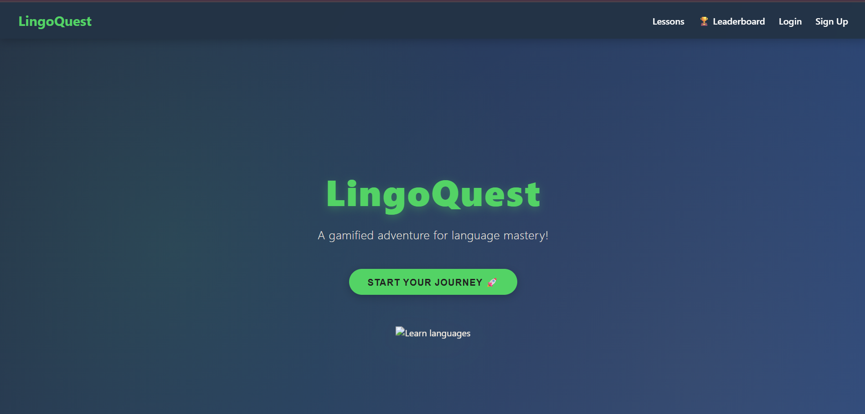

LOGIN AND REGISTRATION
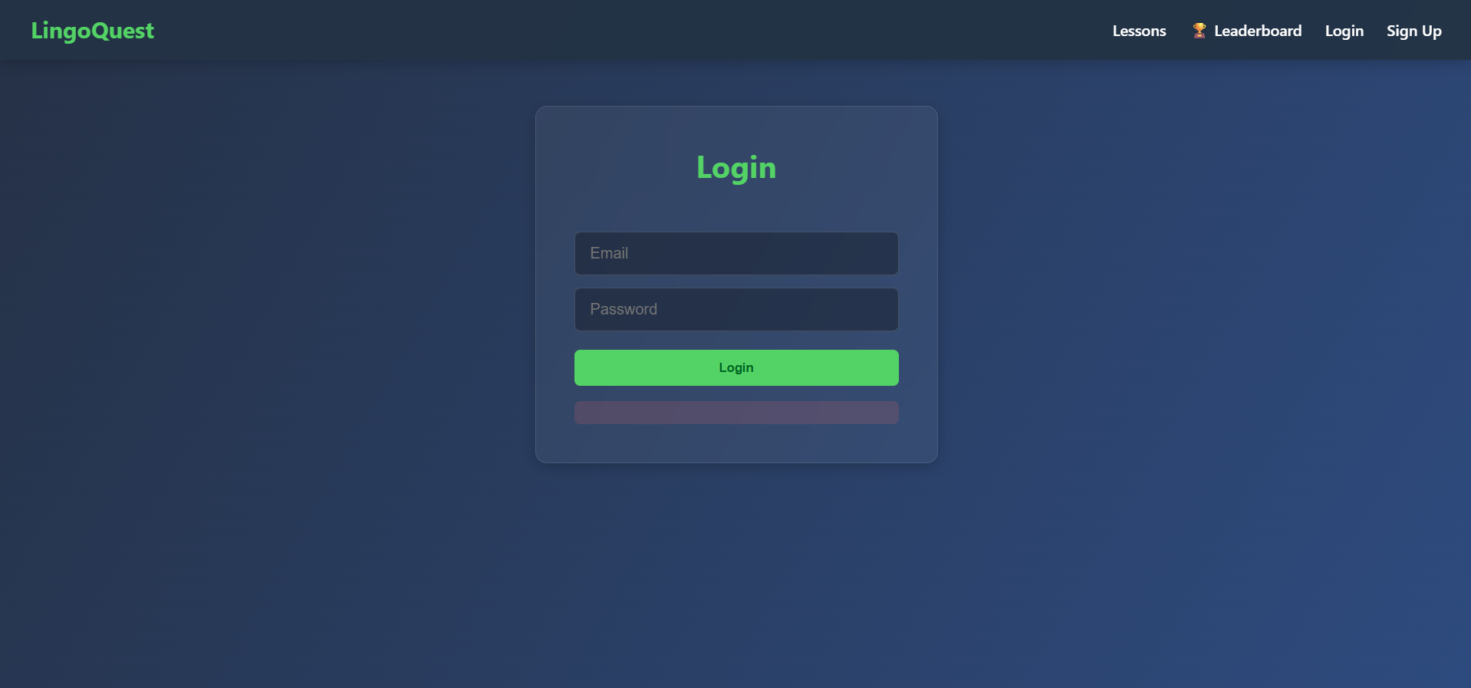

DASHBOARD
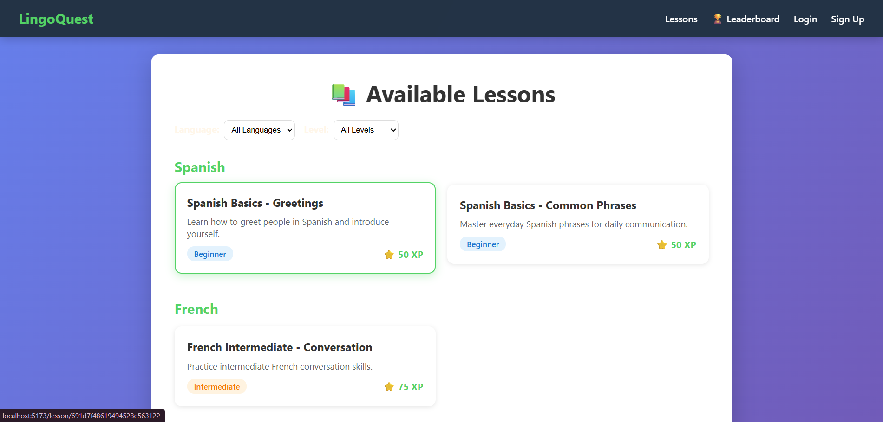

- FEATURES
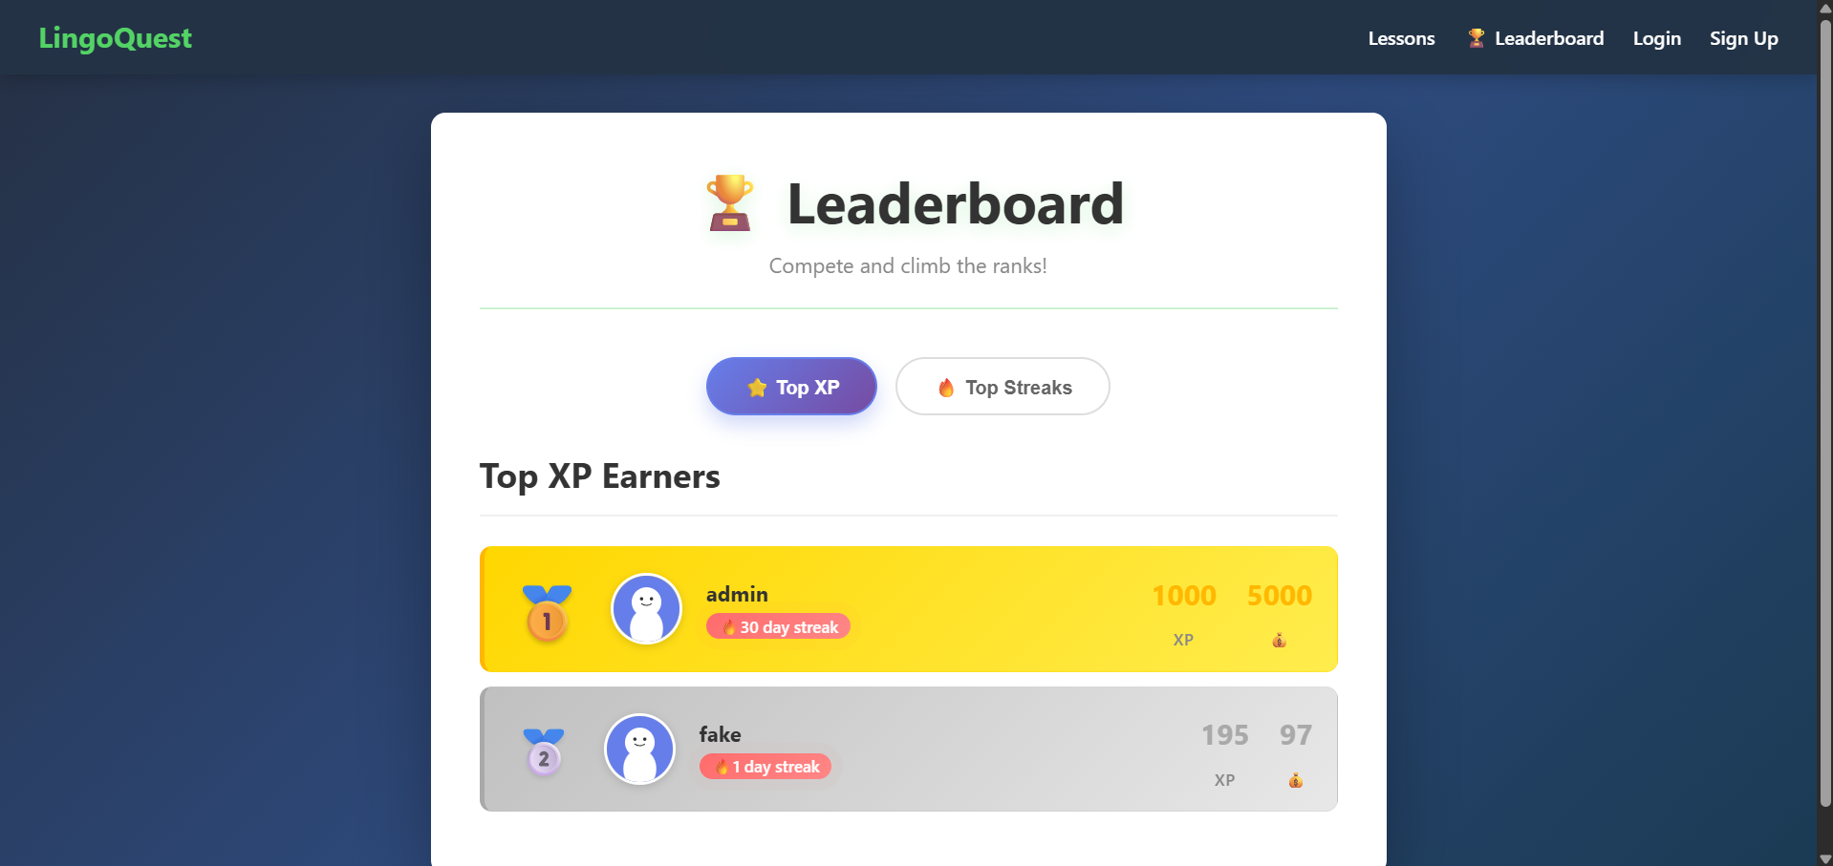

6. Conclusion and Future Work

LingoQuest demonstrates a scalable, modern approach to online language learning, harnessing best practices from educational psychology and software engineering. By integrating gamification, progress tracking, and animated interface elements, it makes learning enjoyable and effective for a wide range of users. The modular architecture supports future enhancements, such as AI-powered adaptive lesson creation, voice recognition exercises, real-time chat with native speakers, and advanced analytics for administrators and teachers. With continuous development and user feedback, LingoQuest is positioned to become a powerful tool for language mastery in both personal and institutional contexts.

7. References
- • ReactJS Documentation
https://react.dev/
- • Node.js Documentation
https://nodejs.org/en/docs
- • Express.js Documentation
https://expressjs.com/
- • MongoDB Documentation
https://www.mongodb.com/docs/
- • Mongoose Documentation
https://mongoosejs.com/docs/
- • Framer Motion Animation Library
https://www.framer.com/motion/
- • JWT (JSON Web Token) Documentation
https://jwt.io/introduction
- • Educational Technology Best Practices
(General resource) https://www.edutopia.org/technology-integration

- GitHub
https://github.com/duttapranjal/LingoQuest

