Cover Page

Creating the new connection
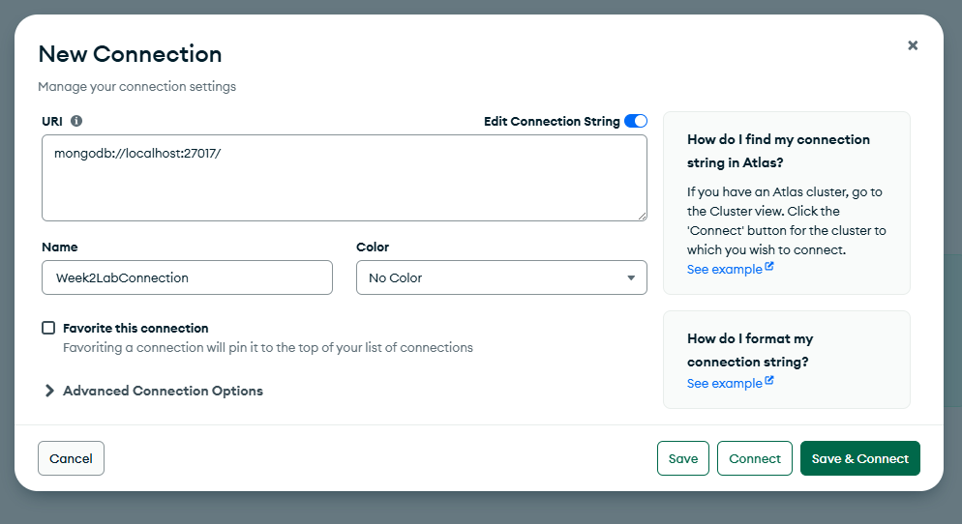
Creating the database
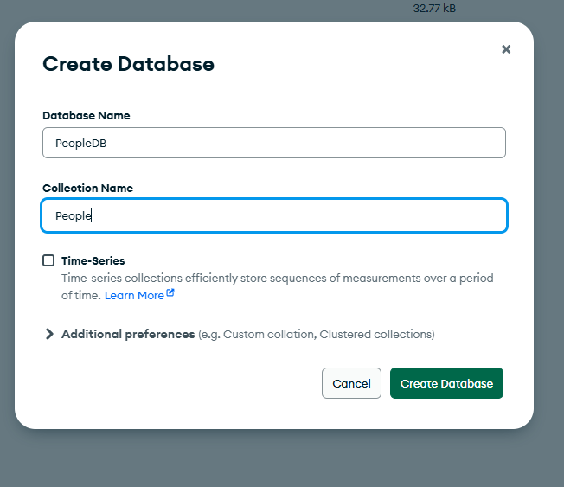

Importing the csv file
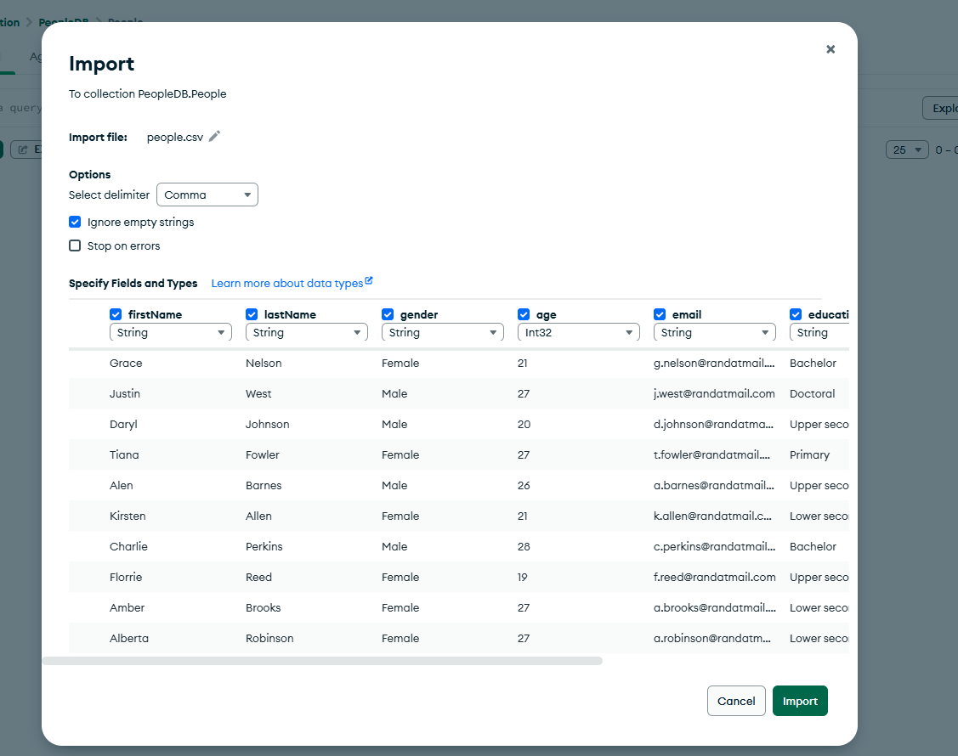

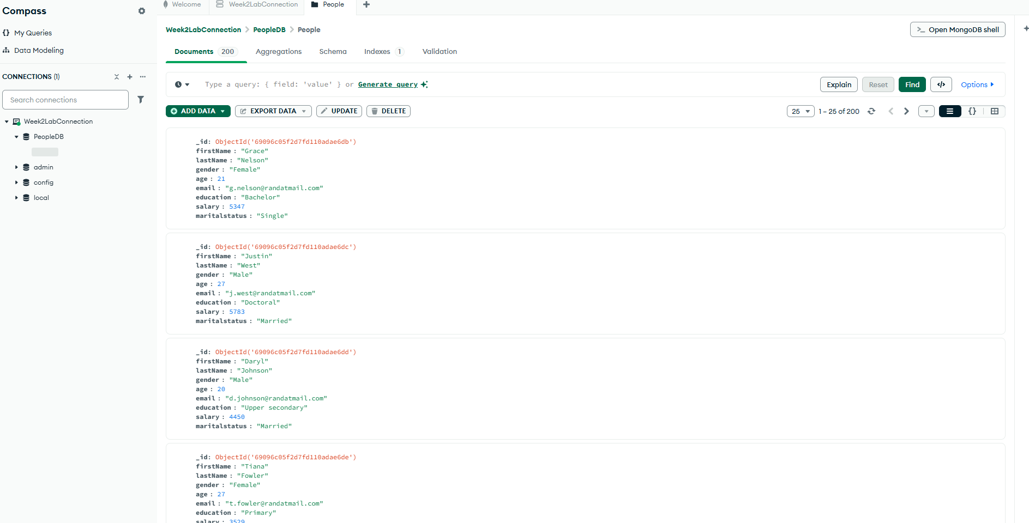

Inserting a new record
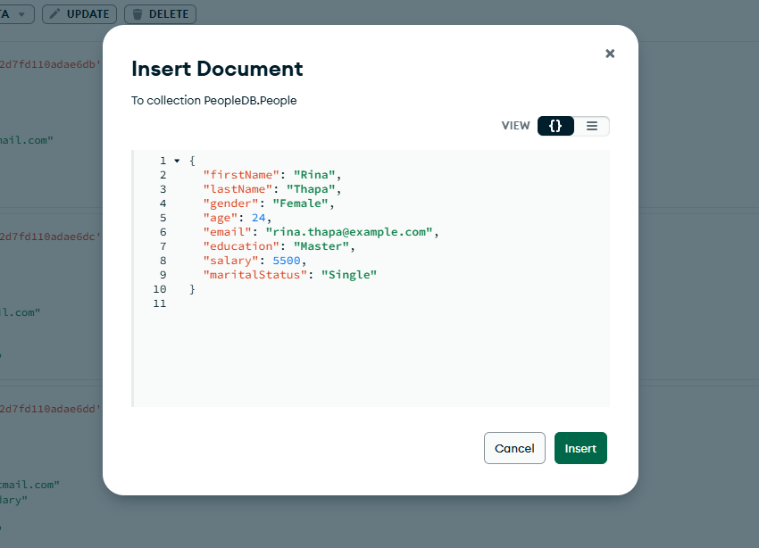
Updating the document
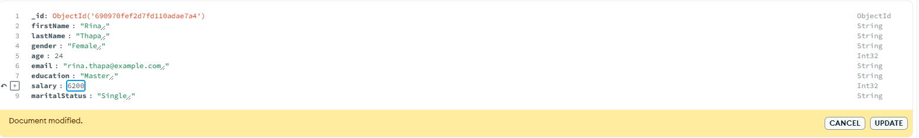
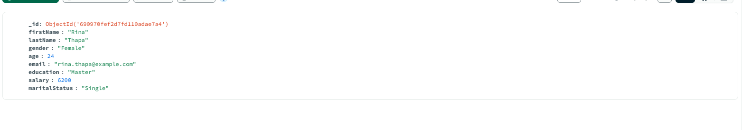
Deleting the document
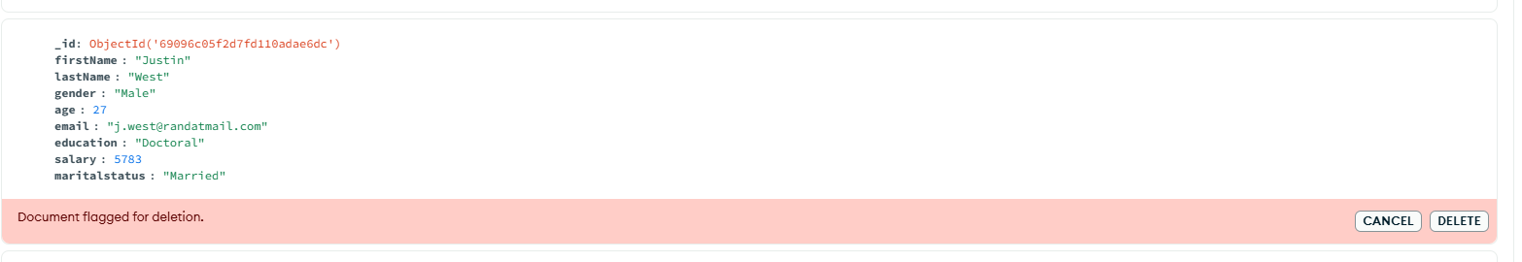
Aggregation tab
Query 1 – Match Bachelor & Age > 21

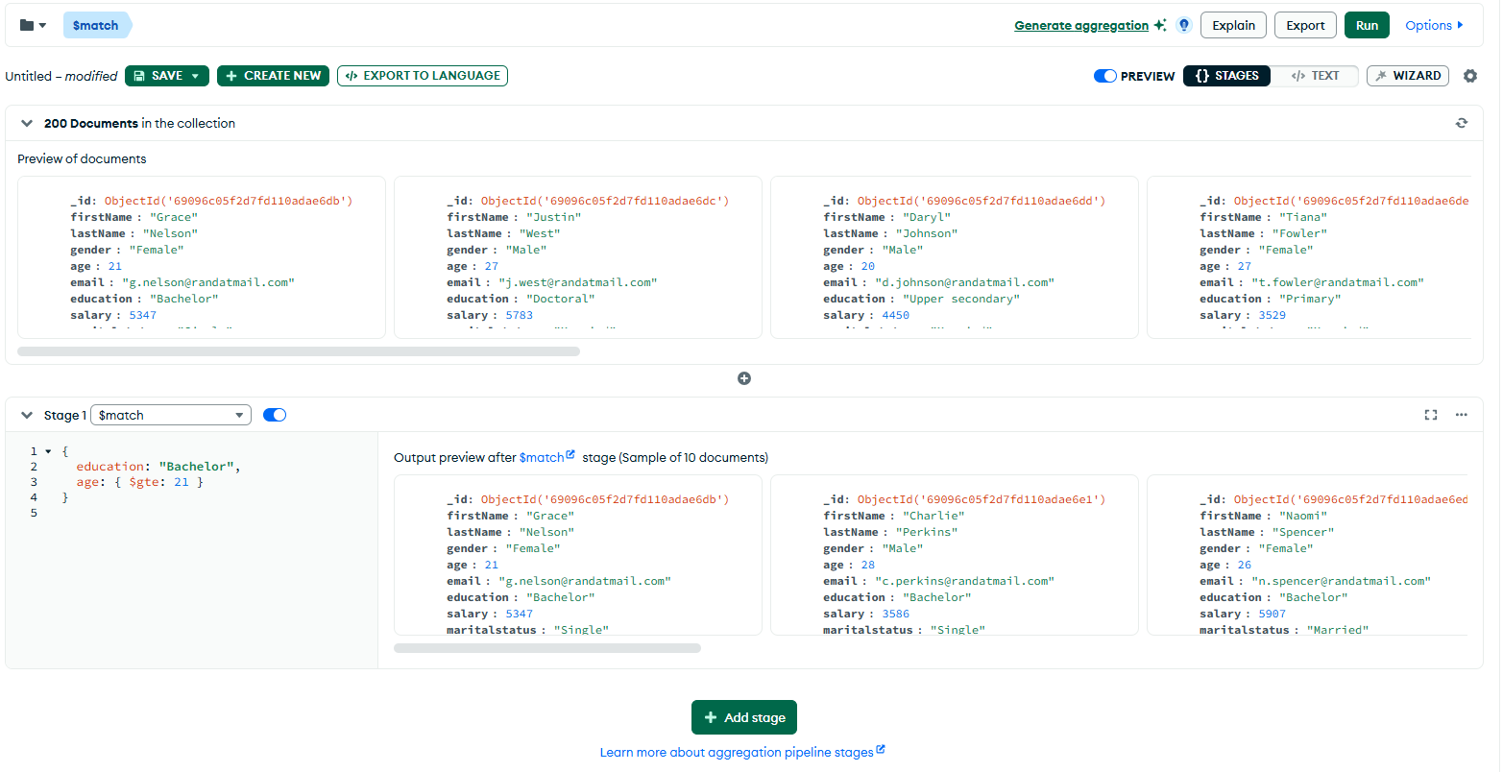
Query 2 – Group by Gender (Avg)
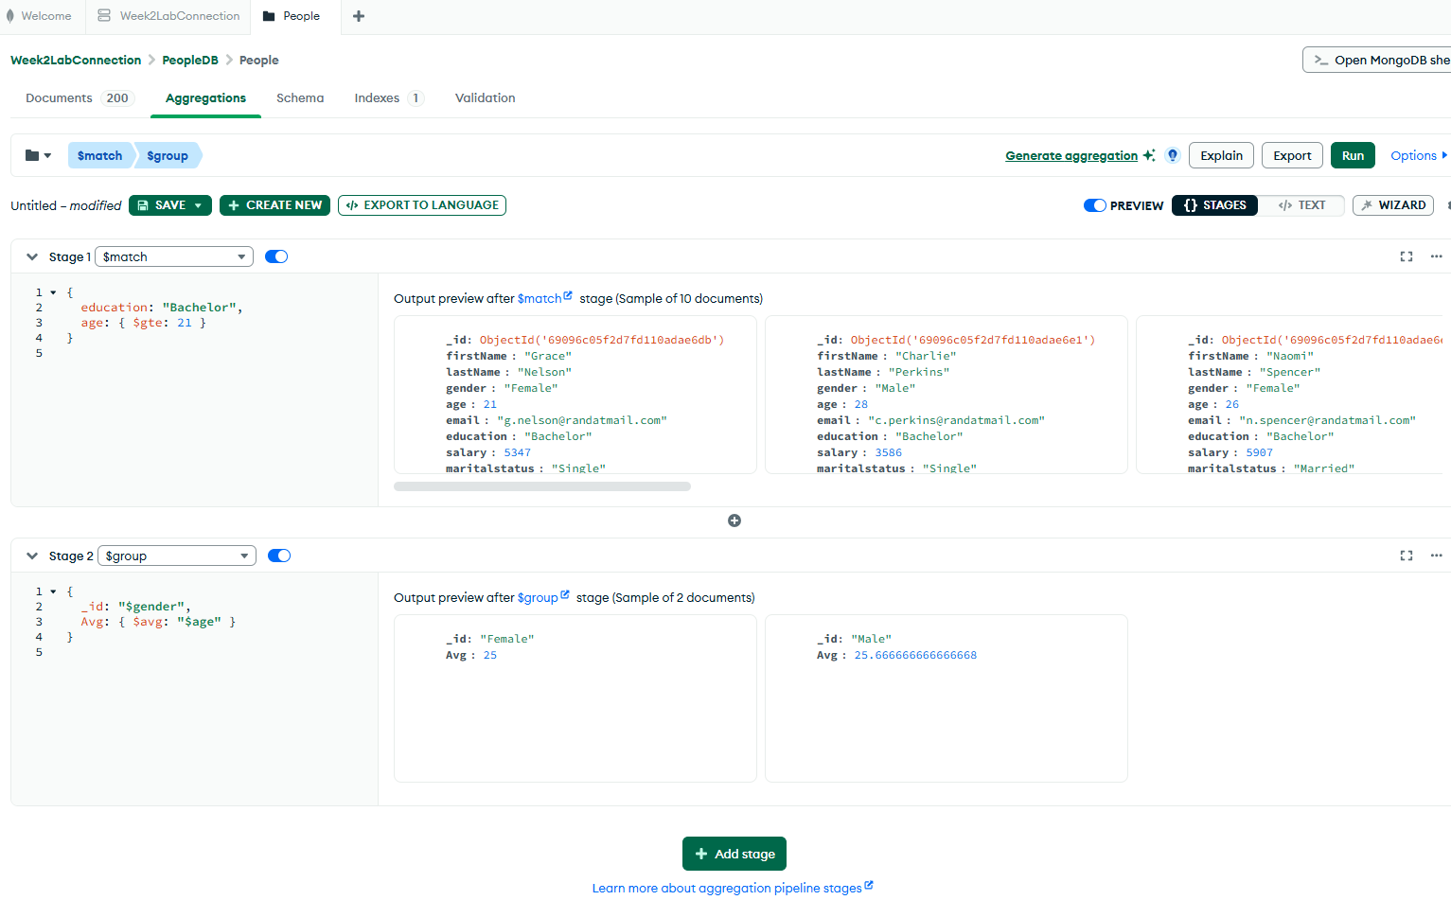

Query 3 – Group by Gender (Min & Max Age)
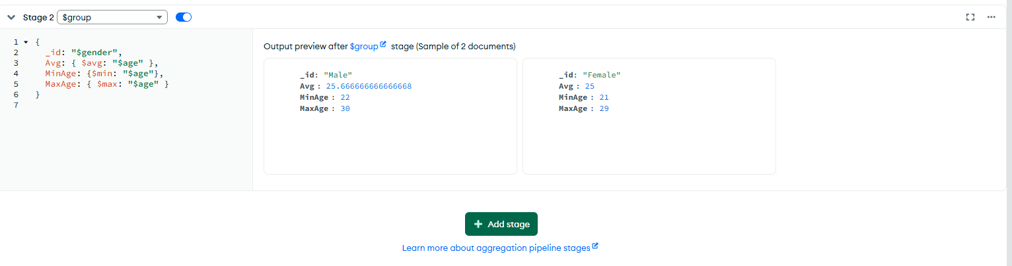

Query 4 – Group by Gender (Salary Stats)
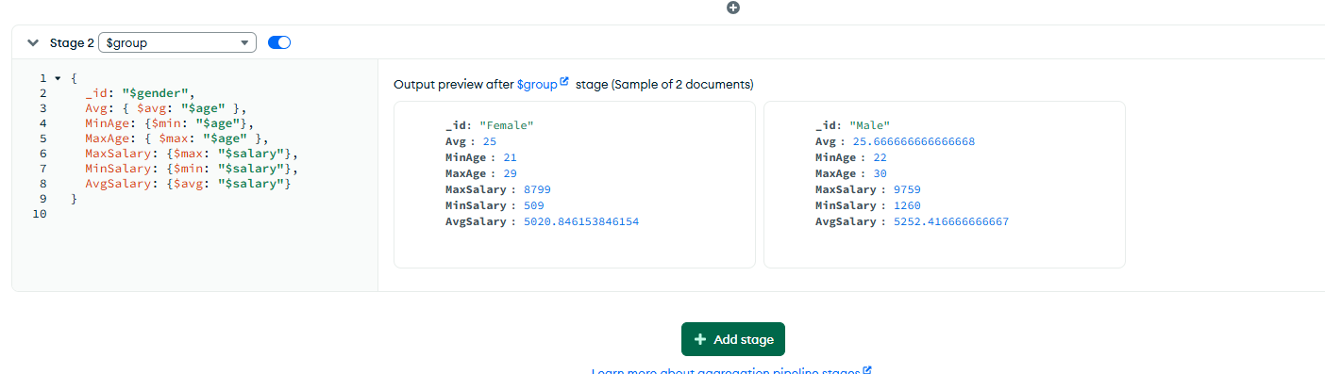

Exporting to the language:
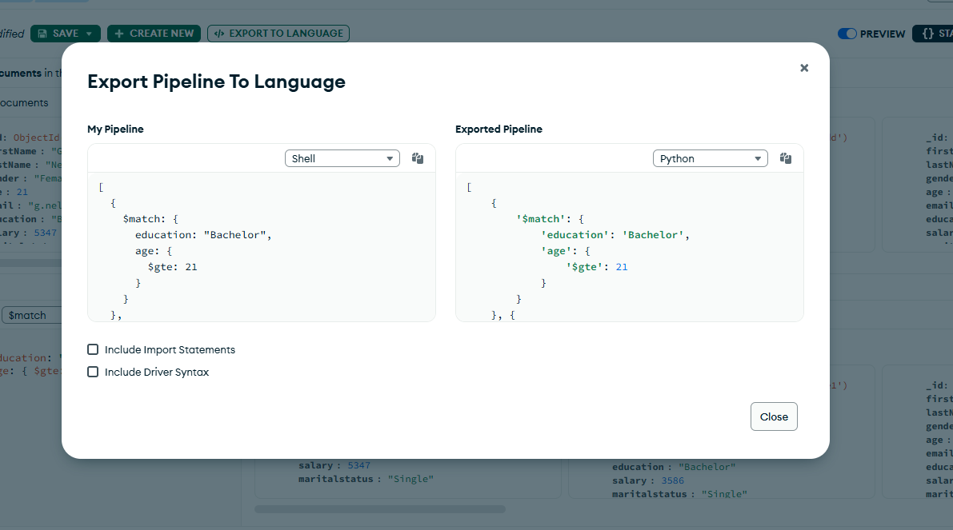

Lab Task Queries
Master’s Education -> Group by Marital Status
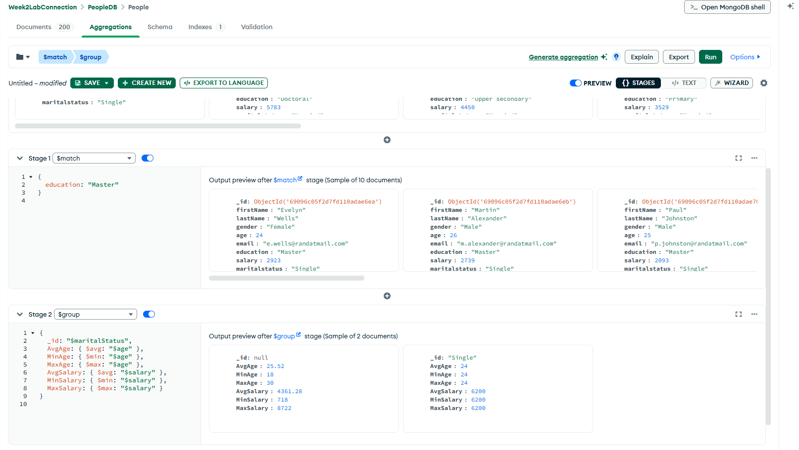

Female Salary by Age Group
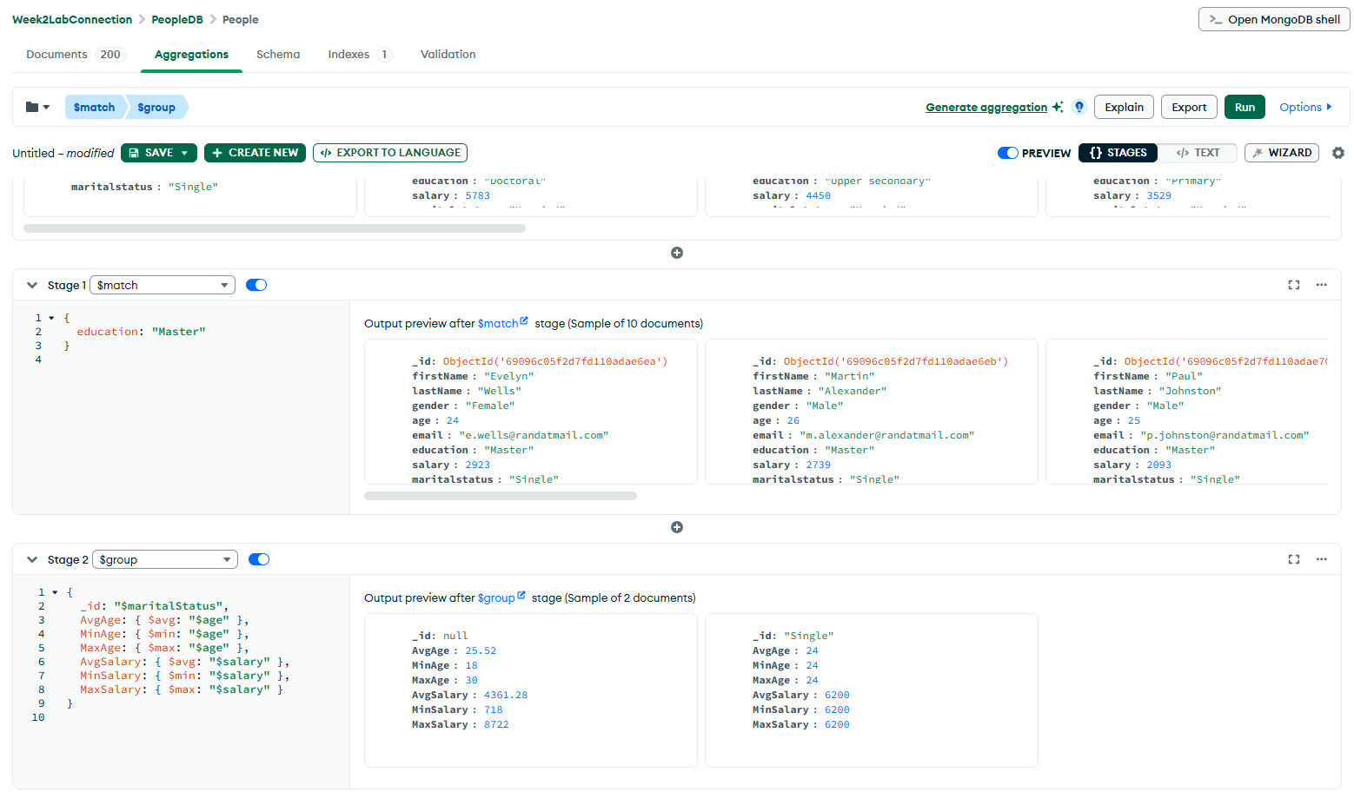
Male Salary by Age Group
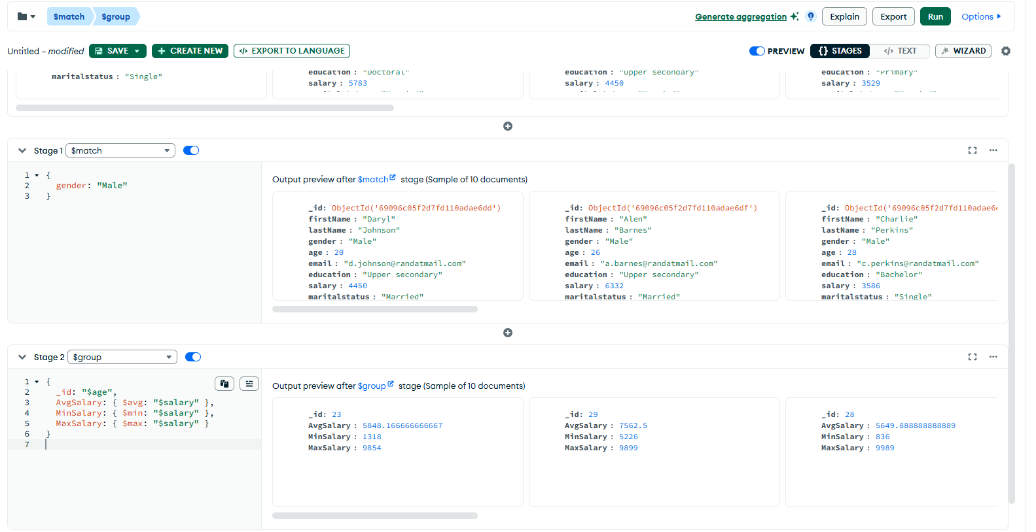
Count married and unmarried females and males.

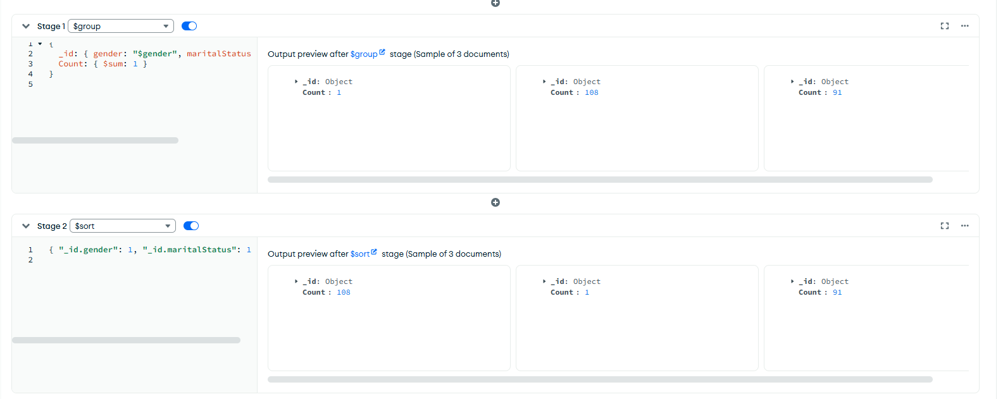
Reflection Report
The lab this week further equipped me with insight into the functionality and working of MongoDB as a NoSQL database system and how data can be edited graphically using MongoDB Compass. The practical began with the creation of a new database called PeopleDB and a collection called People. The people.csv file was importated and included the records of 200 people with first and last names, age, gender, education, wage, and marital status. In the process, I came to understand the way that MongoDB stores data in flexible documents in the form of JSON as opposed to tables that are used in SQL. This offers unstructured and semi structured storage of data and with this it will be extremely efficient in web and mobile applications of today.
After the successful importation of data, I used the basic CRUD functions, which are Create, Read, Update and Delete. I added one record manually and also edited the salary field of an already existing user and removed another record to see how the changes were going to appear in the Compass interface in real-time. Such operations further improved my knowledge of the way MongoDB handles individual documents without interfering with the remaining part of the collection. It was pretty to observe that each document is automatically assigned a unique ObjectID which is a primary key.
The second part of the lab was concerned with Aggregation Pipelines. I also learned to use functions like $match, $group and $sort to carry out a higher level of analysis of the data directly in MongoDB Compass. As an example, I applied the $match to find those people that have a certain level of education (e.g., “Bachelor or Master) and the $group to obtain aggregate operations, such as an average, minimum, and maximum age or salary. Moreover, I categorized the data according to gender and marital status in order to determine the number of people that were married or single. The visualization features of these computations at a glance in Compass allowed me to gain more insight into the stepwise processing of data in pipelines.
In general, the lab of this week enhanced my technical capabilities of working with NoSQL databases and creating analytical queries. In detail, I have grasped how the document-based model of the MongoDB is different than the relational databases, how the CRUD operations change collections, and how the aggregation pipelines simplify the complex analysis of the data. This will prove to be highly useful in the creation of data-driven web or mobile applications, in which performance, flexibility, and scalability are paramount.

