**MINOR-1 PROJECT**

**MID-SEM Report**

**Weather Forecast and Disaster Alarm in Hilly Areas**

Submitted By:

|  |  |  |
| --- | --- | --- |
| **Name** | **Roll No** | **Branch** |
| Anirudh Kushwaha | R110219015 | CCVT B-1 |
| Gaurav Porwal | R110219054 | CCVT B-2 |
| Garvit Pant | R110219050 | CCVT B-2 |
| Kumar baibhav | R110219074 | CCVT B-2 |

**Under the guidance of**

**Dr. Jagdish Chandra Patni**

**Associate Professor**



School of Computer Science

**UNIVERSITY OF PETROLEUM AND ENERGY STUDIES**

**B. Tech CCVT, 5th Sem, Batch: 2019-23**

**Approved by:**

**Project Guide-Dr. Jagdish Chandra Patni**

**Abstract**

India is at risk of numerous natural disasters due to its distinctive geo-climatic condition as a result of its geographical location. This landmass is encircled by water bodies on 3 sides and also the chain of Himalayas on the North. The country has been hit roughly by eight natural calamities annually and there has been about five times increase in frequency of natural disasters within the past 3 decades. This results in losing thousands of human lives every year, excluding heavy damage on property, animal life, etc., due to natural disasters.

In this project we will take an input of live weather and history of data collected so far on disasters in hills to warn about any disaster that may happen. This project will help us to see the weather and if it’s safe to travel or stay in a hilly area, it will help in analyzing what type of impact the weather is going to have an warn accordingly. This will help in detecting the dangers in mountains, hence saving countless lives. The goal of our weather forecast and disaster alarm system is to set an alarm that shows that if it’s safe to stay in a place in mountains or to travel. There are many levels of disaster analysis like floods, landslides, cloud bursts, forest fires etc. In our project we will consider disaster warning as floods. Our project aims to divide or distribute the dangers in hills according to their weather situations and helps reader to identify whether it’s safe or not.

**Keywords— Weather, disaster, safe.**

**Introduction**

Weather forecast and disaster alarm is the use of basic data analyzing, computational analysis to extract the weather readings. It is the processing of computationally identifying and classifying the weather in different areas in hills, is it raining or there can be floods and if the weather is clear or not. Weather forecast has a wide range of applications because it helps people to avoid certain conditions or disasters, whenever we need to go somewhere we look at the weather specially in disaster prone areas. This project is aimed to check the weather and disaster analysis in hilly areas and tell if the place is safe to travel or not.

We aim to perform disaster prediction on certain places in hills because disaster is more likely to happen in hilly areas as the weather changes. We will analyze the weather and disaster data generated by reputed database (API) and classify the weather as being rainy, heavy rain, sunny and clear as for disaster it will be danger and safe, danger of floods. This project will help peoples to avoid potential disasters and travel safely in hilly areas. It will help residential people to be safe.

**For Ex: Weather: Heavy rain., Warning: It is not safe, Danger of floods.**

**This tells people that it is not safe to travel and to stay as there is heavy rain and danger of floods**.

Like this example our project first will forecast the weather and analyses disaster readings of the place and then according to the data It will analyze if it’s safe or not or there can be floods.

**Literature Review**

Here is the conclusion of some of the reference papers that we looked at in order to improve our project and learn about new technologies that we may integrate in our project.

* This book discussed about the climate and disasters are inseparable and climatic parameters have strong association with disaster occurrence in a way that its anomalies give rise to flood, cloudburst, drought, cyclones and storms. The Indian subcontinent receives 80 percent of the total annual rainfall in just three months during the highly variable monsoons. Because of this erratic behavior of the rainfall, the country witnesses’ floods at one part and drought in another at the same time. Flood is one of the most regular features of Indian landscape which affects maximum population and causes highest economic loss to the country [1].
* In this research paper of (Prakash Tripathi, Flood Disaster in India: An Analysis of trend and Preparedness) discuss that flood has been considered as one of the most recurring and frequent disaster in the world. Due to recurrent prevalence, the economic loss and life damage caused by the flood has put more burdens on economy than any other natural disaster. India also has continuously suffered by many flood events which claimed huge loss of life and economy. It has been found that the incidences of the flood are increasing very rapidly. Causes can be climate change, cloud bursting, tsunami or poor river management, silting etc. but devastation is increasing both in terms of lives and economies. Disaster management in India has very organized and structures programmers and policies but administration and implementation of these programs demand more efficiency. In last decade, flood damages more lives and economy than any other disasters. This paper is an analysis of the trend and preparedness of flood in India. Data from CRED has been used to analyses the trend of flood and other disasters in last ten years and damaged caused by these events.
* In this journal of (Sapatarsi Goswami, Sanjay Chakraborty, Sanhita Ghosh, Amlan Chakrabarti, Basabi Chakraborty: A review on application of data mining techniques to combat natural disasters) discuss that thousands of human lives are lost every year around the globe, apart from significant damage on property, animal life, etc., due to natural disasters (e.g., earthquake, flood, tsunami, hurricane and other storms, landslides, cloudburst, heat wave, forest fire). In this paper, we focus on reviewing the application of data mining and analytical techniques designed so far for (a) prediction, (ii) detection, and (iii) development of appropriate disaster management strategy based on the collected data from disasters. A detailed description of availability of data from geological observatories (seismological, hydrological), satellites, remote sensing and newer sources like social networking sites as twitter is presented. An extensive and in-depth literature study on current techniques for disaster prediction, detection and management has been done and the results are summarized according to various types of disasters.

**Problem Statement**

Floods are now an annual nightmare in many parts of southern and western India. These floods appear to be getting more severe. Climate change is causing stronger and more erratic rainfall with recurrent floods in low-lying areas while population growth is putting more people in risky areas.

We aim to perform disaster prediction on certain places in hills because disasters are more likely to happen in hilly areas as the weather changes. We will analyze the weather and disaster data generated by reputed database and alarm people about the danger .We need to have a clear way of calling API and parse the received Weather Forecast JSON data into readable form. After parsing the text, we need to extract the weather forecast data, compare and display it.

**Objectives**

Its main objective is to determine the weather conditions by analyzing the data,and using thisdata we develop an understanding of potential disaster that can occur and warn about it to the people as to save their lives.

* + - It also helps in understanding the nature of floods, by this we can take proper measures as to be safe from the floods.
    - It can lead to more accurate tools for extracting disaster and weather behaviors and provides means for rescue operations before disasters hits hence assuring no human lives are lost.

**Sub objectives:**

* + - To analyze the weather readings.
    - To determine the weather conditions by using the analyzed readings.
    - To display and read the weather conditions and confirm it with the existing data on disasters.
    - To classify the data into danger of floods and safe.

**Methodology**

The principle of the proposed system is as follows: First the live weather data will be fetched by the API of the place entered by user by using KMP algorithm, then the data will be compared with which our researched data on disaster readings, then we will analyze the data and alarm about floods that can happen.

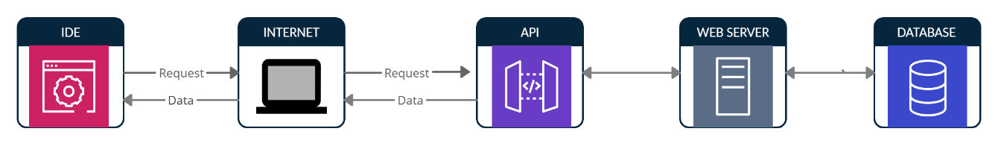

**Figure 1: Establishing connection through API call**

**Stages for API call**

1. Request to api gateway.

2. Fetch information from data server.

**Stages for weather forecast and disaster alarm:**

1. Display the weather data.

2. Sort the data in the table.

3. Analyze the data with the researched disaster data.

4. Alarm about the disaster.

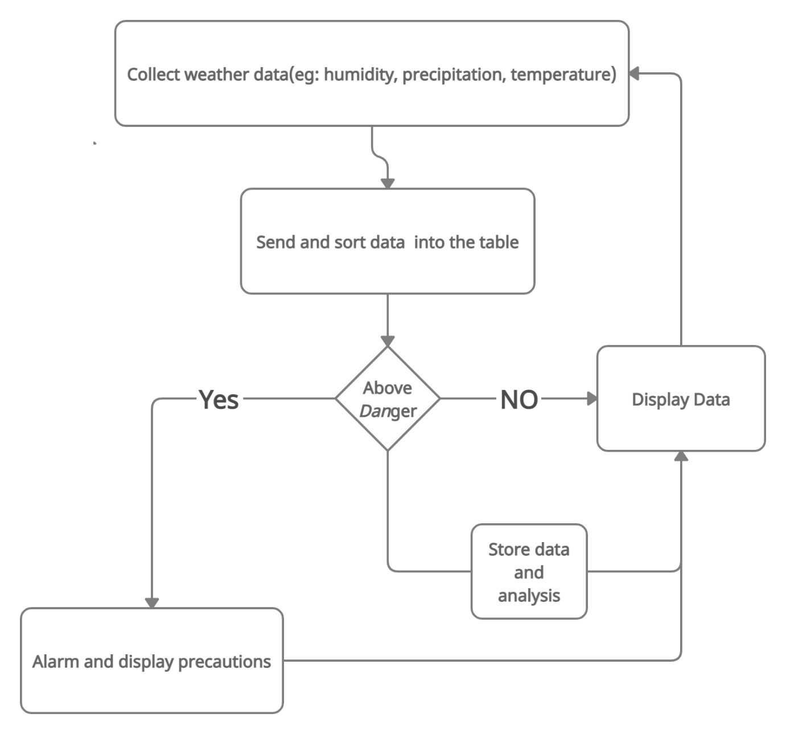

**Figure 2: Basic Workflow of the program**

**USE CASE DIAGRAM**

**System Requirements**

Hardware Interface

* 64 bits processor architecture supported by any Operating System.
* Minimum RAM requirement for proper functioning is 512 MB.

Software Interface

* Operating System: Windows
* IntelliJ
* Openweather API

**References**

1. Flood Disaster in Mountain Environment: A Study of Himachal Pradesh, India Vishwa B. S. Chandel, Simrit Kahlon, Karanjot Kaur Brar: Managing Our Resources Perspectives and Planning

(accessed on 02 Nov 2021 )

:<https://www.researchgate.net/publication/303436834_Flood_Disaster_in_Mountain_Environment_A_Study_of_Himachal_Pradesh_India>.

2. Managing the Risks of Extreme Events and Disasters to Advance Climate Change Adaptation Special Report of the Intergovernmental Panel on Climate Change:

(accessed on 05 Nov 2021)

<https://www.ipcc.ch/site/assets/uploads/2018/03/SREX_Full_Report-1.pdf>.

3. Geological investigations in Rudraprayag district with special reference to mass instability

(accessed on 05 Nov 2021), <https://dmmc.uk.gov.in/files/pdf/Rudraprayag_final.pdf>.

4. Exploring the nature and various forms of the impact of climate change on flora, fauna and local communalities in Uttarkashi, Pithoragarh and Bageswhar districts of Uttarakhand (accessed on 05 Nov 2021)

:<https://dmmc.uk.gov.in/files/Impacts_of_Climate_Change.pdf>.