**Create an AWS S3 bucket**

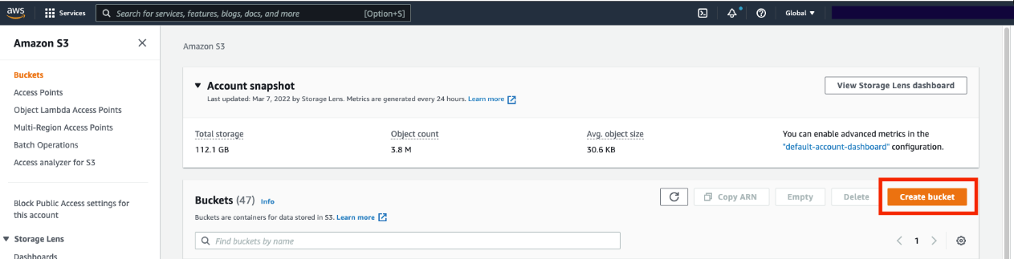

**IAM EC2 Instance Role Creation:**

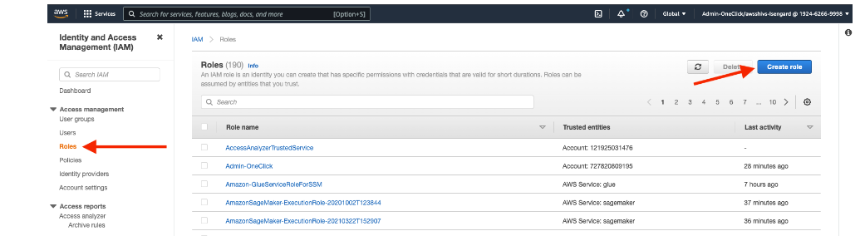

**Select EC2 as the trusted entity**

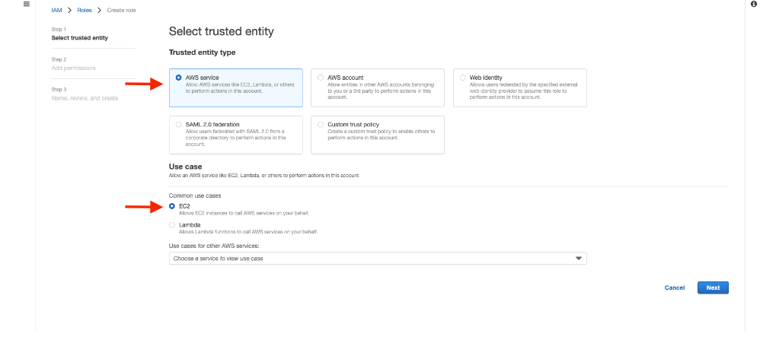

**When adding permissions, include the following AWS managed policies. You can search for them and select them. These policies will allow our instances to download our code from S3 and use Systems Manager Session Manager to securely connect to our instances without SSH keys through the AWS console**.

* **AmazonSSMManagedInstanceCore**
* **AmazonS3ReadOnlyAccess**

