**Part 1: Networking and Security**

1. VPC CREATION: Navigate to the VPC dashboard in the AWS console and navigate to **Your VPCs** on the left hand side.

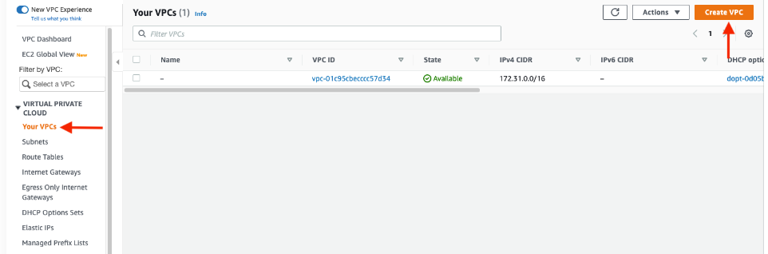

1. Make sure **VPC only** is selected, and fill out the VPC Settings with a **Name tag** and a **CIDR range** of your choice.

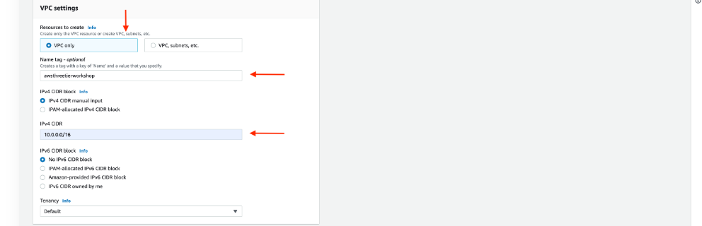

1. Subnet Creation:

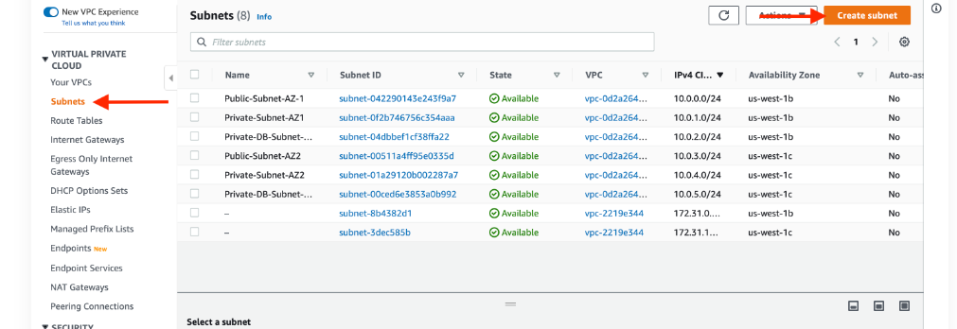

**We will need six subnets across two availability zones. That means that three subnets will be in one availability zone, and three subnets will be in another zone. Each subnet in one availability zone will correspond to one layer of our three tier architecture**.

NOTE: It may be helpful to have a naming convention that will help you remember what each subnet is for. For example in one AZ you might have the following: ***Public-Web-Subnet-AZ-1, Private-App-Subnet-AZ-1, Private-DB-Subnet-AZ-1***

**The final subnet creation should look like this :**

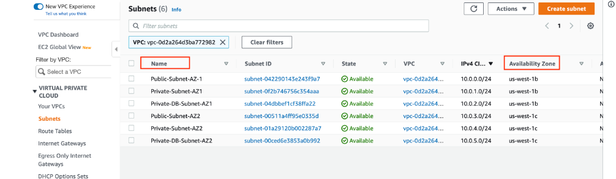

**Part 2: Internet Connectivity**

1. **Internet Gateway:** In order to give the public subnets in our VPC internet access we will have to create and attach an Internet Gateway. On the left hand side of the VPC dashboard, select **Internet Gateway**.

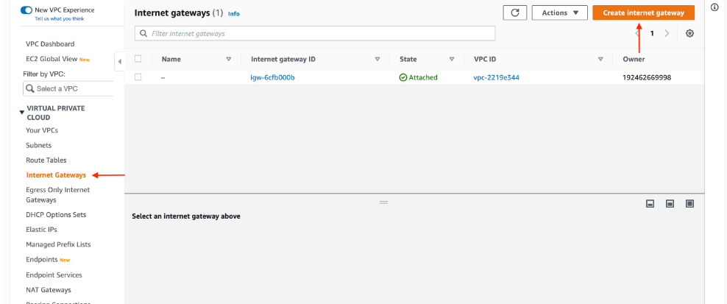

After creating the internet gateway, attach it to your VPC that you create in the **VPC and Subnet Creation** step of the workshop. You have a couple options on how to do this, either with the creation success message or the **Actions** drop down.

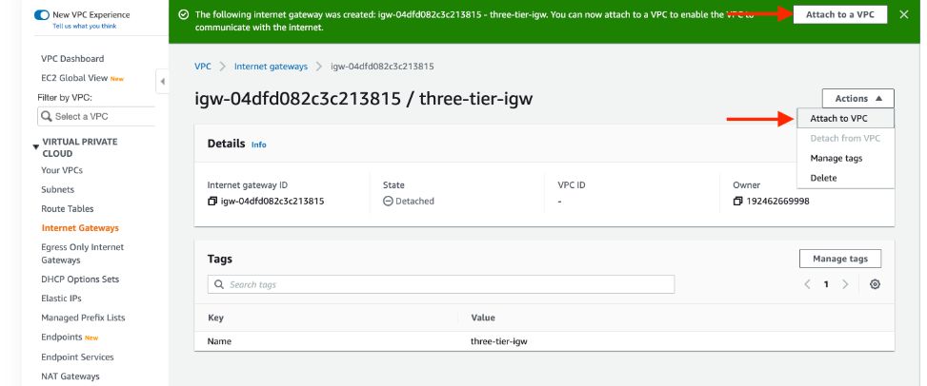

Then, select the correct VPC and click **Attach internet gateway**.

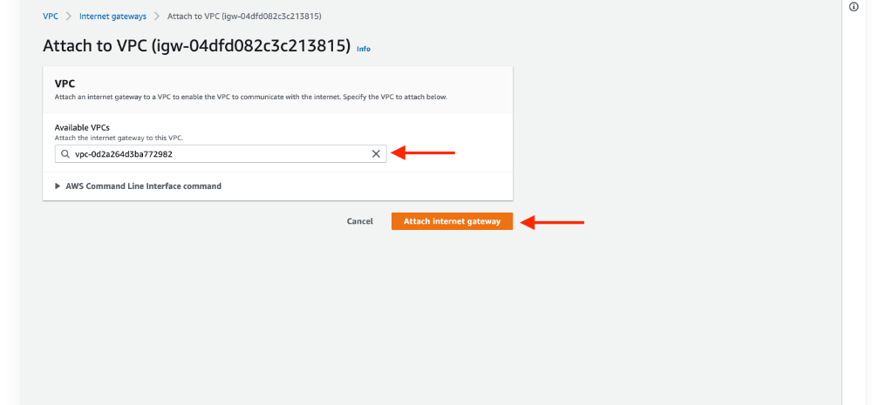

1. **NAT Gateway:** In order for our instances in the app layer private subnet to be able to access the internet they will need to go through a NAT Gateway. For high availability, you’ll deploy one NAT gateway in each of your **public** subnets. Navigate to **NAT Gateways** on the left side of the current dashboard and click **Create NAT Gateway.**

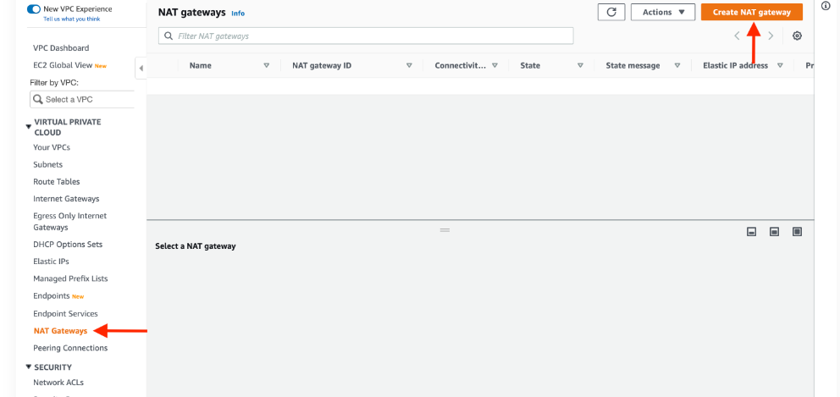

1. Fill in the **Name**, choose one of the **public subnets** you created in part 2, and then allocate an Elastic IP. Click **Create NAT gateway**.

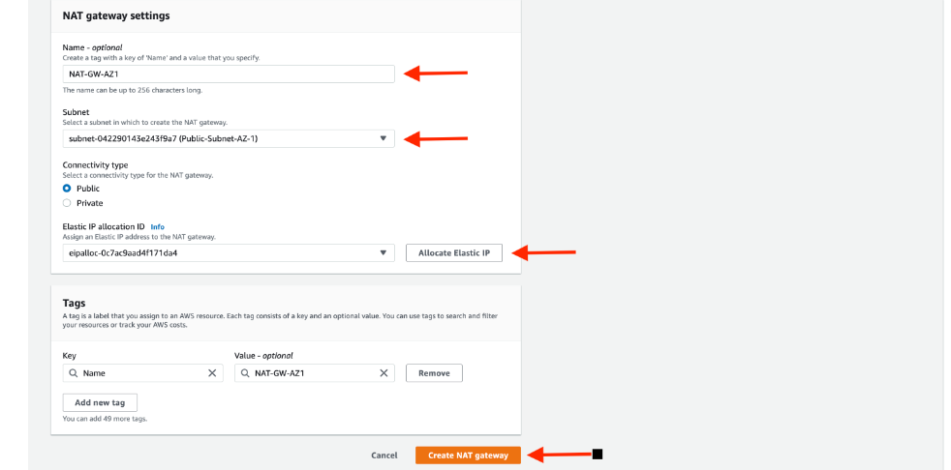

1. **Routing Configuration:**

Navigate to **Route Tables** on the left side of the VPC dashboard and click **Create route table** First, let’s create one route table for the web layer *public subnets* and name it accordingly.

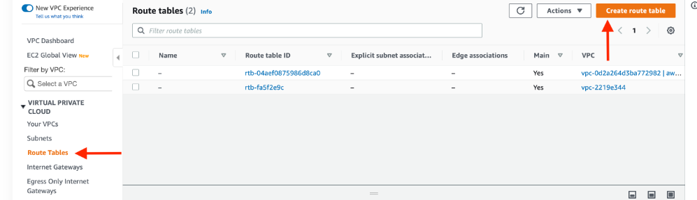

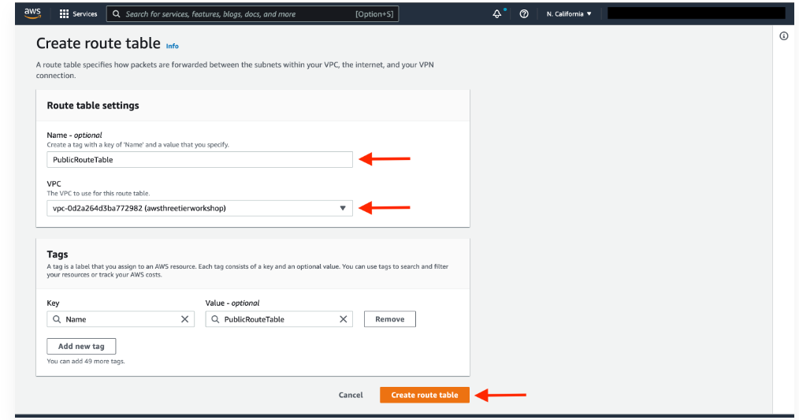

After creating the route table, you'll automatically be taken to the details page. Scroll down and click on the **Routes tab** and **Edit routes.**

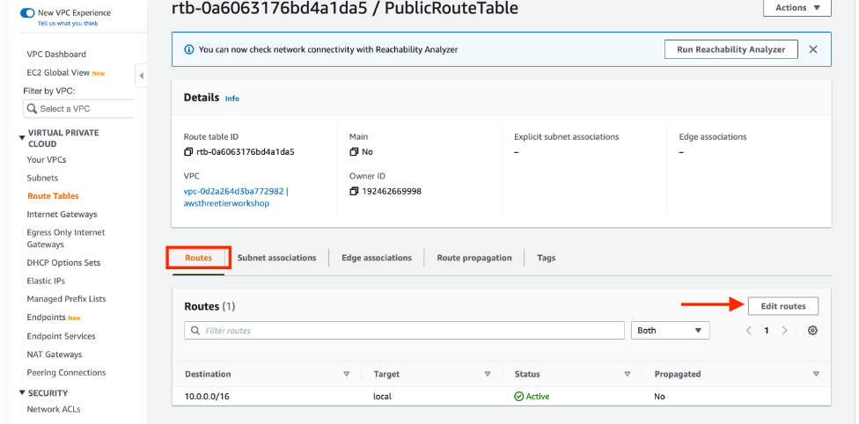

1. 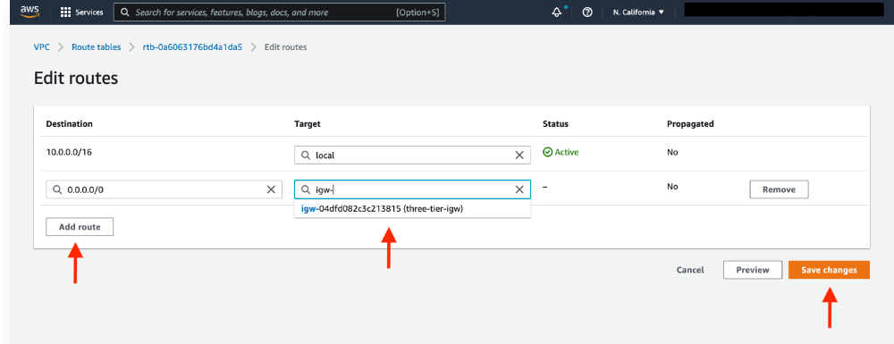Add a route that directs traffic from the VPC to the internet gateway. In other words, for all traffic *destined* for IPs outside the VPC CDIR range, add an entry that directs it to the internet gateway as a *target*. Save the changes.
2. 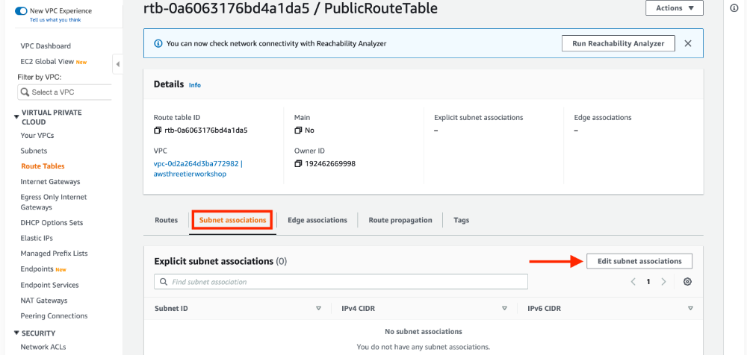Edit the *Explicit Subnet Associations* of the route table by navigating to the route table details again. Select **Subnet Associations** and click **Edit subnet associations**.

Select the two web layer public subnets you created eariler and click **Save associations**.

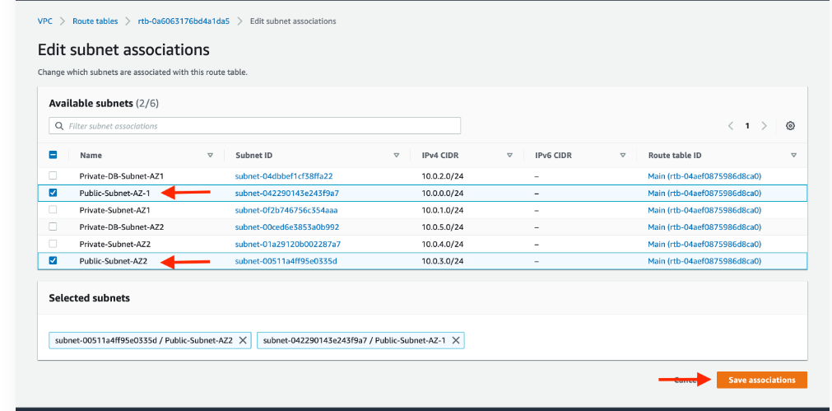

**Repeat the steps for private route table(instead of IGW there will be NAT Gateway).**

**Remember private subnet for the app layer will be associated only.**

**4.Security Groups :** Security groups will tighten the rules around which traffic will be allowed to our Elastic Load Balancers and EC2 instances. Navigate to **Security Groups** on the left side of the VPC dashboard, under **Security.**

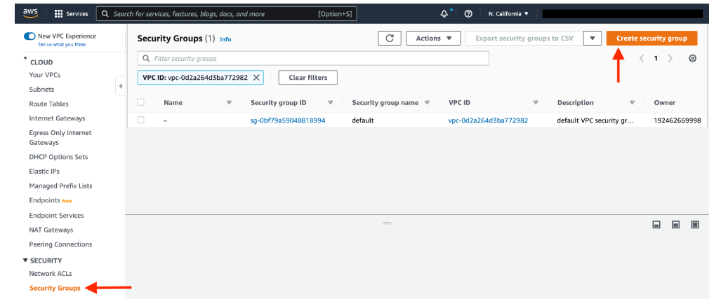

The first security group you’ll create is for the public, **internet facing** load balancer. After typing a name and description, add an inbound rule to allow **HTTP** type traffic for your **IP.**

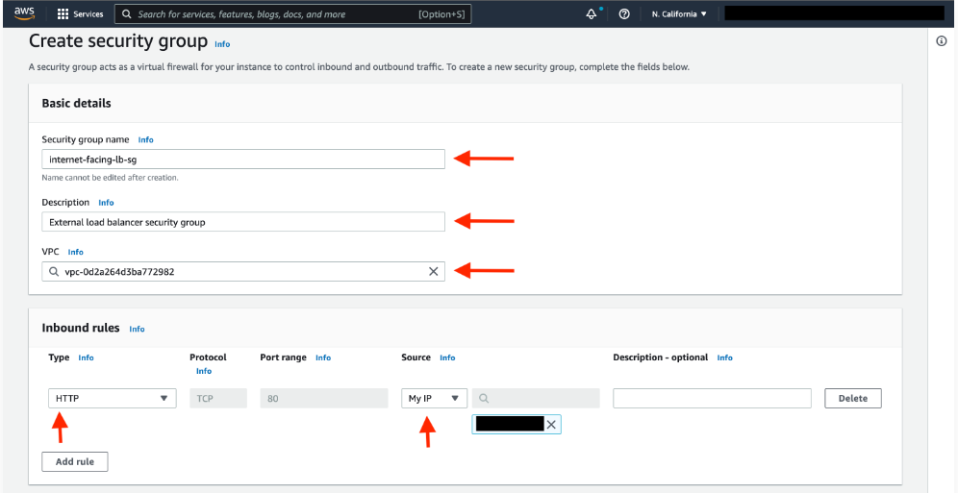

1. The second security group you’ll create is for the public instances in the web tier. After typing a name and description, add an inbound rule that allows **HTTP** type traffic from your internet facing load balancer security group you created in the previous step. This will allow traffic from your public facing load balancer to hit your instances. Then, add an additional rule that will allow HTTP type traffic for your IP. This will allow you to access your instance when we test.

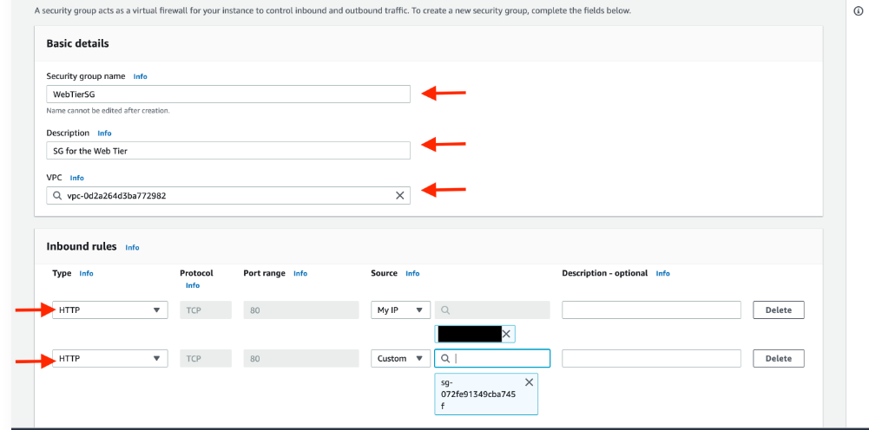

1. The third security group will be for our internal load balancer. Create this new security group and add an inbound rule that allows **HTTP** type traffic from your public instance security group. This will allow traffic from your web tier instances to hit your internal load balancer.

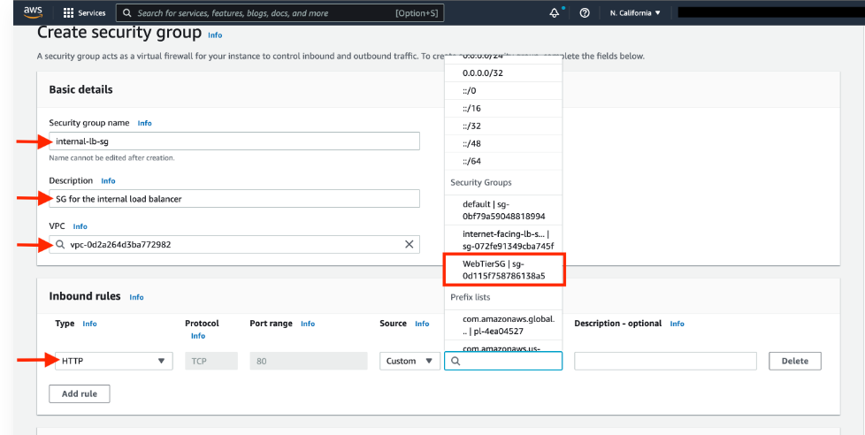

The fourth security group we’ll configure is for our private instances. After typing a name and description, add an inbound rule that will allow **TCP** type traffic on port **4000** from the **internal load balancer security group** you created in the previous step. This is the port our app tier application is running on and allows our internal load balancer to forward traffic on this port to our private instances. You should also add another route for port **4000** that allows **your IP** for testing.

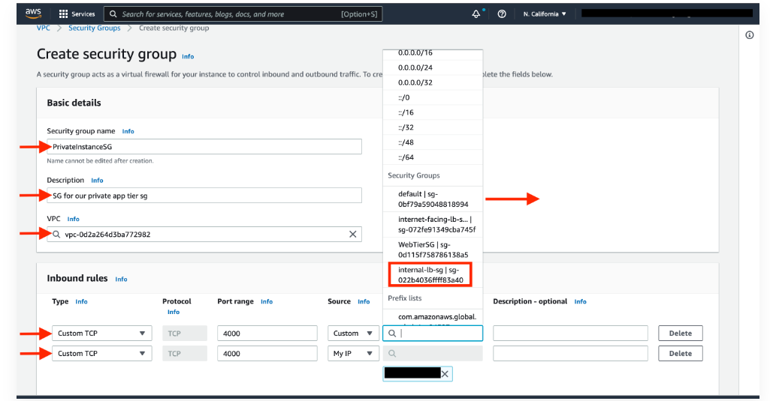

1. The fifth security group we’ll configure protects our private database instances. For this security group, add an inbound rule that will allow traffic from the private instance security group to the MYSQL/Aurora port (3306).

