**Subnet Groups:**

1. Navigate to the RDS dashboard in the AWS console and click on **Subnet groups** on the left hand side. Click **Create DB subnet group**.

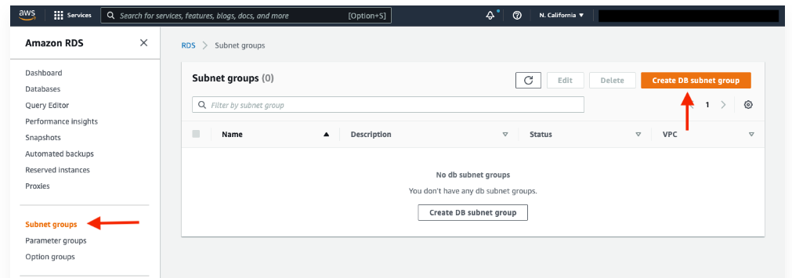

1. Give your subnet group a name, description, and choose the VPC we created.

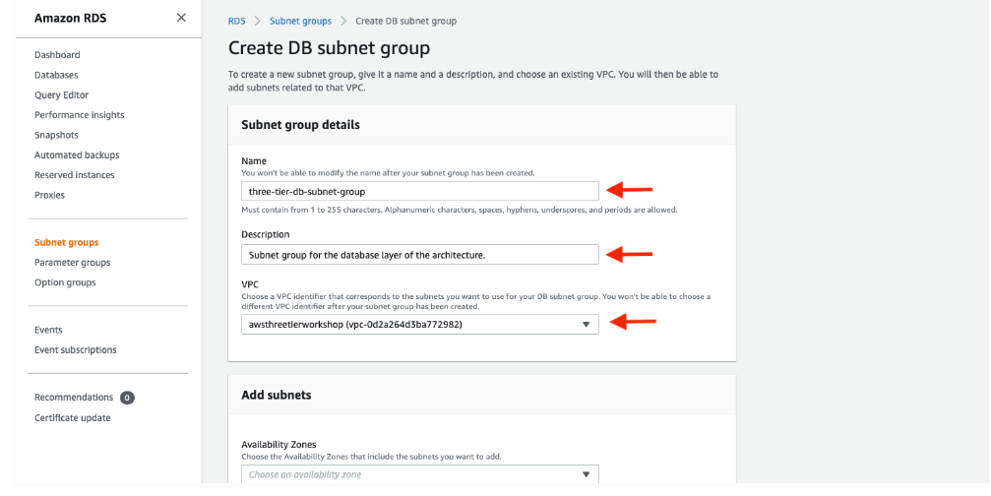

1. 3. When adding subnets, make sure to add the subnets we created in each availability zone specificaly for our database layer. You may have to navigate back to the VPC dashboard and check to make sure you're selecting the correct subnet IDs.

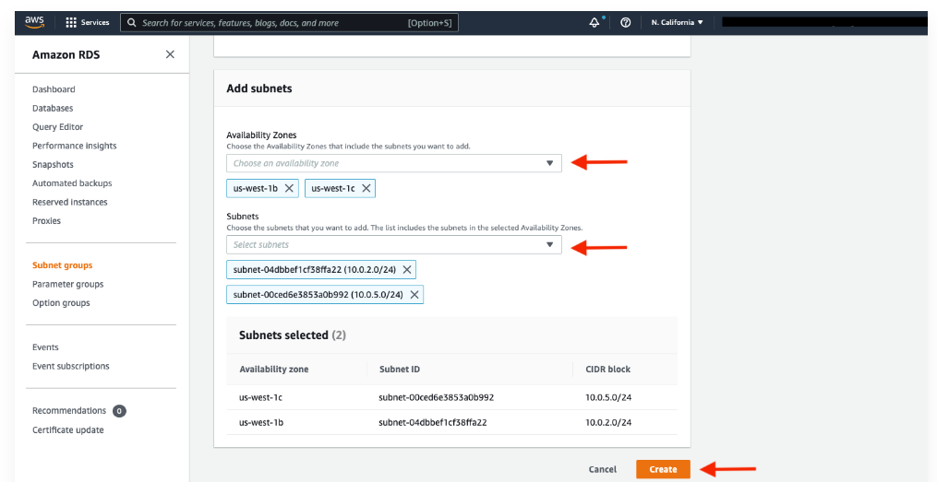

**Database Deployment:**

1. Navigate to **Databases** on the left hand side of the RDS dashboard and click **Create database**.

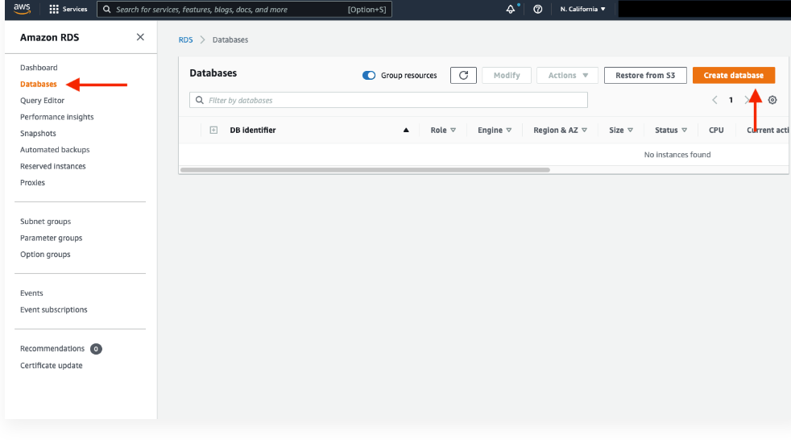

1. 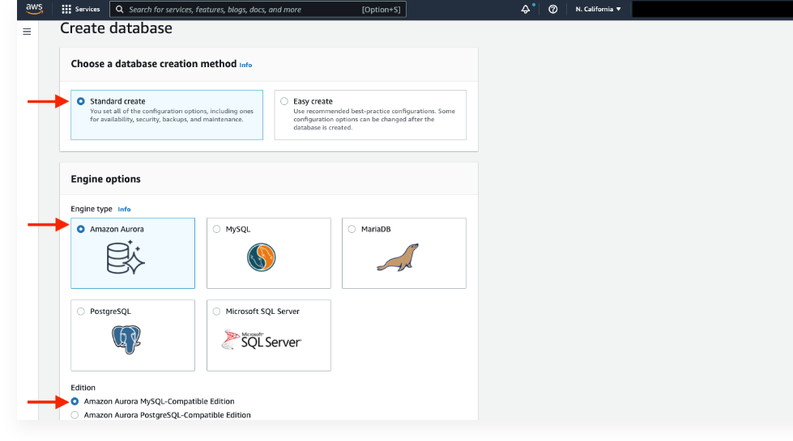We'll now go through several configuration steps. Start with a **Standard create** for this **MySQL-Compatible Amazon Aurora** database. Leave the rest of the defaults in the **Engine options** as default.

3.Under the **Templates** section choose **Dev/Test** since this isn't being used for production at the moment. Under **Settings** set a username and password of your choice and note them down since we'll be using password authentication to access our database.

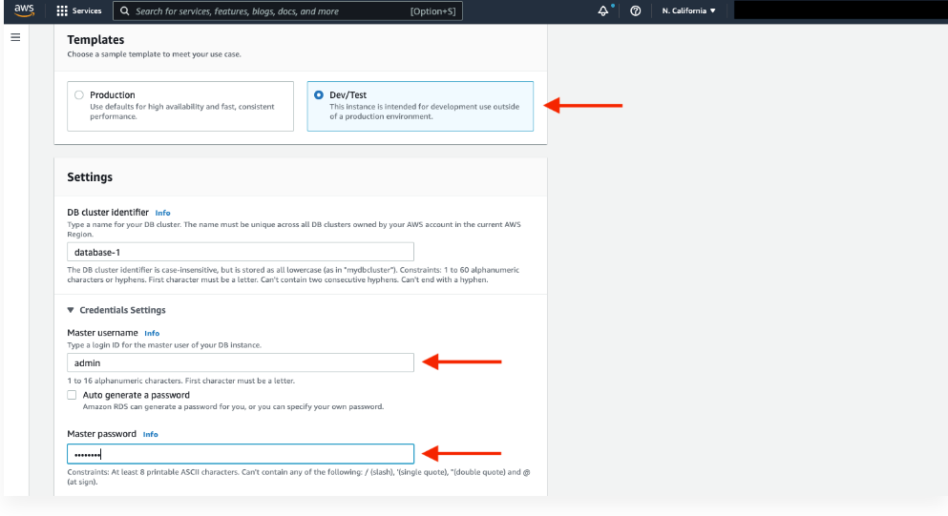

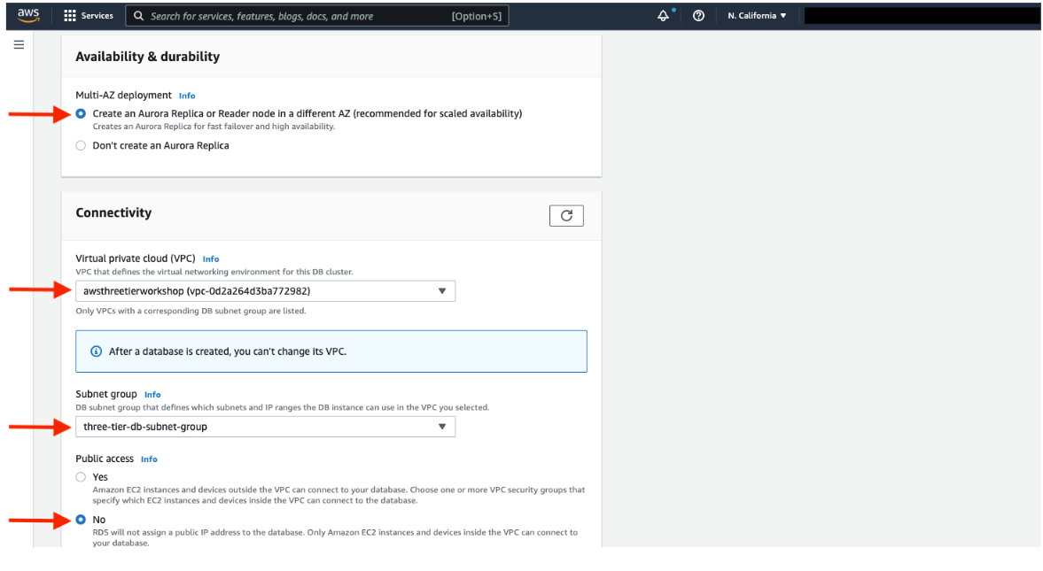Next, under **Availability and durability** change the option to create an Aurora **Replica or reader** node in a different availability zone. Under **Connectivity**, set the VPC, choose the subnet group we created earlier, and select no for public access.

2.Set the security group we created for the database layer, make sure **password authentication** is selected as our authentication choice, and create the database.

Set the security group we created for the database layer, make sure **password authentication** is selected as our authentication choice, and create the database.

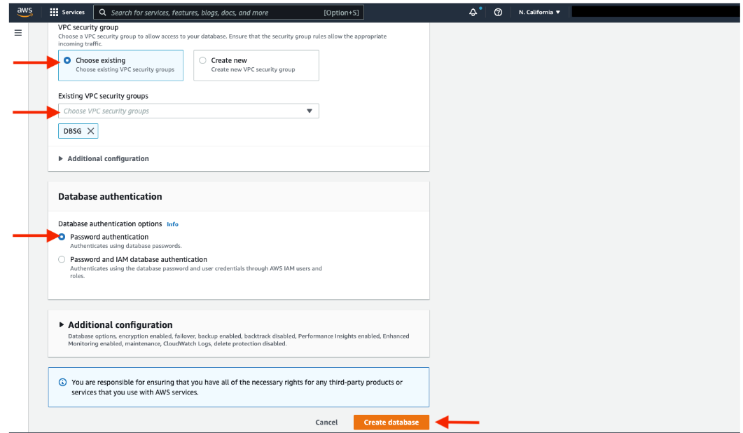

When your database is provisioned, you should see a reader and writer instance in the database subnets of each availability zone. Note down the writer endpoint for your database for later use.

