**Project Design**

Overview of attendance

It will show the attendance of all the students that present on that day

Means it will plot no of student vs day

It will show pie chart of no of students present on that particular day blue is present red is absent

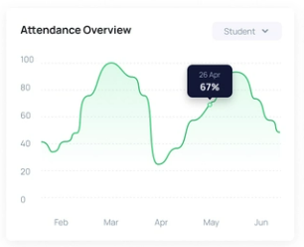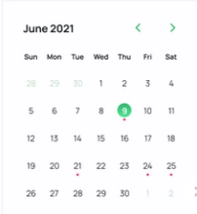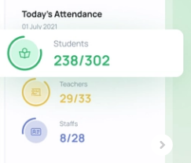 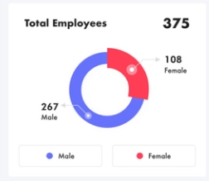]

Bar chart will show the no of students are present on that day

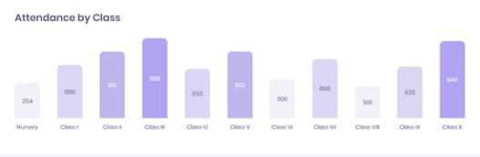

We will show the attendance of students in this type of structure (latest week)

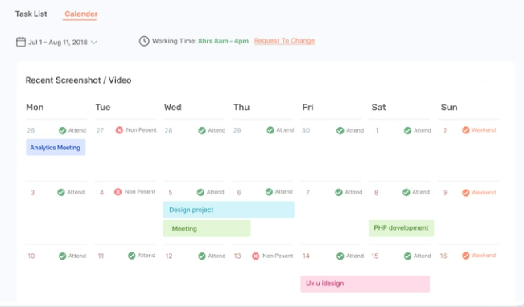

It will show attendance of particular student on that particular month

