# Flight Planning Checklist

* Select Date and Launch Time
  + **Date:** 2 / 8 / 2021
  + **Time:** 8:30 AM CST
* Weather Conditions (https://www.wunderground.com/forecast/us/al/auburn/32.62,-85.49)
  + **Cloud cover < 50% :** 40 %
  + **Rain < 30% :** 6 %
  + **Jet Stream < 100 knots:** 80 knots (<https://weatherstreet.com/models/gfs-jetstream-wind-forecast.php>)
  + **Ground Speed Winds < 12 mph:** 8mph E
* Calculate Balloon Dynamics
  + **Payload mass:** 1410 g
  + **Balloon mass:** 600 g
  + **Positive lift:** 1000 g (<http://tools.highaltitudescience.com/>)
  + **Total lift:** 2410 g
  + **Required helium:** 102.45 cu-f (<http://tools.highaltitudescience.com/>)
  + **Ascent Rate:** 5.1 m/s (<http://tools.highaltitudescience.com/>)
  + **Descent Rate:** 7.1 m/s (https://www.highaltitudescience.com/products/0-9-m-parachute)
  + **Burst Altitude:** 26390 m
* Launch and Landing Location
  + Launch Address (https://www.freemaptools.com/elevation-finder.htm)

**Street:** 2340 Wire Rd

**City:** Auburn State: AL Zip: 36832

**Lat:** 32.5737**, Lon:** -85.5358 **Elev:** 170m

* + - Outside of restricted aerospace (https://skyvector.com/)
  + Predict landing zone (https://predict.habhub.org/)

**Lat:** 32.8543, **Lon:** -83.3750 **Elev:** 152m

* Flight Dynamics
  + **Flight Time:** 1 hrs, 56 min **Landing Time:** 10:26 AM
  + **Total Distance:** 127 mi
  + **Driving distance (Launch to Recovery):** 160 mi, Driving time: 2 hrs, 45 min
  + **Driving distance (Round Trip):** 319 mi, Driving time: 5 hrs, 49 min

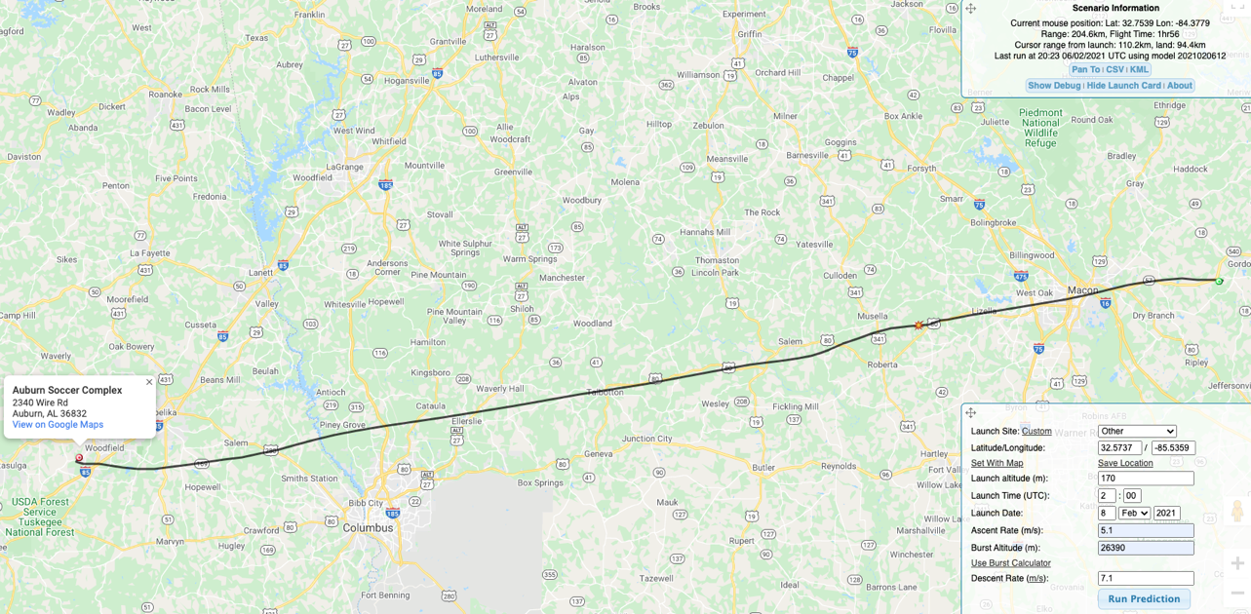

* File NOTEM: (<http://blogs.und.edu/jdosas/wp-content/uploads/sites/108/2017/12/Instructions-Filing-a-NOTAM.pdf>)
  + Call (877) 487-6867
  + Say “Hi, I would like to file a NOTAM for an Unmanned Balloon Flight
  + Launch Location in Lat Lon with Degrees,Min,Second: (https://www.fcc.gov/media/radio/dms-decimal)
  + **Lat:** 32° 34' 25" **Lon:** -85° 32' 08"
  + **Distance to nearest airport:**
  + **Atmosphere Level:** Surface to Unlimited (appr 90,000ft)
  + **Direction of flight:** East
  + **Time Effective:**
    - 8:30am to 11:30am CST or 1430 to 1730 Zulu on 2/8
  + **My Initials:** MTC (Mike Tango Charlie)
  + **NOTEM Number:** TGE02119
  + **Filed Time:** 3:00pm on 2/6

# Departure Checklist

* Packed the following:
  + - Balloon
    - Payload
    - Helium tank and inflator
    - Extra batteries
    - Toolbox
    - Wireless router
    - APRS receiver
* No USB mouse receiver in Pi

# Pre-Flight Checklist

* Payload Preparation
* Identify tall obstacles: light posts, power lines, trees
* Identify wind direction (if applicable)
* Lay down tarp/blanket in location to maximize balloon travel distance to tall objects
* Start heating up hand warmer
* Setup router
* Plug-in battery
* Remove lens cap
* Connect via ssh
* Plugin BNO055 IMU
* Start ROS and verify sensors are working
* Calibrate IMUs (take all items out of pocket)
* Verify Spot3 is tracking
* Verify APRS signal is being transmitted via Direwolf
* Remove electrical tape from antennas
* Plug in Pi Zero power to start side camera recording
* Put hand warmer in box
* Use packing tape to seal box
* Start ROS bag
* Balloon inflation
* Safety rope attached to payload and balloon from tank
* Balloon inflated to provide ______ g lifting force and tied off
* Take pictures of balloon inflation process
* Inspect train rope and knots
* Launch balloon
* Disengage safety rope from balloon
* Disengage safety rope from payload
* Record launch time ____:_____ _____
* Take video of launch process

# Post-Flight Checklist

* Upon Discovery of Payload
* Take picture of payload before touching and moving it
* Cut open box, disconnect battery
* Record landing site: Lat: ___________ Lon: ___________ Elev: __________
* Record recovery time ____:_____ _____