# Flight Planning Checklist

* Select Date and Launch Time
  + **Date:** 4 / 12 / 2021
  + **Time:** 10:30 AM CST
* Weather Conditions (https://www.wunderground.com/forecast/us/al/auburn/32.62,-85.49)
  + **Cloud cover < 50% :** 6 %
  + **Rain < 30% :** 1 %
  + **Jet Stream < 100 knots:** 70 knots (<https://weatherstreet.com/models/gfs-jetstream-wind-forecast.php>)
  + **Ground Speed Winds < 12 mph:** 2mph
* Calculate Balloon Dynamics
  + **Payload mass:** 950 g
  + **Balloon mass:** 600 g
  + **Positive lift:** 875 g (<http://tools.highaltitudescience.com/>)
  + **Total lift:** 1825 g
  + **Required helium:** 87.18 cu-f (<http://tools.highaltitudescience.com/>)
  + **Ascent Rate:** 5.04 m/s (<http://tools.highaltitudescience.com/>)
  + **Descent Rate:** 7.1 m/s (https://www.highaltitudescience.com/products/0-9-m-parachute)
  + **Burst Altitude:** 27450 m
* Launch and Landing Location
  + Launch Address (https://www.freemaptools.com/elevation-finder.htm)

Uniontown Ball Park, Uniontown, AL 36786

**Lat:** 32.4519**, Lon:** -87.5074 **Elev:** 87.0m

* + - Outside of restricted aerospace (https://skyvector.com/)
  + Predict landing zone (https://predict.habhub.org/)

**Lat:** 32.2346, **Lon:** -86.2678 **Elev:** 77m

* Flight Dynamics
  + **Flight Time:** 2 hrs, 2 min **Landing Time:** 1:32 PM
  + **Total Distance:** 73 mi
  + **Driving distance (Launch to Recovery):** 83 mi, Driving time: 1 hrs, 29 min
  + **Driving distance (Round Trip):** 283 mi, Driving time: 5 hrs, 0 min

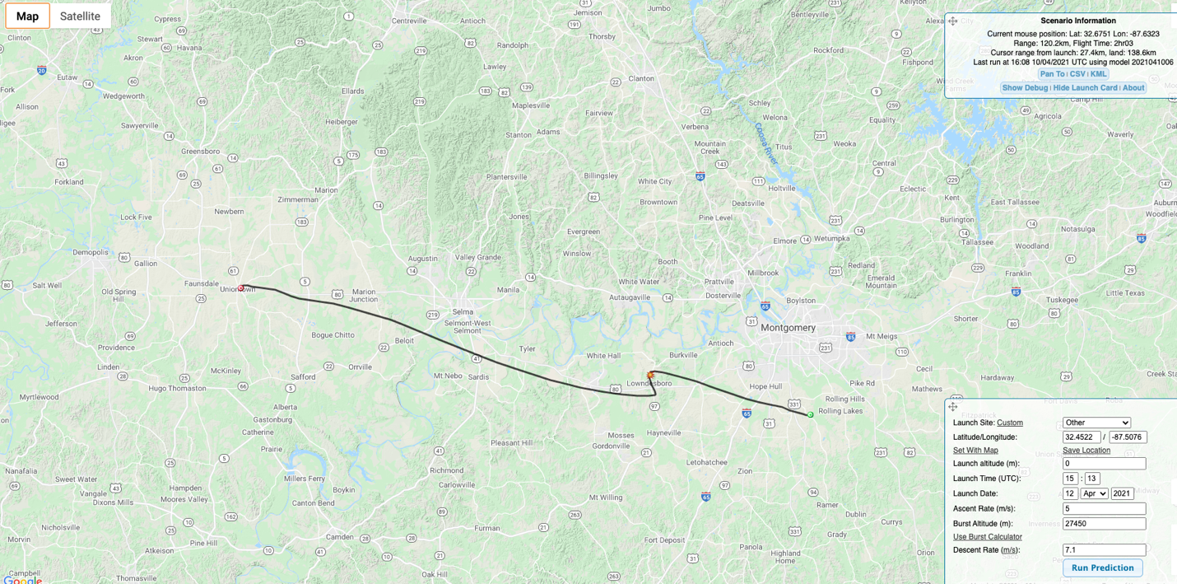

* File NOTEM: (<http://blogs.und.edu/jdosas/wp-content/uploads/sites/108/2017/12/Instructions-Filing-a-NOTAM.pdf>)
  + Call (877) 487-6867
  + Say “Hi, I would like to file a NOTAM for an Unmanned Balloon Flight”
  + Launch Location in Lat Lon with Degrees,Min,Second: (https://www.fcc.gov/media/radio/dms-decimal)
  + **Lat:** 32° 27' 6.84" **Lon:** -87° 30' 26.64"
  + **Distance to nearest airport:** 6.9 nmi
  + **Atmosphere Level:** Surface to Unlimited (appr 90,000ft)
  + **Direction of flight:** South-East
  + **Time Effective:**
    - 10:15am to 1:00pm CST or 1515 to 1800 Zulu on 4/12
  + **My Initials:** MTC (Mike Tango Charlie)
  + **NOTEM Number:** ZTL04/217 by GM
  + **Filed Time:** 11:48am on 4/10

# Departure Checklist

* Packed the following:
  + - Balloon
    - Payload
    - Helium tank and inflator
    - Batteries
    - Toolbox
    - Wireless router
    - APRS receiver
* No USB mouse dongle receiver in Pi

# Pre-Flight Checklist

* Payload Preparation
* Identify tall obstacles: light posts, power lines, trees
* Identify wind direction (if applicable)
* Lay down tarp/blanket in location to maximize balloon travel distance to tall objects
* Setup router
* Remove lens cap
* Plug-in battery
* Connect via ssh
* Start ROS and verify sensors are working
* Calibrate IMUs
* Verify Spot3 is tracking
* Verify APRS signal is being transmitted via Direwolf
* Use duct tape to seal box
* Start recording ROS bag
* Balloon inflation (during payload preparation)
* Safety rope attached to payload and balloon from tank
* Balloon inflated to provide ______ g lifting force and tied off
* Take pictures of balloon inflation process
* Inspect train rope and knots
* Launch balloon
* Disengage safety rope from balloon
* Disengage safety rope from payload
* Record launch time ____:_____ _____
* Take video of launch process

# Post-Flight Checklist

* Upon Discovery of Payload
* Take picture of payload before touching and moving it
* Cut open box, disconnect battery
* Record landing site: Lat: ___________ Lon: ___________ Elev: __________
* Record recovery time ____:_____ _____