RESULTS REPORT
SH800 pipeline validation: CD4-PE on Cytotrol PBMC at three instrument settings
Lab member | Example (pipeline validation on public data)
Date | 2026-10-08
Project / Aim | SH800 flow pipeline validation (lab methods)
Reporting period | 2026-10-08 (analysis of data acquired 04-Jul-2025)
Assay / platform | Flow cytometry, Sony SH800 (instrument code LE-SH800SZFCPL); analysis only, sh800-flow-analysis pipeline
Status | On track — decision needed

1. Objective this period
Check that the SH800 pipeline's QC and gating give a stable CD4+ frequency across three instrument settings (Low, Medium, High) on one sample.
2. Summary
- Ran the sh800-flow-analysis pipeline on six public SH800 files from one lot of lyophilized BD Cytotrol PBMC: a CD4-PE tube and an unstained tube at each of the Low, Medium and High settings (n = 1 biological sample).
- CD4+ was 57.2% (Low), 58.0% (Medium) and 59.7% (High) of singlets; the matched unstained controls read 0.5% by construction of the 99.5th-percentile threshold.
- Resolution improved from Low to Medium and changed little from Medium to High: stain index 71.8, 95.7 and 99.6.
- QC: cells were 15.1-18.1% of events (the rest is debris, typical of lyophilized material); the size-aware singlet gate kept 76.9-79.9% of cells, with no kept event above FSC-A/FSC-H 1.5. The CD4+ gate includes CD4-dim monocytes, so this is not a CD4 T-cell frequency.
- Decision needed: whether to adopt the size-aware singlet gate as the lab default for SH800 data.
3. Methods & samples
Instrument | Sony SH800 (instrument code LE-SH800SZFCPL, serial 314135), University of Ottawa Flow Cytometry & Virometry Core
Acquisition date(s) | 04-Jul-2025
Files analyzed | 6 FCS 3.1 files: 3 stained, 3 negative control
Stained samples | CD4-PE, Low; CD4-PE, Medium; CD4-PE, High
Negative controls | Unstained, Low; Unstained, Medium; Unstained, High
Panel (stained channels) | CD4 PE (FL3-A)
Other detectors | FL1-A [Brilliant Violet 421 filter]; FL2-A [FITC filter]; FL4-A [APC filter]; FL5-A [PerCP-Cy5.5 filter]; FL6-A [PE-Cy7 filter]
Compensation | Embedded spillover is an identity matrix: data are UNCOMPENSATED, none applied
Event QC | Saturated events removed: events piled up at a detector's maximum (>= 5 within 0.01%) are removed as saturated. Then PeacoQC on the time channel. 0.1-1.8% of events removed per tube
Debris gate | OpenCyto mindensity on FSC-A; cells = 15.1-18.1% of events
Singlet gate | Size-aware FSC-A/FSC-H ratio band, +/- 4 robust SD of the doublet-free side; singlets = 76.9-79.9% of cells; kept events with FSC-A/FSC-H > 1.5: 0.0% in every tube
CD4+ gate | CD4 PE (FL3-A) above the 99.5th percentile of the matched negative control (matched by setting)
Transform | Logicle (estimateLogicle on a pooled subsample of all files)
Software | R version 4.5.2 (2025-10-31); flowCore 2.22.1, flowWorkspace 4.22.1, openCyto 2.22.0, PeacoQC 1.20.0; sh800_flow.R (sh800-flow-analysis skill)
Samples & biological replicates | BD Cytotrol lyophilized human PBMC, a single lot: n = 1 biological sample. One CD4-stained tube and one unstained tube at each of the Low, Medium and High instrument settings (6 tubes; the settings are technical conditions, not replicates). Public data: figshare 10.6084/m9.figshare.30584678 (Tang and Welsh, University of Ottawa Flow Cytometry & Virometry Core; CC BY 4.0).
Staining | CD4, clone SK3, PE. Vendor, lot and dilution: not provided. Viability dye: not provided. Fc block: not provided. Stain time/temperature: not provided.
Instrument setup | Sony SH800 at the uOttawa core. Chip size, laser/filter configuration, gain/sensitivity values for the Low, Medium and High settings, and FSC threshold: not provided.
Sort details | Analysis only, no sort.

4. Results
Each tube had 37,276 to 44,499 events acquired, and saturation removal plus PeacoQC took out 0.1-1.8% per tube. Cells were 15.1-18.1% of events: on log FSC-A vs SSC-A the debris cut falls in the valley between the debris cloud and the cell cluster in every tube (Figure 1a; all six tubes in 02_qc_debris.png). The singlet band follows the main FSC-A/FSC-H diagonal at all three settings and kept 76.9-79.9% of cells (5,293 to 5,419 singlets per tube); no kept event had FSC-A/FSC-H above 1.5 (Figure 2).
Sample | Events | QC removed (%) | Cells (% events) | Singlets (% cells) | Singlets (n) | CD4+ (% singlets)
CD4-PE, Low | 42,507 | 1.2 | 15.9 | 79.5 | 5,319 | 57.2
CD4-PE, Medium | 44,499 | 0.1 | 15.1 | 79.0 | 5,293 | 58.0
CD4-PE, High | 40,128 | 0.1 | 16.7 | 79.9 | 5,338 | 59.7
Unstained, Low † | 37,276 | 0.1 | 18.1 | 79.7 | 5,377 | 0.5
Unstained, Medium † | 43,008 | 1.8 | 16.5 | 76.9 | 5,354 | 0.5
Unstained, High † | 38,151 | 0.4 | 18.0 | 79.3 | 5,419 | 0.5

† Negative control.
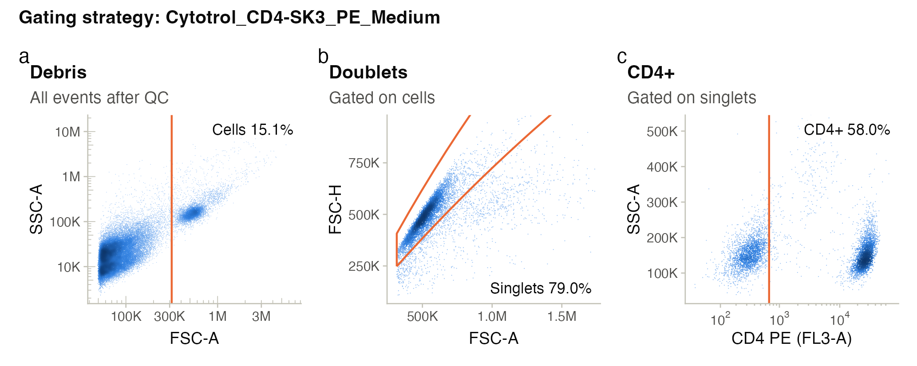
Figure 1. Gating strategy for CD4-PE, Medium: debris (mindensity on FSC-A), singlets (size-aware FSC-A/FSC-H band), CD4+ (99.5th percentile of the matched negative control).
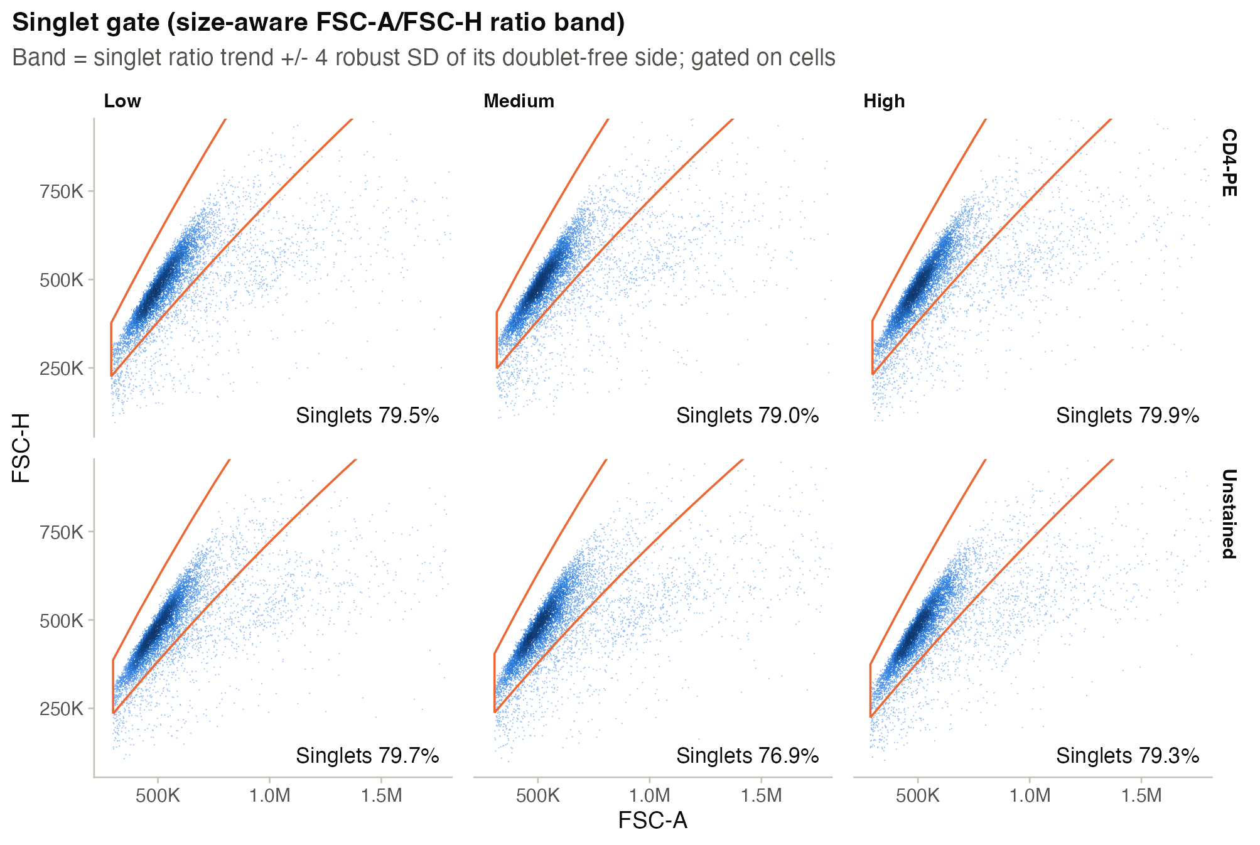
Figure 2. Singlet gate for every tube (FSC-A vs FSC-H). Events below the band are doublets and aggregates.
CD4+ was 57.2% (Low), 58.0% (Medium) and 59.7% (High) of singlets; each matched unstained control read 0.5%, as set by the threshold. The CD4+ and CD4- peaks are separated at every setting (Figure 3), and the stain index was 71.8 at Low, 95.7 at Medium and 99.6 at High (table below). In each stained tube the CD4- peak sits above the unstained control's peak, so its upper tail reaches the threshold, and a small CD4-dim population (the higher-SSC-A events in Figure 1c) lies above the threshold.
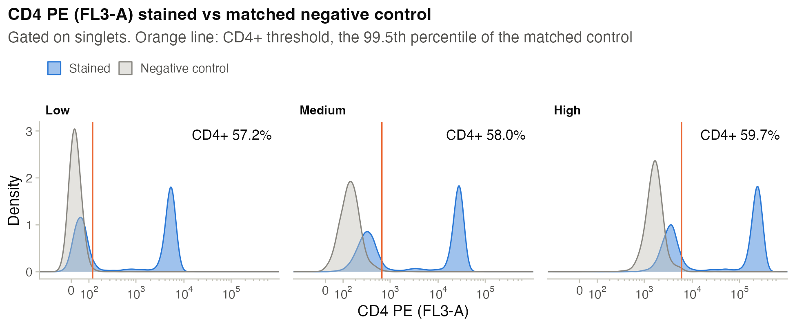
Figure 3. CD4 PE (FL3-A) in stained tubes (blue) against the matched negative control (grey); orange line = CD4+ threshold.
Sample | CD4+ (%) | Median CD4+ | Median CD4− | rSD CD4− | Stain index
CD4-PE, Low | 57.2 | 5,031 | 47 | 35 | 71.8
CD4-PE, Medium | 58.0 | 26,122 | 331 | 135 | 95.7
CD4-PE, High | 59.7 | 228,380 | 3,295 | 1,130 | 99.6

Medians are linear-scale FL3-A values of the CD4+ and CD4− singlets in the same stained tube; rSD is the median absolute deviation scaled to a standard deviation. Medians depend on the instrument settings and are not comparable across settings; the stain index, (median CD4+ - median CD4−) / (2 x rSD CD4−), is.
5. Interpretation
CD4+ frequency is stable across the three settings (57.2-59.7% of singlets). Resolution (stain index) improves from Low to Medium and changes little from Medium to High. Caveats: this is n = 1 lyophilized sample, so it tests consistency across instrument settings, not across samples or donors; the CD4+ gate includes CD4-dim monocytes, so this is not a CD4 T-cell frequency; the data are uncompensated, which is fine for this one-color readout.
- Most acquired events are debris: cells were 15.1-18.1% of events. Typical for lyophilized material; a low FSC threshold would also contribute (threshold not provided).
- Data are uncompensated (identity spillover matrix). Acceptable for a single-color readout; PE spillover into FL2, FL4, FL5 and FL6 is visible in 05_all_detectors.png.
- Unstained controls read about 0.5% CD4+ by construction (99.5th-percentile threshold), so the control value is not an independent false-positive rate.
6. Blockers / decisions needed
DECISION NEEDED Adopt the size-aware FSC-A/FSC-H singlet gate as the lab default for SH800 data? On these six tubes it kept 76.9-79.9% of cells, and no kept event had FSC-A/FSC-H above 1.5 (Figure 2).

No other blockers this period.
7. Next steps
- A lab member runs the pipeline on the lab's own SH800 exports from the next sort. Target: within two weeks.
- Add an index-sort join so SH800 index-sort phenotypes can be linked to PTA / ResolveOME plates. Target date: not provided.
8. Data & code availability
FCS files | SH800_uOttawa_figshare_30584678/ (experiment folder)
Pipeline outputs | SH800_uOttawa_figshare_30584678/plots/
Run script | SH800_uOttawa_figshare_30584678/plots/sh800_flow.R
Run record | SH800_uOttawa_figshare_30584678/plots/run_info.json
Figures not embedded | 02_qc_debris.png, 05_all_detectors.png, 06_population_frequencies.png, 07_stain_index.png
Tables | gate_percent.csv, median_intensity.csv, qc_events.csv, singlet_gate_parameters.csv, stain_index.csv
Raw-data backup | figshare 10.6084/m9.figshare.30584678 (public record) and the shared 'Sony Analysis Test' folder

