**MARKET BASKET INSIGHTS**

* INTRODUCTION
* PROBLEM STATEMENT
* IMPORTING DATA
* DATA CLEANING
* DATA ANALYSING

**INTRODUCTION:**

* **Market Basket Analysis**, known as Association rule analysis is a data analysis technique used in the field of data mining and business analytics.
* It aims to uncover relationships and associations between items that are frequently purchased or used together in transactions. This analysis helps businesses understand customer behavior, improve product recommendations, enhance marketing strategies, and optimize inventory management.
* The primary focus is on identifying patterns and rules that reveal how different products or services are related in customers' buying habits, which, in turn, can inform decision-making and business strategies.

**PROBLEM STATEMENT:**

Unveiling the customer behaviour through association analysis: Utilize the Market Basket Analysis on the provided dataset to uncover hidden patterns and associations between products, aiming to understand customer purchasing behaviour and identify potential cross selling opportunities for the retail business.

**IMPORTING DATA:**

Data importing is a crucial step as it forms the foundation for discovering associations and patterns among items, which can be used to make business decisions such as product placement, recommendation systems, and pricing strategies.

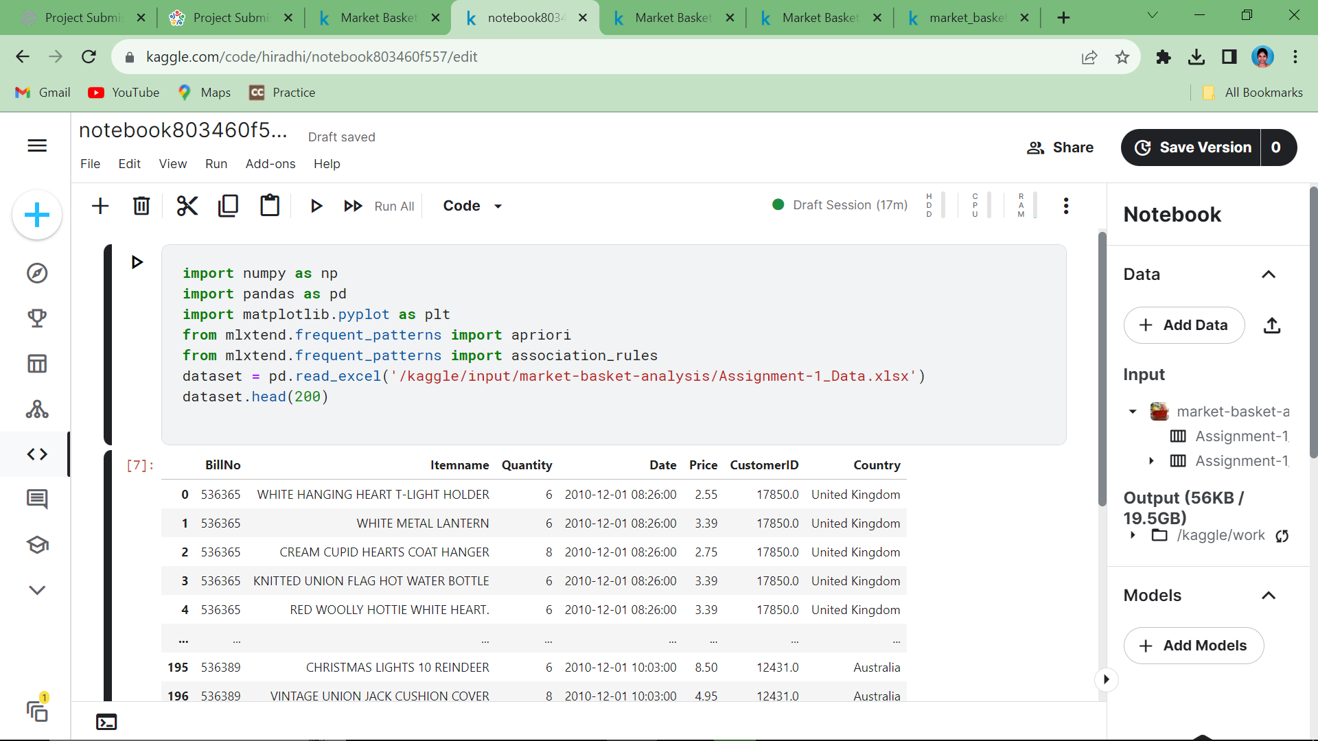

**Data cleaning:**

It is a crucial step in Market Basket Analysis (MBA) to ensure that your transactional data is accurate, reliable, and ready for analysis**.**

Data cleaning is achieved by

* + - * Removing duplicate values
      * Adding missing values

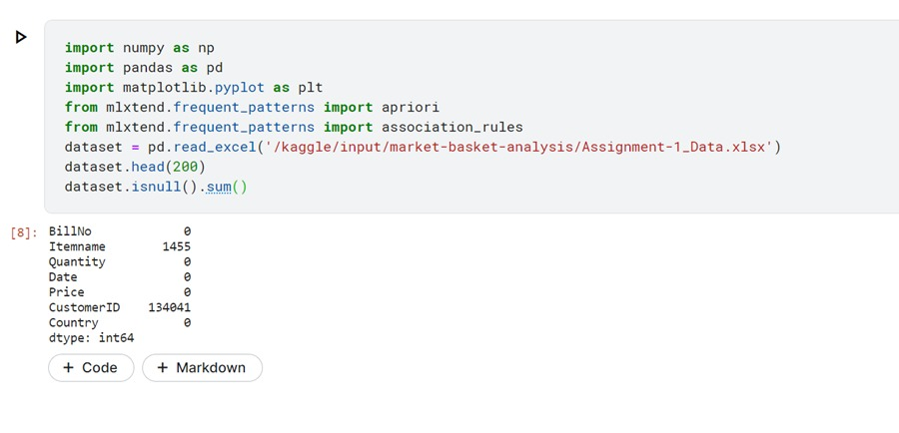

**Data Analyzing:**

It is the process of examining transactional data to identify patterns and relationships between products or items purchased together by customers.

The following steps are used for data analyzing:

* Frequent Itemset Generation
* Support Counting
* Increase k by 1 (k = k + 1)
* Generate Candidate k-Itemsets
* Remove candidate k-itemsets that have infrequent (k-1)-subsets.
* Generate Frequent k-Itemsets
* Form association rules based on frequent k-itemsets.
* Evaluate rule confidence.

**Data Visualization:**

Some data mining tools and libraries that implement the Apriori algorithm for Market Basket Analysis come with built-in visualization features. These visualizations often include support-confidence lift plots, item set diagrams, and association rules.

1. **Libraries are imported**

Importing pandas,numpy,matplotlib,seaborn as the built-in libraries.

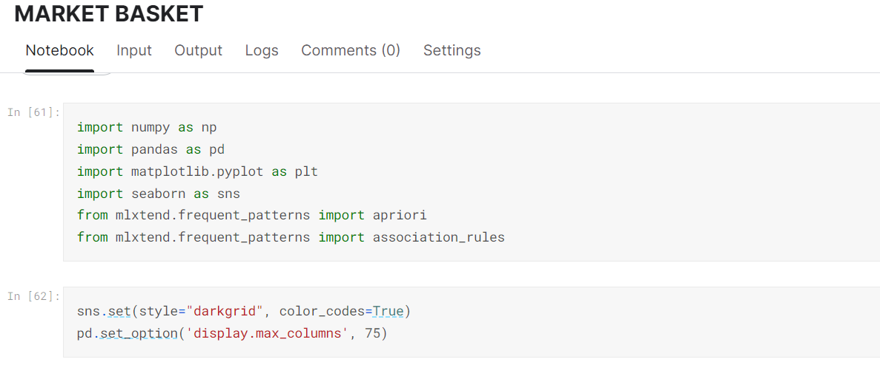

**2.Importing dataset**

The given dataset is being imported in excel format.

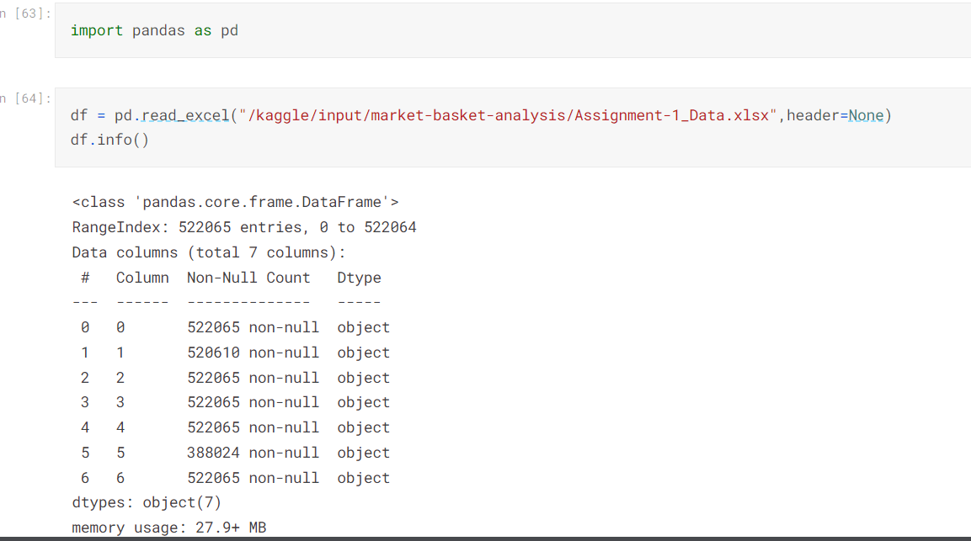

**3.Describing dataset**

The given dataset is described and head of the dataset is shown.

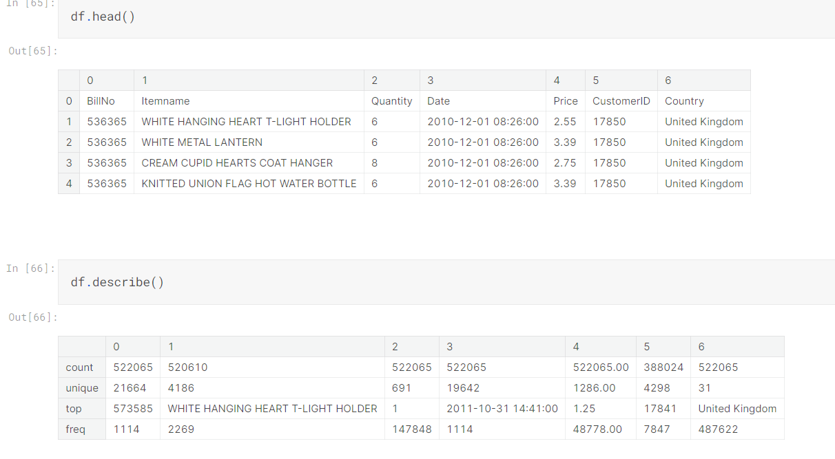

**4.Frequent itemsets are shown using bar graph:**

Frequent itemsets are a fundamental concept in Market Basket Analysis (MBA). They represent sets of items that frequently appear together in transactions. Discovering frequent itemsets is a crucial step in identifying patterns and associations between products in a retail or e-commerce dataset.

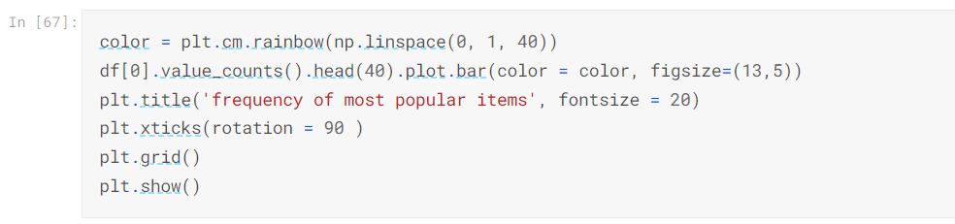

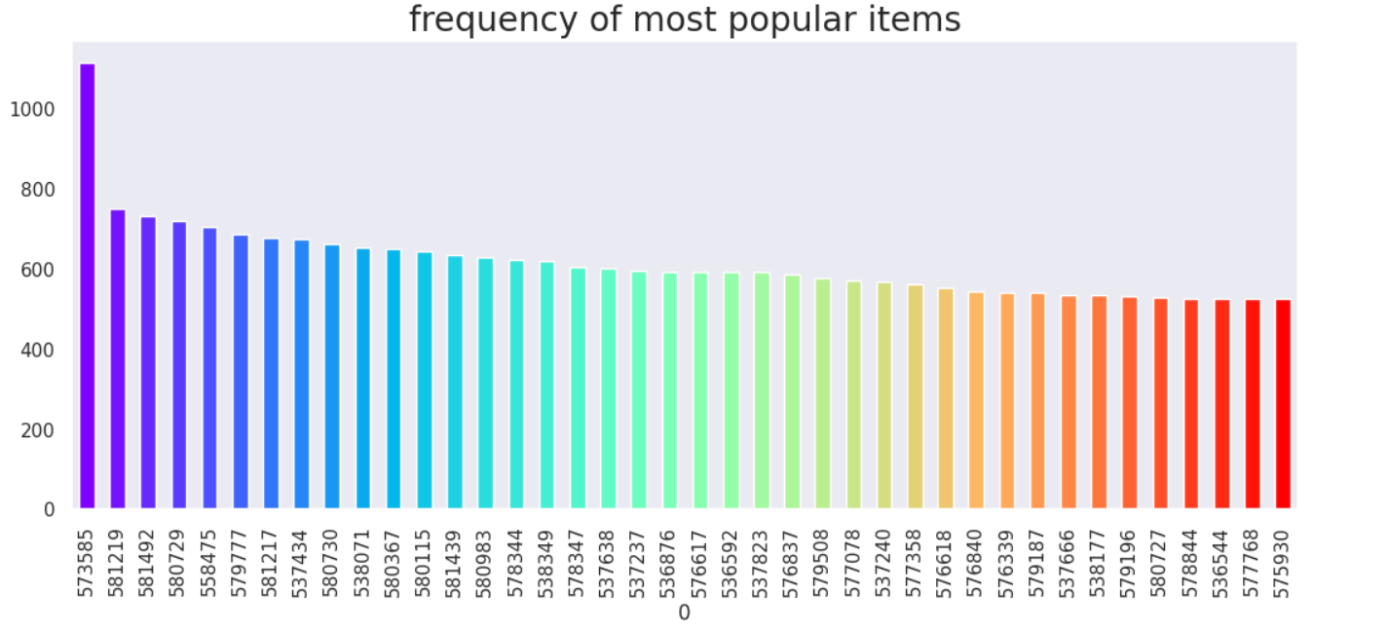

In Market Basket Analysis, unwanted warnings or spurious associations can occur when the data is not properly processed, and the analysis is not appropriately tuned.Using networkx , unwanted warnings are removed in dataset.

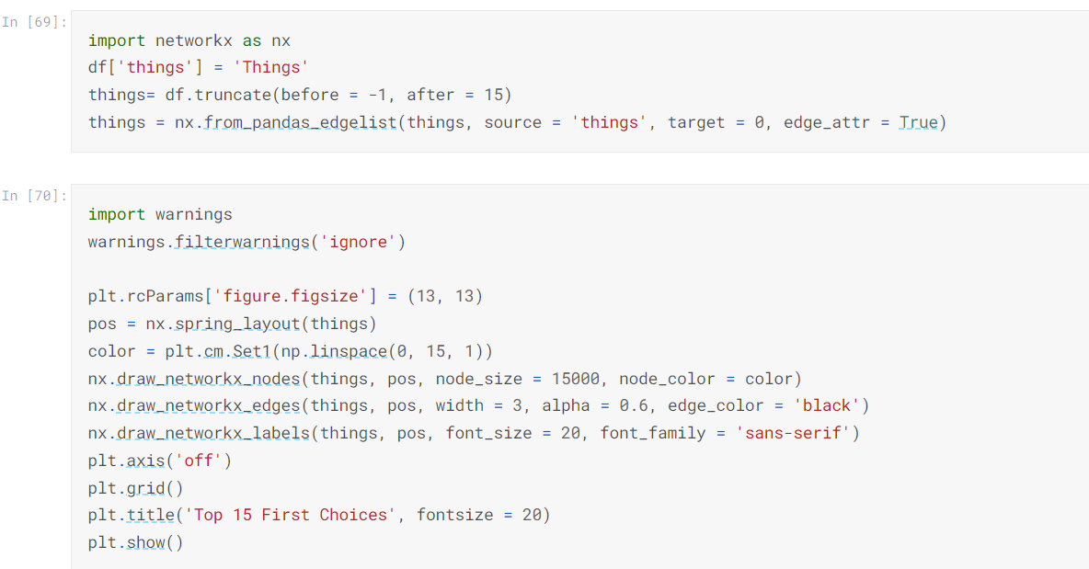

The given below diagram shows the top priority choices in the dataset.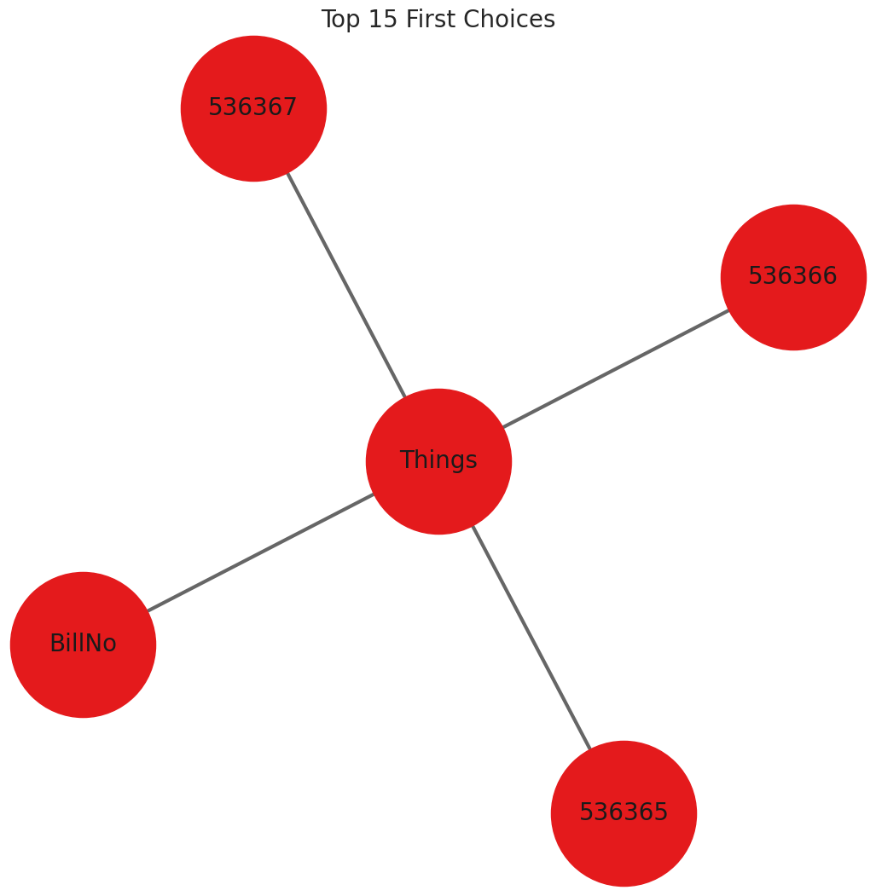

Perform iterative analysis. If you encounter unwanted warnings or associations in your initial analysis, refine your methodology, adjust parameters, and re-run the analysis.

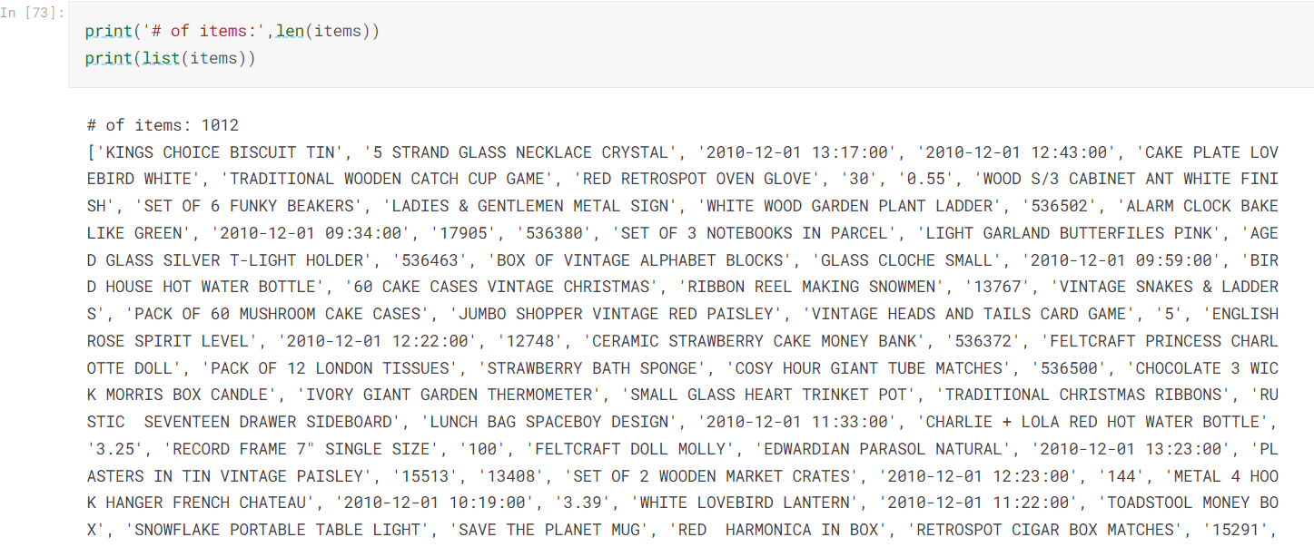

**5.Association rules**:

Association rules are a fundamental concept in Market Basket Analysis , which is used to identify interesting relationships or associations between items in transaction datasets, particularly in retail and e-commerce.

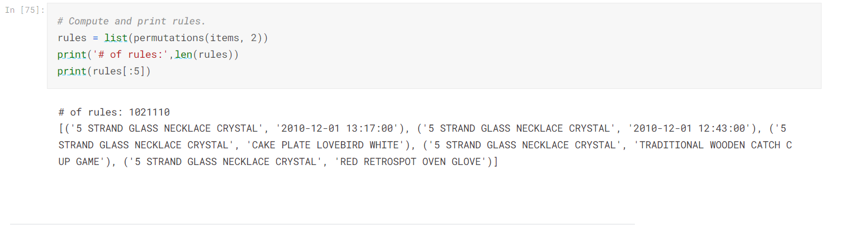

**Link for phase 3 notebook:**

<https://www.kaggle.com/code/uniqueesneh/market-basket/notebook>

**Jupyter source file:**

