**What is NLP?**

Natural language processing (NLP) refers to the branch of computer science—and more specifically, the branch of [artificial intelligence or AI](https://www.ibm.com/cloud/learn/what-is-artificial-intelligence)—concerned with giving computers the ability to understand text and spoken words in much the same way human beings can.

**Applications of NLP:**

* Sentiment Analysis.
* Text Classification.
* Chatbots & Virtual Assistants.
* Text Summarization.
* Auto-Correct.

**What is sentiment analysis?**

Sentiment analysis (or opinion mining) uses NLP to determine whether data is positive, negative or neutral. Sentiment analysis is often performed on textual data to help businesses monitor brand and product sentiment in customer feedback, and understand customer needs.

It is essentially a multiclass text classification text where the given input text is classified into positive, neutral, or negative sentiment. The number of classes can vary according to the nature of the training dataset.

For example, sometimes it is formulated as a binary classification problem with 1 as positive sentiment and 0 as negative sentiment label.

**Applications of sentiment analysis:**

Sentiment analysis has applications in a wide variety of domains including analyzing user reviews, tweet sentiment, etc. Let’s go through some of them here:

* **Movie reviews:** Analysing online movie reviews to get insights from the audience about the movie.
* **News sentiment analysis:** analyzing news sentiments for a particular organization to get insights.
* **Social media sentiment analysis:** analyze the sentiments of Facebook posts, twitter tweets, etc.
* **Online food reviews:** analyzing sentiments of food reviews from user feedback.

**Sentiment analysis in python**

* There are many packages available in python which use different methods to do sentiment analysis.

**Types:**

## Rule-based sentiment analysis

## Rule-based sentiment analysis is one of the very basic approaches to calculate text sentiments. It only requires minimal pre-work and the idea is quite simple, this method does not use any machine learning to figure out the text sentiment. For example, we can figure out the sentiments of a sentence by counting the number of times the user has used the word “sad” in his/her tweet.

## Some python packages for rule based sentiment analysis:

## Textblob

## Vader

## Embedding based models

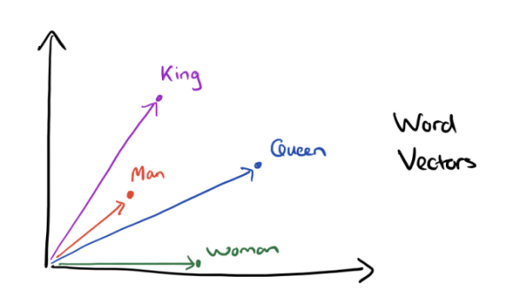Text embeddings are a form of word representation in NLP in which synonymically similar words are represented using similar vectors which when represented in an n-dimensional space will be close to each other.

Embedding based python packages use this form of text representation to predict text sentiments. This leads to better text representation in NLP and yields better model performance.

One of such packages is Flair.

### **Flair**

Flair is a simple natural language processing (NLP) library developed and open-sourced by Zalando Research. Flair’s framework builds directly on PyTorch, one of the best deep learning frameworks out there. The Zalando Research team has also released several pre-trained models for the following NLP tasks:

* **Name-Entity Recognition (NER):** It can recognise whether a word represents a person, location or names in the text.
* **Parts-of-Speech Tagging (PoS):** Tags all the words in the given text as to which “part of speech” they belong to.
* **Text Classification:** Classifying text based on the criteria (labels)
* **Training Custom Models:** Making our own custom models.

Flair outperforms several state-of-the-art results in NLP.

**Trained on IMDB dataset.**