

Portfolio Documentation

Southern Cross University



ASSIGNMENT COVER SHEET

For use with online submission of assignments

Please complete all of the following details and then make this sheet the first page of each file of your assignment – do not send it as a separate document.

Your assignments must be submitted as either Word documents, text documents with .rtf extension or as .pdf documents. If you wish to submit in any other file format, please discuss this with your lecturer well before the assignment submission date.

Student Name: Pralin Karki

Student ID No.: 23868511

Unit Name: Web-Development-1

Unit Code: ISYS001

Tutor’s name: Nectar Costadopoulos

Assignment No.: 3

Assignment Title: portfolio

Due date: 9-02-2022

Date submitted: 11-02-2022

Declaration:

I have read and understand the Rules Relating to Awards (Rule 3 Section 18 – Academic Misconduct Including Plagiarism) as contained in the SCU Policy Library. I understand the penalties that apply for plagiarism and agree to be bound by these rules. The work I am submitting electronically is entirely my own work.

**Contents**

1.Concept Map 2

2.CSS Plan 3

2.1. The CSS Layout Plan 3

2.2 The CSS Text Plan 4

3. Navigation Map 5

4. Structure Chart (Physical) 5

5. Storyboard 6

6.Testing Procedure 14

# 1.Concept Map

Audiences

* students
* Teachers
* Company

Resources

* Links to various sites
* QnA

Contact

* Email Address
* Phone number
* Social media

Layout:-

* Interactive navigation bar
* Link and thumbnail
* Images anfronts

Context

* Hobbies
* Academics
* Skills developed

***Personnel Website***

# 2.CSS Plan

## 2.1. The CSS Layout Plan

The home page of the webpage layout is presented below with all the section that is to be presented in the home page of the website.

|  |  |  |
| --- | --- | --- |
| Title: homepage-index.html | Screen ID:  01 | Date: |
|  | | |
| Studies Details And links to Webpage and social media  General introduction to the page  Thumbnail Image  Navigation option  Footer | | |

1. Navigation options
2. Photo
3. Header
4. Thumbnail image
5. Content

* General introduction to the web page.
* Studies details
* Social media

1. Footer

## 2.2 The CSS Text Plan

|  |  |  |
| --- | --- | --- |
| **enovation-external.css** | **Font Family Text**  **/ Margin** | **Color /Special Characteristics** |
| **Background** | Linear- gradient | max-width: 1200px  width: 90% |
| studies | margin-top: 100px  margin-bottom:  30px | black |
| **Green text** | Italics | Color: - Green  font-size: 2rem |
| **Red text** | Italics | color : red;  font-size: 2rem;  text-align: center; |
| **Intro** | Padding: - 5px; | Background_color :- gainsboro |
| **#footer** | Absolute positioning used Top 1240px, Left 12px | Color: - brown |
| **img** | width: 200px;  height: 200px; | Float: Left |
| container | max-width: 1200px;  width: 90%;  margin: 0 auto; | Text Color black |
| **a** | As body | Text Color #aeaeae  Text decoration: none  Bold |
| **a:hover** | As body | Text color #ff8600  Text decoration none |

# 3. Navigation Map

Internet Page

Screen ID: D

Contact us Page

Screen ID; D

Link Page

Screen ID: E

Skills Page

Screen ID:

C

Home page

Screen ID: A

Resume Page

Screen ID : B

# 4. Structure Chart (Physical)

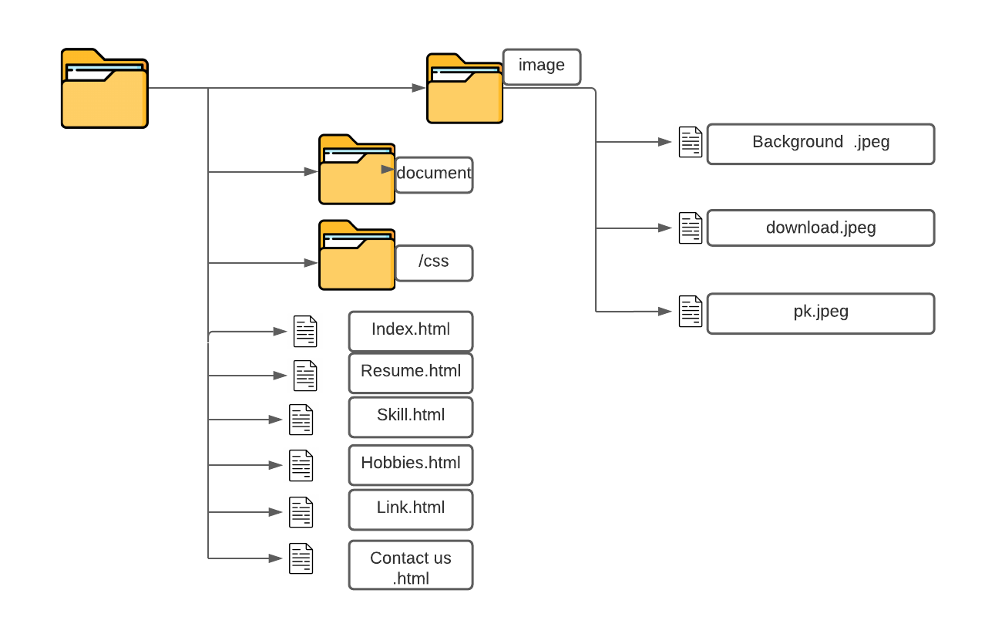

# 5. Storyboard

Link to webpage

|  |  |  |  |  |
| --- | --- | --- | --- | --- |
| Title: homepage-index.html | | Screen ID: A | Date: 11/2/2022 | |
| Web Page Diagram: | | | | |
| Studies and link to webpage  Thumbnail Image  General introduction to the page  Navigation option | | | | |
| Graphics:  This page uses a lot of graphics which is implemented in the page using the CSS. The Graphics contains a background image, a thumbnail image and a logo showing initial of my name. | | | | |
| Text:  This is the main page the home page so it contains a little introduction about the page and instruction to navigate throughout the entire web page. The navigation enables the viewer to check the connecting page. | | | | |
| Multimedia:  The page uses many kinds of images to show people about my life as much as possible. The main page contains a thumbnail image. Then a connecting gallery is present to store some of my images to make the viewer to have a little peek over my happy moments in life.  However; the page doesn’t have any audio neither video. | | | | |
| Notes:  To go through the home page there is not much information about myself as I want to sort every section in my web page. There is a navigation sector which has option to view connecting page which contains information about my academics, experience or a simple blog idea and contact information. The web page will also contain my CV and the skills I have which can help the viewer to get more about me in order. And along with the CV I also plan to include a contact us option page which can take your name, contact information and also small message which can be send to me. And within the footer I have planned to add link of my mail Facebook and other social media to look for me and also a reserved right. | | | | |
| Description: | | This the homepage from where viewer can get access to the entire connecting page to gather all the information about me which is available. | | |
| Content: | | Brief information to navigate through the pages and a introductory welcome to my web page for all the viewers. | | |
| Interactions: | | There are thumbnails images and navigation links to make a use to move through pages in web page. And also, hyperlinks of social sites I am available in. | | |
| Media Creation: | | nil | | |
| Navigation: | | The navigation can be accessed through the navigation option which is located in the top right corner. And through the introductory part as well basic navigation can be made. And in the footer section links can be used to get through social sites. | | |

|  |  |  |  |  |
| --- | --- | --- | --- | --- |
| Title: homepage-Resume.html | | Screen ID: **B** | Date: 11/2/2022 | |
| Web Page Diagram: | | | | |
| Abou page  General introduction to the page  Navigation option | | | | |
| Graphics:  This page uses a lot of graphics which is implemented in the page using the CSS. The Graphics contains a background image, a thumbnail image and a logo showing initial of my name. | | | | |
| Text:  This is the main page the home page so it contains a little introduction about the page and instruction to navigate throughout the entire web page. The navigation enables the viewer to check the connecting page. | | | | |
| Multimedia:  The page uses many kinds of images to show people about my life as much as possible. The main page contains a thumbnail image. Then a connecting gallery is present to store some of my images to make the viewer to have a little peek over my happy moments in life.  However; the page doesn’t have any audio neither video. | | | | |
| Notes:  This page contains the information about the academic record of my life till now. Along with the academic qualification this page also has my CV which provides my name, address, number, and date of birth. This page has a navigation to the other pages on the top left corner of the screen | | | | |
| Description: | | This page has information about the academic qualification and a CV. | | |
| Content: | | Brief information to navigate through the pages and a introductory welcome to my web page for all the viewers. | | |
| Interactions: | | There are thumbnails images and navigation links to make a use to move through pages in web page. And also, hyperlinks of social sites I am available in. | | |
| Media Creation: | | nil | | |
| Navigation: | | The navigation can be accessed through the navigation option which is located in the top right corner. And through the introductory part as well basic navigation can be made. And in the footer section links can be used to get through social sites. | | |

|  |  |  |  |  |
| --- | --- | --- | --- | --- |
| Title: homepage-webskill.html | | Screen ID: C | Date: 11/2/2022 | |
| Web Page Diagram: | | | | |
| Abou page  General introduction to the page  Navigation option | | | | |
| Graphics:  This page uses a lot of graphics which is implemented in the page using the CSS. The Graphics contains a background image, a thumbnail image and a logo showing initial of my name. | | | | |
| Text:  This is the main page the home page so it contains a little introduction about the page and instruction to navigate throughout the entire web page. The navigation enables the viewer to check the connecting page. | | | | |
| Multimedia:  The page uses many kinds of images to show people about my life as much as possible. The main page contains a thumbnail image. Then a connecting gallery is present to store some of my images to make the viewer to have a little peek over my happy moments in life.  However; the page doesn’t have any audio neither video. | | | | |
| Notes:  This page contains the information about all the skill I am have which can be used in the web. The text below mentions the programming language that I am good at. | | | | |
| Content: | | Brief information to navigate through the pages and a introductory welcome to my web page for all the viewers. | | |
| Interactions: | | There are thumbnails images and navigation links to make a use to move through pages in web page. And also, hyperlinks of social sites I am available in. | | |
| Media Creation: | | nil | | |
| Navigation: | | The navigation can be accessed through the navigation option which is located in the top right corner. And through the introductory part as well basic navigation can be made. And in the footer section links can be used to get through social sites. | | |

|  |  |  |  |  |
| --- | --- | --- | --- | --- |
| Title:form.html | | Screen ID: D | Date: 11/2/2022 | |
| Web Page Diagram: | | | | |
| Choose music genra  Age Group  Field to enter name and email  Comments.    Navigation option | | | | |
| Graphics:  This page uses a lot of graphics which is implemented in the page using the CSS. The Graphics contains a background image, a thumbnail image and a logo showing initial of my name. and Java script to make sure the form is filled properly. | | | | |
| Text:  This is the main page the home page so it contains a little introduction about the page and instruction to navigate throughout the entire web page. The navigation enables the viewer to check the connecting page. | | | | |
| Multimedia:  ; the page doesn’t have any audio neither video.  There is only a background image. | | | | |
| Notes: The picture presents the outer sketch about how the interest page will look. In the header section contains the header along with the picture on the left side of the header. After that there is horizontal menu in the top corner. The centre text contains content. | | | | |
| Description: | | This page is created to see our comprehension on HTML and JavaScript. | | |
| Content: | | It contains a form for kings music store. | | |
| Interactions: | | There are places that the viewer must fill and option to choose from and submit the form. | | |
| Media Creation: | | nil | | |
| Navigation: | | The navigation can be accessed through the navigation option which is located in the top right corner. And through the introductory part as well basic navigation can be made. And in the footer section links can be used to get through social sites. | | |

|  |  |  |  |  |
| --- | --- | --- | --- | --- |
| Title: web host.html | | Screen ID: E | Date: 11/2/2022 | |
| Web Page Diagram: | | | | |
| Table for Web Host cmparision  General introduction to the page  Summary  Navigation option | | | | |
| Graphics:  This page uses a lot of graphics which is implemented in the page using the CSS. The Graphics contains a background image, a thumbnail image and a logo showing initial of my name. | | | | |
| Text:  This is a Web Hosting Report page. Here there is short description about the different web host providers and information such as monthly cost, peoples review, uptime speed and other services hat it provides. | | | | |
| Multimedia:  The page doesn’t have any multimedia except for the background image and a table along with links to the web hosting sites. However; the page doesn’t have any audio neither video. | | | | |
| Notes: The picture presents the draft on how the link page will look like. The header section contains the picture as well as the navigation on the top most corner. While the rest of the page will include various link of the sites which can or might not be related to the web page. | | | | |
| Content: | | A brief analysis on Different web hosting sites. | | |
| Interactions: | | There are thumbnails images and navigation links to make a use to move through pages in web page. And also, hyperlinks of social sites I am available in. | | |
| Media Creation: | | nil | | |
| Navigation: | | The navigation can be accessed through the navigation option which is located in the top right corner. And through the introductory part as well basic navigation can be made. And in the footer section links can be used to get through social sites. | | |

|  |  |  |  |  |
| --- | --- | --- | --- | --- |
| Title: homepage-website Issue.html | | Screen ID: F | Date: 11/2/2022 | |
| Web Page Diagram: | | | | |
| General introduction to the page  About page  Navigation option | | | | |
| Graphics:  This page uses a lot of graphics which is implemented in the page using the CSS. The Graphics contains a background image and screenshot of 2 different page to make a comparison and find issue. | | | | |
| Text:  This contains the comparison between 2 different pages and talks about the problem in the webpage in respect to the real portfolio. | | | | |
| Multimedia:  There is a background image and the page consist of images that shows the difference between webpages. However; the page doesn’t have any audio neither video. | | | | |
| Notes: The picture presents the outer sketch about how the interest page will look. In the header section contains the header along with the picture on the left side of the header. After that there is horizontal menu in the top corner. Rest of the page holds detail of my contacts in various social media. And along with that if anyone have any question there is a ask me box where you can mail me. | | | | |
|  | |  | | |
| Content: | | This page is about the Issue that exists in the webpage and the way it differs from the real portfolio. | | |
| Interactions: | | There are thumbnails images and navigation links to make a use to move through pages in web page. And also, hyperlinks of social sites I am available in. | | |
| Media Creation: | | nil | | |

# 6.Testing Procedure

Testing procedure for this Website is as follows.

* + Validation of Files
    - All HTML pages will be validated using HTML validator.
    - All CSS files will be validated using CSS validator
  + Tested on various dimension devices about how it looks like in various devices.
  + Test “Look and Feel” of site on different browsers
    - Firefox 9.0.1
    - Chrome
    - Opera version 11.60
    - Microsoft Edge
  + Test all hyperlinks on site
    - All internal links (site navigation)
    - All external hyperlinks.
  + Test proper functioning of all media on site
    - Images