Regime Switching Online Conformal Prediction with Test Martingales
G. Arul Dalton^{1*} and P. Sankar²
¹Department of Computer Science and Engineering, Saveetha Engineering College, Chennai, Tamil Nadu, India. E-mail: aruldalton@saveetha.ac.in
²Department of Computer Science and Engineering, Saveetha Engineering College, Chennai, Tamil Nadu, India. E-mail: sankarp@saveetha.ac.in
*Corresponding author: G. Arul Dalton, e-mail: aruldalton@saveetha.ac.in
ORCID: G. Arul Dalton, 0000-0002-5981-7176; P. Sankar, 0009-0008-0986-4493
Acknowledgements Not applicable.
Author contributions Conceptualization: G. Arul Dalton; Methodology: G. Arul Dalton; Software: G. Arul Dalton; Formal analysis and investigation: G. Arul Dalton, P. Sankar; Validation: P. Sankar; Visualization: P. Sankar; Writing – original draft preparation: G. Arul Dalton; Writing – review and editing: P. Sankar, G. Arul Dalton; Supervision: G. Arul Dalton. All authors read and approved the final manuscript.
Funding The authors did not receive support from any organization for the submitted work.
Competing interests The authors have no competing interests to declare that are relevant to the content of this article.

Regime Switching Online Conformal Prediction with Test Martingales
Abstract
Online conformal prediction methods, such as adaptive conformal inference, maintain long-run coverage under distribution shift by adjusting a miscoverage level or threshold after every observation. Because these updates are local and blind to when the data-generating process changes, they recover slowly from abrupt regime switches and keep intervals inflated after a stream becomes easier. We propose Martingale-triggered Adaptive Regime-Switching Conformal Prediction (MARS-CP), a plug-in wrapper that gives any online conformal updater an explicit, statistically controlled notion of regime. MARS-CP converts each new nonconformity score into a conformal p-value against the current regime, monitors these p-values with a two-sided conformal test martingale, and raises an alarm only when the martingale exceeds 1/δ, so that the probability of any false alarm on an exchangeable stream is at most δ. On an alarm, the change point is localised, the calibration buffer is rebuilt from post-change scores, and the inner updater is re-initialised. We prove anytime false-alarm control and a long-run coverage bound that degrades gracefully with the number of re-initialisations. On four synthetic scenarios and four public real-world streams, wrapping adaptive conformal inference reduces local coverage error by 29% and under-coverage time by 57% on recurring abrupt shifts, and narrows intervals by 22% on an industrial sensor stream at matched coverage. Gains for faster updaters are smaller and appear mainly in interval width. Under slow gradual drift the method triggers unnecessary resets and local coverage error increases by 4–12%, which we report as its main limitation.
Keywords Conformal prediction · Distribution shift · Concept drift · Test martingales · Change-point detection · Uncertainty quantification

1 Introduction
Machine-learning forecasters are increasingly deployed in settings where a point prediction is not enough: grid operators schedule reserves against demand forecasts, maintenance systems act on predicted sensor trajectories and on fault indicators extracted from streaming sensor data (Kavitha et al., 2022), and clinical monitors raise alerts from predicted vital signs. In each case the downstream decision depends on a calibrated statement of uncertainty, and the distinction between reducible and irreducible uncertainty matters for how such statements are used (Hüllermeier & Waegeman, 2021). Conformal prediction (CP) offers distribution-free uncertainty statements (Angelopoulos & Bates, 2023; Shafer & Vovk, 2008; Vovk et al., 2005): given a black-box predictor and a nonconformity score, split CP returns prediction sets whose marginal coverage is at least 1 − α whenever calibration and test data are exchangeable (Lei et al., 2018).
Streaming data rarely satisfy exchangeability. Demand shifts with holidays and tariffs, industrial sensors switch between operating modes, and weather follows seasonal regimes. A growing line of work therefore replaces exchangeability by online adaptation. Adaptive conformal inference (ACI) (Gibbs & Candès, 2021) updates the working miscoverage level α_{t} by a gradient step on the coverage error, guaranteeing that long-run coverage converges to 1 − α for arbitrary sequences. Its successors tune the step size automatically (DtACI) (Gibbs & Candès, 2024), aggregate experts over step sizes (AgACI) (Zaffran et al., 2022), obtain strongly adaptive regret (SAOCP) (Bhatnagar et al., 2023), or track the score quantile directly with control-theoretic updates (conformal PID / quantile tracking) (Angelopoulos et al., 2023). Recent work accelerates adaptation by retrospectively refitting past predictions (Jun & Ohn, 2026) or by conditioning on the predicted latent state of a switching dynamical system (Sun & Yu, 2025).
These methods share a structural feature: they react to shift implicitly and locally, one observation at a time. After an abrupt switch, the calibration window still contains hundreds of scores from the previous regime; the updater must accumulate enough coverage errors to push α_{t} (or q_{t}) to the new level, and during this period coverage collapses. The reverse problem is equally important but rarely discussed: when a stream becomes easier (for example, a noisy machine returns to its normal mode), stale high scores keep intervals unnecessarily wide, and coverage-driven updates, which respond to errors, provide only weak pressure to shrink them. Meanwhile, a separate literature on conformal test martingales (Prinster et al., 2025; Volkhonskiy et al., 2017; Vovk, 2021; Vovk et al., 2021) provides principled, anytime-valid detection of departures from exchangeability, but leaves the response to an alarm, such as recalibrating or retraining, as a separate design choice (Vovk et al., 2021).
This paper connects the two lines. We ask: can an online conformal method use statistically controlled change detection to decide when its calibration history has become obsolete, and rebuild it immediately, while inheriting the long-run guarantees of existing updaters? Our answer is MARS-CP, a lightweight wrapper around any online CP updater. Its design principle is conservative: on an exchangeable stream it should behave exactly like the updater it wraps, and it should intervene only when there is evidence, quantified by a test martingale with a user-chosen false-alarm budget δ, that the score distribution has changed in either direction.
The main contributions are:
- A regime-switching wrapper for online CP. MARS-CP monitors regime-conditional conformal p-values of the nonconformity scores with a two-sided simple-jumper test martingale, localises the change point at the minimum of the log-martingale path, rebuilds the calibration buffer from post-change scores with a conservative bridge, and re-initialises the inner updater. It wraps ACI, quantile tracking (QT) and DtACI without modification (Sect. 4, Algorithms 1–3).
- Guarantees. We prove that the probability of any false alarm on an exchangeable score stream is at most δ, that MARS-CP then coincides with its inner updater, and that for the ACI inner updater the long-run miscoverage deviates from α by at most (K_{T}+1)(1+(1+n_{min})γ)/(γT), where K_{T} is the number of re-initialisations (Sect. 5).
- A reproducible empirical study. On four synthetic scenarios and four public real-world streams, with hyperparameters fixed on held-out validation seeds, we compare against split CP, rolling CP, ACI, QT and DtACI, with paired Wilcoxon tests, ablations, change-detection statistics, and sensitivity to δ, α and window size (Sects. 6 and 7).
- An honest account of failure modes. We identify the regimes where the approach helps (abrupt and recurring shifts, and easing shifts that stale scores would otherwise inflate), where it hurts (slow gradual drift), and a component that does not deliver measurable benefit (regime memory), giving practitioners concrete guidance (Sect. 8).
Main claim and relation to prior work. Our central claim is that deciding when the calibration history of an online conformal predictor is obsolete, with anytime false-alarm control, is a useful complement to research on how much to adapt after each observation. The closest works either adapt implicitly (Angelopoulos et al., 2023; Bhatnagar et al., 2023; Gibbs & Candès, 2021, 2024; Zaffran et al., 2022), require specific model classes (Jun & Ohn, 2026; Sun & Yu, 2025), or study detection and monitoring without specifying an interval-construction response (Leong, 2026; Prinster et al., 2025; Vovk et al., 2021). No part of this work has been published previously or submitted elsewhere.
The remainder of the paper is organised as follows. Section 2 reviews related work and Section 3 formalises the problem. Section 4 presents MARS-CP and Section 5 its theoretical properties. Sections 6 and 7 describe the experimental protocol and results, Section 8 discusses implications and limitations, and Section 9 concludes.

2 Related Work

2.1 Conformal prediction beyond exchangeability
Classical CP (Shafer & Vovk, 2008; Vovk et al., 2005) and its split variant (Lei et al., 2018) guarantee finite-sample marginal coverage under exchangeability; a comprehensive introduction is given by Angelopoulos and Bates (2023). Conditional validity is attainable only in restricted senses, such as label- or object-conditional coverage for inductive conformal predictors (Vovk, 2013), which is one reason why marginal and long-run guarantees dominate the online literature. Several offline extensions relax exchangeability. Weighted CP corrects for known or estimated covariate shift through likelihood-ratio weights (Tibshirani et al., 2019), and label-shift corrections exist for classification (Podkopaev & Ramdas, 2021). Barber et al. (2023) bound the coverage gap in terms of the total-variation distance between reweighted calibration points and the test point, which motivates down-weighting old data in drifting streams. These methods require either knowledge of the shift type or a weighting scheme fixed in advance; none decides online when the past has become irrelevant.

2.2 Online adaptive conformal inference
ACI (Gibbs & Candès, 2021) treats the miscoverage level as a parameter of an online learner and updates α_{t+1} = α_{t} + γ(α − err_{t}); this yields a deterministic long-run coverage bound for arbitrary data but requires choosing γ, which trades adaptation speed against volatility. DtACI (Gibbs & Candès, 2024) runs ACI experts over a grid of step sizes and aggregates them by exponential weights, with regret guarantees over local intervals. AgACI (Zaffran et al., 2022) aggregates experts with online expert-aggregation rules, and SAOCP (Bhatnagar et al., 2023) attains strongly adaptive regret with scale-free online gradient descent. Conformal PID control (Angelopoulos et al., 2023) updates the score quantile directly (the quantile tracker, QT), optionally adding integral and ‘scorecasting’ terms. For time series, EnbPI (Xu & Xie, 2021) and SPCI (Xu & Xie, 2023) use bootstrap ensembles and residual-quantile regression respectively. RetroAdj (Jun & Ohn, 2026) retrospectively updates past predictions through leave-one-out formulas, which accelerates adaptation but requires regression models with efficient leave-one-out updates. CPTC (Sun & Yu, 2025) conditions intervals on the predicted state of a switching dynamical system, which requires a state-space forecaster. MARS-CP is complementary: it keeps the base predictor a black box and wraps any of the updaters above.

2.3 Change detection with conformal test martingales
Classical sequential change detection includes CUSUM (Page, 1954) and Bayesian online change-point detection (Adams & MacKay, 2007). Conformal test martingales (Volkhonskiy et al., 2017; Vovk, 2021) turn conformal p-values, which are independent and uniform under exchangeability, into nonnegative martingales whose growth is evidence against exchangeability; Ville’s inequality (Ville, 1939) then controls the false-alarm probability uniformly over time. Vovk et al. (2021) used such martingales to decide when to retrain a predictor, and WATCH (Prinster et al., 2025) generalised them to weighted conformal martingales that adapt to mild covariate shift and diagnose severe shifts. Concurrently, Leong (2026) couples a sliding-window Kolmogorov–Smirnov detector, whose alarm threshold is calibrated empirically rather than through an anytime guarantee, with a weighted conformal layer for deployed safety classifiers. These works focus on detection and monitoring; MARS-CP instead uses a test martingale as the trigger inside an online interval-construction procedure and specifies the response (localisation, buffer reconstruction, updater re-initialisation and optional regime recall).

2.4 Concept-drift adaptation
The data-stream literature has long studied concept drift through detectors such as ADWIN (Bifet & Gavaldà, 2007) and adaptive ensembles; see the surveys by Gama et al. (2014) and Lu et al. (2019). Related work on sensor and time-series streams has addressed rotor fault detection from streaming magnetoresistance sensor data (Kavitha et al., 2022) and efficient pattern matching for uncertain time series through optimal sampling and dimensionality reduction (Dinakaran et al., 2020). These methods adapt the predictor or process uncertain signals, but they generally do not produce calibrated, distribution-free prediction intervals. MARS-CP adapts the uncertainty layer and is agnostic to how, or whether, the predictor itself is updated. Table 1 summarises the positioning.
Table 1 Positioning of MARS-CP relative to representative conformal methods for non-exchangeable data (✓ supported, ✗ not supported, — not applicable). The comparison reflects the primary design of each method as described in its original publication
Method | Online adaptation | Explicit change detection | Anytime false-alarm control | Wraps any online CP updater | Black-box predictor
Split CP (Lei et al., 2018) | ✗ | ✗ | — | — | ✓
ACI (Gibbs & Candès, 2021) | ✓ | ✗ | — | — | ✓
DtACI / AgACI (Gibbs & Candès, 2024; Zaffran et al., 2022) | ✓ | ✗ | — | — | ✓
SAOCP (Bhatnagar et al., 2023) | ✓ | ✗ | — | — | ✓
Conformal PID / QT (Angelopoulos et al., 2023) | ✓ | ✗ | — | — | ✓
RetroAdj (Jun & Ohn, 2026) | ✓ | ✗ | — | — | ✗ (LOO-updatable models)
CPTC (Sun & Yu, 2025) | ✓ | via state model | ✗ | ✗ | ✗ (switching forecaster)
CTM retraining (Vovk et al., 2021) | retrain trigger | ✓ | ✓ | ✗ | ✓
WATCH (Prinster et al., 2025) | ✓ (covariate shift) | ✓ | ✓ | ✗ | ✓
KS monitor + weighted CP (Leong, 2026) | on alarm | ✓ (KS) | ✗ (empirical) | ✗ | ✓
MARS-CP (ours) | ✓ | ✓ (two-sided) | ✓ | ✓ | ✓

3 Problem Formulation and Preliminaries

3.1 Setting
We observe a stream (X₁,Y₁), (X₂,Y₂), … with X_{t} ∈ 𝒳 and Y_{t} ∈ ℝ. At each time t a forecaster f̂_{t}, trained only on data before t, produces a point prediction f̂_{t}(X_{t}); the forecaster may be refitted periodically. We use the absolute-residual nonconformity score s_{t} = |Y_{t} − f̂_{t}(X_{t})|. Before Y_{t} is revealed, an online conformal method outputs a threshold q_{t} computed from past scores and forms the interval
Ĉ_{t}(X_{t}) = [ f̂_{t}(X_{t}) − q_{t} , f̂_{t}(X_{t}) + q_{t} ], err_{t} = 𝟙{ s_{t} > q_{t} }. (1)
The target miscoverage is α ∈ (0,1). We model non-stationarity as a sequence of regimes: unknown change points 0 = τ₀ < τ₁ < … partition time such that, within a regime, scores are (approximately) exchangeable, while their distribution may differ arbitrarily across regimes and may recur.

3.2 Evaluation criteria
Long-run coverage (1/T)Σ(1 − err_{t}) is necessary but insufficient, since a method can over-cover in one regime and under-cover in another. Following earlier work (Angelopoulos et al., 2023; Gibbs & Candès, 2021, 2024), we also measure behaviour over time. With rolling coverage c̄_{t} computed over a window of w = 100 steps, we report: (i) marginal coverage; (ii) mean interval width 2q̄ (infinite thresholds, which ACI-type methods produce when α_{t} ≤ 0, are clipped at the largest observed score, and their frequency is reported separately as Inf%); (iii) local coverage error LCE = mean_{t}|c̄_{t} − (1 − α)|; (iv) under-coverage time UCT, the percentage of steps with c̄_{t} < 1 − α − 0.05; and (v) on synthetic streams with known change points, coverage over the 200 steps following each change (post-shift coverage) and its worst case across changes.

3.3 Split conformal quantile and ACI
For a calibration multiset 𝓑 of n scores and a level a, the conformal quantile is
Q(𝓑; a) = s_{(k)} with k = ⌈(n+1)(1 − a)⌉, Q = +∞ if a ≤ 0 or k > n, Q = 0 if a ≥ 1, (2)
where s_{(k)} is the k-th smallest element. Rolling CP uses the last W scores as 𝓑. ACI (Gibbs & Candès, 2021) sets q_{t} = Q(𝓑_{t}; α_{t}) and updates
α_{t+1} = α_{t} + γ(α − err_{t}). (3)

3.4 Conformal test martingales
Given a multiset 𝓗 of n past scores, the smoothed conformal p-value of a new score s is
p(s; 𝓗) = ( #{h ∈ 𝓗 : h > s} + U · (#{h ∈ 𝓗 : h = s} + 1) ) / (n + 1), U ~ Unif(0,1). (4)
If the scores are exchangeable and each p-value is computed against all previous scores, the p-values are independent and uniformly distributed on [0,1] (Volkhonskiy et al., 2017; Vovk et al., 2005). A betting function g: [0,1] → [0,∞) with ∫g = 1 then yields a nonnegative martingale M_{t} = Π g(p_{j}) with M₀ = 1, and Ville’s inequality (Ville, 1939) gives P(sup_{t} M_{t} ≥ 1/δ) ≤ δ. The simple-jumper martingale (Vovk, 2021; Vovk et al., 2021) mixes betting functions g_{ε}(p) = 1 + ε(p − 1/2), ε ∈ {−1, 0, 1}, allowing capital to ‘jump’ between them with rate J, which lets it detect changes that occur long after monitoring starts.

4 The Proposed MARS-CP Framework

4.1 Overview
MARS-CP (Fig. 1) runs three paths. The prediction path is an unmodified online CP updater (ACI, QT or DtACI) that computes q_{t} from the calibration buffer 𝓑_{k} of the current regime k. The monitoring path converts every new score into a conformal p-value with respect to the history of the current regime and feeds it to a two-sided test martingale (Algorithm 2). The response path (Algorithm 3) is executed only when the martingale raises an alarm: it localises the change point, closes regime k, opens regime k+1 with a buffer made of post-change scores, and re-initialises the updater. An optional regime-memory bank stores closed regimes and recalls a matching one when a regime recurs. Algorithm 1 combines the three paths, and Fig. 2 traces the life cycle of a regime through them.
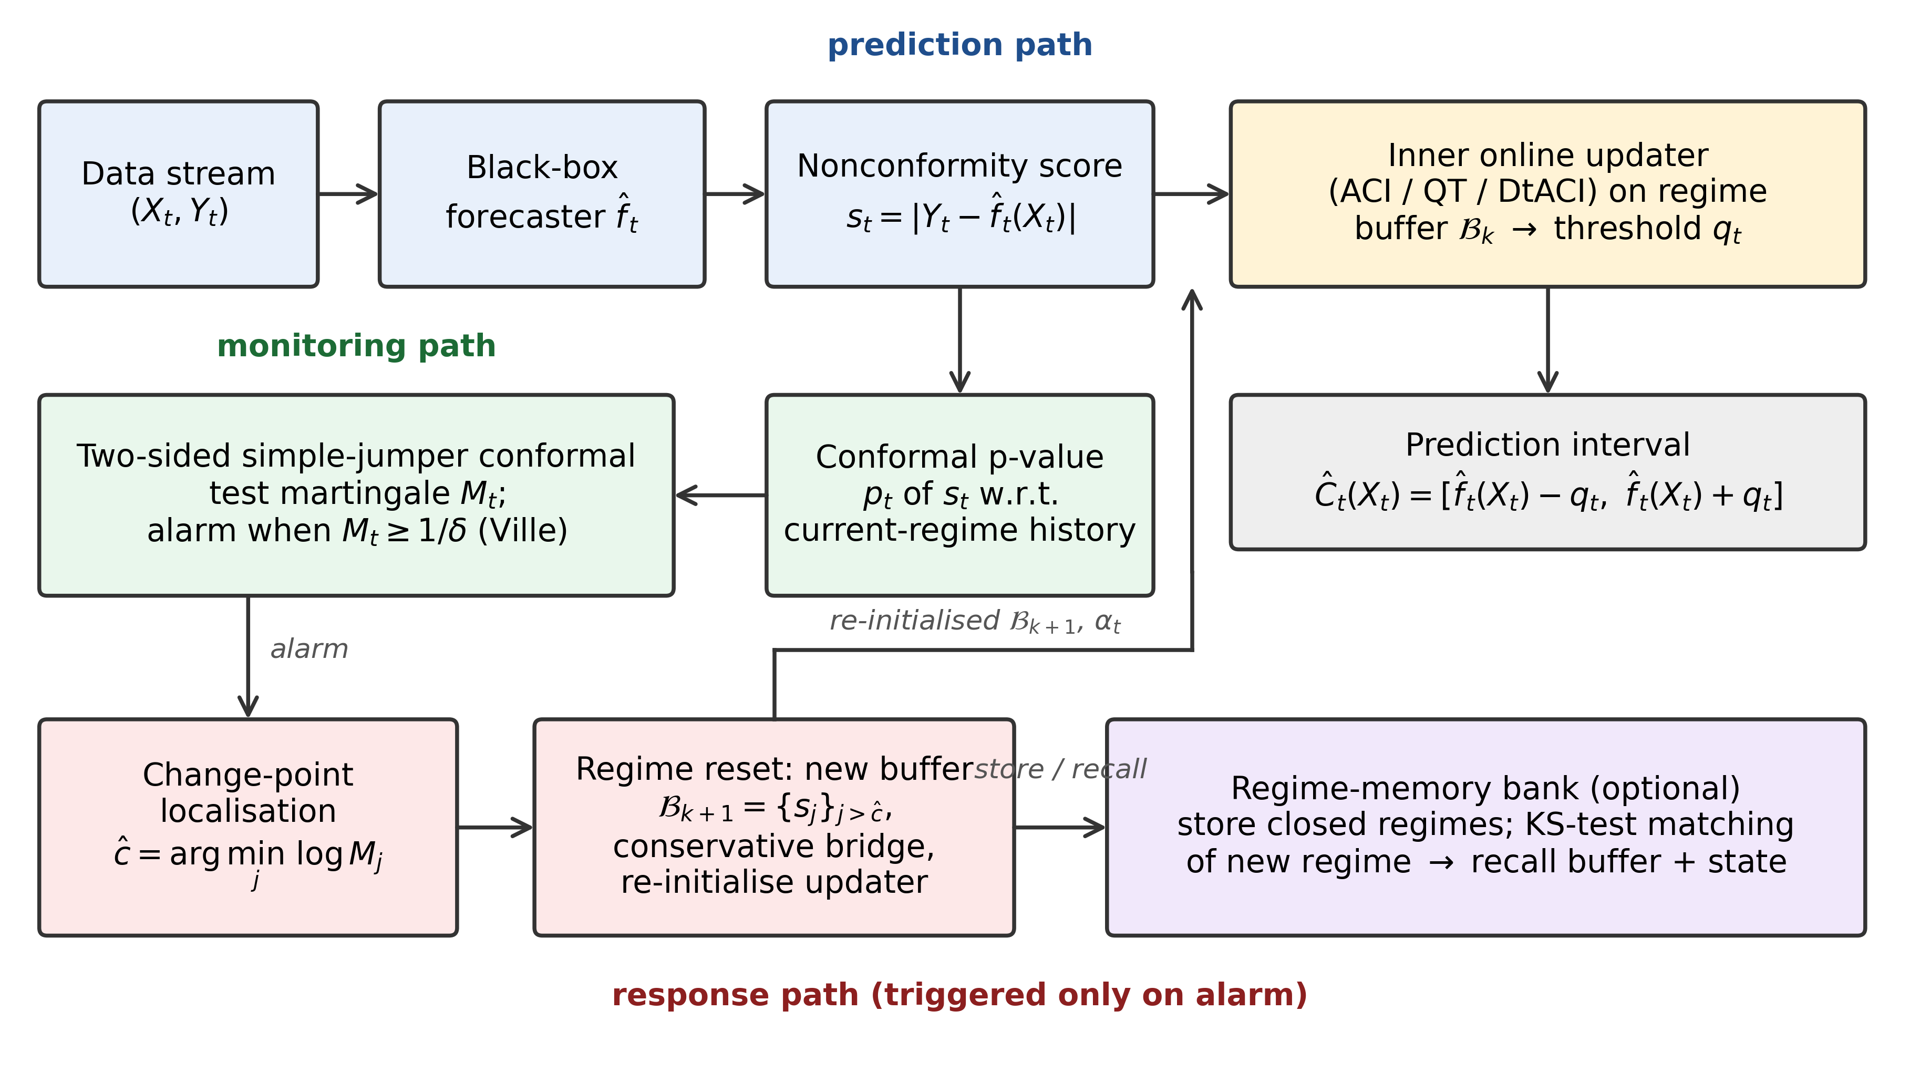
Fig. 1 Architecture of MARS-CP. The prediction path is any online conformal updater operating on the current regime buffer. The monitoring path computes regime-conditional conformal p-values and a two-sided simple-jumper test martingale. The response path, triggered only when the martingale exceeds 1/δ, localises the change, rebuilds the buffer and re-initialises the updater; the regime-memory bank is optional

4.2 Regime-conditional conformal p-values
Let 𝓗_{k} denote all scores observed since regime k was opened (including the post-change scores it was initialised with). When s_{t} is revealed, MARS-CP computes p_{t} = p(s_{t}; 𝓗_{k}) by Eq. (4) and inserts s_{t} into 𝓗_{k}, kept sorted so that each p-value costs O(log n) comparisons. Crucially, p-values are computed against the full regime history rather than the size-W calibration window, which is what makes them independent and uniform when the regime is exchangeable, and hence what makes the false-alarm guarantee of Sect. 5 hold. The p-values do not depend on q_{t} or on the inner updater, so the monitor is identical for all wrapped methods.

4.3 Two-sided simple-jumper martingale
Small p-values mean that new scores are larger than those of the current regime (the stream became harder and coverage is threatened); large p-values mean that they are smaller (the stream became easier and intervals are needlessly wide). Coverage-driven updaters see the first kind of change through errors but see the second only weakly. MARS-CP therefore uses the full simple jumper with states ε ∈ {−1, 0, +1}: the state ε = −1 profits from small p-values, ε = +1 from large ones, and ε = 0 is neutral. With capital vector C_{t} over the states, each step performs
C_{t} ← (1 − J) C_{t−1} + (J/3) · ΣC_{t−1}, C_{t}(ε) ← C_{t}(ε) · (1 + ε(p_{t} − 1/2)), M_{t} = Σ_{ε} C_{t}(ε), (5)
computed in log-space for numerical stability. An alarm is raised when log M_{t} ≥ log(1/δ). Algorithm 2 gives the monitoring procedure, including change localisation. The one-sided variant (states {−1, 0}) is evaluated as an ablation.
Algorithm 2 MONITOR: two-sided jumper update and change localisation
Input: new score s_{t}; sorted regime history 𝓗; capital vector C over ε ∈ {−1, 0, +1}; log-martingale path Λ; jumper rate J; budget δ.
Output: alarm flag and, on alarm, the localised change point ĉ.
n ← |𝓗|; g ← #{h ∈ 𝓗 : h > s_{t}}; e ← #{h ∈ 𝓗 : h = s_{t}}; draw U ~ Unif(0,1)
p_{t} ← (g + U(e + 1)) / (n + 1) ▷ regime-conditional p-value, Eq. (4)
C ← (1 − J) C + (J/3) ΣC ▷ jumping between betting states
for ε ∈ {−1, 0, +1} do C(ε) ← C(ε) · (1 + ε(p_{t} − 1/2)) ▷ ε = −1 bets on harder, ε = +1 on easier
Λ_{t} ← Λ_{t−1} + log ΣC; C ← C / ΣC ▷ log-space normalisation
insert s_{t} into 𝓗 (sorted); append Λ_{t} to path
if Λ_{t} ≥ log(1/δ) then
ĉ ← (index of the first monitored score) + argmin_{j} Λ_{j} ▷ evidence started to grow after ĉ, Eq. (6)
return (ALARM, ĉ)
return (NO ALARM)

4.4 Change localisation, regime reset and conservative bridge
A martingale alarm occurs after the change, with a delay that depends on its magnitude. Discarding only the scores after the alarm would waste post-change information, while keeping all scores since the last reset would contaminate the new buffer with pre-change data. MARS-CP localises the change at
ĉ = argmin_{j ≤ t} log M_{j}, (6)
the point after which the accumulated evidence started to grow, in the spirit of CUSUM (Page, 1954). Scores after ĉ (at most W of them) form the new buffer 𝓑_{k+1} and history 𝓗_{k+1}, the martingale is reset to M = 1, and the inner updater is re-initialised: ACI restarts from α_{t} = α; QT restarts from q_{t} = Q(𝓑_{k+1}; α); for DtACI, the experts’ levels restart from α while the expert weights are retained, because the step size that suited the previous regime is informative about the next. The pre-change scores are kept as 𝓑_{prev}.
Immediately after a reset the new buffer may contain very few scores, and Eq. (2) would return +∞. For the first n_{min} scores of a new regime (and unless a recall has occurred), MARS-CP therefore uses the conservative bridge
q_{t} = max{ min(q^{inner}_{t}, max 𝓑_{k+1}), Q(𝓑_{prev}; α) }, (7)
which never falls below the previous regime’s quantile while fresh evidence is scarce, and grows immediately if the new scores are larger. Figure 2 shows how these steps form the life cycle of a regime, and Algorithm 3 states the response procedure.
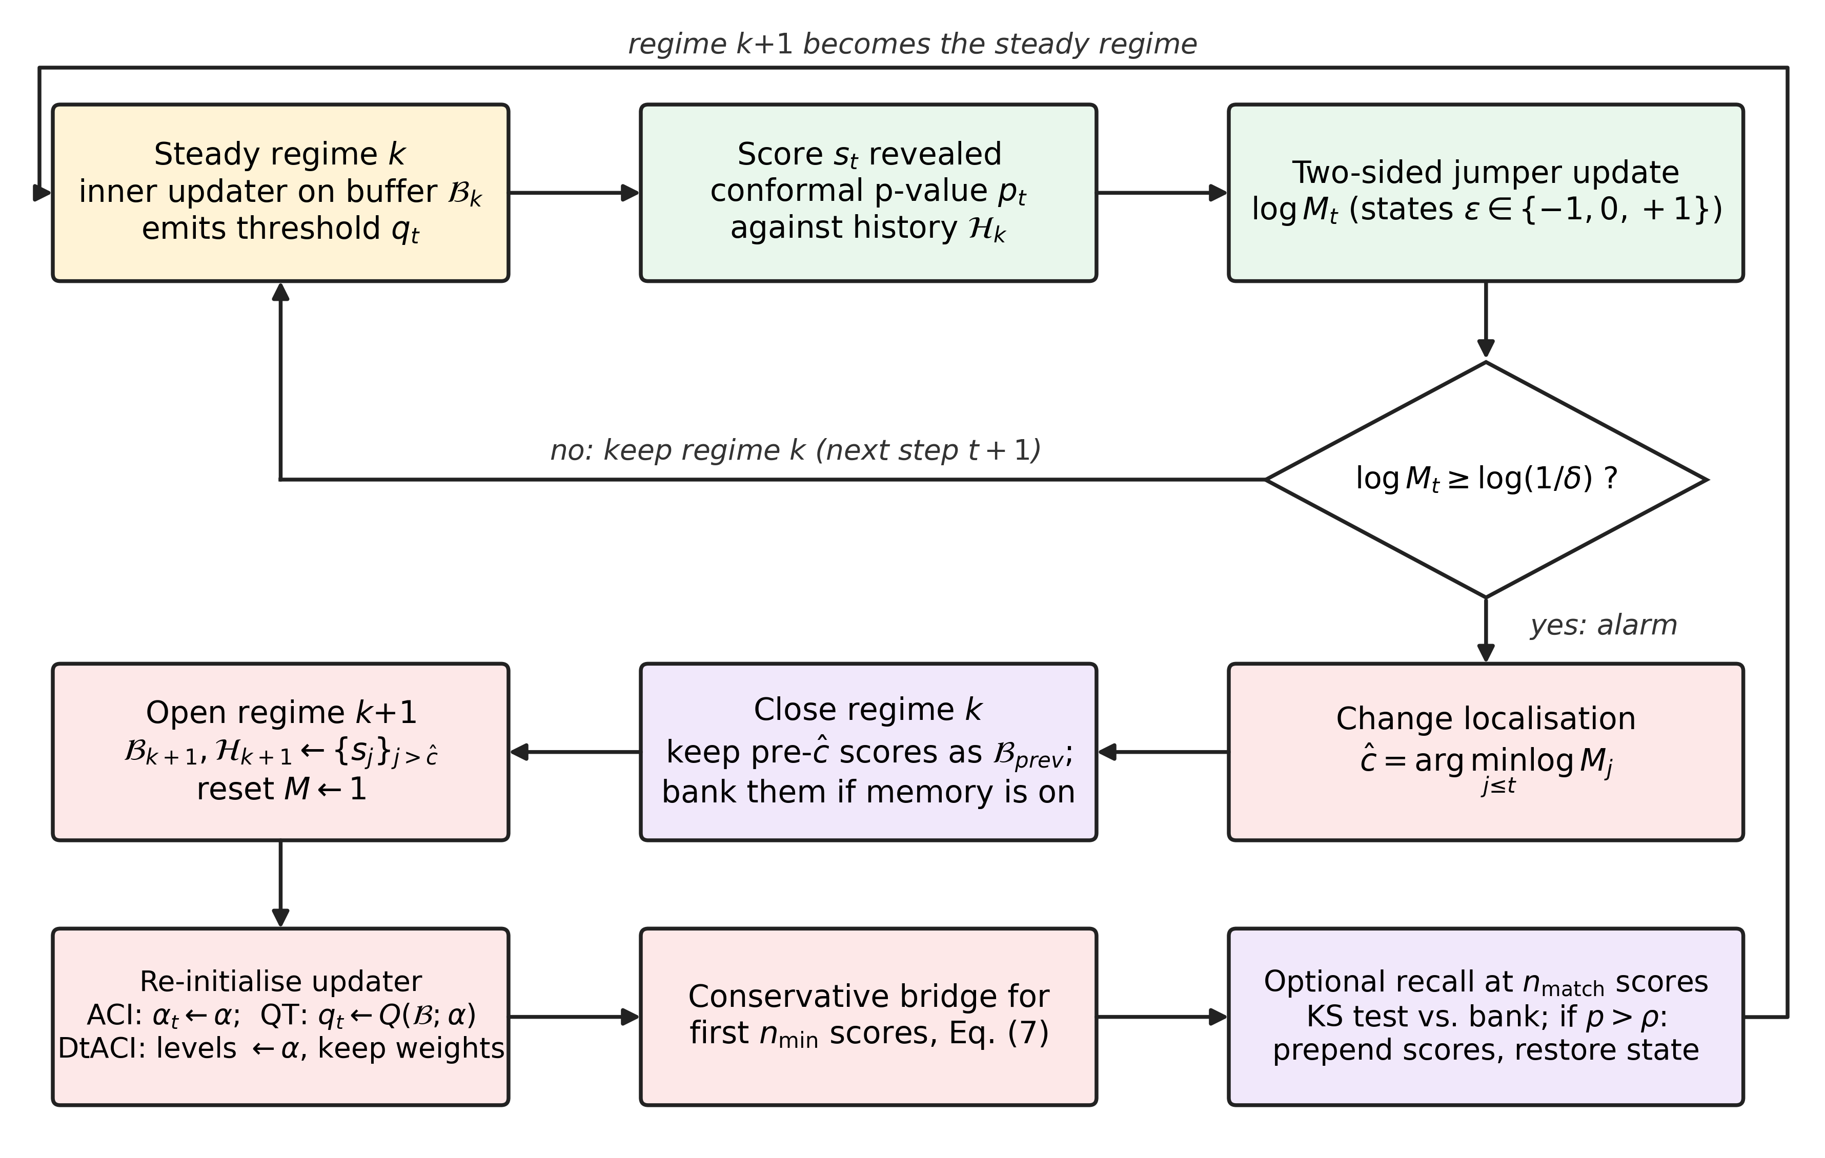
Fig. 2 Life cycle of a regime in MARS-CP. In the steady state, every revealed score updates the regime-conditional p-value and the two-sided jumper. An alarm triggers change localisation, closes the regime, opens a new one from post-change scores, re-initialises the inner updater, applies the conservative bridge and, optionally, attempts a single recall from the regime-memory bank
Algorithm 3 RESPOND: regime reset, updater re-initialisation and optional recall
Input: localised change point ĉ; ordered regime scores S; recalled scores 𝓜 (possibly empty); inner updater 𝒰; window W; memory settings (n_{match}, ρ, B).
S_{pre} ← scores of S before ĉ; S_{post} ← last W scores of S from ĉ onward
𝓑_{prev} ← last W scores of (𝓜 ⧺ S_{pre}) ▷ previous regime, used by the bridge, Eq. (7)
if memory and |𝓑_{prev}| ≥ n_{match} then push (𝓑_{prev}, state of 𝒰) to bank; keep the last B entries
𝓑 ← S_{post}; 𝓗 ← sort(S_{post}); C ← (1/3, 1/3, 1/3); path ← [0]; 𝓜 ← ∅
re-initialise 𝒰: ACI: α_{t} ← α; QT: q_{t} ← Q(𝓑; α) (max 𝓑 if infinite); DtACI: expert levels ← α, keep weights
mark bridge active for the next n_{min} scores; recall_tried ← false
procedure RECALL (called once |𝓗| ≥ n_{match} and recall_tried = false)
recall_tried ← true; j′ ← argmax_{j} KS-p(𝓗, bank_{j}) ▷ two-sample Kolmogorov–Smirnov p-value
if KS-p(𝓗, bank_{j′}) > ρ then 𝓜 ← scores of bank_{j′}; 𝓑 ← 𝓜 ⧺ 𝓑; restore 𝒰 state; remove bank_{j′}
▷ recalled scores enter 𝓑 but never 𝓗, so recall cannot affect false-alarm control

4.5 Optional regime memory
Many streams revisit earlier regimes (weekday/weekend demand, machine operating modes). MARS-CP can store each closed regime (its last W scores and final updater level) in a bank of capacity B. Once the new regime holds n_{match} scores, a two-sample Kolmogorov–Smirnov test compares it with every banked regime; if the largest p-value exceeds a recall threshold ρ, the matched scores are prepended to the calibration buffer and the updater state is restored. Only one recall attempt is made per regime, so that the KS tests do not become a multiple-testing problem. Recalled scores enter the calibration buffer but not the martingale history, so recall cannot affect false-alarm control.

4.6 Complete procedure and complexity
Algorithm 1 gives the complete procedure, calling Algorithm 2 at every step and Algorithm 3 on every alarm. Per step, the p-value and insertion cost O(log n) comparisons plus an O(n) list insertion, the conformal quantile costs O(W) by selection, and the martingale update is O(1). The response path costs O(n) per alarm, and each recall attempt O(B·W log W). The measured overhead is below 0.1 ms per step for every inner updater (Sect. 7.7).
Algorithm 1 MARS-CP (wrapping an inner updater 𝒰 ∈ {ACI, QT, DtACI})
Input: target α; window W; false-alarm budget δ; jumper rate J; bridge length n_{min}; memory flag, n_{match}, ρ, B; initial scores s₁, …, s_{n₀}.
Init: 𝓑 ← last W initial scores; 𝓗 ← sorted initial scores; C ← (1/3, 1/3, 1/3); path ← [0]; bank ← ∅; 𝓑_{prev} ← ∅; initialise 𝒰.
for t = n₀+1, n₀+2, … do
q_{t} ← 𝒰.threshold(𝓑) ▷ Eq. (2)/(3), QT or DtACI rule
if bridge active and no recall in this regime then apply the conservative bridge, Eq. (7)
output Ĉ_{t} = [ f̂_{t}(X_{t}) ± q_{t} ]; observe Y_{t}; s_{t} ← |Y_{t} − f̂_{t}(X_{t})|; err_{t} ← 𝟙{s_{t} > q_{t}}
𝒰.update(s_{t}, err_{t}); insert s_{t} into 𝓑 (keep the last W)
(flag, ĉ) ← MONITOR(s_{t}, 𝓗, C, path) ▷ Algorithm 2
if memory and |𝓗| ≥ n_{match} and bank ≠ ∅ then RECALL ▷ Algorithm 3, at most once per regime
if flag = ALARM then RESPOND(ĉ, regime scores, 𝒰) ▷ Algorithm 3
end for

5 Theoretical Properties
Proposition 1 (Anytime false-alarm control). Suppose that, from the opening of a regime onward, the scores are exchangeable and have a continuous distribution or ties are broken by the randomisation in Eq. (4). Then the probability that MARS-CP ever raises an alarm within that regime is at most δ, for any stopping rule and any horizon.
Proof. Under exchangeability, smoothed conformal p-values computed against all previous scores in the sequence are independent and Unif(0,1) (Volkhonskiy et al., 2017; Vovk et al., 2005). MARS-CP computes p_{t} against the full regime history 𝓗_{k}, which includes the scores that opened the regime, so this condition holds. Each betting function g_{ε}(p) = 1 + ε(p − 1/2) with |ε| ≤ 1 is nonnegative and integrates to one on [0,1]. The mixing step in Eq. (5) redistributes capital without changing its total, so M_{t} = M_{t−1}·Σ_{ε}w_{t}(ε)g_{ε}(p_{t}) with predictable weights w_{t} summing to one. Hence E[M_{t} | past] = M_{t−1}, and M is a nonnegative martingale with M₀ = 1. Ville’s inequality (Ville, 1939) gives P(∃t: M_{t} ≥ 1/δ) ≤ δ. □
Corollary 1 (Conservativeness on exchangeable streams). If the entire stream is exchangeable, then with probability at least 1 − δ MARS-CP never alarms, the memory bank remains empty, and its thresholds coincide with those of its inner updater run on the same size-W window.
Proof. Without an alarm, no reset, bridge or recall is ever executed (recall requires a non-empty bank, which is filled only on alarms), so the prediction path is exactly the inner updater. The claim follows from Proposition 1. □
Proposition 2 (Long-run coverage, ACI inner updater). Let K_{T} be the number of re-initialisations of α_{t} (alarms plus recalls) up to time T, and assume that scores are almost surely positive. For any sequence of data, MARS-CP with the ACI inner updater satisfies
| (1/T) Σ_{t=1}^{T} err_{t} − α | ≤ (K_{T} + 1) · (1 + (1 + n_{min}) γ) / (γ T). (8)
Proof. Partition [1, T] into the K_{T} + 1 maximal segments on which α_{t} evolves by Eq. (3) without re-initialisation. On a segment [a, b], summing Eq. (3) gives Σ_{t=a}^{b}(err_{t} − α) = (α_{a} − α_{b+1})/γ. Re-initialisations set α to a value in [0, 1] (α itself, or a clipped banked level). Outside the bridge, α_{t} ≤ 0 yields q_{t} = +∞ and err_{t} = 0, so α increases; α_{t} ≥ 1 yields q_{t} = 0 and err_{t} = 1 almost surely, so α decreases. Hence α_{t} ∈ [−γ, 1 + γ] there, as in Gibbs and Candès (2021). The bridge lasts at most n_{min} steps per segment, and each step changes α by at most γ·max(α, 1 − α) ≤ γ, so it can push α at most n_{min}γ further outside this interval. Therefore |α_{a} − α_{b+1}| ≤ 1 + (1 + n_{min})γ. Summing over segments and dividing by T gives Eq. (8). □
Remarks. (i) Proposition 2 recovers the ACI bound (1 + γ)/(γT) when K_{T} = 0 and n_{min} = 0, and gives long-run coverage whenever K_{T} = o(T), for example when the number of genuine regime changes grows sublinearly (by Proposition 1, false alarms within exchangeable regimes are rare). (ii) Analogous segment-wise arguments apply to QT, whose threshold update q_{t+1} = q_{t} + η_{t}(err_{t} − α) telescopes in the same way, and to DtACI, whose guarantees (Gibbs & Candès, 2024) hold on each segment. (iii) The guarantees concern marginal, long-run coverage. Like all methods in this family, MARS-CP offers no conditional coverage guarantee, which is attainable only in restricted senses even under exchangeability (Vovk, 2013); the local behaviour after a change is an empirical question addressed in Sect. 7.

6 Experimental Setup
Figure 3 summarises the experimental pipeline. Every method receives the identical score stream, so differences between methods reflect only how they construct thresholds.
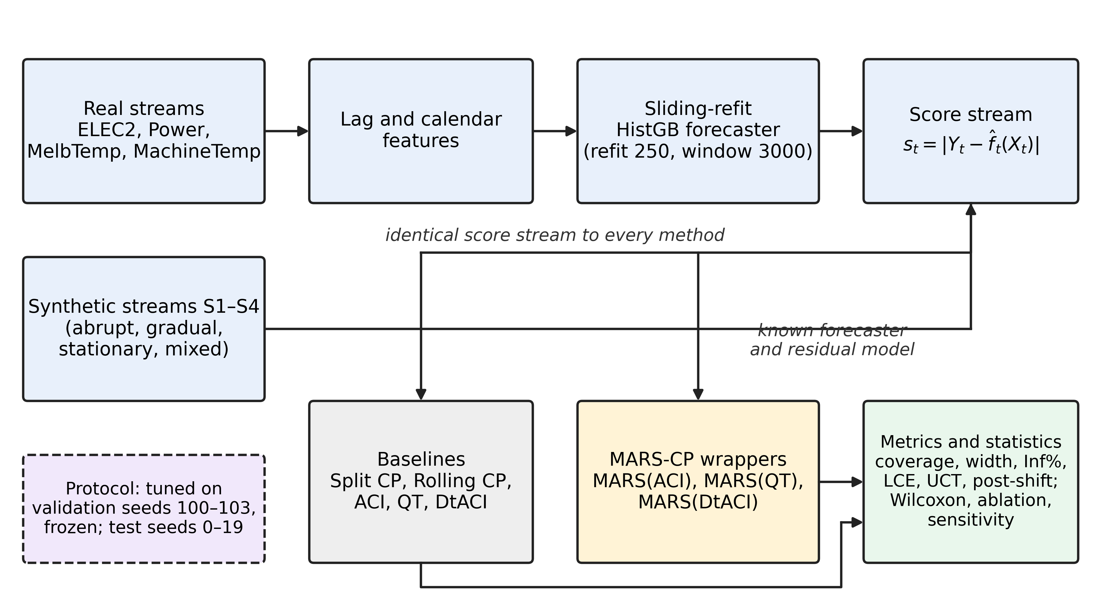
Fig. 3 Experimental pipeline. Real streams pass through lag and calendar features and a sliding-refit gradient-boosting forecaster; synthetic streams use a known forecaster. The resulting score stream is fed identically to the baselines and to the MARS-CP wrappers, and all methods are scored with the same metrics and statistical tests. Hyperparameters were tuned on validation seeds and then frozen

6.1 Synthetic streams
Covariates X_{t} ∈ ℝ⁵ are standard Gaussian, the forecaster is the true regression function of the baseline regime, f̂(x) = x⊤β with β = 𝟏/√5, and Y_{t} = f̂(X_{t}) + b_{t} + σ_{t}e_{t}, with T = 10,000 steps and regimes of 1,250 steps. The four scenarios are: S1 Recurring-Abrupt, with noise scale σ following the pattern (1, 3, 1, 0.4) repeated twice, so that it contains both harder and easier shifts that recur; S2 Gradual, with σ_{t} = 1 + 0.75(1 − cos(2πt/5000)), a smooth periodic drift; S3 Stationary, with σ = 1 throughout, used to measure false alarms; and S4 Mixed-Recurring, with the pattern (baseline, bias b = 2, baseline, Student-t_{2.5} heavy-tailed noise) repeated twice. Each scenario is run with 20 test seeds (0–19).

6.2 Real-world streams
We use four public streams that exhibit different forms of non-stationarity (Table 2). For each we build lagged features, and the base forecaster is a histogram gradient-boosting regressor (Pedregosa et al., 2011) refitted every 250 steps (90 for MelbTemp) on a trailing window of 3,000 observations, and used only for data after its training window. This produces genuinely online residuals whose distribution shifts both with the data and with each refit.
Table 2 Streams used in the experiments. Stream length counts points with forecaster outputs; the first 500 scores of each stream initialise every method and are excluded from evaluation
Stream | Domain | Target (resolution) | Features | Stream length | Eval. steps
ELEC2 (Harries, 1999) | Electricity market (NSW) | Normalised demand (30 min) | lags 1,2,3,48,336; period sin/cos; lagged price, VIC demand, transfer | 42,976 | 42,476
Power (Hébrail & Bérard, 2012) | Household consumption | Global active power (1 h) | lags 1,2,3,24,168; hour sin/cos; day of week | 32,421 | 31,921
MelbTemp | Climate | Daily min. temperature, Melbourne | lags 1,2,3,7; day-of-year sin/cos | 2,913 | 2,413
MachineTemp (Lavin & Ahmad, 2015) | Industrial IoT (NAB) | Machine temperature (5 min) | lags 1,2,3,6,12,288 | 20,407 | 19,907
S1–S4 | Synthetic | Linear-Gaussian with regimes | 5 Gaussian covariates | 10,000 | 9,500

6.3 Baselines and configuration
We compare split CP (fixed calibration on the initial 500 scores), rolling CP (W = 500), ACI (Gibbs & Candès, 2021) (γ = 0.005, W = 500), the quantile tracker QT (the P-control step of conformal PID (Angelopoulos et al., 2023), learning rate 0.05 scaled by the maximum of the last 100 scores), and DtACI (Gibbs & Candès, 2024) (eight step sizes from 0.001 to 0.128, interval length I = 100, weighted-average output). MARS-CP wraps each of ACI, QT and DtACI with the same inner hyperparameters, giving MARS(ACI), MARS(QT) and MARS(DtACI). Its own parameters are δ = 0.01, J = 0.01, W = 500, n_{min} = 20, n_{match} = 30, ρ = 0.2 and B = 8, with memory enabled. These values, and the choice of the two-sided jumper without additional power-betting states, were selected on validation seeds 100–103, which are disjoint from the test seeds, and then frozen. The target is α = 0.1 unless stated otherwise.

6.4 Implementation and statistics
All methods are implemented in Python 3 with NumPy, SciPy and scikit-learn (Pedregosa et al., 2011) and run on a single CPU core; all figures were produced with Matplotlib. Synthetic results are averaged over 20 seeds and compared by two-sided paired Wilcoxon signed-rank tests between each inner updater and its wrapped version. On real streams the baselines are deterministic, and MARS-CP’s only randomness is the tie-breaking variable U in Eq. (4); we report means over 5 seeds. The seed-to-seed standard deviation of coverage was at most 0.0015; that of width was small relative to the mean but reached 0.09 units on MachineTemp, so small width differences on that stream should be read with care.
Use of AI tools. In accordance with the journal’s policy, we disclose that a large language model (Claude, Anthropic) was used to assist with the literature search, the implementation of the methods and experiment scripts, the execution of the experiments, and the drafting of this manuscript. All code, numerical results and text were reviewed and verified by the authors, who take full responsibility for the content of this article.

7 Results

7.1 Synthetic streams
Table 3 reports the synthetic results. All adaptive methods reach the nominal 0.90 long-run coverage, whereas split CP loses up to 21 points under drift, confirming that marginal coverage alone cannot discriminate between adaptive methods. On the recurring abrupt stream S1, wrapping ACI reduces LCE from 0.0422 to 0.0298 and under-coverage time from 14.0% to 6.1% of steps, while also shrinking the mean width from 4.81 to 4.56. Figure 4 shows the mechanism. When the noise scale drops at t = 2,500 and t = 7,500, ACI keeps its inflated threshold for several hundred steps and over-covers, until the stale scores leave its window. MARS(ACI) detects the easing shift through the ε = +1 state of the martingale and drops to the new level within about 50 steps. The subsequent under-coverage episodes that ACI suffers while α_{t} readjusts (near t = 3,000 and t = 8,000) are also avoided.
Table 3 Synthetic results (mean ± std over 20 test seeds, α = 0.1). LCE: local coverage error; UCT: percentage of steps with 100-step rolling coverage below 0.85. Post-shift coverage is not defined for the gradual stream S2 (—). Shaded rows are MARS-CP wrappers
Stream | Method | Coverage | Width | LCE | UCT (%) | Worst post-shift cov.
S1-RecurringAbrupt | SplitCP | 0.801 | 3.308 ± 0.139 | 0.1653 ± 0.0050 | 30.05 ± 2.02 | 0.401 ± 0.028
S1-RecurringAbrupt | RollingCP | 0.894 | 4.687 ± 0.045 | 0.0578 ± 0.0014 | 14.41 ± 1.41 | 0.568 ± 0.024
S1-RecurringAbrupt | ACI | 0.900 | 4.806 ± 0.053 | 0.0422 ± 0.0014 | 14.03 ± 0.96 | 0.813 ± 0.013
S1-RecurringAbrupt | MARS(ACI) | 0.900 | 4.562 ± 0.054 | 0.0298 ± 0.0022 | 6.07 ± 0.94 | 0.785 ± 0.024
S1-RecurringAbrupt | QT | 0.900 | 4.572 ± 0.042 | 0.0195 ± 0.0008 | 3.29 ± 0.30 | 0.833 ± 0.007
S1-RecurringAbrupt | MARS(QT) | 0.900 | 4.590 ± 0.051 | 0.0184 ± 0.0009 | 3.18 ± 0.30 | 0.834 ± 0.013
S1-RecurringAbrupt | DtACI | 0.897 | 4.724 ± 0.061 | 0.0221 ± 0.0009 | 4.18 ± 0.84 | 0.861 ± 0.007
S1-RecurringAbrupt | MARS(DtACI) | 0.899 | 4.609 ± 0.053 | 0.0207 ± 0.0012 | 3.38 ± 0.52 | 0.849 ± 0.012
S2-Gradual | SplitCP | 0.691 | 3.495 ± 0.162 | 0.2163 ± 0.0180 | 78.62 ± 3.78 | —
S2-Gradual | RollingCP | 0.898 | 5.880 ± 0.047 | 0.0372 ± 0.0014 | 13.48 ± 1.82 | —
S2-Gradual | ACI | 0.901 | 5.940 ± 0.044 | 0.0229 ± 0.0017 | 3.35 ± 1.19 | —
S2-Gradual | MARS(ACI) | 0.902 | 5.935 ± 0.041 | 0.0256 ± 0.0014 | 4.30 ± 1.18 | —
S2-Gradual | QT | 0.899 | 5.934 ± 0.044 | 0.0145 ± 0.0006 | 0.16 ± 0.14 | —
S2-Gradual | MARS(QT) | 0.900 | 5.949 ± 0.045 | 0.0151 ± 0.0007 | 0.29 ± 0.22 | —
S2-Gradual | DtACI | 0.900 | 5.933 ± 0.043 | 0.0194 ± 0.0011 | 1.36 ± 0.51 | —
S2-Gradual | MARS(DtACI) | 0.900 | 5.905 ± 0.044 | 0.0203 ± 0.0009 | 1.77 ± 0.61 | —
S4-MixedRecurring | SplitCP | 0.729 | 3.308 ± 0.139 | 0.1845 ± 0.0112 | 54.33 ± 3.47 | 0.347 ± 0.041
S4-MixedRecurring | RollingCP | 0.889 | 4.681 ± 0.046 | 0.0499 ± 0.0021 | 15.57 ± 1.59 | 0.573 ± 0.019
S4-MixedRecurring | ACI | 0.900 | 4.797 ± 0.062 | 0.0349 ± 0.0012 | 10.37 ± 0.87 | 0.818 ± 0.014
S4-MixedRecurring | MARS(ACI) | 0.900 | 4.726 ± 0.062 | 0.0285 ± 0.0016 | 6.48 ± 1.00 | 0.797 ± 0.026
S4-MixedRecurring | QT | 0.898 | 4.728 ± 0.066 | 0.0165 ± 0.0008 | 2.26 ± 0.33 | 0.847 ± 0.007
S4-MixedRecurring | MARS(QT) | 0.899 | 4.775 ± 0.090 | 0.0159 ± 0.0013 | 2.14 ± 0.50 | 0.843 ± 0.014
S4-MixedRecurring | DtACI | 0.898 | 5.022 ± 0.418 | 0.0213 ± 0.0007 | 4.03 ± 0.76 | 0.854 ± 0.009
S4-MixedRecurring | MARS(DtACI) | 0.899 | 4.885 ± 0.273 | 0.0205 ± 0.0008 | 3.45 ± 0.83 | 0.848 ± 0.010

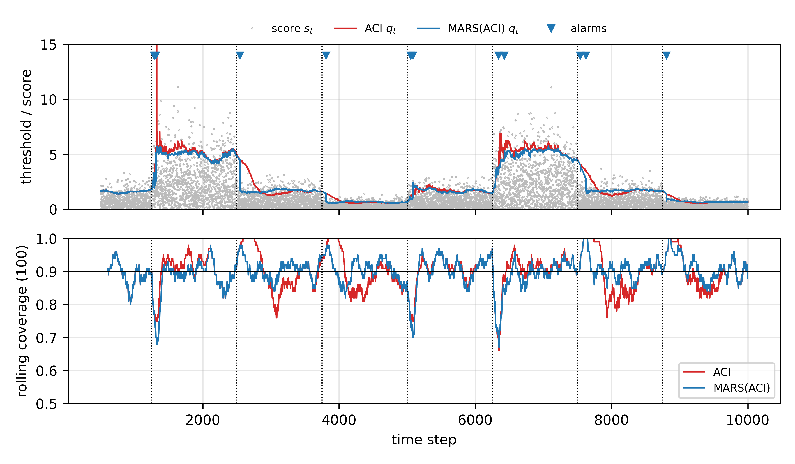
Fig. 4 Stream S1 (seed 0). Top: nonconformity scores, thresholds q_{t} of ACI and MARS(ACI) (clipped at 15), and MARS alarms (triangles); dotted lines mark the true change points. Bottom: 100-step rolling coverage. MARS(ACI) reacts to both harder shifts (t = 1,250 and 6,250) and easier shifts (t = 2,500, 3,750, 7,500 and 8,750), avoiding ACI’s prolonged over- and under-coverage
For DtACI and QT, which already adapt quickly, the wrapper’s effect is smaller but still structured. MARS(DtACI) narrows intervals by 2.4% on S1 and 2.7% on S4, reduces UCT by 19.1% and 14.3%, and reduces the frequency of infinite intervals (0.77% to 0.48% on S1). MARS(QT) slightly improves LCE on S1 and S4 but widens intervals by 0.4–1.0%. The main exception is the gradual stream S2. There the martingale detects the slow drift in steps, and every reset discards useful recent scores, so LCE increases by 11.8% for ACI, 4.1% for QT and 4.7% for DtACI. This is the principal failure mode of the approach, and we return to it in Sect. 8.

7.2 Statistical significance
Table 4 lists paired Wilcoxon tests across the 20 synthetic seeds. For ACI the improvements in LCE, width and UCT on the abrupt streams S1 and S4 are all significant at p < 0.001. For DtACI, the reductions in LCE, width and UCT on S1 and S4 are significant (p ≤ 0.001). For QT, the LCE reduction is significant but small, and the width increase is also significant. On S2 all three wrappers significantly increase LCE (p < 0.001), which confirms that the gradual-drift degradation is systematic rather than noise.
Table 4 Paired two-sided Wilcoxon signed-rank tests between each inner updater and its MARS-CP wrapper (20 seeds). Negative Δ indicates improvement for all three metrics
Stream | Inner | Metric | Inner mean | MARS mean | Δ (%) | p-value
S1-RecurringAbrupt | ACI | LCE | 0.0422 | 0.0298 | -29.4 | <0.001
S1-RecurringAbrupt | ACI | width | 4.8056 | 4.5622 | -5.1 | <0.001
S1-RecurringAbrupt | ACI | UCT | 14.0325 | 6.0664 | -56.8 | <0.001
S1-RecurringAbrupt | QT | LCE | 0.0195 | 0.0184 | -5.5 | <0.001
S1-RecurringAbrupt | QT | width | 4.5724 | 4.5904 | +0.4 | 0.003
S1-RecurringAbrupt | QT | UCT | 3.2890 | 3.1842 | -3.2 | 0.140
S1-RecurringAbrupt | DtACI | LCE | 0.0221 | 0.0207 | -6.4 | <0.001
S1-RecurringAbrupt | DtACI | width | 4.7237 | 4.6094 | -2.4 | <0.001
S1-RecurringAbrupt | DtACI | UCT | 4.1751 | 3.3794 | -19.1 | <0.001
S2-Gradual | ACI | LCE | 0.0229 | 0.0256 | +11.8 | <0.001
S2-Gradual | ACI | width | 5.9400 | 5.9348 | -0.1 | 0.245
S2-Gradual | ACI | UCT | 3.3454 | 4.3011 | +28.6 | 0.008
S2-Gradual | QT | LCE | 0.0145 | 0.0151 | +4.1 | <0.001
S2-Gradual | QT | width | 5.9345 | 5.9490 | +0.2 | 0.012
S2-Gradual | QT | UCT | 0.1564 | 0.2883 | +84.4 | 0.004
S2-Gradual | DtACI | LCE | 0.0194 | 0.0203 | +4.7 | <0.001
S2-Gradual | DtACI | width | 5.9331 | 5.9048 | -0.5 | <0.001
S2-Gradual | DtACI | UCT | 1.3610 | 1.7663 | +29.8 | 0.001
S4-MixedRecurring | ACI | LCE | 0.0349 | 0.0285 | -18.4 | <0.001
S4-MixedRecurring | ACI | width | 4.7969 | 4.7259 | -1.5 | <0.001
S4-MixedRecurring | ACI | UCT | 10.3702 | 6.4754 | -37.6 | <0.001
S4-MixedRecurring | QT | LCE | 0.0165 | 0.0159 | -3.5 | 0.007
S4-MixedRecurring | QT | width | 4.7281 | 4.7749 | +1.0 | <0.001
S4-MixedRecurring | QT | UCT | 2.2572 | 2.1391 | -5.2 | 0.099
S4-MixedRecurring | DtACI | LCE | 0.0213 | 0.0205 | -3.9 | <0.001
S4-MixedRecurring | DtACI | width | 5.0223 | 4.8849 | -2.7 | <0.001
S4-MixedRecurring | DtACI | UCT | 4.0336 | 3.4550 | -14.3 | 0.001

7.3 Real-world streams
Table 5 summarises the real streams. All methods except split CP stay within 0.008 of nominal coverage. The clearest effect appears on MachineTemp, the NAB stream containing documented system failures and operating-mode changes. Wrapping ACI reduces the mean width from 5.53 to 4.28 (−22.5%) at essentially unchanged coverage (0.900 vs. 0.898), cuts the fraction of infinite intervals from 0.75% to 0.04%, and lowers UCT from 17.5% to 14.5%. Wrapping QT reduces width by 9.5%, and wrapping DtACI by 4.1%, together with fewer infinite intervals (2.21% to 1.66%). Figure 5 shows that after each abnormal episode ACI remains inflated for a long time, whereas MARS(ACI) resets once scores return to their normal level. The cost is a lower worst-case rolling coverage (0.44 vs. 0.65): immediately after some resets, the small post-change buffer under-estimates the quantile of a still-evolving regime.
Table 5 Real-world results (α = 0.1). Width is in target units (ELEC2 is normalised to [0,1]; Power in kW; MelbTemp in °C; MachineTemp in sensor units). Inf: percentage of infinite intervals. Shaded rows are MARS-CP wrappers
Stream | Method | Coverage | Width | Inf (%) | LCE | UCT (%) | ms/step
ELEC2 | SplitCP | 0.854 | 0.039 | 0.00 | 0.0834 | 36.84 | 0.000
ELEC2 | RollingCP | 0.897 | 0.048 | 0.00 | 0.0608 | 18.36 | 0.003
ELEC2 | ACI | 0.900 | 0.050 | 0.04 | 0.0474 | 16.62 | 0.004
ELEC2 | MARS(ACI) | 0.900 | 0.049 | 0.01 | 0.0419 | 14.03 | 0.045
ELEC2 | QT | 0.897 | 0.048 | 0.00 | 0.0286 | 8.23 | 0.003
ELEC2 | MARS(QT) | 0.897 | 0.048 | 0.00 | 0.0281 | 8.33 | 0.026
ELEC2 | DtACI | 0.899 | 0.051 | 1.24 | 0.0252 | 5.56 | 0.018
ELEC2 | MARS(DtACI) | 0.898 | 0.050 | 0.83 | 0.0256 | 6.32 | 0.079
Power | SplitCP | 0.938 | 2.234 | 0.00 | 0.0449 | 1.52 | 0.000
Power | RollingCP | 0.900 | 1.825 | 0.00 | 0.0333 | 7.16 | 0.003
Power | ACI | 0.900 | 1.831 | 0.00 | 0.0302 | 6.39 | 0.004
Power | MARS(ACI) | 0.900 | 1.838 | 0.00 | 0.0276 | 5.99 | 0.036
Power | QT | 0.898 | 1.834 | 0.00 | 0.0196 | 2.54 | 0.003
Power | MARS(QT) | 0.900 | 1.851 | 0.00 | 0.0197 | 2.39 | 0.017
Power | DtACI | 0.899 | 1.842 | 0.29 | 0.0209 | 2.36 | 0.018
Power | MARS(DtACI) | 0.899 | 1.840 | 0.20 | 0.0208 | 2.30 | 0.072
MelbTemp | SplitCP | 0.929 | 8.656 | 0.00 | 0.0362 | 0.39 | 0.000
MelbTemp | RollingCP | 0.902 | 8.107 | 0.00 | 0.0302 | 7.09 | 0.004
MelbTemp | ACI | 0.899 | 8.071 | 0.00 | 0.0283 | 9.29 | 0.004
MelbTemp | MARS(ACI) | 0.898 | 8.066 | 0.00 | 0.0287 | 9.98 | 0.035
MelbTemp | QT | 0.899 | 7.984 | 0.00 | 0.0185 | 0.56 | 0.003
MelbTemp | MARS(QT) | 0.901 | 8.085 | 0.00 | 0.0179 | 0.65 | 0.014
MelbTemp | DtACI | 0.896 | 8.007 | 0.00 | 0.0231 | 4.80 | 0.019
MelbTemp | MARS(DtACI) | 0.897 | 8.019 | 0.00 | 0.0222 | 4.80 | 0.071
MachineTemp | SplitCP | 0.983 | 10.378 | 0.00 | 0.1045 | 2.77 | 0.000
MachineTemp | RollingCP | 0.892 | 4.580 | 0.00 | 0.0729 | 16.90 | 0.003
MachineTemp | ACI | 0.900 | 5.531 | 0.75 | 0.0513 | 17.49 | 0.004
MachineTemp | MARS(ACI) | 0.898 | 4.284 | 0.04 | 0.0489 | 14.53 | 0.041
MachineTemp | QT | 0.899 | 4.648 | 0.00 | 0.0374 | 9.28 | 0.003
MachineTemp | MARS(QT) | 0.893 | 4.205 | 0.00 | 0.0323 | 9.45 | 0.022
MachineTemp | DtACI | 0.899 | 5.620 | 2.21 | 0.0259 | 6.02 | 0.019
MachineTemp | MARS(DtACI) | 0.898 | 5.389 | 1.66 | 0.0265 | 7.37 | 0.076

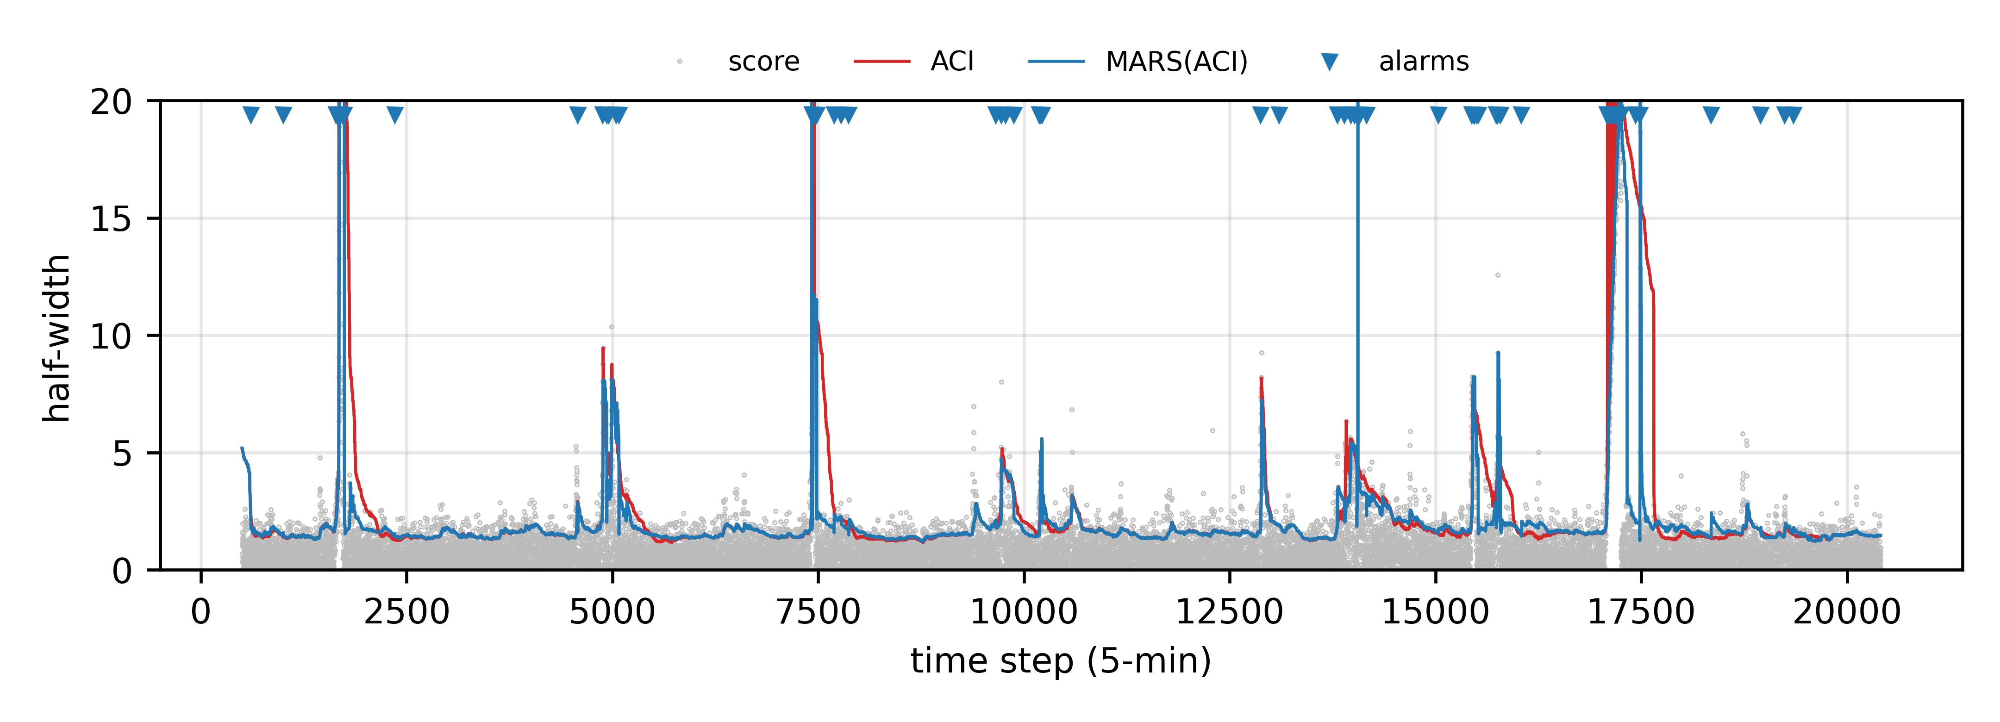
Fig. 5 MachineTemp: scores and interval half-widths of ACI and MARS(ACI), clipped at the 99.9th score percentile. Triangles mark MARS alarms. After abnormal episodes ACI stays inflated, whereas MARS(ACI) resets once the stream returns to normal operation
On ELEC2, which changes regime frequently (157 alarms over 42,476 steps, reflecting daily, weekly and market-driven patterns), MARS(ACI) lowers LCE from 0.047 to 0.042 and UCT from 16.6% to 14.0% with slightly narrower intervals, whereas MARS(DtACI) is marginally worse than DtACI (LCE 0.026 vs. 0.025; UCT 6.3% vs. 5.6%). On Power, MARS(ACI) raises ACI’s worst rolling coverage from 0.30 to 0.65 and lowers LCE from 0.030 to 0.028, while the QT and DtACI wrappers are essentially neutral. MelbTemp triggers only one alarm, and every wrapper stays within 1.3% of its inner updater’s width, which is consistent with Corollary 1’s design goal of intervening only when there is evidence of change. Figure 6 aggregates the relative changes across all streams.
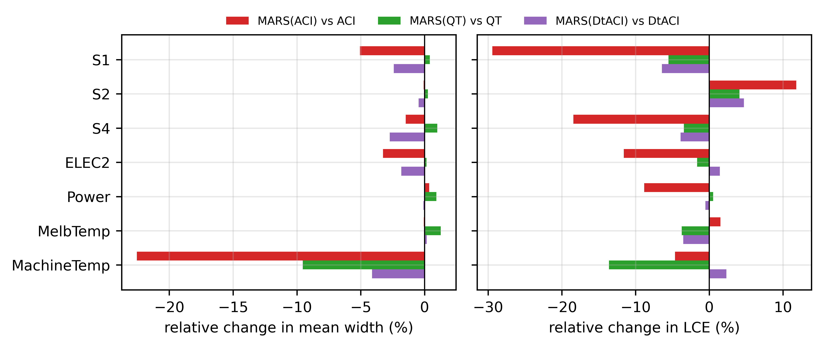
Fig. 6 Relative change (%) in mean width (left) and LCE (right) of each MARS-CP wrapper with respect to its inner updater, across all streams (negative is better). Gains concentrate on streams with abrupt or recurring shifts (S1, S4, ELEC2, MachineTemp); the gradual stream S2 is the main adverse case

7.4 Ablation study
Table 6 isolates each component of MARS(ACI). Removing the martingale reset recovers ACI exactly, confirming that all gains stem from the regime mechanism. The two-sided martingale is essential. The one-sided variant, which detects only harder shifts, raises 60–90% fewer alarms (for example 29 instead of 156 on ELEC2) and loses most of the benefit: on MachineTemp its width is 4.86 against 4.31, and on ELEC2 its UCT is 18.8% against 14.1%, worse than ACI itself. This supports our claim that detecting easing shifts is a distinct and useful signal. Change localisation is not clearly beneficial. The variant without it, which simply keeps the last 20 scores, raises fewer alarms on S1 (7.1 vs. 9.1) at a slightly higher UCT (6.3% vs. 6.1%), and on the real streams it is neutral or marginally better (e.g. ELEC2 UCT 13.7% vs. 14.1%; Power 5.4% vs. 5.9%). We retain localisation because it is principled and its cost is negligible, but we do not claim it as a source of gains. The regime-memory module does not deliver a consistent benefit. Disabling it gives marginally lower LCE on S1, S4 and ELEC2, but on MachineTemp the full model holds coverage better (0.899 vs. 0.892) with lower UCT (14.2% vs. 15.5%). We attribute this to the detection delay (≈50 steps, Sect. 7.5): by the time a recall is attempted, the new regime already has enough fresh scores, so recalled scores add little. We therefore regard memory as optional.
Table 6 Ablation of MARS(ACI) (20 seeds on synthetic streams, 3 on real streams). Removing the martingale reset reduces the method to ACI
Stream | Variant | Coverage | Width | LCE | UCT (%) | Alarms | Recalls
S1-RecurringAbrupt | MARS(ACI) full | 0.900 | 4.562 | 0.0298 | 6.07 | 9.1 | 4.1
S1-RecurringAbrupt | w/o regime memory | 0.897 | 4.540 | 0.0276 | 5.84 | 9.1 | 0.0
S1-RecurringAbrupt | w/o martingale reset | 0.900 | 4.806 | 0.0422 | 14.03 | 0.0 | 0.0
S1-RecurringAbrupt | one-sided martingale | 0.897 | 4.690 | 0.0414 | 14.45 | 2.5 | 0.1
S1-RecurringAbrupt | w/o change localization | 0.900 | 4.574 | 0.0303 | 6.28 | 7.1 | 4.0
S4-MixedRecurring | MARS(ACI) full | 0.900 | 4.726 | 0.0285 | 6.48 | 6.2 | 2.9
S4-MixedRecurring | w/o regime memory | 0.898 | 4.701 | 0.0271 | 6.35 | 6.2 | 0.0
S4-MixedRecurring | w/o martingale reset | 0.900 | 4.797 | 0.0349 | 10.37 | 0.0 | 0.0
S4-MixedRecurring | one-sided martingale | 0.897 | 4.759 | 0.0341 | 10.72 | 2.4 | 0.0
S4-MixedRecurring | w/o change localization | 0.900 | 4.733 | 0.0285 | 6.61 | 4.6 | 2.6
ELEC2 | MARS(ACI) full | 0.900 | 0.049 | 0.0418 | 14.05 | 156.3 | 114.3
ELEC2 | w/o regime memory | 0.897 | 0.048 | 0.0396 | 14.27 | 156.3 | 0.0
ELEC2 | w/o martingale reset | 0.900 | 0.050 | 0.0474 | 16.62 | 0.0 | 0.0
ELEC2 | one-sided martingale | 0.894 | 0.049 | 0.0474 | 18.75 | 29.0 | 5.0
ELEC2 | w/o change localization | 0.900 | 0.050 | 0.0395 | 13.69 | 136.3 | 100.7
Power | MARS(ACI) full | 0.900 | 1.838 | 0.0275 | 5.95 | 34.0 | 18.0
Power | w/o regime memory | 0.901 | 1.832 | 0.0266 | 5.44 | 34.0 | 0.0
Power | w/o martingale reset | 0.900 | 1.831 | 0.0302 | 6.39 | 0.0 | 0.0
Power | one-sided martingale | 0.900 | 1.829 | 0.0301 | 6.36 | 3.0 | 1.0
Power | w/o change localization | 0.900 | 1.835 | 0.0270 | 5.38 | 30.3 | 13.7
MachineTemp | MARS(ACI) full | 0.899 | 4.312 | 0.0490 | 14.18 | 62.3 | 33.0
MachineTemp | w/o regime memory | 0.892 | 4.171 | 0.0467 | 15.53 | 62.3 | 0.0
MachineTemp | w/o martingale reset | 0.900 | 5.531 | 0.0513 | 17.49 | 0.0 | 0.0
MachineTemp | one-sided martingale | 0.890 | 4.858 | 0.0535 | 19.64 | 24.0 | 3.0
MachineTemp | w/o change localization | 0.896 | 4.211 | 0.0478 | 14.89 | 58.0 | 25.3

7.5 Change detection behaviour
Table 7 evaluates the monitor itself on synthetic streams with known change points. All seven changes of S1 are detected, with a mean delay of 51.8 ± 5.2 steps. On S4, 4.25 of 7 changes are detected on average; the undetected ones are mostly transitions into and out of the heavy-tailed regime, whose absolute-residual distribution overlaps substantially with the baseline. On the stationary stream S3, no alarm occurred in any of the 20 × 9,500 steps, which is consistent with Proposition 1 at δ = 0.01. The ≈2 additional alarms per stream on S1 and S4 are re-triggers shortly after a genuine change, when the localised buffer still contains a few pre-change scores; they are not false alarms in the sense of Proposition 1, because the regime was not exchangeable from its opening.
Table 7 Change-detection statistics of MARS(ACI) on synthetic streams (mean over 20 seeds; delay reported as mean ± std). A change is counted as detected if an alarm occurs within 400 steps after it
Stream | True changes | Detected | Delay (steps) | Additional alarms
S1-RecurringAbrupt | 7 | 7.00 | 51.8 ± 5.2 | 2.05
S3-Stationary | 0 | 0.00 | — | 0.00
S4-MixedRecurring | 7 | 4.25 | 52.3 ± 24.8 | 2.00

7.6 Sensitivity analysis
Figure 7 varies the false-alarm budget δ. On S1 the results are almost flat over two orders of magnitude (LCE 0.031 to 0.028, width within 0.2%). On MachineTemp larger budgets trade more alarms (47 at δ = 0.001, 94 at δ = 0.1) for somewhat narrower intervals and lower LCE. On the stationary stream an alarm appears in 1 of 10 runs only when δ ≥ 0.05, as the guarantee predicts. The window size W ∈ {250, 500, 1000} changes width by about 1% or less on both S1 and MachineTemp. Table 8 varies the target level. The width reductions on MachineTemp persist at α = 0.05 (7.54 to 5.88, −21.9%) and α = 0.2 (3.92 to 3.32, −15.4%), ELEC2 LCE improves at every α, and nominal coverage is maintained within 0.002 in all 12 cases.
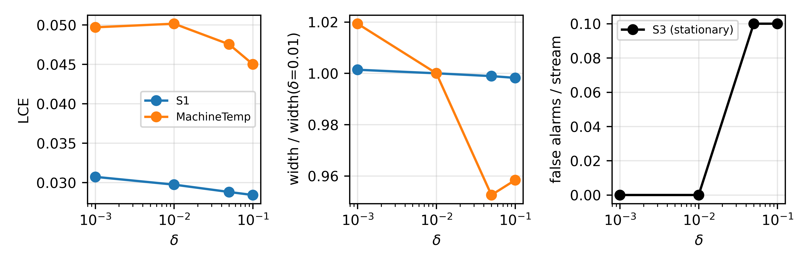
Fig. 7 Sensitivity of MARS(ACI) to the false-alarm budget δ: LCE (left), width relative to δ = 0.01 (middle), and alarms per run on the stationary stream S3 (right; 10 seeds)
Table 8 ACI versus MARS(ACI) across target miscoverage levels on the real streams
Stream | α | Coverage (ACI / MARS) | Width (ACI / MARS) | LCE (ACI / MARS) | Inf % (ACI / MARS)
ELEC2 | 0.05 | 0.950 / 0.950 | 0.069 / 0.064 | 0.0303 / 0.0274 | 0.47 / 0.14
ELEC2 | 0.1 | 0.900 / 0.900 | 0.050 / 0.049 | 0.0474 / 0.0414 | 0.04 / 0.03
ELEC2 | 0.2 | 0.800 / 0.801 | 0.035 / 0.034 | 0.0688 / 0.0596 | 0.00 / 0.00
MachineTemp | 0.05 | 0.950 / 0.949 | 7.536 / 5.884 | 0.0343 / 0.0354 | 1.42 / 0.77
MachineTemp | 0.1 | 0.900 / 0.899 | 5.531 / 4.311 | 0.0513 / 0.0502 | 0.75 / 0.03
MachineTemp | 0.2 | 0.800 / 0.800 | 3.922 / 3.319 | 0.0694 / 0.0631 | 0.40 / 0.00
MelbTemp | 0.05 | 0.950 / 0.949 | 9.875 / 9.870 | 0.0201 / 0.0205 | 0.00 / 0.00
MelbTemp | 0.1 | 0.899 / 0.898 | 8.071 / 8.066 | 0.0283 / 0.0287 | 0.00 / 0.00
MelbTemp | 0.2 | 0.799 / 0.799 | 6.130 / 6.125 | 0.0394 / 0.0398 | 0.00 / 0.00
Power | 0.05 | 0.950 / 0.950 | 2.428 / 2.428 | 0.0196 / 0.0189 | 0.00 / 0.04
Power | 0.1 | 0.900 / 0.900 | 1.831 / 1.838 | 0.0302 / 0.0276 | 0.00 / 0.00
Power | 0.2 | 0.800 / 0.800 | 1.254 / 1.250 | 0.0416 / 0.0374 | 0.00 / 0.00

7.7 Computational cost
The per-step cost (Table 5) of MARS(ACI) is 0.035–0.045 ms, and that of MARS(DtACI) 0.07–0.08 ms, on a single CPU core. This is about 10× the cost of ACI’s bare update but negligible next to any forecaster evaluation: the whole ELEC2 stream is processed in under 4 s. MARS(QT) is cheaper than MARS(ACI) (0.014–0.026 ms/step) because QT requires no quantile computation.

8 Discussion
When does MARS-CP help? The gains are largest when the inner updater is slow (ACI with a small γ) and when the stream has abrupt or recurring regime changes, including changes that make the stream easier. In these conditions an explicit, evidence-based reset replaces hundreds of small corrective steps with a single rebuild of the calibration buffer. For updaters that already adapt quickly (QT and DtACI), the wrapper mainly improves efficiency: intervals are narrower, infinite intervals rarer, and under-coverage periods shorter, while long-run coverage is unchanged.
When does it hurt? Under slow gradual drift (S2), a detector designed for piecewise-exchangeable data fires repeatedly as the drift accumulates, and each reset throws away scores that remained informative. A practitioner who expects smooth drift should either use a smaller δ (which delays alarms), increase n_{min}, or simply rely on the inner updater. A natural remedy is to combine regime resets with the weighted conformal schemes of Barber et al. (2023), which down-weight rather than discard old scores. The lower worst-case rolling coverage on MachineTemp reveals a related tension: a fresh buffer adapts quickly but is statistically fragile for its first few dozen observations. The conservative bridge mitigates this for n_{min} steps, and extending the bridge adaptively is a promising direction.
Regime memory. Our hypothesis that recalling past regimes would speed recovery on recurring shifts was not supported: the memory module is roughly neutral. Its effectiveness is bounded below by the detection delay, because recall can only occur after an alarm. A faster, possibly less conservative, recurrence detector that runs in parallel with the martingale would be needed to exploit recurrence, and we report the negative result so that future work can build on it.
Guarantees and scope. MARS-CP inherits marginal long-run coverage from its inner updater, degraded only by the number of re-initialisations (Proposition 2), and adds a false-alarm guarantee that makes its interventions interpretable: each reset is backed by evidence of non-exchangeability at level δ. Like all online CP methods, it provides no conditional coverage and treats the forecaster as fixed between refits; the refit schedule itself can induce score shifts, which the martingale may detect.

8.1 Limitations and future work
- Experiments cover univariate regression with absolute-residual scores. Extensions to classification (e.g. adaptive prediction sets), to multivariate or quantile-regression scores such as conformalized quantile regression (Romano et al., 2019), and to high-dimensional deep-learning pipelines remain to be evaluated.
- We compare against ACI, QT and DtACI, which the wrapper can host, but not against SAOCP (Bhatnagar et al., 2023), RetroAdj (Jun & Ohn, 2026) or CPTC (Sun & Yu, 2025), which require different interfaces (scale-free learners, leave-one-out-updatable regressors and switching state-space forecasters respectively). Wrapping SAOCP is straightforward and is planned.
- The false-alarm guarantee assumes exchangeability within regimes. For autocorrelated residuals it holds only approximately, which partly explains the frequent alarms on ELEC2. Block-wise or weighted conformal martingales (Prinster et al., 2025) could restore validity under dependence.
- Hyperparameters were tuned on synthetic validation seeds only; per-domain tuning could change the magnitude of the real-data effects in either direction.

9 Conclusion
We introduced MARS-CP, a plug-in wrapper that gives online conformal predictors an explicit and statistically controlled notion of regime. A two-sided conformal test martingale with anytime false-alarm control decides when calibration history has become obsolete, change localisation and a conservative bridge rebuild the calibration buffer, and the inner updater (ACI, QT or DtACI) is re-initialised. The wrapper provably reduces to its inner updater on exchangeable data with probability at least 1 − δ and keeps long-run coverage when the number of re-initialisations grows sublinearly. Empirically, it substantially improves ACI on abrupt and recurring shifts (up to 29% lower local coverage error, 57% less under-coverage time and 22% narrower intervals on an industrial stream), gives consistent efficiency gains for DtACI on abrupt shifts, and is roughly neutral for quantile tracking. It degrades under slow gradual drift, and its regime-memory module is not yet effective. These results suggest that detecting when to adapt is a useful, largely orthogonal complement to research on how to adapt in online conformal prediction.

Statements and Declarations
Funding The authors did not receive support from any organization for the submitted work.
Competing interests The authors have no competing interests to declare that are relevant to the content of this article.
Ethics approval Not applicable; the study uses only public, non-personal data.
Consent to participate Not applicable.
Consent for publication Not applicable.
Data availability All datasets analysed in this study are publicly available: ELEC2 (Harries, 1999), from the scikit-multiflow streaming-datasets repository; the UCI Individual Household Electric Power Consumption dataset (Hébrail & Bérard, 2012); the Melbourne daily minimum temperature series (public CSV); and the NAB machine_temperature_system_failure series (Lavin & Ahmad, 2015). The per-seed results underlying every table are included in the code repository.
Code availability The complete implementation (methods, data preparation, experiment and figure scripts) is available at https://github.com/GArulDalton/mars-cp.
Author contributions Conceptualization: G. Arul Dalton; Methodology: G. Arul Dalton; Software: G. Arul Dalton; Formal analysis and investigation: G. Arul Dalton, P. Sankar; Validation: P. Sankar; Visualization: P. Sankar; Writing – original draft preparation: G. Arul Dalton; Writing – review and editing: P. Sankar, G. Arul Dalton; Supervision: G. Arul Dalton. All authors read and approved the final manuscript.

References
Adams, R. P., & MacKay, D. J. C. (2007). Bayesian online changepoint detection. arXiv preprint arXiv:0710.3742.
Angelopoulos, A. N., & Bates, S. (2023). Conformal prediction: A gentle introduction. Foundations and Trends in Machine Learning, 16(4), 494–591. https://doi.org/10.1561/2200000101
Angelopoulos, A. N., Candès, E. J., & Tibshirani, R. J. (2023). Conformal PID control for time series prediction. In Advances in Neural Information Processing Systems (Vol. 36).
Barber, R. F., Candès, E. J., Ramdas, A., & Tibshirani, R. J. (2023). Conformal prediction beyond exchangeability. The Annals of Statistics, 51(2), 816–845. https://doi.org/10.1214/23-AOS2276
Bhatnagar, A., Wang, H., Xiong, C., & Bai, Y. (2023). Improved online conformal prediction via strongly adaptive online learning. In Proceedings of the 40th International Conference on Machine Learning (PMLR Vol. 202, pp. 2337–2363).
Bifet, A., & Gavaldà, R. (2007). Learning from time-changing data with adaptive windowing. In Proceedings of the 2007 SIAM International Conference on Data Mining (pp. 443–448).
Dinakaran, K., Rajalakshmi, D., & Valarmathie, P. (2020). Efficient pattern matching for uncertain time series data with optimal sampling and dimensionality reduction. Microprocessors and Microsystems, 75, Article 103057. https://doi.org/10.1016/j.micpro.2020.103057
Gama, J., Žliobaitė, I., Bifet, A., Pechenizkiy, M., & Bouchachia, A. (2014). A survey on concept drift adaptation. ACM Computing Surveys, 46(4), Article 44. https://doi.org/10.1145/2523813
Gibbs, I., & Candès, E. J. (2021). Adaptive conformal inference under distribution shift. In Advances in Neural Information Processing Systems (Vol. 34, pp. 1660–1672).
Gibbs, I., & Candès, E. J. (2024). Conformal inference for online prediction with arbitrary distribution shifts. Journal of Machine Learning Research, 25(162), 1–36.
Harries, M. (1999). SPLICE-2 comparative evaluation: Electricity pricing (Technical report). School of Computer Science and Engineering, University of New South Wales.
Hébrail, G., & Bérard, A. (2012). Individual household electric power consumption [Dataset]. UCI Machine Learning Repository. https://doi.org/10.24432/C58K54
Hüllermeier, E., & Waegeman, W. (2021). Aleatoric and epistemic uncertainty in machine learning: An introduction to concepts and methods. Machine Learning, 110(3), 457–506. https://doi.org/10.1007/s10994-021-05946-3
Jun, J., & Ohn, I. (2026). Online conformal inference with retrospective adjustment for faster adaptation to distribution shift. Pattern Recognition, 180, 114406. https://doi.org/10.1016/j.patcog.2026.114406
Kavitha, S., Bhuvaneswari, N. S., Senthilkumar, R., & Shanker, N. R. (2022). Magnetoresistance sensor-based rotor fault detection in induction motor using non-decimated wavelet and streaming data. Automatika, 63(3), 525–541. https://doi.org/10.1080/00051144.2022.2052533
Lavin, A., & Ahmad, S. (2015). Evaluating real-time anomaly detection algorithms – the Numenta Anomaly Benchmark. In Proceedings of the 14th IEEE International Conference on Machine Learning and Applications (pp. 38–44).
Lei, J., G’Sell, M., Rinaldo, A., Tibshirani, R. J., & Wasserman, L. (2018). Distribution-free predictive inference for regression. Journal of the American Statistical Association, 113(523), 1094–1111. https://doi.org/10.1080/01621459.2017.1307116
Leong, J. W. (2026). Online shift detection and conformal adaptation for deployed safety classifiers. arXiv preprint arXiv:2606.11949.
Lu, J., Liu, A., Dong, F., Gu, F., Gama, J., & Zhang, G. (2019). Learning under concept drift: A review. IEEE Transactions on Knowledge and Data Engineering, 31(12), 2346–2363. https://doi.org/10.1109/TKDE.2018.2876857
Page, E. S. (1954). Continuous inspection schemes. Biometrika, 41(1/2), 100–115. https://doi.org/10.1093/biomet/41.1-2.100
Pedregosa, F., Varoquaux, G., Gramfort, A., Michel, V., Thirion, B., Grisel, O., Blondel, M., Prettenhofer, P., Weiss, R., Dubourg, V., Vanderplas, J., Passos, A., Cournapeau, D., Brucher, M., Perrot, M., & Duchesnay, É. (2011). Scikit-learn: Machine learning in Python. Journal of Machine Learning Research, 12, 2825–2830.
Podkopaev, A., & Ramdas, A. (2021). Distribution-free uncertainty quantification for classification under label shift. In Proceedings of the 37th Conference on Uncertainty in Artificial Intelligence (PMLR Vol. 161, pp. 844–853).
Prinster, D., Han, X., Liu, A., & Saria, S. (2025). WATCH: Adaptive monitoring for AI deployments via weighted-conformal martingales. In Proceedings of the 42nd International Conference on Machine Learning (PMLR Vol. 267, pp. 49830–49859).
Romano, Y., Patterson, E., & Candès, E. J. (2019). Conformalized quantile regression. In Advances in Neural Information Processing Systems (Vol. 32).
Shafer, G., & Vovk, V. (2008). A tutorial on conformal prediction. Journal of Machine Learning Research, 9, 371–421.
Sun, S. H., & Yu, R. (2025). Conformal prediction for time-series forecasting with change points. In Advances in Neural Information Processing Systems (Vol. 38).
Tibshirani, R. J., Barber, R. F., Candès, E. J., & Ramdas, A. (2019). Conformal prediction under covariate shift. In Advances in Neural Information Processing Systems (Vol. 32).
Ville, J. (1939). Étude critique de la notion de collectif. Gauthier-Villars.
Volkhonskiy, D., Burnaev, E., Nouretdinov, I., Gammerman, A., & Vovk, V. (2017). Inductive conformal martingales for change-point detection. In Proceedings of the 6th Symposium on Conformal and Probabilistic Prediction and Applications (PMLR Vol. 60, pp. 132–153).
Vovk, V. (2013). Conditional validity of inductive conformal predictors. Machine Learning, 92(2–3), 349–376. https://doi.org/10.1007/s10994-013-5355-6
Vovk, V. (2021). Testing randomness online. Statistical Science, 36(4), 595–611.
Vovk, V., Gammerman, A., & Shafer, G. (2005). Algorithmic learning in a random world. Springer. https://doi.org/10.1007/b106715
Vovk, V., Petej, I., Nouretdinov, I., Ahlberg, E., Carlsson, L., & Gammerman, A. (2021). Retrain or not retrain: Conformal test martingales for change-point detection. In Proceedings of the 10th Symposium on Conformal and Probabilistic Prediction and Applications (PMLR Vol. 152, pp. 191–210).
Xu, C., & Xie, Y. (2021). Conformal prediction interval for dynamic time-series. In Proceedings of the 38th International Conference on Machine Learning (PMLR Vol. 139, pp. 11559–11569).
Xu, C., & Xie, Y. (2023). Sequential predictive conformal inference for time series. In Proceedings of the 40th International Conference on Machine Learning (PMLR Vol. 202, pp. 38707–38727).
Zaffran, M., Féron, O., Goude, Y., Josse, J., & Dieuleveut, A. (2022). Adaptive conformal predictions for time series. In Proceedings of the 39th International Conference on Machine Learning (PMLR Vol. 162, pp. 25834–25866).

