A Quantitative Comparison of Docker Containers vs Multithreading

Name: George Aslanidis
Date: March 2026


Table of Contents
1. Introduction 3
2. Objectives 3
3. Basic Concepts 3
4. Set Up 4
5. Experiment 20
6. Conclusion 32
7. Bibliography 32

Introduction

In modern computing, there are different approaches that are used to run applications efficiently and handle multiple tasks at the same time. Docker is a popular solution, which allows applications to run inside containers that provide isolation while still using the same operating system which makes them easy to deploy. At the same time, operating systems can support concurrency through processes and threads, where a single application can use multiple threads to handle concurrent requests efficiently with sharing resources. This project compares these two execution models by running the same application using Docker containers and a multithreaded server setup, evaluating them based on CPU usage, memory consumption, storage requirements, and performance under load, to determine in which cases container execution is more effective than a traditional server.

Objectives

The objectives of this project are:

- Compare two execution models that run the same application using multiple Docker containers and a multithreaded server
- Run both models under the same workload conditions
- Observe how each of the models behave at the operating system level
- Examine the differences between isolated container instances and thread execution within a single application
- Determine which method is more suitable depending on the system requirements

Basic Concepts

Docker can be used to run applications inside containers, which are isolated environments that share the host operating system. These environments keep applications separate from each other while still using the same system resources. Each container runs its own copy of an application along with the required dependencies and configuration files. This makes it easier to deploy and replicate the applications across different systems with consistent behaviour [1].
On the other hand, a traditional server runs a single application that handles multiple tasks at the same time using threads. Threads are lightweight “execution units” that exist within the same process and share the same memory space. This allows the system resources to be used better since this method avoids the overhead of running separate instances. However, this approach provides less isolation as all the threads depend on the same application environment [2].

Set Up

The experiments were conducted on an Ubuntu virtual machine running on Oracle VirtualBox, which provided a controlled environment for testing both execution models under the same conditions. System information such as CPU, memory, and storage was obtained using standard Linux commands including uname, lscpu, free, df, and lsblk, while process and thread activity was observed using ps. Furthermore, Docker was installed using the package manager and its functionality was verified using systemctl as well as basic container commands like docker run. Moreover, Docker was configured to run without requiring sudo privileges, allowing easier interaction during the experiments. Also, Flask [3] and Gunicorn [4] were installed to create the application that is going to be used in both the Docker containers and the multithreaded experiments for testing. Flask was used to create the application and Gunicorn was used to run it with multiple threads on the same server. The same application is going to be run multiple times using Docker containers, and also run once using multiple threads on the same server. This way, the comparison is fair as the same program is used in both cases and the only difference is the way it is run.

- Virtual Machine Configuration

This figure shows the virtual machine used for the experiments, including the OS, the architecture, the memory, the processor, and all the basic information that are needed for the configuration.
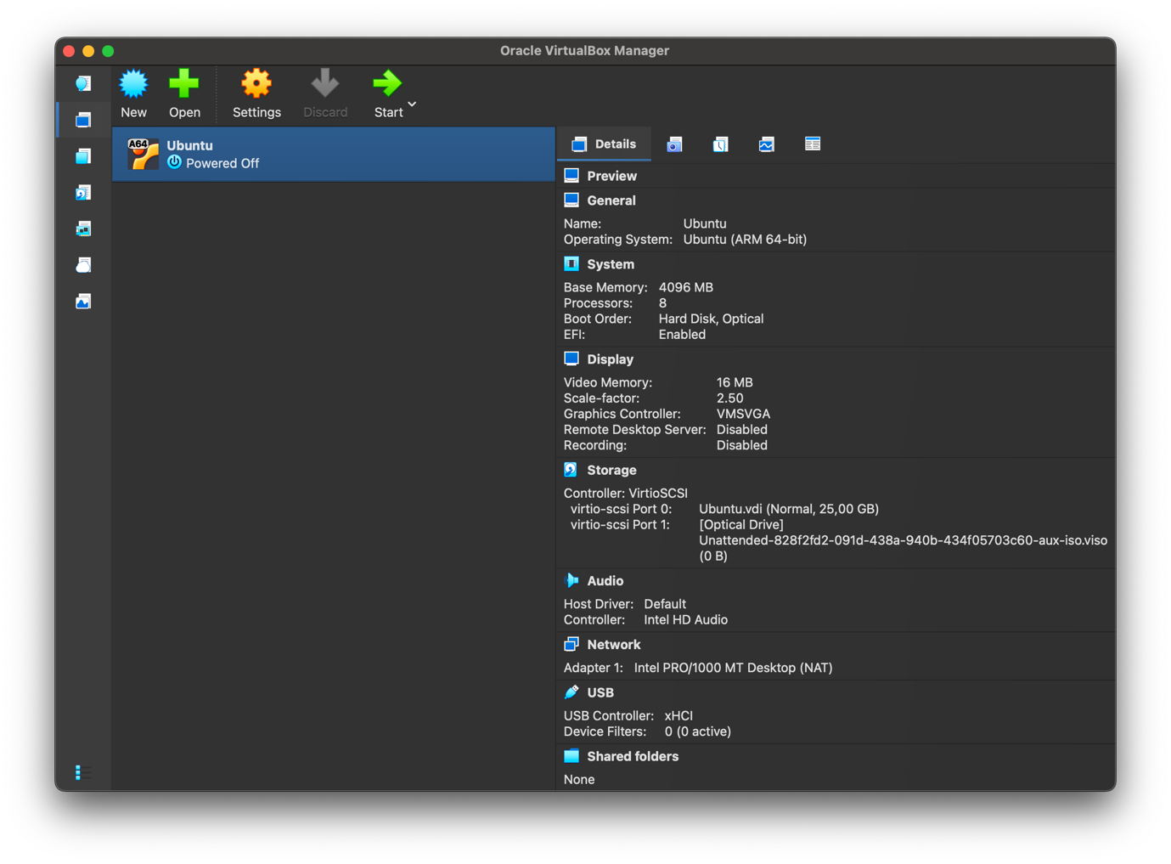
- System Information using the CLI

The commands below show the system architecture, kernel version, and CPU information.

- uname -a: To show the OS and Kernel information
- lscpu: To show the CPU details

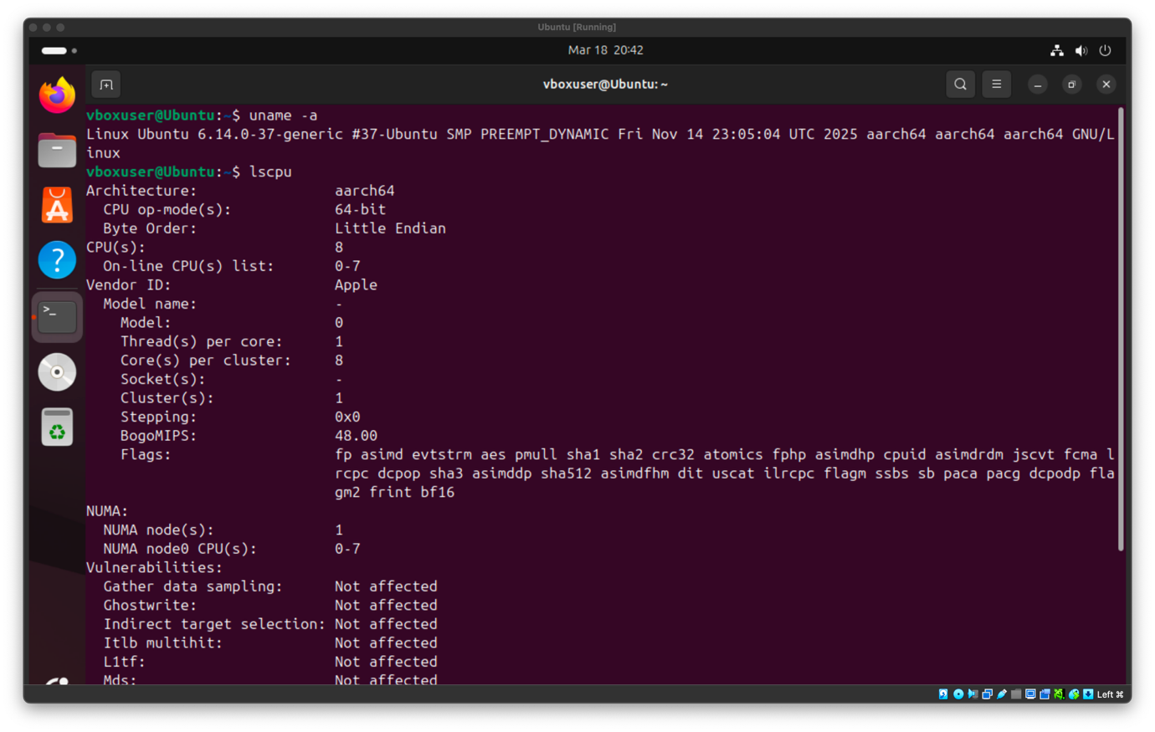

- Memory and Storage

The following commands were used to show information about the system memory, disk usage, and storage devices. These tools help to provide an overview of the system’s available resources before running the experiment.

- free -m: To show system’s RAM memory usage
- df -h: To show the disk memory usage
- lsblk: To list all the available storage devices and their partitions

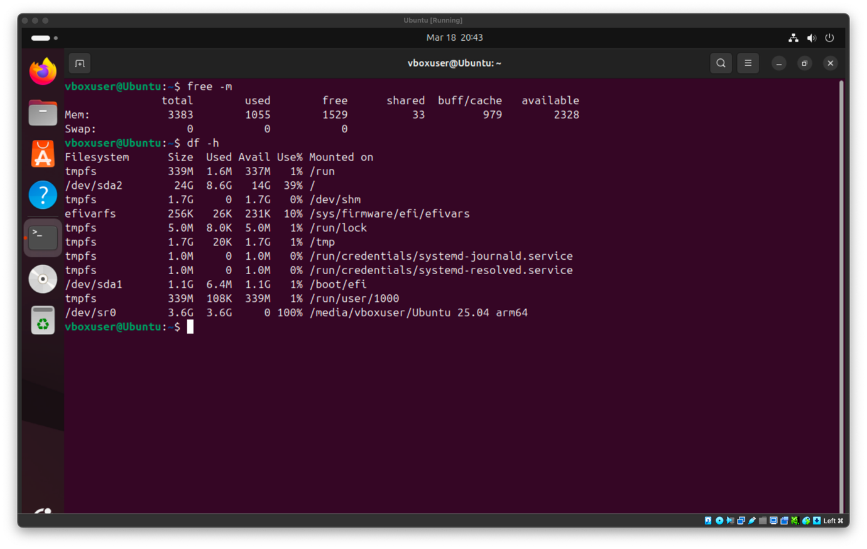
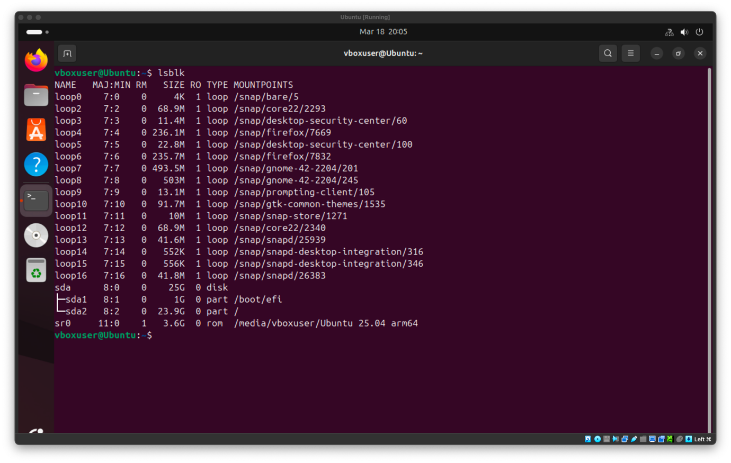
- Processes and Thread Information

To observe the running processes and the thread activity these are the commands that were used. However, as the output of these commands is large, only the first lines are going to be displayed to show a representative sample of the running processes and threads.

- ps -ef | head:
- ps -eLf | head:

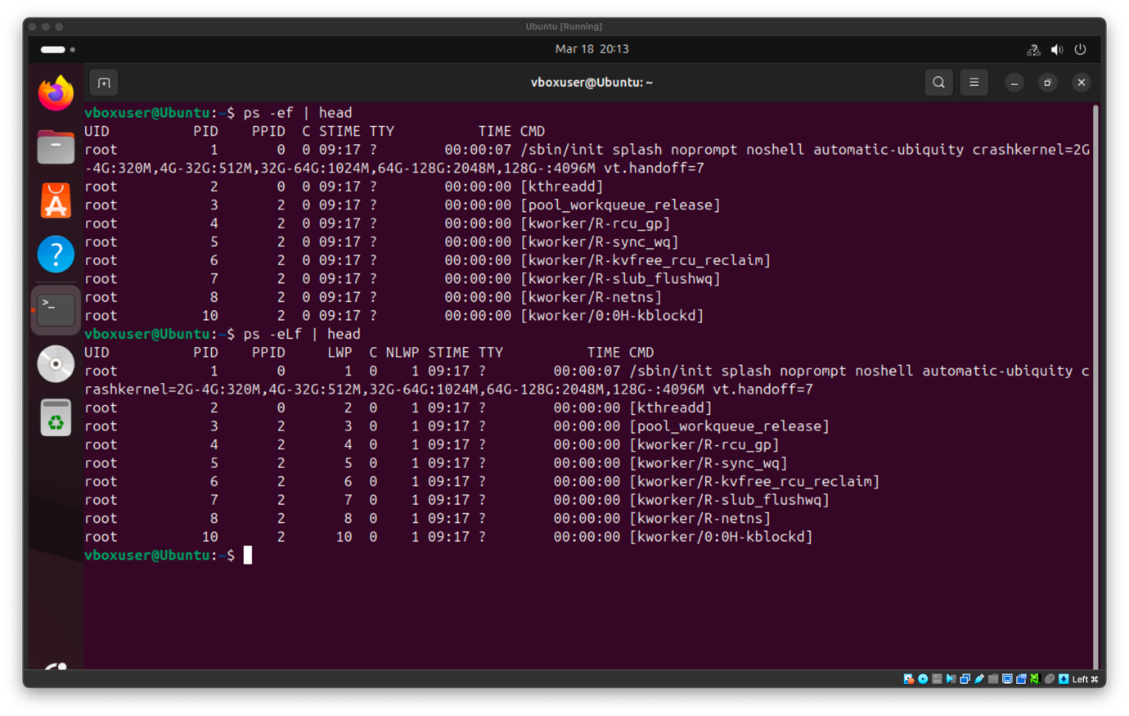

- Docker Installation and Configuration

Docker was installed using the package manager and was verified using the system service status.

- sudo apt install docker.io: To install Docker
- systemctl status docker: To verify Docker installation

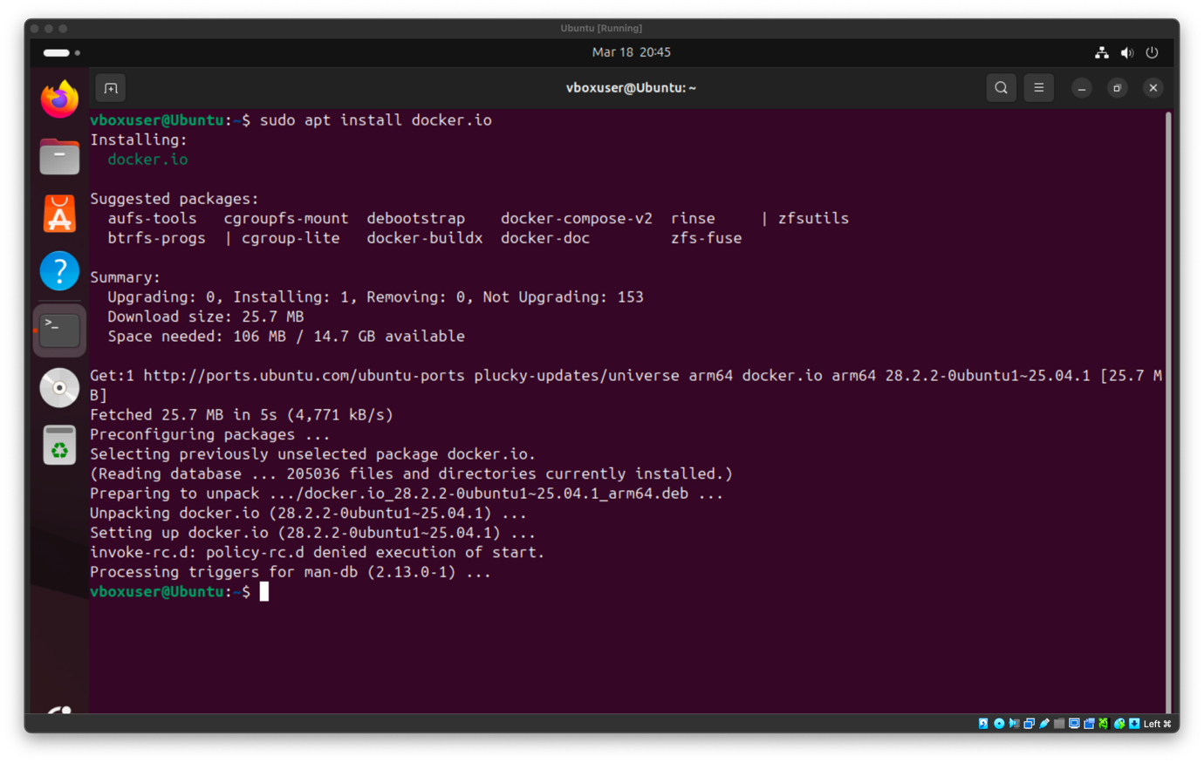
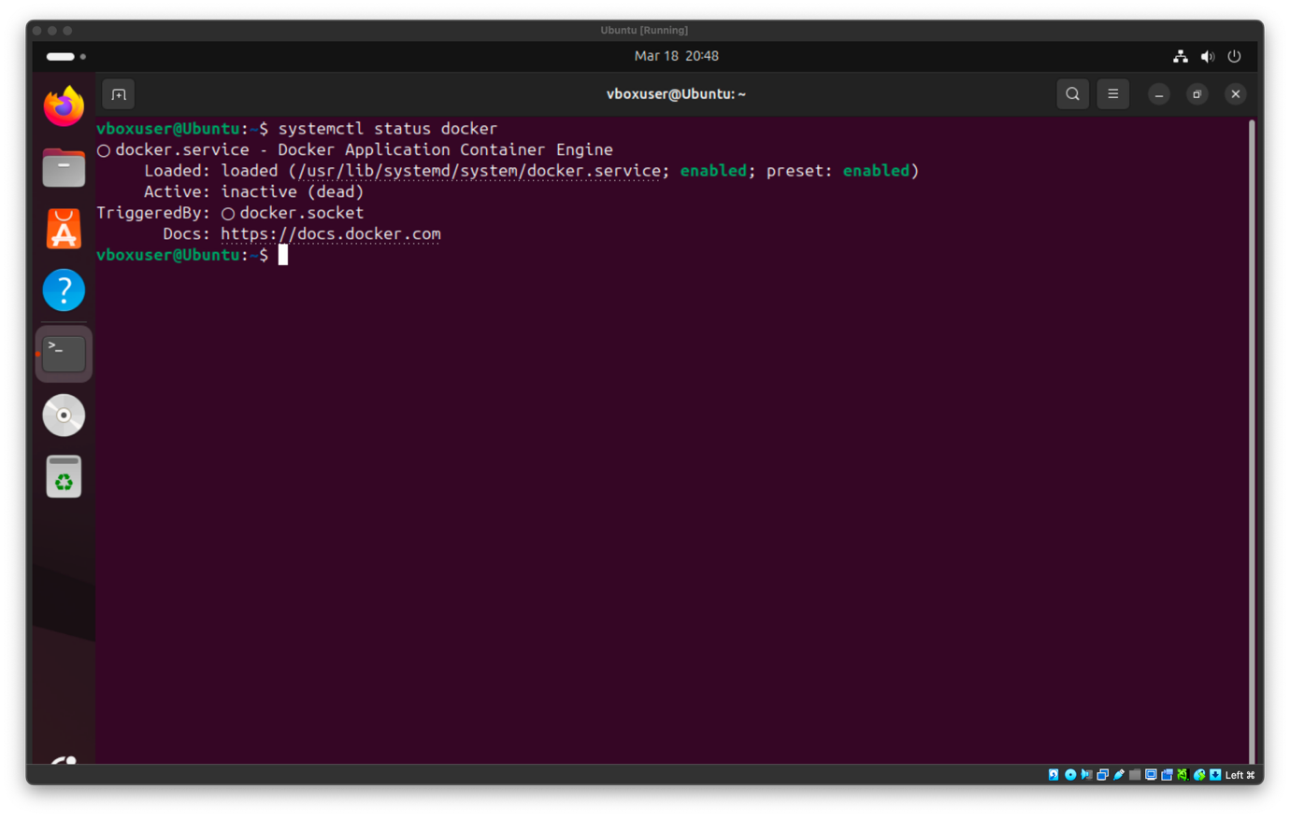
As it is shown in the image above, the Docker service was inactive, meaning that the Docker daemon was not running. Thus, I used systemctl start docker to start the daemon so that the Docker commands could function properly.

- systemctl start docker: To start the Docker daemon

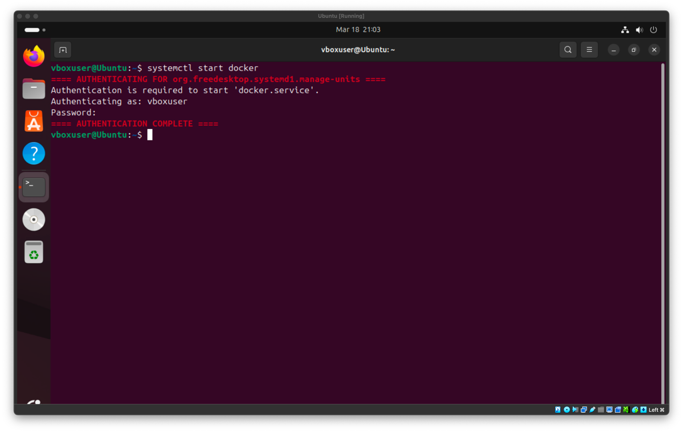

To allow the user to use docker without the need for sudo privileges this command was followed.

- sudo usermod -aG docker vboxuser: To add vboxuser to the group with docker
- sudo su - vboxuser: To make the group membership effective

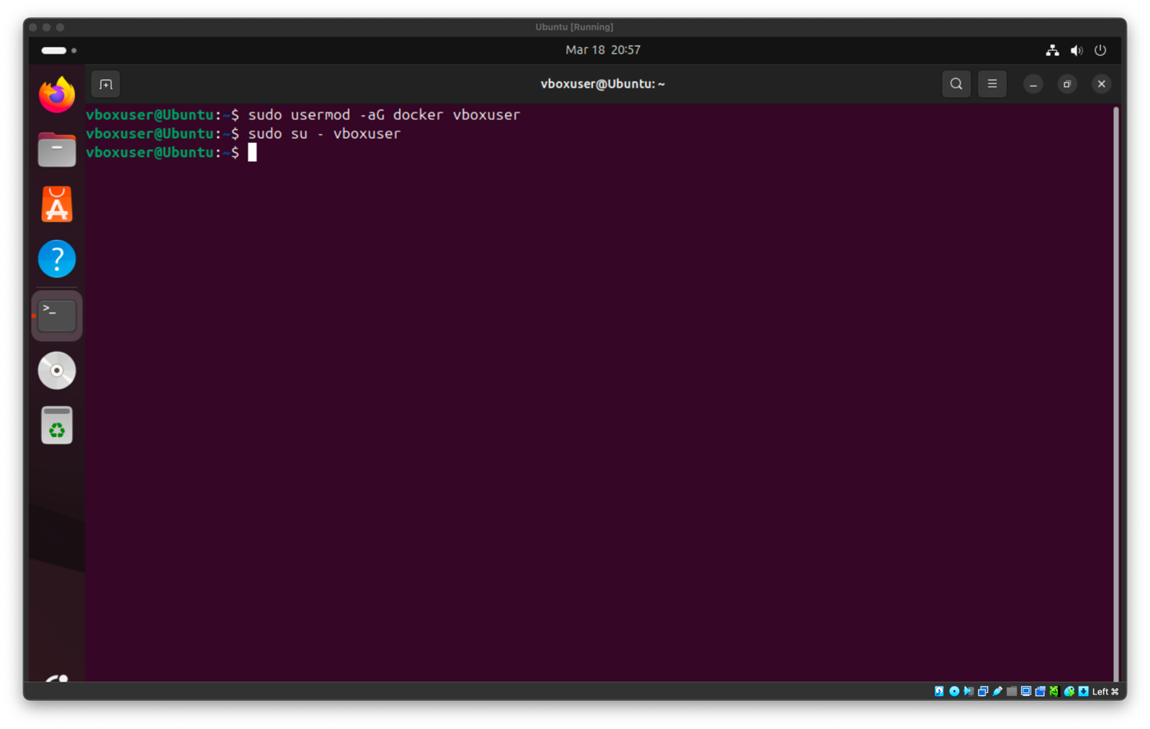

Now to verify that the daemon was started successfully and that the user’s membership was effective the following commands are going to be followed.

- systemctl status docker: To verify that Docker is operational
- docker pull hello-world: To install the hello-world image
- docker run hello-world: To verify and run the hello-world image

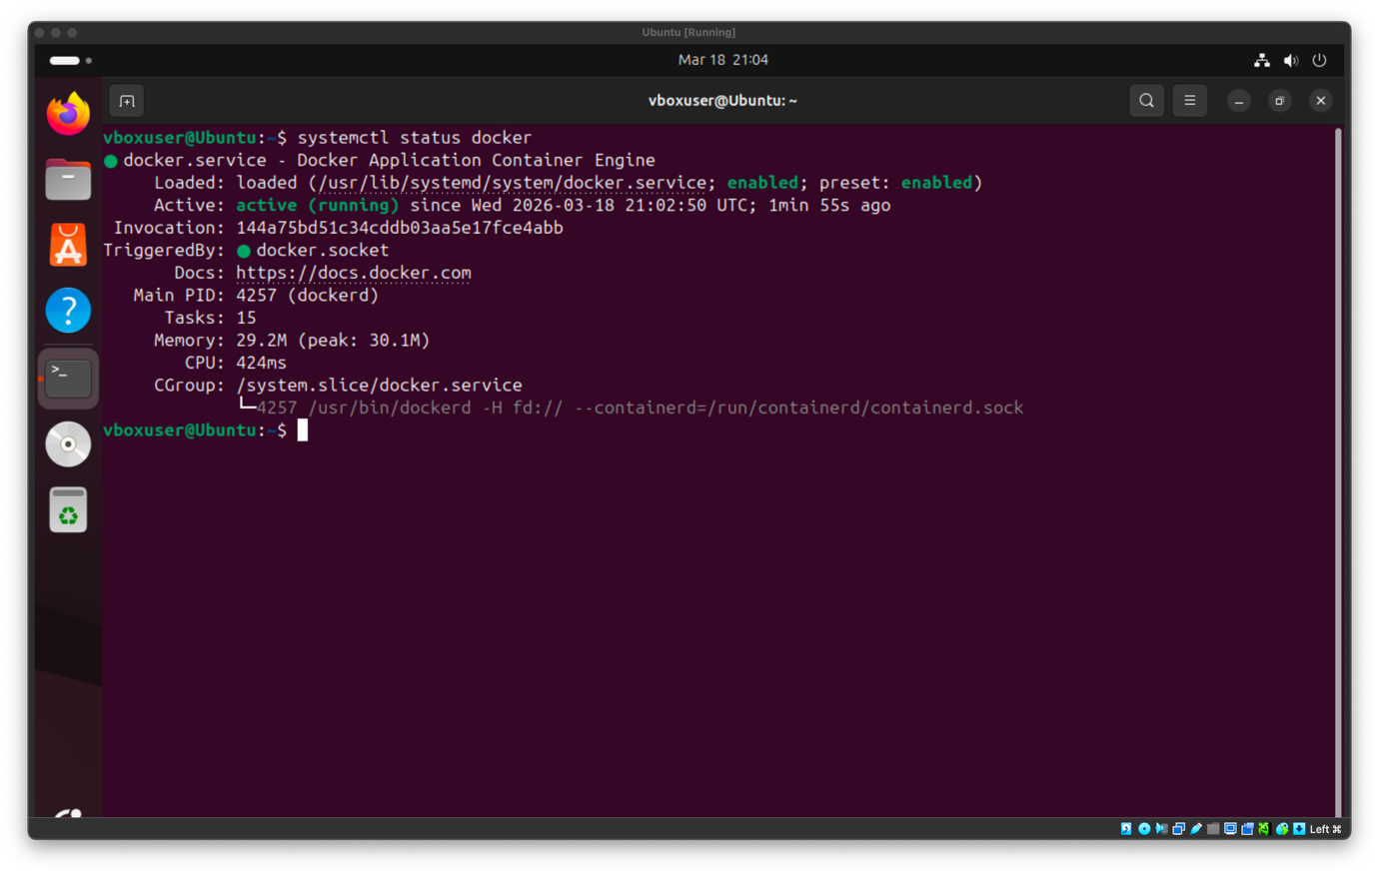
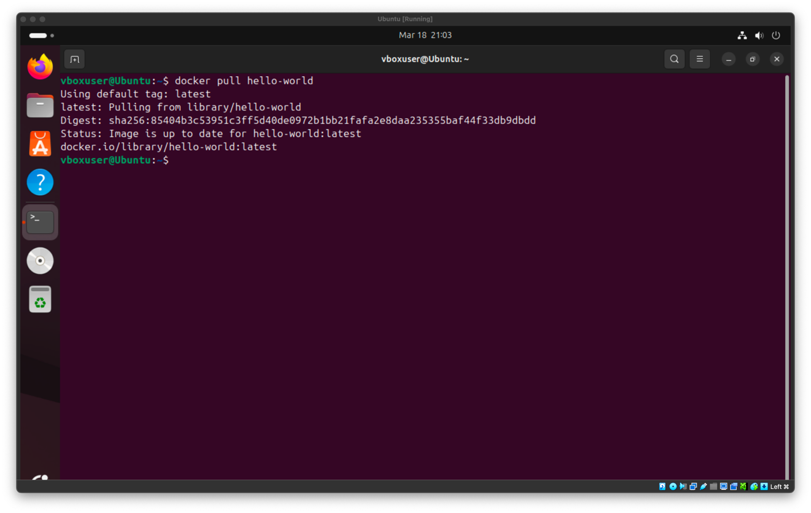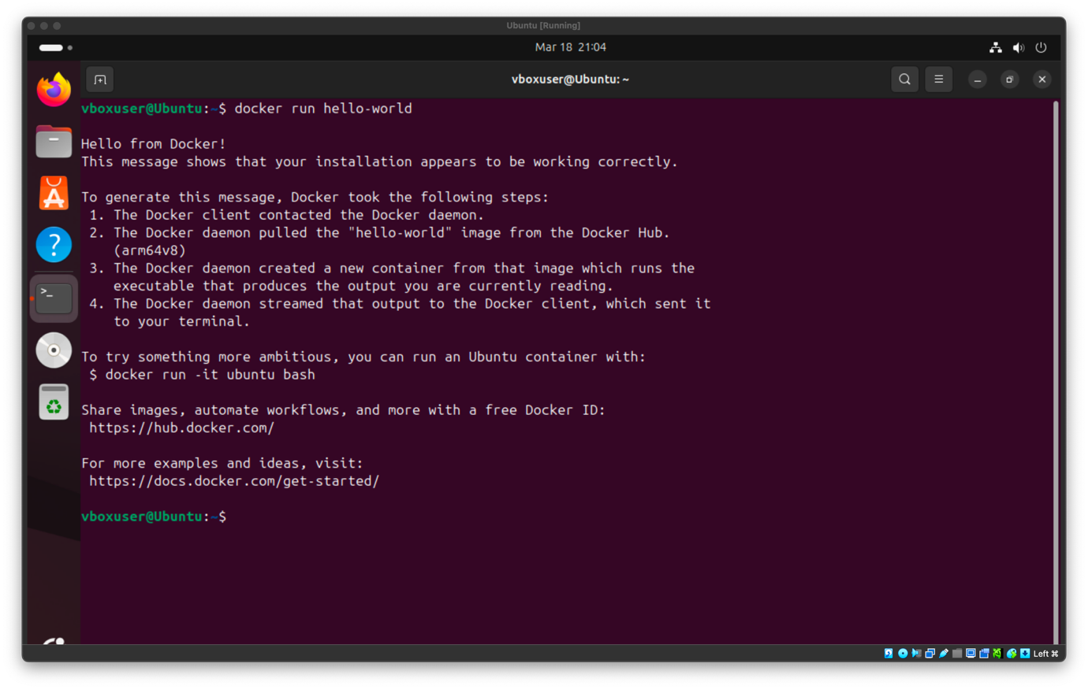

As it is shown in the images, the daemon was started successfully with the systemctl start docker command, and the hello-world image was installed and run successfully without the need of sudo privileges.
- Python Libraries Installation

In the following image the necessary Python library installation is showcased. Here Python and pip is installed again using the package manager. In this case, pip is going to be used to install and manage Python libraries such as Flask and Gunicorn.

- sudo apt install python3-pip -y

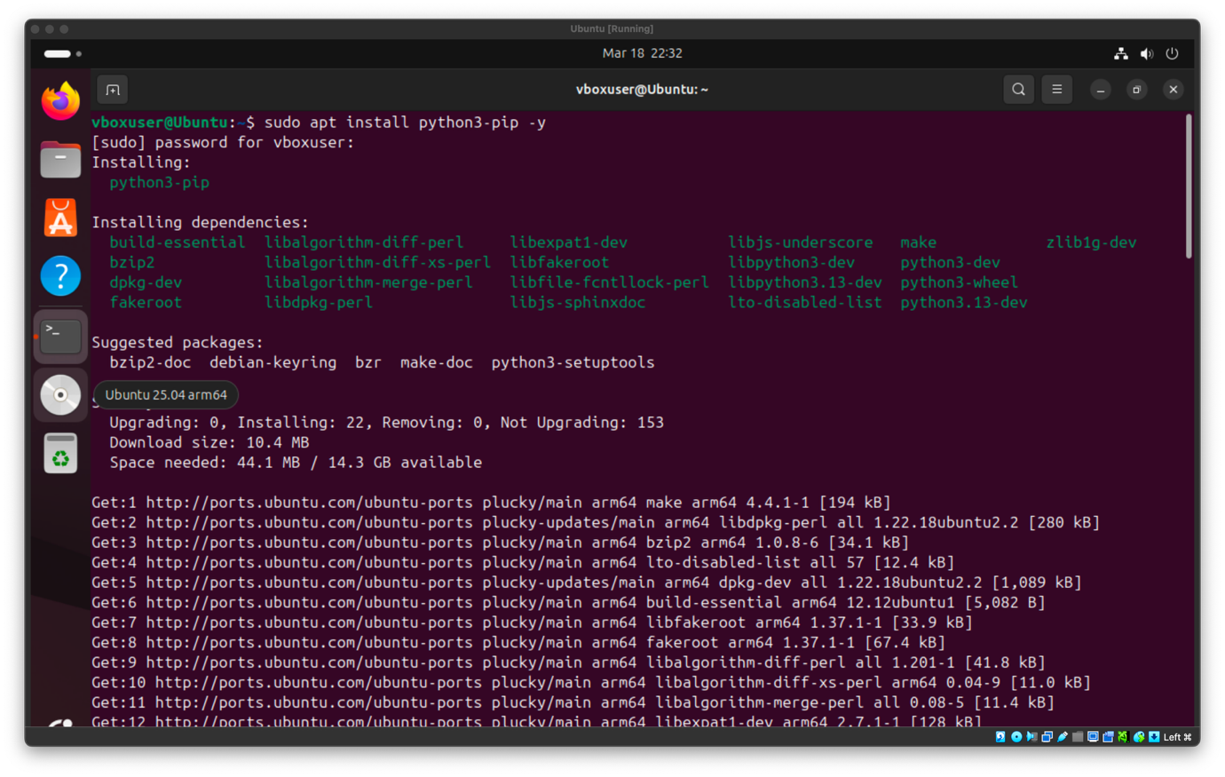

To verify the installation of Python and pip the commands python3 --version and pip --version are run.

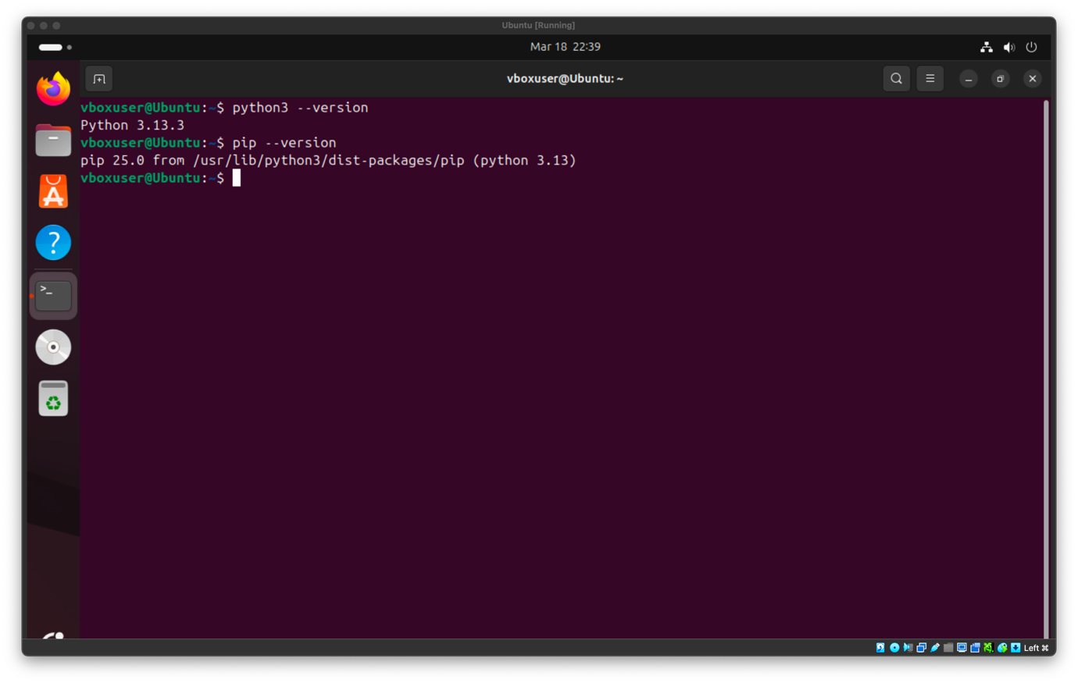

Thus both libraries are installed properly.

- Flask and Gunicorn Installation

As mentioned previously, to install these two packages pip is used as they are Python libraries.

- pip install flask gunicorn

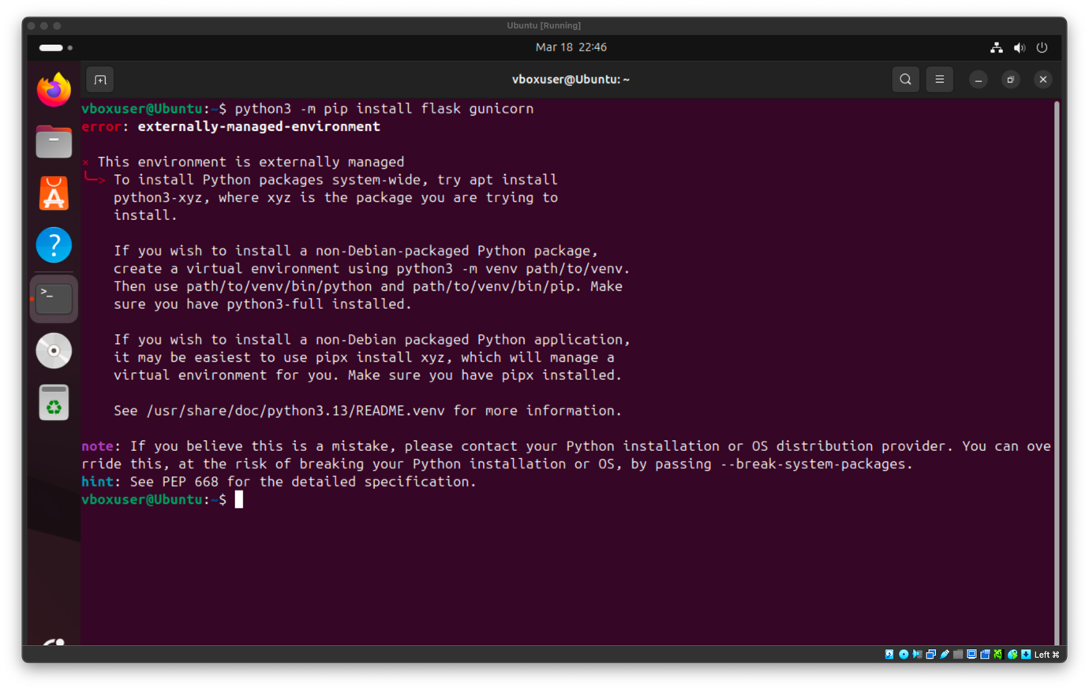

However, Ubuntu is blocking the pip installation to protect the Python files that are managed from the system, thus the --break-system-packages flag is necessary to be included in the installation command to bypass these restrictions and install Flask and Gunicorn successfully.

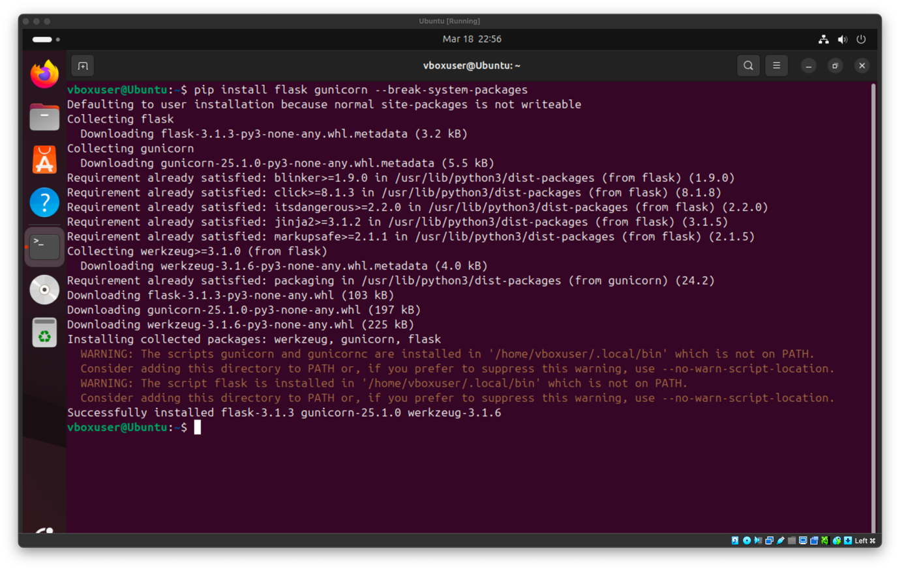

Now Flask and Gunicorn have been installed successfully.
- Python Test Application Development

As mentioned before, the small test web application is built using Flask. The application defines a single route called /hello that just returns a simple test response. This application can be executed directly using Python or through Gunicorn, allowing it to be used both for the multithreaded and the container executions. Also, to create the file that will contain the code for the application the nano command was used and the application was named app.py.

- nano app.py: To create and save the file that contains the Flask application code
- python3 app.py: To run the application and start the server

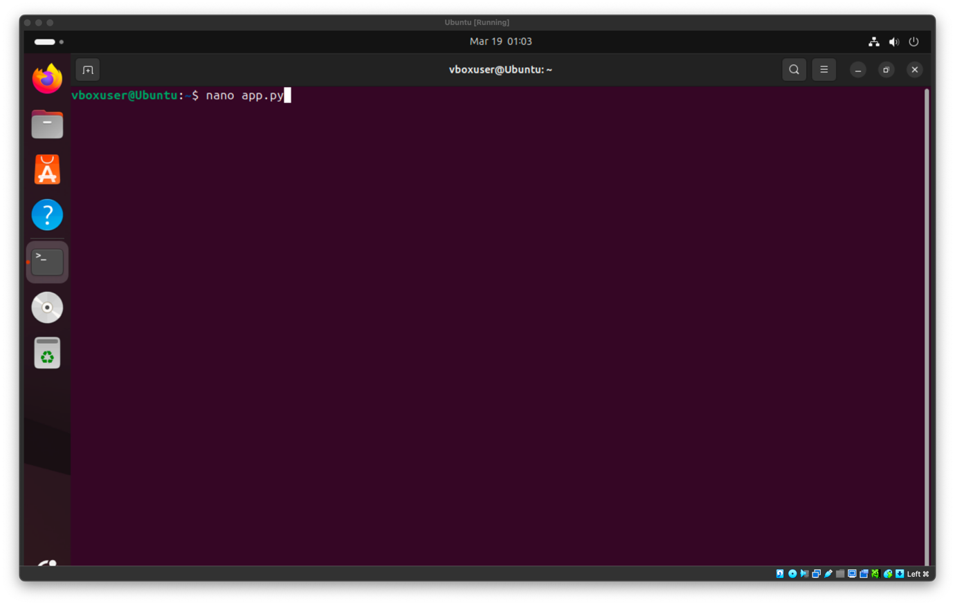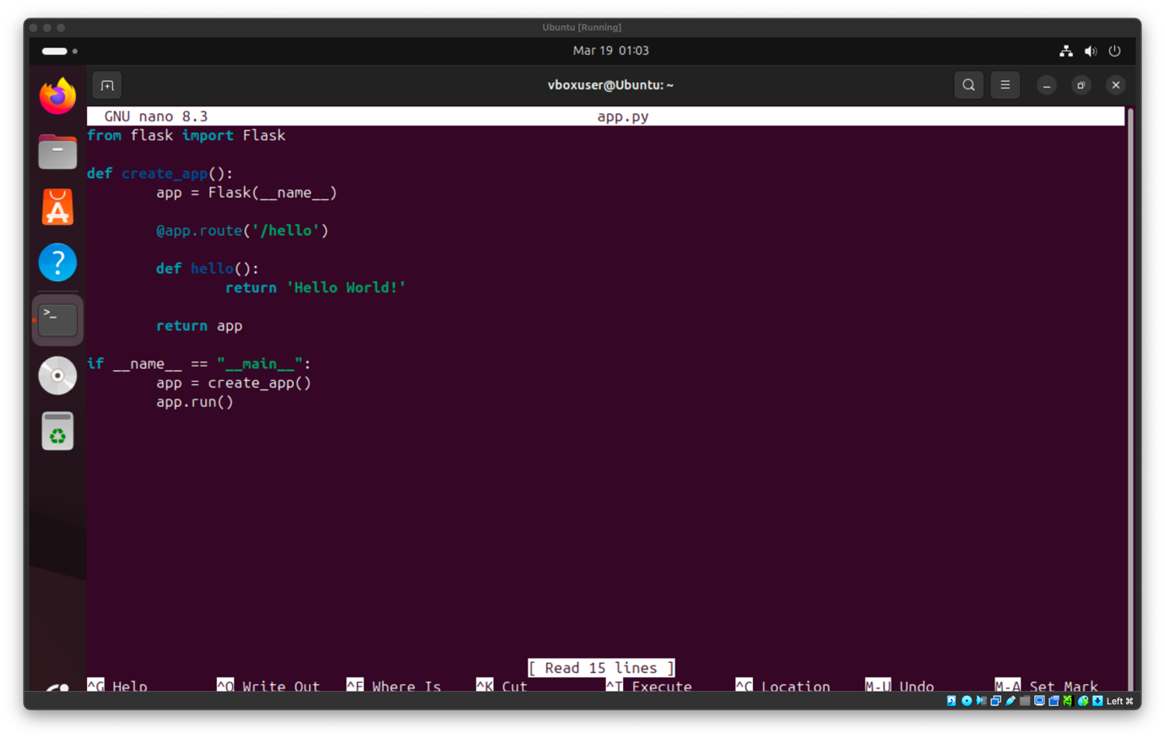
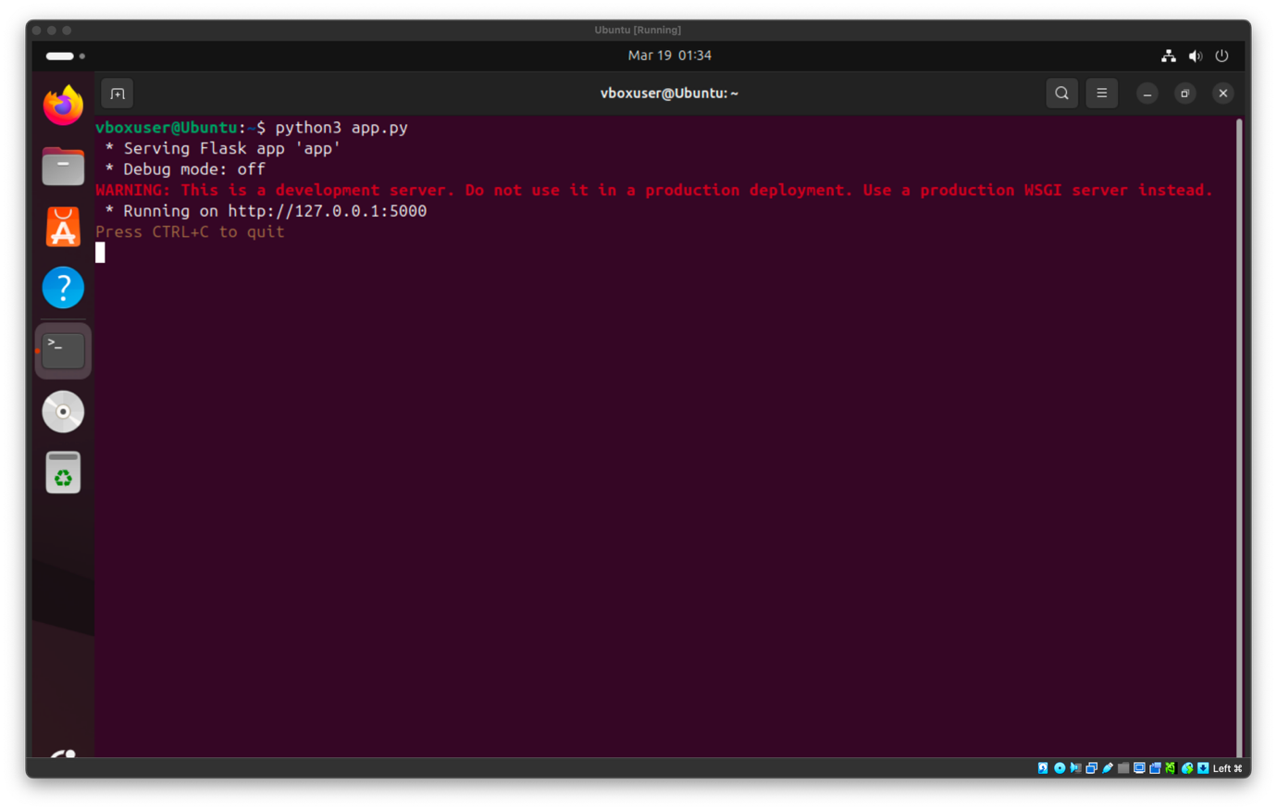

Furthermore, to test the application, the curl command was used to send a request to the server and check the response. Also, the curl command needed to be installed using the package manager.

- sudo apt install curl: To install curl
- curl http://127.0.0.1:5000/hello: To verify that the application responds properly with “Hello World!”
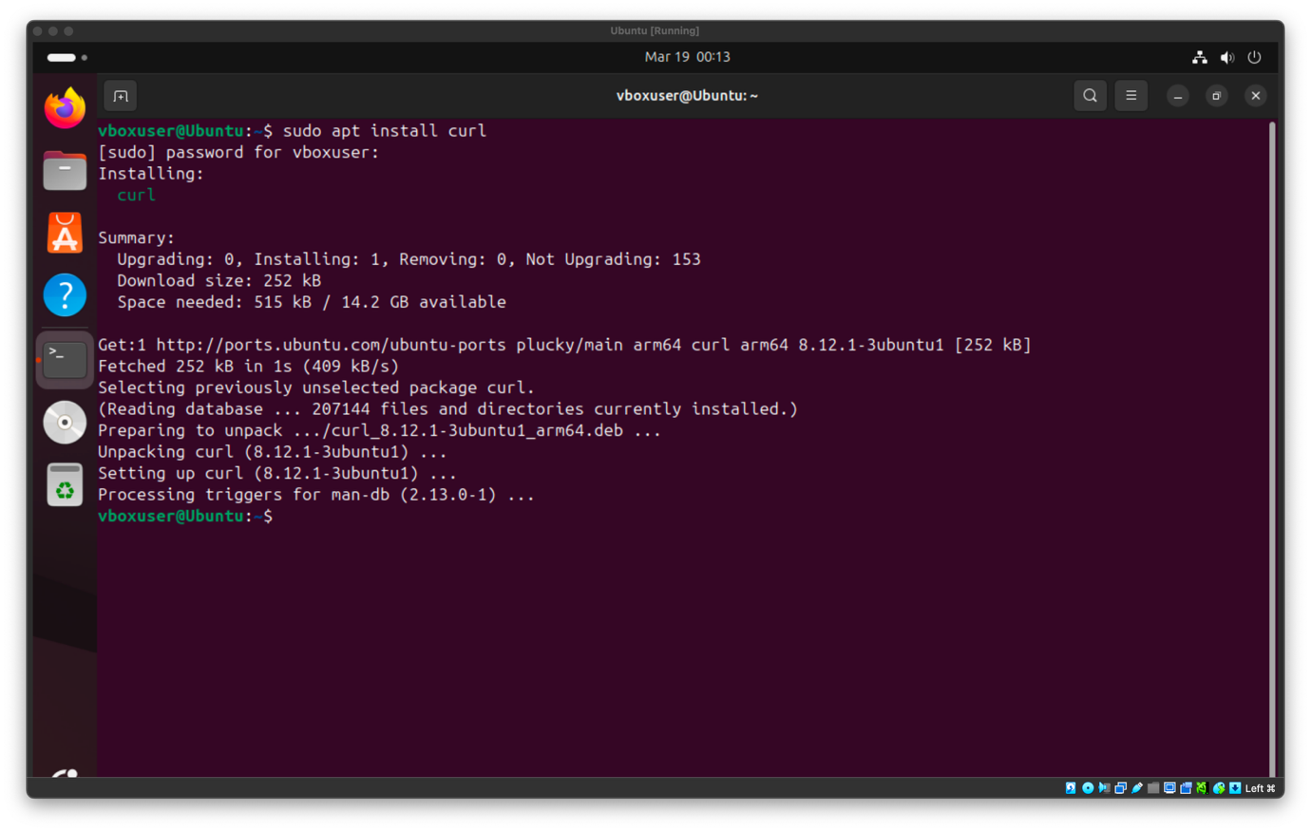
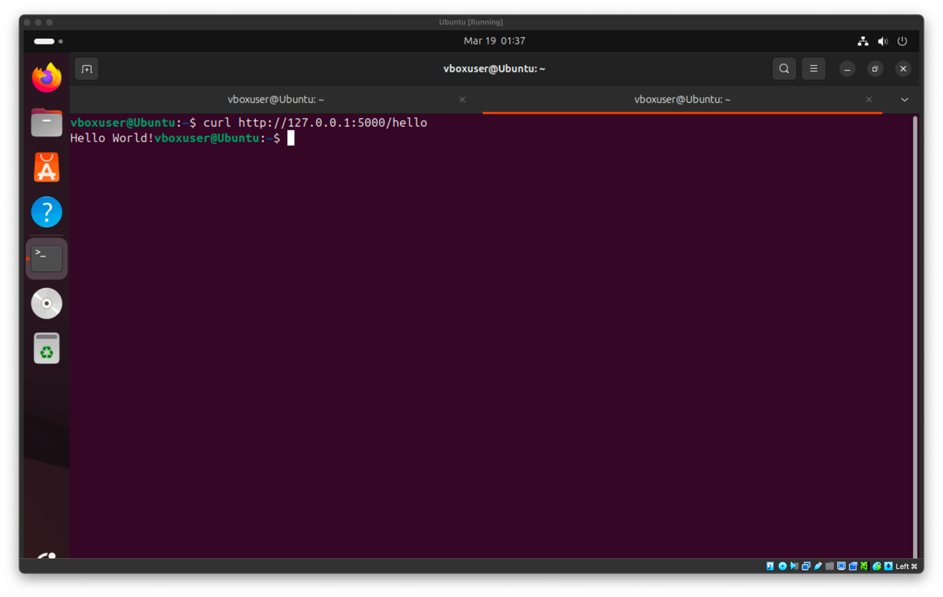

As it was shown from the curl command, the connection to server was successful and it responded correctly with the “Hello World!” print.

Experiment

In this part of the project, the Flask application is going to be executed using the two different methods, so that later their results can be compared. In the first case, the application is going to run using Gunicorn with 20 threads, meaning that one instance of the application will handle multiple requests at the same time. In the second case, the same application is going to be executed inside 20 different Docker containers, where each container will run its own instance of the application.

- Multithreaded Experiment

To begin the multithreaded execution, Gunicorn is going to be used to run the application with 20 threads.

- gunicorn --threads 20 'app:create_app()'

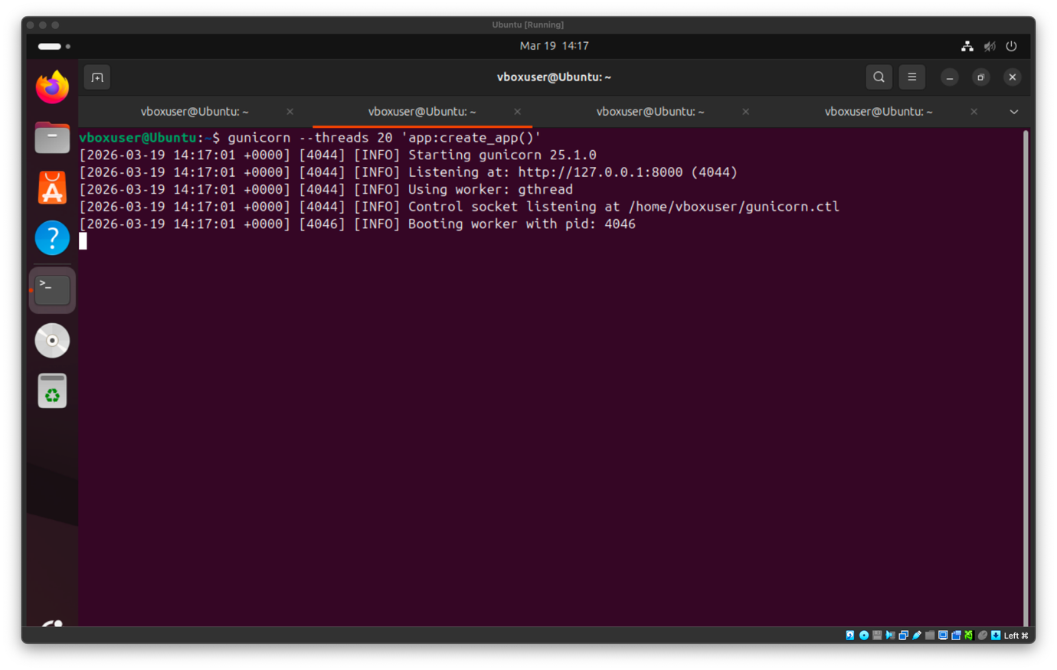

As it is shown in the output, the application started successfully with gunicorn and it is listening on port 8000 for requests.

Also, with the command ps -eLf | grep gunicorn we can confirm the multithreading
- ps -eLf | grep gunicorn
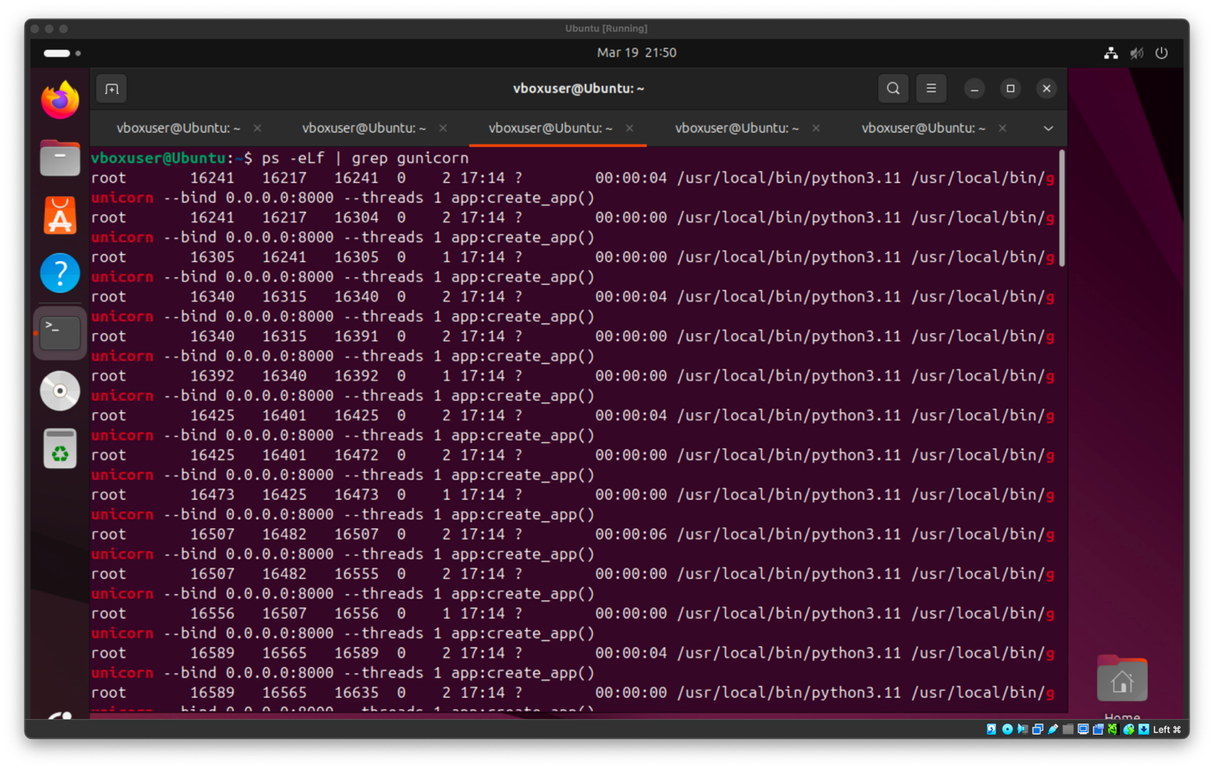

Before executing the requests, the system resource usage needs to be observed with htop while the application is running. This will allow us to understand the system’s resource usage in an idle state and make it easier to conclude the workload of the requests.

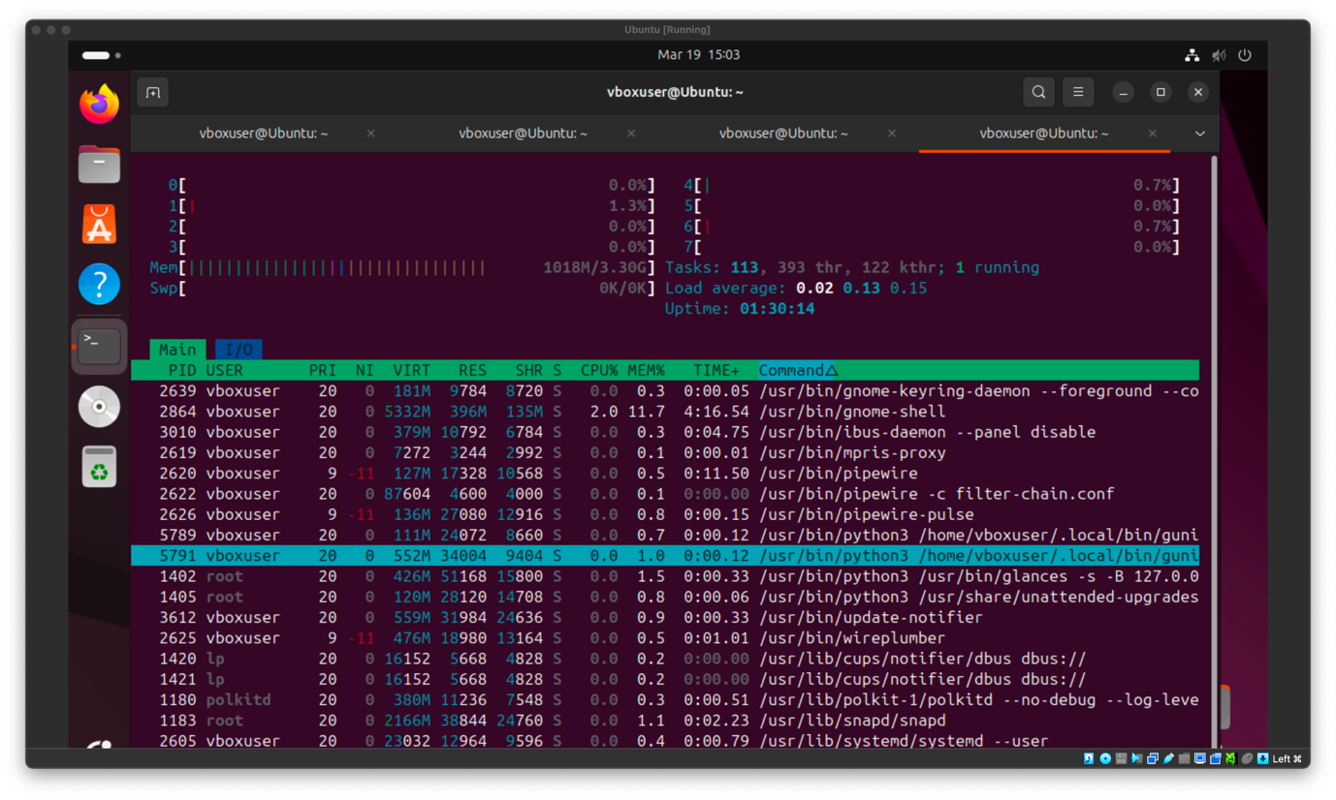
As it is shown in the image above, the CPU usage in an idle state remains very low close to 0% - 1%, and the memory usage is 1018MB out of the 3.30GB total. The next step now would be to run the curl command to send the requests to the application.

However, to observe the behaviour of the 20 thread execution, multiple and concurrent requests must be sent to the server. So, multiple curl requests must be sent in parallel so that the application receives 20 requests at the same time using a shell loop [5]. During this process, the htop command is going to be used to observe the CPU and memory usage of the application.

- for i in {1..20}; do curl http://127.0.0.1:8000/hello & done; wait
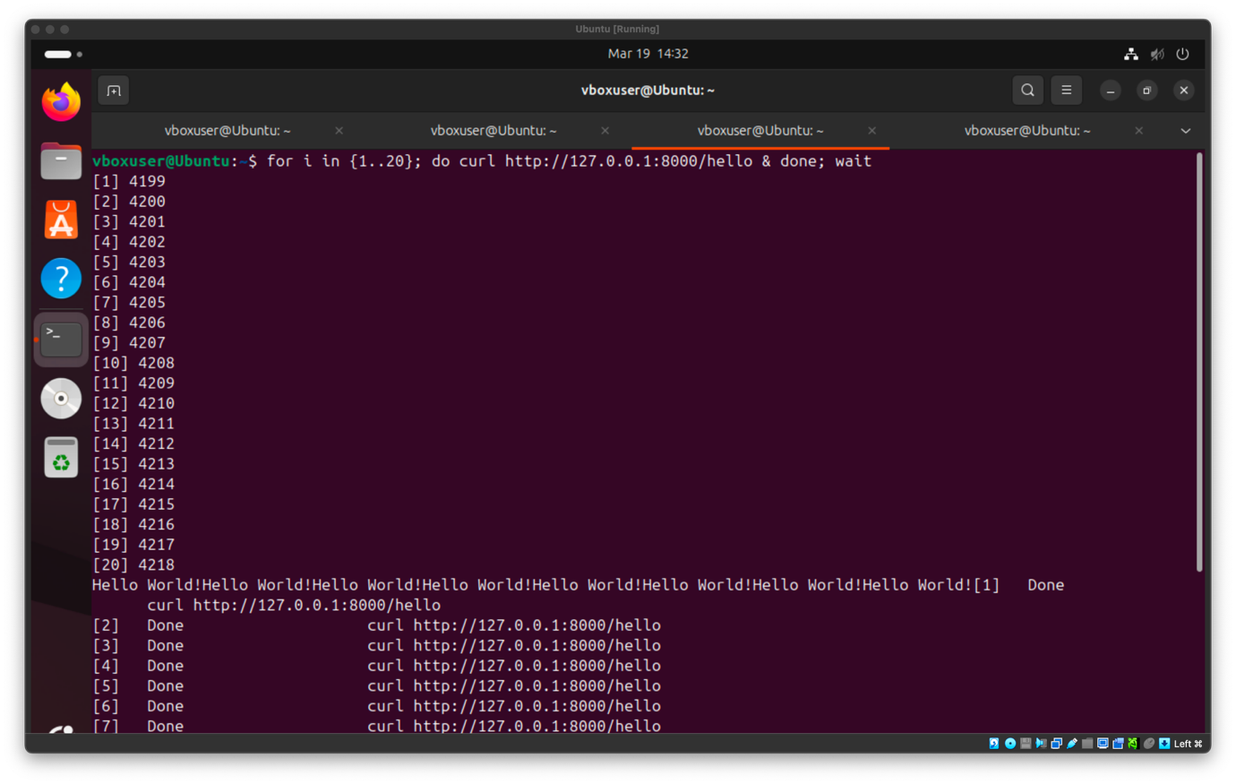
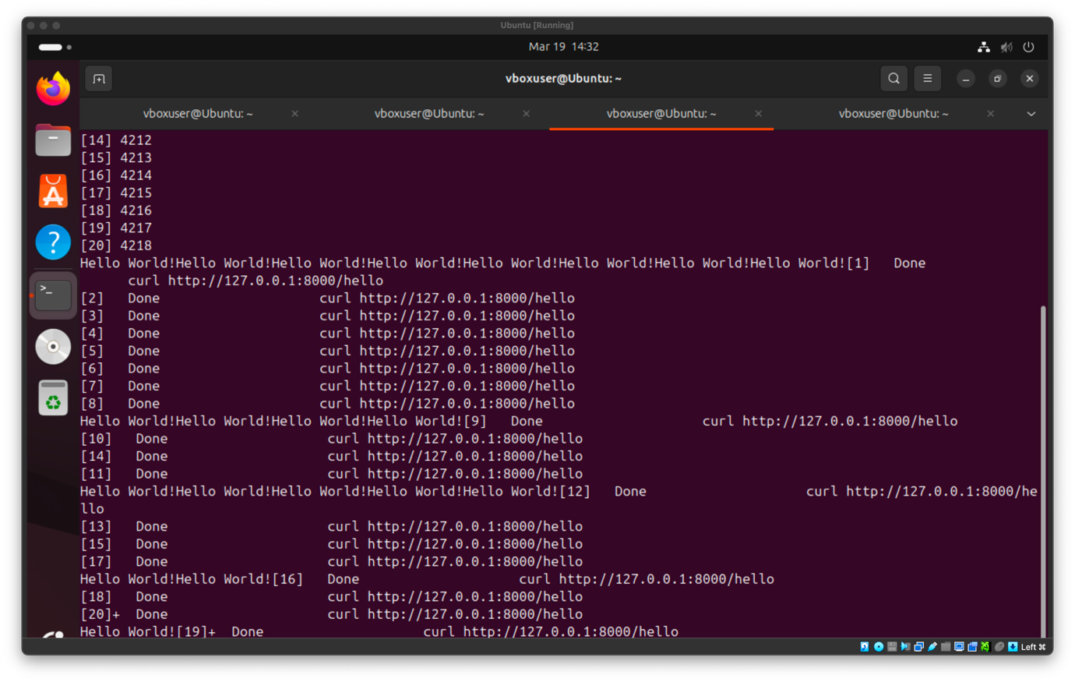
As shown, the shell loop is executed successfully and now the CPU and memory usage can be observed.

While the requests are being sent, the htop is observed to see the system’s behaviour. The CPU usage increases compared to the idle state, reaching around 5% to 8% in all cores. Also, the memory usage is relatively stable going up only to 1.02GB from 1.018GB, indicating that the application is lightweight and does not require much additional resources even under concurrent execution.

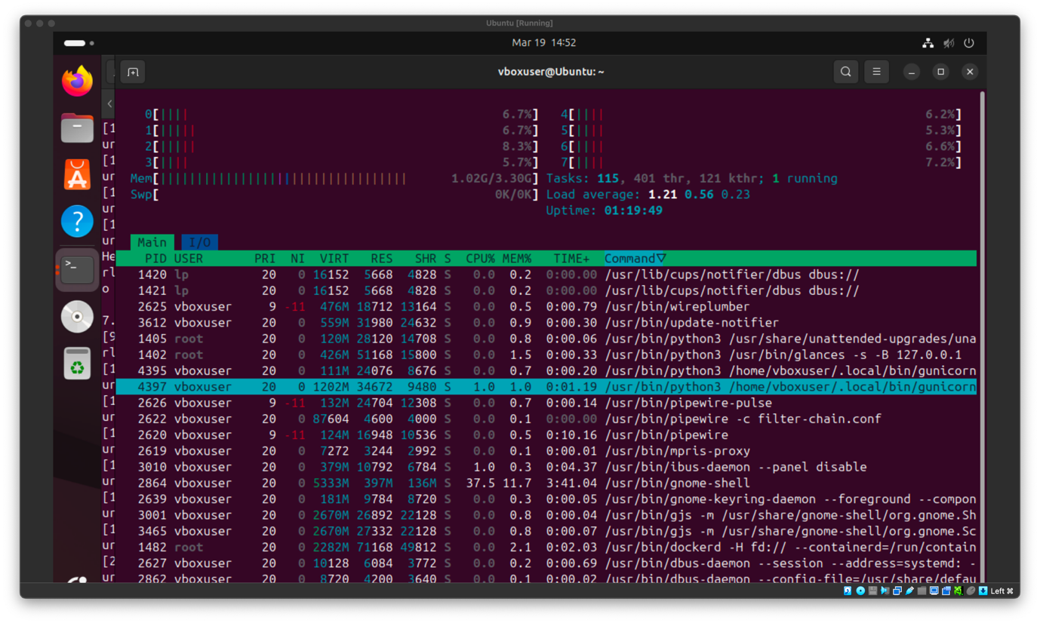
- Docker Containers Execution

To start the Docker container experiment, a Dockerfile needs to be created to define how the application will be executed inside the container. The Dockerfile contains the necessary instructions on how to set up the environment, copy the application file, install the required libraries, and then run the application using Gunicorn. This will ensure that each container runs the same application under the same conditions.

- nano Dockerfile: To create the Dockerfile that contains the instructions for building the container image

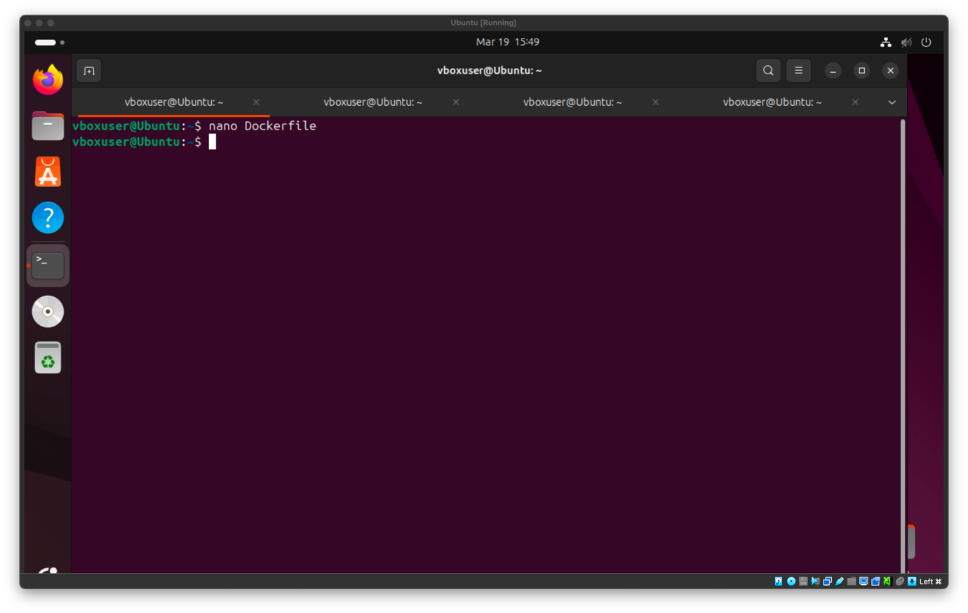
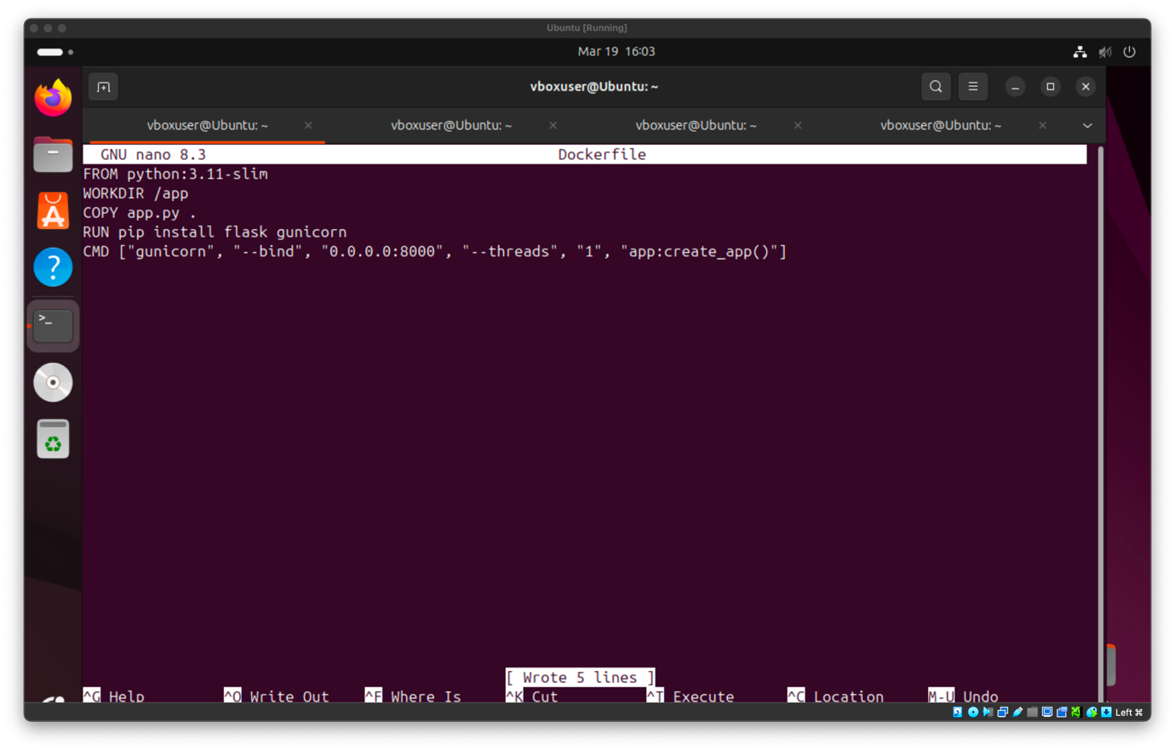

To verify that the creation of the file was successful the cat command was used.

- cat Dockerfile

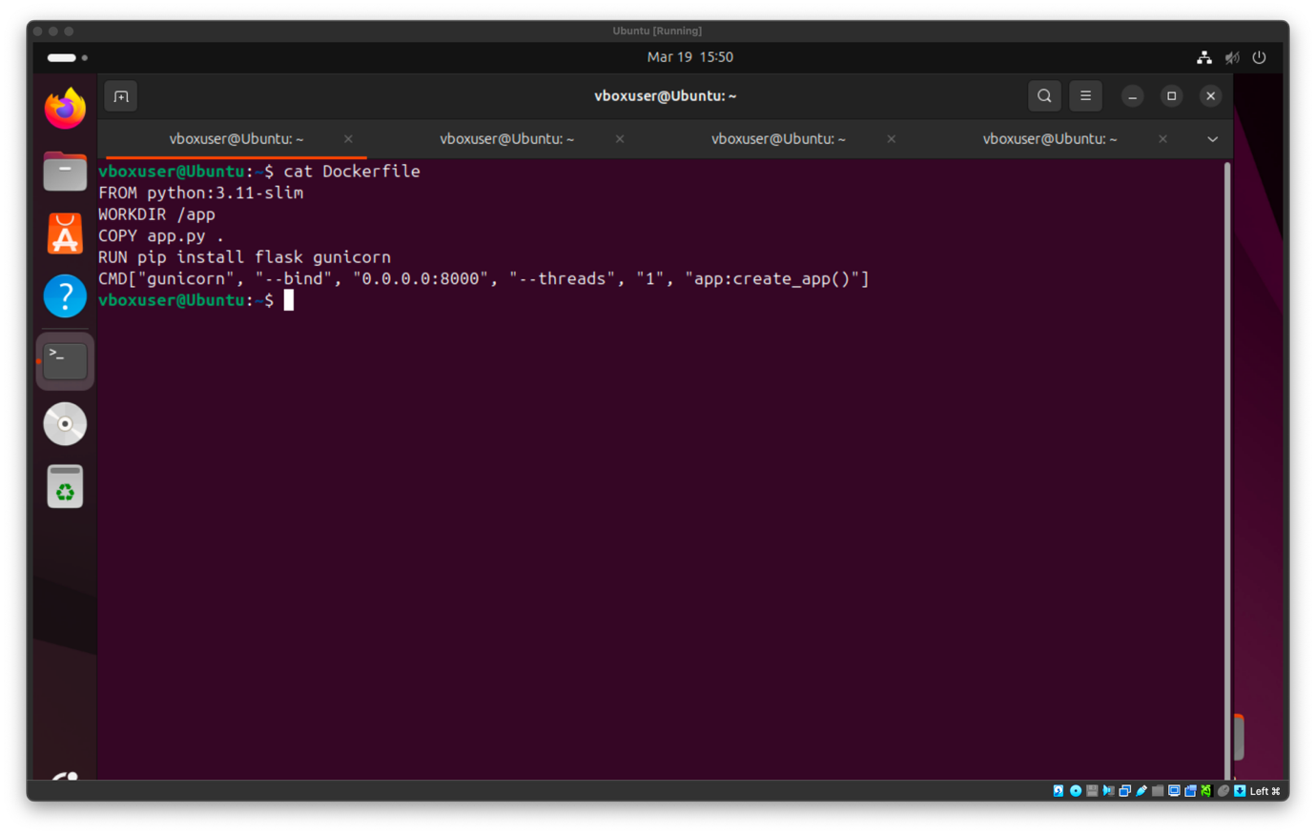

After the creation of the file was confirmed, the Docker image can be built using the defined instructions from the file. This process prepares the application so it can be executed inside the multiple containers.

- docker build -t flasktest .: To build the image that is going to be run inside the containers which is called flasktest

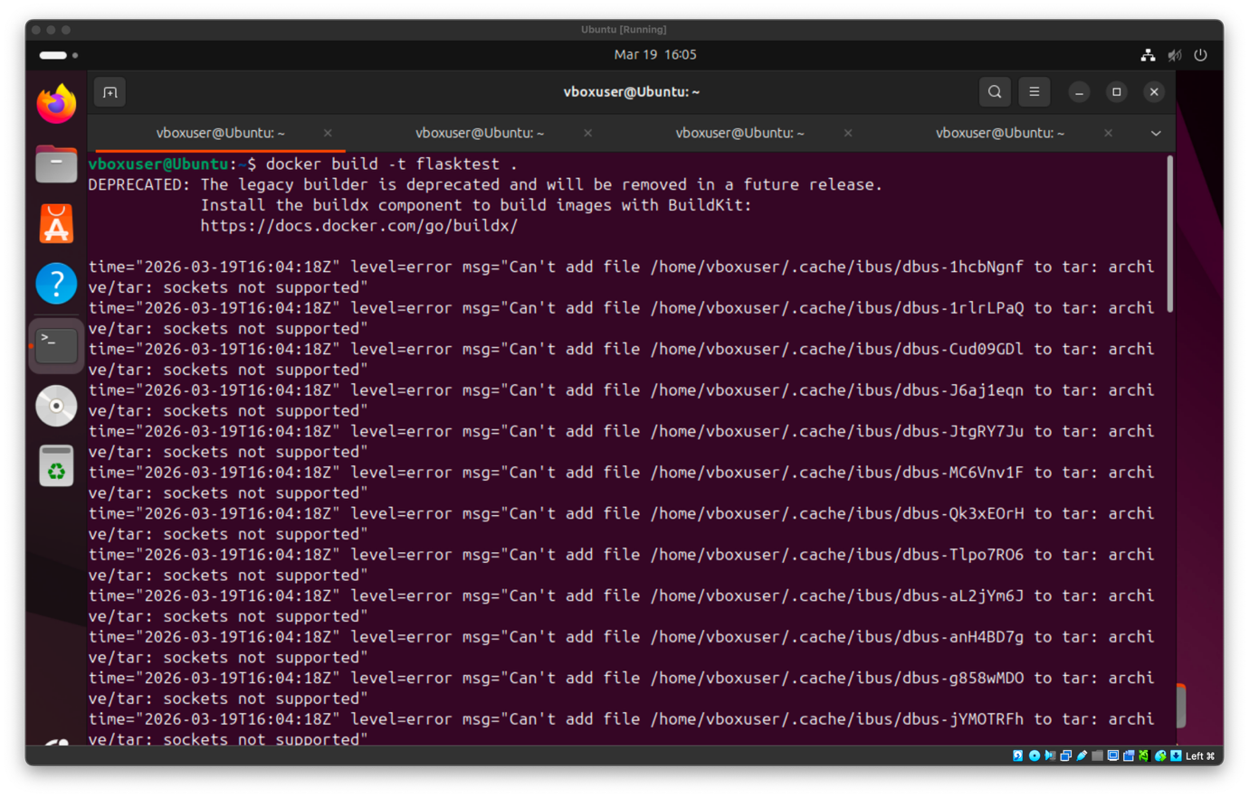

As shown, there are some errors during the creation of the image about the deprecation of the legacy builder, however using the command docker images shows that the image was created successfully.

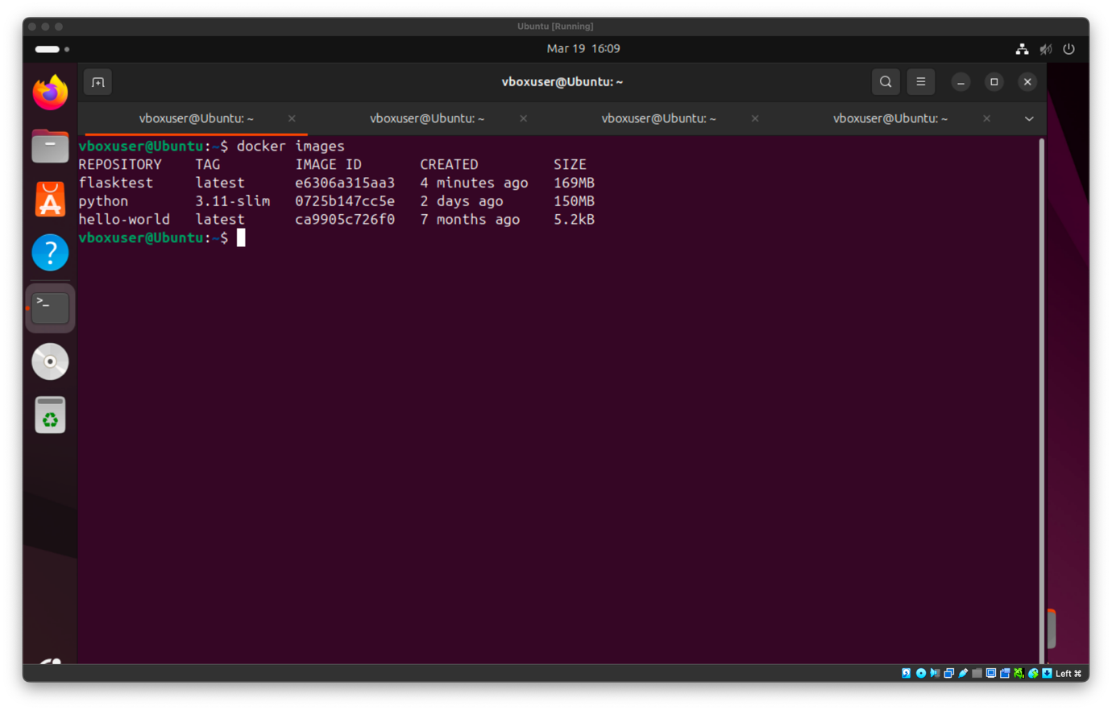

This is further supported using the command docker run to actually run the image.

- docker run -p 8000:8000 flasktest: To run the Docker image called flasktest in port 8000.

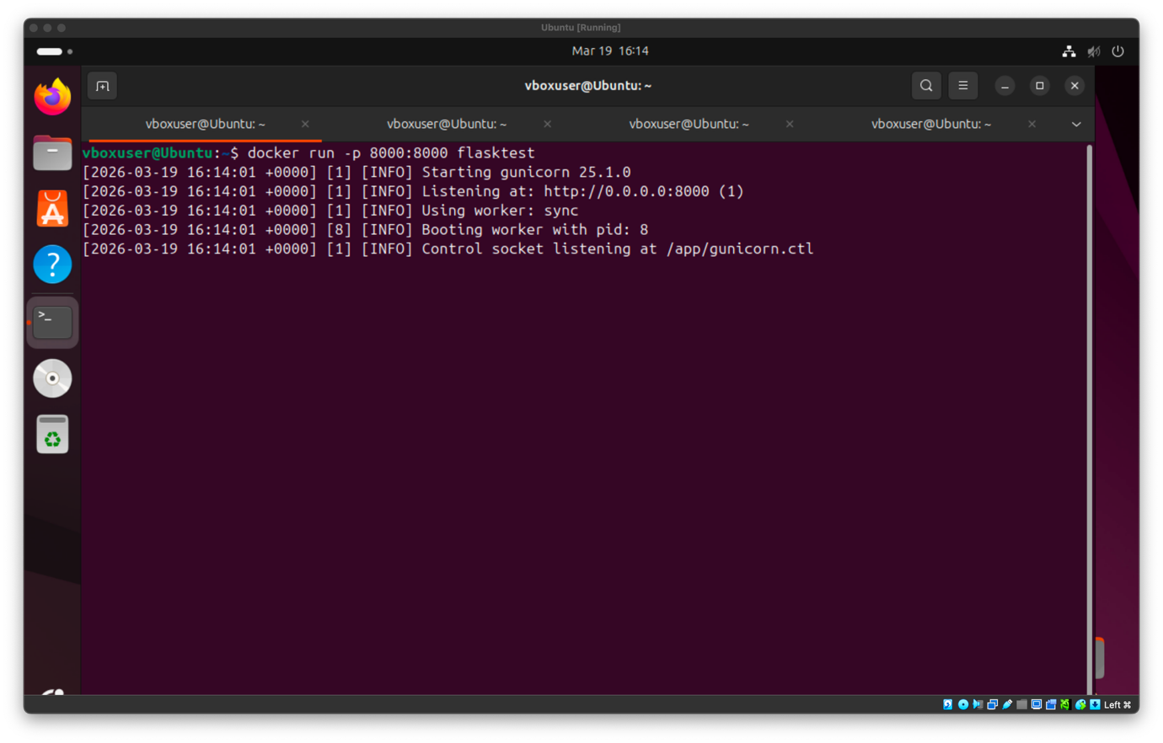
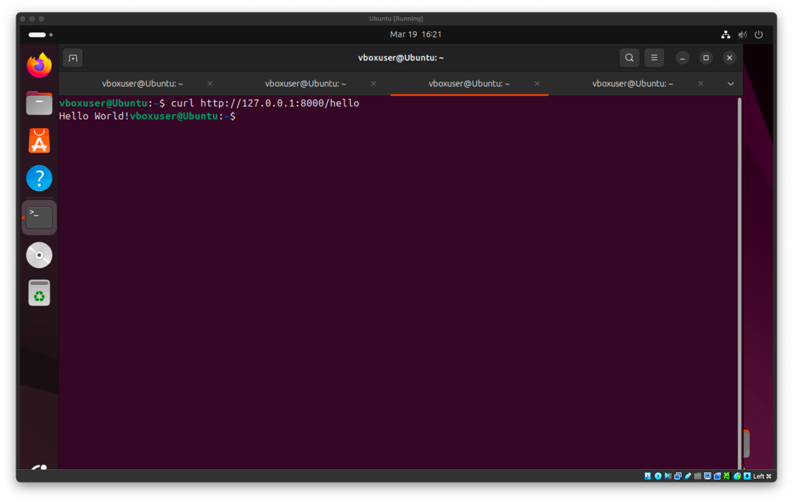

Since the server responded correctly with Hello World it confirms that the image was built successfully. Now it is time that the containers are created and run with the docker run command and a shell loop.

- for i in {1..20}; do docker run -d -p $((8000+i)):8000 flasktest; done

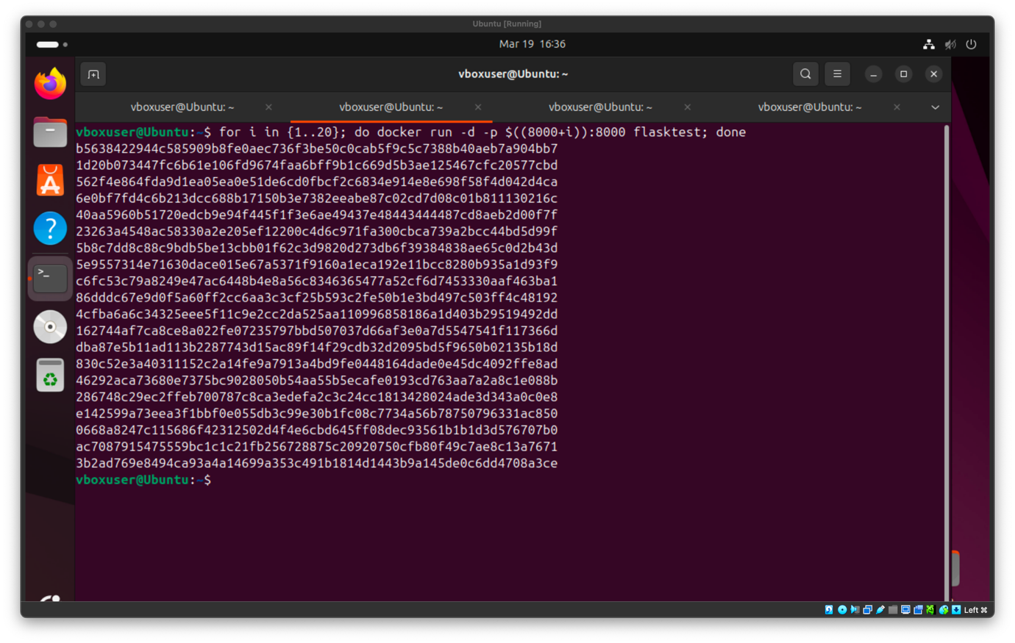

Also, the ps command was used to verify that all the container instances were running at the same time. As shown in the image below, each container was assigned a different port, confirming that the containers were run successfully. Furthermore, the different port assignments are what allow multiple instances of the same application to run at the same time.

While the containers are running in htop it is already observed that the CPU and memory usage went up from just running the 20 different containers without them having to respond to a request. The usage of some CPU cores went up some small percentages, however it is shown that some cores reach around 5% of usage.

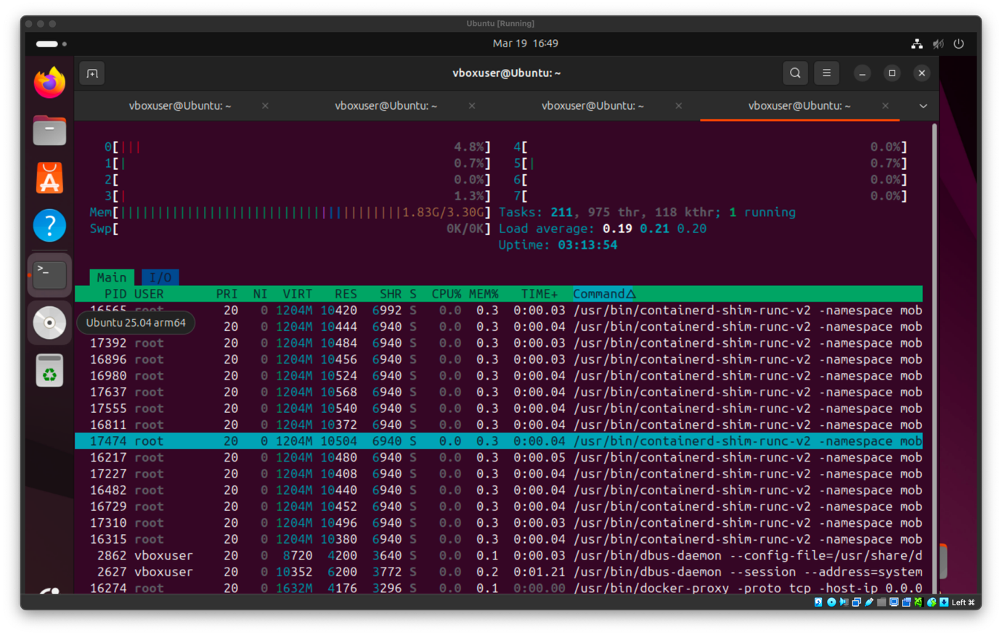

Now to send the requests, the curl command with a shell loop was used to send 20 requests at the same time to all the different ports that the containers were running.

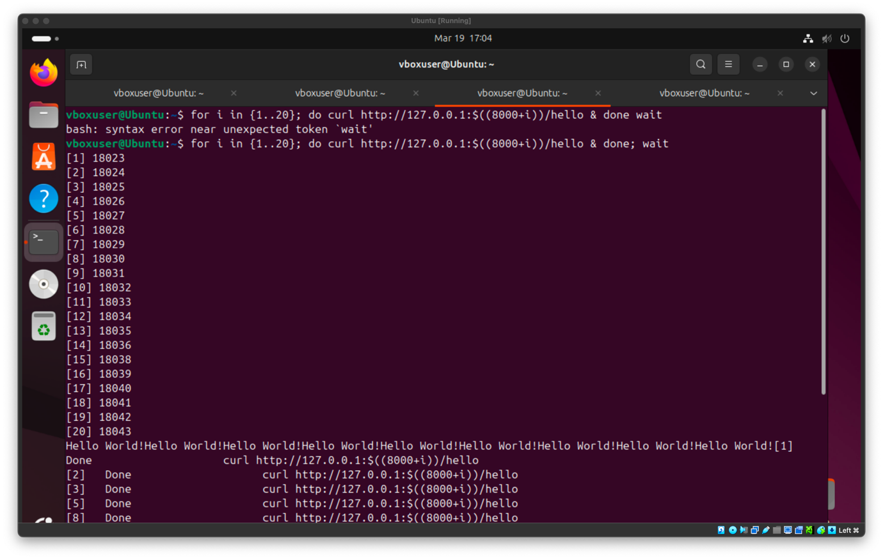

From htop it is observed that during the request being sent there was not much difference in CPU and memory usage. This was expected as the application that is running is lightweight, however some cores went from 0% - 1% usage up to 1% - 5%, and the memory usage from 1.83GB to 1.84GB.

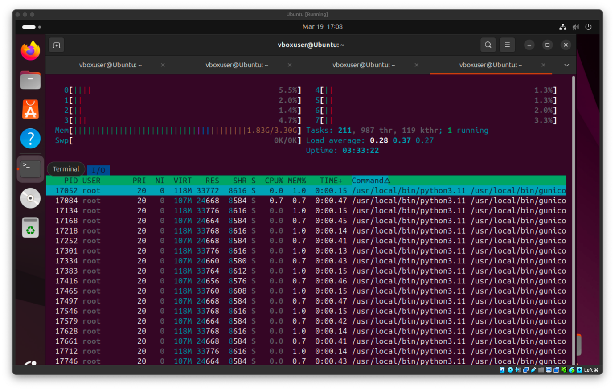

The docker stats command can also be used to observe the CPU and memory usage of the running containers. This shows how much resources each of the containers consume, helping us to understand better the overhead that is caused from the multiple container instances.

- docker stats

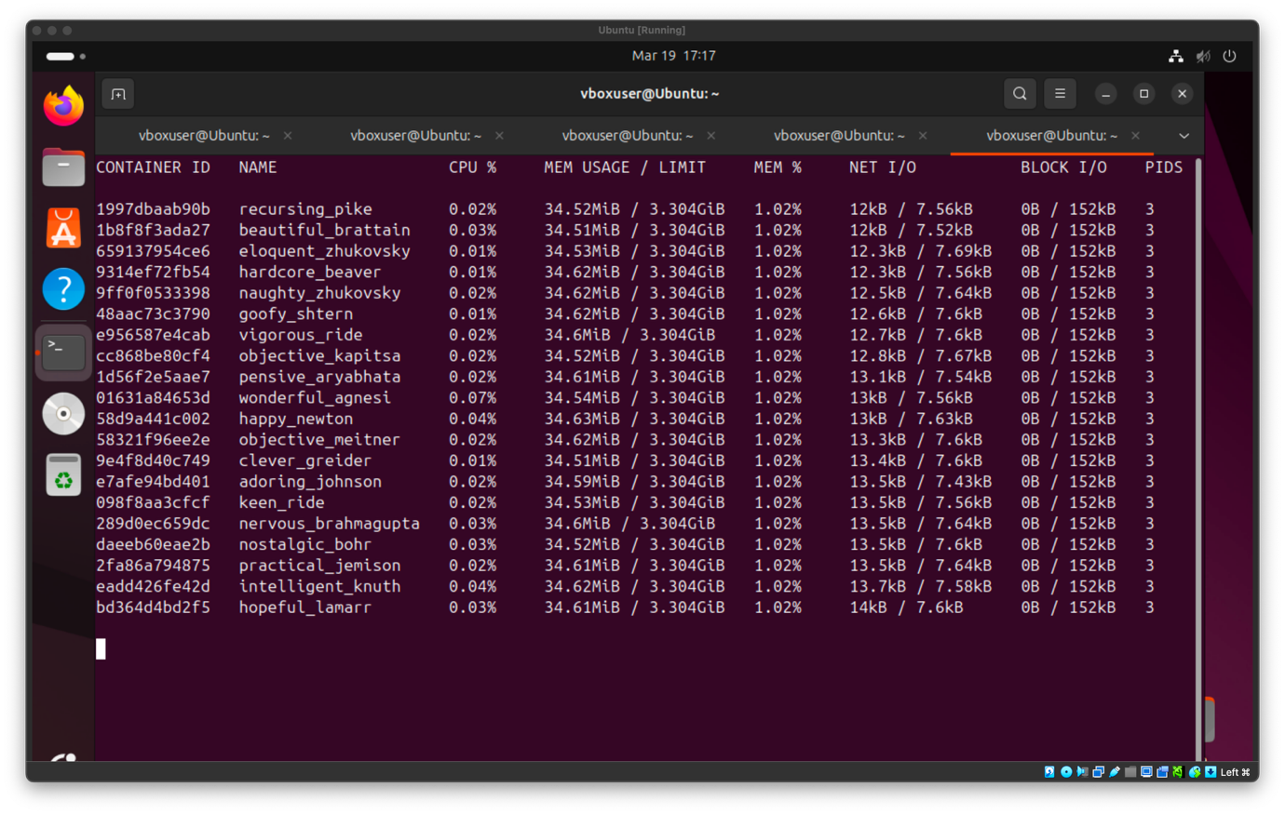
As it is shown, each container requires around 0.02% of CPU and 34.6MB memory. This happens because each container is an isolated environment and requires its own resources, which increases the memory usage but provides better separation between the containers.

- Comparison of Threads and Containers

The results from both execution models show clear differences in how the system resources are used. In the multithreaded example, the CPU usage increased from 0% - 1% in the idle state to 5% - 8% during the requests, and the memory usage remained almost the same increasing only a bit from 1.018GB to 1.02GB during the execution. This shows that the application that was used for the experiment was lightweight and that the threads shared the same memory space efficiently without causing much overhead.
On the other hand, during the multiple Docker containers execution the CPU also showed small increases, as well as the memory. Some cores reached approximately 5% of CPU usage, and the memory usage was higher compared to the threads experiment. The system memory increased only from 1.83GB to 1.84GB during the execution of the requests, and it was observed that each container consumed around 34MB of memory in both in the idle and the execution state. However, the difference between the system memory usage of the threads at 1.018GB – 1.02GB and for the containers at 1.83GB – 1.84GB shows that running multiple instances of containers have more overhead than using multiple threads as each container operates as an isolated instance of an application.
To summarise, the results show that running multiple containers has higher memory usage compared to running multiple threads in the same application, while CPU usage remains almost the same in both methods.

Conclusion

To conclude, based on the findings of this project it is shown that multithreaded execution is more efficient in terms of usage as it has low memory consumption and stable CPU performance. In contrast, running multiple Docker containers consumes more memory than having multiple threads as each container requires its own resources and does not share the same memory with the other containers. However, Docker containers provide advantage when it comes to scalability and deployment. This is because new containers can be created at any moment and are easy to deploy as their dependencies are packaged with them inside an image, making sure that they will operate the same in any system. On the other hand, multithreading is better when performance and low memory consumption are needed, such as in local servers and any other applications that run on limited hardware.
Finally, a limitation of this experiment was that the application that was used to test the methods was lightweight, meaning that it did not stress the system enough to show the differences between multithreading and containers better. Any future work could include a more complex application, such as a database with lots of data, or more requests to improve the experiment for showing the differences better.

Bibliography

[1] “What is Docker?,” Docker Documentation. Accessed: Mar. 18, 2026. [Online]. Available: https://docs.docker.com/get-started/docker-overview/
[2] A. Silberschatz, P. B. Galvin, and G. Gagne, Operating System Concepts Essentials, 2nd ed. Hoboken, NJ, USA: Wiley, 2013.
[3] “Application Setup — Flask Documentation (3.1.x).” Accessed: Mar. 19, 2026. [Online]. Available: https://flask.palletsprojects.com/en/stable/tutorial/factory/
[4] “Gunicorn - Python WSGI HTTP Server for UNIX.” Accessed: Mar. 19, 2026. [Online]. Available: https://gunicorn.org/quickstart/
[5] “Looping Statements | Shell Script,” GeeksforGeeks. Accessed: Mar. 19, 2026. [Online]. Available: https://www.geeksforgeeks.org/linux-unix/looping-statements-shell-script/

