College Database Management System (Oracle SQL & PL/SQL)

Developer: George Aslanidis
Date: 28-03-2025

Presentation
This project is a college database that doesn't just store student information but actively processes it. It uses advanced SQL and PL/SQL to build an automated system that serves different users across a college:
- Administrators get organized data on the professor hierarchy through hierarchical queries.
- Professors can access and analyze their students' performance through correlated and non-correlated subqueries.
- The system itself automates complex operations through PL/SQL, such as calculating final grades and GPAs, applying penalties, and updating records across multiple tables.

Table Description

My tables build on an earlier version of this database with a few alterations, and the addition of one more table called pr_grades to serve the extra needs of this project. For example, pr_Students now contains a new column named “GPA”, which at first is empty (null values), and filled later in the code with the use of a view, function, and a procedure. With the same logic, pr_students contains one more column which consists of the status of the student (ACTIVE or INACTIVE based on his enrolled courses), pr_enrolments contain a new column named “absences”, holding the number of absences for every student and for each course, the student is enrolled in, pr_professors table new column is “title” and one called “supervisor_id”, which both are based on the level of the professor in the hierarchy of the college’s professor personnel, there is also a new table called pr_grades and holds the final (total) grade for every course that a student is enrolled in, and finally, I removed the original primary columns from the tables pr_assignments_results, pr_projects_results, pr_midterms_results, and pr_finals_results. The primary keys of these tables, as well as for the pr_enrolments table, were replaced with composite primary keys consisting of student_id and the corresponding foreign key from each assessment table (e.g. assign_id for pr_assignments_results from pr_assignments_tests), making my tables, in this manner, reflect a more normalized design. Without further ado, below is the structure of my tables:

A) pr_Students - Details of Students:

- Sex Defines the Sex of each Student (String)

2) Full_Name The Full Name of the Student (String)

3) Student_ID Primary Key of the table - Defines the ID of the student (String)

4) Date_of_Birth The Date of Birth of the Student (Date)

5) Full_Address The Address of the Student (String)

6) Contact_Number The Telephone of the Student (String)

7) Nationality The Nationality of the Student (String)

8) GPA The GPA of a Student (Number)

9) Status If student is active or inactive, meaning if the student has not paused or stopped his studies (String)

B) pr_Courses - Details for Courses:

- Course_ID Primary Key - Defines the ID of the course (String)

2) Course_Title The Title of the Course (String)

3) Credits The Credit Hours each Course is Worth (Number)

4) Semester The Semester in which the Course is taught (String)

5) Professor_ID Foreign Key - Defines the ID of the Professor that Teaches this Course (String)

C) pr_Enrollments - Defines the Courses that the Student Has Enrolled In:

- Student_ID Part of Composite Primary Key - Defines the Student’s ID (String)

- Course_ID Part of Composite Primary Key - Defines the Course’s ID (String)

- Absences Holds the number of absences for a particular course (Number)

D) pr_Professors - Details of the Professors:

- Professor_ID Primary Key - Defines the Professor’s ID (String)

2) Sex Defines the Sex of the Professor (String)

3) First_Name The First Name of the Professor (String)

4) Last_Name The Last Name of the Professor (String)

5) Division Defines to which Academic Division does the Professor belong to (String)

6) Email The Email of the Professor (String)

7) Contact_Number The Contact Number of the Professor (String)

8) Supervisor_ID The ID of each professors’ supervisor - References the ID of another professor (String)

9) Title The title that the particular professor holds in the college (Dean, Chair, etc.) (String)

E) pr_Assignments_Tests - The Assignments and Tests that each Course might Have:

- Assign_ID Primary Key - Defines the ID of the Assignment/Test (String)

2) Assign_Test_Title The Title of the Assignment/Test (String)

3) Course_ID Foreign Key - Defines the ID of the Course that any Assignment/Test belongs (String)

4) Calculated_Weight The Weight that “this” Assignment/Test has to the Final Grade of the Course (Number)

5) Due_Date Defines the Date that the Assignment/Tests will be Due (Date)

F) pr_Projects - The Projects that each Course might Have:

1) Project_ID Primary Key - Defines the ID of each Project (String)

2) Title The Title of the Project (String)

3) Course_ID Foreign Key - Defines the ID of the Course that this Project is part of (String)

4) Calculated_Weight The Weight that “this” Project has to the Final Grade of the Course (Number)

5) Due_Date Defines the Date that the Project will be Due (Date)

G) pr_Midterms - The Midterms that each Course might Have:

1) Midterms_ID Primary Key - Defines the ID of each Midterm (String)

2) Title The Title of the Midterm (String)

3) Course_ID Foreign Key - Defines the ID of the Course that is this Midterm belong to(String)

4) Calculated_Weight The Weight that “this” Midterm has to the Final Grade of the Course (Number)

5) Dates Defines the Date that the Midterm will be on (Date)

H) pr_Finals - The Finals that each Course might Have:

1) Finals_ID Primary Key - Defines the ID of each Finals (String)

2) Title The Title of the Finals (String)

3) Course_ID Foreign Key - Defines the ID of the Course that is this Finals belong to(String)

4) Calculated_Weight The Weight that “this” Finals has to the Final Grade of the Course (Number)

5) Dates Defines the Date that the Finals will be on (Date)

I) pr_Assignments_Results - The Grades of the Assignments/Tests

1) Student_ID Part of Composite Primary Key - Defines to Whom this Result Belongs to (String)

2) Assign_ID Part of Composite Primary Key - Defines for Which Assignment this Result is (String)

3) Date_Delivered The Date that the Student handed in his Assignment (Date)

4) Grade The Grade of the Student for “This” Assignment (Number)

J) pr_Projects_Results - The Grades of the Projects

1) Student_ID Part of Composite Primary Key - Defines to Whom this Result Belongs to (String)

2) Project_ID Part of Composite Primary Key - Defines for Which Project this Result is (String)

3) Date_Delivered The Date that the Student handed in his Project (Date)

4) Grade The Grade of the Student for “This” Project (Number)

K) pr_Midterms_Results - The Grades of the Assignments/Tests

1) Student_ID Part of Composite Primary Key - Defines to Whom this Result Belongs to (String)

2) Midterms_ID Part of Composite Primary Key - Defines for Which Midterm this Result is (String)

3) Grade The Grade of the Student for “This” Midterm (Number)

L) pr_Finals_Results - The Grades of the Assignments/Tests

1) Student_ID Part of Composite Primary Key - Defines to Whom this Result Belongs to (String)

2) Finals_ID Part of Composite Primary Key - Defines for Which Finals this Result is (String)

3) Grade The Grade of the Student for “This” Finals (Number)

M) pr_Grades - The Final Grades for each Course for every Student

1) Student_ID Part of Composite Primary Key - Defines to Whom this Result Belongs to (String)

2) Course_ID Part of Composite Primary Key - Defines the ID of the Course this Grade is for (String)
3) Grade The Grade of the Student for “This” Course in Percentage Format (Number)

Queries

For the hierarchical queries and the subqueries, the commands can be executed with any priority. For the “User Defined or Oracle Functions & Report Producing Procedures” the “Tasks” and the Queries should be executed in the exact order they are writing to have the proper results. For example, some of these Tasks calculate the final grades and the GPA of the students, thus, the GPA cannot be calculated properly if the final grades have not been calculated first. The “Tasks” essentially represent grouped queries as they collectively solve a specific part of the “system’s functionality”. Each of these Tasks may include views, functions, procedures, anonymous blocks, and simple SQL queries.

- Hierarchical Queries

- Create a query to list records in a hierarchy in their proper hierarchical order.

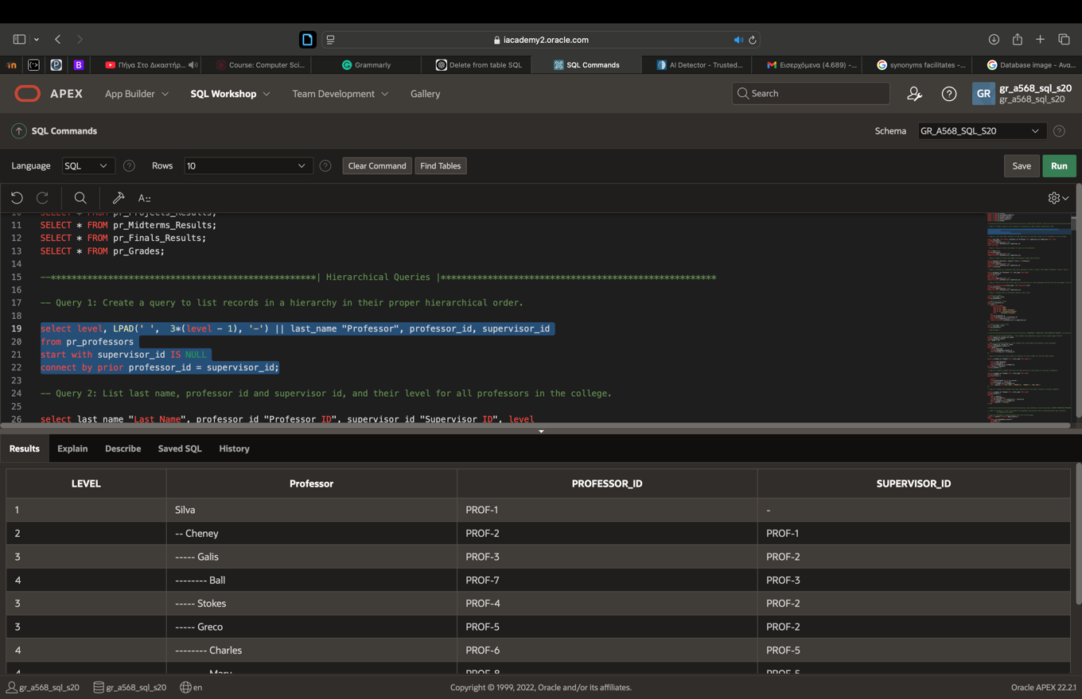

- List last name, professor id and supervisor id, and their level for all professors in the college.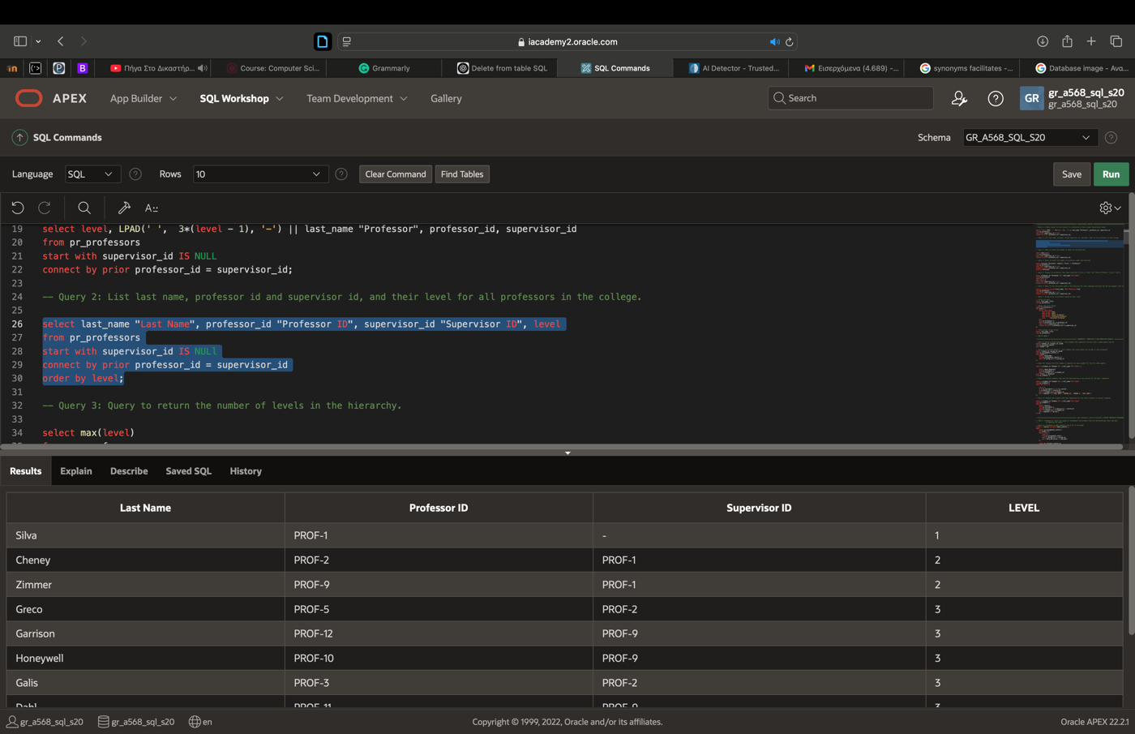

3) Query to return the number of levels in the hierarchy. 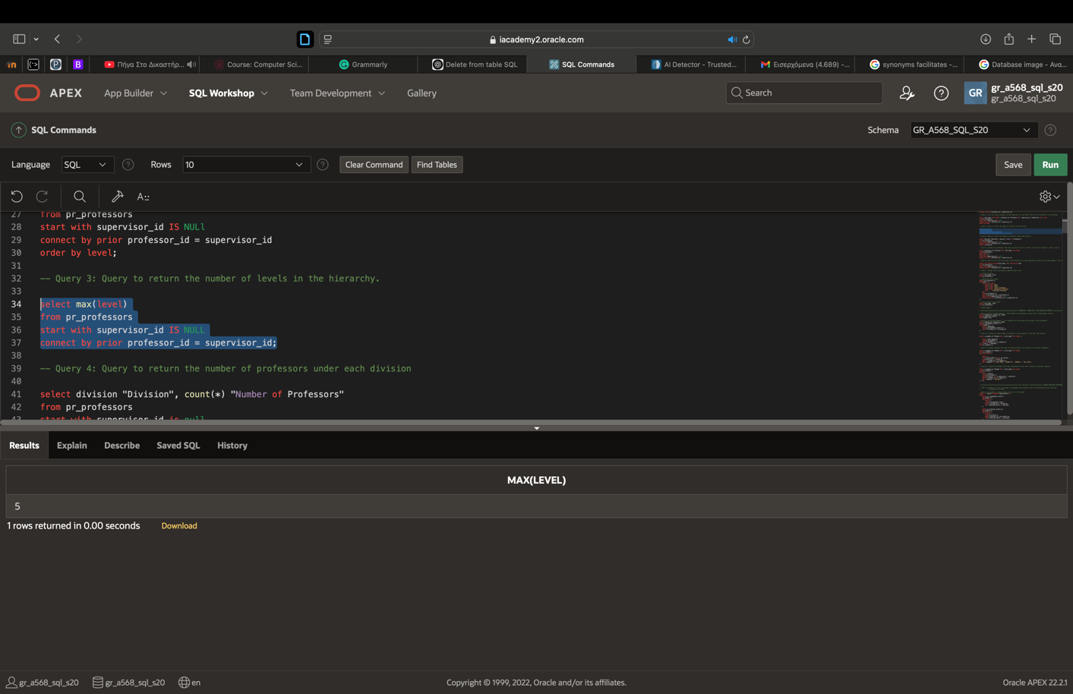

4) Query to return the number of professors under each division
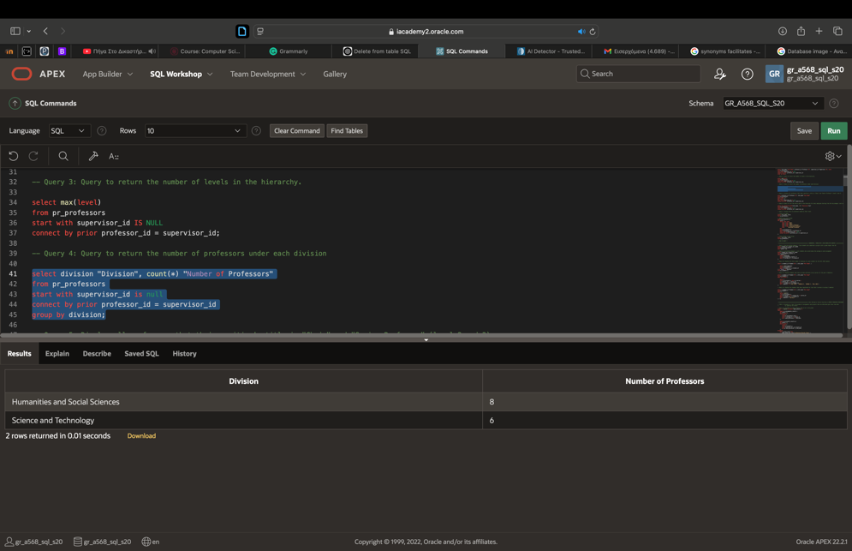

5) Display all professors that their position's title is "Chair" and "Senior Professor" (level 2 and 3)
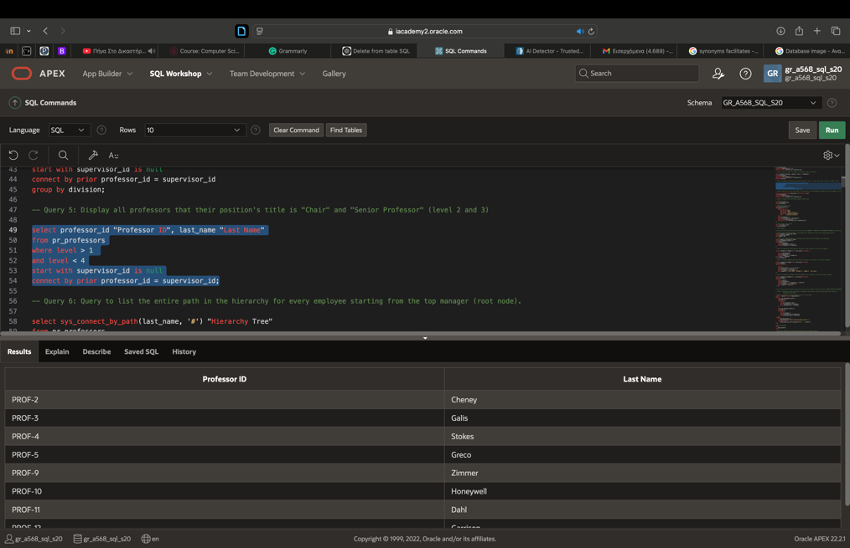

6) Query to list the entire path in the hierarchy for every employee starting from the top manager (root node).
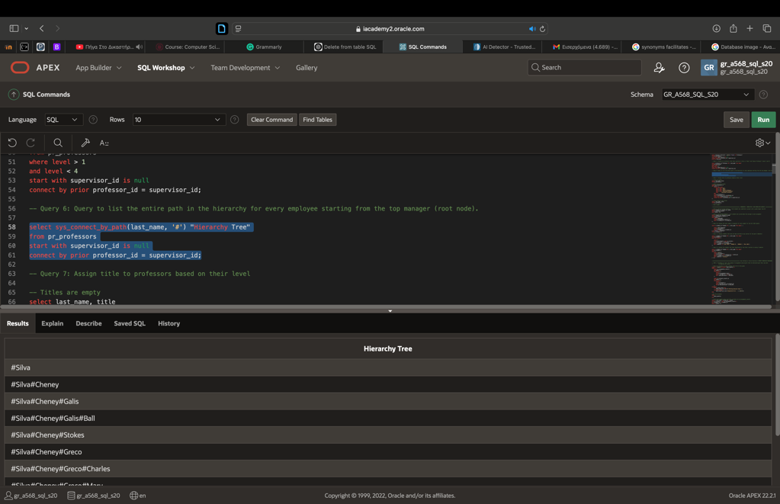
7) Assign title to professors based on their level
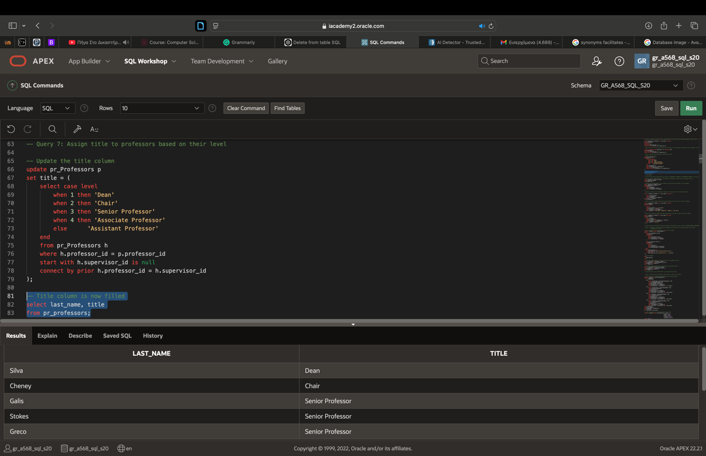

B) Subqueries

8) Non-Correlated Subquery - Find students who submitted a project with a grade higher than 80
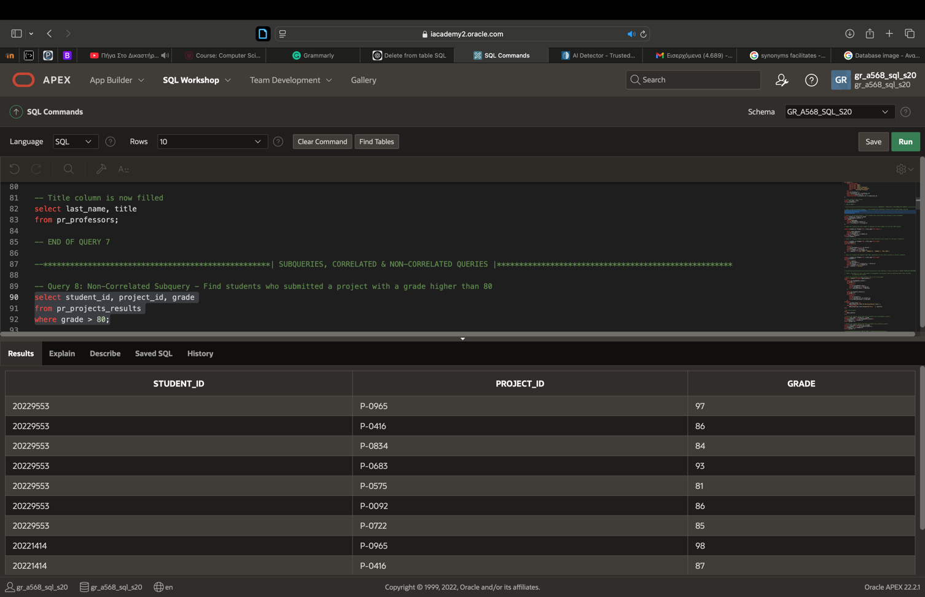

9) Correlated Subquery - List students who scored above the average in each assignment
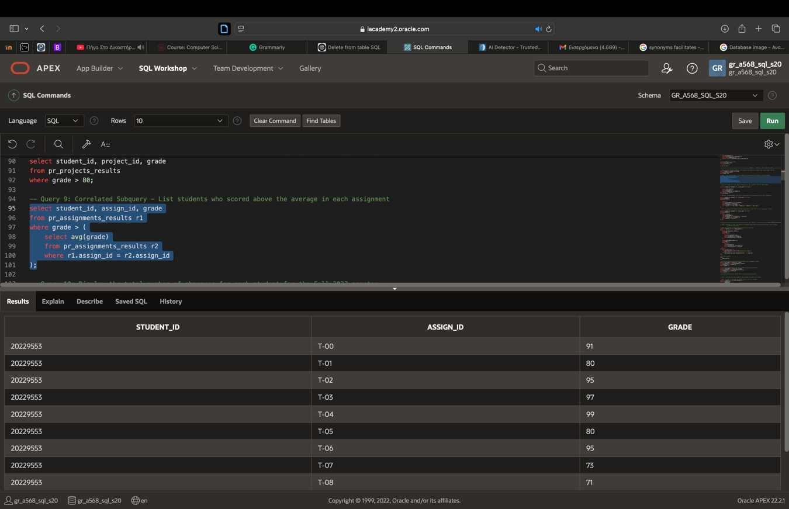

10) Display the total number of absences for each student for the Fall 2023 semester
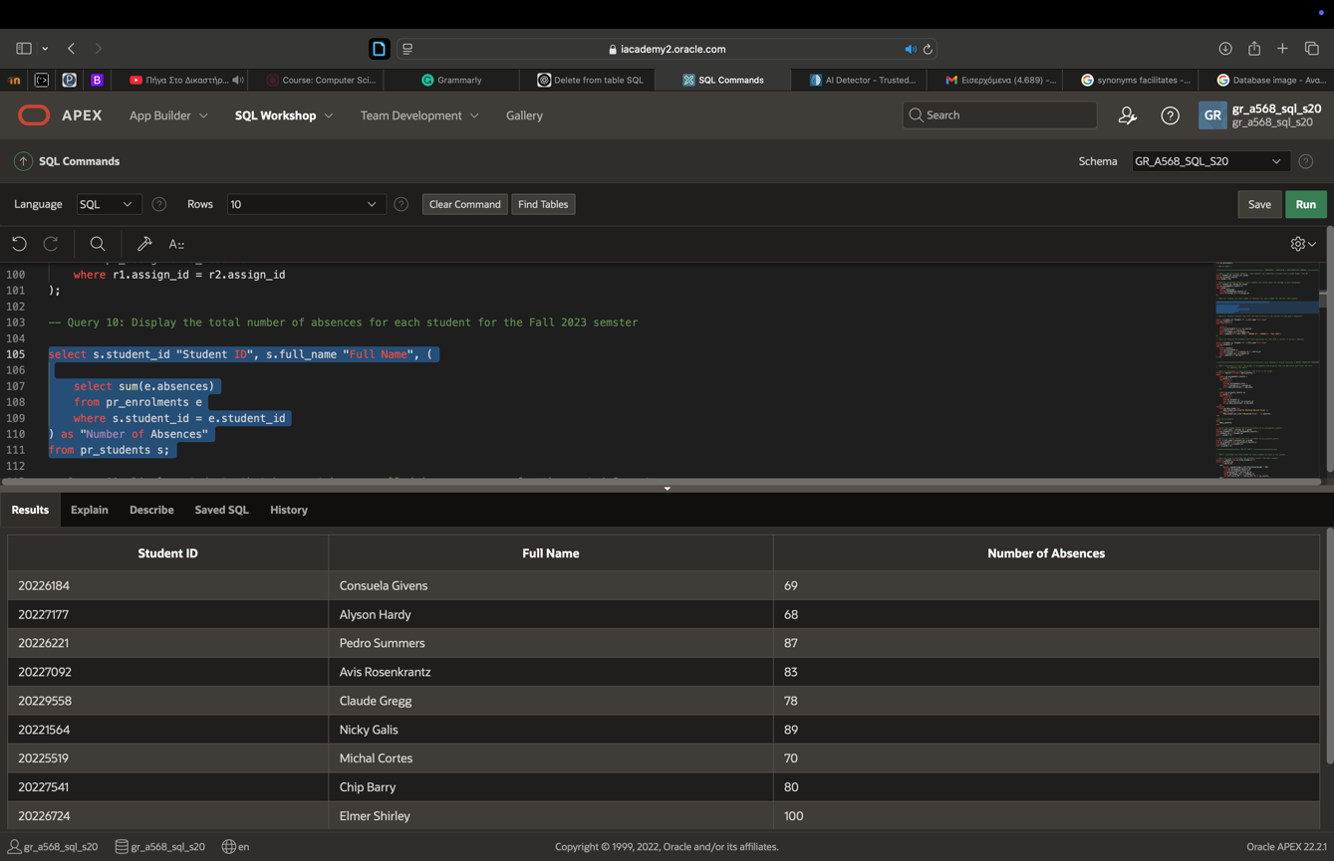

11) Display students that have not been enrolled in any courses for the past 4 Semesters
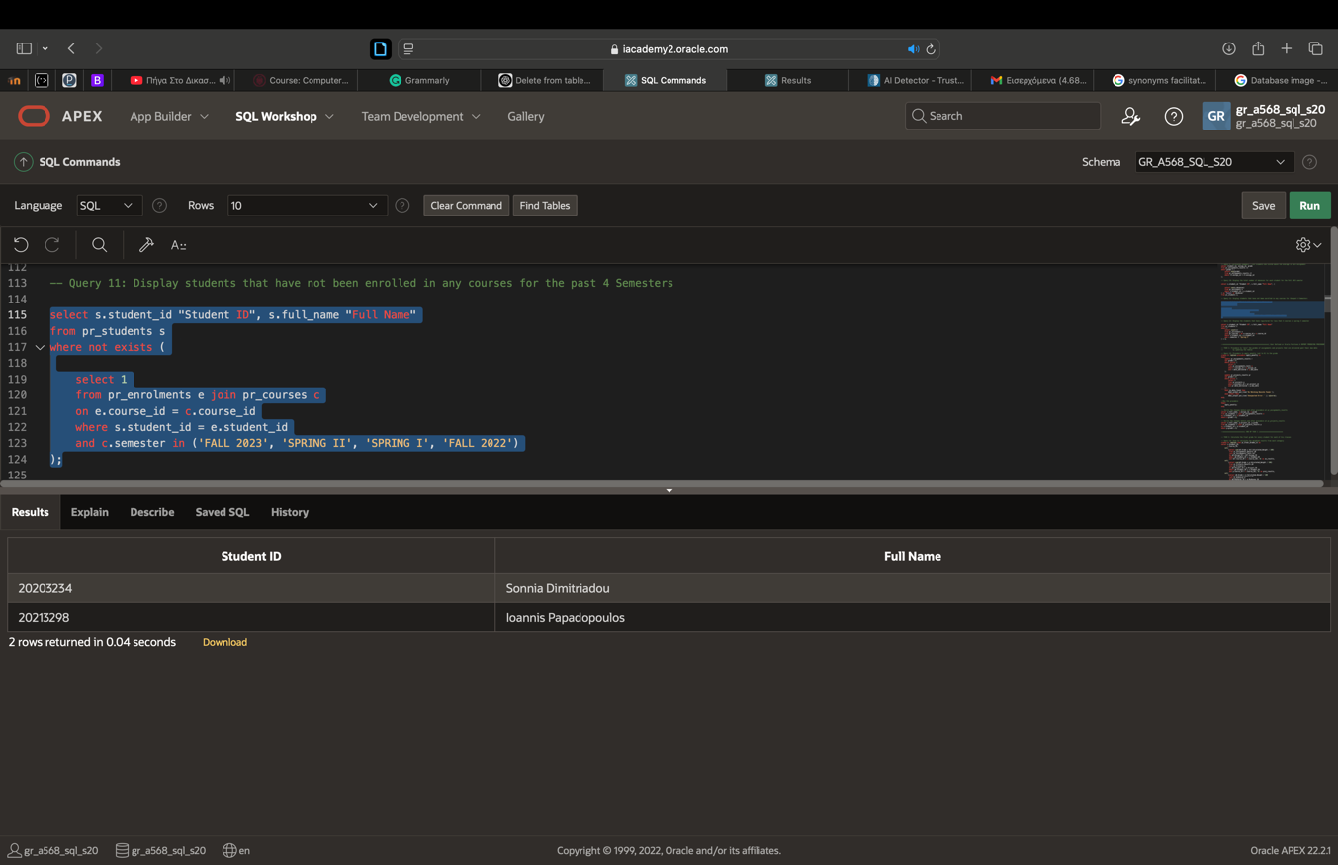

12) Display the students that have registered for less that 4 courses in spring I semester
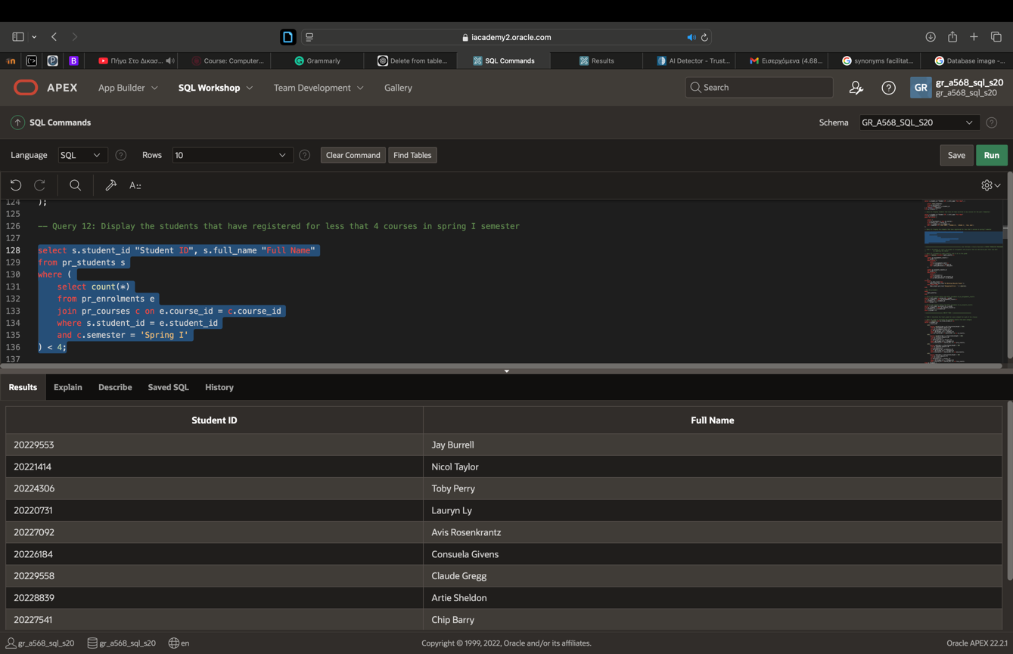

C) User Defined or Oracle Functions & Report Producing Procedures

TASK 1: Procedure to "zero" the grades of assignments and projects that are delivered past their due date by updating the tables

13) Procedure to apply penalty (set to 0) to the grade
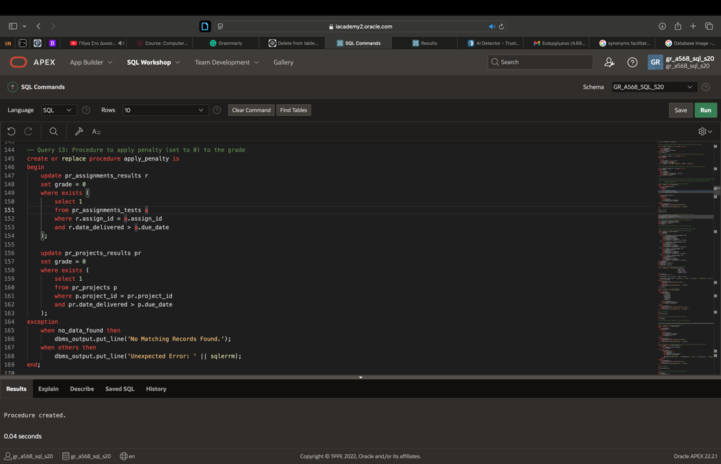

By executing two simple SQL commands we can check the results (results should be only students that their assignments and project are delivered after due date and therefor their grade is 0 (Simple SQL commands are included inside the .sql file).
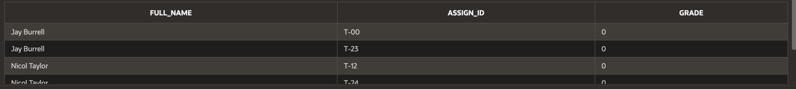

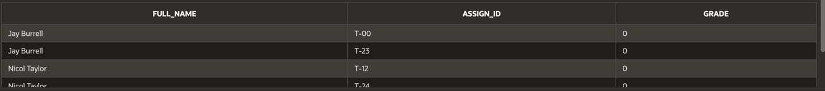

TASK 2: Calculate the final grade for every student for each of his classes

14) View to calculate the weighted results from each category
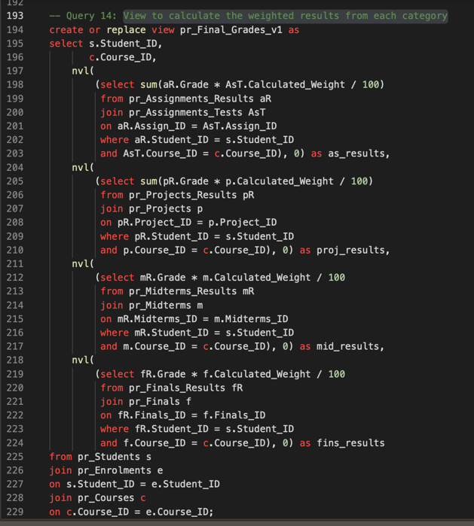

15) Function to calculate the total final grade
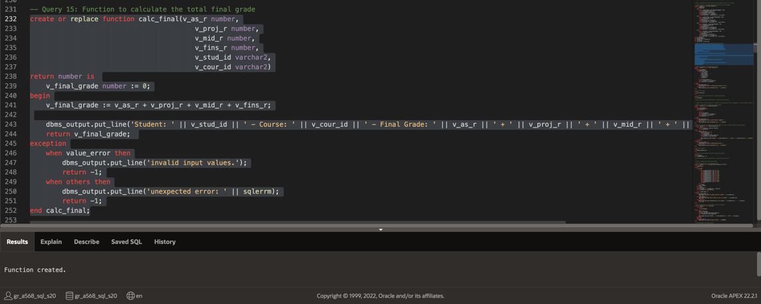

16) Procedure to execute the function (with results from both view and functions showing they work correctly as final grade results are correct)
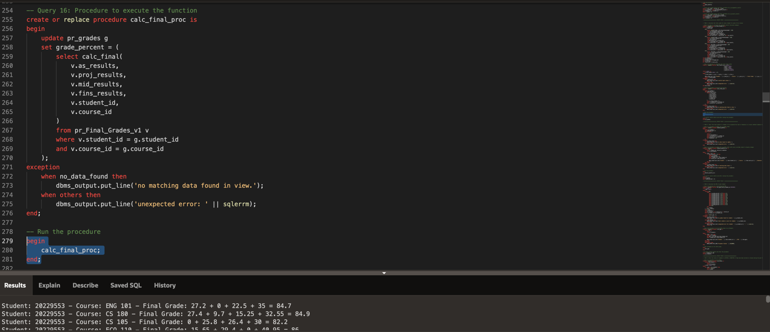

Final Grades results set() into the pr_grades table correctly
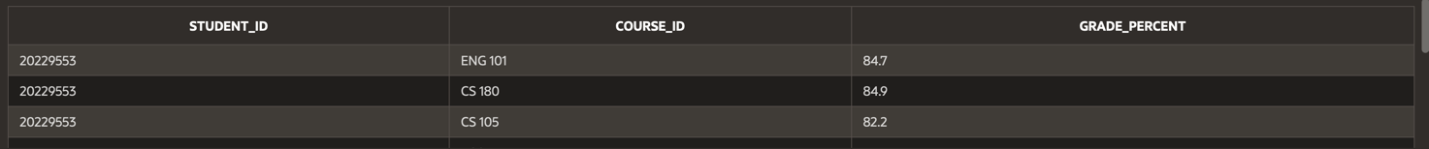

TASK 3: "Zero" the final grade of a student who exceeds the absence limit in a course (default limit: 10 absences per course)

17) Procedure to update the pr_grades table
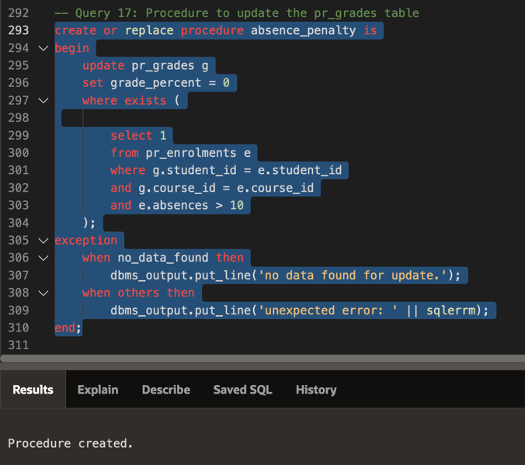

18) Procedure to update the pr_grades table with cursor and dbms output to display changes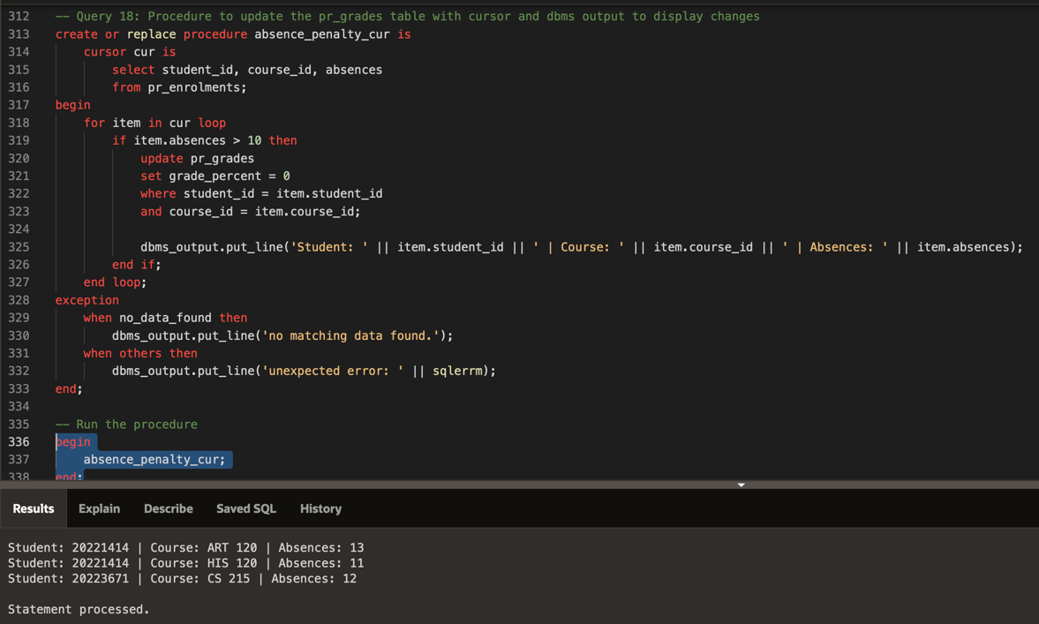

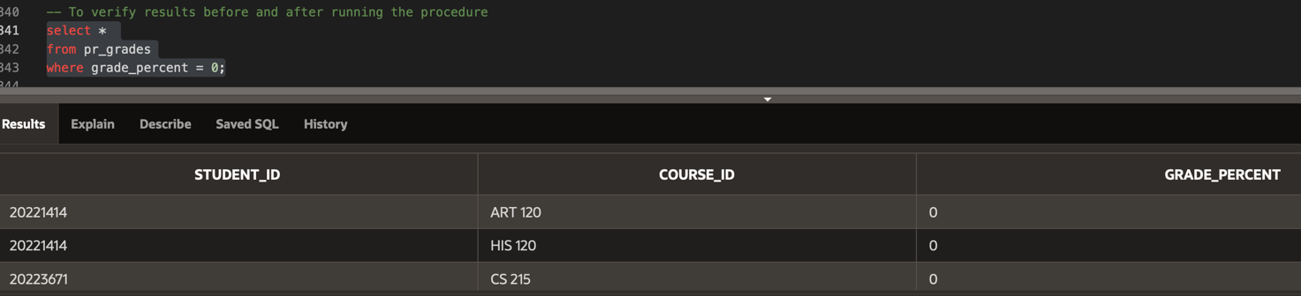

TASK 4: Calculate the GPA of each student

19) Function for calculating the GPA
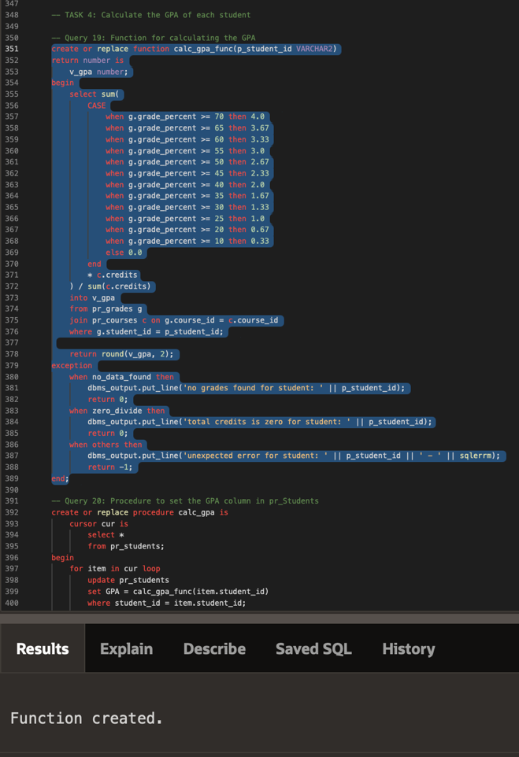

20) Procedure to set the GPA column in pr_Students
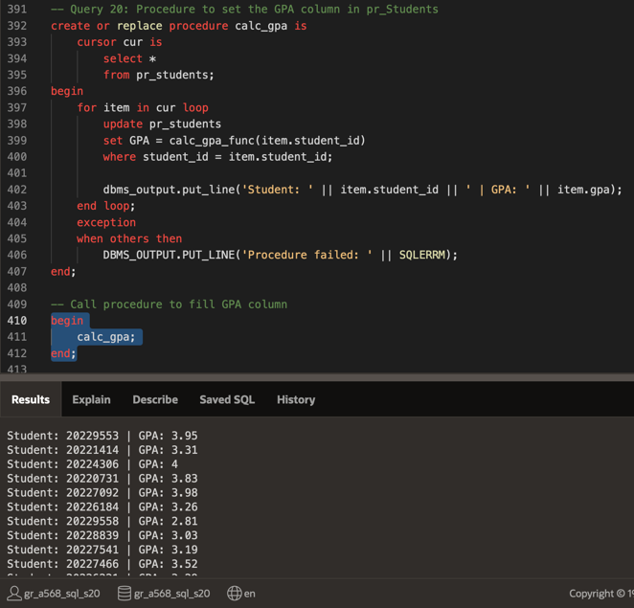

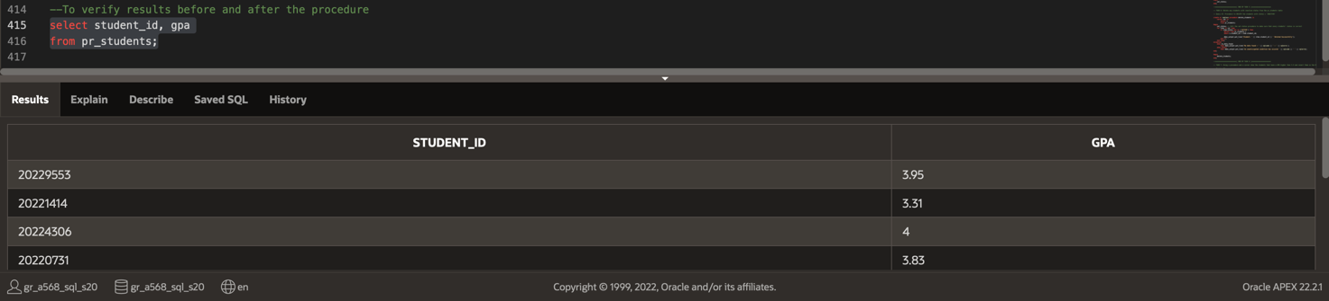
TASK 5: Alter the status of students to ACTIVE or INACTIVE if they have been enroled in classes during the past 4 semesters

21) Procedure to set status
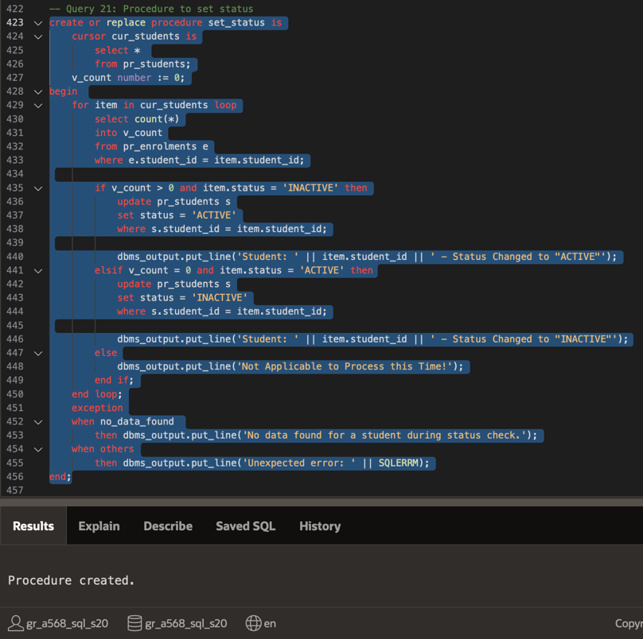

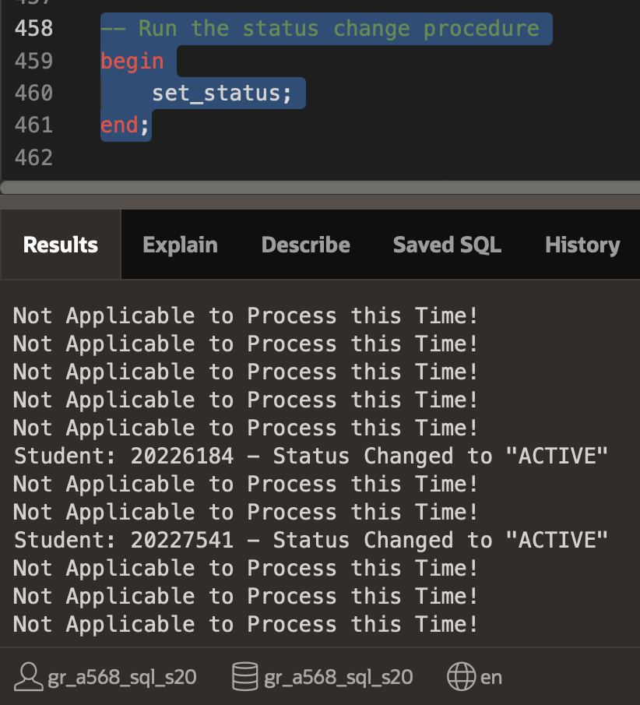

TASK 6: Delete any students with inactive status from the pr_students table

22) Procedure to DELETE the students with status = 'INACTIVE'
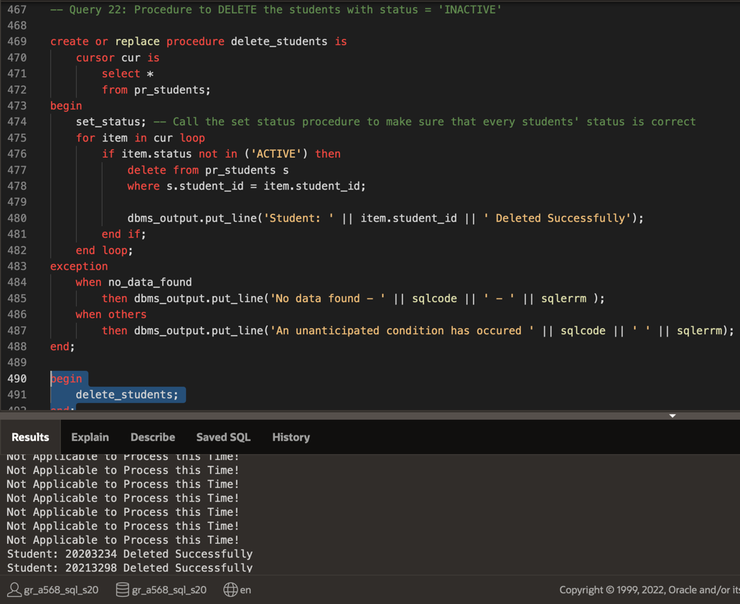

TASK 7: Using a procedure and a cursor show the students that have a GPA higher than 3.5 and insert them in the Dean's List

23) Table to hold the data for the dean’s list
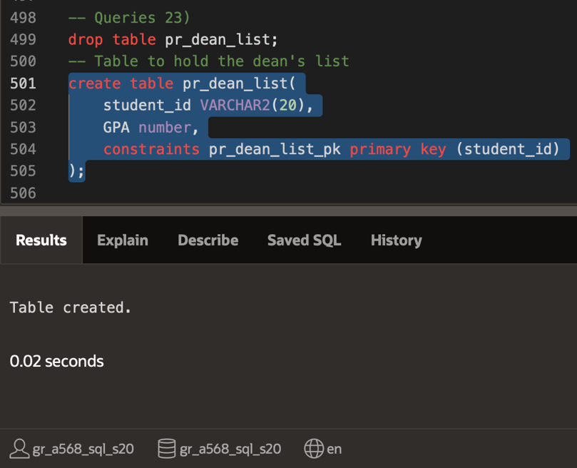

24) Procedure that checks GPA with explicit cursor and inserts students into table if GPA >= 3.5
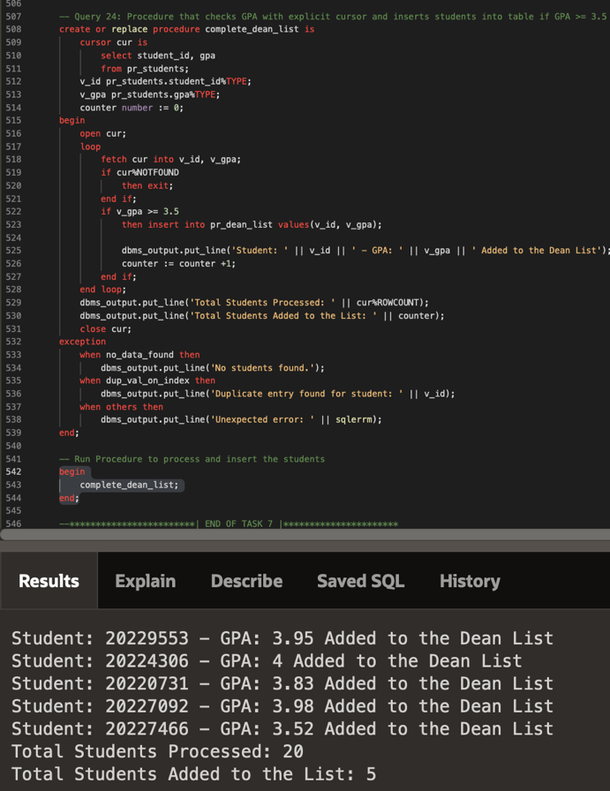

TASK 8: Showcase the students that failed a course with a grade < 40 (print both student_id, full_name, course_id, and course_title of the course they failed)

25) Explicit Cursor in an Anonymus Block to make the display
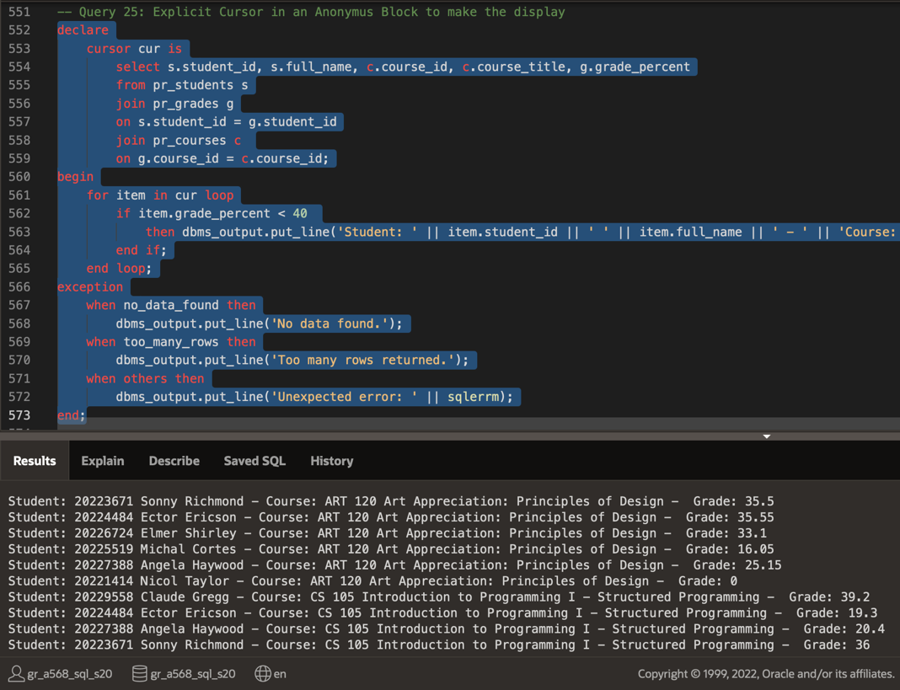

TASK 9: Implicit Cursor in an Anonymus Block to discover the GPA of student with id = 20221414

26)
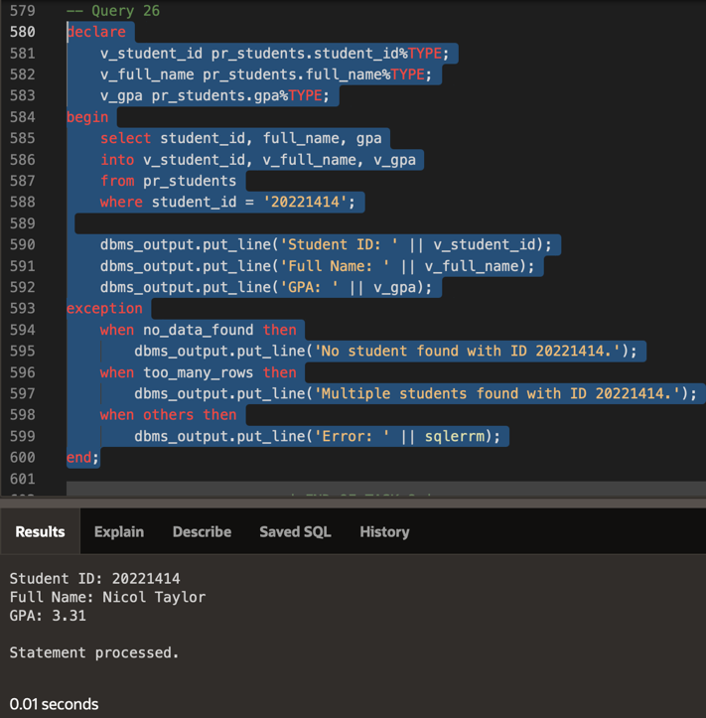

D) TRIGGERS

TASK 10: Auto-assign STATUS value to new students inserted into the pr_Students table

27) Trigger to auto-assing the activity status to students (Triggered before insertion in pr_students)

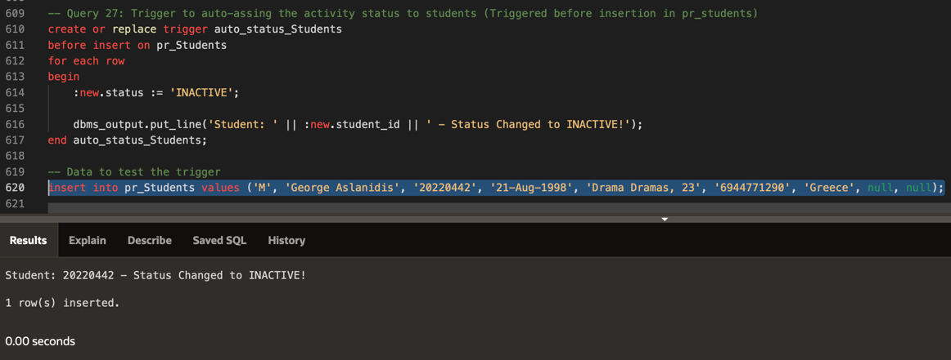

TASK 11: Auto-assign title value to new professors inserted into the pr_professors table

28) Function to return the title for assignment
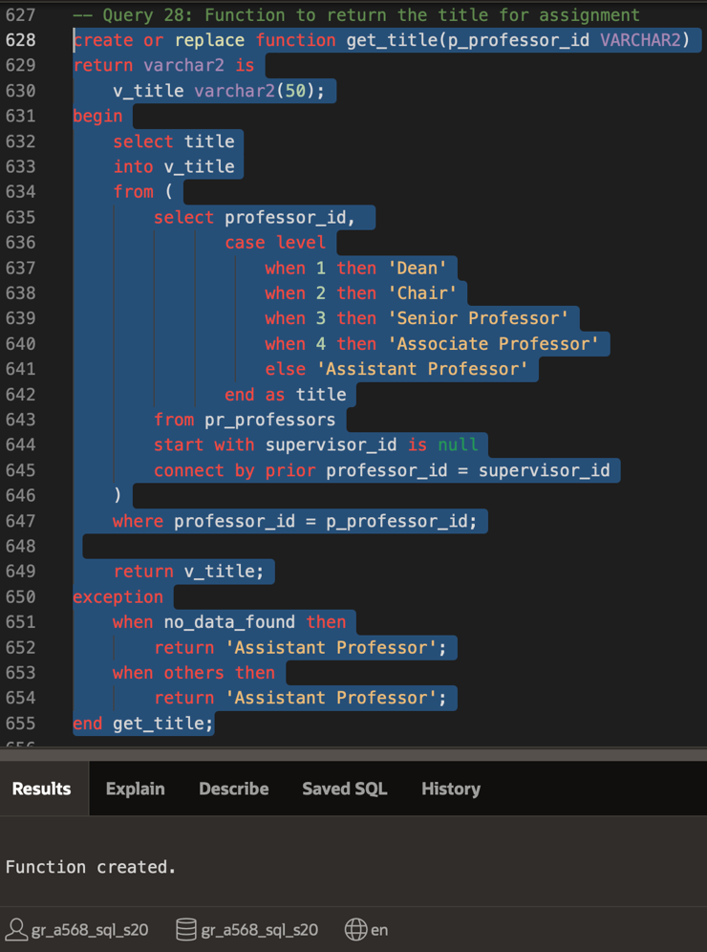

29) Trigger to auto-assing the titles to professors (Triggered before insertion in pr_Professors)
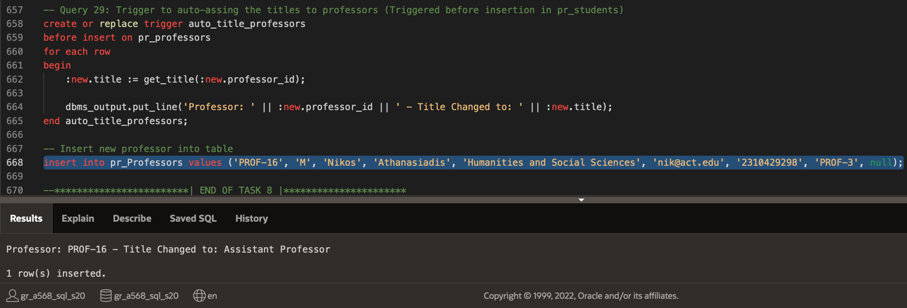

TASK 12: Save any changes inside the pr_courses table in a newly created table

30) Create and Drop the new table
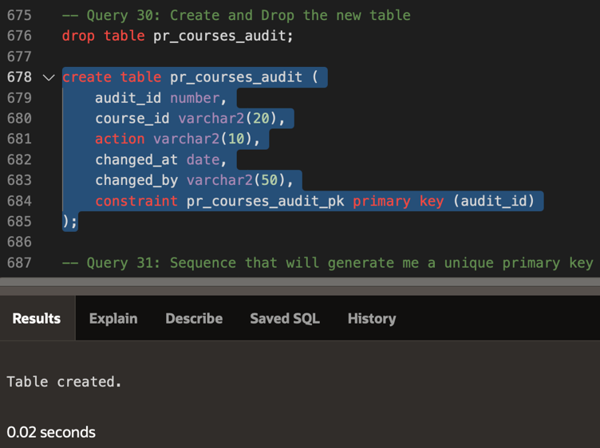

31) Sequence that will generate me a unique primary key
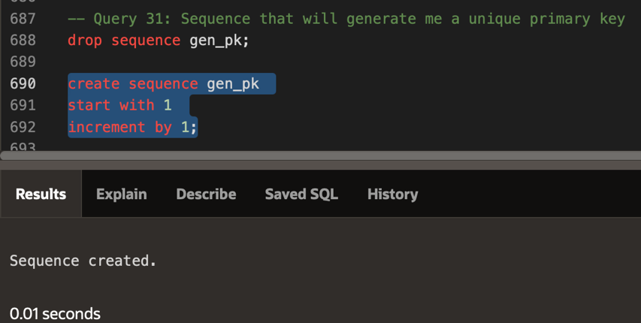

32) Create the trigger that is going to save the action that took place, for which course it took place, and who changed it
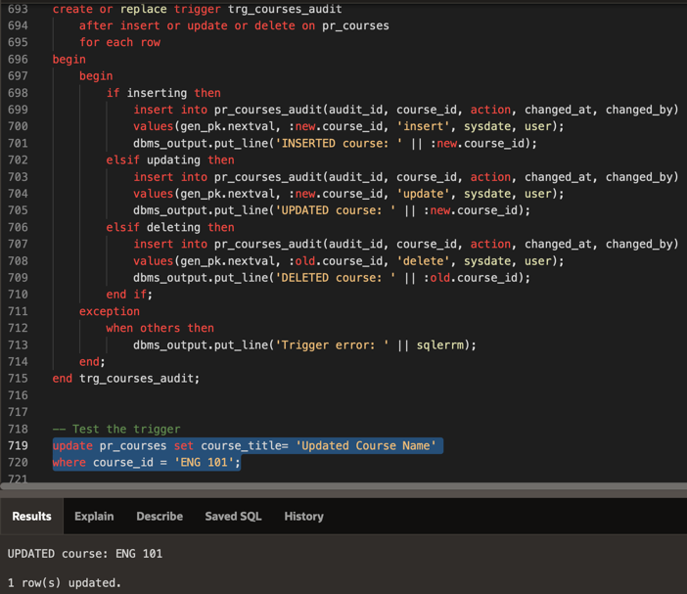

Suggestions for further development

Such projects, as the College Database that I did for my project, can have a lot of requirements, proving a real challenge for a single programer, let alone for a junior one, to be fully implemented. This project contains around 30 queries, and I believe that in real-life senarios these 30 queries would not even cover half of the functionality required for a fully developed system. Thus, the first thing that could be further developed are more queries in order to serve the vast needs of such projects. Secondly, another thing that could be implemented for futher development would be to intergrate more modern technologies along with SQL, such as web interfaces or external applications, in order to interact with the database in a more user-friendly environment.

