spookyHash

wwwrohitabcomdiscussappmembersappmembersmodulelistshowall0sortkeyjoinedsortorderascmaxresults20quickjumpBnameboxbeginsnameBquickjumpM,

110764747456415508317803877439886233129,

16767899677159353463,

2390256759

OriginalURL

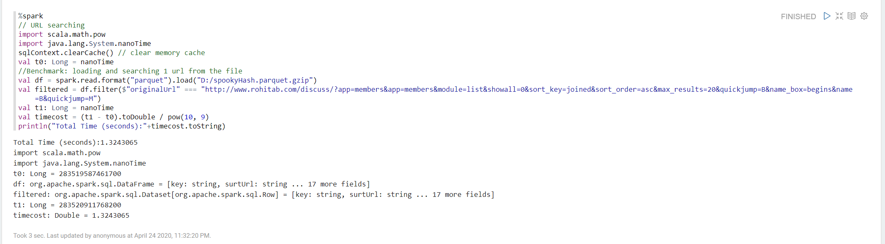

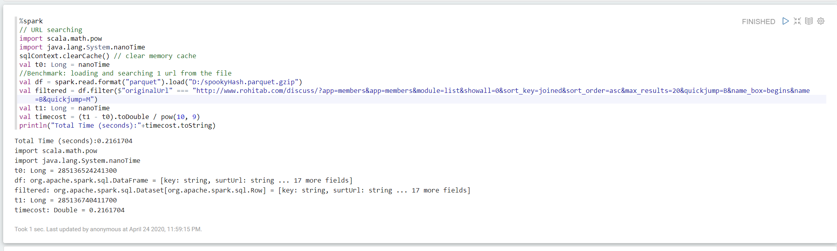

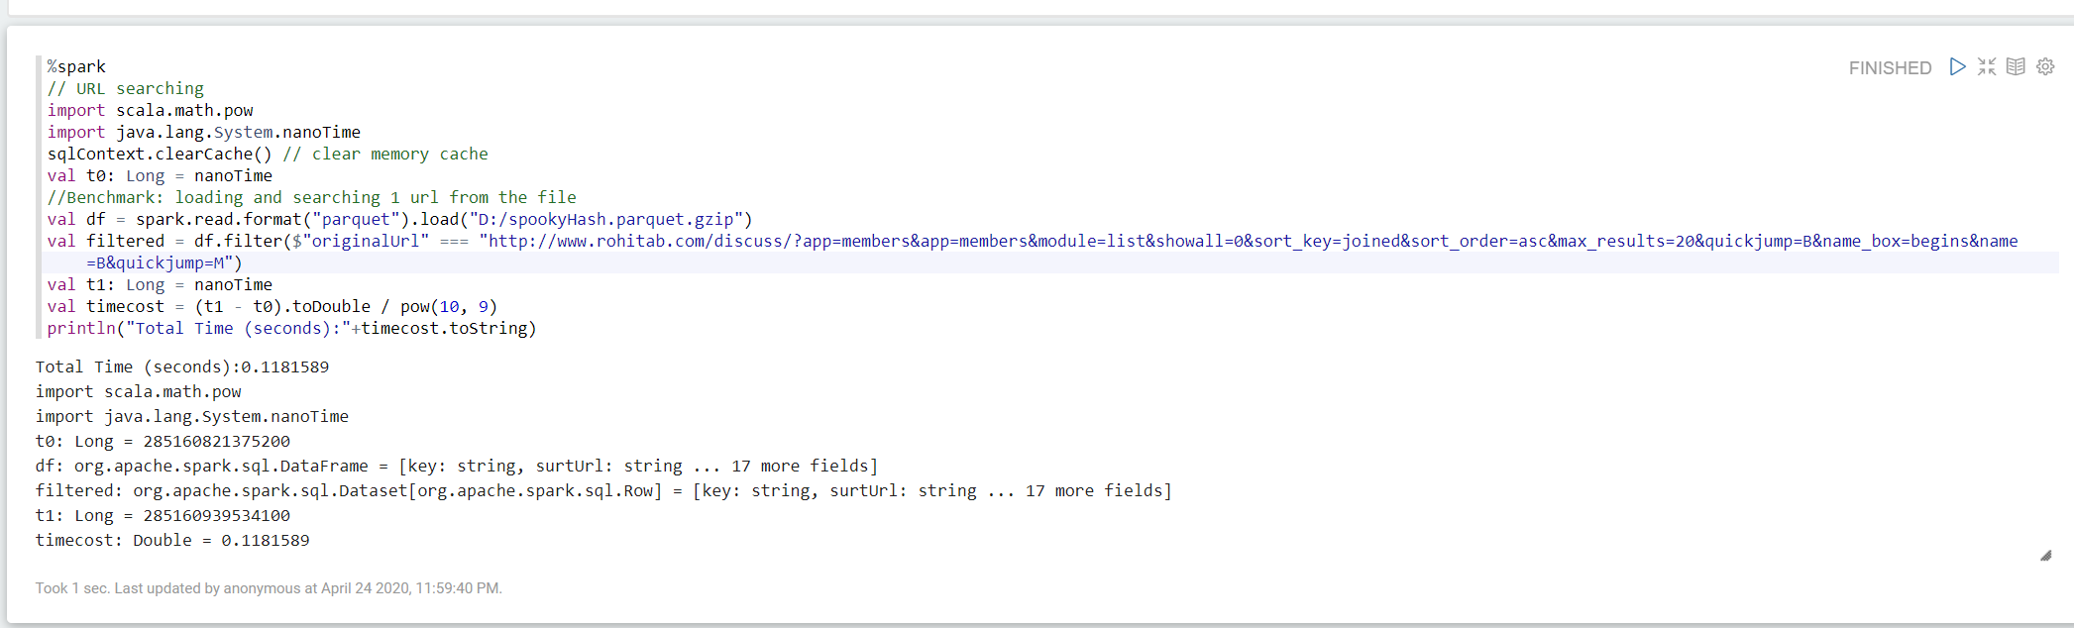

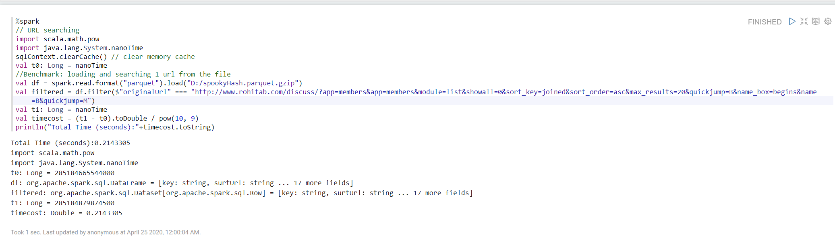

Hash128

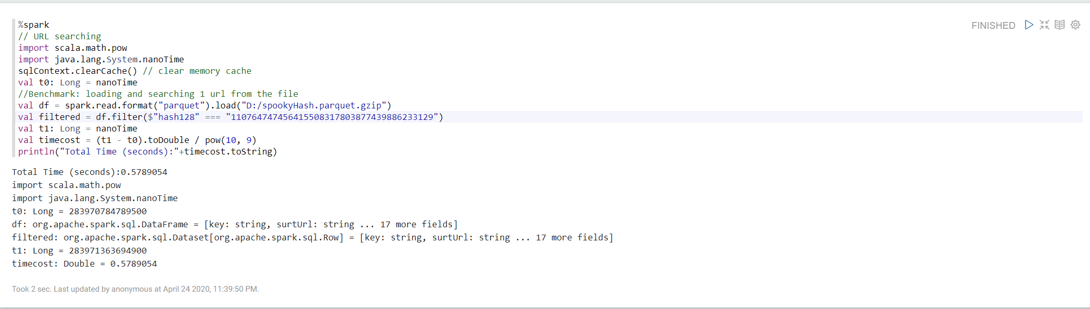

Hash64

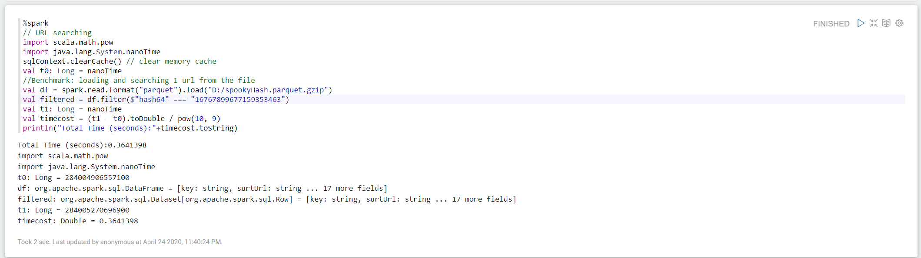

Hash32

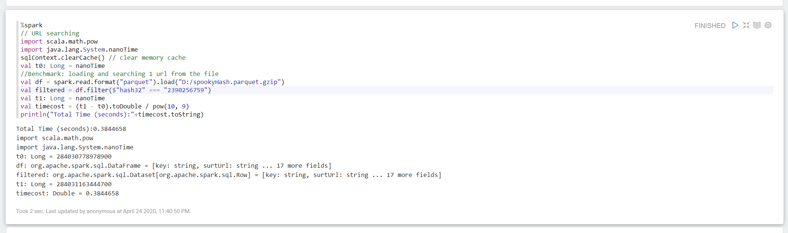

XXHash

45851,http://www.rohitab.com/discuss/?app=members&app=members&module=list&showall=0&sort_key=joined&sort_order=asc&max_results=20&quickjump=B&name_box=begins&name=B&quickjump=M,

cc574cdb,

4707f50bc1e41d67

Original URL

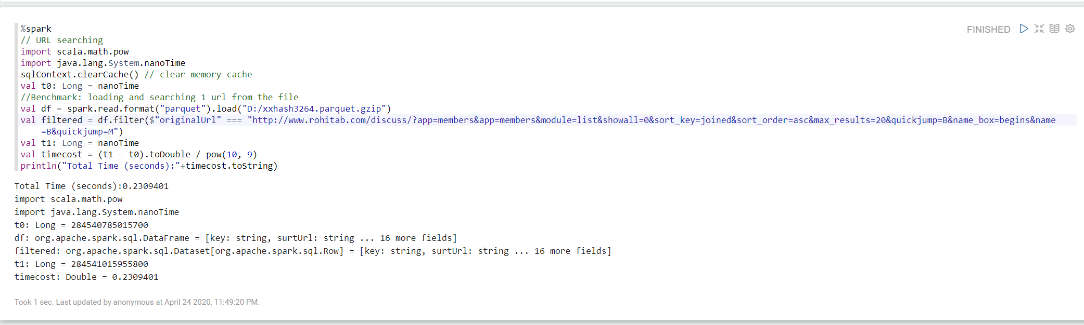

Hash32

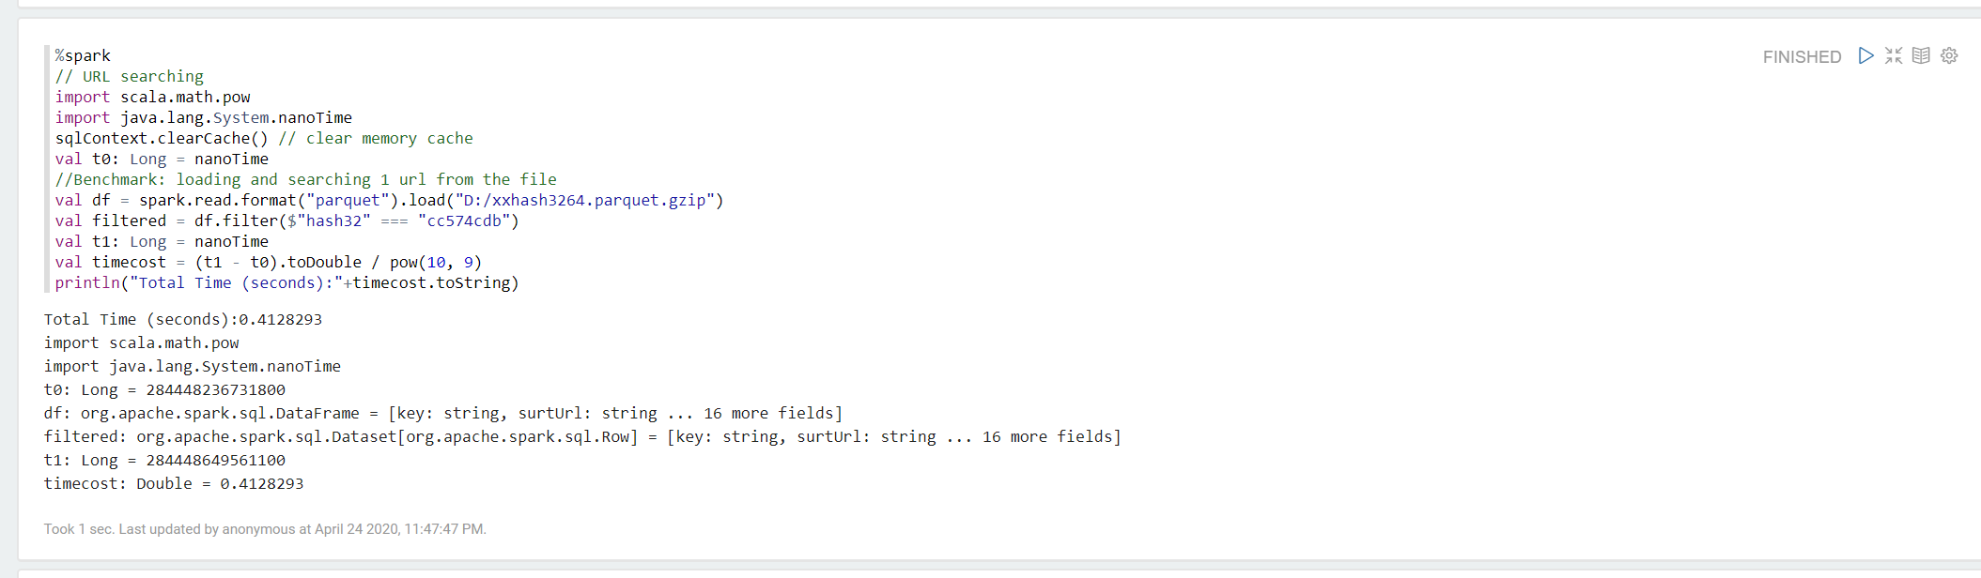

Hash64

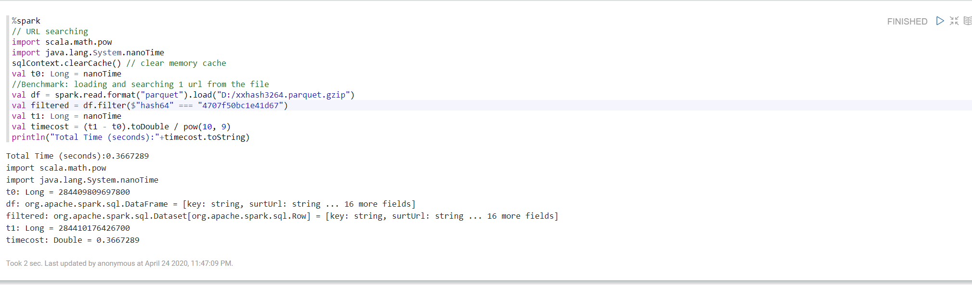

Simple Hash

45851,http://www.rohitab.com/discuss/?app=members&app=members&module=list&showall=0&sort_key=joined&sort_order=asc&max_results=20&quickjump=B&name_box=begins&name=B&quickjump=M,

18jrohitabwww

Original URL

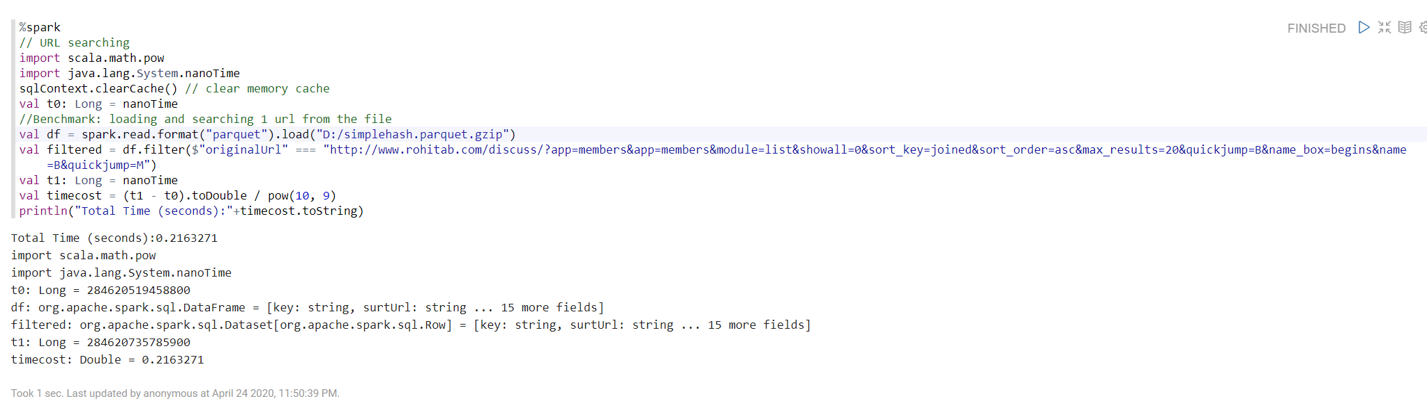

Hash

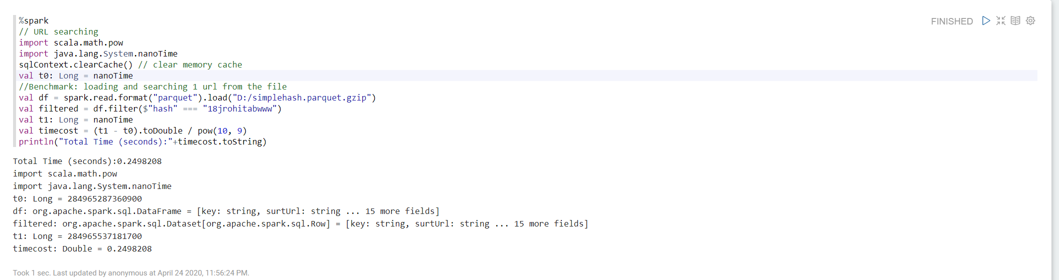

Cityhash

45851,wwwrohitabcomdiscussappmembersappmembersmodulelistshowall0sortkeyjoinedsortorderascmaxresults20quickjumpBnameboxbeginsnameBquickjumpM,

1163841628249245450,

3110830394

Original Url

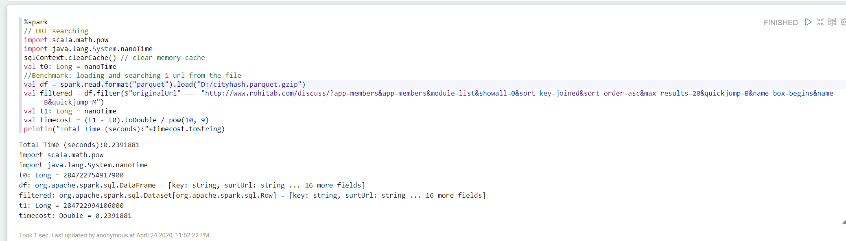

hash64

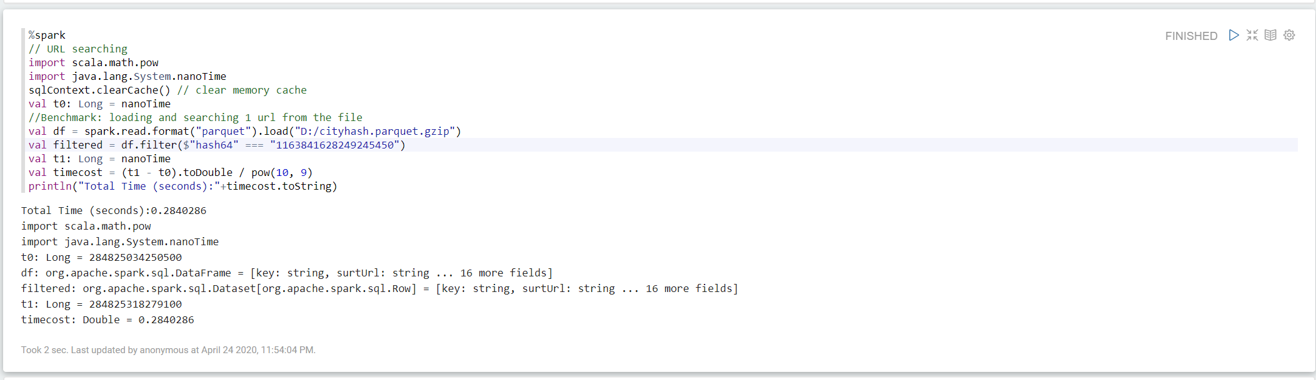

Hash32

