Multi-evidence Computational Prioritization and Cross-cohort Assessment of Candidate Targets in AML
Project report for PhD application discussion
Qinuo Shi
Project positioning: This report presents an auditable pre-experimental prioritization workflow for AML candidate targets. The findings should be interpreted as computational support for candidate selection, not as evidence that any gene has been functionally validated as an AML therapy target.

Abstract
Acute myeloid leukemia (AML) is molecularly and clinically heterogeneous, so candidate-target prioritization should integrate expression robustness, normal hematopoietic expression, patient outcome association, and biological context. This project built a reproducible statistical and bioinformatics workflow that reduced a transcriptome-scale search space to a small set of experimentally testable candidates. The discovery matrix combined TCGA-LAML AML samples with GTEx whole-blood controls [1,2], and GSE13159 was used as an independent leukemia expression-direction filter [3]. Because disease status and data source are completely confounded in the TCGA-versus-GTEx comparison, cross-platform concordance was used as a conservative robustness criterion. This produced 131 robust differential genes and 106 candidates after applying a normal hematopoietic stem/progenitor cell (HSPC) expression filter based on GSE24759 [4]. In 130 TCGA-LAML patients with usable follow-up, exploratory survival screening identified 13 genes with hazard ratio (HR) > 1.5 and nominal P < 0.05. IL1R2, SLC15A3, and VNN2 were retained as priority discussion candidates, whereas IL3RA/CD123 served as a known-target benchmark. GSE10846 was used as a DLBCL cross-disease outcome comparison with treatment-adjusted Cox models, not as an independent AML validation cohort [7]. STRING/CTD and Node2Vec supplied network-assisted evidence based on 128-dimensional cosine similarity [8-10]. Overall, the report defines a multi-evidence, pre-experimental prioritization framework rather than a claim of therapeutic efficacy.

1. Rationale and Analytical Strategy
The objective was to prioritize candidate genes or protein targets with disease association, prognostic relevance, and plausible intervention value before committing wet-lab resources. This distinction is important: differential expression and adverse survival association can rank hypotheses, but they do not prove causal AML dependency or demonstrate that target intervention will improve treatment outcome. The workflow therefore treats differential expression genes, prognostic genes, biomarkers, and functional therapy targets as related but non-equivalent categories.
The project is also relevant to mRNA therapeutic development, but it does not currently specify a final mRNA drug format. The first step is to prioritize candidate genes and protein targets; subsequent mRNA platform selection would depend on protein localization, desired intervention direction, and immunological properties [11]. Cell-surface candidates could be evaluated for mRNA-encoded CAR, antibody, or bispecific strategies, whereas tumor-antigen candidates would require HLA presentation and immunogenicity assessment. Intracellular or endolysosomal proteins may be better suited for mechanistic studies, functional perturbation, or alternative delivery approaches rather than direct antibody or CAR targeting.
The analysis was built around separable evidence layers: cross-cohort disease-associated expression, low normal HSPC expression, exploratory AML survival ranking, cross-disease outcome comparison, and network-assisted evidence. These layers answer different questions and were not collapsed into a single proof of target validity.

2. Data Sources and Workflow
Stage | Main input | Method | Output
Data integration | TCGA-LAML, GTEx whole blood, GSE13159 | Expression harmonization; Ensembl or gene-symbol alignment | Discovery and expression-validation matrices
Robust differential expression | TCGA/GTEx discovery plus GSE13159 | limma analysis followed by concordant cross-cohort intersection | 131 robust AML-associated DEGs
HSPC safety filter | GSE24759 hematopoietic hierarchy | Mean normalized log2 microarray intensity across selected HSPC samples; exclude genes with mean >= 7.0 | 106 retained candidates
AML survival ranking | TCGA-LAML clinical survival data | Median expression groups; Kaplan-Meier, log-rank, univariate Cox | 13 genes with HR > 1.5 and nominal P < 0.05
Outcome and network context | GSE10846 DLBCL; STRING/CTD graph | Treatment-adjusted DLBCL Cox; Node2Vec cosine ranking | Cross-disease patterns and network-assisted ranking

The integrated discovery matrix contained 906 samples and 55,617 measured genes. GSE13159 contained 2,096 samples, including 542 AML, 74 normal, and 1,480 other hematologic disease samples; the AML-versus-normal subset was used to evaluate expression-direction reproducibility in an independent single-platform setting [3]. Dataset roles were fixed before downstream ranking: TCGA/GTEx generated hypotheses, GSE13159 tested expression-direction robustness, GSE24759 supported normal HSPC filtering, TCGA-LAML supported AML survival prioritization, GSE10846 supported cross-disease outcome comparison in DLBCL, and STRING/CTD plus Node2Vec supplied network-assisted evidence.
A central methodological issue is that TCGA contributed AML samples and GTEx contributed normal controls, making disease status and data source non-identifiable from one another. Aggressive correction could remove true disease signal together with platform variation. The project therefore used harmonized identifiers and expression scales, limma differential analysis [5], and a GSE13159 concordance filter. This reduces dependence on one cohort but does not make the TCGA/GTEx contrast equivalent to a platform-matched experimental design.

3. Main Results

3.1 Differential expression and safety-oriented filtering
The discovery and expression-validation analyses produced 131 overlapping AML-associated differential genes. For the HSPC filter, GSE24759 was read as a normalized microarray expression matrix, probes were mapped to gene symbols with GPL570 annotation, and duplicated probes were aggregated to gene-level values by mean. The selected normal HSPC samples were those annotated as HSC, CMP, GMP, or MEP. For each gene, the code calculated the mean normalized log2 expression intensity across these selected HSPC samples; genes with hspc_mean_expr >= 7.0 were labeled HSPC-high and removed from the main candidate set, whereas HSPC-low and not-evaluated genes were retained. This threshold was an internal operational filter, not a universal toxicity or safety boundary. The filter retained 106 candidates, including 19 up-regulated and 87 down-regulated genes.
The relationship between differential expression direction and survival ranking requires careful interpretation. Differential expression compares AML samples with normal samples, whereas survival analysis compares relative expression among AML patients. A gene can be lower in AML than in normal tissue overall yet still mark poorer outcome among AML patients with relatively higher expression. Bulk RNA-seq can also reflect tumor purity, immune infiltration, and cell-composition differences. This is not a statistical contradiction, but it affects target interpretation: direct therapeutic development should prioritize candidates that are AML-upregulated, adverse within AML, low in normal HSPC and key normal tissues, and localized consistently with the intended modality. Down-regulated genes can remain useful biomarkers, cell-composition markers, or mechanistic candidates, but they should not be treated as equivalent to up-regulated surface targets.

3.2 Exploratory AML survival prioritization
Among the 106 filtered genes, Kaplan-Meier/log-rank analysis and univariate Cox regression were used to screen overall-survival associations in 130 TCGA-LAML patients with valid expression and follow-up data. Median expression defined high and low groups, and the pre-specified exploratory prioritization rule was HR > 1.5 with nominal P < 0.05. Thirteen genes met this rule: IL1R2, SLC15A3, NKX2-3, NCF1C, NCF1, VNN2, CXCR1, IL3RA, CXCR2, CD14, CMTM2, GZMB, and FPR2. The leading estimates were IL1R2 (HR 1.87, 95% CI 1.19-2.93; P = 0.006), SLC15A3 (HR 1.85, 95% CI 1.17-2.92; P = 0.009), and VNN2 (HR 1.78, 95% CI 1.13-2.82; P = 0.013). IL3RA/CD123 served as a known-target benchmark.
Because multiple candidate genes were screened, HR > 1.5 and nominal P < 0.05 should be interpreted as an exploratory ranking rule rather than multiplicity-corrected prognostic confirmation. Median dichotomization loses continuous expression information, and the univariate Cox models do not replace multivariable models including age, cytogenetic risk, mutation status, treatment, and ELN risk group. Future analysis should report BH-FDR and validate continuous standardized expression in independent AML cohorts before claiming a stable prognostic effect.
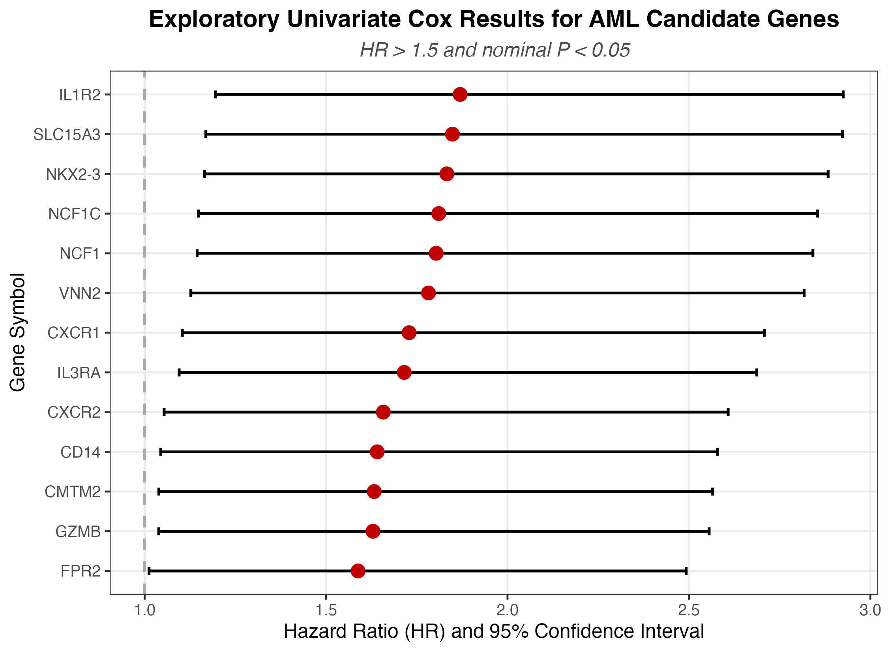
Figure 1. Univariate Cox estimates for the 13 AML candidate genes that met the exploratory screening rule after differential-expression and HSPC filtering. Nominal P values were used for candidate prioritization and are not interpreted as multiplicity-corrected prognostic confirmation.

3.3 Pathway enrichment and candidate-development maturity
GO and KEGG analyses performed with clusterProfiler [6] linked the candidate set to leukocyte migration, cytokine-receptor interaction, chemokine signaling, reactive oxygen species biology, and hematopoietic lineage processes. Enrichment was used to assess pathway coherence, not to assign a causal mechanism to any single gene. Excluding mature AML clinical or drug-development targets such as CD33, FLT3, BCL2, IDH1/2, IL3RA, and WT1 indicates that the remaining candidates are less mature in AML targeted-therapy development; it does not prove that they have never been studied.
A key limitation of the three main candidates is that IL1R2, SLC15A3, and VNN2 were all down-regulated in the AML-versus-normal comparison. Their current priority mainly comes from survival association within AML patients and network-assisted evidence, not from a demonstrated AML-over-normal therapeutic expression window. Higher expression within AML patients being associated with poorer outcome does not mean that the gene is higher in AML than in normal tissue. These genes should therefore first be treated as prognostic or mechanistic candidates; direct therapeutic development value will depend on cell-type-specific and protein-level expression in AML blasts, normal HSPCs, and other normal myeloid cells.
Gene | AML differential direction | AML HR | AML P | DLBCL result | Graph rank/cosine similarity
IL1R2 | Down | 1.87 | 0.006 | Not significant after treatment adjustment | Rank 3 / 0.610
SLC15A3 | Down | 1.85 | 0.009 | Not significant after treatment adjustment | Rank 1 / 0.780
VNN2 | Down | 1.78 | 0.013 | Protective in DLBCL: adj HR 0.58, P < 0.001 | Rank 9 / 0.363

Gene | Protein localization | Suggested next validation focus | Main limitation
IL1R2 | Membrane and soluble forms; membrane protein window requires confirmation | Prioritize validation of membrane-protein expression window in AML blasts versus normal myeloid cells, and distinguish membrane-bound from soluble forms. | Normal myeloid/HSPC expression and soluble decoy-receptor biology may limit therapeutic specificity.
SLC15A3 | Lysosome/endosome multi-pass membrane protein [12] | Prioritize functional dependency and intracellular mechanism validation; do not primarily interpret it as a CAR, ADC, or antibody surface target. | Network rank does not imply surface accessibility or direct antibody/CAR suitability.
VNN2 | GPI-anchored cell membrane protein [12] | Prioritize comparison of surface expression in AML blasts, normal neutrophils, other myeloid cells, and HSPCs. | DLBCL direction is opposite to AML, suggesting context dependence.

4. Cross-cohort Robustness, Cross-disease Outcome Assessment, and Network-assisted Evidence
To evaluate whether AML-prioritized genes also show outcome association in another hematologic malignancy, the project used the GSE10846 diffuse large B-cell lymphoma (DLBCL) cohort [7]. This analysis is best described as cross-disease, cross-lineage outcome assessment or DLBCL treatment-adjusted survival analysis. It cannot establish AML specificity and should not be described as independent AML validation. Because CHOP-like versus R-CHOP-like therapy can affect survival in DLBCL, Cox models were adjusted for treatment group.
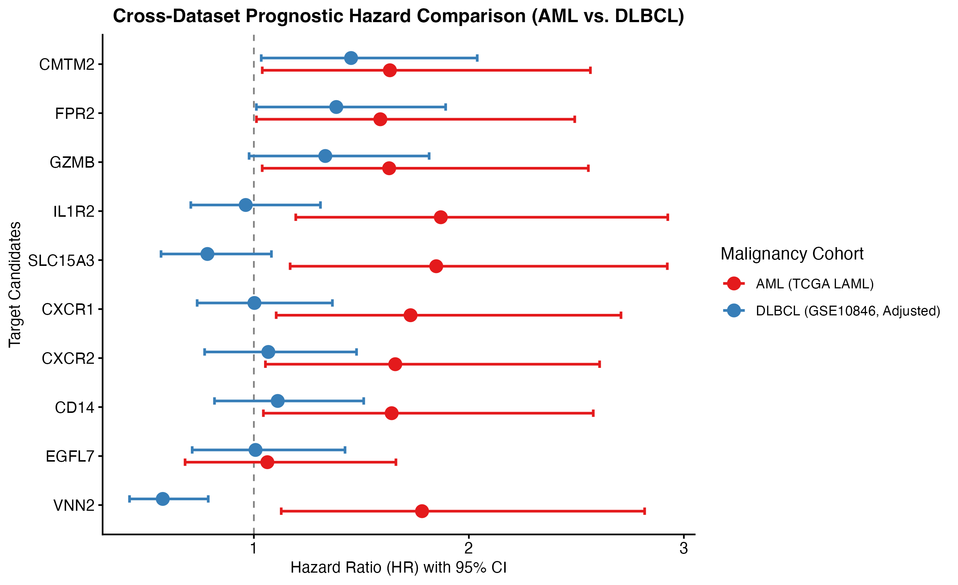
Figure 2. Cross-disease outcome comparison of AML-prioritized candidates in AML and treatment-adjusted DLBCL. In both cohorts, HR represents the high-expression group relative to the low-expression group using cohort-specific median splits. AML estimates are from univariate Cox models, whereas DLBCL estimates are from Cox models adjusted for treatment regimen; the figure is intended to compare association direction, confidence intervals, and cross-disease patterns, not to treat HR magnitudes as strictly equivalent.
The adjusted DLBCL results separated candidates into interpretable but hypothesis-generating categories. CMTM2 (adjusted HR 1.45, 95% CI 1.03-2.04; P = 0.031) and FPR2 (adjusted HR 1.38, 95% CI 1.01-1.89; P = 0.042) retained adverse associations in DLBCL, consistent with possible cross-hematologic or microenvironment relevance. IL1R2, CD14, CXCR1/2, and SLC15A3 were adverse in AML but not significant in DLBCL; this pattern may support AML/myeloid-enriched hypotheses, but non-significance in one DLBCL cohort does not prove disease specificity. VNN2 reversed direction, from adverse in AML to protective in DLBCL (adjusted HR 0.58, 95% CI 0.42-0.79; P < 0.001), so it should be treated as a context-dependent candidate.
STRING protein associations [8] and CTD disease-gene associations [9] were used to build a heterogeneous graph with 16,014 nodes and 233,709 edges. Node2Vec [10] generated 128-dimensional embeddings, and candidate ranking was based on cosine similarity to the centroid of 14 known AML targets in that original 128-dimensional space. SLC15A3 ranked first (0.780), followed by EGFL7 (0.620) and IL1R2 (0.610); CD14 and GZMB completed the top five. The two-dimensional UMAP is only a visualization of the embedding distribution and should not be used as formal distance evidence.
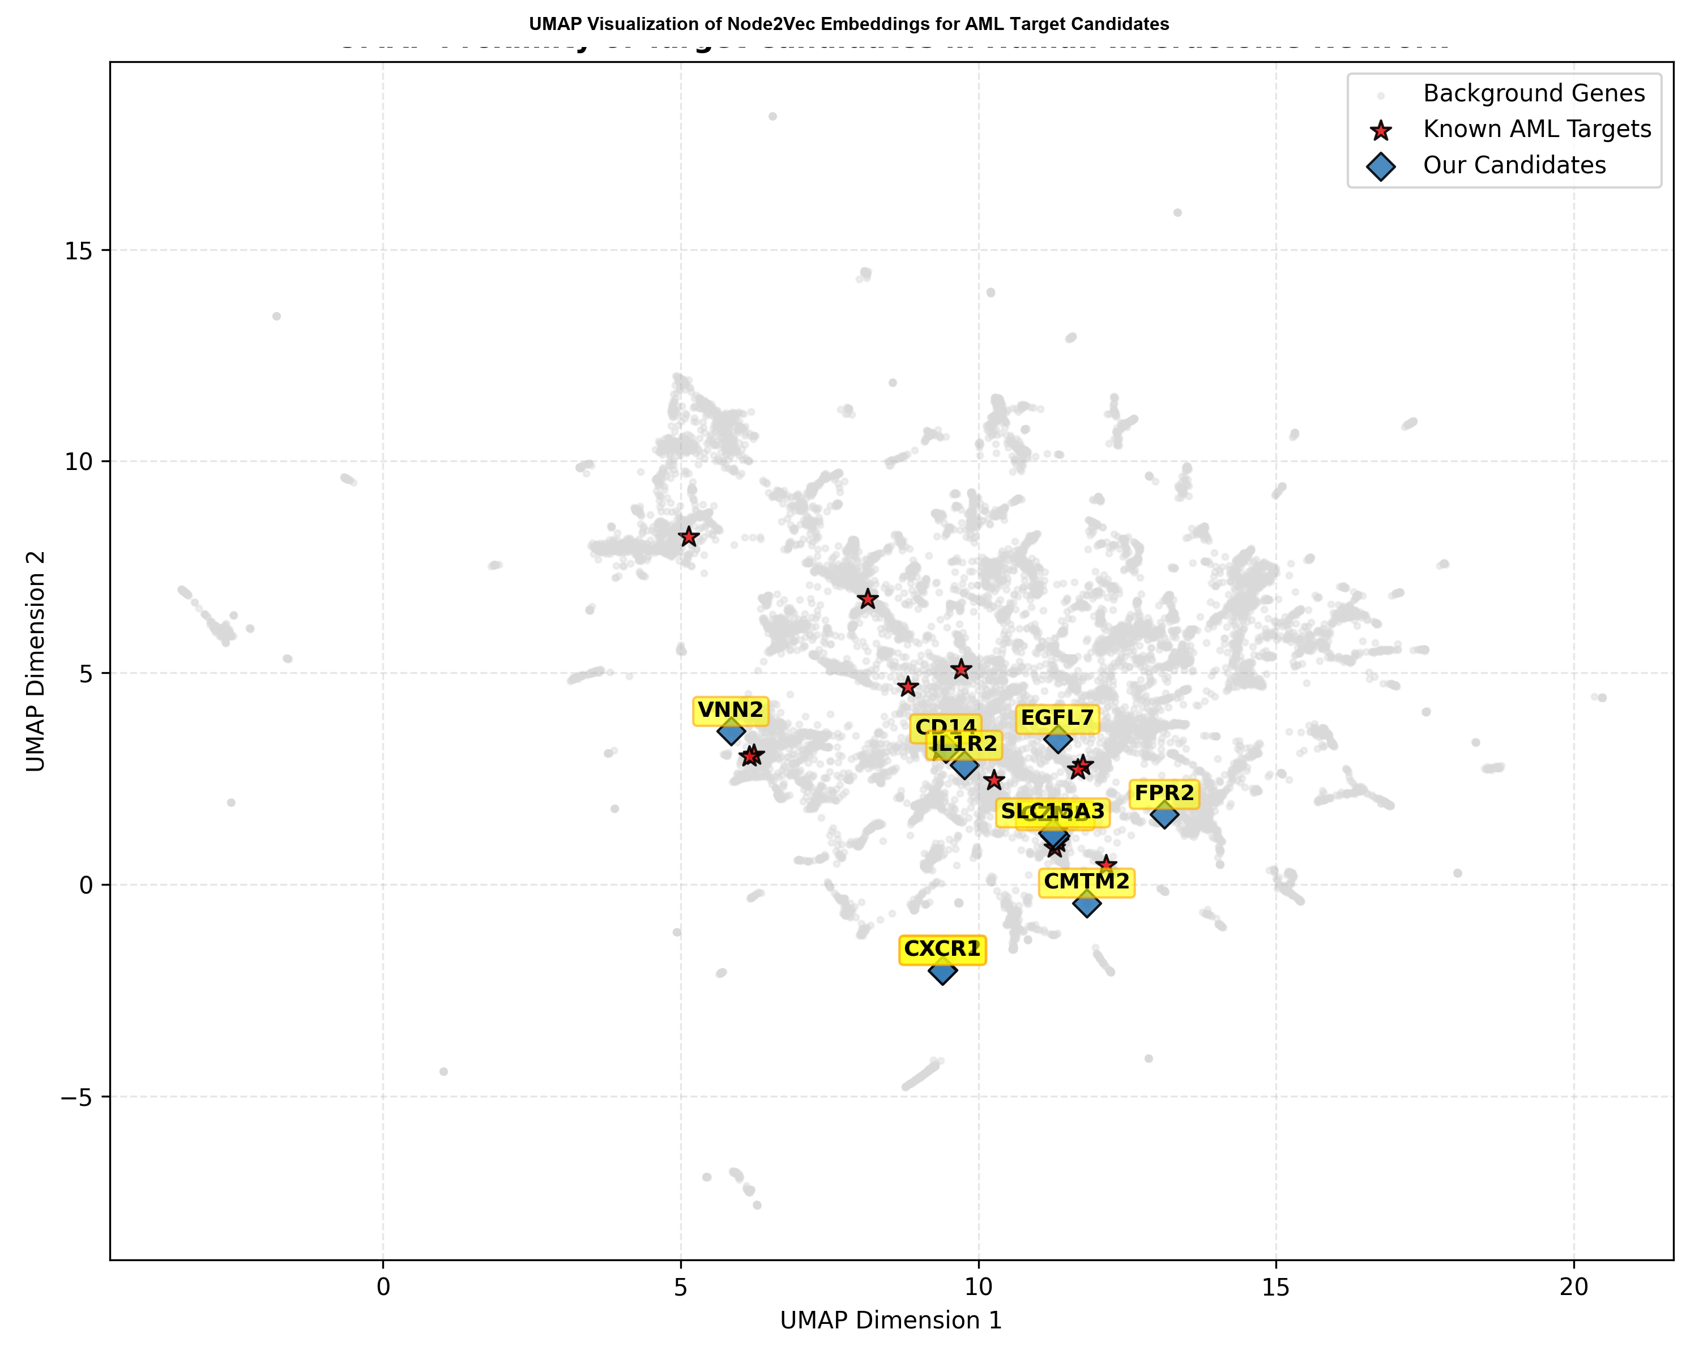
Figure 3. UMAP visualization of Node2Vec embeddings for candidate genes and known AML targets. UMAP displays the overall distribution of 128-dimensional embeddings, but the two-dimensional projection may distort high-dimensional distances. Candidate ranking is based on cosine similarity in the original 128-dimensional space, not visual distance in the UMAP plot.

5. Significance and Experimental Handoff
The project provides a reproducible, auditable prioritization framework: it handles TCGA/GTEx confounding, applies GSE13159 expression-direction filtering, uses normal HSPC expression as safety-oriented evidence, ranks candidates by exploratory AML survival association, compares cross-disease outcome patterns with treatment-adjusted DLBCL Cox models, and adds network embedding as systems-level support. The output is a wet-lab-ready candidate portfolio, not a single definitive therapy target.
IL1R2, SLC15A3, and VNN2 represent different evidence structures. IL1R2 has the strongest AML survival association and a high graph rank, but membrane/soluble biology and normal myeloid expression remain limiting questions. SLC15A3 has the top graph rank, but its endolysosomal localization favors mechanistic or intracellular-intervention hypotheses over direct surface targeting. VNN2 is membrane/GPI-anchored and worth surface-expression review, but its opposite DLBCL direction makes lineage context central.

6. Limitations and Conclusion
- TCGA/GTEx comparison contains unavoidable cohort-source confounding; GSE13159 filtering reduces but does not eliminate it.
- Bulk RNA-seq may reflect malignant-cell expression, immune infiltration, and sample composition; nominal P values, median splits, and univariate Cox models support exploratory ranking, not confirmed prognostic inference.
- GSE10846 is a DLBCL cohort for cross-disease outcome comparison, not AML replication.
- Network proximity cannot measure drug response, dependency, mechanism, surface accessibility, or normal-tissue safety; ranking depends on 14 AML target seeds, node degree, and heterogeneous STRING/CTD evidence.
In conclusion, this workflow integrates cross-cohort expression, HSPC filtering, AML survival association, DLBCL outcome comparison, and network context as independent evidence layers. IL1R2, SLC15A3, and VNN2 remain experimental priorities, not therapeutic claims, pending cell-specific expression, protein-level, perturbation, and modality-fit validation.

References
1. Cancer Genome Atlas Research Network. Genomic and epigenomic landscapes of adult de novo acute myeloid leukemia. N Engl J Med. 2013;368(22):2059-2074. PMID: 23634996. DOI: 10.1056/NEJMoa1301689. PubMed
2. GTEx Consortium. The GTEx Consortium atlas of genetic regulatory effects across human tissues. Science. 2020;369(6509):1318-1330. PMID: 32913098. DOI: 10.1126/science.aaz1776. PubMed
3. Haferlach T, et al. Clinical utility of microarray-based gene expression profiling in the diagnosis and subclassification of leukemia. J Clin Oncol. 2010;28(15):2529-2537. PMID: 20406941. DOI: 10.1200/JCO.2009.23.4732. PubMed
4. Novershtern N, et al. Densely interconnected transcriptional circuits control cell states in human hematopoiesis. Cell. 2011;144(2):296-309. PMID: 21241896. DOI: 10.1016/j.cell.2011.01.004. PubMed
5. Ritchie ME, et al. limma powers differential expression analyses for RNA-sequencing and microarray studies. Nucleic Acids Res. 2015;43(7):e47. PMID: 25605792. DOI: 10.1093/nar/gkv007. PubMed
6. Yu G, et al. clusterProfiler: an R package for comparing biological themes among gene clusters. OMICS. 2012;16(5):284-287. PMID: 22455463. DOI: 10.1089/omi.2011.0118. PubMed
7. Lenz G, et al. Stromal gene signatures in large-B-cell lymphomas. N Engl J Med. 2008;359(22):2313-2323. PMID: 19038878. DOI: 10.1056/NEJMoa0802885. PubMed
8. Szklarczyk D, et al. The STRING database in 2023: protein-protein association networks and functional enrichment analyses for any sequenced genome of interest. Nucleic Acids Res. 2023;51(D1):D638-D646. PMID: 36370105. DOI: 10.1093/nar/gkac1000. PubMed
9. Davis AP, et al. Comparative Toxicogenomics Database (CTD): update 2023. Nucleic Acids Res. 2023;51(D1):D1257-D1262. PMID: 36169237. DOI: 10.1093/nar/gkac833. PubMed
10. Grover A and Leskovec J. node2vec: Scalable feature learning for networks. Proceedings of the 22nd ACM SIGKDD International Conference on Knowledge Discovery and Data Mining. 2016:855-864. DOI: 10.1145/2939672.2939754. DOI
11. Sahin U, Kariko K, Tureci O. mRNA-based therapeutics--developing a new class of drugs. Nat Rev Drug Discov. 2014;13(10):759-780. PMID: 25233993. DOI: 10.1038/nrd4278. PubMed
12. The UniProt Consortium. UniProt: the Universal Protein Knowledgebase in 2023. Nucleic Acids Res. 2023;51(D1):D523-D531. DOI: 10.1093/nar/gkac1052. DOI

