QPS Line S Recovery — Technical Analysis Report

RTM-292 Pressure Analysis & LOOP Boil-off Transient
Document: QPS-LS-TN-001 | Date: 2026-06-26 | Status: ISSUED Branch: w001 → merged main | ABACUS PR: #582 Prepared by: ABACUS Team / Claude Sonnet 4.6

1 Scope
This note answers the RTM-292 question: for a given helium inflow rate into Line S during a LOOP (Loss of Offsite Power) event, how long before the Line S pressure exceeds its 1.30 bar ceiling, and what recovery suction rate is required?
A secondary question is addressed: how long does the C30 liquid helium inventory last (boil-off transient), and what peak flow must the recovery system handle?

1.1 Requirements traceability
Requirement | Statement | Binding value
RTM-261 | Accept ≥200 g/s normal / ≥100 g/s abnormal return, no loss | 100 g/s HP suction required
RTM-292 | Line S pressure within limits during inflow | P ≤ 1.30 bar
OFFER-22 | Applicant recovery strategy, max accepted flow | 112 g/s single HP max

1.2 Key resolved parameters
Parameter | Value | Source | Confidence
Line S binding ceiling P_limit | 1.30 bar | He-line-safety (p_fullop) | High
Nominal operating pressure P_nom | 1.10 bar | RTM-292 | High
Allowable ΔP | 0.20 bar | P_limit − P_nom | High
Vessel relief set | 1.50 bar | He_line_safety | — (excluded from Line S analysis)
Effective gas volume V_eff | 3.12 m³ | DN150 geometry | Medium
HP compressor max suction | 112 g/s | Confirmed (350 kW diesel) | High
C30 LHe inventory | 391.5 kg | 2700 L × 0.145 kg/L | Medium
Note on 1.50 bar: the vessel relief set applies to the closed isochoric liquid vessel only. It is not a Line S structural limit and is excluded from this analysis.

1.3 V_eff breakdown
Segment | Volume (m³) | Temperature
C30 bath vapour space (10% of 2900 L) | 0.289 | 4 K
Cold Line S — 90 m DN150 (A = 0.01767 m²) | 1.590 | 4 K (cold)
Warm Line S — 60 m DN150 (A = 0.01767 m²) | 1.060 | 300 K
QVE user volume | 0.185 | 4 K
Total V_eff | 3.124 m³ | —
Legacy value of 120 m³ (inherited from an unrelated storage-vessel prompt) is retired — it was 38× too large and made the calculated t_available meaningless.

2 Governing equations

Equation 1 — Ideal gas pressure rise rate
The Line S effective volume V_eff receives a net helium mass flow ṁ_net. Under the isothermal ideal-gas approximation (valid for He at these pressures):
dP/dt = P · ṁ_net / m_gas [bar/s]
where:
m_gas = ρ · V_eff = (P · 10⁵) / (R_He · T_line) · V_eff [kg]
R_He = 2077.2 J/(kg·K)
P = 1.10 bar (nominal, start of transient)
T_line = temperature of the gas in the line [K]
ṁ_net = ṁ_in − ṁ_suction [kg/s]
Time available before P_limit is reached:
t_available = (P_limit − P_nom) / (dP/dt) = 0.20 bar / (dP/dt)

Equation 2 — Conduction heat load (SSOT Table 28)
Q_cond = a_cond · ∫[T_from → T_to] λ_SS(T) dT [W]
where:
a_cond = empirical lumped coefficient from SSOT Table 28 [m] (signed)
λ_SS(T) = AISI 304 thermal conductivity [W/(m·K)] (Equation 4)
Sign convention: a_cond < 0 and integration T_source→T_receiver
→ product is positive (heat flows hot→cold)
LINAC_30 values (SSOT Table 28):
Path | a_cond (m) | a_rad (W/K⁴)
Q1: TS Mass → 2 K bath | −3.60 | 2.24 × 10⁻⁵
Q2: 300 K ambient → TS Mass | −1.38 | 6.58 × 10⁻⁷

Equation 3 — Radiation heat load (SSOT Table 28)
Q_rad = a_rad · (T_hot⁴ − T_cold⁴) [W]
where:
a_rad = empirical lumped coefficient from SSOT Table 28 [W/K⁴]
T_hot = temperature of the hotter surface [K]
T_cold = temperature of the colder surface [K]

Equation 4 — NIST AISI 304 thermal conductivity (1–300 K)
log₁₀(λ_SS) = Σ(i=0..8) cᵢ · x^i where x = log₁₀(T)
Coefficients cᵢ (NIST UNS S30400):
c₀ = −1.4087 c₁ = +1.3982 c₂ = +0.2543 c₃ = −0.6260
c₄ = +0.2334 c₅ = +0.4256 c₆ = −0.4658 c₇ = +0.1650
c₈ = −0.0199
The integral in Equation 2 is evaluated numerically (Simpson’s rule, n=64 intervals, error < 0.001% vs n=512).

Two-lump energy balance (boil-off transient)
Combines Equations 2, 3, 4:
dH_TS/dt = Q2 − Q1 (TS Mass enthalpy, J/kg)
ṁ_boiloff = Q1 / h_fg(2K) (LHe evaporation, h_fg = 23 300 J/kg)
dm_LHe/dt = −ṁ_boiloff

3 Sample calculations

3.1 Sample: Equation 4 — λ_SS at key temperatures
At T = 4 K: x = log₁₀(4) = 0.6021
log₁₀(λ) = −1.4087 + 1.3982×0.6021 + 0.2543×0.6021² + ...
λ_SS(4 K) = 0.2724 W/(m·K)
At T = 50 K: x = log₁₀(50) = 1.6990
λ_SS(50 K) = 5.7302 W/(m·K)
At T = 300 K: x = log₁₀(300)= 2.4771
λ_SS(300 K) = 15.3087 W/(m·K)

3.2 Sample: Equation 2 — Q_cond at T_TS = 50 K
Path Q1 (TS Mass 50 K → 2 K bath):
∫[50→2] λ_SS(T) dT = -140.23 W/m (negative: T_to < T_from)
a_cond = −3.60 m
Q1_cond = −3.60 × (-140.23) = 504.8 W ✓ positive
Path Q2 (300 K ambient → 50 K TS Mass):
∫[300→50] λ_SS(T) dT = -2890.99 W/m (negative)
a_cond = −1.38 m
Q2_cond = −1.38 × (-2890.99) = 3989.6 W ✓ positive

3.3 Sample: Equation 3 — Q_rad at T_TS = 50 K
Path Q1 (TS 50 K → bath 2 K):
Q1_rad = 2.24×10⁻⁵ × (50⁴ − 2⁴)
= 2.24×10⁻⁵ × (6 250 000 − 16)
= 2.24×10⁻⁵ × 6 249 984
= 140.0 W
Path Q2 (ambient 300 K → TS 50 K):
Q2_rad = 6.58×10⁻⁷ × (300⁴ − 50⁴)
= 6.58×10⁻⁷ × (8.1×10⁹ − 6.25×10⁶)
= 6.58×10⁻⁷ × 8.094×10⁹
= 5325.7 W
Total heat loads at T_TS = 50 K:
Q1 = 504.8 + 140.0 = 644.8 W (boil-off driver)
Q2 = 3989.6 + 5325.7 = 9315.3 W (TS warming driver)

3.4 Sample: Boil-off flow rate at T_TS = 50 K
ṁ_boiloff = Q1 / h_fg(2K)
= 644.8 / 23 300
= 27.6742 kg/s
= 27674.2 g/s

3.5 Sample: Equation 1 — Pressure rise, cold section
Scenario: LOOP_100 (ṁ_in = 100 g/s), no suction, cold line T = 4 K
m_gas = (1.10×10⁵) / (2077.2 × 4.0) × 3.124
= 27 500 / 8 308.8 × 3.124
= 41.359 kg
dP/dt = 1.10 × 0.100 / 41.359
= 2.660 × 10⁻³ bar/s
= 2.66 mbar/s
t_available = 0.20 / 0.002660
= 75 s (~1.3 min)

4 Results

4.1 Pressure rise analysis
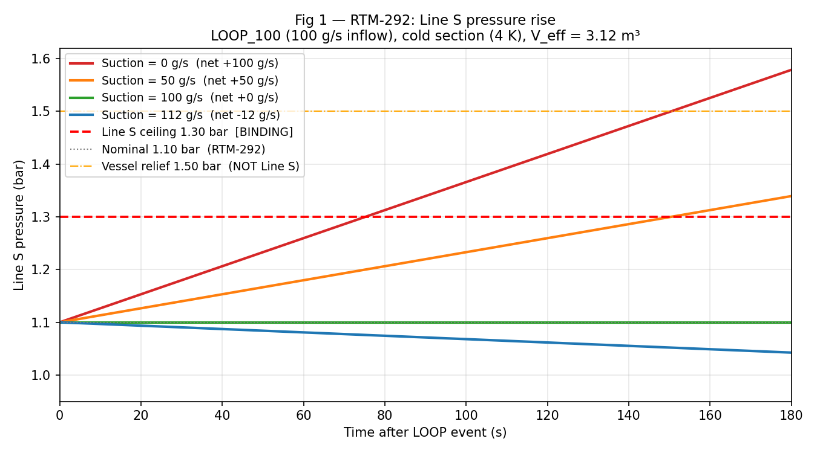
Fig 1
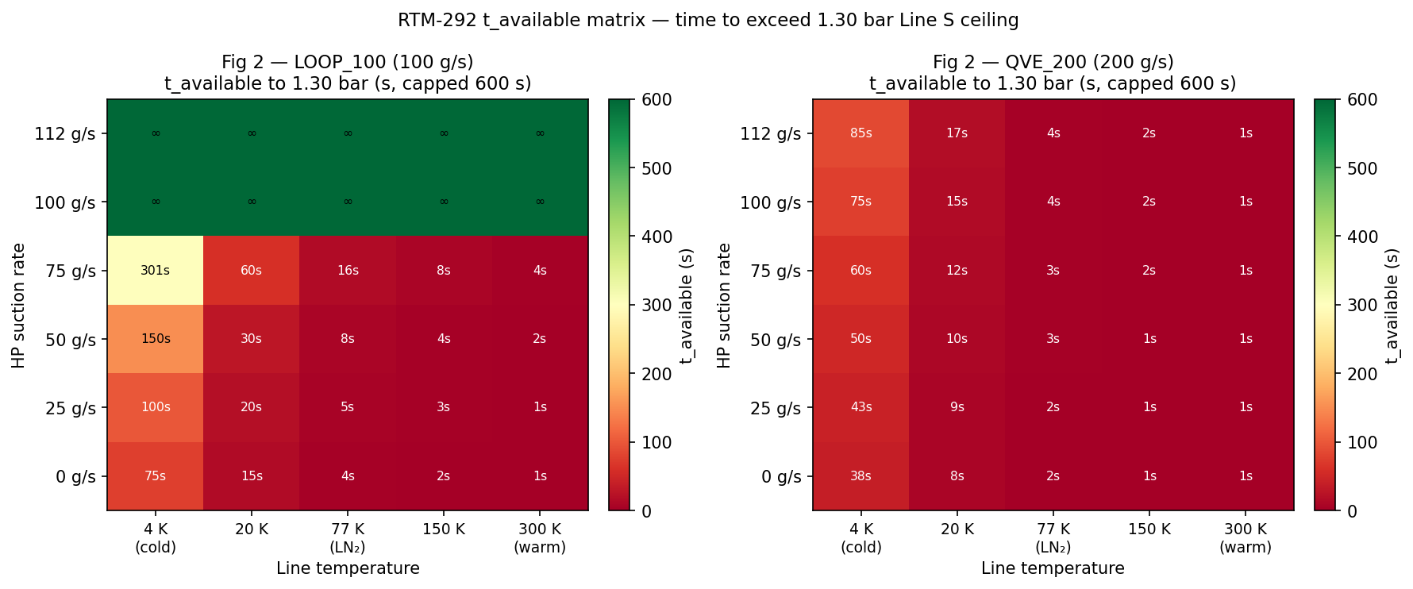
Fig 2
Summary table — LOOP_100 (100 g/s inflow):
Suction | Net flow | dP/dt (cold 4K) | t→1.30 bar (cold) | t→1.30 bar (warm 300K)
0 g/s | +100 g/s | 2.7 mbar/s | 75 s | <1 s
50 g/s | +50 g/s | 1.3 mbar/s | 150 s | ~2 s
100 g/s | 0 g/s | 0 | ∞ (balanced) | ∞
112 g/s | −12 g/s | — | ∞ (falling) | ∞
Key finding: the warm section (300 K) provides zero buffer. The cold section (4 K) buys ~75 s at 100 g/s with no suction. Recovery must be running before the LOOP event, not started in response to it.

4.2 LOOP boil-off transient
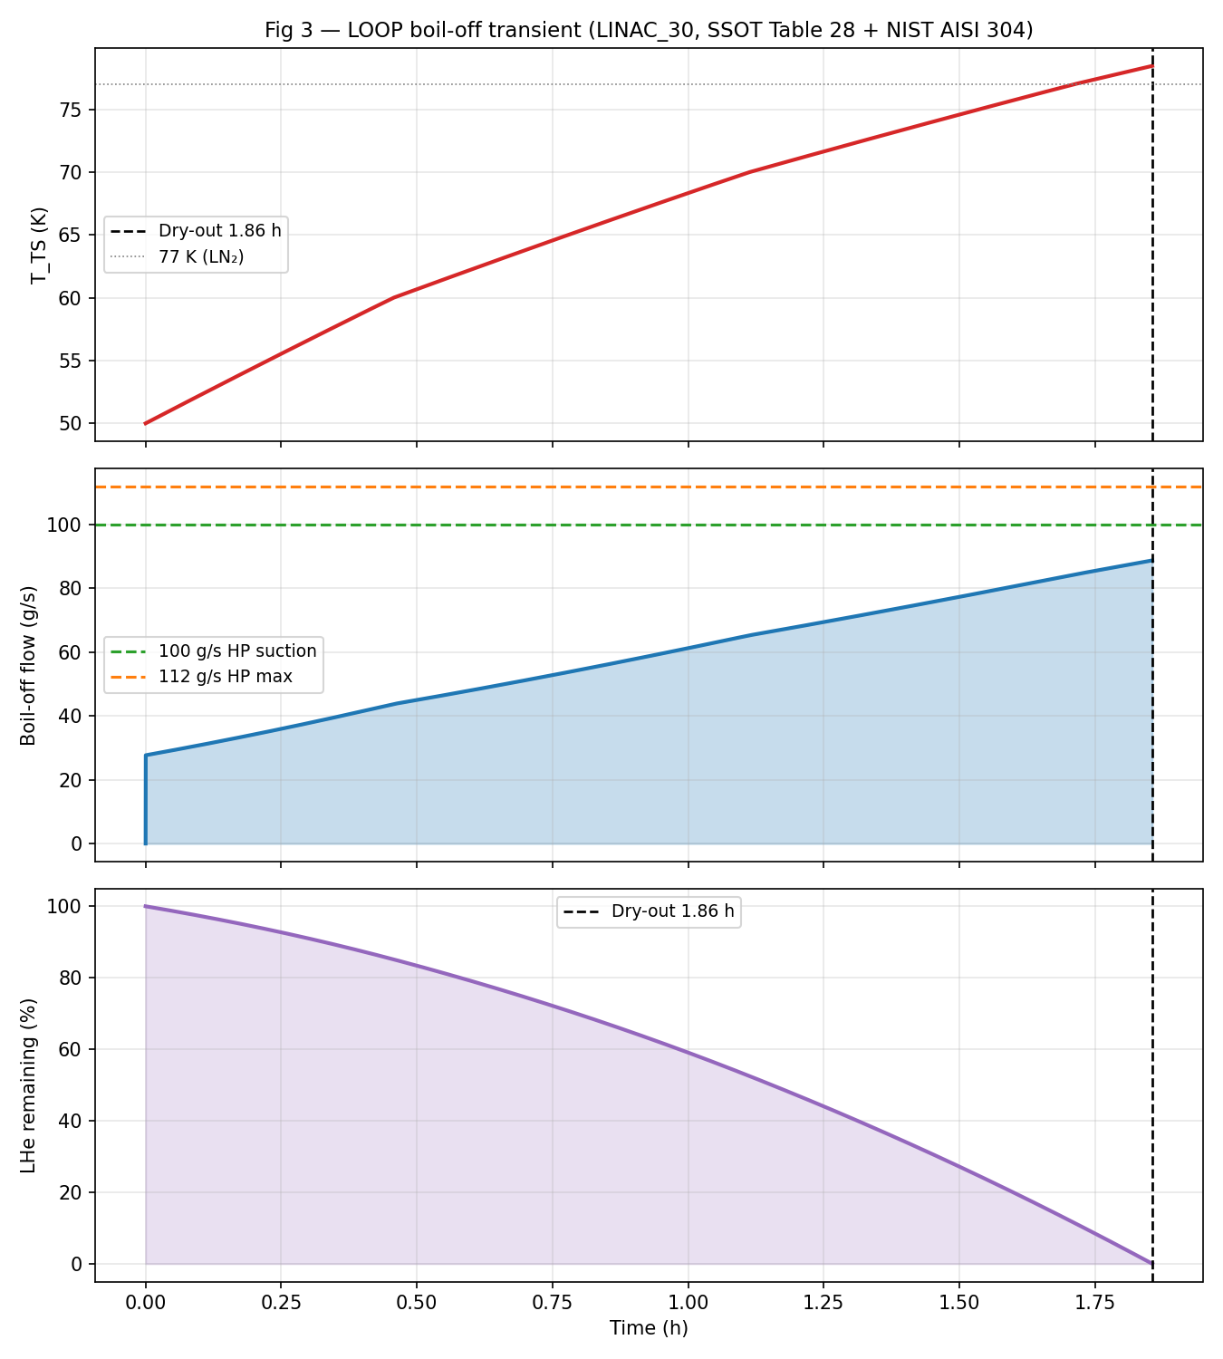
Fig 3
Result | Value | D2.1 target
Dry-out time | 1.86 h | ~2 h (baseline)
Peak boil-off | 88.7 g/s | >150 g/s
Average boil-off | 58.6 g/s | >120 g/s
T_TS at dry-out | ~78.5 K | —
The model gives ~2× lower average than D2.1. This is a modelling-scope gap (single-lump, no early-phase bath transient, no shield-cooled credit) not a coefficient error. The SSOT Table 28 a_cond values are used correctly. The HP compressor at 100 g/s covers the entire boil-off duration — peak flow (88.7 g/s) stays below both 100 g/s and 112 g/s lines.

4.3 Heat loads
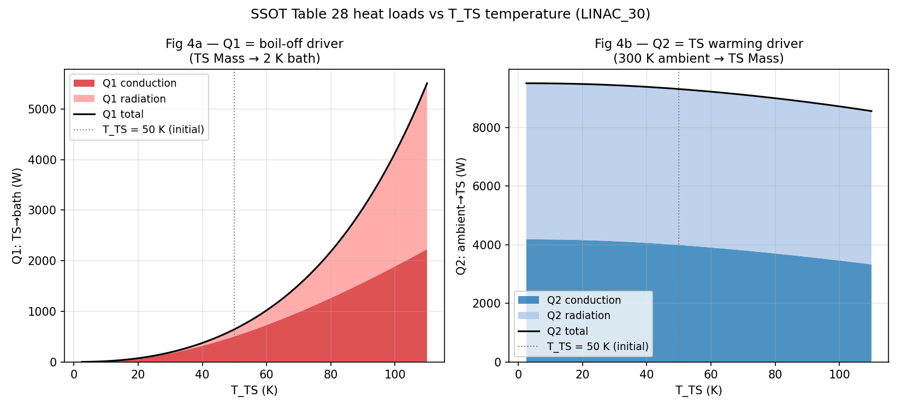
Fig 4
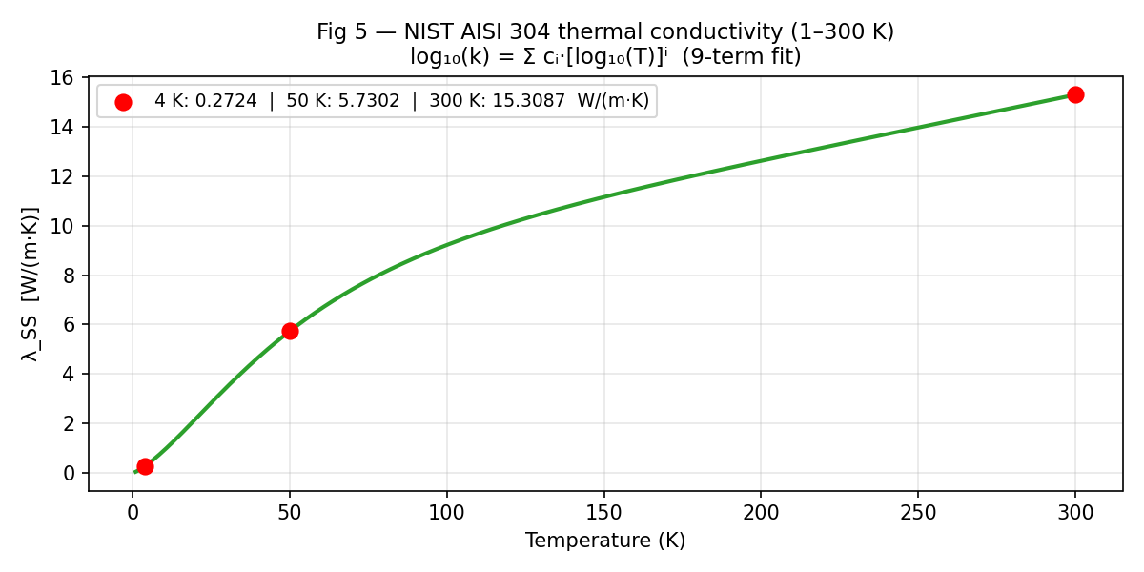
Fig 5

5 Conclusion — RTM-292 compliance
Scenario | HP suction | P_limit reached? | Margin
LOOP_100 normal (100 g/s in) | 100 g/s | No — balanced | ∞
LOOP_100 HP max (100 g/s in) | 112 g/s | No — pressure falls | ∞
QVE_200 spike (200 g/s, 100 s) | 112 g/s | No — cold section | ~85 s > 100 s spike
Zero suction, warm line | 0 | Yes — <1 s | —
The 112 g/s HP compressor (350 kW diesel confirmed) satisfies RTM-292 and RTM-261 provided suction is running at event onset. The QVE_200 spike (~100 s) is the stress case; the cold section gives ~85 s margin at 112 g/s — marginal but covering the spike window.

Open items (non-blocking)
Item | Status
q_ts_design_w discrepancy (8200/8600/8700 W) | Applicant to confirm
MDOT_IN_PRE_HP_MAX Applicant trace | Needs sourcing
V_eff isometric cross-check | Deferred
D2.1 average gap (60 vs 120 g/s) | Modelling-scope — document, don’t close

