**TRIBUTE TO ALBERT EINSTEIN**

***Albert Einstein*  was born in 1879**  in Germany, the first child of a bourgeois Jewish couple. The young Albert displayed an early interest in science, but he was unhappy with the principles of obedience and conformity that governed his Catholic elementary school.

* **Developed the theory of relativity**
* *Won the Nobel Prize in Physics in 1921*
* Made significant contributions to the philosophy of science

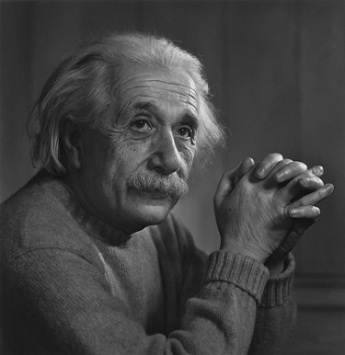

|  |  |  |
| --- | --- | --- |
| Invention Name | Year | Description |
| Theory of General Relativity | 1915 | Fundamental theory in physics explaining gravitation |
| Photoelectric Effect | 1905 | Discovery explaining interaction of light with matter |
| Brownian Motion | 1905 | Experimental evidence supporting atomic theory |
| Mass-Energy Equivalence (E=mc^2) | 1905 | Famous equation demonstrating equivalence of mass and energy |

* He is best known to the general public for his mass–energy equivalence formula E = mc2, which has been dubbed "the world's most famous equation".
* Einstein published more than 300 scientific papers and more than 150 non-scientific works. His intellectual achievements and originality have made the word "Einstein" synonymous with "genius".
* He received the 1921 Nobel Prize in Physics "for his services to theoretical physics, and especially for his discovery of the law of the photoelectric effect", a pivotal step in the development of quantum theory.
* He lived in Switzerland between 1895 and 1914, except for one year in Prague, and he received his academic diploma from the Swiss federal polytechnic school (later the Eidgenössische Technische Hochschule, ETH) in Zürich in 1900. He taught theoretical physics there between 1912 and 1914 before he left for Berlin.