Application System – School Side

1. Schools will receive an email notification once a parent applies for their registration opening.

Remarks: It is updated.



2. School will be able to view the list of applicants against each registration opening.

Remarks: It is updated.

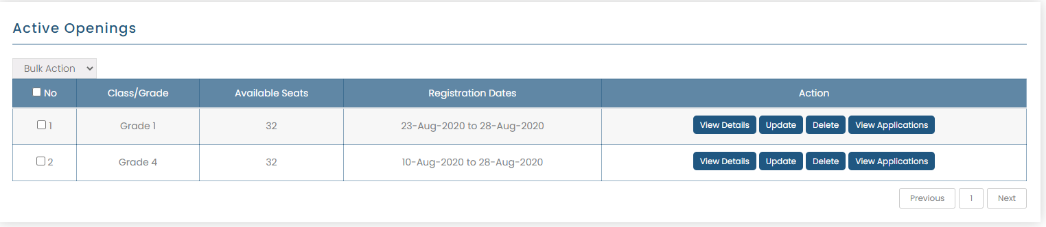

3. School can view the profile of a child, either accept or reject or put on hold.  
Remarks: It is updated.

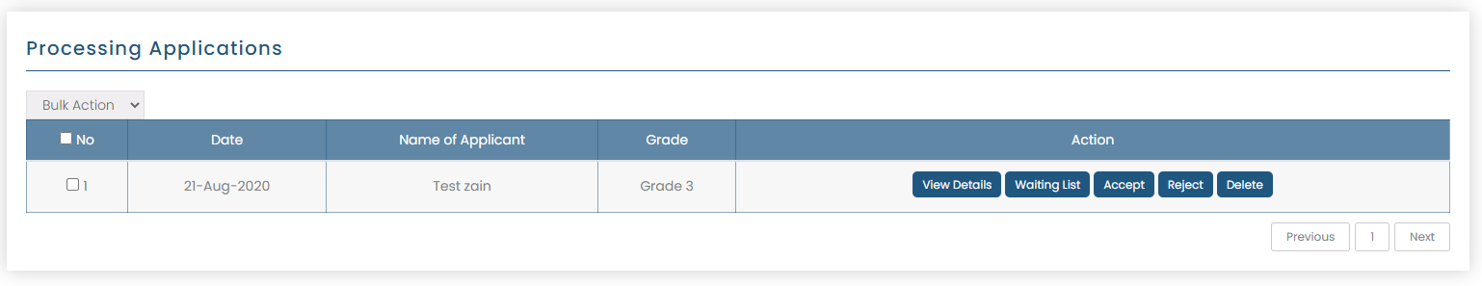

4. School will be able to view the contact details of parent and in case of acceptance, they can call the parent and tell them the procedure to submit their fee.

Remarks: It is updated.

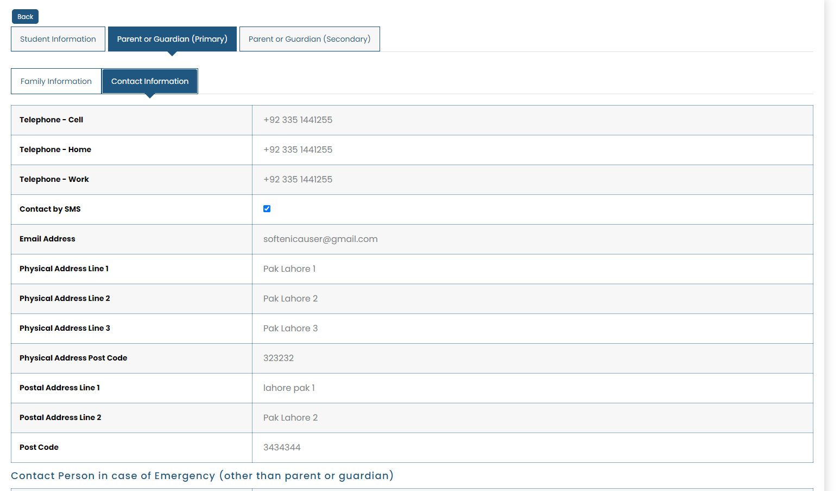

5. Once the fee will be submitted, school can mark that student as registration fee paid in their approved list. (Website will not offer a finance management system for whole school expense - no online payments involved)

Remarks: It is updated.

6. In case of acceptance, an e-mail will also be sent to parents mentioning that their application has been accepted and school authorities will contact them soon with further steps.

Remarks: It is updated.



7. If the application is rejected, the school will need to add a reason for that, and that will be sent to parents.

Remarks: It is updated.



8. If the application is put on hold by the school, the parents will receive an email for that.

Remarks: It is updated.



9. At parent’s side, parents will be able to view their accepted applications, rejected applications and on-hold applications in their dashboard.

Remarks: It is updated.

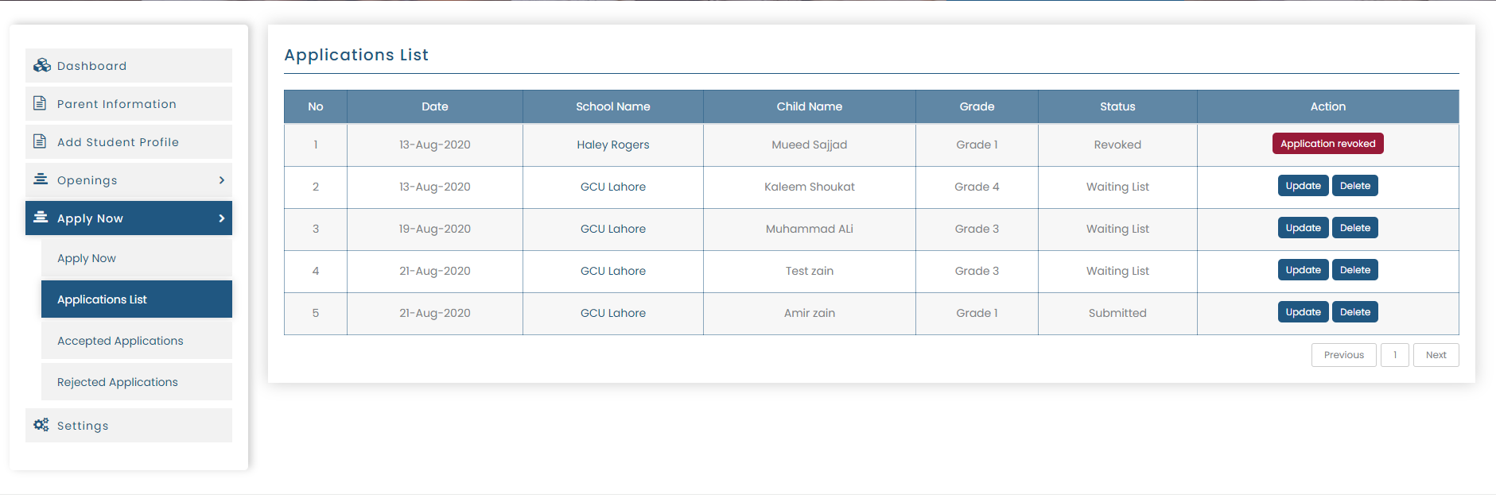

10. Parents will be able to cancel only the pending and on-hold applications.

Remarks: It is updated.

11. On Admin side, admins will be able to view all applications, search for applications by school name, parents name, child name or registration opening. In an application, the admins will see the name of school, clicking which will open school profile, name of registration opening, clicking which will open its details, name of parent, name of student and will be able to view the status of application and student/parent profile.

Remarks: Admin Module is updated.

