EQUITY RESEARCH | INDIA | PRIVATE BANKS | 30 SEPTEMBER 2026
Karur Vysya Bank (NSE: KARURVYSYA)
Initiating coverage: best-in-class quality, but the price already treats FY26 as normal
Rating: HOLD | 12-month fair value: Rs300 | CMP (30-Sep-26): Rs325 | Downside: -8% | Probability-weighted: Rs283

Investment summary  A transformed bank. Gross NPA fell from 5.96% (FY22) to 0.75% (FY26) with 96.5% provision coverage, and ROE reached ~19%. Q1 FY27 was stronger still: profit +45% YoY, ROA 2.11%.  But FY26 profits were flattered. Recoveries from written-off loans added Rs679cr to FY26 other income (Rs638cr in FY25), about 40 bp of post-tax ROA. Management has signalled these cannot recur indefinitely; as they fade we see sustainable ROE of ~17%, not 19-20%.  Margins are near a cyclical high. Q1 FY27 NIM was 4.26% against FY27 guidance of 3.75-3.80%. Repo-linked loans (55%) help if RBI hikes, but CASA has slipped from 33.2% (FY23) to 27.6%.  Valuation leaves little room. At 1.75x Sep-27E adjusted book, the price implies a sustainable ROE of ~17.4% or a cost of equity of ~13.2%. Our P/ABV and residual income blend gives Rs300. Bull Rs372 (+14%) vs bear Rs159 (-51%): the skew is negative. Nearer Rs260 (~1.5x FY27E ABV) the base case would offer ~15% upside.
  Key data
  Market cap | Rs31,364cr
  Shares (post 1:5 bonus) | 96.5cr
  52-week range | Rs208-359
  P/E FY27E / FY28E | 10.5x / 10.1x
  P/ABV Sep-27E | 1.75x
  FY26 ROE / ROA | 19.1% / 1.93%
  CRAR (FY26) | 18.76%
  Dividend yield | 0.8%
  Next results | 15-Oct-2026
  Scenario | Value | Upside
  Bear (25%) | Rs159 | -51%
  Base (50%) | Rs300 | -8%
  Bull (25%) | Rs372 | 14%

Key financials (Rs crore)
Year to March | FY25 | FY26 | FY27E | FY28E | FY29E
Net interest income | 4,260 | 4,938 | 5,769 | 6,563 | 7,497
Pre-provision operating profit | 3,213 | 4,075 | 4,575 | 5,025 | 5,663
Net profit | 1,942 | 2,510 | 2,990 | 3,114 | 3,491
EPS (Rs) | 20.1 | 26.0 | 31.0 | 32.3 | 36.2
Adjusted book value / share (Rs) | 121.9 | 144.3 | 171.4 | 199.2 | 230.6
ROA | 1.73% | 1.96% | 2.02% | 1.82% | 1.77%
ROE | 17.7% | 19.3% | 19.3% | 17.1% | 16.5%
P/E at Rs325 (x) | 16.1x | 12.5x | 10.5x | 10.1x | 9.0x
P/ABV at Rs325 (x) | 2.67x | 2.25x | 1.90x | 1.63x | 1.41x
Source: company filings, Screener.in, analyst estimates. ROA/ROE on model averages; EPS on 96.5cr shares. Student research exercise: not investment advice; the author is not a SEBI-registered research analyst.
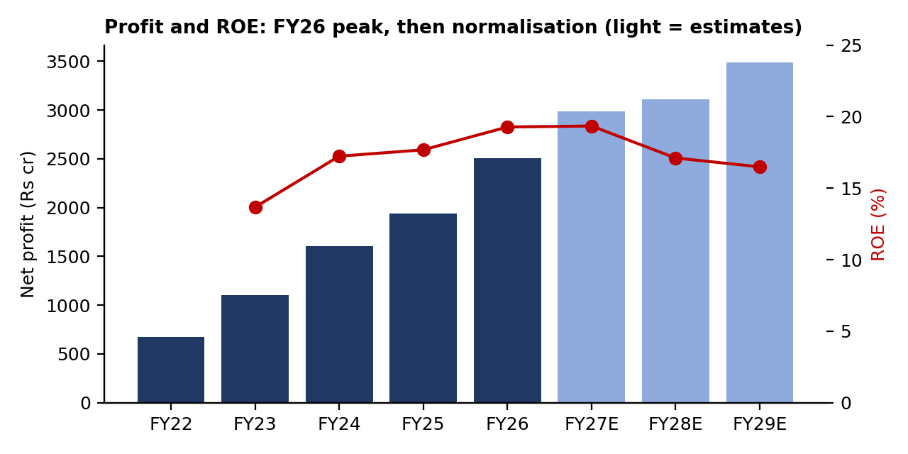
1. Investment thesis
1.1 From turnaround to top quartile
KVB spent FY19-FY22 cleaning up a corporate and MSME book. Gross NPA has since fallen to 0.75% and net NPA to 0.19%, with a provision coverage ratio of 96.5%. FY26 slippages were Rs744cr (0.75% of loans) and FY26 provisions included a Rs163cr prudential buffer. The book is now granular: retail, agriculture and MSME (RAM) are 86% of loans, unsecured lending is only 1.81%, and gold loans are ~30% (internal cap 35%).
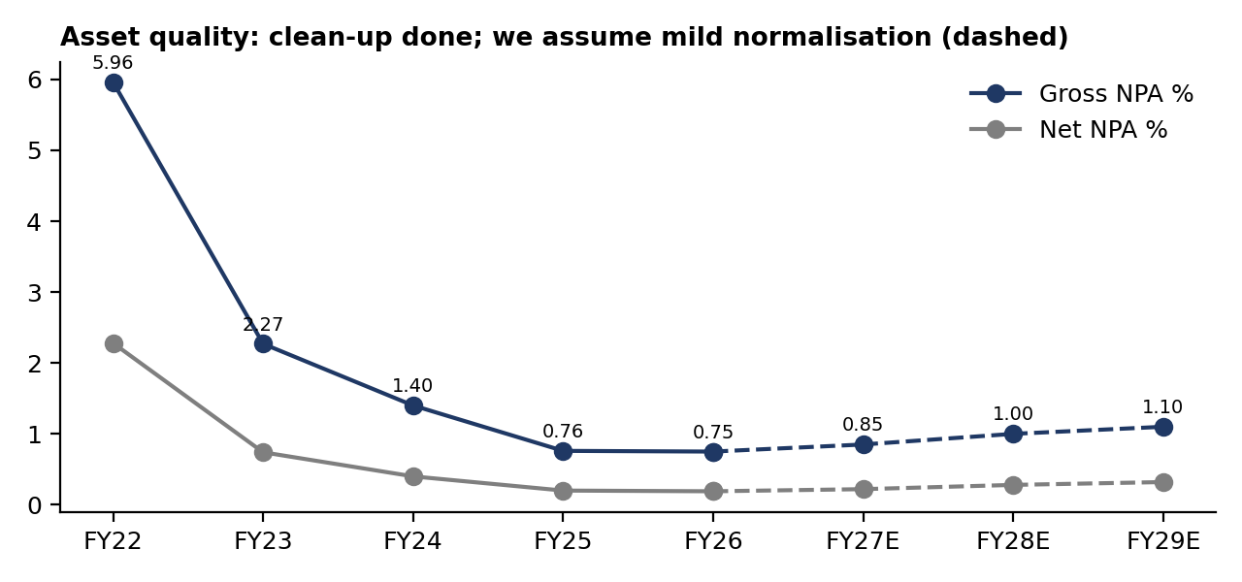
We assume a mild normalisation: gross NPA drifting to 1.10% by FY29E and credit cost rising from 0.55% (FY27E) to 0.70% as the RBI expected-credit-loss (ECL) framework arrives. Management expects minimal ECL impact (provisions already 1.77% of advances), and guides to credit cost below 1%.
1.2 The recovery tailwind fades
Recoveries from loans written off in earlier years were Rs638cr in FY25 and Rs679cr in FY26, booked in other income. They are real cash, but they come from a finite pool. Excluding them, FY26 ROA was ~1.56%, not 1.96% (model basis). We forecast recoveries of Rs550cr / Rs400cr / Rs300cr for FY27E-FY29E.
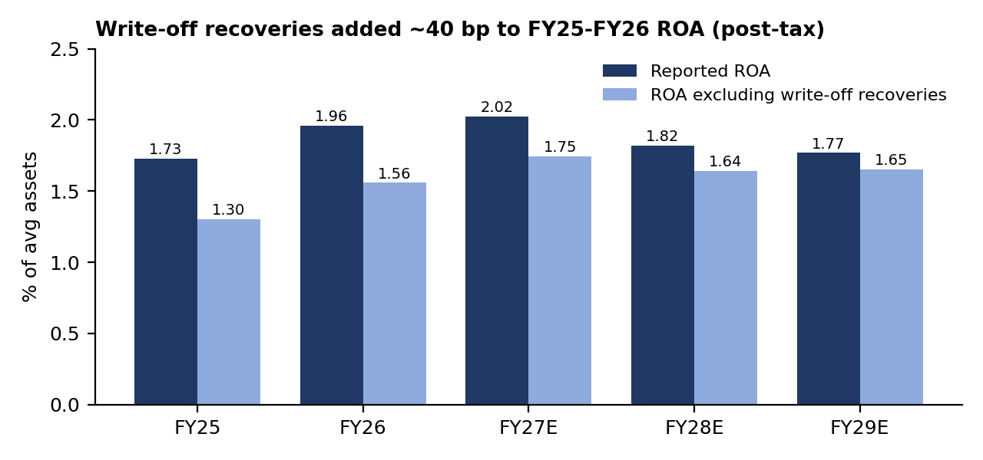
Our FY27E ROA of 2.0% is above the 1.7-1.8% guidance because Q1 ran at 2.11%; we assume the guided normalisation arrives in FY28E (1.82%). The result is the key debate for the stock: FY28E EPS grows only ~4% as recoveries fall, credit cost rises and NIM eases.
1.3 Margins: the rate cycle helps now, deposits hurt later
Q1 FY27 NIM was 4.26% (yield on advances 10.01%, cost of deposits 5.45%). About 55% of loans are linked to the external benchmark (repo) rate, 29-30% are fixed and 14% MCLR-linked, so an RBI hike lifts yields quickly: the 10-year G-sec is ~7.1% and markets expect tightening. The structural headwind is funding: CASA fell from 33.2% (FY23) to 27.6% (Q1 FY27). Our calculated NIM (on loans plus investments) eases from 4.17% in FY27E to 4.04% in FY29E.
1.4 Growth is healthy, capital is ample
Advances grew 17.1% YoY in Q1 FY27 to Rs1,04,680cr; management guides 1-2% above industry growth, with 50 new branches in FY27 and no capital raise. We model 17% / 16% / 15% loan growth; our estimated CRAR stays near 19% through FY29E.
2. Business snapshot
Founded in 1916 in Karur, Tamil Nadu, KVB is a mid-size old private-sector bank with deposits of Rs1,22,587cr and a CASA ratio of 27.6% (Q1 FY27).
Loan mix, Q1 FY27 | Rs crore | Share
Commercial | 36,459 | 34.8%
Personal (incl. jewel loans) | 27,770 | 26.5%
Agriculture | 26,095 | 24.9%
Corporate | 14,356 | 13.7%
Total advances | 104,680 | 100%
Loan pricing: EBLR (repo-linked) 55%, fixed 29-30%, MCLR 14%. Gold loans ~30% of the book across segments.
3. Five-year track record
Rs crore | FY22 | FY23 | FY24 | FY25 | FY26
Advances | 57,568 | 64,168 | 74,423 | 84,491 | 98,754
Deposits | 68,486 | 76,638 | 89,113 | 102,078 | 115,666
Net interest income | 2,716 | 3,349 | 3,818 | 4,260 | 4,938
Other income | 769 | 1,159 | 1,649 | 1,830 | 2,084
of which write-off recoveries | – | – | – | 638 | 679
Operating expenses | 1,855 | 2,032 | 2,638 | 2,877 | 2,947
Pre-provision profit | 1,630 | 2,476 | 2,829 | 3,213 | 4,075
Provisions | 699 | 1,039 | 729 | 622 | 755
Net profit | 673 | 1,106 | 1,605 | 1,942 | 2,510
Gross NPA | 5.96% | 2.27% | 1.40% | 0.76% | 0.75%
Net NPA | 2.28% | 0.74% | 0.40% | 0.20% | 0.19%
Provision coverage | 80.3% | 92.1% | 94.8% | 96.8% | 96.5%
CASA ratio | – | 33.2% | 30.4% | 27.3% | 26.9%
Cost-to-income | 53.2% | 45.1% | 48.3% | 47.2% | 42.0%
ROA (model basis) | – | 1.30% | 1.64% | 1.73% | 1.96%
ROE | – | 13.7% | 17.2% | 17.7% | 19.3%
4. Forecasts and key assumptions
Driver | FY27E | FY28E | FY29E | FY27 guidance
Advances growth | 17% | 16% | 15% | 1-2% above industry
Deposit growth | 16% | 15.5% | 15% | -
NIM (calc., loans + investments) | 4.17% | 4.08% | 4.04% | 3.75-3.80% (reported basis)
Cost-to-income | 42.3% | 43.0% | 42.9% | <50%
Credit cost | 0.55% | 0.70% | 0.70% | <1%
Write-off recoveries (Rs cr) | 550 | 400 | 300 | Not guided
Gross NPA | 0.85% | 1.00% | 1.10% | <1.5%
ROA | 2.02% | 1.82% | 1.77% | 1.7-1.8%
ROE | 19.3% | 17.1% | 16.5% | -
CRAR (estimate) | 19.1% | 19.0% | 18.8% | No capital raise
EPS (Rs) | 31.0 | 32.3 | 36.2 | -
NIM is calculated on average loans plus investments, a narrower base than the reported figure (FY26 reported 3.97% excluding one-offs), so compare trends rather than levels.
5. Valuation: fair value Rs300
Banks are valued on book value because their raw material is capital. A bank that earns a return on equity (ROE) above its cost of equity (Ke) deserves to trade above book. We use the Gordon growth identity, justified P/ABV = (ROE - g) / (Ke - g), applied to September-2027 adjusted book, and cross-check with a residual income (RI) model that values the bank as book value plus the present value of returns above Ke. We weight them 70/30.
Input / output | Value | Comment
Risk-free rate | 7.10% | 10-year G-sec, Sep-2026
Beta x equity risk premium | 1.0 x 6.5% | Market-like risk
Cost of equity (CAPM) | 13.6% | Rf + beta x ERP
Long-term growth (g) | 8.5% | Below nominal GDP
Sustainable ROE | 16.8% | Average FY28E-FY29E
Justified P/ABV | 1.63x | (ROE - g) / (Ke - g)
Adjusted book value, Sep-27E | Rs185.3 | Average of FY27E and FY28E
Value: P/ABV method | Rs302 | 70% weight
Value: residual income method | Rs297 | 30% weight
12-month fair value | Rs300 | vs CMP Rs325: -7.7%
5.1 What the price implies
At Rs325 the stock trades at 1.75x Sep-27E adjusted book. Solving the same formula backwards, that multiple is justified only if sustainable ROE is ~17.4% (we assume 16.8%) or if investors accept a cost of equity of ~13.2% (we use 13.6%). The gap is small, which is why we rate the stock HOLD rather than SELL: the market is not wrong about quality, it is simply paying for FY26 returns lasting.
5.2 Sensitivity
Value per share (Rs), P/ABV method: cost of equity (rows) x long-term growth (columns)
Ke \ g | 7.5% | 8.0% | 8.5% | 9.0% | 9.5%
12.6% | 338 | 355 | 375 | 401 | 436
13.1% | 308 | 320 | 334 | 353 | 376
13.6% | 283 | 291 | 302 | 314 | 330
14.1% | 261 | 267 | 275 | 283 | 294
14.6% | 243 | 247 | 252 | 258 | 265

Value per share (Rs): change in NIM (rows, bp) x change in credit cost (columns, bp), FY28E basis
NIM \ credit cost | -20 | -10 | 0 | +15 | +30
-30 | 267 | 248 | 229 | 201 | 173
-20 | 291 | 272 | 253 | 225 | 197
-10 | 315 | 296 | 277 | 249 | 221
0 | 339 | 320 | 302 | 274 | 246
+10 | 363 | 344 | 326 | 298 | 270
+20 | 387 | 368 | 350 | 322 | 294
A 10 bp change in NIM moves value by ~Rs24; a 10 bp change in credit cost moves it by ~Rs19. Both are first-order estimates holding the FY28E balance sheet constant.
5.3 Scenarios
 | Bear | Base | Bull
Loan and deposit growth vs base | -4 pp | base | +2 pp
Yield on earning assets vs base | -15 bp | base | +10 bp
Credit cost vs base | +30 bp | base | -10 bp
Write-off recoveries | x0.6 | base | x1.2
FY28E net profit (Rs cr) | 2,335 | 3,114 | 3,506
FY28E ROA | 1.44% | 1.82% | 2%
FY28E ROE | 13.5% | 17.1% | 18.8%
12-month value | Rs159 | Rs300 | Rs372
Upside / (downside) | -51.2% | -7.7% | 14.4%
Probability | 25% | 50% | 25%
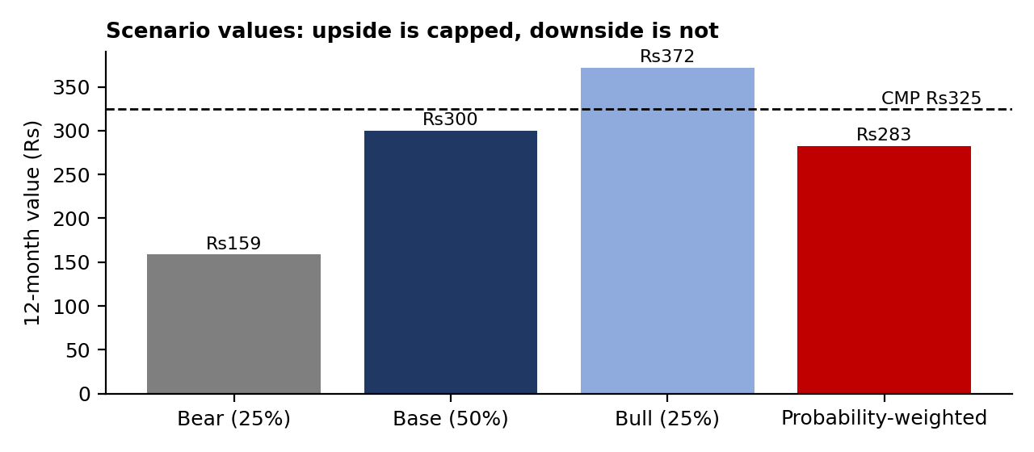
The bear case is not a crisis: credit cost of 0.85-1.00% is still within guidance. It falls hard because value is non-linear in ROE: at a 13.5% ROE, close to the 13.6% cost of equity, a bank is worth roughly its book value. That asymmetry, not a weak franchise, is the reason for caution.
5.4 Relative valuation
Bank | P/E (TTM, x) | Q1 FY27 profit growth
Karur Vysya Bank | 11.2 | 44.9%
City Union Bank | 15.2 | 25.1%
Tamilnad Mercantile Bank | 9.5 | 35.0%
South Indian Bank | 8.4 | 17.3%
Karnataka Bank | 8.5 | 43.3%
DCB Bank | 8.3 | 35.6%
CSB Bank | 8.2 | 26.5%
Federal Bank (mid-cap) | 17.0 | 36.8%
Median, 10 private banks below Rs35,000cr market cap | 9.0
KVB trades at a ~24% P/E premium to smaller private banks, which its higher ROA supports. Across our 20-bank sample, one-quarter profit growth explains almost none of the variation in P/E (R-squared ~0), which is why we anchor on P/B versus ROE rather than on P/E. Source: Screener.in industry table, 30-Sep-2026.
6. Risks to our view
Upside risks: recoveries stay near Rs600cr a year for longer; RBI hikes keep NIM above 4.2% through FY28; loan growth above 18% with stable credit cost; a re-rating towards City Union Bank-like multiples.
Downside risks: a fall in gold prices (gold loans ~30% of the book) hitting collateral cover; faster deposit repricing or CASA erosion; MSME stress as ECL provisioning starts; RBI rate cuts, which would compress yields quickly on a 55% repo-linked book.
7. What to watch on 15 October 2026 (Q2 FY27 results)
Rs crore (Screener basis) | Q2 FY26 actual | Q1 FY27 actual | Q2 FY27E (model-implied)
Net interest income | 1,261 | 1,422 | 1,449
Other income | 512 | 442 | 575
Profit before tax | 743 | 1,005 | 994
Net profit | 574 | 756 | 745
Q2 FY27E spreads the model's FY27E remainder evenly over Q2-Q4. Signposts: (1) NIM versus 4.26% in Q1; (2) recoveries inside other income; (3) slippages and the gold-loan share; (4) CASA ratio and cost of deposits. A profit clearly above Rs745cr driven by recoveries would test our fade thesis.
Appendix: financial summary (Rs crore)
Year to March | FY24 | FY25 | FY26 | FY27E | FY28E | FY29E
Advances | 74,423 | 84,491 | 98,754 | 115,542 | 134,029 | 154,133
Deposits | 89,113 | 102,078 | 115,666 | 134,173 | 154,969 | 178,215
Investments | 22,344 | 23,831 | 29,020 | 33,543 | 38,742 | 44,554
Net worth | 10,040 | 11,930 | 14,108 | 16,799 | 19,601 | 22,743
Total assets | 105,453 | 119,368 | 136,604 | 158,753 | 183,558 | 211,294
Net interest income | 3,818 | 4,260 | 4,938 | 5,769 | 6,563 | 7,497
Other income | 1,649 | 1,830 | 2,084 | 2,166 | 2,258 | 2,418
Operating expenses | 2,638 | 2,877 | 2,947 | 3,360 | 3,796 | 4,252
Provisions | 729 | 622 | 755 | 589 | 873 | 1,009
Net profit | 1,605 | 1,942 | 2,510 | 2,990 | 3,114 | 3,491
EPS (Rs) | 16.6 | 20.1 | 26.0 | 31.0 | 32.3 | 36.2
Book value / share (Rs) | 104.0 | 123.6 | 146.2 | 174.1 | 203.1 | 235.7
Dividend / share (Rs) | 2.0 | 2.2 | 2.6 | 3.1 | 3.2 | 3.6
Credit-deposit ratio | 83.5% | 82.8% | 85.4% | 86.1% | 86.5% | 86.5%
Cost-to-income | 48.3% | 47.2% | 42.0% | 42.3% | 43.0% | 42.9%
ROA | 1.64% | 1.73% | 1.96% | 2.02% | 1.82% | 1.77%
ROE | 17.2% | 17.7% | 19.3% | 19.3% | 17.1% | 16.5%
Disclosures and sources
This report is a student research exercise prepared for learning and portfolio purposes by Gaurav Waghmode (FRM Part 1). It is not investment advice or a recommendation to buy or sell any security. The author is not registered with SEBI as a research analyst or investment adviser. Author holding in KVB: [state none / details].
Sources: Screener.in financials, quarterly results and industry table (30-Sep-2026); KVB Q4 FY26 earnings call (7-May-2026); Q1 FY27 results coverage (July 2026); KVB annual reports; Trading Economics (India 10-year G-sec, Sep-2026). Model: KVB_Initiation_Model.xlsx (base case). History from filings; FY27E-FY29E are the author's estimates.

