EQUITY VALUATION MEMO | INDIA | AUTO COMPONENTS | 29 SEPTEMBER 2026
M M Forgings (NSE: MMFL)
What does Rs612 price in? A DCF and reverse-DCF memo, read alongside my credit rating of the same company
CMP: Rs612 | Base-case DCF: Rs118 | Justified P/B: Rs167 | EV/EBITDA (TTM): 14.3x | ROIC FY26 vs WACC: 6.2% vs 13.0%
Summary
Lenders are comfortable. CARE rates MMFL A (Stable). EBITDA covers interest 3.6x, and in our base case net debt/EBITDA falls from 4.4x (FY26) to 1.9x by FY31E as the capex cycle ends.
Equity investors are paying for a different company. At Rs612 the stock trades at 14.3x trailing EV/EBITDA, 29.8x FY26 earnings and 3.0x book, while FY26 post-tax return on invested capital (ROIC) was 6.2% against a 12.95% cost of capital.
Our base case does not bridge the gap. With ~12% revenue CAGR, EBITDA margin back to 19.5% and capex easing, ROIC reaches 10.0% by FY31E, still below WACC. The DCF gives Rs118 per share and a justified P/B cross-check Rs167.
What has to be true for Rs612. An exit multiple of ~12.1x EV/EBITDA in FY31 (our assumptions imply 4.6x) and ~26% ROIC on today's capital base. Even at an 11% discount rate, the price needs roughly 18% revenue CAGR with 24% EBITDA margins for five years, against a 9% CAGR (FY22-FY26) and a 19.4% peak margin.
Returns hinge on sentiment, not cash. Buying the whole firm at today's EV and selling at 14.3x EBITDA in March 2031 returns 16.9% a year on our base cash flows; at 10x, 8.4%; at 6x, -2.5%.
Rs crore | FY24 | FY25 | FY26 | FY27E | FY29E | FY31E
Revenue | 1,563 | 1,525 | 1,590 | 1,829 | 2,335 | 2,799
EBITDA margin | 18.7% | 19.4% | 17.6% | 18.5% | 19.5% | 19.5%
Net profit | 135 | 123 | 99 | 152 | 174 | 223
EPS (Rs) | 28.0 | 25.5 | 20.5 | 31.4 | 36.1 | 46.3
Pre-tax ROCE | 14.7% | 11.9% | 9.0% | 12.7% | 12.5% | 13.2%
Post-tax ROIC | 10.1% | 8.1% | 6.2% | 7.1% | 9.0% | 10.0%
Net debt / EBITDA | 3.1x | 4.0x | 4.4x | 3.6x | 2.6x | 1.9x
EBITDA / interest | 7.0x | 4.9x | 3.6x | 3.9x | 5.3x | 6.3x
Consolidated. History from Screener.in; FY27E-FY31E are the author's base-case estimates. FY27E profit includes a Rs63cr one-off gain booked in Q1 FY27.
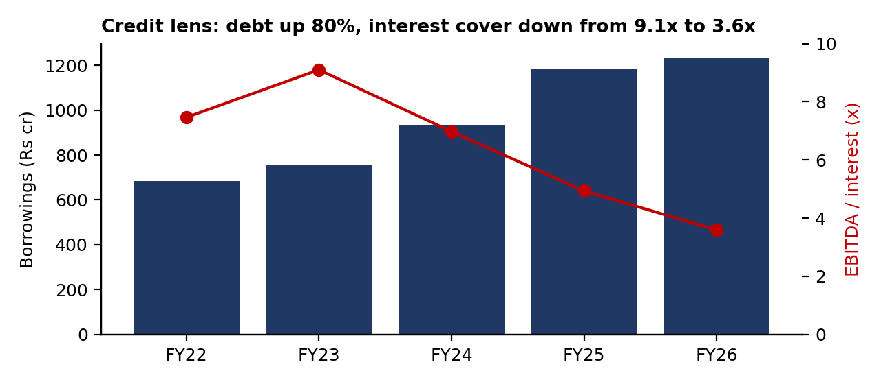
1. How we got here: a capex cycle funded with debt
Between FY22 and FY26 revenue grew 39% (Rs1,140cr to Rs1,590cr) but EBITDA only 34%, while borrowings rose 80% to Rs1,235cr. MMFL spent ~Rs1,150cr on capex over five years; Rs335cr of capital work-in-progress was still waiting to be commissioned at FY26. Working capital absorbed cash too: net working capital rose from 37% of revenue (FY23) to 48% (FY26) as debtor days went from 49 to 96. Reported free cash flow was negative in three of five years (cumulative -Rs283cr).
Two accounting points to check in the annual report before relying on any of this: the effective tax rate was 14% in FY26 and ~1% in Q1 FY27 (Screener flags a low tax rate), and some interest appears to be capitalised into work-in-progress, which flatters reported interest cost. Our forecast uses the full 25.17% tax rate and a 7% interest rate.
2. Base-case forecast
Driver | FY27E | FY28E | FY29E | FY30E | FY31E
Revenue growth | 15% | 14% | 12% | 10% | 9%
EBITDA margin | 18.5% | 19.0% | 19.5% | 19.5% | 19.5%
Capex, % of revenue | 10.0% | 9.0% | 8.5% | 8.5% | 8.5%
Net working capital, % of revenue | 46% | 44% | 42% | 41% | 40%
Free cash flow to firm (Rs cr) | 25 | 68 | 118 | 126 | 149
Post-tax ROIC | 7.1% | 8.0% | 9.0% | 9.5% | 10.0%
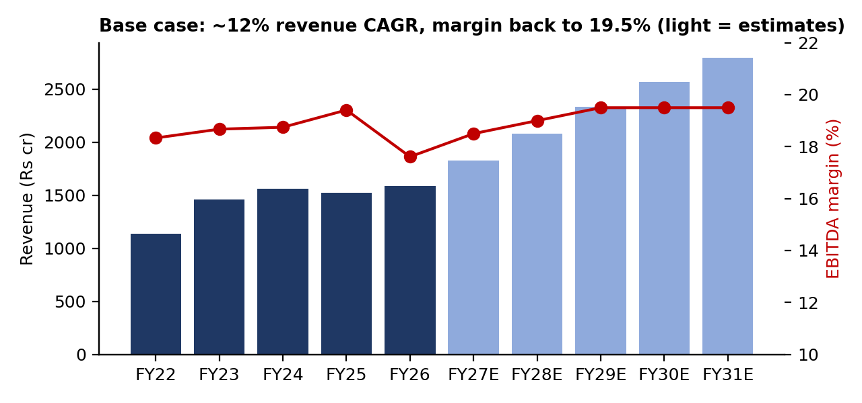
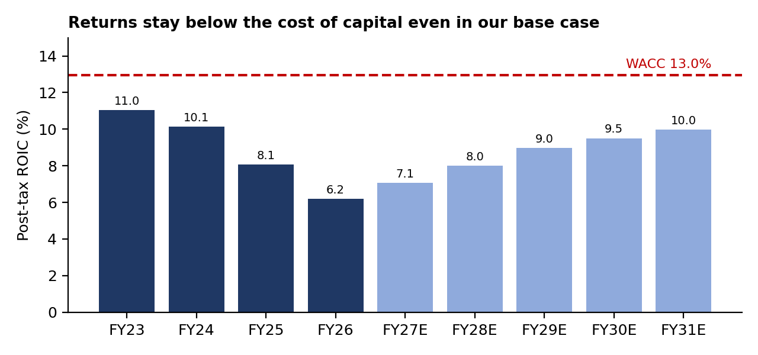
3. DCF valuation
WACC build | Value | Note
Risk-free rate | 7.10% | 10-year G-sec, Sep-2026
Unlevered beta | 1.00 | Cyclical auto supplier
Debt / equity (market values) | 0.42x | Rs1,235cr debt / Rs2,950cr market cap
Levered beta | 1.31 | Relevered for leverage (Hamada)
Cost of equity | 15.64% | Rf + levered beta x 6.5% ERP
Post-tax cost of debt | 6.55% | 8.75% pre-tax
Weights (equity / debt) | 70.5% / 29.5% | Market values
WACC | 12.95%

DCF summary (Rs crore) | Value
PV of FCFF, H2 FY27E-FY31E | 344
Terminal value at Mar-31 (g 6%, RONIC 15%) | 2,510
PV of terminal value (81% of EV) | 1,451
Enterprise value | 1,794
Less borrowings, add investments | -1,235 / +10
Equity value | 569
Value per share (Rs) | 118
Implied EV/EBITDA FY27E / exit multiple FY31E | 5.3x / 4.6x
The terminal value uses the value-driver formula, TV = NOPAT x (1 - g/RONIC) / (WACC - g): growth only adds value when new investment earns more than the cost of capital. Cross-check: sustainable ROE of 13.0% against a 15.6% cost of equity justifies 0.72x book, or Rs167 per share.
Value per share (Rs): WACC (rows) x terminal growth (columns)
WACC \ g | 4% | 5% | 6% | 7% | 8%
11% | 208 | 236 | 273 | 328 | 418
12% | 145 | 161 | 181 | 209 | 249
13% | 95 | 104 | 115 | 129 | 148
14% | 56 | 61 | 66 | 73 | 81
15% | 24 | 26 | 28 | 30 | 32
4. Reverse DCF: what Rs612 requires
Holding our cash flows and WACC, the market price implies | Value
Market enterprise value (Rs cr) | 4,175
Terminal value needed at Mar-31 (Rs cr) | 6,628
Exit EV/EBITDA on FY31E | 12.1x
FY32E NOPAT needed vs our base | 2.6x
Implied FY31E ROIC on our invested capital | 25.7%
Implied perpetual growth of FY31E cash flow | 10.5%
Value per share (Rs) at an 11% WACC: revenue CAGR FY26-FY31 (rows) x steady EBITDA margin (columns). Shaded = at or above Rs612.
CAGR \ margin | 16% | 18% | 20% | 22% | 24% | 26%
6% | 54 | 128 | 201 | 275 | 349 | 423
8% | 71 | 151 | 231 | 311 | 391 | 472
10% | 88 | 175 | 263 | 350 | 437 | 524
12% | 107 | 202 | 296 | 391 | 485 | 580
14% | 128 | 230 | 332 | 435 | 537 | 640
16% | 149 | 260 | 371 | 482 | 593 | 703
18% | 172 | 292 | 412 | 532 | 652 | 772
20% | 197 | 326 | 456 | 585 | 715 | 844
22% | 223 | 363 | 502 | 642 | 782 | 922
At our 12.95% WACC no combination in the same grid reaches Rs612 (maximum Rs567 at 22% CAGR and 26% margin). Live version: the Reverse_DCF_Grid sheet.
5. Returns if you buy today
Unlevered IRR: buy the firm at today's EV, exit in Mar-2031 at... | 6x EBITDA | 10x EBITDA | 14.3x (today)
Bear cash flows | -9.5% | 0.5% | 8.4%
Base cash flows | -2.5% | 8.4% | 16.9%
Bull cash flows | 3.2% | 14.6% | 23.6%
The exit multiple matters far more than operating performance: base-case cash flows give a ~17% return only if today's 14.3x multiple survives, and a negative return if the stock de-rates to a multiple consistent with its returns.
6. Scenarios
 | Bear | Base | Bull
Revenue growth vs base | -5 pp | base | +3 pp
EBITDA margin vs base | -2 pp | base | +2 pp
Working capital vs base | +4 pp | base | -3 pp
Revenue CAGR FY26-31 | 7.0% | 12.0% | 15.0%
FY31E EBITDA margin | 17.5% | 19.5% | 21.5%
FY31E post-tax ROIC | 7.1% | 10.0% | 12.8%
FY31E net debt / EBITDA | 2.9x | 1.9x | 1.3x
DCF value per share | Rs4 | Rs118 | Rs240
vs CMP Rs612 | -99% | -81% | -61%
The bear case is simply FY26-level returns persisting (ROIC ~7%). On a DCF, a business that earns well below its cost of capital is worth little more than its debt, so equity value approaches zero; in practice the replacement cost of the plant would act as a floor. Probability-weighted (25/50/25): Rs120.
7. Same company, two lenses
 | Credit view (lender) | Equity view (shareholder)
Question | Will debt be repaid on time? | Will capital earn more than it costs?
Key metric | EBITDA / interest 3.6x; net debt / EBITDA 4.4x, falling | ROIC 6.2% vs WACC 12.95%
Verdict | Adequate: CARE A (Stable) | Price assumes a step-change in returns
Both can be right at once. The rating depends on cash covering interest; the share price depends on returns exceeding the cost of capital.
8. What would prove this memo wrong
- A new growth leg (exports, new customers or segments) that lifts revenue growth above 18% while margins expand as the new capacity fills.
- A persistently low tax rate: our 25.17% assumption is conservative against the 14% FY26 effective rate.
- A lower cost of capital: at an 11% WACC and 8% growth the base case is worth ~Rs418 (Section 3), still below Rs612.
- Before any interview: find out what drove the rally from the 52-week low of Rs276, and confirm the cash balance, tax note and capitalised interest in the FY26 annual report.
Disclosures and sources
Student valuation exercise by Gaurav Waghmode (FRM Part 1); not investment advice and not a recommendation. The author is not registered with SEBI as a research analyst. Sources: Screener.in consolidated financials and quarterly results (29-Sep-2026); CARE Ratings releases (Apr and Jun 2026); Trading Economics (10-year G-sec). Model: MMFL_Valuation_Model.xlsx; Python replica: mmfl_dcf.py.

