INDEPENDENT CREDIT RATING NOTE
M M Forgings Ltd | NSE: MMFL · BSE: 522241 · Consolidated · Actual public data
Model rating (as built) | CARE-comparable basis | CARE rating (30-Jun-2026) | Analyst view | Date
BBB (gross debt) | A- (after bridge) | CARE A; Stable / CARE A1 | A defensible; limited headroom | 18-Sep-2026
Prepared by Gaurav Waghmode as an independent educational exercise using public data. Not an official credit rating or investment advice.

1. Summary
M M Forgings (MMF) is a 50-year-old closed-die forging company with 130,000 MTPA capacity, ₹1,590 Cr of FY26 revenue and a stable 17.6–19.4% operating margin. CARE Ratings reaffirmed it at CARE A; Stable in June 2026. I rebuilt the rating from public financials using a transparent 18-factor scorecard.
Finding: on a conservative basis (gross debt, blended FY26/FY27E metrics) the scorecard gives BBB — three notches below CARE. A step-by-step bridge shows how the gap closes: netting ₹225 Cr of liquid investments, adopting CARE's narrower debt definition, rating on FY27E alone and using CARE's expected accruals together lift the score to 7.08 (A-). CARE's A is therefore supportable, but it leans on a forward expectation that accruals rise from ₹202 Cr in FY26 to ~₹290 Cr. If the new presses do not deliver that ramp-up, the rating has little room.
Key metric | FY24 | FY25 | FY26 | FY27E | Trend
Debt / PBILDT | 3.18x | 4.00x | 4.41x | 3.80x | Weakened; above CARE's 3.0x upgrade level
Overall gearing | 1.18x | 1.33x | 1.27x | 1.12x | Within 1.5x downgrade trigger
Interest coverage | 6.98x | 4.93x | 3.59x | 3.95x | Halved since FY24
ROCE | 14.7% | 11.9% | 9.0% | 9.3% | CWIP of ₹335 Cr not yet earning
PBILDT margin | 18.7% | 19.4% | 17.6% | 18.0% | Range-bound

2. Business profile
MMF makes forgings of 0.1–120 kg in carbon, alloy, micro-alloy and stainless steel, mostly semi- or fully machined, from plants in Tamil Nadu and a machining unit near Lucknow. The strengths CARE highlights are real and visible in the numbers: long client relationships, in-house die design and machining, and a sizeable export book (about 35% of FY26 sales, with Europe at 20% and the US at 10%). The weaknesses are equally structural: around three-quarters of FY25 sales went to commercial vehicles, the most cyclical auto segment, and the top-10 customers still account for ~62% of revenue. A 16,500-tonne press due in FY27 should extend the part-weight range beyond 170 kg and open heavier, higher-value work.

3. Financial analysis
₹ crore | FY22 | FY23 | FY24 | FY25 | FY26 | FY27E
Revenue | 1,140 | 1,462 | 1,563 | 1,525 | 1,590 | 1,717
PBILDT | 209 | 273 | 293 | 296 | 280 | 309
Interest | 28 | 30 | 42 | 60 | 78 | 78
PAT | 91 | 128 | 135 | 123 | 99 | 97
Cash accruals | 159 | 207 | 218 | 216 | 202 | 215
Gross debt | 685 | 756 | 931 | 1,185 | 1,235 | 1,175
Net worth | 559 | 673 | 789 | 893 | 975 | 1,052
CFO | 150 | 160 | 149 | 182 | 228 | –
Free cash flow | 24 | -27 | -83 | -176 | 46 | –
Cash conversion cycle (days) | 118 | 123 | 158 | 178 | 164 | –

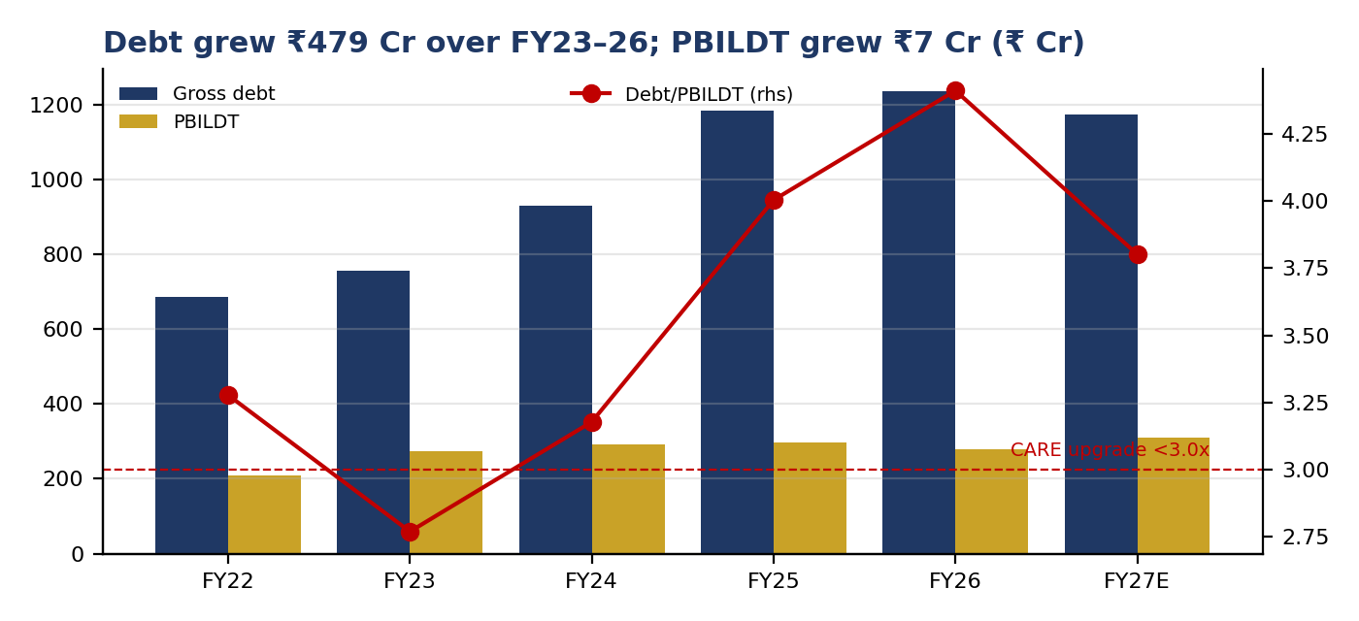
Figure 1 — Gross debt, PBILDT and debt/PBILDT (FY27E = analyst base case)
The capex cycle is the credit story. CARE reports ~₹850 Cr of capex over three years, ~₹610 Cr of it debt-funded. Gross debt rose by ₹479 Cr between FY23 and FY26 while PBILDT rose by only ₹7 Cr, so leverage and coverage weakened even though the underlying business held steady. Cumulative free cash flow over FY23–FY26 was negative ₹240 Cr. Capital-work-in-progress of ₹335 Cr (about 23% of fixed assets) explains much of the fall in ROCE: those assets carry debt and interest but do not yet produce revenue.
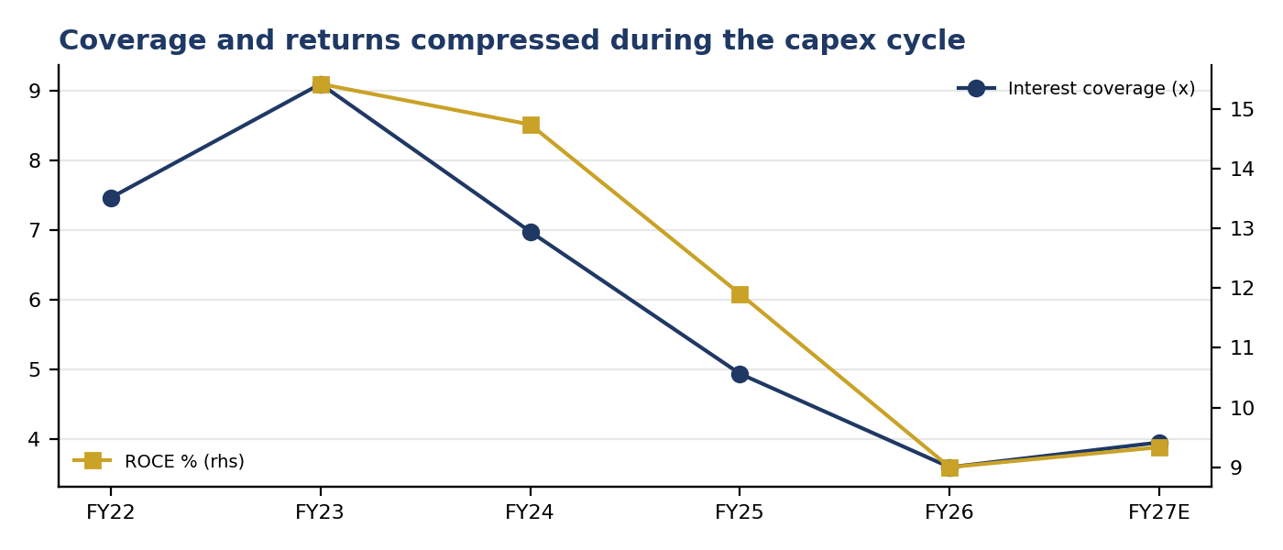
Figure 2 — Interest coverage and ROCE
Working capital lengthened. The cash conversion cycle widened from 118 days in FY22 to 164 in FY26, driven by debtor days rising from 50 to 96 — consistent with a larger export mix on longer terms, but worth monitoring. Operating cash flow improved to 81% of PBILDT in FY26, the best conversion in five years.
Recent trend. Margins troughed at ~17% in Q2–Q3 FY26 as US tariffs cut higher-margin machined volumes, then recovered to ~19% in Q4 FY26 with Q1 FY27 sales up 16% year on year. Q1 FY27 PAT of ₹90 Cr is flattered by ₹63 Cr of other income against a run-rate of ₹4–8 Cr and a ~1% tax charge; I treat it as non-recurring and exclude it from the base case.
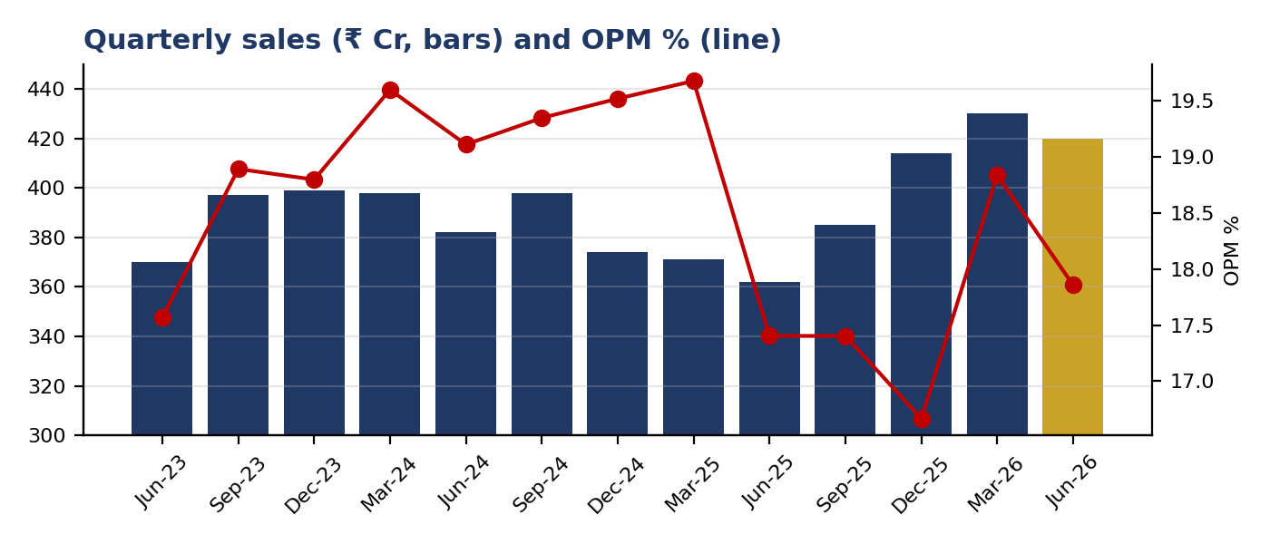
Figure 3 — Quarterly sales and operating margin, Jun-23 to Jun-26

4. Debt-service capacity
CARE discloses term-debt repayments of ₹150–170 Cr a year for the next three years. My FY27E base case — 8% revenue growth and an 18% margin — gives cash accruals of ₹215 Cr, covering repayment 1.34x. Using all interest (including working-capital interest), the DSCR is 1.23x.
Scenario | PBILDT | Accruals | Repayment | DSCR | Accruals + liquidity / repayment
FY26 actual, mid repayment | 280 | 193 | 160 | 1.14x | 2.61x
FY27E base case | 309 | 215 | 160 | 1.23x | 2.75x
FY27E: PBILDT −15% (CV downturn) | 263 | 180 | 160 | 1.08x | 2.53x
FY27E: PBILDT −25%, repayment at high end | 232 | 157 | 170 | 0.95x | 2.24x
FY27E: PBILDT −25%, rates +200 bps, high repayment | 232 | 139 | 170 | 0.89x | 2.14x

Accruals alone cover repayment only until PBILDT falls about 24% below the base case. Beyond that, the ₹225 Cr of liquid investments carries the debt service — covering repayment more than 2x even in the severest scenario. This liquidity is the main reason a moderately leveraged, cyclical company can sit in the A category, and why CARE lists a significant fall in liquid investments as a downgrade trigger.

5. Rating scorecard and notch bridge
Factor | Weight | Value (blend) | Score
Debt / PBILDT | 10% | 4.17x | 5
Overall gearing | 8% | 1.21x | 6
Interest coverage (PBILDT / interest) | 7% | 3.73x | 8
Cash accruals / term-debt repayment | 8% | 1.29x | 5
ROCE | 6% | 9.1% | 4
PBILDT margin | 4% | 17.8% | 8
Operating scale (revenue ₹ Cr) | 4% | 1,641 | 7
Cash conversion (CFO / PBILDT) | 3% | 81.4% | 8
Track record & market position | 5% | qualitative | 9
Product & geographic diversity | 5% | qualitative | 8
Customer concentration | 5% | qualitative | 5
End-market cyclicality | 5% | qualitative | 4
Raw-material & tariff exposure | 5% | qualitative | 6
Promoter experience & commitment | 5% | qualitative | 8
Governance & disclosure | 5% | qualitative | 7
Liquid investments & cash | 5% | qualitative | 8
Working-capital headroom | 5% | qualitative | 7
Access to capital | 5% | qualitative | 8
Weighted score / grade | 100% | fin. 6.04 | 6.52 → BBB

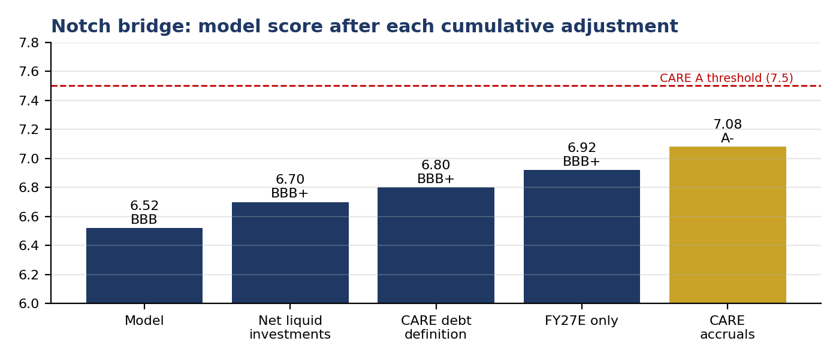
Figure 4 — Score after each cumulative adjustment (python/rating_bridge.py)
The bridge ends at A-, one notch below CARE. I attribute the residual notch to what an outside analyst cannot see: management's detailed projections, lender discussions and the weight CARE gives to a five-decade track record. I would not override the scorecard to force a match — the gap is itself the finding.

6. Reconciliation with CARE's figures
- Revenue, PBILDT, PAT, interest coverage and ROCE reconcile to CARE within 3%.
- Gearing and debt/PBILDT do not reconcile for FY26: CARE's 1.10x gearing and 3.84x debt/PBILDT imply ~₹1,075 Cr of debt, versus ₹1,235 Cr in the reported balance sheet. FY24 and FY25 gearing do reconcile, so the gap is specific to FY26 — most likely a classification difference (such as lease liabilities or acceptances). I keep the higher figure as the conservative base and test CARE's figure in the bridge.
- CARE's text quotes FY26 interest coverage of 3.98x while its own table shows 3.58x; the table matches PBILDT ÷ interest.

7. Key monitorables
CARE trigger | Threshold | FY26 | FY27E | Status
Upgrade: gearing below | 0.80x | 1.27x | 1.12x | Not met
Upgrade: debt / PBILDT below | 3.00x | 4.41x | 3.80x | Not met
Upgrade: ROCE above | 15% | 9.0% | 9.3% | Not met
Downgrade: gross gearing above | 1.50x | 1.27x | 1.12x | Not met

- Upside: reaching debt/PBILDT below 3.0x at FY27E PBILDT needs about ₹248 Cr of debt reduction, or PBILDT near ₹390 Cr at current debt — realistic only after FY28 if the new presses ramp up fully.
- Downside: gearing is well inside the 1.5x trigger, so the nearer risks are a CV downturn, a renewed US tariff shock, or liquid investments being used for capex.
- Watch: quarterly PBILDT versus the ~₹77 Cr/quarter needed for the base case, debtor days, CWIP capitalisation and the nature of the Q1 FY27 other income.

Sources and limitations
Financials: Screener.in consolidated data (C-MOTS), accessed 18-Sep-2026. Rating, liquidity, repayment and business details: CARE Ratings press release on M M Forgings Ltd, 30 June 2026. Quarterly results: company filings as summarised by Screener and Business Standard (May 2026). Screener's balance sheet is aggregated, so inventory and receivable levels are not separately available; working-capital analysis uses reported day-counts. FY27E figures are my estimates. Scorecard weights, grids and PDs are illustrative, not calibrated to default data.

