**USECASES**

**Administrator**

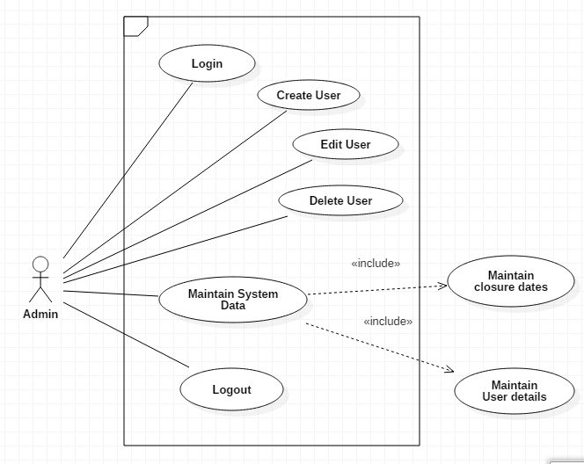

**Primary scenario for Administrator use case**

|  |  |  |  |
| --- | --- | --- | --- |
| **Use case** | **Pre-condition** | **Flow of events** | **Post condition** |
| Login | Admin has to login | 1. Admin enters username 2. Admin enters password | Admin logs in |
| Create User | Admin wants to create User | Admin creates User | User created successfully |
| Edit User | Admin would like to edit User | Admin edits User | User edited |
| Delete Student | Admin would like to delete student | Admin deletes User | User successfully deleted |
| Maintain System data | Admin wants to maintain system data | 1. Admin updates closure dates 2. Admin updates Student details 3. Admin updates staff details | System data maintained |
| Logout | Admin wants to logout | Admin clicks on logout button | Admin successfully logged out |

**Student**

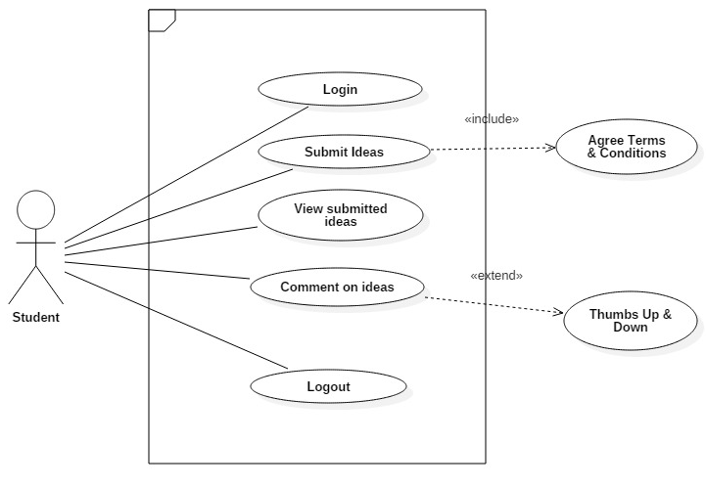

**Primary scenario for Student use case**

|  |  |  |  |
| --- | --- | --- | --- |
| **Use case** | **Pre-condition** | **Flow of events** | **Post condition** |
| Login | Student wants to login | 1. Student enters username 2. Student enters password | 1. Student logs in successfully 2. Student receives notification that account is created |
| Submit ideas | Student wants to submit ideas | 1. Agree Terms & conditions 2. Input ideas 3. Click on Submit ideas | 1. Idea submitted successfully 2. Student receives email notification when his/her idea has been commented on |
| View submit ideas | Student would like to view submitted ideas | Click on View submitted ideas | Student views ideas |
| Comment on submitted ideas | Student wants to comment on ideas | 1. Student selects submitted ideas 2. Comments on ideas | Ideas successfully commented on |
| Logout | Student would like to logout | Student clicks on logout button | Student logged out successfully |

**Staff**

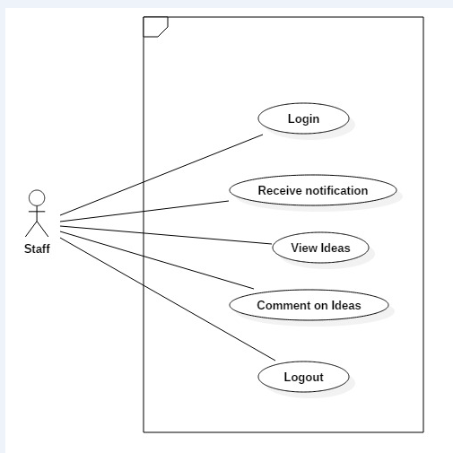

**Primary scenario for Staff use case**

|  |  |  |  |
| --- | --- | --- | --- |
| **Use case** | **Pre-condition** | **Flow of events** | **Post condition** |
| Login | Staff wants to login | 1. Staff enters username 2. Staff enters password | 1. Staff logs in 2. Receives notification an account is created 3. Receives notification account has been approved |
| View ideas | Staff wants to view ideas | Staff clicks on view ideas | Staff views ideas |
| Comment on ideas | Staff would like to comment on ideas | Staff clicks on comment on ideas | Ideas commented on |
| Logout | Staff wants to logout | Staff clicks on logout button | Staff successfully logged out |

**Quality Assurance Coordinator**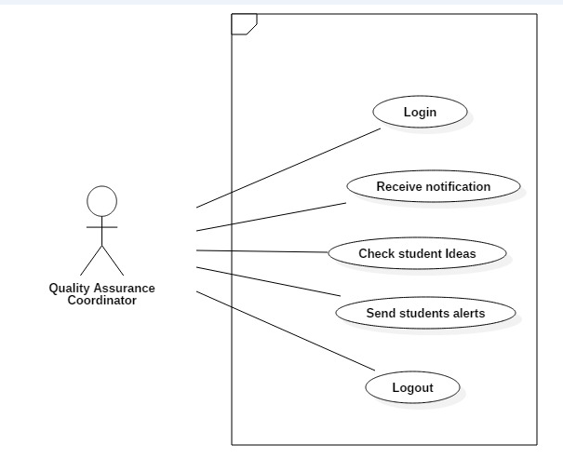

**Primary scenario for Quality Assurance Coordinator (QAC) use case**

|  |  |  |  |
| --- | --- | --- | --- |
| **Use case** | **Pre-condition** | **Flow of events** | **Post condition** |
| Login | QAC wants to login | 1. QAC enters username 2. QAC enters password | 1. QAC logs in successfully 2. QAC receives notification that his account is created |
| Receive email that an idea has been created | QAC would like to know if he has received any ideas | 1. QAC is able to log in 2. QAC creates or has an email account | QAC receives a notification that an idea has been submitted |
| Check which students send more ideas | QAC wants to know which student submitted more ideas | QAC reads a statistical report showing number of ideas against each student | QAC knows which students sent more ideas |
| Send reminder messages to students | QAC wants to encourage students to send more ideas | QAC flashes eye catching messages to students | QAC reminds students to send more ideas |
| Logout | QAC would like to logout | QAC clicks on logout button | QAC logged out successfully |

**Quality Assurance Manager**

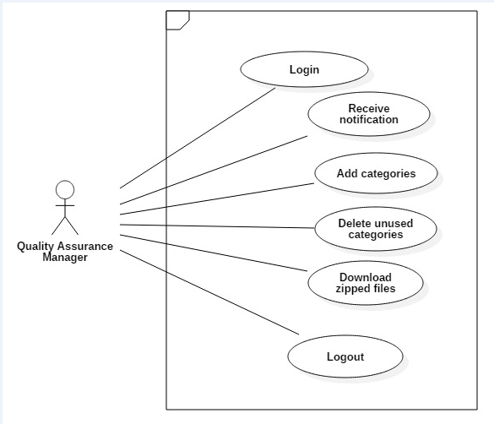

**Primary scenario for Quality Assurance Manager (QAM) use case**

|  |  |  |  |
| --- | --- | --- | --- |
| **Use case** | **Pre-condition** | **Flow of events** | **Post condition** |
| Login | QAM wants to login | 1. QAM enters username 2. QAM enters password | 1. Student logs in successfully 2. Student receives notification that account is created |
| Add additional categories | QAM would like to add more categories | Click on Add categories | Additional categories added successfully |
| Delete unused categories | QAM would like to delete unused categories | Click on Delete categories | Unused categories deleted successfully |
| Download zipped files | QAM would like to download zipped files | Click on Download zipped files | Zipped files downloaded successfully |
| Logout | QAM would like to logout | QAM clicks on logout button | QAM logged out successfully |