**EX:No.5 ESTIMATING AND ELIMINATING TREND 25/3/25 221501016 USING AGGREGATING AND SMOOTHING**

**AIM :** To implement aggregation and smoothing to estimate and eliminate trend in time series analysis.

**PROCEDURE:**

1. Read the dataset and convert the date column to datetime format.

2. Set the date column as the index for time series analysis.

3. Aggregate the data by calculating the monthly mean.

4. Apply a 12-month moving average for smoothing.

5. Plot the original data, aggregated data, and smoothed data.

6. Display the graph to visualize trend estimation and elimination.

**IMPLEMENTATION :**

import pandas as pd

import matplotlib.pyplot as plt

**Load dataset**

df = pd.read_csv("/mnt/data/Electric_Production.csv")

df["DATE"] = pd.to_datetime(df["DATE"])

df.set_index("DATE", inplace=True)

**Aggregation (Monthly Mean)**

df_monthly = df.resample("M").mean()

**Smoothing (Moving Average)**

df["SMA_12"] = df["IPG2211A2N"].rolling(window=12).mean()

**Visualization**

plt.figure(figsize=(10,5))

plt.plot(df["IPG2211A2N"], label="Original Data", color="blue", alpha=0.5)

plt.plot(df_monthly, label="Monthly Aggregated", color="red")

plt.plot(df["SMA_12"], label="12-Month Moving Average", color="green")

plt.legend()

plt.title("Trend Estimation & Elimination in Time Series")

plt.xlabel("Year")

plt.ylabel("Production Value")

plt.show()

**OUTPUT:**

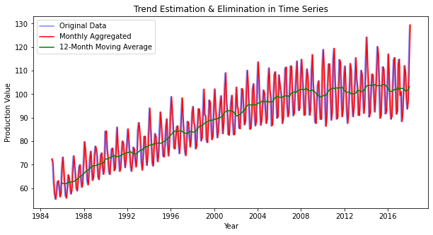

**RESULT :** Thus trends has been estimated and eliminated using aggregating and smoothing techniques.