FinAssist – Stage 2 Implementation Report
EECS3311 Fall 2026 – Course Project, Stage 2
Repository layout: src/finassist/ (source), build.sh, README.md, docs/diagrams/ (UML diagrams used here). Run: bash build.sh, then java -cp out finassist.Main [gui|cli] [--demo] [--data file].

1. Project overview and implementation status

1.1 Application and users
FinAssist is a personal finance assistant for one individual user (a student or young professional) who wants to record income and expenses, see a monthly picture of their money, follow savings goals and subscriptions, and get plain-language help. It is a Java 11 desktop/command-line program with no external libraries. It has two interchangeable user interfaces (Swing GUIView and text CLIView) that share the same controller, facade and services.

1.2 AI / LLM integration
- OpenAILLMService calls the OpenAI chat-completions API through java.net.http (model from OPENAI_MODEL, default gpt-4o-mini; key from OPENAI_API_KEY). Used to word advice, explain unusual expenses, interpret the monthly summary and answer coach questions.
- VoiceInputService records 8 s from the microphone and sends it to the OpenAI whisper-1 transcription endpoint. If no key or microphone exists, the view asks the user to type the sentence instead (typed voice fallback).
- MockLLMService offline implementation of LLMService used when no key is set and in the self-tests; setAvailable(false) simulates an outage.
- Design rule all numbers (totals, profit, savings rate, goal progress, anomaly test, savings recommendation) are computed deterministically in Java. The LLM only produces wording or explanations, so an LLM failure never changes a figure; it only produces a visible notice or error message.

1.3 What works now
- Log income and expenses (GUI form or CLI), by voice (with confirmation) or typed.
- Monthly dashboard: income, expenses, profit, savings rate, category totals, unusual expenses, subscription cost, goals; text bars in CLI and bar chart + progress bar in GUI.
- Monthly summary with AI interpretation (or an explicit notice when the LLM is unavailable).
- Financial goals with progress and required monthly savings; savings advice that automatically switches between goal-based and expense-based strategies.
- Subscriptions: add, remove, list, monthly and annual cost.
- Automatic unusual-expense detection after each saved expense, with an AI explanation.
- AI financial coach for free-form questions, using the user's data as context.
- Saving data between runs (Java serialization, default finassist-data.ser); --demo seeds sample data. 45 automated self-checks (finassist.test.SelfTest) pass via build.sh.

1.4 Limitations and incomplete functionality (honest list)
- Real OpenAI chat and whisper calls and the real microphone were not exercised during development (no API key or microphone in the build environment). They are implemented against the documented API and covered only by the offline mock and typed fallback. The GUI was smoke-tested under a virtual display only.
- Not built from Stage 1: AI explanation of a goal (F06 optional part); explanation of recurring spending and duplicate-subscription warning (F09 / UC09 alternative); coach agent choosing its own tools (F10 uses a fixed context from prepareContext()); LLM-based field extraction from speech (simple English rules are used instead); automatic redraw of an already displayed dashboard (the Observer only invalidates the cache; the user requests the dashboard again); add-transaction shortcuts on an empty dashboard (a message is shown).
- Single user only. The data file uses Java serialization and is not human-readable or versioned.
- Observers run synchronously, so an unusual-expense alert can be printed before the "Expense saved" line.

2. Feature to implementation mapping
Types: Deterministic = computed only by Java code; AI-based = result produced by the LLM; Hybrid = Java computes the facts, the LLM words or explains them. Every request enters through a View, goes to FinancialController, then FinAssistFacade, then services; results return the same way and the controller calls the View.
Video link / timestamp columns are placeholders: the demonstration video must be recorded and linked by the team.

F01 – Voice transaction entry
Feature ID and name | F01 – Voice transaction entry
Stage 1 feature / reference | F01
Status / change | Implemented (modified: typed fallback, confirmation step, rule-based parsing)
Implemented classes / files and responsibilities | VoiceInputService – captures and converts speech; FinAssistFacade – holds the pending entry; FinancialController – asks the user to confirm; GUIView/CLIView – show prompt and take the answer; FinancialService – saves; Income/Expense – result entities.
Key methods | VoiceInputService.captureSpeech(), validateTranscript(), convertToEntry(), setFallbackInput(); FinAssistFacade.logVoiceEntry(), getPendingVoiceEntry(), confirmVoiceEntry(boolean); FinancialController.logVoiceEntry().
Design patterns | MVC, Facade, Observer (after save)
Video link / timestamp | [TO FILL: video link + timestamp]

How the classes collaborate: The user chooses voice entry in the view; the view calls controller.logVoiceEntry(); the facade asks VoiceInputService.captureSpeech() (whisper-1, or typed text if unavailable), validates it (at least two words and a positive amount), converts it to an Income or Expense with regex and keyword rules, and keeps it pending. The controller shows "I understood … Save it? (yes/no)" and reads the answer with view.getUserInput(); confirmVoiceEntry(true) calls FinancialService.addIncome/addExpense, which saves and notifies observers. Invalid text raises ValidationException which the controller shows with displayError.
Behaviour type: Hybrid (AI transcription, deterministic parsing)

F02 – Manual income entry
Feature ID and name | F02 – Manual income entry
Stage 1 feature / reference | F02
Status / change | Implemented
Implemented classes / files and responsibilities | View form/menu; FinancialController; FinAssistFacade; FinancialService; FinancialRepository; Income.
Key methods | FinancialController.logIncome(Income); FinAssistFacade.logIncome(); FinancialService.addIncome(); FinancialRepository.saveEntry(); notifyObservers().
Design patterns | MVC, Facade, Observer
Video link / timestamp | [TO FILL: video link + timestamp]

How the classes collaborate: The view builds an Income (amount, date, source, type) and calls controller.logIncome. The facade forwards to FinancialService.addIncome, which validates (positive amount, date, source), stores it through FinancialRepository.saveEntry and calls notifyObservers(); DashboardService clears its cache. The controller displays "Income saved".
Behaviour type: Deterministic

F03 – Unusual expense detection and explanation
Feature ID and name | F03 – Unusual expense detection and explanation
Stage 1 feature / reference | F03
Status / change | Implemented
Implemented classes / files and responsibilities | FinancialService (subject); ExpenseDetectionAgent (observer and agent); ExpenseDetectionAgentCreator; LLMService; FinancialView.
Key methods | ExpenseDetectionAgent.update(), detectUnusualExpense(Expense), analyzeExpense(Expense), hasEnoughHistory(), setView().
Design patterns | Observer, Factory Method, MVC
Video link / timestamp | [TO FILL: video link + timestamp]

How the classes collaborate: After an expense is saved FinancialService.notifyObservers() calls ExpenseDetectionAgent.update(). The agent takes the newest expense (only once, via lastAnalyzedId), compares it with same-category history (≥3 items, otherwise all expenses, otherwise "not enough history"); it is unusual if amount > mean + 2σ (1.5×mean when σ = 0). If unusual, Expense.setUnusual(true) and analyzeExpense() asks the LLM for an explanation, which is displayed directly on the view. LLM failure shows an error but the expense stays saved.
Behaviour type: Hybrid (deterministic test, AI explanation)

F04 – Manual expense entry
Feature ID and name | F04 – Manual expense entry
Stage 1 feature / reference | F04
Status / change | Implemented
Implemented classes / files and responsibilities | View; FinancialController; FinAssistFacade; FinancialService; FinancialRepository; Expense.
Key methods | FinancialController.logExpense(Expense); FinAssistFacade.logExpense(); FinancialService.addExpense().
Design patterns | MVC, Facade, Observer
Video link / timestamp | [TO FILL: video link + timestamp]

How the classes collaborate: Same path as F02 with an Expense (category, merchant). After saving, observers are notified, which also triggers F03.
Behaviour type: Deterministic

F05 – AI monthly summary / interpretation
Feature ID and name | F05 – AI monthly summary / interpretation
Stage 1 feature / reference | F05
Status / change | Implemented
Implemented classes / files and responsibilities | FinancialController; FinAssistFacade; DashboardService; MonthlySummary; AgentOrchestrator; FinancialCoachAgent; LLMService.
Key methods | FinancialController.requestMonthlySummary(month, year); FinAssistFacade.getMonthlySummary(); DashboardService.generateMonthlyDashboard(); AgentOrchestrator.processRequest(), selectAgent(); FinancialCoachAgent.process(); MonthlySummary.setInterpretation(), setAiNotice().
Design patterns | MVC, Facade, Factory Method (agents created via creators)
Video link / timestamp | [TO FILL: video link + timestamp]

How the classes collaborate: The facade first obtains the deterministic MonthlySummary from DashboardService, returns it directly if empty, otherwise builds a prompt (including which data is missing: goals, subscriptions, income) and sends it through AgentOrchestrator to FinancialCoachAgent and the LLM. The text is stored with setInterpretation(). If LLMUnavailableException occurs, setAiNotice() records that the interpretation is unavailable and the figures stay valid. See SD-03.
Behaviour type: Hybrid

F06 – Financial goal tracking
Feature ID and name | F06 – Financial goal tracking
Stage 1 feature / reference | F06
Status / change | Implemented (AI explanation of goal not built)
Implemented classes / files and responsibilities | FinancialGoal; FinAssistFacade; FinancialRepository; View.
Key methods | FinancialController.addGoal(), requestGoalSummary(); FinAssistFacade.addGoal(), getGoalSummary(); FinancialGoal.getProgress(), getRemainingAmount(), getRequiredMonthlySavings().
Design patterns | MVC, Facade
Video link / timestamp | [TO FILL: video link + timestamp]

How the classes collaborate: addGoal validates name, positive target, non-negative current savings and a future deadline, then calls FinancialRepository.saveGoal. getGoalSummary formats each goal with progress % and required monthly savings = remaining ÷ max(1, ceil(days/30)). All arithmetic is in FinancialGoal.
Behaviour type: Deterministic

F07 – Monthly dashboard
Feature ID and name | F07 – Monthly dashboard
Stage 1 feature / reference | F07
Status / change | Implemented (no automatic redraw)
Implemented classes / files and responsibilities | FinancialController; FinAssistFacade; DashboardService; MonthlySummary; DashboardFormatter; CLIView/GUIView (ChartPanel, JProgressBar).
Key methods | FinancialController.requestDashboard(); FinAssistFacade.getDashboard(); DashboardService.generateMonthlyDashboard(), calculateIncome(), calculateExpenses(), calculateProfit(), calculateSavingsRate(), update(); MonthlySummary.calculateProfit(), calculateSavingsRate(); FinancialView.showDashboard().
Design patterns | MVC, Facade, Observer
Video link / timestamp | [TO FILL: video link + timestamp]

How the classes collaborate: The month is validated by the facade, DashboardService reads the month's entries from the repository (or its cache), totals them and fills a MonthlySummary, and the controller calls view.showDashboard(summary). DashboardService is an Observer: update() clears the cache so the next request is fresh.
Behaviour type: Deterministic

F08 – Savings advice
Feature ID and name | F08 – Savings advice
Stage 1 feature / reference | F08
Status / change | Implemented
Implemented classes / files and responsibilities | SavingsAnalyzer (Strategy context); SavingsStrategy; GoalBasedSavingsStrategy; ExpenseBasedSavingsStrategy; LLMService.
Key methods | FinancialController.requestSavingsAdvice(); FinAssistFacade.getSavingsAdvice(); SavingsAnalyzer.selectStrategy(), setStrategy(), analyze(), update(); SavingsStrategy.calculateRecommendation().
Design patterns | Strategy, Observer, Facade
Video link / timestamp | [TO FILL: video link + timestamp]

How the classes collaborate: analyze() calls selectStrategy(): GoalBasedSavingsStrategy if goals exist, otherwise ExpenseBasedSavingsStrategy (top 3 categories and the saving from a 10% cut). The chosen strategy computes the recommendation text; the LLM only rephrases it, and if it is unavailable the computed text is returned. As an Observer, SavingsAnalyzer.update() re-selects the strategy when data changes. See SD-03b.
Behaviour type: Hybrid

F09 – Subscription tracking
Feature ID and name | F09 – Subscription tracking
Stage 1 feature / reference | F09
Status / change | Implemented (recurring-spending explanation and duplicate warning not built)
Implemented classes / files and responsibilities | Subscription; SubscriptionService; FinancialRepository; FinAssistFacade; View.
Key methods | FinancialController.manageSubscription(), removeSubscription(), requestSubscriptions(); FinAssistFacade.addSubscription(), removeSubscription(), getSubscriptionSummary(); SubscriptionService.addSubscription(), removeSubscription(), getSubscriptions(), calculateMonthlyCost(); Subscription.getMonthlyCost(), getAnnualCost().
Design patterns | MVC, Facade
Video link / timestamp | [TO FILL: video link + timestamp]

How the classes collaborate: SubscriptionService validates and stores subscriptions; Subscription converts weekly/monthly/yearly prices to monthly and annual cost. The facade builds a summary with the total and the controller displays it.
Behaviour type: Deterministic

F10 – AI financial coach
Feature ID and name | F10 – AI financial coach
Stage 1 feature / reference | F10
Status / change | Implemented (fixed context, no agent-chosen tools)
Implemented classes / files and responsibilities | FinancialCoachAgent; FinancialCoachAgentCreator; AgentOrchestrator; LLMService; FinancialRepository.
Key methods | FinancialController.askFinancialCoach(String); FinAssistFacade.askCoach(); AgentOrchestrator.processRequest(), selectAgent(), addAgent(); FinancialCoachAgent.process(), generateAdvice(), prepareContext().
Design patterns | Factory Method, Facade, MVC
Video link / timestamp | [TO FILL: video link + timestamp]

How the classes collaborate: The orchestrator routes requests starting with "analyze unusual expense" to ExpenseDetectionAgent and every other request to FinancialCoachAgent, creating the agent through its creator if absent. The coach asks a clarifying question when the question has fewer than two words, asks the user to add data when there is none, otherwise builds a context (totals, categories, goals, last 6 conversation lines) with prepareContext() and sends it to the LLM.
Behaviour type: AI-based

N1 – Saved data between sessions
Feature ID and name | N1 – Saved data between sessions
Stage 1 feature / reference | New
Status / change | New
Implemented classes / files and responsibilities | FinancialRepository (optional file), Main (--data).
Key methods | FinancialRepository.persist(), saveEntry(), saveGoal(), saveSubscription().
Design patterns | N/A (supports MVC Model)
Video link / timestamp | [TO FILL: video link + timestamp]

How the classes collaborate: Each save method writes the User object to the file with Java serialization; Main loads it at start-up.
Behaviour type: Deterministic

N2 – Offline AI mode and typed voice fallback
Feature ID and name | N2 – Offline AI mode and typed voice fallback
Stage 1 feature / reference | New
Status / change | New
Implemented classes / files and responsibilities | MockLLMService; LLMService; VoiceInputService; Main.
Key methods | MockLLMService.generate(), setAvailable(); VoiceInputService.setFallbackInput().
Design patterns | N/A (LLMService interface allows substitution)
Video link / timestamp | [TO FILL: video link + timestamp]

How the classes collaborate: Main chooses OpenAILLMService when OPENAI_API_KEY exists, otherwise MockLLMService, so the whole program and the tests run without network.
Behaviour type: Deterministic

N3 – Complete command-line interface
Feature ID and name | N3 – Complete command-line interface
Stage 1 feature / reference | New
Status / change | New (Stage 1 only described one interface)
Implemented classes / files and responsibilities | CLIView; FinancialView.
Key methods | CLIView.run(), display(), displayError(), showDashboard(), getUserInput().
Design patterns | MVC (second View)
Video link / timestamp | [TO FILL: video link + timestamp]

How the classes collaborate: A 12-option text menu calls the same controller methods as the GUI.
Behaviour type: Deterministic

N4 – Background GUI actions
Feature ID and name | N4 – Background GUI actions
Stage 1 feature / reference | New
Status / change | New
Implemented classes / files and responsibilities | GUIView.
Key methods | GUIView worker (single-thread executor), invokeLater, submitEntry().
Design patterns | MVC
Video link / timestamp | [TO FILL: video link + timestamp]

How the classes collaborate: GUIView runs controller calls on a worker thread and updates Swing components with invokeLater so the window never freezes during LLM or microphone calls.
Behaviour type: Deterministic

3. Implemented design patterns
All five patterns required by the course are implemented and match the Stage 1 design. The class diagram below was generated from the compiled code (javap), so every class, attribute and method shown exists in the source. Colours: blue MVC, green Facade, pink Strategy, light green Observer, purple Factory Method, beige entities, grey infrastructure.
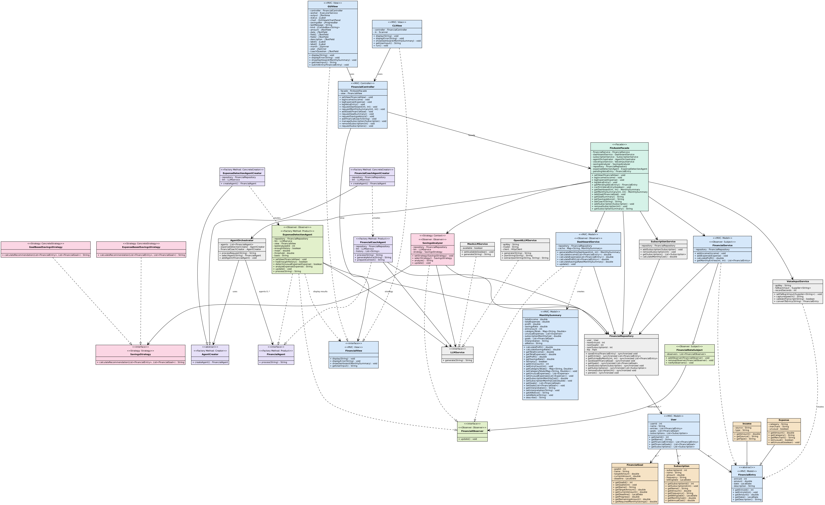
Figure 1 – Updated UML class diagram of the implemented system (also available as docs/diagrams/class_diagram_full.svg).

3.1 MVC (Model–View–Controller)
Design problem | Separate the user interface from business logic so that two different interfaces (GUI and CLI) can use the same logic.
Participating classes and roles | View: FinancialView (interface), GUIView, CLIView, DashboardFormatter. Controller: FinancialController. Model: FinancialService, DashboardService, SubscriptionService, SavingsAnalyzer, FinancialRepository, User, FinancialEntry, Income, Expense, FinancialGoal, Subscription, MonthlySummary.
Source files and methods | view/FinancialView.java, GUIView.java, CLIView.java; controller/FinancialController.java (logIncome, logExpense, logVoiceEntry, requestDashboard, requestMonthlySummary, addGoal, requestGoalSummary, requestSavingsAdvice, askFinancialCoach, manageSubscription, removeSubscription, requestSubscriptions, setView); view methods display, displayError, showDashboard, getUserInput.
How the implementation follows the pattern / why useful | Views never touch services: they only call the controller. The controller never formats output: it calls FinancialView. Its private run() converts ValidationException, LLMUnavailableException and RuntimeException into displayError. Useful because GUIView and CLIView are interchangeable (Main selects gui|cli).
Match with Stage 1 | Matches Stage 1. Added: FinancialView.showDashboard() and getUserInput() (needed for the confirmation dialog and chart), and the controller → view association.

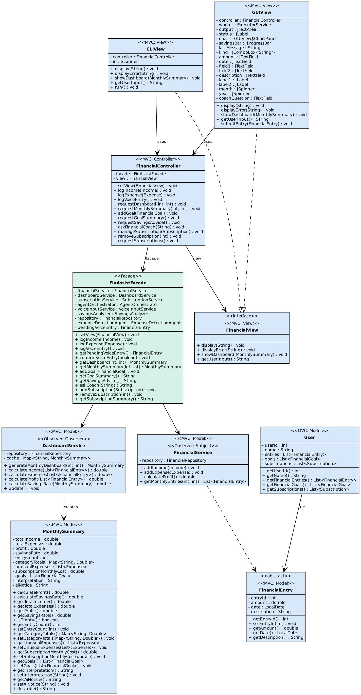
Figure – MVC (Model–View–Controller) classes (extract of the implemented class diagram).

3.2 Facade
Design problem | Give the controller one simple entry point instead of knowledge of ten collaborating services and agents.
Participating classes and roles | Facade: FinAssistFacade. Subsystem: FinancialService, DashboardService, SubscriptionService, SavingsAnalyzer, VoiceInputService, AgentOrchestrator, FinancialRepository.
Source files and methods | facade/FinAssistFacade.java: constructor wiring; logIncome, logExpense, logVoiceEntry, getPendingVoiceEntry, confirmVoiceEntry, getDashboard, getMonthlySummary, addGoal, getGoalSummary, getSavingsAdvice, askCoach, addSubscription, removeSubscription, getSubscriptionSummary, setView.
How the implementation follows the pattern / why useful | The controller holds only a FinAssistFacade. The facade creates the services, creators and orchestrator, registers the observers on FinancialService and applies shared validation (month range, goal fields). Useful: changing a service does not affect the controller or the views.
Match with Stage 1 | Matches Stage 1. Added facade methods addGoal, getMonthlySummary, getSubscriptionSummary, getPendingVoiceEntry, confirmVoiceEntry, setView.

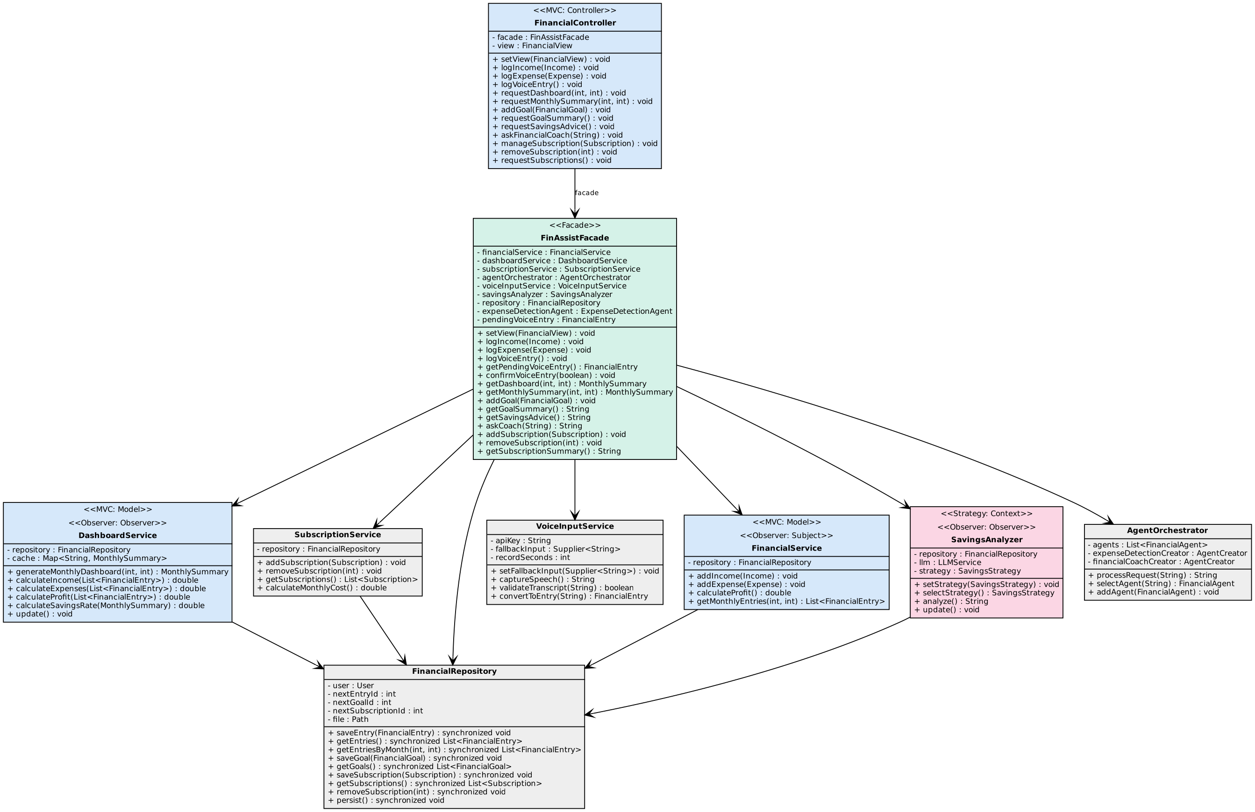
Figure – Facade classes (extract of the implemented class diagram).

3.3 Strategy
Design problem | Choose the savings calculation at run time (goal-based vs expense-based) without if/else in the analyzer.
Participating classes and roles | Context: SavingsAnalyzer. Strategy: SavingsStrategy. Concrete strategies: GoalBasedSavingsStrategy, ExpenseBasedSavingsStrategy (package-private helper Stats).
Source files and methods | service/SavingsAnalyzer.java: setStrategy(), selectStrategy(), analyze(), update(); strategy/*.java: calculateRecommendation(entries, goals).
How the implementation follows the pattern / why useful | The analyzer delegates the calculation to whichever SavingsStrategy is set; selectStrategy() picks GoalBased when goals exist. New strategies can be added without changing the analyzer.
Match with Stage 1 | Matches Stage 1.

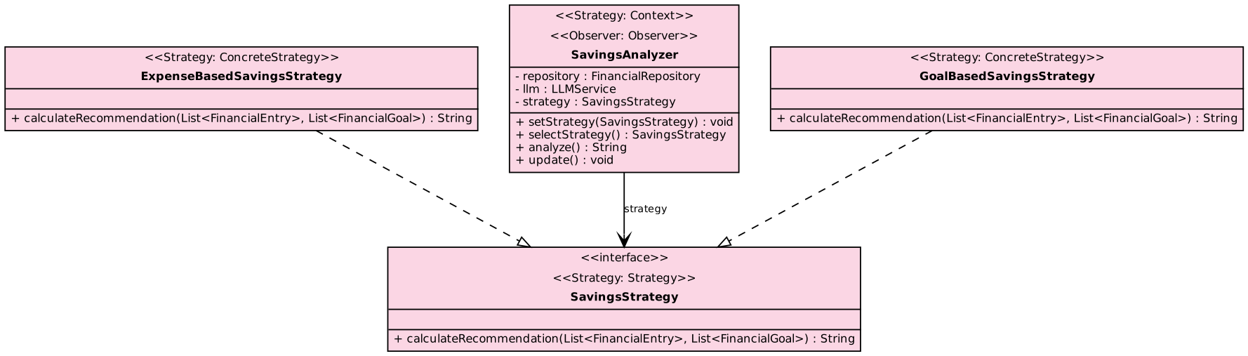
Figure – Strategy classes (extract of the implemented class diagram).

3.4 Observer
Design problem | When financial data changes, dependent components must refresh or react without FinancialService knowing about them.
Participating classes and roles | Subject: FinancialDataSubject (base class of FinancialService). Observer: FinancialObserver. Concrete observers: DashboardService, SavingsAnalyzer, ExpenseDetectionAgent.
Source files and methods | observer/FinancialDataSubject.java: addObserver, removeObserver, notifyObservers; FinancialService.addIncome/addExpense call notifyObservers(); update() in the three observers.
How the implementation follows the pattern / why useful | After every save the subject calls update() on all observers: DashboardService clears its cache, SavingsAnalyzer re-selects its strategy, ExpenseDetectionAgent checks the newest expense. FinAssistFacade registers them.
Match with Stage 1 | Matches Stage 1. Note: notifications are synchronous.

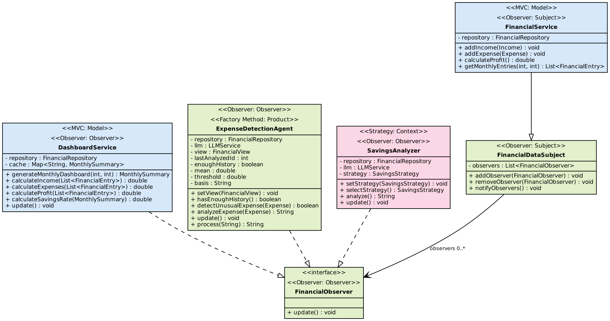
Figure – Observer classes (extract of the implemented class diagram).

3.5 Factory Method
Design problem | Create agents without the orchestrator depending on concrete agent classes.
Participating classes and roles | Creator: AgentCreator (abstract). Concrete creators: ExpenseDetectionAgentCreator, FinancialCoachAgentCreator. Product: FinancialAgent. Concrete products: ExpenseDetectionAgent, FinancialCoachAgent. Client: AgentOrchestrator.
Source files and methods | agent/AgentCreator.java createAgent(); the two creators override createAgent(); AgentOrchestrator.selectAgent(), processRequest(), addAgent().
How the implementation follows the pattern / why useful | selectAgent() finds an existing agent or asks the matching creator to createAgent(), so adding a new agent type means adding one creator. Useful for the planned extension of more AI agents.
Match with Stage 1 | Matches Stage 1 (creator constructors take repository and LLMService).

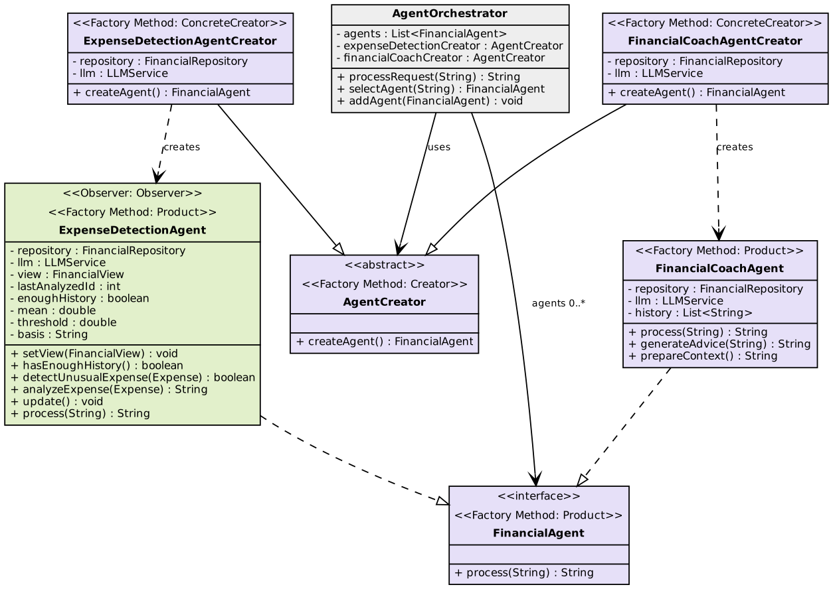
Figure – Factory Method classes (extract of the implemented class diagram).

3.6 Updated sequence diagrams
The Stage 1 use-case diagram and sequence diagrams SD-02 (unusual expense), SD-04 (subscriptions) and SD-05 (coach) remain valid with these remarks: in SD-02 the agent displays the alert on the view itself before the "saved" message; SD-04 additionally offers remove and list. SD-01 and SD-03 changed and are redrawn from the code:
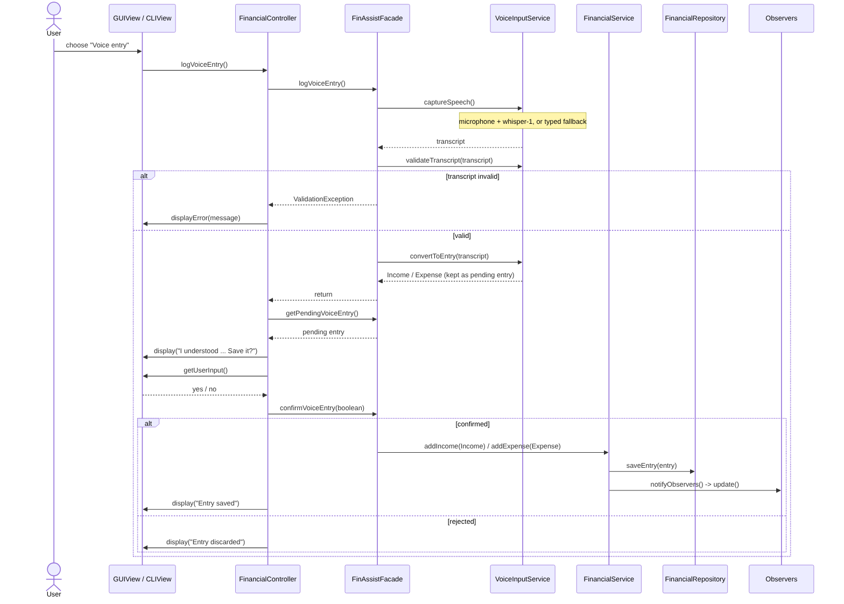
Figure – SD-01 Voice entry as implemented (confirmation step, typed fallback).
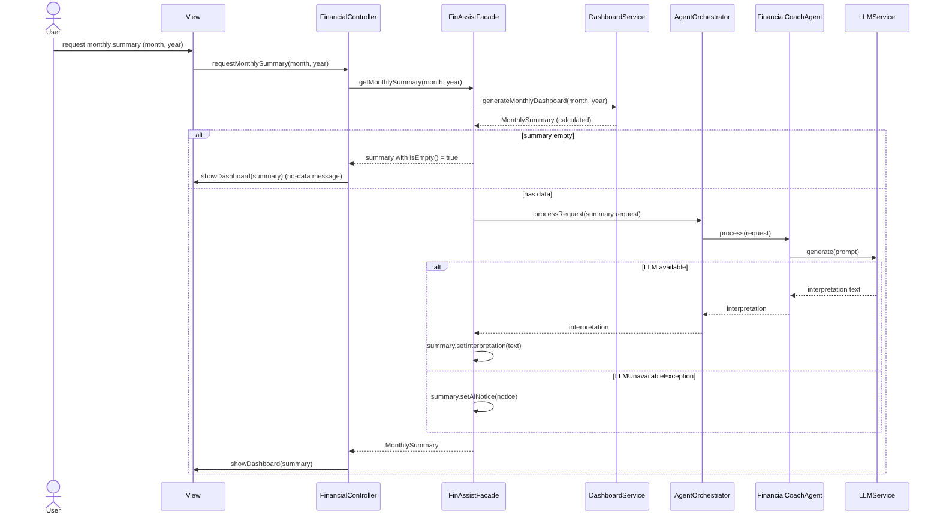
Figure – SD-03 Monthly summary as implemented (getMonthlySummary via orchestrator and coach).
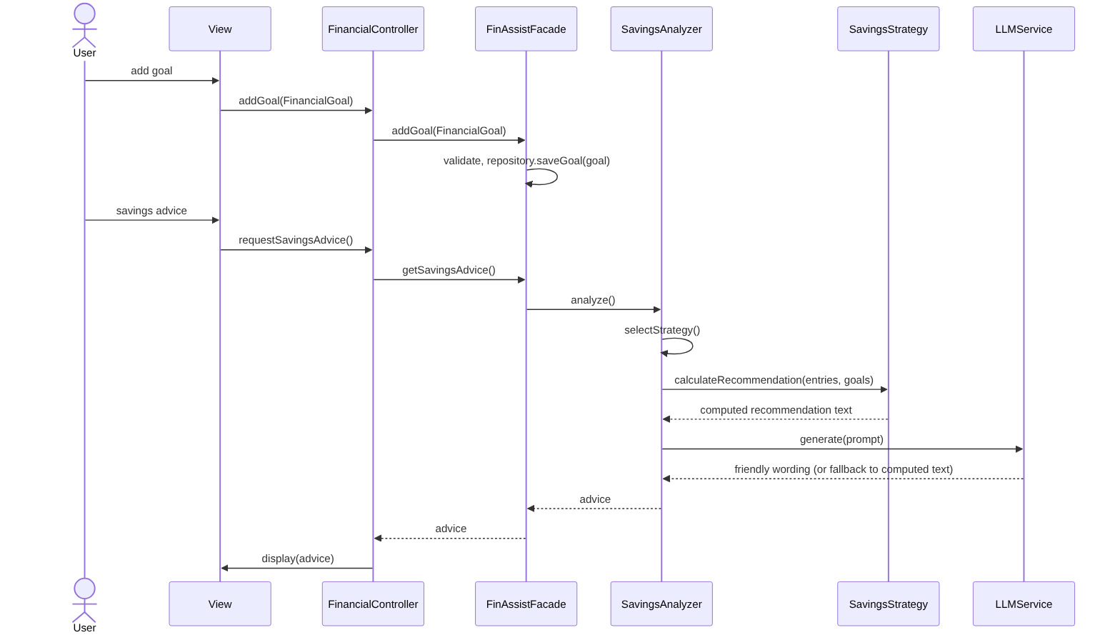
Figure – Goal tracking and savings advice (Strategy) as implemented.

4. Changes and rationale
Format: Original design → Implemented change → Reason → Impact.
Original design | Implemented change | Reason | Impact
F01 voice entry: speech converted straight to a transaction by the LLM | Whisper transcription (or typed fallback), rule-based parsing, user confirmation before saving; new facade methods getPendingVoiceEntry, confirmVoiceEntry | Parsing errors would silently store wrong money values; rules are testable and work offline; typed fallback keeps the feature usable without a microphone/key | Safer and testable; limited to simple English sentences
F06 goal with AI explanation | Deterministic progress and required savings only | Explanation was optional; numbers are the user need | Less AI; no behaviour risk
F07 dashboard redraws automatically on data change | Observer clears DashboardService cache; user requests dashboard again | Keeps Observer meaningful without UI threading complexity | Slightly less convenient; always correct data
F09 recurring-spending explanation and duplicate warning | Not implemented; add/remove/list/cost implemented | Time; core tracking need covered | Reduced scope
F10 coach selects tools | Fixed context via prepareContext() plus recent history | Simpler, deterministic and cheaper; avoids unpredictable tool calls | Coach cannot fetch extra data on demand
F05 summary generated only by AI | Deterministic MonthlySummary plus AI interpretation, notice if LLM unavailable | Figures must never depend on the LLM | Hybrid design; clear failure behaviour
One user interface | GUIView and CLIView behind FinancialView (N3, N4) | Course asked for GUI and CLI; demonstrates MVC | Two views to maintain
Data in memory only | Serialization file (N1) | Users expect data to remain | Not human-readable
Only the real LLM | LLMService interface with OpenAILLMService and MockLLMService (N2) | Tests and demos without network or key | Real API calls not tested here
Observer: DashboardService and agent observers | SavingsAnalyzer also an observer (re-selects strategy) | Strategy stays correct after goals/entries change | Pattern participants increased
Facade/controller methods in Stage 1 list | Added addGoal, getMonthlySummary, getSubscriptionSummary, removeSubscription, requestSubscriptions, setView and others | Needed by the views for features F05, F06, F09 | Class diagram and sequence diagrams updated
No pattern replaced | All five patterns kept as designed | Stage 1 choices fit the implementation | No architectural rework

5. AI tools and collaboration log
Tool | LLM / model | Purpose | Example tasks
Claude (Claude Code agent, claude.ai) | claude-sonnet-5-5 (configured; the serving model may differ and cannot be confirmed) | Design, diagrams, implementation, testing, documentation | UMLet use-case, class and sequence diagrams; consistency audit; the whole Java implementation and 45 self-checks; this report
OpenAI API (runtime component of FinAssist) | gpt-4o-mini (default) and whisper-1 | Product feature, not a development tool | Wording of advice, explanations, coach, summary interpretation; speech transcription. Not exercised during development

Token cost and money cost: [TO FILL from your Claude usage page – not available to the assistant, so no figure is invented here]. OpenAI runtime cost during development: none (no API calls were made).

Representative interactions
- Diagrams asked for use-case and sequence diagrams in UMLet; Claude generated .uxf files with scripts. After the instruction "don't make it complicated", the sequence diagrams were simplified.
- Consistency asked that classes and methods match across diagrams. An audit found misaligned use-case relations, duplicate or missing use-case descriptions, different creator names and missing methods; they were fixed and the Word document updated.
- Patterns asked to include MVC, Facade, Strategy, Observer and Factory Method; Claude added stereotypes and a legend to the class diagram.
- Implementation asked to create the project from the document with exact patterns, classes and features; Claude wrote the Java code and SelfTest (45 checks).
- Debugging examples the voice parser captured too much text for the merchant (fixed by limiting the regex to "at|from"); the orchestrator routed unusual-expense requests to the wrong agent (fixed with startsWith("analyze unusual expense")).
- Human contribution the team defined requirements, features, patterns and checks, reviewed every output, and chose to keep deterministic calculations separate from AI wording. The team must review and run the code before submission.

6 Development and verification summary

6.1 Weekly commit summary
The commit history lives in your GitHub repository, which the assistant cannot access, so the weekly rows below must be completed from git log. Run: git log --since="<week start>" --until="<week end>" --pretty="%ad %s" --date=short. The "Work done" column lists the actual development phases, which you can match to your commits. No commit counts or dates are invented here.
Week | Commits (from git log) | Work done
Stage 1 weeks | [TO FILL] | Requirements, use-case diagram, sequence diagrams SD-01 to SD-05, class diagram with the five patterns, traceability and consistency audit, Stage 1 document aligned to the diagrams.
Week of 2026-11-02 | [TO FILL] | GUIView and CLIView design on top of the MVC structure (request of 2026-11-06).
Week of 2026-11-02 to 11-08 | [TO FILL] | Java implementation of all classes (2026-11-07), 45 self-checks, build.sh and README, change log and AI-collaboration document, then this report with the regenerated class diagram and redrawn sequence diagrams (2026-11-08).

6.2 Checks performed
- Automated self-checks build.sh compiles every class and runs finassist.test.SelfTest with assertions enabled; the final run printed "All 45 checks passed." The checks use MockLLMService and a recording view, so no network is needed.
- Feature checks F01 transcript validation, conversion of spending and income sentences, confirmation prompt, saving after confirmation, unclear speech; F02/F04 invalid amount and missing category rejected, income and expense saved; F03 insufficient-history message, alert with AI explanation, no alert for normal expense, LLM outage message; F05 interpretation text and the no-LLM notice; F06 expired deadline rejected, progress, remaining amount, required monthly savings; F07 income, expense total, unusual list, category totals, empty-data message, month validation; F08 advice uses the goal strategy; F09 monthly total, invalid subscription, removing a missing one, annual cost; F10 clarifying question, coach answer, no-data prompt.
- Pattern checks Strategy selection (goals give GoalBasedSavingsStrategy, none give ExpenseBasedSavingsStrategy); Factory Method (orchestrator creates the right agent and reuses it, creators extend AgentCreator); Observer (add, notify, remove; FinancialService is the subject; DashboardService and SavingsAnalyzer are observers; dashboard refreshes after a new entry); MVC/Facade exercised through the controller on every feature test.
- Consistency checks the class diagram in this report is generated from javap output of the compiled code; the sequence diagrams SD-01 and SD-03 were checked against FinAssistFacade and FinancialController source; earlier audit compared use-case, class and sequence diagrams and the Stage 1 document.
- Manual smoke test the Swing GUI was started under a virtual display (xvfb) and a screenshot taken; the CLI menu was run with --demo.

6.3 Important defects found and corrected
Defect | Found by | Fix
Voice parser captured too much text as the merchant (for example whole phrases) | Voice self-check on "coffee at Tim Hortons" | Merchant regex restricted to the words "at" and "from"
Unusual-expense requests (F05 flow) were routed to the wrong agent | Factory Method / orchestrator check | AgentOrchestrator.selectAgent() routes only requests starting with "analyze unusual expense" to ExpenseDetectionAgent, all others to the coach
Test harness did not feed typed voice input correctly | F01 confirmation check | Voice input queue in SelfTest corrected
build.sh could not run directly (bad interpreter: Permission denied on the output mount) | First build attempt | README now says: bash build.sh
Early sequence diagrams used methods not in the class diagram; use-case relations misaligned; duplicate or missing use-case text; creator names differed | Consistency audit (Stage 1 phase) | Diagrams rebuilt strictly from the class diagram and the Stage 1 document corrected

6.4 Remaining limitations
These repeat and extend section 1.4:
- Real OpenAI chat and whisper calls and the physical microphone are untested; only the offline mock and typed fallback were verified.
- Not built: AI goal explanation, recurring-spending explanation, duplicate-subscription warning, agent-chosen tools, LLM-based speech field extraction, automatic dashboard redraw, add-transaction shortcuts on an empty dashboard.
- Voice parsing supports only simple English sentences with an amount.
- GUI was smoke-tested only; no automated GUI tests. Observers run synchronously.
- One user; serialized data file is not human-readable or versioned; no file-corruption recovery.
- Video links, token cost, money cost and weekly commit rows still need the team's own data.

