1. INTRO, SPEC, DAN MANFAAT PROGRAM
   1. This program’s function is to test your knowledge. All questions in this program is about general knowledge. But each of the difficulty levels are designed by multiple individuals (excluding Hard and Sudden Death mode). Thus the variation of creativity levels of the answers and the questions themselves.
   2. This program is made in Free Pascal, but it also utilizes the Windows Command-Line Processor ( CMD )
   3. In the DATA folder, there are few batch files (.bat) which is only used in the hardcore / sudden death mode, to end a specific process through the CMD with force. The program to end can be specified when the user is asked to enter a name. Type “ter_(batchnamefile)” (without quotes) to select which process to end (for .bat file names look in DATA folder). The default is shutdown (not ending process, but still a batch file), so save all your works before continuing to try hardcore/sudden death mode because executing the shutdown command **will** makeyour system turn off immediately
   4. Because changing which-process-to-end is considered a cheat, you can’t enter your name. Instead, ter_batchnamefile will appear as your name
   5. This program also utilizes the TProcess library, aside from the Cathode Ray Tube (CRT) library. Hence, do **not delete or modify** of the files inside the program folder
   6. https://www.youtube.com/watch?v=95QqcTr8tdQ
2. FLOWCHART PROGRAM (Jalan step-by step)

Main Program

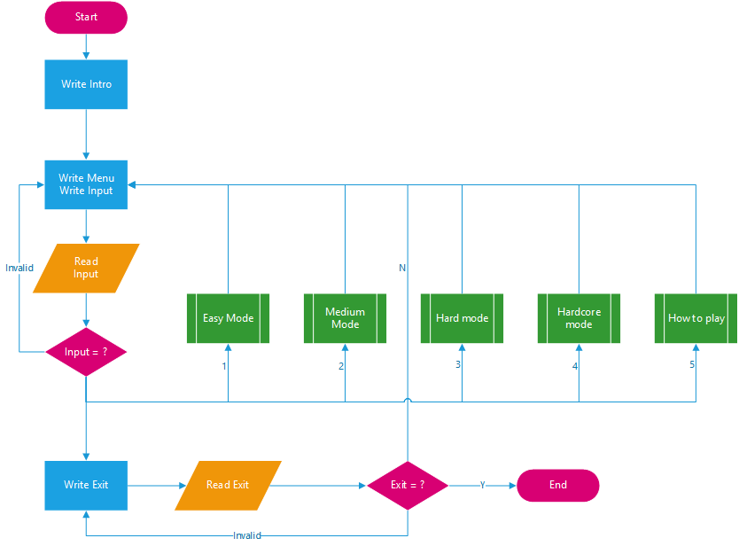

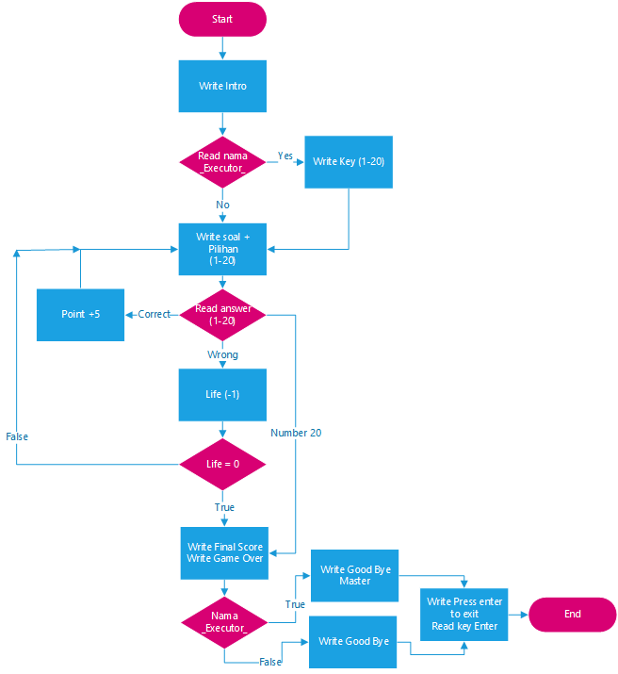

EASY

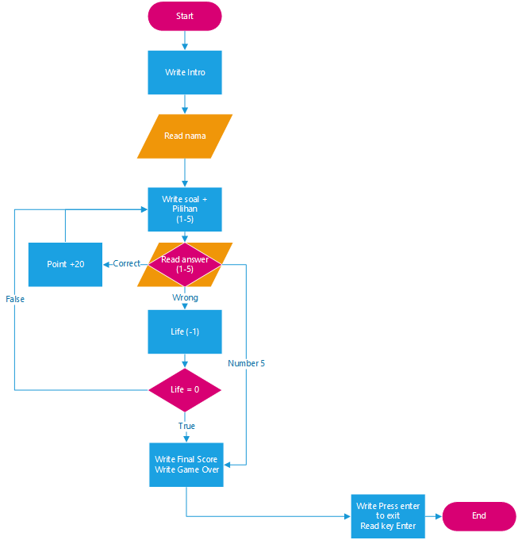HARD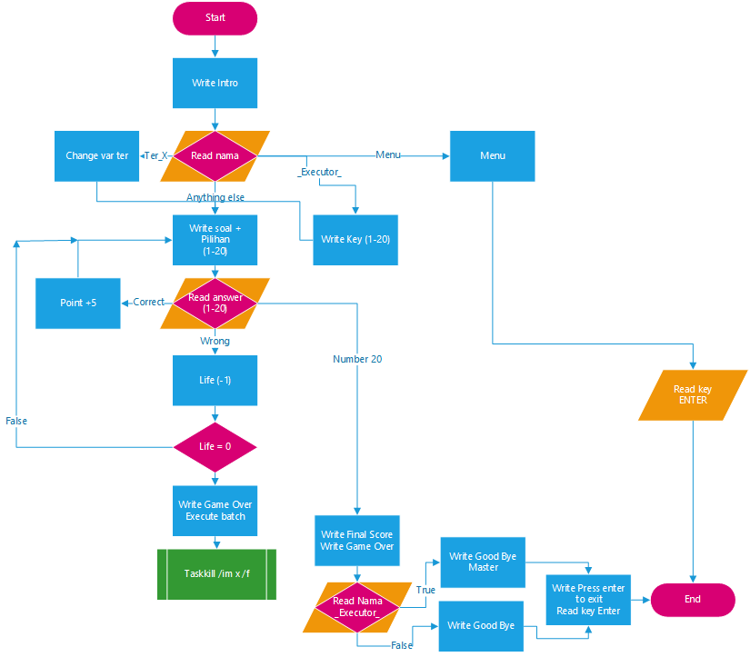HARDCORE / SUDDEN DEATH

|  |  |  |  |  |  |
| --- | --- | --- | --- | --- | --- |
| No. | Name | Place | Absent | Works | Part |
| 8 | Edwin | The Via and The Vue apartments | ✓ |  | Sleeping at home |
| 13 | Tony |  | ✓ | Easy Mode + flowchart |
| 15 | Bryan |  | ✓ | Hard, Hardcore mode + flowchart, Papers, PPT, intro, Owner of apartment |
| 30 | Ivan |  | ✓ | Main menu + flowchart, Group lead |
| 39 | Timothy | ✓ | ✓ | Help (send by email) |

1. Report Form