**Yield Curve Modeling Task**

1. We picked the government securities from Hong Kong. The data source is from investing.com.
2. We picked a range of government bond/note of different tenor. 8 tenor are selected, they are : 6month, 1Year, 3Year , 5Year, 7Year , 10Year, 15year and 20 year.
3. We fit the data using Nelson-Siegel(NS) model.

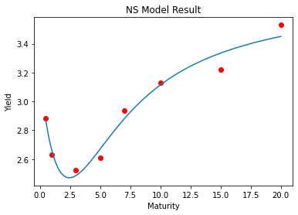

The blue line is the fitted line and the red dot are the actual data.

1. We have also fit the data using Cubic-Spline(CS) model.

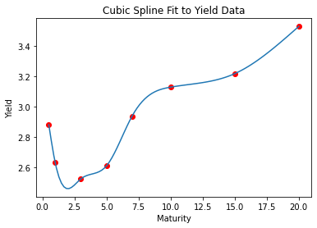

The blue line is the fitted line and the red dot are the actual data.

1. Comparing the fit of NS and CS, we can observe that NS does not perfectly fit all observed data, only a single smooth curve that passes through most points. In contrast, CS demonstrates the ability to fit observed data closely, but its fitted line may exhibit a "kink."

In terms of interpretation:

a) NS offers better interpretability because its fitted line is smooth, potentially yielding more explainable results. Additionally, NS can handle extrapolation effectively. Since CS relies on interpolation, it may not be well-defined for out-of-sample calculations. However, as a parametric method, NS can provide results for out-of-sample inputs.

b) NS also provides intuitive meaning for its model parameters. According to M1L3, 𝜆 represents the decay rate, which ranges between 0 and 1. The parameter 𝛽0 describes the level of the yield curve, 𝛽1 describes its slope, and 𝛽2 describes its shape.

1. For NelsonSiegelCurve, the fitted values are :

|  |  |
| --- | --- |
| beta0 | 3.7992 |
| beta1 | -0.5993 |
| beta2 | -3.450 |
| tau | 1.730 |

For Cublic spline the model parameter is:

|  |  |  |  |  |  |  |  |
| --- | --- | --- | --- | --- | --- | --- | --- |
|  | **(0.5 to 1.0)** | **(1.0 to 3.0)** | **(3.0 to 5.0)** | **(5.0 to 7.0)** | **(7.0 to 10.0)** | **(10.0 to 15.0)** | **(15.0 to 20.0)** |
| **Cubic(x^3)** | 0.1938 | -0.0574 | 0.0206 | -0.0189 | 0.0045 | 0.0007 | -0.0005 |
| **Quadratic(x^2)** | 0.0000 | 0.2907 | -0.0540 | 0.0699 | -0.0434 | -0.0028 | 0.0074 |
| **Linear(x^1)** | -0.5504 | -0.4051 | 0.0683 | 0.1002 | 0.1532 | 0.0147 | 0.0378 |
| **Constant(x^0)** | 2.8810 | 2.6300 | 2.5230 | 2.6090 | 2.9380 | 3.1290 | 3.2180 |

1. Although Nelson-Siegel is smoothing the yield curve, this is not necessarily considered as unethical. It is because:

a) The smoothing is not intended to mislead the true. The smoothing is by construction of the model design. It is also intend to produce a interpretable representation of the yield curve for analysis.

b) In Econometrics, you will smooth time series to filter out noise. Nelson-Siegel can filter out the noise to prevent overfiting. So the intention is not unethical.