<$hn> Introduction
Why ftd in c9 patients end up developing semantic dementia?
C9bac500 $463.46 for a breeder pair (hemizig + noncarrier)
C9 HRE in microglia increases sting activity
C9 poly PR end up activating p53 cascade (and Puma) which induces cell death. But what happens between poly PR and p53 is still unkow
Early life stress increases stress response later in life
Evidence for this mechanism
- much higher ftd for PTST patients (what else?) he
- Elevated sting response in ftd patients.

Always genotype the mice in your studies. Options:
- • Standard PCR: primers + Taq Polymerase + free nucleotides (dNTPs))
- • Melt curve analysis: above + fluorescent dsDNA (evagreen) + thermocycler (rtPCR machine)
- • Quantitative PCR (qPCR) or real-time PCR (rtPCR):
- • Probe/Endpoint analysis

qPCR:

- 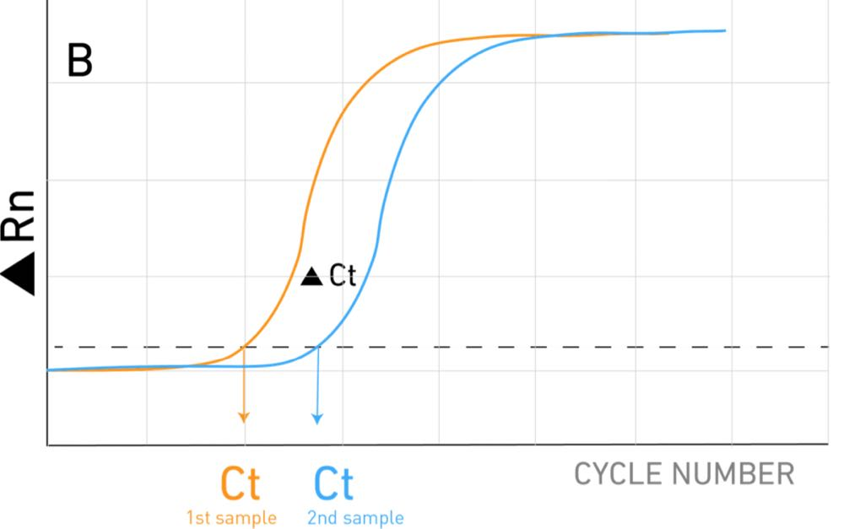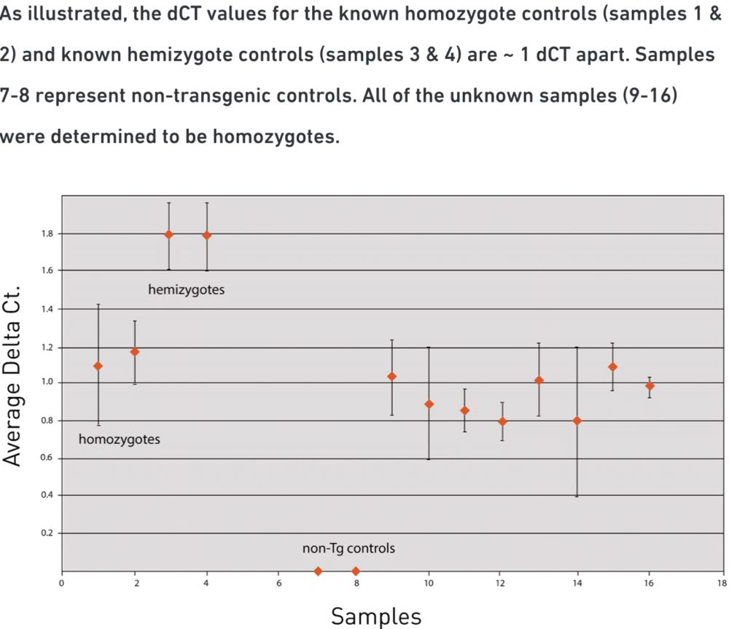

- Hybridisation: used in pcr and Gene expression analysis

Phenotyping (Rizzo et al. 2018).
The spontaneous alteration test is used to assess spatial working memory and is one that can be performed in mice with reduced visual acuity
An assay of sensory and fine motor ability is the adhesion removal test, which consists of putting a small adhesive sticker on the top of the mouse’s head and then tracking the time it takes for the mouse to remove the sticker.
Recommended for aged mice:
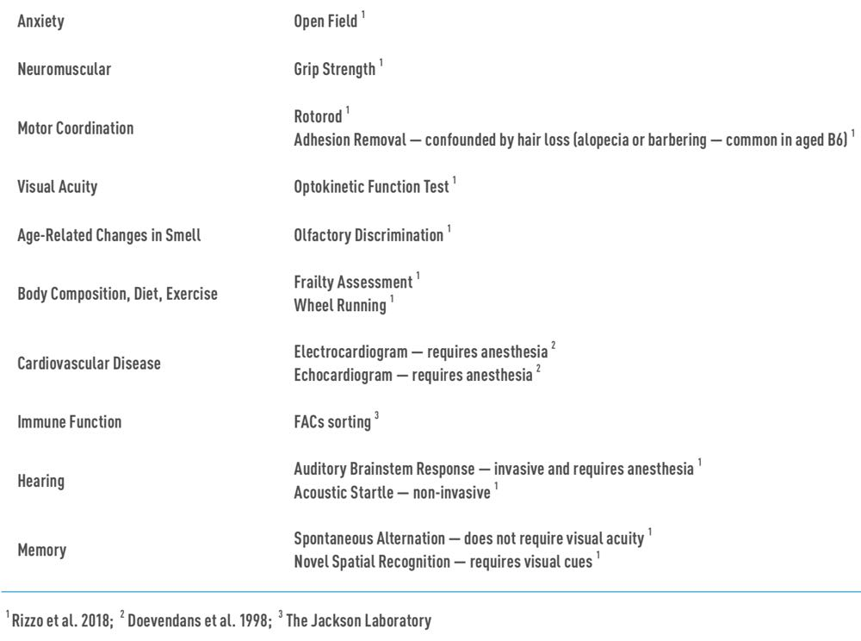

- Always validate assays/experiments/tests (cognitive or otherwise) with a control group
For some assays, such as tests that assess cognitive function, scopolamine can be used for validation. Scopolamine can mimic the cognitive deficits seen in aged mice
you may need to control for other variables as well, such as body weight — as mice age and their body weight become more variable. For tests such as grip strength, results should be normalized to body weight
- consider statistical power (n required) to show a difference between groups in your assays/tests
- have an Endpoint:
An endpoint is the point for the mouse when the study is over — whether because you have collected the data that is necessary for your research, or because of the accumulation of health issues from aging means the mouse needs to be euthanized
have a way of assessing the health of the mouse. Frailty and body conditioning assessments are a common method of general health assessment. Frailty is defined as “weakness, slowness, low activity, and poor endurance” (Toth 2018). There are multiple ways to assess frailty, but the most studied in mice is the clinical frailty index (CFI, Toth 2018, Rizzo 2018).
across different strains, a decline in body weight and temperature can be predictive of death, even in the absence of indications of morbidity (Toth 2018).

