To publish in frontiers in neurology: you need a translational perspective if working with animal models
“Reviewing abstracts for quality and relevance to the Topic”

Review:
350 words
￼
15 fig + tables
12'000 words
￼
￼
￼

<$Scr_H::5>2.3.1.10. Abstract<!$Scr_H::5>
GUIDELINES (MAX. LIMITS)
Abstract length: 1000 words
As a primary goal, the abstract should render the general significance and conceptual advance of the work clearly accessible to a broad readership. In the abstract, minimize the use of abbreviations and do not cite references. The text of the abstract section should be in 12 point normal Times New Roman. See Summary Table for abstract requirement and length according to article type.
For Clinical Trial article types, please include the Unique Identifier and the URL of the publicly accessible website on which the trial is registered.

“Experimental models of Frontotemporal Dementia-ALS spectrum disorder: a translational approach”
Experimental design for preclinical translational research should include consideration of the genetic backgrounds, diets, bioburden, and other environmental impacts on the selected model, and early implementation of pathology to optimize specimens for analysis, and the contributions of pathology to research success.

Mice phenotypes databases:
- Mouse Phenome Database based at the Jackson Laboratory
- IMPC International Mouse Phenotyping Consortium
Phenotyping strategies: in vivo evaluations, imaging strategies, molecular evaluations (microarray, proteomics, metabolomics etc), and clinical and anatomic pathology.
Motor: rotarod, swim test, tail hang (graps limbs),

Phenotyping variables:
In vivo phenotypes manifest at different ages, change over time, may be induced to appear or disappear, or expected phenotypes may not be evident, eye and coat color, subjective evaluation of morphology/dysmorphology, body condition, activity, and behavior; body weights for growth curves), to behavioral, metabolic, physiologic, or imaging assessments that require substantial equipment investments, to diet manipulations, and invasive interventions
Pathology might be key to assess similarities and differences between model and control
Phenotype descriptors: clinical/behavioural phenotype; gross pathological (morphological) findings; histopathology findings; genetic determinism (nature); environmental conditions (nurture)

Consider these for project
1. What Mice do you use? Why were these selected?
2. Where do they come from? Why did you select this source?
3. What are complete names of experimental and control mice, including substrain and origin?
4. Do your experimental and control mice live together? In the same cages (e.g. littermates)? In the same rooms? In the same facilities?
5. What is their microbial status? and surveillance program?
6. What do they eat? Brand and type? Percent and type of protein? Percent and type of fat? How is it monitored for contaminants?
7. What do they sleep on (what type of bedding)? Paper? Wood?
8. Do you provide enrichment material or devices? Why or Why not?
9. What do they drink? Auto? Bottle? pH? Chlorine levels? How is it monitored for contaminants?
10. What is their light cycle? Why?
11. What are environmental noise levels and ranges? Does it matter to your study?

Neurology & Behaviour
B - Pipeline "Emotionality"
C - Pipeline "Memory impairment"
D - Pipeline "Motor disorders"
E - Pipeline "Sensory disorders"
N - Pipeline "General neuro-behavioural assessment"
Physiology, energy metabolism & diabetes
F- Pipeline "Kidney function"
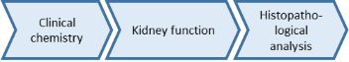
G - Pipeline "Glucose metabolism"
H - Pipeline "Energy metabolism"
(1) Online monitoring of physiological functions using implanted transponders, for example core and peripheral body temperature, locomotor activity.

I - Pipeline "Non-invasive imaging techniques"
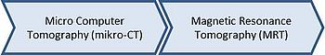
Immunology, allergy & lung disease
J - Pipeline "Immune function"
(1) Flow cytometric analysis of peripheral blood and lymphiod organs; Immunoglobulin isotyping and autoantibody detection
(2) Primary resistance to Listeria monocytogenes infection
(3) Antigen-specific T-cell response
(4) Protective capacity of memory T-cells against high-dose challenge with Listeria monocytogenes
K - Pipeline "Allergy"
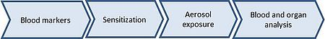
L - Pipeline "Lung function"
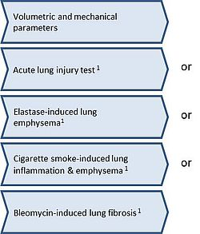
(1) Each of the Lung function pipelines requires one cohort of mice. The decision on which of the pipelines is most suitable for your hypothesis will be taken in close discussion with the PI.

_________________________________________________________________________________
M - Pipeline "Progressive changes"


