# **A Short Guide for New IST Lab Assistants**

## Forms and Paperwork and Labbie On-boarding

1. As a new IST department lab assistant ("labbie") we have a few things to complete,, and you have some action items. First We fill out forms:
   1. Student Verification form (you sign, this goes to the Student employment Office (SEO)). This form is only required if you have not been a student employee at RIT previously
   2. SEO hire form. We fill this out with you, print two copies, the supervisor signs both, and you get one to take to the SEO
   3. NYS Wage notification form - we fill this out with you, you sign both copies, and you get one to take to the SEO
   4. Student Confidentiality Form - you read and sign this, we keep it. This is basically a non-disclosure agreement.
2. Once you take the necessary forms to the SEO, you will be issued an SEO card (if you do not already have one, or if you need a new one). When you get that card, scan it or take a picture with your phone, and email the picture to your supervisor. We need to be able to prove all our student staff have valid SEO cards, so this goes in your file.
3. The SEO and the Payroll Office will issue you a "Kronos Badge Number", aka your Kronos ID. Kronos is the time card system, and you will have a unique Kronos ID for each job you have on campus. Unfortunately, they never tell you (or us) that the Kronos ID has been issued. We check our portal in to the Kronos system, and will let you know when we see your new Kronos ID. You can also login to the Kronos system and find your Kronos ID there. If you do so, please send the number to your supervisor in email.
4. While we are waiting for (2) and (3) to occur, your supervisor will do several things for you:
   1. Add you to the labbie mailing list. We communicate a lot by email, so do pay attention to your email.
   2. Invite you to Slack; we invite your RIT email address. Once you accept, and are added to some default channels (random and general), we can then add you to the more important channels, *#labassistants* and *#ist-ta*. We use Slack a lot, and it is important that you are connected.
   3. We create a lab network account for you on the lab's AD server. If you have taken any NSSA courses (like 221, 241, 245) you have a student account in the labs. This is different.
   4. We grant access to our inventory system, so you can check items out/in for students and faculty.
   5. We grant you access to some Google Drive Shares
   6. We create an account for you on the student worker portal <https://workportal.rit.edu/ist> (very important!)
   7. We set up your access in the Lenel system (the card-swipe door lock system). You will need a 5-digit PIN number for the Lenel system, and we'll need to set that up with you.
   8. Your supervisor will add you to the payroll racking spreadsheet we maintain.
5. Just because your supervisor is busy, doesn't mean you won't be - here's what you will need to do:
   1. Accept the Slack invitation. If you can join the #labassistant and #ist-ta channels, do so, otherwise let your supervisor know you've joined Slack.
   2. Login to the work portal <https://workportal.rit.edu/ist> - you use your RIT login name and password. You need to do two things (details later in this document):
      1. Specify how many hours you are willing to work per week for each semester of employment. This should be an integer between 4 and 20. We typically don't assign less than 4 hours, and can't assign more than 20. We rarely schedule anyone for more than 16 hours/week, and usually schedule between 8 and 12 hours per week.
      2. Specify your schedule of availability, blocking off those times during which you cannot work as a labbie. Unavailable means you are at another job, in class or have scheduled project time. In addition, if you are in ROTC, you can block those times off, if you are on a sports team, you can block those times off. We expect all labbies to have some availability mornings, evenings, and weekends.
   3. If you are here on campus, stop by and have your lab account password reset.
   4. Your Lenel access has associated start/end dates. If you are within that window of time, make sure your card works and that you know your PIN. If you do not have a PIN, have your supervisor set one up for you.
6. For those labbies hired at the beginning of a semester, we usually have an orientation meeting the Sunday afternoon before classes start. We send out a notice via the email list a couple weeks ahead of time. We usually provide some light snacks (pizza or subs, soft drinks, maybe some cookies). Attendance at these are mandatory (and you can clock in and get paid for your time). Occasionally, a labbie is still travelling and can't attend - they need to clear that with their supervisor and get written (email) permission to miss the orientation meeting.

## Logging into the Work Portal

Setting up your number of hours per week and your availability is critical - we can't schedule you until you've done this, and if we can't schedule you - we can use you as a labbie.

Use your browser to go to <https://workportal.rit.edu/ist>. You will need to provide your RIT username and password.

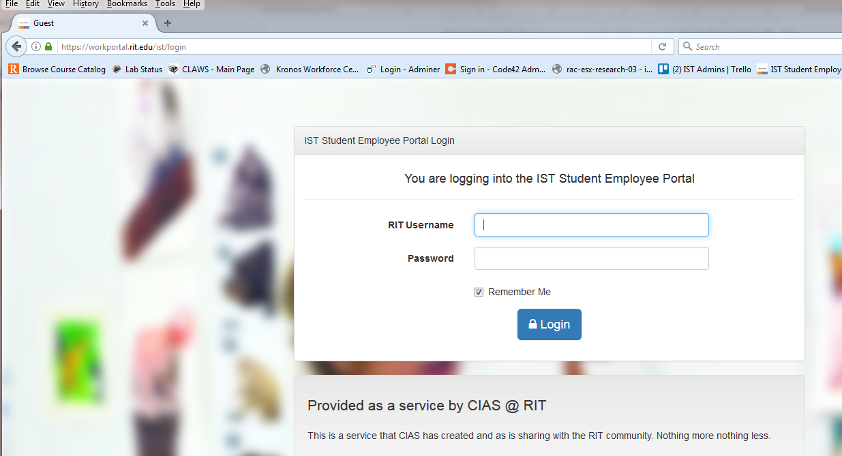

If you did everything right, you should see something like this:

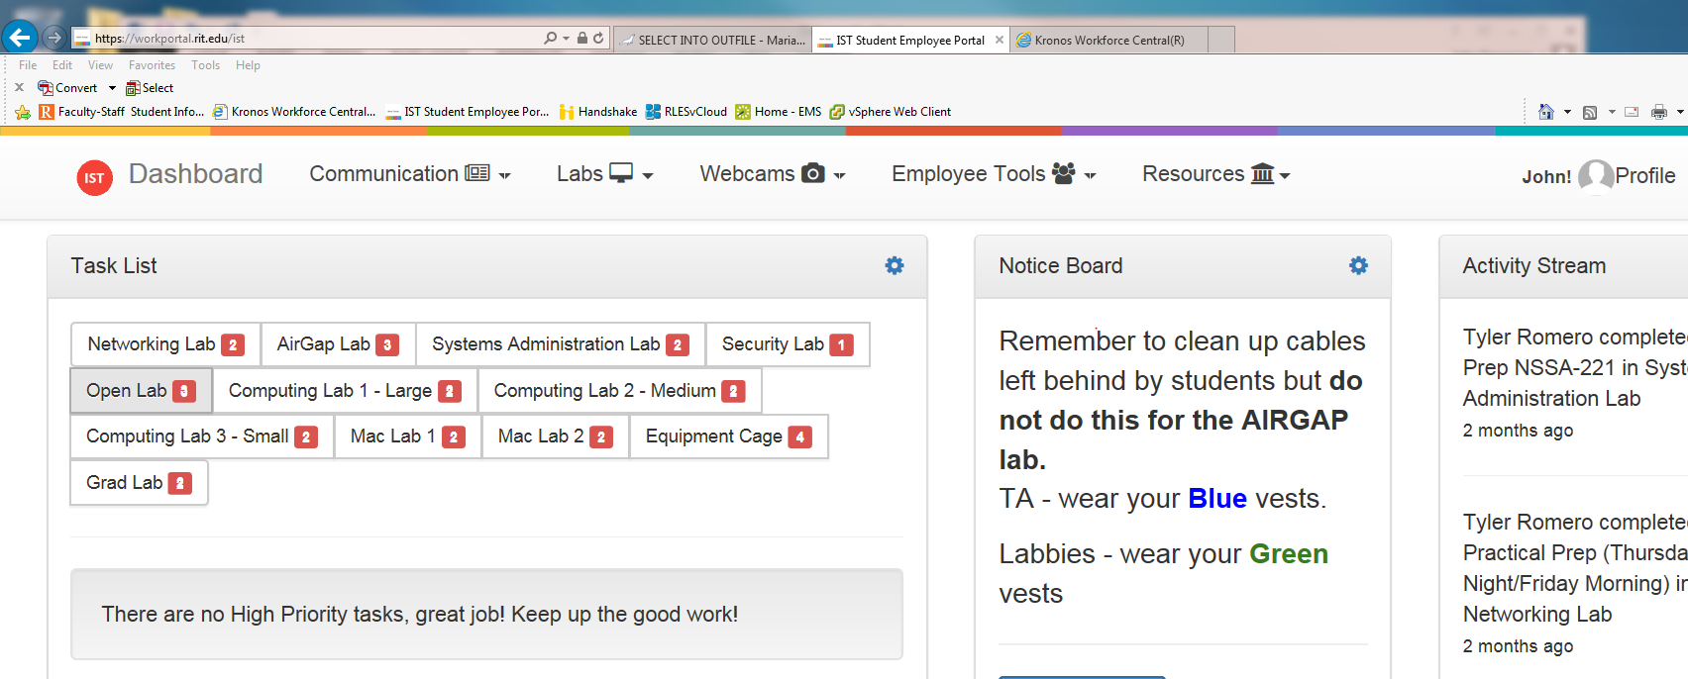

In the screen shot above, notice the 'profile' tab, here a little easier to see:

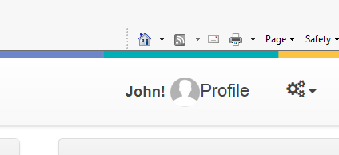

Clock on that tab to get to your personal profile/settings page. That page is divided into a top and bottom section, each with their own "Update" button. If you make a change in one section (e.g., update the number of hours you want to work) be sure to click the update button for that section *before* you make changes to the other section - otherwise you changes will be discarded and you will be sad.

So first, scroll down your profile to set the number of hours you wish to work:

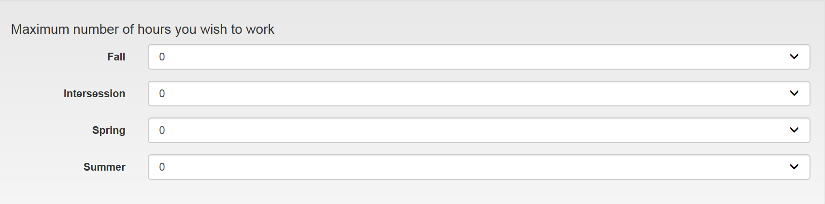

You need to set the hours for those semesters you will be working. "Intersession" and "Summer" are not typically used anymore, so do not bother with those. Then, be sure to update that section - scroll down a bit more and you will see the update button:

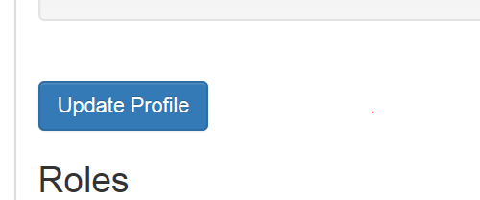

So click on that and wait a bit as it does the update to the back-end database. Now scroll down farther to get to the section for managing your schedule of availability:

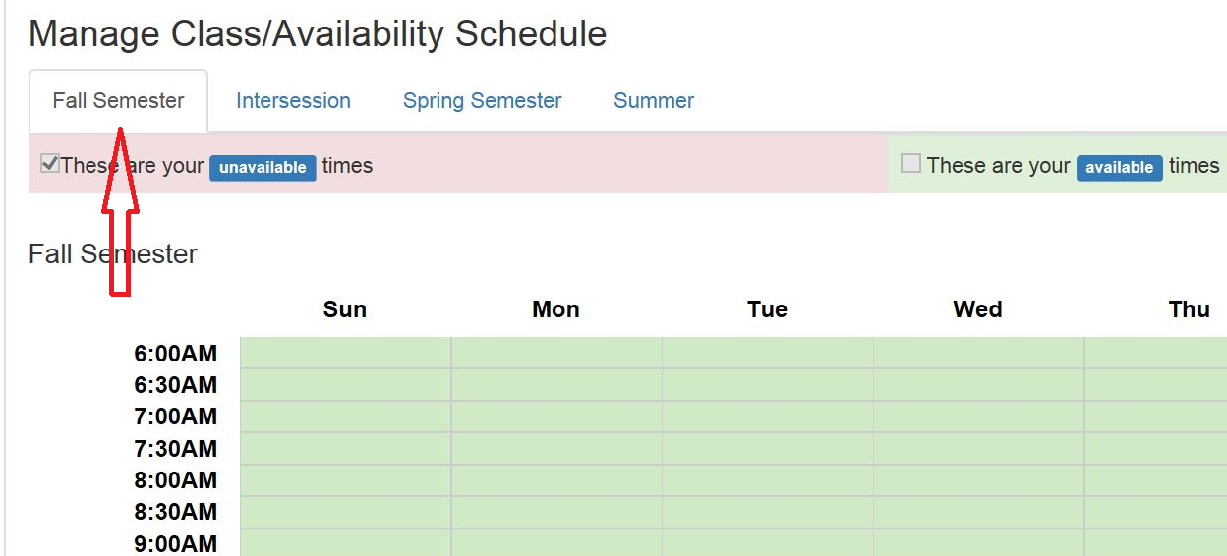

***Very important!*** Be sure you have selected the correct semester. We switch the default to match the current semester, but only a couple of weeks before the semester's start. In the screen shot above, note that "Fall Semester" is selected (we added the red arrow for this example).

If for example you are in class from 8:15 to 9:05 on Mondays, you would click on the Monday cells for 8:00AM through 9:30AM. After that, the schedule would look like:

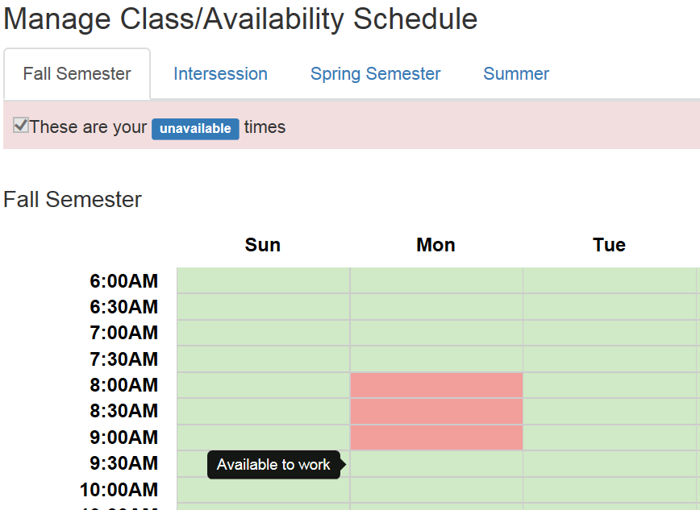

When you are done setting up your schedule, scroll down and click on the "Update All Schedules" button:

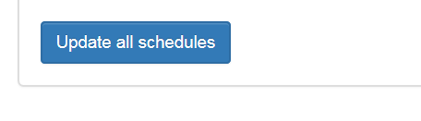

The work portal is a very important tool, and labbies should check it frequently.

## The Work Portal and Missed Punches

Because TAs often grade at home (where they cannot clock in/out of Kronos), they make heavy use of the portal's *missed punch* facility. But TAs and labbies also need the missed punch facility because

1. They simply forget to punch in or out (we all get distracted sometimes).
2. They punch in with the wrong Kronos number
3. They find punches on their time card that are wrong (e.g., someone mistyped their Kronos number and entered yours by accident)
4. Kronos did not record your punch

One of your important and required tasks as a labbie is to check your time card periodically, looking for mistakes, and reporting and correcting those in a timely fashion via the missed punch facility. And importantly, always check your time card on the Friday morning (before 10AM) and make sure all problems and their corrective actions have been submitted before 10AM on sign-off weeks. If you do not, your timecard will be either (a) rejected by payroll, or (b) garbled/incorrect entries removed, which can result in you not getting some (or all) of your pay for that period. That can be corrected later, but it is a onerous process for your supervisor (and the department chair has to review and sign off on the corrective action) and will result in you being viewed unhappily by your supervisor and reduces your chances of being rehired. If your time card mistake is uncorrected, and results in you getting paid more than you should - that becomes a serious matter, as it is considered fraud, and RIT may pursue legal action (which results in unhappiness all around).

Note that your submission does not change your time card - your supervisor gets the submission and applies the changes for you after reviewing the submission.

To submit a missed punch, you need four pieces of information:

1. The date of the missed or incorrect punch (the form has a little calendar for selecting the date)
2. The exact time (not a guess or estimate) in 24-hour ("military time") notation. Don't enter 19:00 if it was really 18:58 or 19:04.
3. Whether the punch was an in or out punch (the form has a pull-down selector)
4. A reason for the submission. BE CLEAR, COMPLETE AND EXACT! If you need a punch removed, say so exactly. We cannot apply the changes to your time card unless the reasons is very clean - and WE CANNOT ASSUME ANYTHING. If your reason is "wrong punch" - we can't do anything, unless you write also "wrong punch, please remove this punch" as the reason (again, if we assume, it could be fraud, and we do not want to get a $10k fine and 1 year in jail).

## Submitting a Missed Punch

To submit a missed punch then, login to the portal, and use the drop-down "Employee Tools" menu:

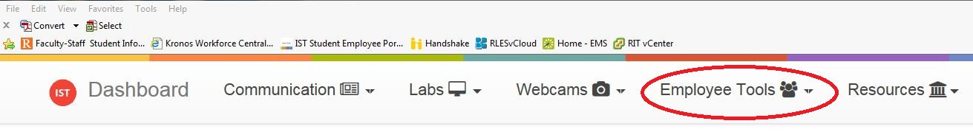

In the pull-down menu select "Missed Punch":

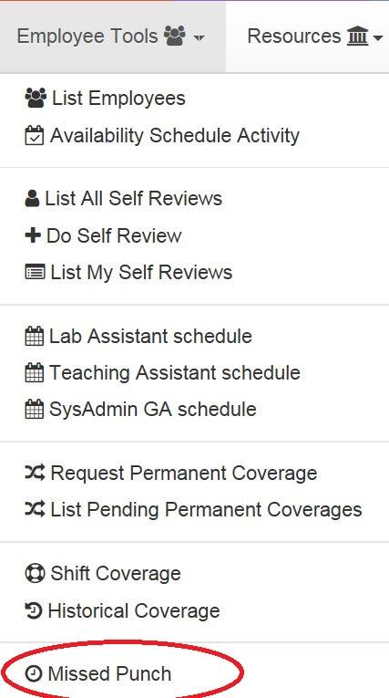

That will bring up the missed punch submission form:

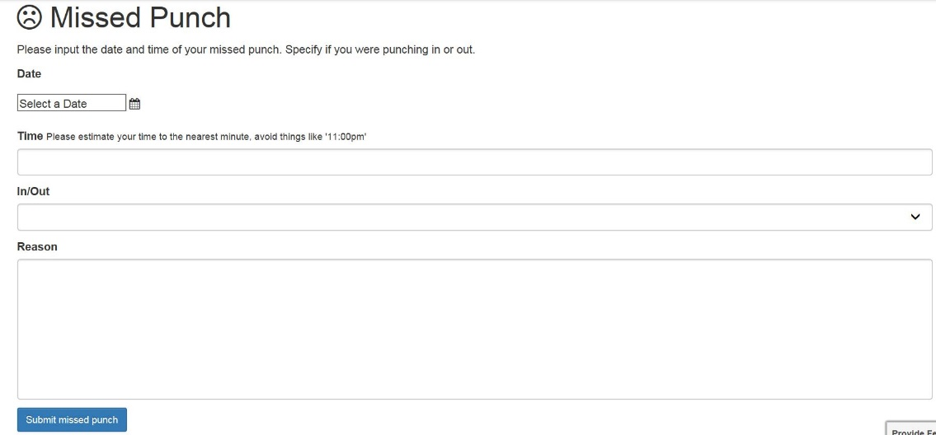

To enter a simple missed punch you might enter something like:

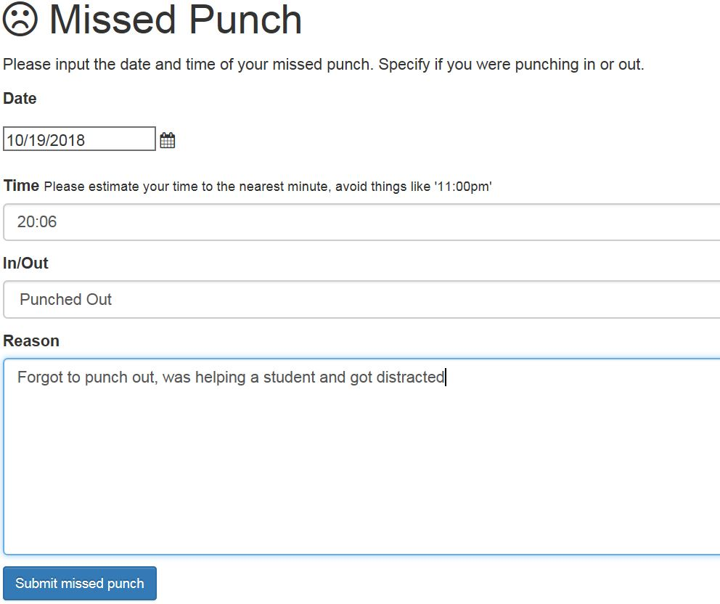

If you were submitting a missed punch to drop an errant punch, you would submit something like (the reason you give needs to be explicit):

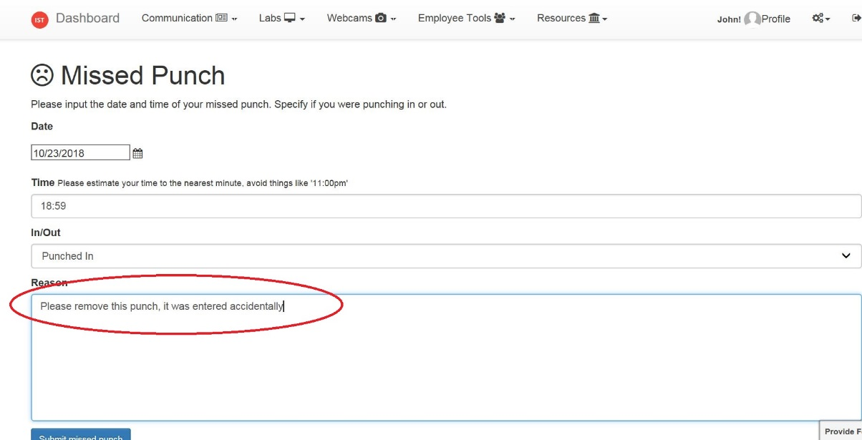

## Labbie Skills

There are a few skills/abilities all labbies need to have

* The ability to check items out and back in correctly
* Collect usability information ("head counts" in selected labs)
* Write-erase the Cisco routers and switches
* Re-flash Cisco routers and switches
* Clear passwords from Cisco routers and switches
* Lab cleaning

There are also some more advanced skills, that are nice to have, and some labbies must be able to do these things, and we encourage labbies to learn these additional skills

* Computer imaging - using Ghost Solution Suite to deploy/redeploy system images to lab computers
* Cabling for cat-5 and cat-6
  + RJ45 termination
  + Cat-5 Panduit
  + Cat-6 Panduit
  + Panduit patch panels
  + Cable testing
* Scripting, as used with Ghost Solution Suite to deploy patches, additional packages to lab computers.

There is a loose-leaf bind in the cage that has instructions for check-in/out and inventory operations, and for write-erase operations. Note we are always interested in labbies who want to improve our documentation, improve/update/maintain our web sites, and maintain and improve our lab networking and procedures.