**CAD Student Employee Portal – Configuring**

**Step 1** – login to <https://workportal.rit.edu/ist> with your web browser; you will be prompted for your RIT login name and password.

**Step 2** – on the main screen, on the top menu bar, locate and click on your profile tab:



You will see something like this:

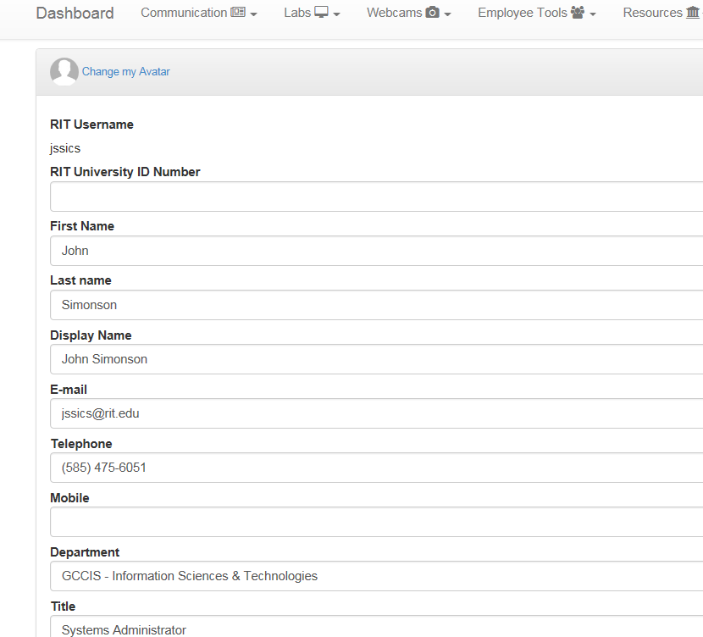

Update this and enter any information you feel is important. Many of the fields are filled automatically when your account is created, but additional information can be helpful for us, especially your phone and mobile/cell number. You can also select your “personal color” use to highlight your name in the schedule:



Click on the “personal color” field and you will see a color selection pop-up.

**Step 3a** – **iSchool TA’s only** - Set the maximum number of *tutoring* hours you wish to work (I usually set this for you; if I have, please do not alter this item). Please note –this is **not** the total number of hours you wish to work, ***this is the number of tutoring hours you will be scheduled***. For most TAs, this is two (2) hours for each course/section for which you TA. Do not enter the actual total number of hours you wish you work overall.

**Step 3b** – everyone else – Set the maximum number of hours you wish to work per week

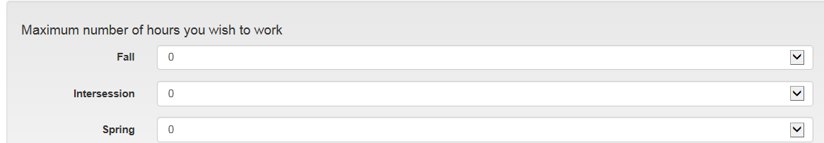

**Step 4** - Please leave the “Email Preferences” set with all items checked.

Then click on the “Update Profile” button.

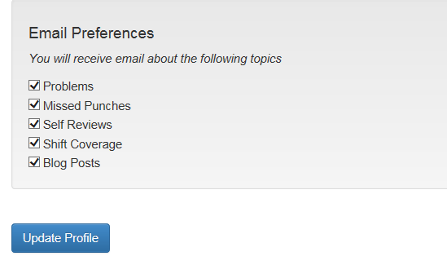

If you see the following items, please do not alter them:

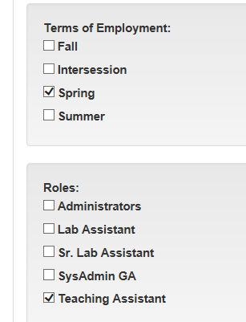

**Step 5** – set your schedule of availability – IMPORTANT – when setting your schedule, make sure you select the correct session. E.g., for spring semester, click on the “Spring Semester” item (I know, it seems obvious, but…)

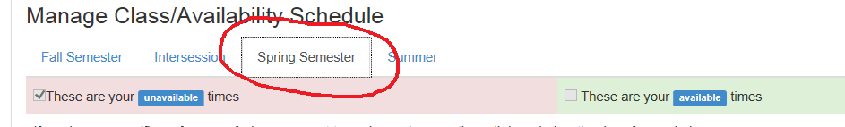

Now in the availability section, check those times when you are NOT available. By “not available” it is meant you are in class, at another job, or the class lecture for the course for which you TA is at that time, or when the labs are closed (this semester we are open 9AM-10PM, but on Saturday and Sunday, there is no tutoring before Noon). We expect everyone to have some evening and weekend availability, and failure to provide a reasonable amount of availability can remove you from a TA position.

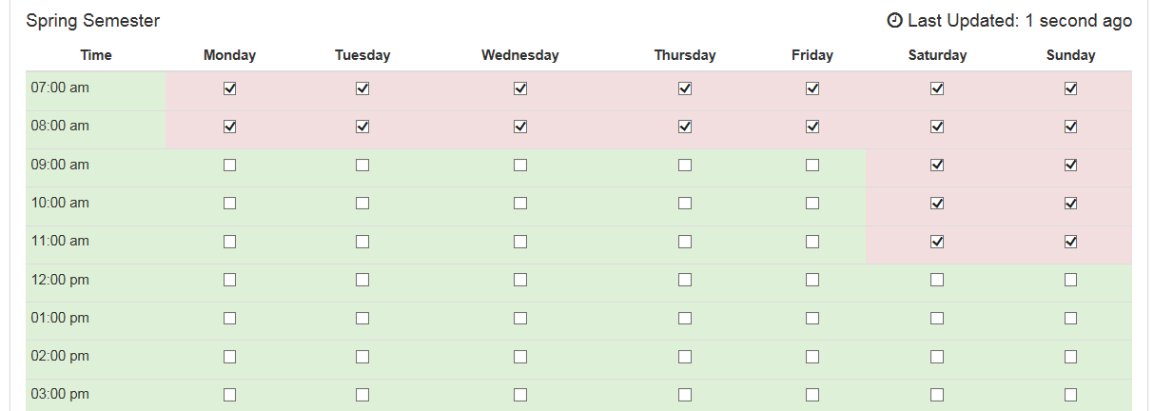

Notice that the label is “Spring Semester” which should (and does here) correspond with the selection you made. Remember, the times check are when you are not available; green (unchecked) times indicate when you are available. When I set up your identity in the portal, I usually check as unavailable those times when tutoring is not available.

When you are done, click on the “Update all schedules” button at the bottom of the page:

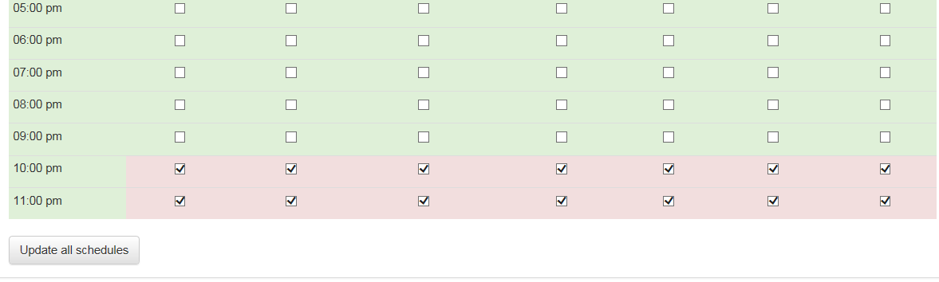

If you make changes to availability you wish to keep, click the Update button; the same for the profile section. When you click on Update for one of the sections, any changes in the other section that were not saved/updated are lost.